AXPO
AXPO Simulator
User Manual - Administrator
Create, review and share energy offers from one workspace.
Version 1.0 | 17 August 2026

About this manual
This manual explains the tasks available to the selected role in AXPO Simulator. Screens were captured from the preview environment. Available records and labels can change as the application evolves or when permissions are customized.
Role scope: This manual deliberately excludes System Administrator functions.

Contents
- Purpose and role scope
- Signing in securely
- Application navigation
- Working with tables
- Creating a simulation
- Reviewing and sharing offers
- Help, preferences and troubleshooting
- Client, user and agency administration
- Base values, analytics, logs and configurations

Role capabilities
Area | Access for this role
Simulations | Create, review, edit, share, duplicate, archive, download and delete.
Clients | Create, edit, deactivate, restore and delete.
Users & agencies | Create and maintain accounts, roles, sessions, access requests and agencies.
Base values | Import, review, activate and archive economic reference sets.
Operations | Analytics, audit logs, simulation issues, OCR usage and system configuration.
Important: Permissions can be customized by an administrator. The live application is authoritative when a button or section differs from this guide.

1. Sign in securely
- Open the AXPO Simulator internal address provided by your organization.
- Enter your work email address and password, then select Sign in.
- When Two-Factor Authentication appears, enter the six-digit code sent to your email.
- Select Verify Code. The application opens the Simulations workspace.
Security: Never share your password, OTP, simulation PIN or client link. Sign out on shared devices.

2. Navigate the application
- The left sidebar contains only the sections available to your role.
- The top bar contains the page title, current actions, notifications and the profile menu.
- Use global search (Command+K on macOS) to find accessible records and destinations quickly.
- Use Help & Tutorials to launch guided walkthroughs that are automatically filtered by permission.
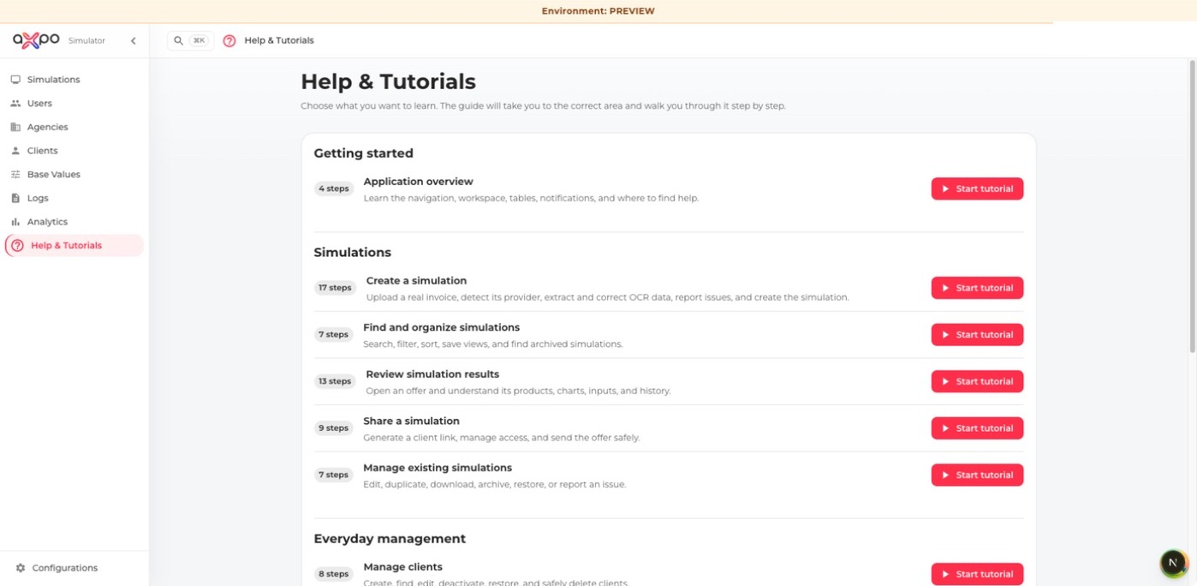
Help & Tutorials presents permission-aware walkthroughs.

3. Work with lists and tables
- Search narrows visible records using free text.
- Filters narrow structured fields such as status, agency, date or commodity.
- View presets restore useful filter and sorting combinations.
- Show/hide columns and Density change the table layout for the current browser.
- Select a column header to sort. Select row checkboxes only when a permitted bulk action is required.
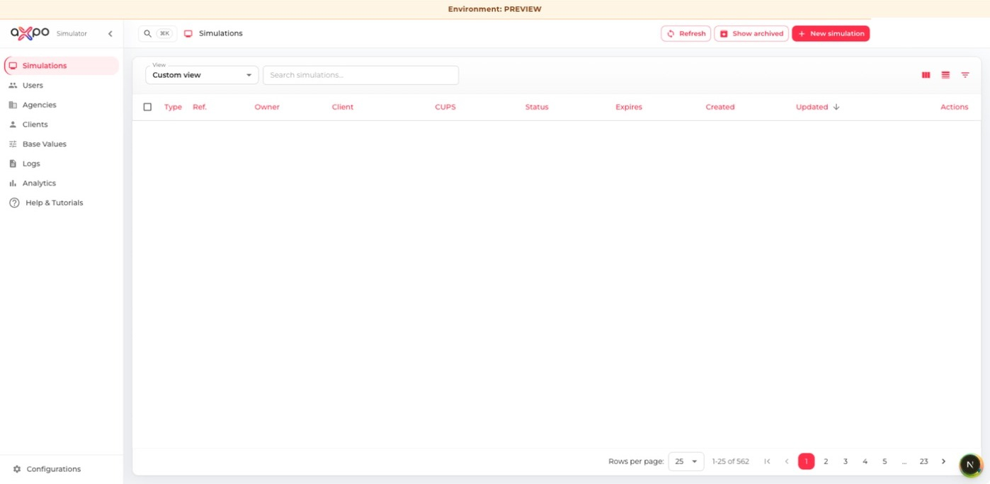
The simulations list with search, filters, columns, density and row actions.
Privacy: Clear searches and filters before sharing your screen. Do not place client or user data in screenshots or support messages unless required and authorized.

4. Create a simulation: invoice to validated data
Simulation work follows four visible stages: Source, Extract, Validate and Create. Finish each stage in order; the progress strip shows what is ready and what still needs attention.

4.1 Upload the source invoice
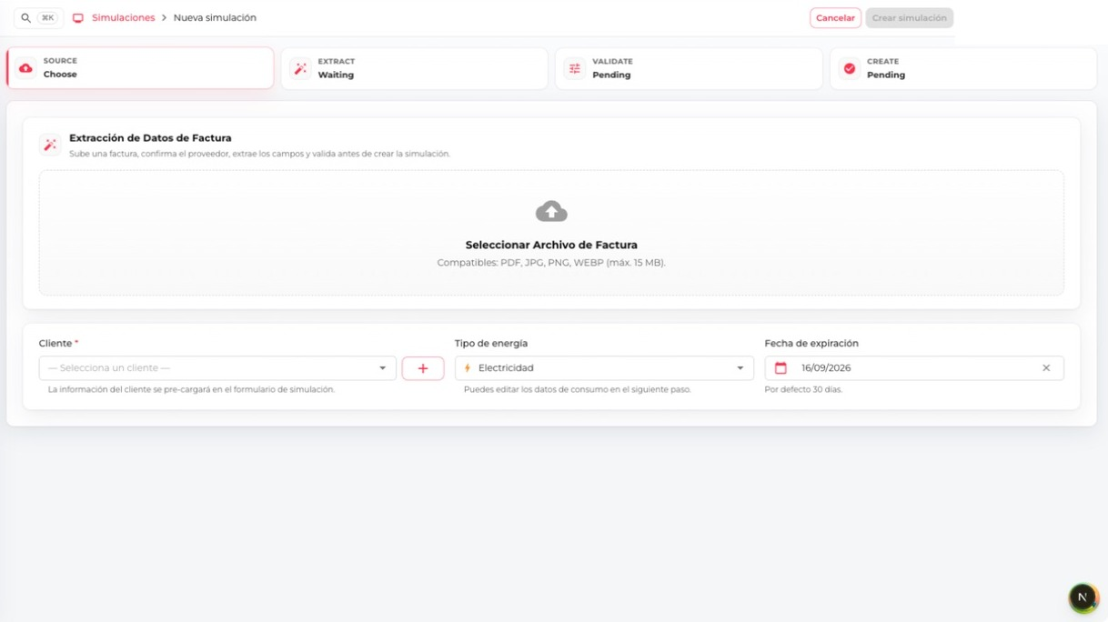
Start with the complete invoice and the correct customer, commodity and expiry date.
- From Simulations, select New simulation.
- Upload the complete invoice as PDF or supported image files. For image invoices, include every page.
- Confirm the detected invoice provider and invoice type. Correct the provider when detection is wrong.
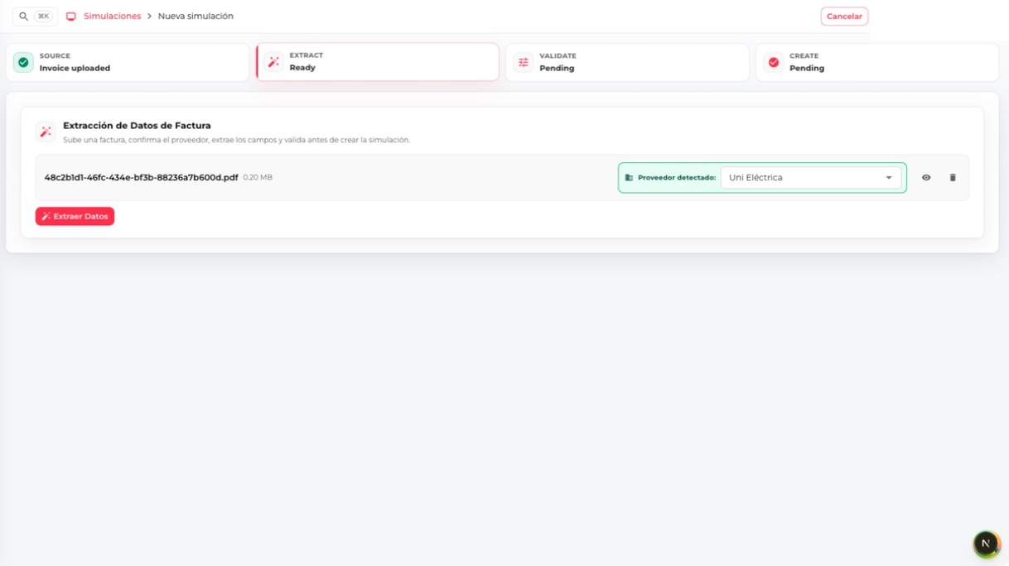
Provider recognition must be confirmed before OCR extraction begins.

4.2 Extract the invoice
- Select Extract data and wait for OCR processing to finish.
- Select an existing client. If your role permits client creation and no match exists, create the client from the dialog.
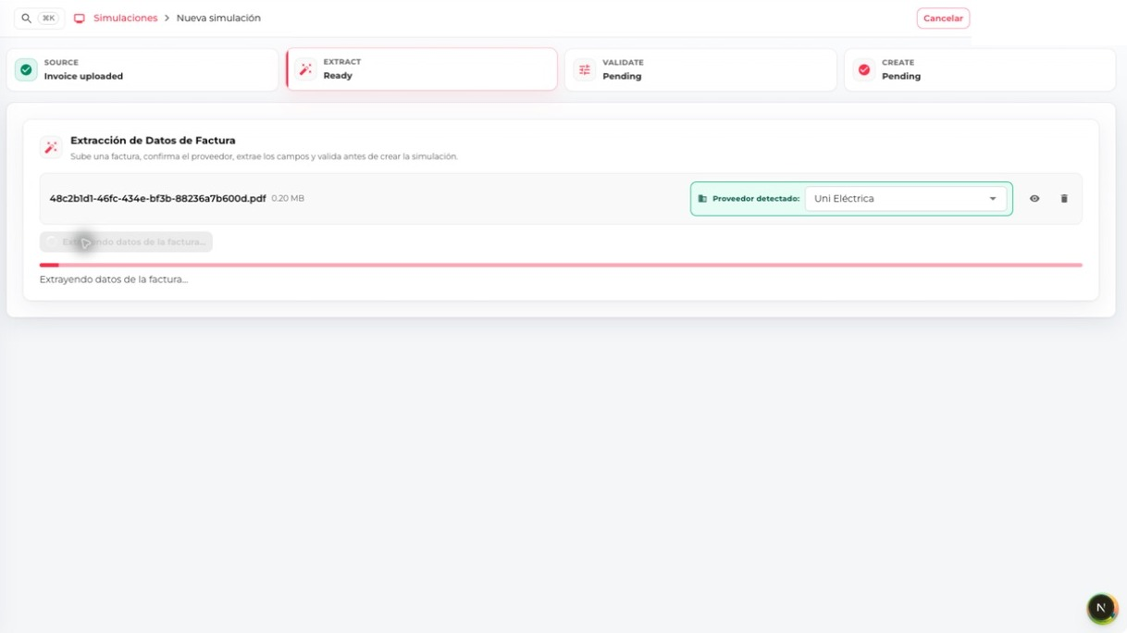
Keep the page open while OCR reads and structures the invoice.

4.3 Review and validate every field
- Compare every extracted value with the original invoice: commodity, CUPS, dates, consumption, contracted power, prices, taxes and total.
- Correct inaccurate or missing values, then select Validate.
- Complete the remaining offer fields and expiration date. Select Create simulation only after the review is complete.
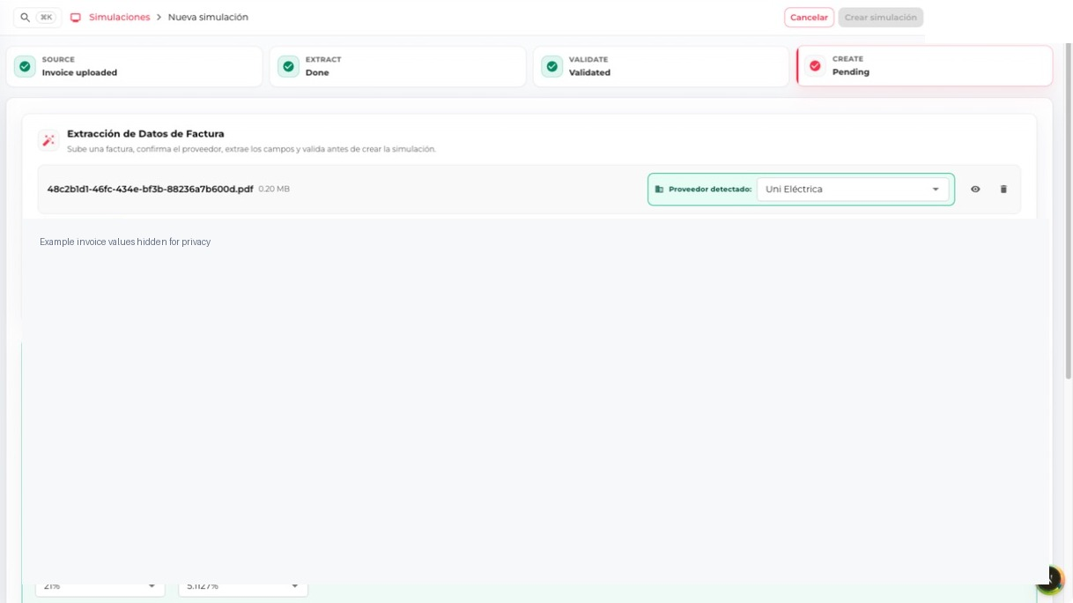
Validation confirms that the reviewed form can proceed to simulation creation; example values are hidden.
Quality check: OCR accelerates entry but does not replace verification against the source invoice.

5. Review, adjust and compare a simulation
The simulation detail is the operational centre of AXPO Simulator. Its header identifies the reference, status, expiry, invoice and PIN; the Data and Results tabs separate calculation inputs from commercial output.
- Find the simulation by reference, client, CUPS, owner, agency, commodity or status.
- Select Simulate for a draft or View for a shared simulation.
- Check the summary, attached invoice, status, PIN and expiration date.
- Use Results to compare products, totals, savings, percentages, charts and historical values.
- Use Inputs to review the full set of invoice, client, consumption, power, pricing and tax values.
- After changing an input, recalculate and review every result before selecting an offer.

5.1 Inspect calculation inputs
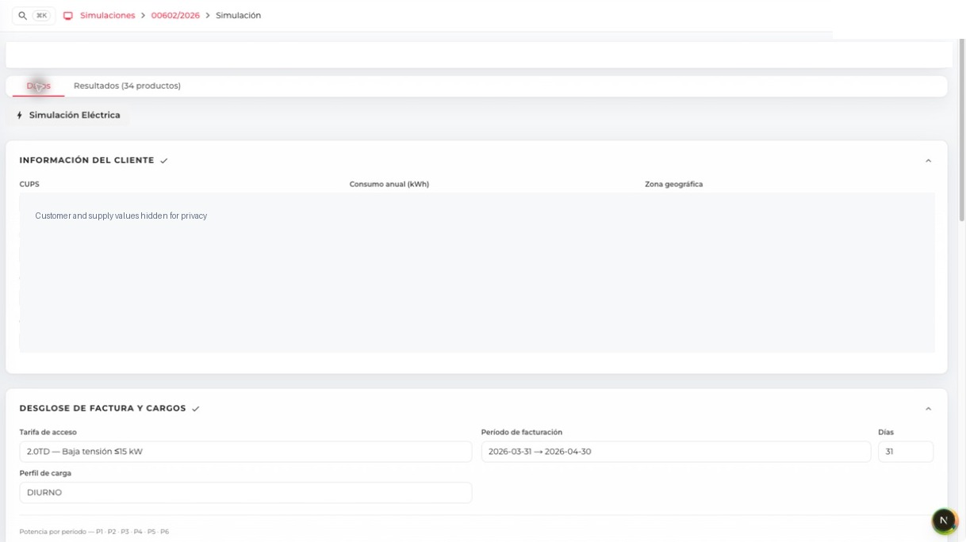
Inputs group customer, supply, billing, consumption, power, charges and tax data; identifying values are hidden.
Recalculation: Any changed input can alter product order, savings and totals. Select Recalculate offers and repeat the comparison before sharing.

5.2 Compare offers
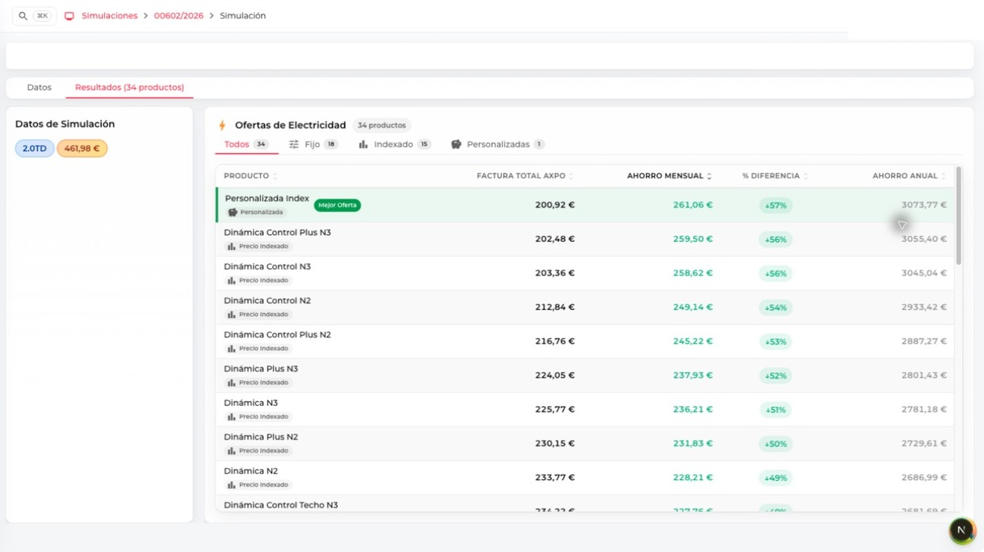
Filter fixed, indexed and customized products, then compare AXPO total, monthly saving, percentage difference and annual saving.
- The Best offer marker identifies the lowest calculated total; it is not an automatic recommendation.
- A positive saving should still be checked against product conditions, billing month and all assumptions.
- Select only one product after confirming that its commercial conditions fit the customer.

5.3 Select and share an offer
- Select the intended offer after checking totals, assumptions and savings.
- Open Share and choose PDF download or email, according to your permission.
- Choose the correct language and template. Review client details, selected product, values and branding.
- Download the PDF or send the email only when the preview is correct. Sharing changes the simulation status.
Before sharing: Confirm the client, selected product, language, recipient, totals, savings and expiration date. Email and public-link actions affect external recipients.

6. Managing clients
Clients are shared business records used by simulations. Create a client only after checking that it does not already exist.
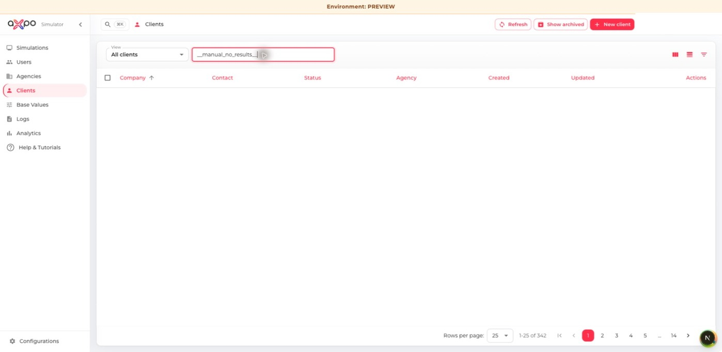
Clients list with a privacy-safe empty result
- Use search and filters to check for duplicates.
- Select New client and enter company, tax, contact, address, agency and preferred language data.
- Save only verified information. Deactivate records that should no longer be used; restore them when appropriate.
- Permanent deletion is irreversible and should follow the organization's retention policy.
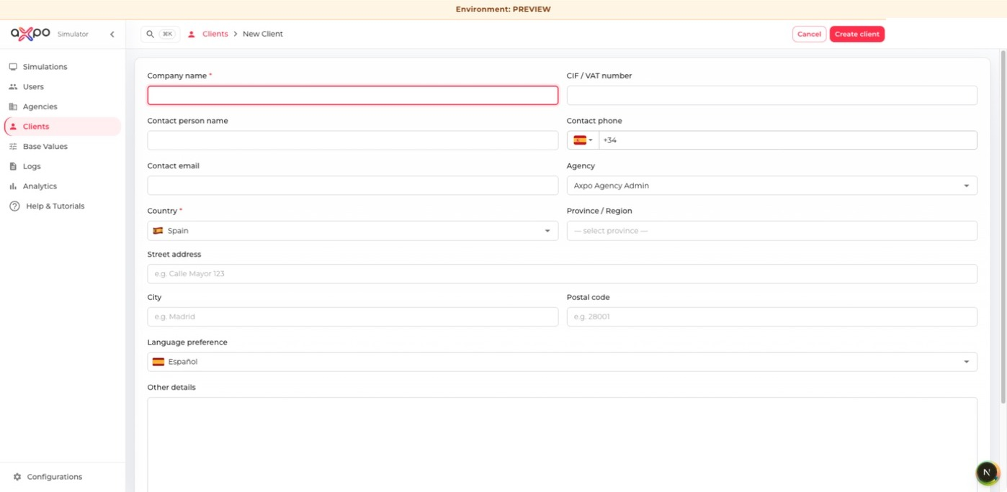
Blank client creation form

7. Managing users
User administration controls identity, role, agency, preferences and active access.
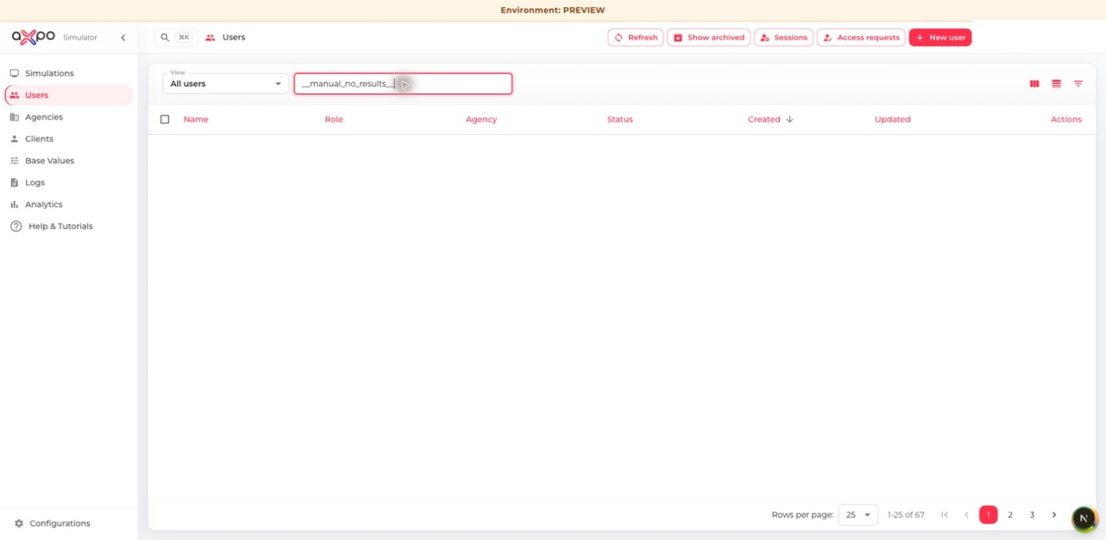
User list, search and access actions
- Select New user and enter the identity and contact fields.
- Assign the minimum role and correct agency required for the person's work.
- Review Preferences before saving, then confirm the welcome/setup process.
- Use Access requests to verify and approve or reject requested access.
- Use Sessions to inspect or revoke active sessions; deactivation prevents future sign-in.
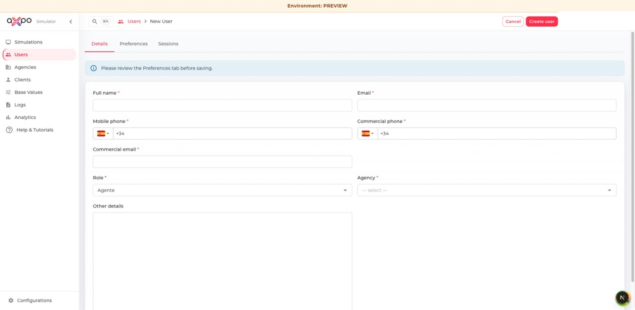
Blank user form and role assignment

8. Managing agencies
Agencies scope users, clients, commercial rules and product availability.
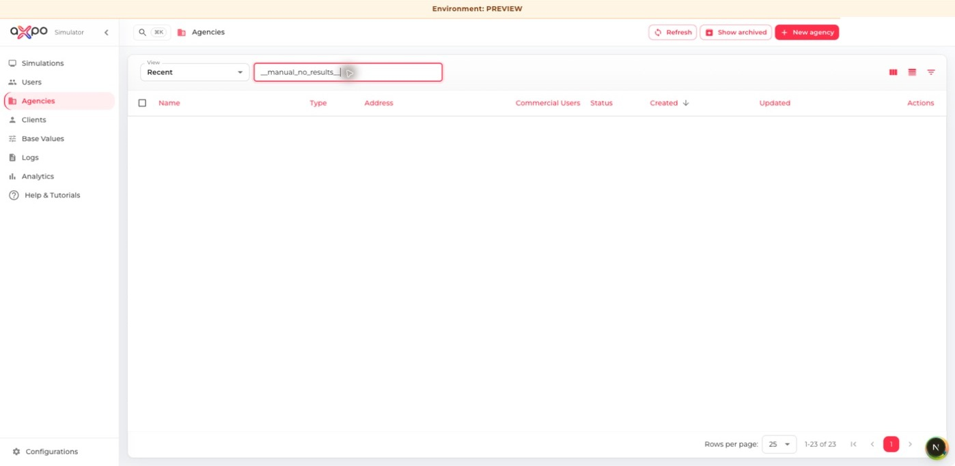
Agency list and management actions
- Create an agency with a clear unique name and accurate location.
- Enable TLV only for the appropriate agency type.
- In the agency detail, review users, products, tariffs and operational settings.
- Test a sample simulation after tariff or product changes.
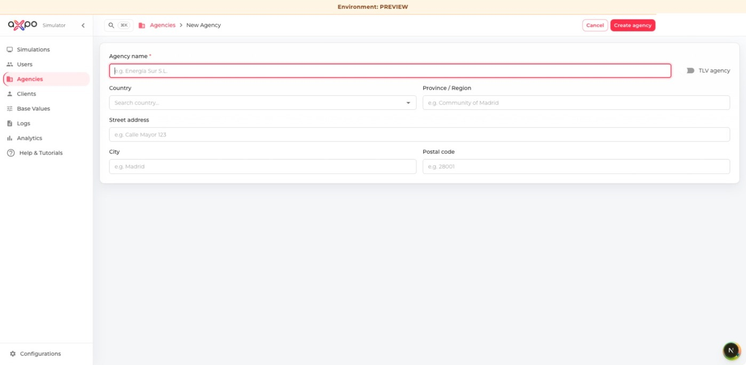
Blank agency creation form

9. Base values
Base values are economic reference data used by simulation calculations. Versions preserve calculation history.
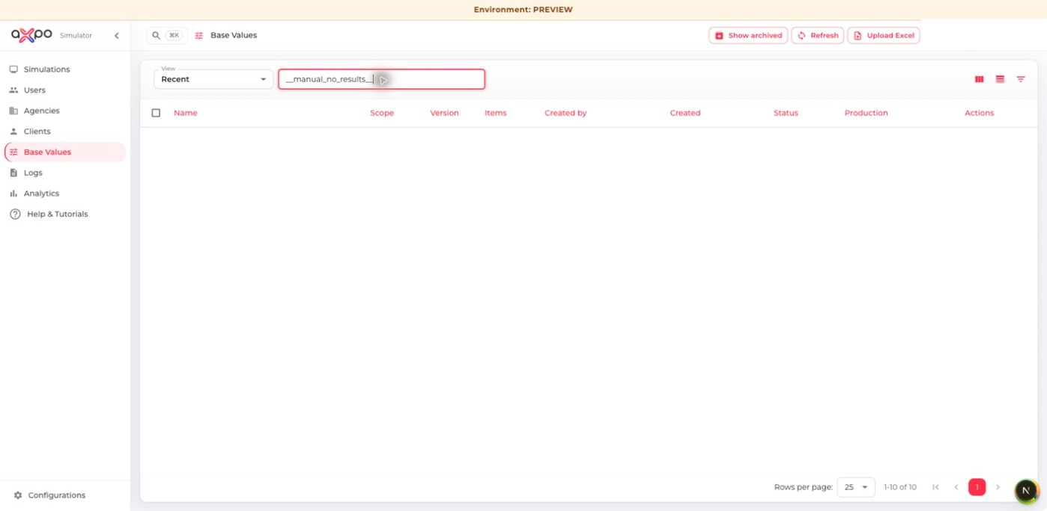
Base-value versions and publishing actions
- Upload a prepared XLSX or XLSM workbook.
- Choose global or agency scope and verify the target agency.
- Review validation messages, item coverage, version and effective dates.
- Activate only after validation and test a representative simulation.
- Archive superseded versions instead of deleting historical data.

10. Analytics
Analytics summarizes simulation creation, sharing, opening and agency performance for the selected period and scope.
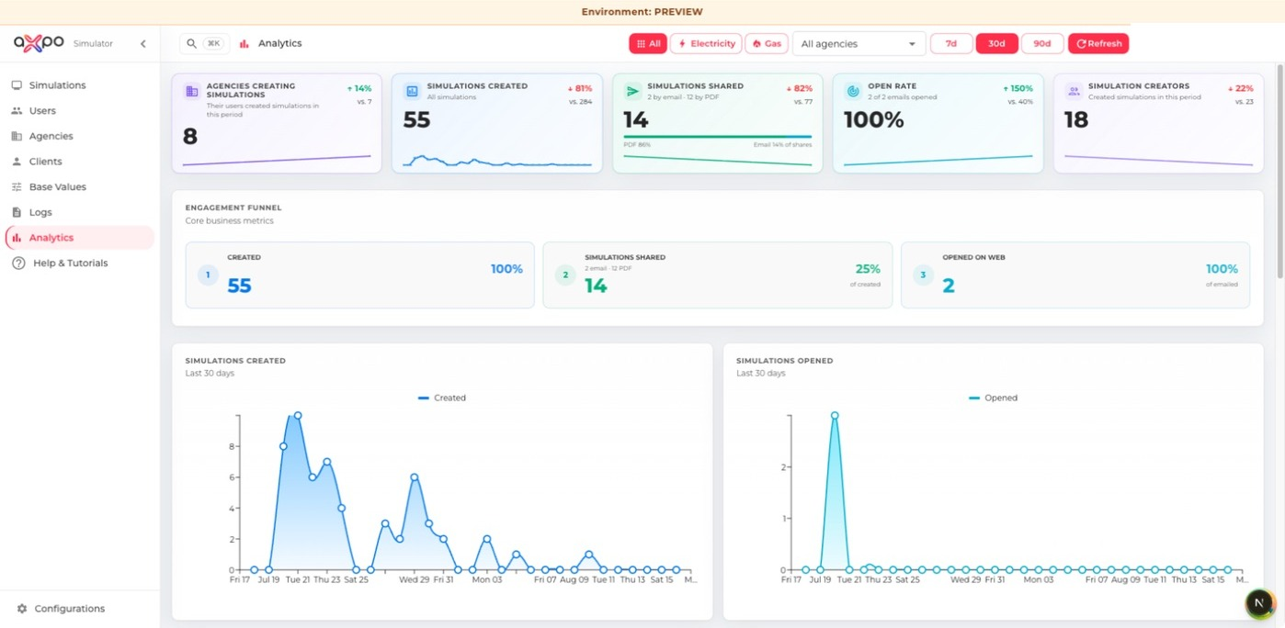
Analytics dashboard and engagement funnel
- Select commodity, agency and reporting period.
- Compare like-for-like periods and note the record scope.
- Use counts and date ranges when communicating a result.
- Treat incomplete, archived or expired simulations as possible context for a change.

11. Audit logs and simulation issues
The current Administrator configuration provides access to audit activity and reported simulation issues. Email, cron, OCR and application-error logs are not enabled for this role.
- Filter audit activity by date, type, user or reference before opening details.
- Use the simulation reference and event time to connect a reported issue with relevant audit actions.
- Do not copy sensitive payloads into general communication channels.
- Resolve or dismiss simulation issues only after recording the reason and outcome.

12. Configurations
Configuration changes can affect every user, calculation, document or outbound message.
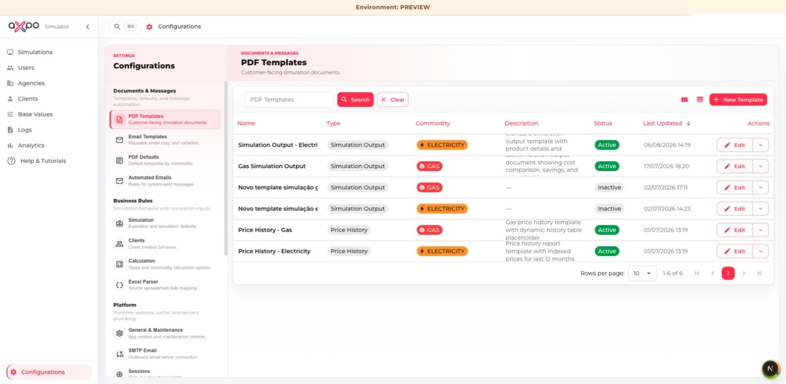
Configuration groups for documents, business rules, platform, AI/OCR and access
- Read the current value and description before editing.
- Change one logical setting at a time and keep a rollback value.
- Test changes to PDF/email templates, calculations, OCR prompts and role permissions in preview.
- Role-permission changes should be validated with the affected role before release.

13. Profile, language and help
- Open My profile to review your information and personal defaults.
- Use the profile menu language selector to switch the interface language.
- Use Notifications for application updates that require your attention.
- Open Help & Tutorials to repeat guided workflows at any time.

14. Troubleshooting
- No OTP email: wait a minute, check spam, then use Resend when available. Only the newest code is valid.
- Create button disabled: review required fields and complete validation.
- Unexpected OCR value: correct it before validation and use Report issue when the extraction should be investigated.
- Missing action or section: the capability may not be granted to your role. Contact an administrator.
- Outdated screen after an update: refresh the page. If the issue continues, sign out and sign in again.
Support request: Include the page, simulation reference (when relevant), time, expected result, actual result and a privacy-safe screenshot. Never include passwords, OTP codes or simulation PINs.

Quick pre-share checklist
- Correct client and CUPS
- Correct commodity, period, consumption and power
- Correct pricing, taxes and calculated totals
- Intended offer selected
- Correct language and template
- Correct recipient and expiration date
- Preview checked; no internal notes or unintended data

