AXPO
AXPO Simulator
User Manual - Agent
Create, review and share energy offers from one workspace.
Version 1.0 | 17 August 2026

About this manual
This manual explains the tasks available to the selected role in AXPO Simulator. Screens were captured from the preview environment. Available records and labels can change as the application evolves or when permissions are customized.
Role scope: This manual deliberately excludes System Administrator functions.

Contents
- Purpose and role scope
- Signing in securely
- Application navigation
- Working with tables
- Creating a simulation
- Reviewing and sharing offers
- Help, preferences and troubleshooting
- Client management and analytics

Role capabilities
Area | Access for this role
Simulations | Create, review, edit, share, duplicate and archive.
Clients | View, create, edit and delete client records.
Analytics | View operational metrics within the permitted scope.
Restricted | No base values, users, agencies, logs, OCR usage or configuration administration.
Important: Permissions can be customized by an administrator. The live application is authoritative when a button or section differs from this guide.

1. Sign in securely
- Open the AXPO Simulator internal address provided by your organization.
- Enter your work email address and password, then select Sign in.
- When Two-Factor Authentication appears, enter the six-digit code sent to your email.
- Select Verify Code. The application opens the Simulations workspace.
Security: Never share your password, OTP, simulation PIN or client link. Sign out on shared devices.

2. Navigate the application
- The left sidebar contains only the sections available to your role.
- The top bar contains the page title, current actions, notifications and the profile menu.
- Use global search (Command+K on macOS) to find accessible records and destinations quickly.
- Use Help & Tutorials to launch guided walkthroughs that are automatically filtered by permission.
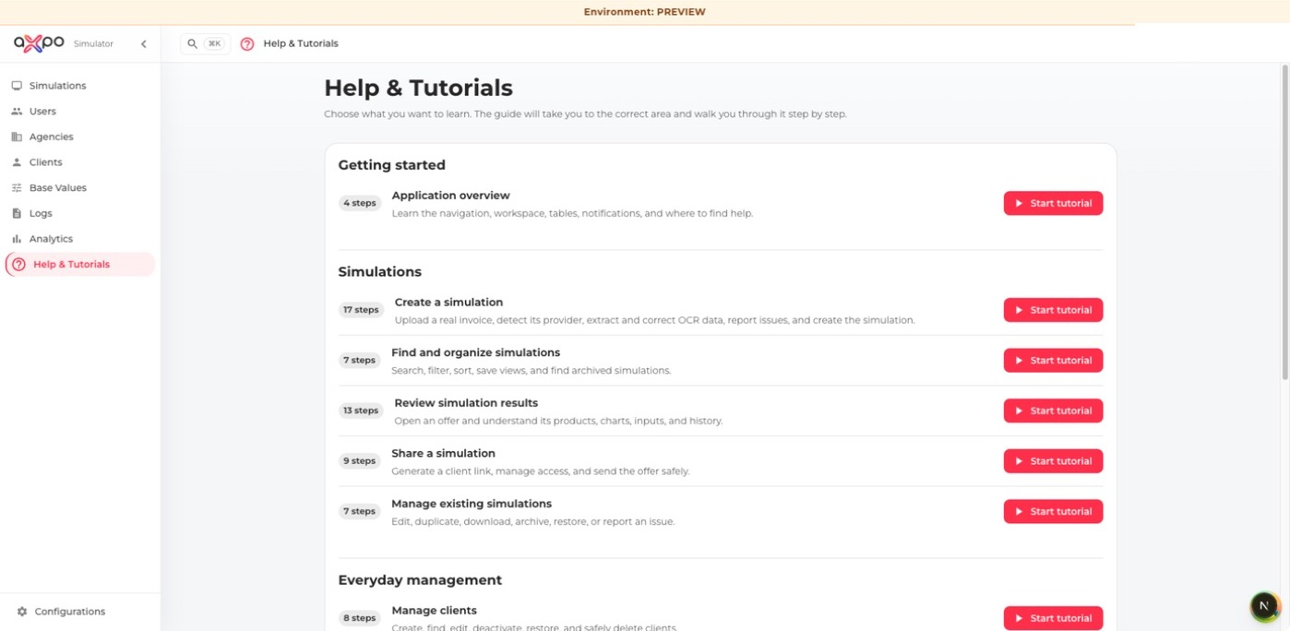
Help & Tutorials presents permission-aware walkthroughs.

3. Work with lists and tables
- Search narrows visible records using free text.
- Filters narrow structured fields such as status, agency, date or commodity.
- View presets restore useful filter and sorting combinations.
- Show/hide columns and Density change the table layout for the current browser.
- Select a column header to sort. Select row checkboxes only when a permitted bulk action is required.
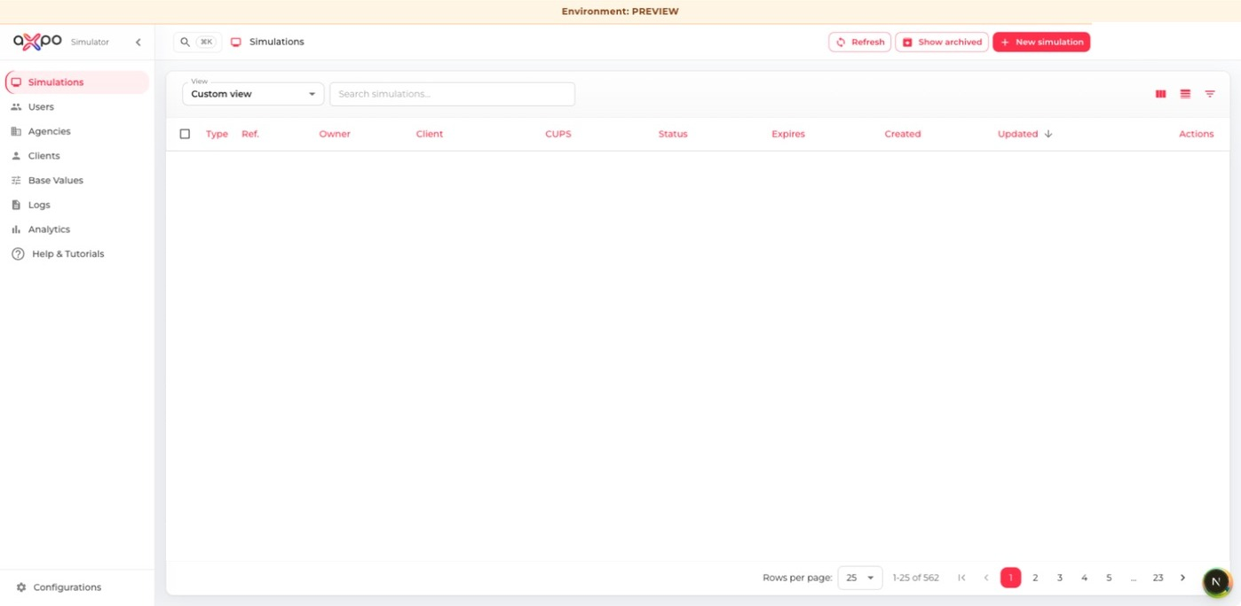
The simulations list with search, filters, columns, density and row actions.
Privacy: Clear searches and filters before sharing your screen. Do not place client or user data in screenshots or support messages unless required and authorized.

4. Create a simulation: invoice to validated data
Simulation work follows four visible stages: Source, Extract, Validate and Create. Finish each stage in order; the progress strip shows what is ready and what still needs attention.

4.1 Upload the source invoice
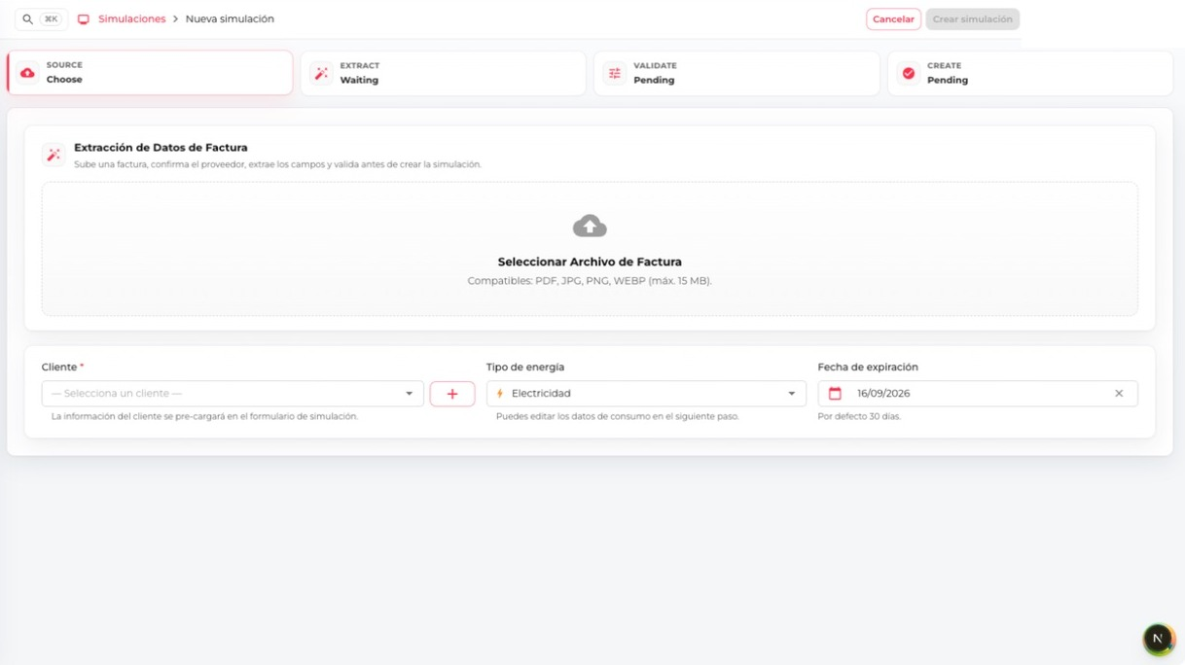
Start with the complete invoice and the correct customer, commodity and expiry date.
- From Simulations, select New simulation.
- Upload the complete invoice as PDF or supported image files. For image invoices, include every page.
- Confirm the detected invoice provider and invoice type. Correct the provider when detection is wrong.
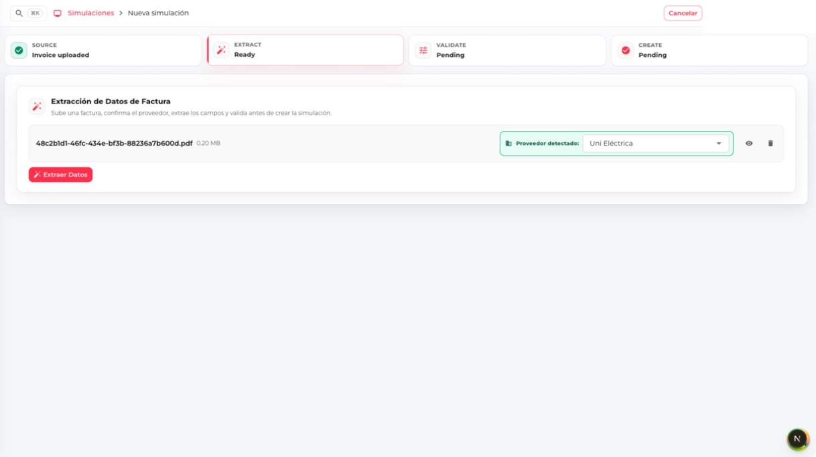
Provider recognition must be confirmed before OCR extraction begins.

4.2 Extract the invoice
- Select Extract data and wait for OCR processing to finish.
- Select an existing client. If your role permits client creation and no match exists, create the client from the dialog.
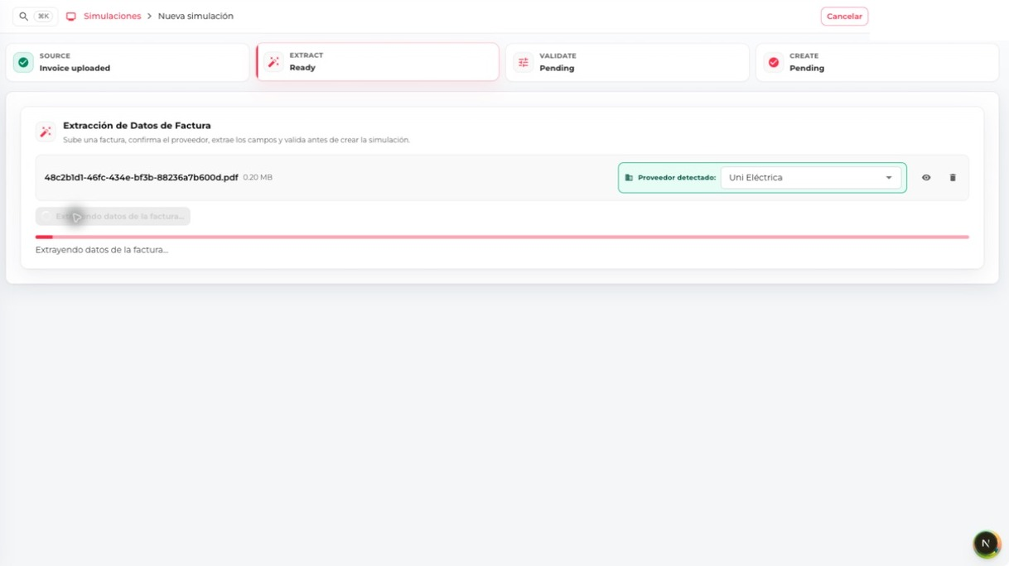
Keep the page open while OCR reads and structures the invoice.

4.3 Review and validate every field
- Compare every extracted value with the original invoice: commodity, CUPS, dates, consumption, contracted power, prices, taxes and total.
- Correct inaccurate or missing values, then select Validate.
- Complete the remaining offer fields and expiration date. Select Create simulation only after the review is complete.
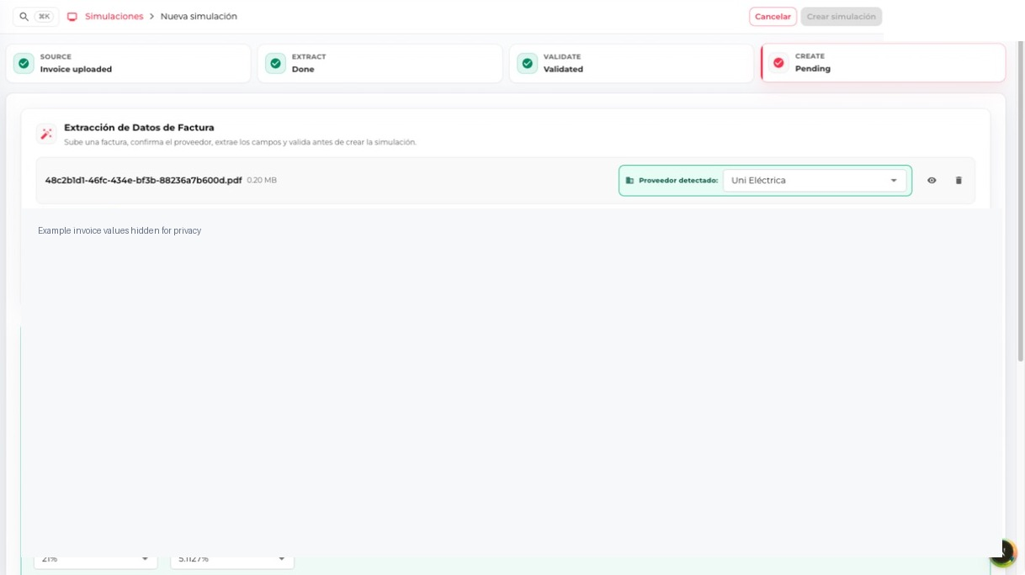
Validation confirms that the reviewed form can proceed to simulation creation; example values are hidden.
Quality check: OCR accelerates entry but does not replace verification against the source invoice.

5. Review, adjust and compare a simulation
The simulation detail is the operational centre of AXPO Simulator. Its header identifies the reference, status, expiry, invoice and PIN; the Data and Results tabs separate calculation inputs from commercial output.
- Find the simulation by reference, client, CUPS, owner, agency, commodity or status.
- Select Simulate for a draft or View for a shared simulation.
- Check the summary, attached invoice, status, PIN and expiration date.
- Use Results to compare products, totals, savings, percentages, charts and historical values.
- Use Inputs to review the full set of invoice, client, consumption, power, pricing and tax values.
- After changing an input, recalculate and review every result before selecting an offer.

5.1 Inspect calculation inputs
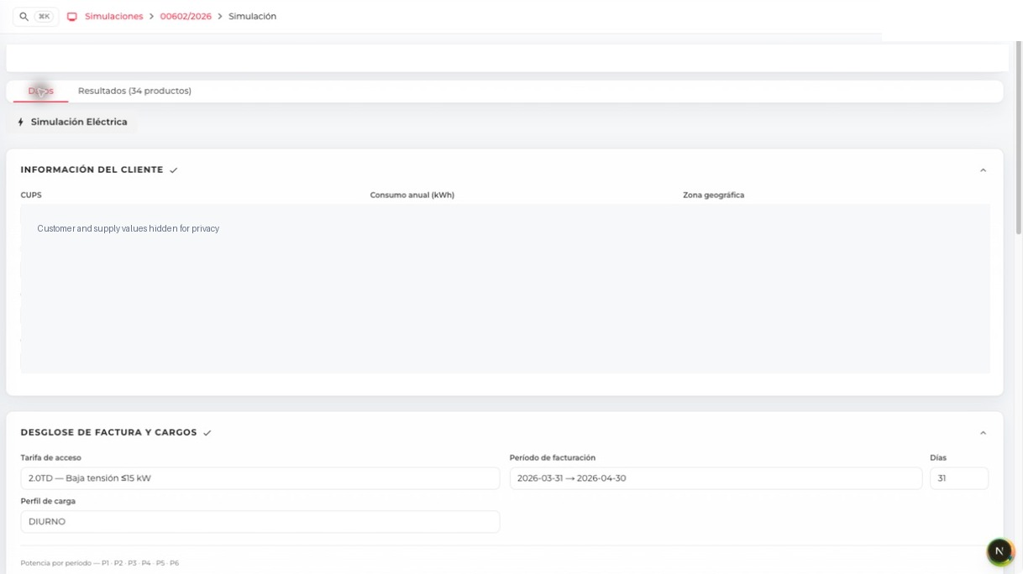
Inputs group customer, supply, billing, consumption, power, charges and tax data; identifying values are hidden.
Recalculation: Any changed input can alter product order, savings and totals. Select Recalculate offers and repeat the comparison before sharing.

5.2 Compare offers
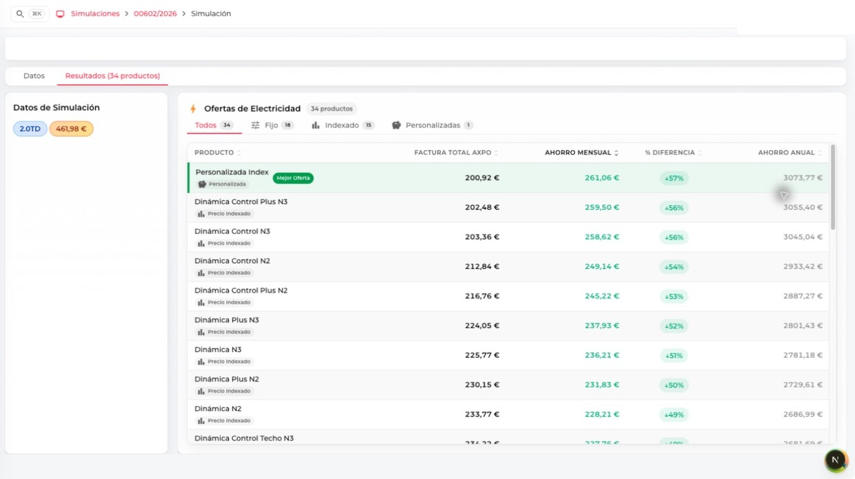
Filter fixed, indexed and customized products, then compare AXPO total, monthly saving, percentage difference and annual saving.
- The Best offer marker identifies the lowest calculated total; it is not an automatic recommendation.
- A positive saving should still be checked against product conditions, billing month and all assumptions.
- Select only one product after confirming that its commercial conditions fit the customer.

5.3 Select and share an offer
- Select the intended offer after checking totals, assumptions and savings.
- Open Share and choose PDF download or email, according to your permission.
- Choose the correct language and template. Review client details, selected product, values and branding.
- Download the PDF or send the email only when the preview is correct. Sharing changes the simulation status.
Before sharing: Confirm the client, selected product, language, recipient, totals, savings and expiration date. Email and public-link actions affect external recipients.

6. Client management
Agents can view, create, edit and delete client records required by simulation work.
- Search before creating a client to avoid duplicates.
- Complete company, contact, address, agency and language information.
- Keep tax and contact data aligned with the source invoice.
- Before deleting, confirm the record is the intended client and follow the organization's retention rules.

7. Analytics
The dashboard shows the activity and performance available to your operational scope.
- Select a consistent period and commodity.
- Use totals and date ranges when sharing results.
- Ask an administrator when agency-level visibility appears incomplete.

8. Profile, language and help
- Open My profile to review your information and personal defaults.
- Use the profile menu language selector to switch the interface language.
- Use Notifications for application updates that require your attention.
- Open Help & Tutorials to repeat guided workflows at any time.

9. Troubleshooting
- No OTP email: wait a minute, check spam, then use Resend when available. Only the newest code is valid.
- Create button disabled: review required fields and complete validation.
- Unexpected OCR value: correct it before validation and use Report issue when the extraction should be investigated.
- Missing action or section: the capability may not be granted to your role. Contact an administrator.
- Outdated screen after an update: refresh the page. If the issue continues, sign out and sign in again.
Support request: Include the page, simulation reference (when relevant), time, expected result, actual result and a privacy-safe screenshot. Never include passwords, OTP codes or simulation PINs.

Quick pre-share checklist
- Correct client and CUPS
- Correct commodity, period, consumption and power
- Correct pricing, taxes and calculated totals
- Intended offer selected
- Correct language and template
- Correct recipient and expiration date
- Preview checked; no internal notes or unintended data

