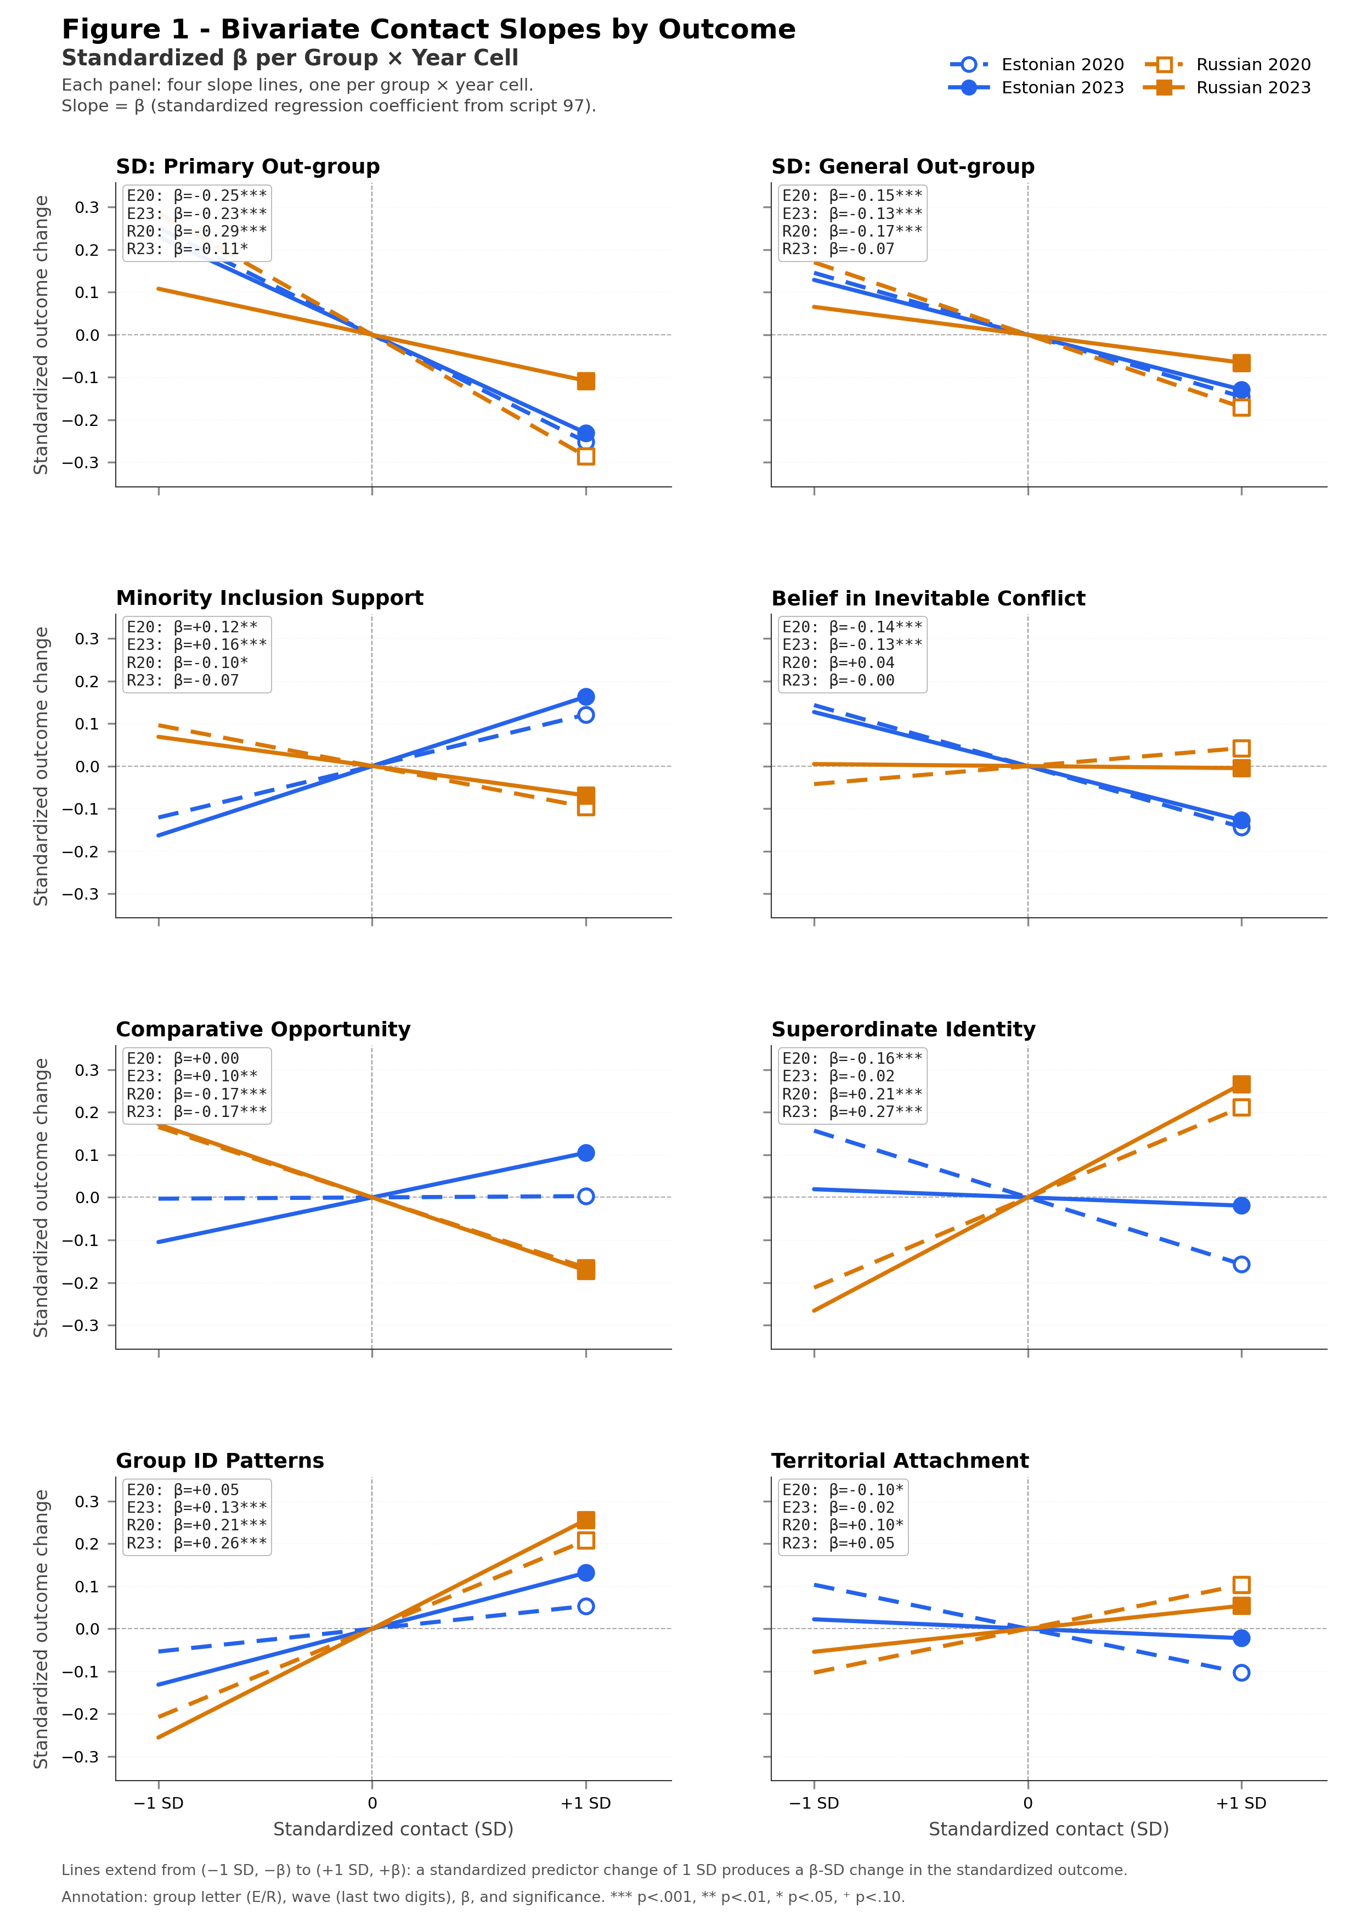
Figure 1. Bivariate contact slopes by outcome (standardized β per group × year cell).

