Comparative Opportunity Assessment — Item-Level Distribution Plots
For each of the 12 items in the Q44 / K3X1 battery, this report shows the distribution of responses for Russian and Estonian respondents in 2020 and 2023. The visual format mirrors the polarization-check figures used for Superordinate Identity (fig_polarization_density.jpg) and Belief in Inevitable Conflict (fig_bic_density.jpg).

Scale interpretation. All Q44 / K3X1 items use the same 1–5 response scale: 1 = "much better for Estonians," 3 = "equal," 5 = "much better for people of other nationalities." Lower scores indicate that the respondent perceives an Estonian structural advantage in that domain. The vertical light-grey line at 3 in each panel marks the "equal opportunity" midpoint.

Statistical annotations. Each chart's footer reports the within-group t-test p (whether the mean changed 2020 → 2023) and Levene's test p (whether the variance changed 2020 → 2023). A significant Levene's test with a non-significant t-test indicates polarization without mean shift — a finding the composite-level analysis does not surface.

Item 1: Material well-being
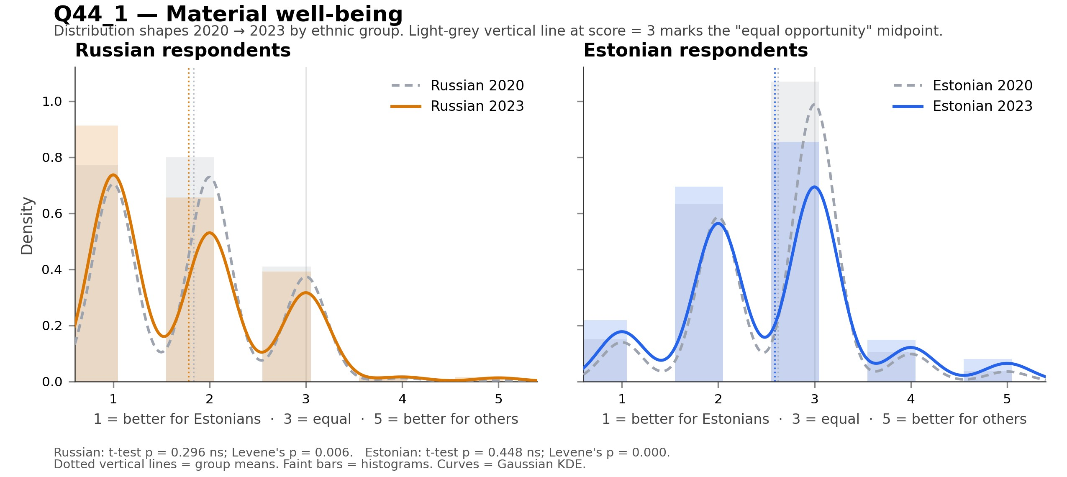
Notable: Russian respondents: significant variance change (Levene's p = 0.006); Estonian respondents: significant variance change (Levene's p = 0.000).

Item 2: Cultural participation
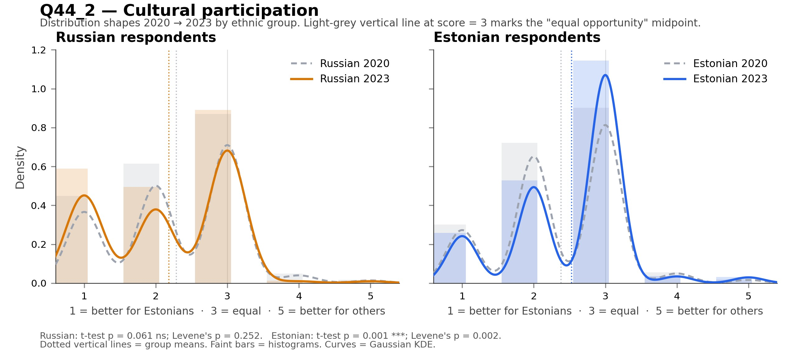
Notable: Estonian respondents: significant mean shift (p = 0.001); Estonian respondents: significant variance change (Levene's p = 0.002).

Item 3: Education
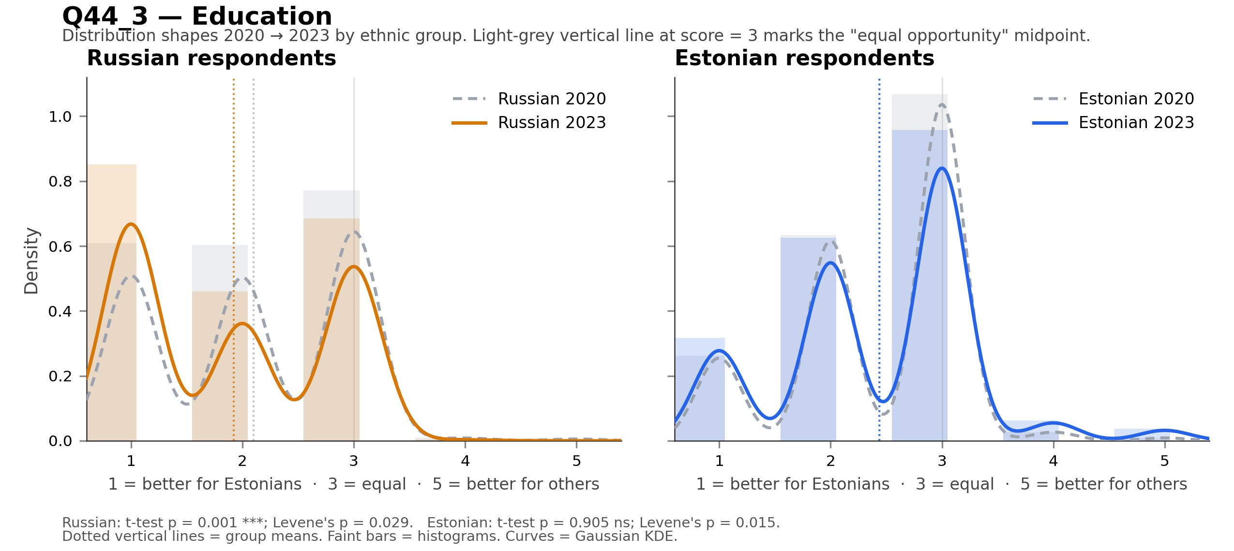
Notable: Russian respondents: significant mean shift (p = 0.001); Russian respondents: significant variance change (Levene's p = 0.029); Estonian respondents: significant variance change (Levene's p = 0.015).

Item 4: Social/political rights
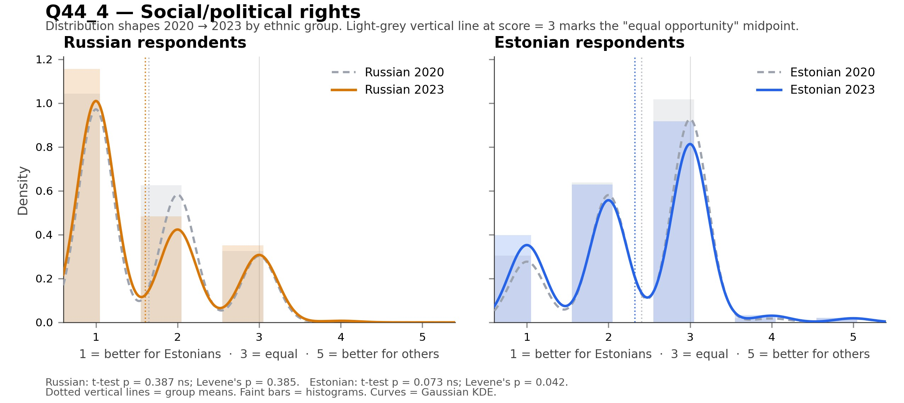
Notable: Estonian respondents: significant variance change (Levene's p = 0.042).

Item 5: Entrepreneurship
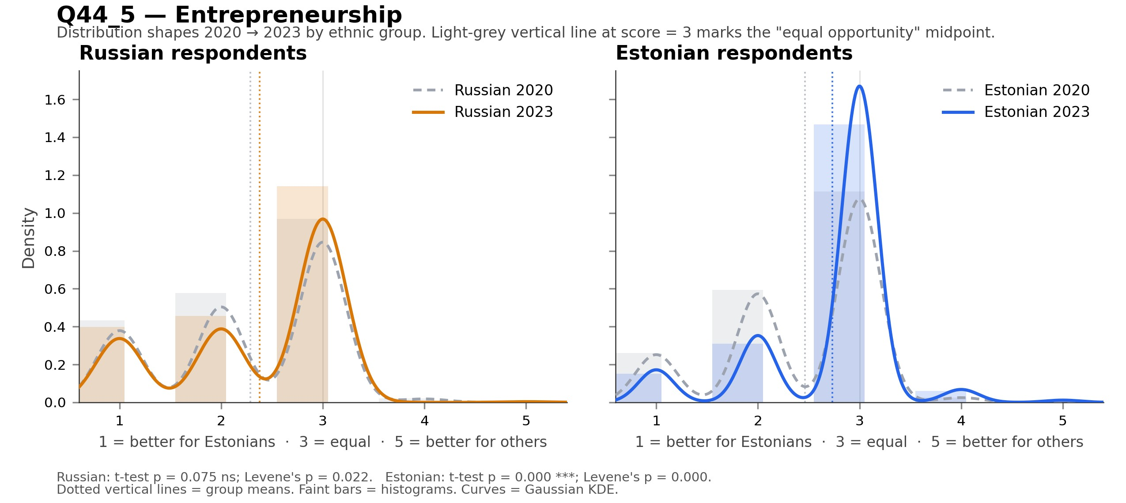
Notable: Russian respondents: significant variance change (Levene's p = 0.022); Estonian respondents: significant mean shift (p = 0.000); Estonian respondents: significant variance change (Levene's p = 0.000).

Item 6: Career & jobs
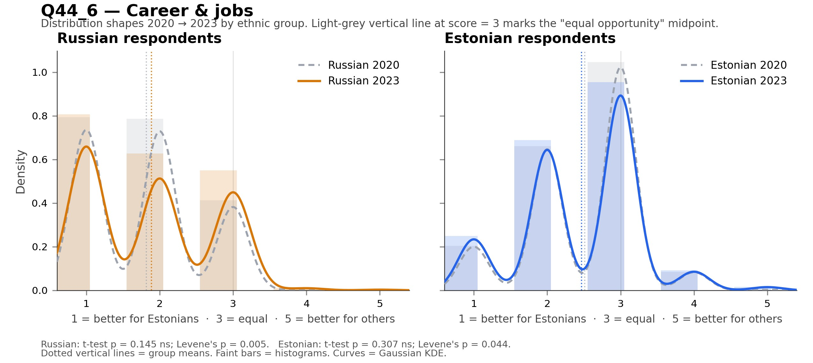
Notable: Russian respondents: significant variance change (Levene's p = 0.005); Estonian respondents: significant variance change (Levene's p = 0.044).

Item 7: Medical care
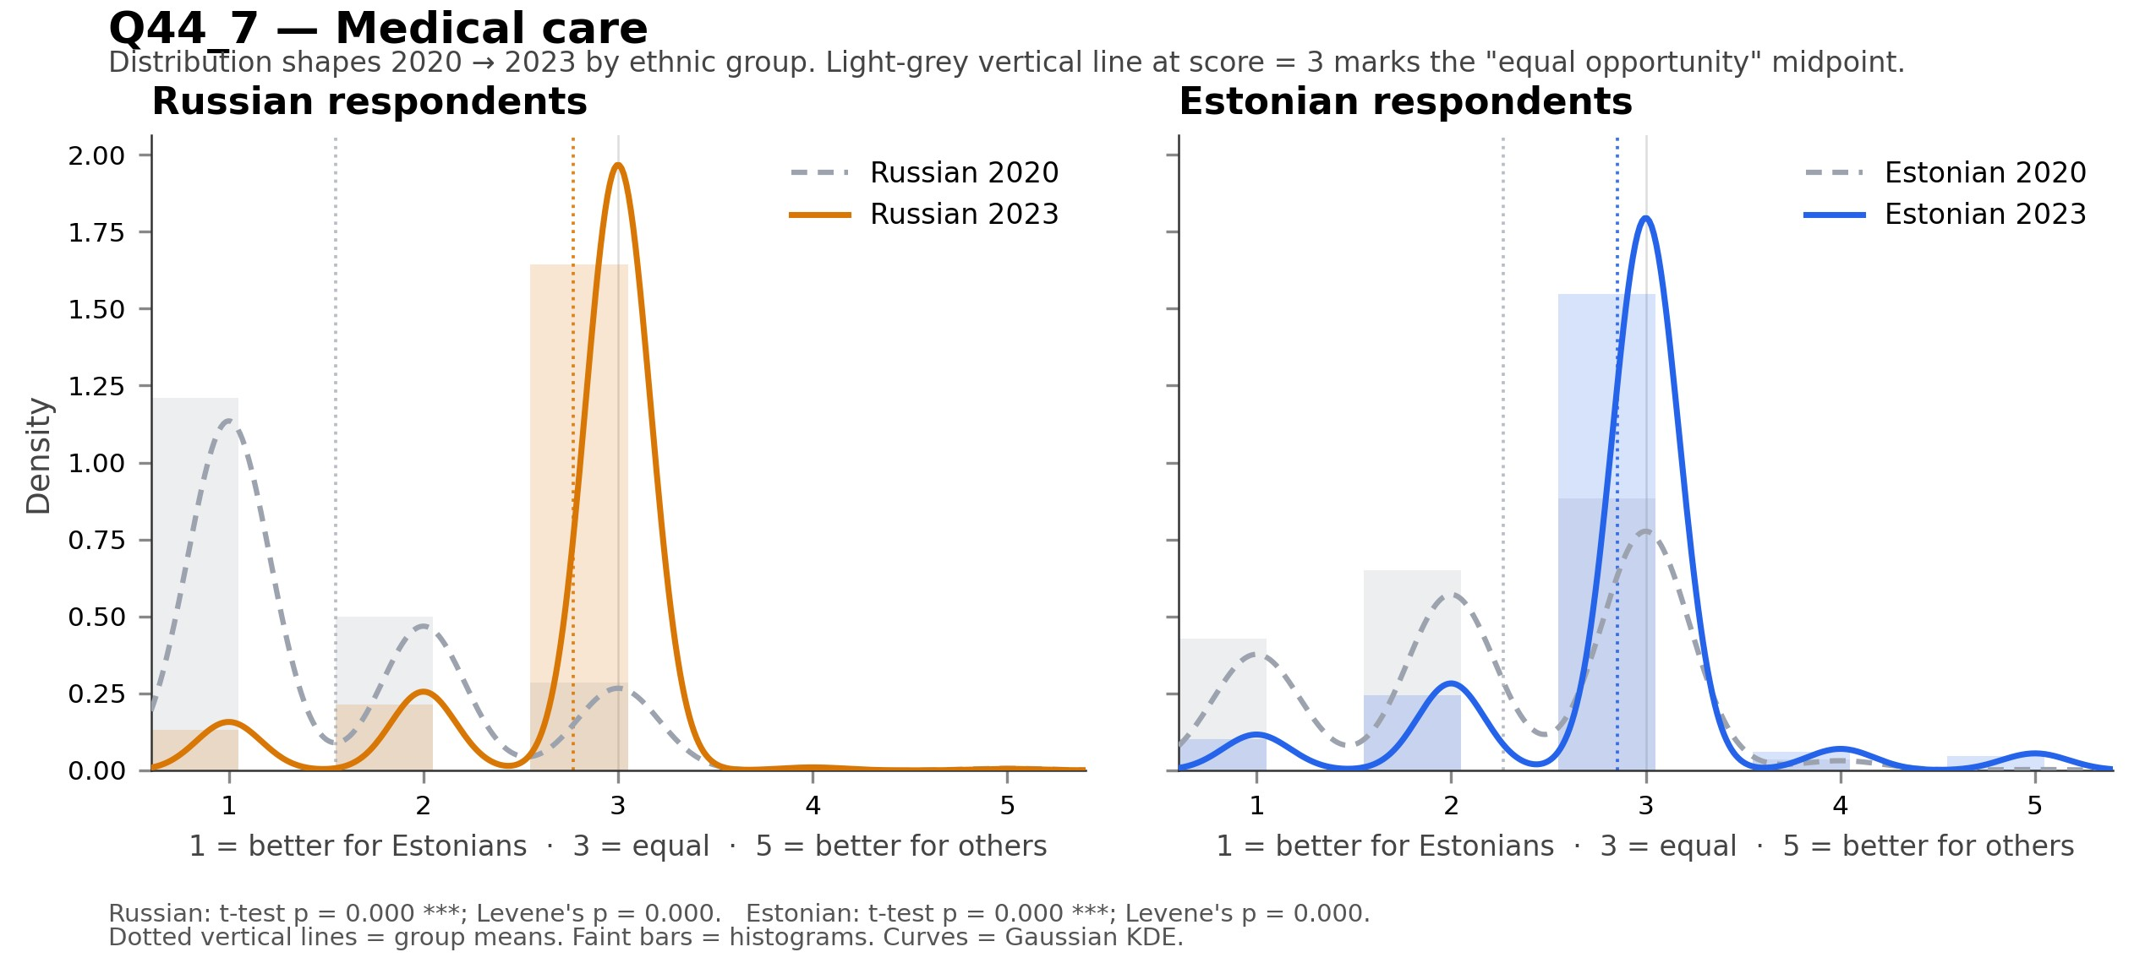
Notable: Russian respondents: significant mean shift (p = 0.000); Russian respondents: significant variance change (Levene's p = 0.000); Estonian respondents: significant mean shift (p = 0.000); Estonian respondents: significant variance change (Levene's p = 0.000).

Item 8: Housing
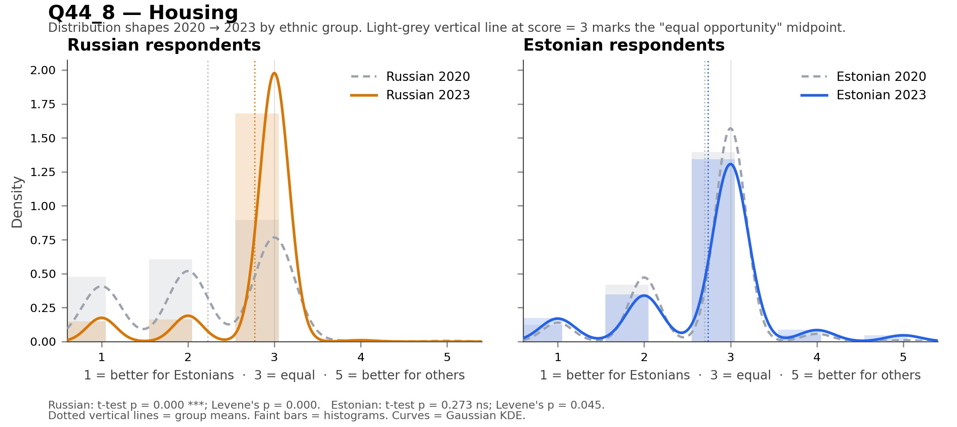
Notable: Russian respondents: significant mean shift (p = 0.000); Russian respondents: significant variance change (Levene's p = 0.000); Estonian respondents: significant variance change (Levene's p = 0.045).

Item 9: Leisure & holidays
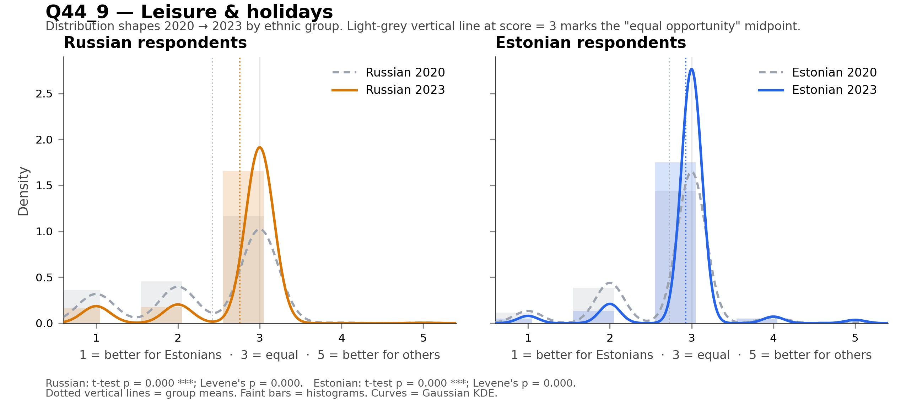
Notable: Russian respondents: significant mean shift (p = 0.000); Russian respondents: significant variance change (Levene's p = 0.000); Estonian respondents: significant mean shift (p = 0.000); Estonian respondents: significant variance change (Levene's p = 0.000).

Item 10: Children & youth opportunities
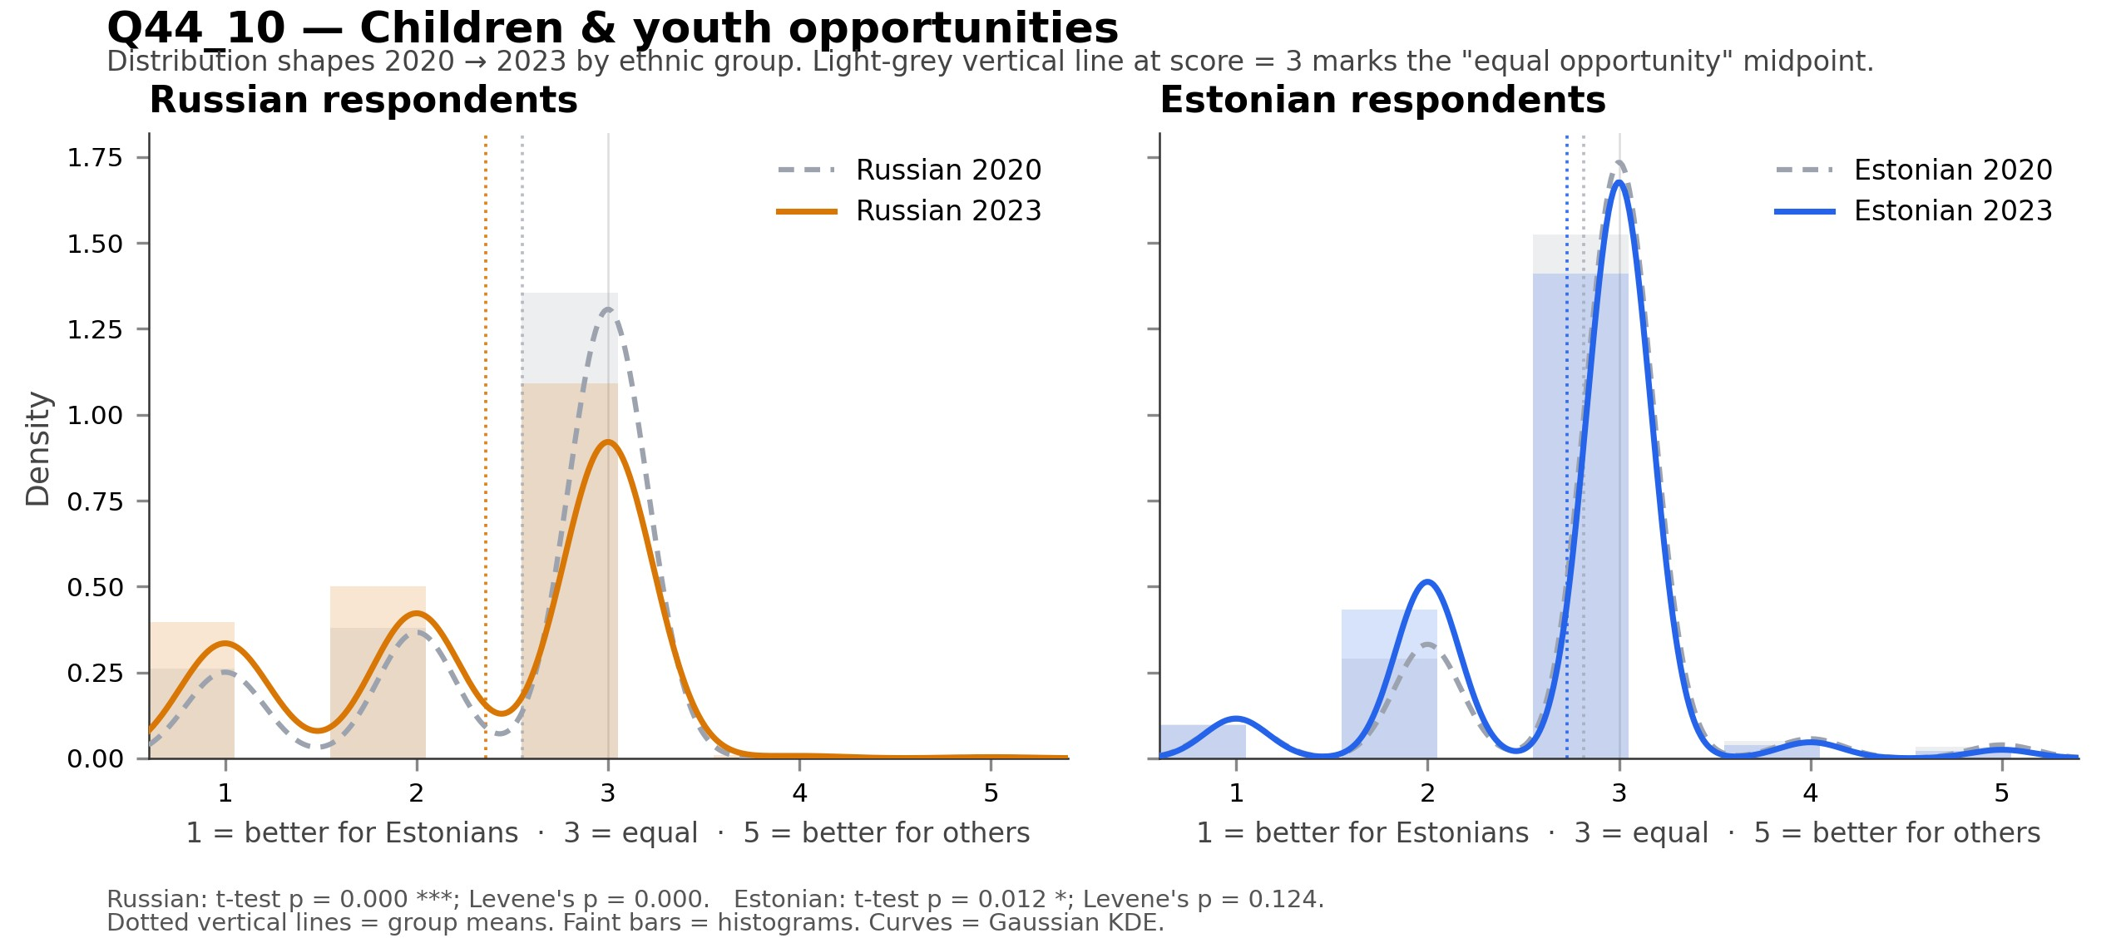
Notable: Russian respondents: significant mean shift (p = 0.000); Russian respondents: significant variance change (Levene's p = 0.000); Estonian respondents: significant mean shift (p = 0.012).

Item 11: Sports & exercise
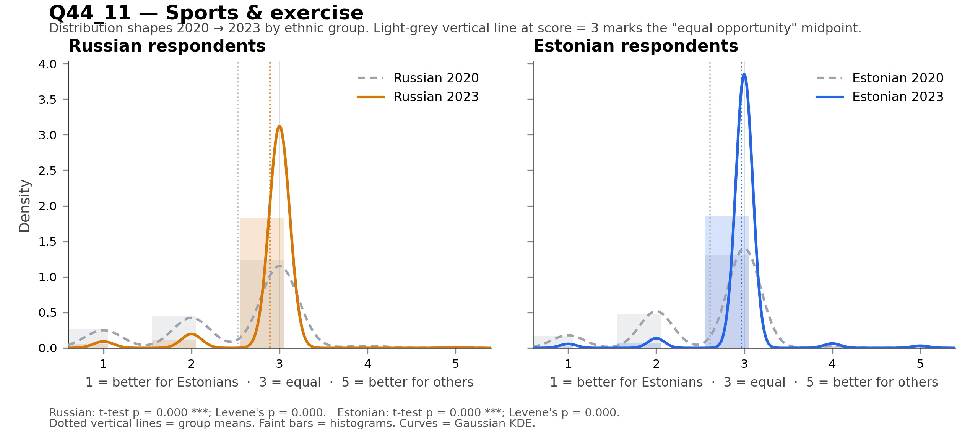
Notable: Russian respondents: significant mean shift (p = 0.000); Russian respondents: significant variance change (Levene's p = 0.000); Estonian respondents: significant mean shift (p = 0.000); Estonian respondents: significant variance change (Levene's p = 0.000).

Item 12: State benefits/services
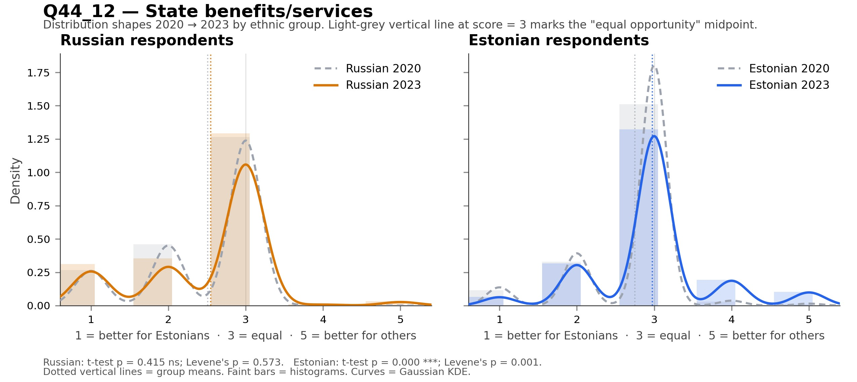
Notable: Estonian respondents: significant mean shift (p = 0.000); Estonian respondents: significant variance change (Levene's p = 0.001).

Notes. Means are reported on the raw 1–5 Q44 scale (NOT the inverted scale used in the composite-level analysis). All t-tests are independent-samples Welch's t. Levene's tests use the median-centered version, which is robust to non-normality. Significance: *** p<.001, ** p<.01, * p<.05, ns = not significant. Code 9 ("Don't know") was recoded to NA before computing distributions.

