Using the Multipage Form Generator

(aka Dweedle)

Rev 1 – 12/1/2018 - BW

Address Label Section

The Address Label section is where the data you would like to display on the page goes.

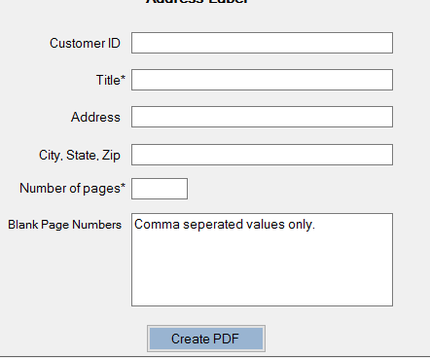

The only required fields here are the Title and Number of Pages.

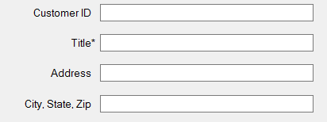

These fields are visible on the “printed” pages. Title must be filled in.

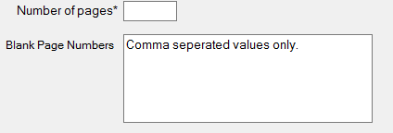

The two bottom fields are for the number of pages needed. Max of 9999 here.

The blank page numbers text box is where you can tell the application which pages to make blank. This text box will only accept digits or commas.

Example Data: 5,10,15,20

When you print your pages, you will notice that these listed pages are indeed blank.

Settings Section

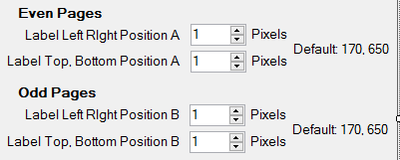

Here we have the more complicated section of this app. The Even pages positioning will move the address label around the “printed” page.

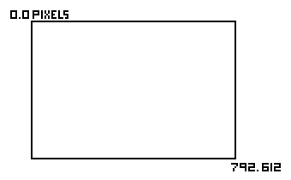

This application is defaulted to landscape or portrait mode. The top corner is 0, 0 pixels and the bottom right hand corner is 792, 612.

The positional boxes will not allow you to position the text beyond these values. It will take a little playing to get your positioning just right.

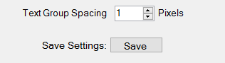

The Text Group Spacing box adjusted the margin between the text on the address label.

The Save settings button will save your chosen settings. You will see them populate with the same numbers upon closing and reopening of the application.