Polyglots

Corey McMurray, Adhiraj Pathak, Brian Jackman and Chris Ginsburg

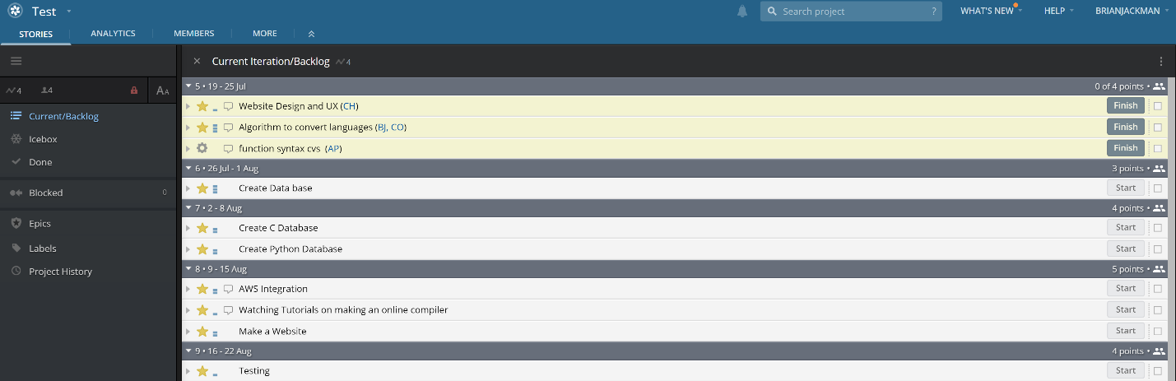<https://www.pivotaltracker.com/n/projects/2356352>

<https://github.com/brja3022/CSCI3308>

How to run: After downloading the project from github, go to /website/views/index.html. This will take you to the web page. Here insert your code into the text box that says insert code or press the swap button to change which language you are inputting. You can also use the link below.

<http://127.0.0.1:59580/Website/views/index.html>