Executive Summary
This document reports on the establishment of genetic monitoring programs for BONY and RASU populations in the lower Colorado River and adjacent off-channel habitats (OCH). In addition to characterization of genetic variation, this work took the important steps of producing a database for storage of genetic data from monitoring activities and an archive for storage in perpetuity of these valuable samples.

Bonytail.—Genetic variation in bonytail (BONY) is severely limited due to formation of the captive broodstock from a small number of individuals following collapse of the natural population. We successfully developed a Genotyping-in-Thousands by sequencing (GT-seq) panel to replace the existing microsatellite-based genetic monitoring for BONY. Using family groups, we were able to verify utility of the 238 loci GT-seq panel for accurate identifications of parent-offspring relationships and for monitoring genetic diversity, relatedness and effective population size (N_{e}) in broodstock and OCH.

Using the GT-seq panel, genetic diversity in the F₁ (first generation of progeny), F₂ (second filial generation [produced by crossing F1 individuals]), and F₃ (third filial generation [produced by crossing F2 individuals]) broodstocks of BONY maintained at the Southwestern Native Aquatic Resources and Recovery Center (SNARRC) were evaluated. For the F₁s N_{e} was similar (N_{e} = 12) to the original number of founders (N = 10), and three pairs of individuals gave rise to a disproportionate number of offspring, consistent with previous data (Hedrick et al. 2000). Observed heterozygosity (H_{obs}) was highest in the F₁ sample. Genetic analysis presented here shows that the F₂ and F₃ stocks contain similar levels of diversity to the F₁s and the sibship estimate of N_{e} (N_{e-sib}) was relatively large.

Genetic diversity, relatedness, and effective population size were estimated for BONY at Cibola High Levee Pond (CHLP) and for adults stocked and recruits produced at United States Fish and Wildlife Service (USFWS) Imperial National Wildlife Refuge (INWR). Imperial Ponds 2, 5 and 6 (IP2, IP5, and IP6) were designated BONY ponds at INWR and were originally stocked in 2017. IP5 and IP2 were restocked in 2022 and 2023, respectively, following die-offs. Allelic diversity in the CHLP population slightly exceeded that observed in all others including the stock held at SNARRC. Expected heterozygosity (H_{exp}) and H_{obs} were lower when compared to SNARRC, but these metrics were within the range seen at INWR ponds. Effective population size of the CHLP population exceeded 100, relatedness (r) was generally low, and we observed low variance in reproductive success (VRS) among spawners. Major findings include small values of N_{e} estimated using linkage disequilibrium (N_{e-LD}) for the stocked adults especially for IP2 and IP5, and among stocked adults, there were many individuals with close-kin relationships (estimated as r). N_{e-LD} of the adults stocked in 2017 at IP6 was larger and there were fewer individuals with close-kin relationships (e.g., lower mean r-values) compared to adults used to restock IP2 and IP5. Encouragingly, in all INWR ponds, the number of close kin recruits declined in the years following population establishment. In all INWR ponds, we found minimal variance in reproductive success among males and females and between ponds, which explains the maintenance of diversity between stocked adults and recruits. Genotyping of individuals collected in early 2025 and in future sampling efforts will allow us to continue to monitor this trend. Results also are consistent with previous microsatellite-based genetic monitoring of INWR ponds and of BONY in Lake Mohave backwaters (Osborne et al. 2018).

Identification of parent offspring pairs at IP2 and CHLP allowed evaluation of a simple Close-Kin Mark-Recapture (CKMR) method for estimating BONY abundance at these sites. We estimated abundance using CKMR at CHLP and compared this estimate to a traditional mark-recapture abundance estimate. In both cases, estimates show some biases but were within the range of expected values. Such biases would need to be accounted for in any future work.

Razorback sucker.—Evaluation of patterns of genetic variation with GT-seq demonstrated the utility of this approach for monitoring genetic variation in razorback sucker (RASU). The RASU broodstock at SNARRC and stocking cohorts (SCs) derived from SNARRC and wild-caught larvae from Lake Mohave exhibited comparable levels of variation with Lake Mohave derived samples; however, consistent values of the standard inbreeding coefficient (F_{is}) greater than 0 and low N_{e} for SNARRC-derived SCs indicates that these stocks were likely derived from a very small number of parents.

Analyses of single nucleotide polymorphisms (SNPs) included in the GT-seq panel for adults and larvae from riverine populations indicated that levels of genetic variation were generally stable over time. There were few deviations of F_{is} from 0; but when observed, these were generally scattered and may reflect sampling effects associated with pooling across different breeding groups (Dowling et al. 2014). N_{e} was particularly informative. For example, N_{e} was significantly higher in adults from Lake Mohave than in Reach 3 and Lake Mead. Variation of N_{e} in larvae was also valuable. Confidence intervals (CIs) were generally narrower after 2019 due to increased sample sizes; however, width of CI was largest in Lake Mohave and lowest in Lake Mead, consistent with size of N_{e} estimates. N_{e} was generally stable over time in Lake Mohave and Reach 3, indicating that conservation actions are maintaining the effective number of breeders and resulting levels of genetic variation over time. N_{e} has been declining in Lake Mead since 2021, consistent with fewer individuals contributing to production of larvae in later years. This result is especially concerning as long term reduced N_{e} can result in significant genetic issues for this population into the future.

Analysis of RASU populations in OCH also yielded informative results. In Yuma Cove backwater (YCB), patterns of genetic variation are similar between stocked adults, recruits, and larvae. Quantification of N_{e} and relatedness identified a significant reduction in the number of breeders from the initial stocking contributing to progeny, with levels stabilizing after the initial change. This stabilization likely reflects the influx of new parents from augmentations in 2014, 2015, and 2020 despite the limited survival from these stocking events. Currently, YCB is a stable, self-sustaining population, albeit requiring removal of individuals to prevent overcrowding. Therefore, this pond provides a unique opportunity to examine the genetics and demographics of an OCH and the impact of conservation actions on such populations.

The GT-seq panel was found to perform better than microsatellites in assigning parentage to recruits and larvae from YCB. Levels of parentage assignment declined over time, likely due to complexity associated with relatedness of many individuals. Many individuals contributed progeny each year. Individual reproduction was highly variable over time, with some apparently skipping years. The estimate of CKMR provided a reasonable estimate of census size given the number of individuals stocked in the pond, demonstrating its potential in providing another estimate of census size in RASU populations.

Results were similar from the only RASU pond at INWR (IP1) with sufficient samples for statistical analyses. Early mortality in stocked adults was sufficiently high that it is reflected in reduced N_{e} estimates in progeny. Unlike YCB, N_{e} was lower in larvae than recruits. This likely reflects difficulty in consistently sampling larvae, yielding non-representative samples of reproduction.

Parentage assignment in IP1 with the GT-seq panel was not as high as that in YCB but was more stable over time. This likely reflects the presence of several uncharacterized individuals that were holdovers from the prior population that regularly contributed to reproduction. Many of the individuals stocked in 2017 contributed progeny throughout the sampling period, showing similar patterns to YCB.

There was a precipitous drop in assignment percentage in larval and recruit samples from IP1 for the last year sampled. New individuals were stocked late in 2024 that have not been characterized, possibly resulting in the observed decline in larval parentage assignment for 2025. This, however, does not explain the decline in parentage assignments for recruits as they were sampled near the time when the population was augmented; therefore, this likely means that recruits have been contributing to reproduction in this pond like in YCB.

Given the success of the GT-seq panel for monitoring, male markers are being added to the panel. The current process of using gel electrophoresis to identify genetic sex is time consuming and cost inefficient, requiring time, sample handling, and supplies to obtain genetic sex from a relatively small number of individuals. To this end, the male markers were added to the GT-seq panel and methods are being tested and optimized for obtaining genotypic sex from every individual that is genotyped. Once optimized, genotypic sex will be available for almost every individual that is genetically characterized in the future, allowing for assessment of sex ratio variation over time and in different situations. This information will aid in adaptive conservation of riverine and OCH populations.

Metrics.—In this report we emphasize two key metrics that are particularly useful for both species for monitoring and identifying when conservation action is required. These are genetic effective population size (N_{e}) and relatedness (r) that measures kinship of individuals. N_{e} is roughly proportional to the number of spawning parents that gave rise to a sample of individuals. This number differs from the adult census size (N_{c}) in most natural populations because some spawners contribute more offspring than others, resulting in VRS. Higher VRS yields lowered N_{e}:N_{c} ratio. Relatedness measures the kinship of individuals and has values that range from 0 to 1, where r = 0.5 indicates either a parent-offspring or full sibling relationship and r = 0 indicates unrelated individuals. An r-value of 1 (genetic identity of a pair of samples) is not observed except in cases where the same individual is genotyped twice.
Generally speaking, conservation actions should maximize N_{e} and minimize r in all cases when feasible. Here we focus on trends in these metrics as key indicators of when conservation actions should occur. Large downward changes in N_{e} and upward changes in r indicate problems with a focal population that can be addressed by adjusting the number and source of spawners, the sex-ratio, or survivorship. Tracking these metrics over time reflects the need to detect and respond to demographic shifts before populations reach critical thresholds. Effective population size and relatedness metrics capture both demographic and genetic health, enabling the management agencies to anticipate risks and intervene before declines become irreversible.
Estimators of N_{e} employed in this report account for differences in population types. For example, mainstem and lake populations and broodstocks are larger and age-structured with many parents of unknown genotype. OCH populations are usually smaller with more parents that are genotyped, at least at early stages of OCH establishment. For mainstem populations, an estimate of N_{e-LD} is employed, whereas for OCHs where parents are known, an estimate of N_{e-sib} is primarily used. Both estimators of N_{e} are conceptually related and offer complementary information but rely on different aspects of genotypic data depending on characteristics of the population being monitored.
Our report shows that relatedness statistics, specifically confident identification of parent-offspring pairs, can be used to estimate adult census size (N_{c}) using CKMR methods. We apply CKMR to RASU and BONY OCH populations including CHLP and show that it is a potentially powerful means of estimating abundance and demographic parameters from genetic data while simultaneously informing effective size estimates. The integration of CKMR into ongoing demographic and genetic monitoring represents an important methodological advance as it allows direct linkage of individual-level relatedness to population-level trends. However, models that estimate abundance based on CKMR are relatively new and require additional mathematical development and ground-truthing. Nonetheless, by combining CKMR outputs and trends in genetic metrics, we outline a management toolkit capable of guiding conservation actions across mainstem and OCH populations. This coordinated suite of metrics is expected to improve early detection of population instability and strengthen decision-making for long-lived, endangered fishes in the Lower Colorado River Basin.

For example, results from genetic evaluations of populations of BONY at CHLP and INWR are important because they demonstrate that OCHs can fulfill demographic and genetic goals of the Minckley (2003) OCH conservation plan. Results also highlight the need to (i) maximize the genetic variation (by increasing N_{e}) of stocked fish so that these populations start from the best available position, (ii) take actions to maximize the number of individuals spawning/recruiting in the BONY backwaters through habitat enhancements (adding structure and improving habitat heterogeneity) to minimize VRS and increase N_{e}, and (iii) minimize the periodic loss of these populations due to water quality/temperature issues. Ideally, any future genetics-based projects should use the BONY GT-seq panel so that results can be compared to existing data (presented here).

Genetic database.—Development of the database and online interface for genetic specimens (i.e., larvae and fin clips) was completed (http://lcrgenetics.net). The online interface includes forms and processes for specimen and genetic data entry and download, summary reports for QA/QC and annual reporting, and documentation including collection protocols and data entry manuals. Genetic data can be filtered online by collection events or by LCR MSCP river reach, and all genetic data can be downloaded from the online interface in csv format. In addition, GitHub projects have been developed to provide direct access to the specimen collection and genetic data for genetic analysis and genepop file generation. As of August 10, 2025, the database contains a total of 13,251 fin clip sample records: 9,127 RASU and 4,120 BONY. A total of 5,282 SNP genetic records has been uploaded and matched to fin clip samples and their associated PIT tag (4,200 RASU and 1,082 BONY). In addition to adult fin clip samples, 1,538 SNP genetic records for larval RASU have been uploaded.

BONY and RASU sample archive.—Completion of this task established a permanent, large-scale tissue archive to support genetic monitoring of RASU and BONY. Since project inception, more than 20,000 tissue samples were accessioned into the Museum of Southwestern Biology (MSB) Division of Fishes permanent collections, creating the most comprehensive tissue collection available for these species. A key accomplishment was development and implementation of a Whatman filter paper archival system, an economical and durable method for preserving tens of thousands of fin clips. This system was used for newly collected samples from hatcheries, broodstocks, and at-large individuals, and adapted for legacy samples from earlier research. A complementary vial-jar curation system was implemented for larval fish, and this collection now contains thousands of specimens available for future use.
Digital records associated with collections were captured in the Arctos Collaborative Collections database, a web-based system that enhances sample visibility and accessibility to scientists and researchers. Project-specific data were transferred to the Genetics Database (see above). The archive and database directly supported project activities by distributing, tracking, and recording over 13,000 samples and genotypes.
Joint efforts led to standardized sampling protocols, pre-printed and customized templates for partner agencies, and streamlined accessioning procedures that were rigorously tested and refined. The archive model is replicable and scalable for future genetic monitoring programs. Together, these activities created a robust tissue archive and data system that secures critical genetic resources, enhances collaborative sample collection, and strengthens the scientific foundation of the Lower Colorado River Multi-Species Conservation Program conservation efforts.

Introduction
The Colorado River historically contained five unique big river fishes that were once broadly distributed throughout much of the basin (Minckley and Marsh 2009) including two large and long-lived endemic taxa, razorback sucker (Xyrauchen texanus) and bonytail (Gila elegans). These species are respectively referred to as RASU and BONY by the Lower Colorado River Multi-Species Conservation Program (LCR MSCP). Unfortunately, human activities including water development and the introduction and establishment of nonnative aquatic species resulted in widespread extirpation and declines in distribution and abundance of these and other native fishes beginning early in the 20th century. Impact on RASU and BONY has been especially profound.

RASU are highly fecund, long-lived, and were once abundant and widespread (figure 1), hence this species exhibits high levels of genetic variation that persist in some populations (Dowling et al. 1996a, b, 2005, 2014; Carson et al. 2016), with some of the largest populations found in the lower Colorado River in recent history (Bestgen et al. 2021). Given this combination of population size and high levels of genetic diversity, the lower river has been a focal point for conservation action on behalf of this species. Early efforts (initiated in the late 1970s) focused on stocking large numbers of hatchery-reared individuals; however, this approach met with limited success (reviewed in Marsh et al. 2015). After assessing several different approaches, it was found that the best method to maintain these populations involved growth of hatchery-produced individuals or wild-caught larvae that were reared in protective custody and recruited when they reached sufficient size to maximize chances of survival (Mueller 1995). This program has been successful at establishing and maintaining a population of several thousand adults in lakes Havasu and Mohave (Kesner et al. 2016; Bullard et al. 2022; Pacey et al. 2023).

Genetic monitoring of lower Colorado River populations of RASU has been continuous in the Lake Mohave population since 1997 and has increased in Lake Mead and the Lake Havasu region in recent years. These studies have yielded valuable information on levels and patterns of genetic variation and population dynamics, providing a complement to traditional ecological and demographic monitoring. This continuing work contributed information on levels and patterns of genetic variation in wild adults, larvae, and recruited individuals in Lake Mohave (Dowling et al. 2005, 2014; Turner et al. 2007; Carson et al. 2016) and Lake Mead (Dowling et al. 2012a) as well as contrasts with populations from the upper Colorado River basin (Dowling et al. 1996a, 2012b). This genetic monitoring approach has been especially useful when considered in conjunction with information provided by typical monitoring studies (Belmar-Lucero et al. 2012, Dowling et al. 2014, Bernos and Frazer 2016, Ruzzante et al. 2016), yielding additional insight into demographic stability of these populations over time.
Figure 1.—Historical and present distributions of RASU in the Colorado River basin of Western North America.
(Past and present distributions are in light gray and black, respectively. Point locations [circles] represent archaeological sites (map taken from Marsh et al. 2015.)

Historically, BONY was widespread and common throughout rivers of the Colorado River basin. Habitat changes resulted in large declines in abundance of BONY in the 1950’s, and subsequent closure of Flaming Gorge Dam in 1963 further exacerbated this trajectory in the upper Colorado River basin. Population trends in the lower basin were similar, with declines likely due to the installation of mainstem dams which altered the habitats preferred by BONY (Mueller and Marsh 2002). Concomitant pressures from non-native fishes also have played a significant role in the demise of BONY (Minckley and Deacon 1991). BONY now is functionally extirpated in the wild (Marsh 2004).
Efforts to prevent extinction and total loss of BONY began in 1981 with establishment of a captive broodstock. Fewer than 10 individuals were available to initiate the captive stock due in part to the rarity of the species in the wild (Hamman 1982; Hedrick et al. 2000). Genetic variation in existing captive stocks and all recruited BONY are derived from these original founders. A stocking program for BONY also began in the 1980’s with releases into numerous sites in the Colorado River basin including the Green River, the upper and lower Colorado River basin, Lake Mohave and Lake Havasu (summarized in Mueller 2006). These efforts have failed to improve the status of BONY in the wild due largely to predation pressures (by fishes and birds) and resulting recruitment failure (Marsh 2004). Presence of BONY within the Colorado River basin is now entirely dependent on stocking efforts from hatchery production.
BONY and RASU are both listed as endangered (U.S. Fish and Wildlife Service [USFWS] 1980, 1991a, respectively); therefore, it is important to develop programs that maximize successful conservation management of these species. Because of the importance of demographic and genetic factors, Minckley et al. (2003) developed a repatriation concept for the lower Colorado River basin that incorporates independent, self-sustaining, predator-free off-channel habitats (OCH) that could be used to support the perpetuation of “natural” populations in mainstem and reservoir (hereafter mainstem) environments. Individuals would be exchanged among all mainstem and backwater populations, effectively increasing population size and ameliorating demographic and genetic issues (recently reviewed by Marsh et al. 2024).

There are several concerns for a conservation program that incorporates populations in a variety of habitats and locations, especially if some of them are relatively small and closed to gene exchange with other populations. Matings between related individuals (inbreeding) are more likely in small populations, resulting in increased frequency of abnormalities in progeny and reduced fitness and survivorship (inbreeding depression). This leads to even smaller populations and increased likelihood of matings among relatives, ultimately leading to loss of such populations.
While the harmful effects of abnormalities associated with inbreeding in small populations are immediately obvious and known to be an issue for RASU (Dowling et al. 1996b), there are other significant genetic impacts associated with small populations. The ability to survive degraded environmental conditions and changing environments is partly determined by levels of genetic variation, which is closely tied to population size (Lande 1988, 1995; Hedrick and Miller 1992; Lynch 1996). Reduced levels of genetic variation in small populations may lead to reduction in adaptive potential, increasing the probability of extinction in a changing and unpredictable world. The impact of these forces is so profound that conservation biologists have emphasized the significance of genetic factors since inception of the field (reviewed in Soulé and Wilcox 1980), and consideration of genetic parameters typically has played a prominent role in formulation of recovery plans for endangered species.
Demographic parameters and life-history features (e.g., longevity, fecundity, reproductive strategy) of a species are also important determinants of the trajectory of genetic change within a population (e.g., Whitlock 1992; Waples and Yokota 2007). For example, levels of genetic diversity are greatly influenced by reproductive strategy including how many and how often individuals breed, whether fertilization is external or internal, and whether there is competition for mating opportunities (e.g., Gaggiotti and Vetter 1999; Garrant et al. 2001). Change in population size generally is related to availability of sufficient resources (e.g., space, food, spawning habitat) that promote reproductive success, as well as forces that influence mortality rates (e.g., predation pressure, density effects) (e.g., Perrson 1988; Denney et al. 2002). Importance of these forces varies with life stage, and their influence can be enhanced in small populations. Differential reproductive success or survivorship can effectively reduce the number of breeders in small populations, contributing to loss of variation over time (genetic drift) and ultimately eliminating genetic variation (Ryman and Laikre 1991).
The OCH program (Minckley et al. 2003, reviewed in Marsh et al. 2024) was developed as researchers worked towards restoring RASU in Lake Mohave. The program started in the early 1990s, utilizing wild-produced larvae that were reared in captivity to recruit the lake, with the ultimate goal of replacing the pre-existing wild population. In an attempt to ensure accurate representation of wild (and now established recruit) RASU adults from Lake Mohave, larvae are sampled from all major spawning areas throughout the spawning period (January through April). This approach has been successful at perpetuating the Lake Mohave population while maintaining genetic variation (Marsh et al. 2015, 2024); however, post-stocking mortality of recruits is high because of non-native fish predation (Karam and Marsh 2010). While the population is being maintained through stocking, its growth is nil (Kesner et al. 2010), leading Marsh et al. (2015) to conclude that it is essential to implement the use of OCH as refuges for conservation of RASU.
The LCR MSCP initiated its stocking of BONY into isolated ponds, connected backwaters, and the mainstem of the lower Colorado River in 2005, as reported in the Native Fish Augmentation Plan, 2021–2025 (LCR MSCP 2021). However, post-release monitoring suggests that post-stocking survival is poor and adult populations have not become established at any release location. Despite this, the Native Fish Augmentation Plan (2021–2025) provides a proposed timeline and allocation strategy for BONY stockings based on production capacities expected by FY25, which includes annual goals of up to 7,000 BONY in LCR MSCP Reach 2, 4,000 in Reach 3, and up to 8,000 in Reach 4-5 for the next 45–50 years. The LCR MSCP Habitat Conservation Plan (LCR MSCP 2004) involved augmentation of the Lake Mohave population. However, the species has not been captured in the lake since 2005 (Karam and Marsh 2010) and hence is no longer thought to persist in Lake Mohave. Augmentation efforts for Lake Mohave now involve research and monitoring efforts to determine if, and how, the species can be reestablished in Lake Mohave.

Elsewhere in the lower basin, BONY were stocked into LCR MSCP Reach 3, Lake Havasu, Arizona, California, and Nevada, and Reach 4-5, Arizona and California. Lake Havasu stocking was initiated in 1981 by?, with more than 216,000 fish released through 2015, which includes LCR MSCP stockings. Recaptures represent about 0.15% of total releases and there is no evidence of long-term survival, reproduction, or population establishment (Humphrey et al. 2016). BONY stocking into Reach 4-5 of the lower Colorado River, between Parker Dam and Imperial Diversion Dam, began in 2006. As with Lake Mohave (Reach 2), there has been no evidence of long-term survival or population establishment in the reach (Schooley et al. 2008, Haas et al. 2019).
Because there are no self-sustaining wild populations of RASU or BONY (see references cited above), the LCR MSCP initiated experimental populations of these species in separate ephemeral backwaters in 2010 and 2014. These OCH were utilized because they were free of predatory non-native fishes that reduce or eliminate native species’ recruitment by predation on their larvae. The objective of these studies was to determine potential genetic and demographic consequences of rearing these species in isolated backwater habitats and to better understand their reproductive behaviors. Equal numbers of each sex were stocked into experimental OCHs, and genetic analyses of the parents, larvae, and recruits were conducted to understand the breeding dynamics in these isolated habitats (Osborne et al. 2018; Dowling et al. 2019). Genetic monitoring using microsatellites was useful for monitoring genetic and demographic variation in ephemeral OCH for both species (Osborne et al. 2018; Dowling et al. 2019).

While the ephemeral backwaters provided valuable genetic and demographic perspective, studies of these fishes in long-term permanent populations are necessary to establish viable, self-sustaining backwater populations. One such population of RASU, in Yuma Cove Backwater (YCB) adjacent to Lake Mohave, was established in 2013. That population has exhibited consistent larval production and recruitment to adulthood, providing valuable information for conservation; however, microsatellites lacked sufficient power to estimate these parameters in self-sustaining backwater populations (Dowling et al. 2019). In 2016 and 2017, six larger, isolated ponds were stocked at USFWS Imperial National Wildlife Refuge (INWR), adjacent to the Colorado River. These six permanent ponds at INWR (hereafter IP1–6) each were stocked with samples sizes (N) of 150 males and 150 females of BONY (IP2, IP5, IP6) or RASU (IP1, IP3, IP4), and unlike the ephemeral Lake Mohave backwaters, were expected to result in age-structured populations.
While genetic monitoring has been successfully established and implemented for mainstem RASU in lower Colorado River populations, there is insufficient information on the reproductive biology of either BONY or RASU to understand the necessary conditions for persistence of small populations over a long period of time in isolated backwater ponds. Given the utility of genetic and demographic parameters for conservation of BONY and RASU, next-generation sequencing methods were used to develop and utilize hundreds of genetic markers to provide more detailed information on the levels of genetic variation and important demographic parameters in different populations of these species. Because of the large quantities of information generated with this approach and the importance of these samples for future studies, a database was also developed to maintain genetic information and tissue samples in an easily accessible archive.

Methods - Samples
To prevent extinction of BONY, a captive broodstock was established by collection of 18 wild individuals from the remnant wild population in Lake Mohave in the late 1970’s (Minckley et al. 1989). The surviving individuals (five females and five males) were used to create an F₁ generation in 1981. The majority of the F₁s were returned to Lake Mohave and the rest were taken to Dexter National Fish Hatchery (DNFH) to form the BONY broodstock. Hedrick et al. (2000) used allozymes and mitochondrial deoxyribonucleic acid (DNA) to assess variation in the founding fish collected from Lake Mohave and the F₁ generation. Results showed that the F₁s had a single mitochondrial haplotype and female effective population size (N_{ef}) estimates were very small (N_{ef} = 3.48–8.48) consistent with only three mating pairs contributing to the F₁ progeny. DNA representing the F₁ generation (N = 30) was archived by T. Dowling, and these samples were genotyped using the newly developed BONY GT-seq panel. These data are included here to provide baseline data as all BONY are derived from this population.

SNARRC F₂ & F₃ Broodstock
The broodstock of BONY is held at SNARRC and is used to produce fish for other rearing facilities and LCR MSCP stocking needs. The F₂ broodstock was created between 1999 and 2004 using 120 paired matings of unrelated individuals from the original F₁ population (USFWS 2004). The F₃ broodstock was created between 2012 and 2014 (Wilson 2025, USFWS, Dexter, New Mexico, personal communication). We received fin clip samples from 2,070 BONY broodstock representing the F₂ and F₃ broodstocks.

Imperial National Wildlife Refuge Ponds
The ponds at INWR are constructed habitats that are adjacent to the Colorado River. There are six ponds - three were stocked with BONY in 2017, and three were stocked with RASU in 2016. BONY ponds are 12.5 acres (IP2), 21.3 acres (IP5) and 8.8 acres (IP6) (Marsh et al. 2024). Other details are provided in Marsh et al. (2024). Following fish die-offs in 2020 and 2022, IP2 and IP5 were each stocked with 150 males and 150 females to reestablish populations in 2022 (IP5) and 2023 (IP2).

Cibola High Levee Pond
CHLP is a semi-natural pond that is adjacent to the lower Colorado River. This pond was formed from a cutoff oxbow when the river was channelized in the 1960s (Mueller 2006; Marsh et al. 2024). BONY and RASU can complete their lifecycle at CHLP because non-native piscivores are largely absent. For this reason, CHLP has been an important site for study of life history and ecology of these species (Mueller 2006, Marsh et al. 2013). This backwater was originally stocked with BONY and RASU in 1993 and has periodically been home to large numbers of BONY. Populations of these species are sustained by natural reproduction and recruitment and periodic stocking. Fin clips were provided from BONY collected from CHLP (N = 159) in 2023 including 40 and 67 individuals identified phenotypically as males and females, respectively. The sex of the remaining 52 individuals was not determined.

Methods - SNP Panel Development

SNP Discovery
Low genetic diversity can impede development of sufficiently variable markers necessary for parentage analysis. For this reason, samples for development of single nucleotide polymorphism (SNP) loci for BONY were selected to maximize genetic variability. Based on microsatellite genotypes of broodstock (Osborne et al. 2018), 62 males and 63 females with the highest proportion of heterozygous loci were selected using the R function in GENHET v. 2.3 (Coulon 2010) to calculate the proportion of heterozygous to genotyped loci. In addition, eight family groups (male and female parents plus 5–10 full and half-siblings) identified using parentage analysis with microsatellites were also included for SNP discovery. These family groups were from INWR and from other Lake Mohave backwater populations (Osborne et al. 2018).
Raw DNA sequences (or raw reads) obtained from Nextera-tagmented reductively-amplified DNA (nextRAD, Russello et al. 2015) sequencing from 190 individuals were received from SNPsaurus, Eugene, Oregon, after removal of polymerase chain reaction (PCR) adapters and DNA barcodes. Raw reads from each individual and sequencing lane were demultiplexed, i.e., identified and sorted by unique DNA barcodes. The ends of each sequence read were trimmed with Trimmomatic v. 0.36 (Bolger et al. 2014) if nucleotide quality was below 20 and then reads were mapped against a draft BONY genome with Bowtie v. 2.3.1 (Langmead and Salzberg 2012). Successfully aligned reads were filtered with samtools v. 1.6 (Danecek et al. 2011; Li et al. 2009) to remove reads with low mapping quality (MAPQ) and BEDtools v. 2.27.1 (Quinlan et al. 2010) was used to remove alignments with at least 10x of depth of coverage or less before variant calling. Variants were identified using FreeBayes v. 1.3.1 (Garrison and Marth 2012) and the parallel code implemented by the dDocent pipeline v. 2.7.8 (Puritz et al. 2014). A series of filters were then applied to raw sequence variants, and only SNPs present in more than 80% of samples were retained. Multi-nucleotide polymorphisms were decomposed into single variants with vcflib (https://github.com/ekg/vcflib, Garrison et al. 2022) and insertion/deletions as well as other complex variants were removed from our data set using VCFtools. After this step, SNPs were filtered using the bash script ‘dDocent_filters’ (https://github.com/jpuritz/dDocent/blob/master/scripts/dDocent_filters). Potential incorrectly assembled paralogous loci were filtered out based on read depth. VCFtools was used to calculate read depth for each locus, and the package stats implemented in R v. 4.0.3 (R Core Team 2020) was used to estimate standard deviation (SD) for each locus across individuals. Loci with a mean variation in read depth higher than 50 across all individuals were removed. To obtain the final dataset, VCFtools was used to perform a final quality check by removing SNPs with missing data higher than 20%. Finally, haplotypes for the variable positions at each locus were generated. Haplotyping SNPs within a locus also eliminates possible paralogous loci while neutralizing physical linkage without losing data (Willis et al. 2017). This was performed with the ‘rad_haplotyper.pl’ pearl script (https://github.com/chollenbeck/rad_haplotyper; Willis et al. 2017) excluding loci with more than 10 SNPs and loci with more than the expected number of haplotypes in more than five individuals.

Locus Selection for GT-seq and Primer Design
A key requirement for GT-seq is that sequences from nextRAD loci where SNPs were discovered are long enough to design primers in flanking regions of the target sequences. Thus, to facilitate primer design, only nextRAD loci with at least 33 base pairs (bp) before the first and after the last SNP were retained. The first and last 25 bp allow for sufficient flanking regions for primer design while the other 8 bp guarantee enough room for in-silico probes required for SNP genotyping with GTscore pipeline v. 1.3 (https://github.com/gjmckinney/GTscore, McKinney et al. 2020); therefore, loci that would result in sequences longer than 150 bp were removed as this is the maximum length that this sequencing approach allows. For primer design, we used Primer3 command line v. 2.5.0 (Untergasser et al. 2012) and a scaffold-level BONY genome (unpublished). Primers were designed to be 18 to 25 bp long, with a melting temperature of 60°C, guanine-cytosine (GC) contents of 50%, no more than four consecutive repeat motifs, and to obtain a product size of 100 to 150 bp. The primers designed were then ‘blasted’ against the BONY draft genome using the blastn program with the blastn-short task implemented in BLAST+ v. 2.9.0 (Camacho et al. 2009) to search for those that matched one or more off-target sites (i.e., when either the forward or the reverse primer from the same pair aligned to an off-target site with 100% coverage and 100% identity). Primers with off-target matches in the genome were redesigned, when possible, until no off-target matches were detected (i.e., when both forward and reverse primers from the same pair aligned only to the on-target site with 100% coverage and 100% identity). Since the total number of loci (385) for which we were able to design PCR primers was just slightly higher than our goal of 300 loci for inclusion in the final GT-seq panel (see Results), we used all the primers identified to optimize multiplex PCR reactions during library construction.

GT-seq Test Library Preparation
Library preparations were conducted following the method of Campbell et al. (2015) with two minor modifications. First, the read 1 primer, that allowed for generating sequence from target fragments, was used without the last adenine base (A), as advised by the authors. Second, we used a NextSeq 500 or a NextSeq 2000 platform for sequencing, but Illumina sequencing kits compatible with these platforms do not include an index 2 sequencing primer. For this reason, we designed a custom index 2 primer to read the i5 index that is spiked into the NextSeq reagent cartridge. The sequence of the custom index 2 primer is the reverse-complement of the read 1 primer.

When designing a GT-seq panel, primer interactions can result in many loci being discarded. For BONY, the number of loci to be tested was relatively small (385), so in the first test the total number of primer pairs were split into two and three libraries (i.e., for the same samples, loci were amplified using either two or three pools [multiplexes] of different primer pairs), to reduce the number of potential primer interactions and to maximize the number of loci retained. When separating primers into two libraries, samples for one library were amplified using 192 primer pairs and the other using 193 primer pairs. Testing of three libraries was conducted using 130, 130, and 125 primer pairs. Prior to sequencing, the quality of the five libraries was tested with a 2100 Bioanalyzer high sensitivity DNA assay v. 1.03. Separating primers into three libraries performed slightly better initially, after evaluating outputs from Bioanalyzer (mostly due to lower estimations of primer and/or adapters dimers). However, after two rounds of optimization and removing several interacting primers, we reevaluated the pools of primers by rearranging them into two new multiplexes, which performed better than previous tests. Hence, we optimized these two libraries. Libraries for GT-seq optimization were prepared with 64 samples previously used for nextRAD-seq to assess genotyping consistency across methods. Those samples (8 females, 11 males, and 45 offspring) comprise five full-sibling families (10 adults and 24 offspring) and three half-sibling families (three females, six males, and 21 offspring; the progeny of each female ranged from four to eleven).

Primer Pool Optimization and Genotyping
A total of six iterative optimization rounds were performed following the procedure described below. Raw sequencing data from the first three sequencing runs were processed using the scripts described in Campbell et al. (2015) and available online at https://github.com/GTseq/GTseq-Pipeline. When obtained from a NextSeq 500 sequencing instrument, demultiplexed reads from each lane were combined by individual sample. The NextSeq 2000 platform outputs reads in a single fastq file per sample. Information of unique reads within each sample were summarized with the script GTseq_HashSeqs.pl. Primer interactions were identified using the script GTseq_Primer-Interaction-Test.pl. Primers showing higher number of interactions with other primers than the number of on-target reads were discarded from subsequent libraries.

After the third optimization round most primers contributing to large proportions of primer and adapter-primer interactions were discarded. Subsequently, the data from the next three optimization rounds were processed with the scripts AmpliconReadCounter.pl and GTscore.R from the GTscore pipeline. Briefly, the AmpliconRadCounter.pl script was used to count the number of unique reads per individual, to identify on-target reads by aligning the locus forward primer and the in-silico probe for each SNP allele to each unique read and to count the number of reads containing each SNP allele for every individual. The matrix with counts of reads containing a SNP allele for each individual was then outputted by AmpliconRadCounter.pl script and was used for microhaplotype genotyping with the maximum likelihood algorithm described in McKinney et al. (2018) and implemented in GTscore.R script. Loci were removed if primer-probe proportion was lower than 50%, genotype rate lower than 75%, read depth lower than 60, and/or if there was over- or under amplification, i.e., we estimated the cumulative read proportion across loci and those with increased or decreased proportion of reads when compared to the whole distribution were discarded. We then evaluated genotyping consistency with data obtained from nextRAD.

After primer pool optimization, the 64 samples from family groups were re-sequenced and genotyped with GTscore.R. The dataset included all SNPs per locus in cases where multiple SNPs are present (microhaplotypes) and monomorphic loci were excluded.

Genetic Monitoring of Backwaters
Prior to development of the GT-seq panel, genetic diversity from 2020 recruits were characterized using microsatellites. Recruits from IP2 (N = 36) and IP6 (N = 74) were collected by the Bureau of Reclamation (Reclamation) representing 2020 recruits. DNA was isolated from fin clips using NextTec DNA isolation kits according to the manufacturer's directions. Eighteen tetranucleotide microsatellites were amplified from these samples using the protocols described in Osborne et al. (2018). Genetic diversity and parentage analyses based on microsatellite data were conducted using the methods described in Osborne et al. (2018).

DNA Isolation and Library Preparation
DNA was extracted from BONY samples using proteinase K digestion and Axygen® AxyPrep MAG Tissue Genomic DNA kit according to the manufacturer’s directions. GT-seq libraries containing 238 loci were prepared following the method of Campbell et al. (2015) with the minor modifications described above. For each individual, loci were amplified in two different PCRs (125 loci in one and 117 loci in another one). These products were then diluted and used as template DNA for a second amplification. The second PCR attaches adapters containing specific 6 bp sequences (barcodes) that permit individuals to be identified. Primer and probe sequences and primer pools are available from the authors. Individual samples (or DNA libraries) are normalized (to make sure all individuals are evenly represented) and non-target fragments removed (i.e., fragments that are too small, such as primer and adapter dimmers, or too large, like genomic DNA) using magnetic beads. Amplicons from individuals are pooled into a single tube referred to as pooled DNA libraries. Prior to sequencing, quality of pooled DNA libraries was assessed using a Bioanalyzer to determine the concentration of target and non-target fragments. If needed, an additional clean-up with magnetic beads was performed to further remove non-target fragments. DNA libraries for BONY were sequenced at the University of New Mexico on an Illumina NextSeq2000. Sequences were demultiplexed into separate files for individuals using the unique barcodes, and genotypes determined for each locus and individual for downstream statistical analyses. For BONY, microhaplotypes were identified with GTscore as described above. Individuals with more than 15 % missing data were excluded. In a few cases, particularly in older samples, library preparation and sequencing were repeated to increase coverage until missing data per locus was less than 15 %.

Statistics

Genetic Diversity
For BONY occupying ponds at INWR and CHLP we used the R package diveRsity (Keenan et al. 2013) to estimate expected heterozygosity (H_{exp}), observed heterozygosity (H_{obs}), average inbreeding co-efficient (F_{is}), allelic richness (A_{R}), and percent polymorphic loci (table 1). Slightly different numbers of loci were used to estimate these metrics based on comparisons to be made and the number of variable loci among populations. For example, all samples from IP were genotyped at 222 loci (the remaining loci were monomorphic). We also estimated these parameters for captive population of BONY held at SNARRC (F₂ and F₃) and for the original BONY F₁ produced at Willow Beach National Fish Hatchery (WBNFH) and subsequently transferred to DNFH. DiveRsity was also used to estimate 95% confidence intervals (CIs) for F_{is} using 1,000 bootstraps. GenoDive was used to estimate 95% CIs for H_{exp} and H_{obs}.

Parentage Analysis
The program COLONY v. 2.0.6.4 (Jones and Wang 2010) was employed to jointly infer parentage and sibship for eight BONY family groups identified previously with microsatellites. This analysis was run to evaluate whether the GT-seq panel had sufficient power to identify families and to estimate variance in reproductive success (VRS) among adults in OCH and to identify parent-offspring pairs for Close-Kin Mark-recapture (see section below). COLONY analysis was conducted using a dataset including microhaplotypes and a dataset with one SNP per locus for known families. This last dataset was created by selecting only one SNP per locus with higher observed heterozygosity. In cases where multiple SNPs within a locus had the same heterozygosity, one SNP was selected at random. Locus-specific heterozygosity was estimated with GenoDive v. 3.0.6 (Meirmans 2020). We also estimated parentage among known families using the R package, Sequoia v. 2.11.2 (Huisman 2017). In this case, we used only the dataset with one SNP per locus as Sequoia only handles biallelic SNP data. Parentage assignments were then compared between datasets and between programs. This analysis was conducted to compare results between different methods and to determine which method to use for downstream analysis.

COLONY implements full-pedigree likelihood methods and considers the likelihood over the entire pedigree configuration, rather than for pairs of individuals (dyads) (Jones and Wang 2010). For this analysis input parameters were both sexes specified as polygamous, inbreeding, and full-likelihood analysis. The full likelihood method has been shown to provide the most accurate results (Wang 2013). No sibship prior was used and allele frequencies were updated to account for inferred relationships. Two runs of COLONY were conducted, the first run was used to obtain genotyping error rates for each locus and the second run was completed specifying the per locus error rates obtained from the first run. For the SNARRC samples, we used the archived F₁s as potential parents. As multiple generations of recruits were sampled from IP6, individuals may also be parents of subsequent generations. For this reason, we included recruits collected in 2021 and 2022 as potential parents.

Relatedness Estimation
We estimated relatedness among individuals stocked into IP2 in 2023, IP5 in 2022, IP6 in 2017 and recruits in IP2 and IP6. We also conducted this analysis for the original archived F₁ broodstock, and for the 2023 CHLP sample. Maximum likelihood estimation (MLE) of identity-by-descent (IBD) for each pair of individuals was estimated with the R package SNPrelate v. 1.32.2 (Zheng et al. 2012) using the Expectation-Maximization algorithm. We used the dataset containing one SNP per locus because SNPrelate does not accept loci with more than two alleles as input. SNPs with more than 15% missing data were excluded. Resulting MLE-IBD coefficients (k0 and k1) were used to construct k0, k1 plots (e.g., Galván‐Femenía et al. 2017), where k0 and k1 are the probabilities that two individuals share zero or one IBD alleles, respectively. This analysis was performed to evaluate the relatedness levels among stocked individuals and the original F₁ broodstock and to assess trends in relatedness over time at INWR ponds.

Effective Population Size
The sibship method implemented in COLONY was used to estimate effective population size (N_{e-sib}) for BONY populations at IP2 and IP6, historical material (F₁s and SNARRC F₂s), and CHLP. We used the linkage disequilibrium method (Hill 1981) to estimate N_{e} (N_{e-LD}) of the original F₁s produced at WBNFH (Hamman 1982) as well as hatchery stocks currently held at SNARRC. A critical probability value of 0.02 was used to exclude low frequency alleles. N_{e-LD} and CIs were estimated using the parametric procedure in NeEstimator (Do et al. 2014). Single sample N_{e} methods (such as those provided by N_{e-LD}) yield an estimate of the effective number of parents that produced the progeny from which the sample is drawn, and most closely approximates the inbreeding effective size, N_{eI} (Laurie-Ahlberg and Weir 1979; Waples 2005).

Population Monitoring
Records for PIT tagged RASU and BONY stocked, captured, or remotely contacted (PIT scanned) within Imperial Ponds or Yuma Cove backwater, or transferred out of same, were filtered from the Lower Colorado River Native Fishes Database (herein referred to as “the database”). Demographic parameters (e.g., survival and population size) for populations of BONY and RASU in Imperial Ponds (IP 1-6) and RASU in Yuma Cove backwater were estimated from these data. Data for untagged BONY and RASU captured and released or transferred were recorded by Reclamation but were not included in this report. These fish were generally young-of-year fish. When these fish were transferred, they no longer contributed to backwater demographics. Untagged young-of-year fish released into the backwater could not be assessed for growth or survival unless they were captured and tagged later, at which point they became part of the analyses in this report as newly PIT tagged recruits. All analyses were performed in R (R Core Team 2026, version 4.6.0) within an Rstudio (Posit team 2026, version 2026.05.0) project that is available on GitHub (https://github.com/brk828/BackwaterGenetics).

Detection probability was assessed as a surrogate to post-stocking survival using the glmmTMB package in R, which is a generalized linear model (GLM) BONY were modeled together with location (pond) added as a fixed factor, and IPCA ponds with RASU were modeled together in the same way. Although all IPCA ponds had more than one stocking, all but the first stockings (since 2016 and 2017) was removed from this analysis due to a lack of PIT scanning post-stocking (2024 stockings) or due to a lack of sexing data (unknown sex). RASU data for 2015 stocking in YCB was removed from analysis because there was no encounter (PIT scanning contact) data for stocked males. Detection probability was treated as a binomial dependent where a fish was labeled as a survivor (1) if it was detected via PIT scanners at least once 90 days or more after stocking, otherwise the fish was considered dead (0). All backwater models were additive only (no interaction effects).

Populations of RASU and BONY were estimated from known survivor analysis and mark-recapture. Known survivor analysis used PIT scanning data to track individual survival of PIT tagged fish. Individual fish were coded as a survivor on a given date if it was tagged and released prior to that date (x-axis), and it was recorded on a PIT scanner at least once 90 days after its release date. Fish that were PIT scanned within a few days of tagging but died before contributing significantly to the population were excluded from the “known population”. For example, a fish tagged and released on January 1, 2019, will be included in the known population total for every day after January 1, 2019, if it was scanned once after May 1, 2019. If it was never scanned again after May 5, 2019, then it would be a part of the known population from January 1, 2019, through May 5, 2019, and removed from the known population for all subsequent dates.

Annual modified Peterson single-census mark recapture population estimates where calculated for all backwaters based on PIT scanning data:
$N^{*}=\frac{(M+1)(C+1)}{R+1}$ (Ricker 1975)

These estimates were for PIT tagged fish only. Fish had to be stocked or captured and tagged to be included in these estimates as only fish that were stocked or handled could be included in adult genetic analysis and known population analysis. The marking period was January through February of each year. For a fish to be included, it must have been tagged at least 6 months prior to the marking period and scanned at least once within the marking period. The capture period was from October through April. Fish must have been tagged 15 months prior to the start of the capture period, which coincided with the criteria for the marking period. The mark and capture periods as well as the formula for the estimates were the same used for reporting standardized population estimates within the lower Colorado River for the LCR MSCP (e.g. Downey et al. 2025). Any estimate with fewer than 4 recaptures was excluded (Ricker 1975).

Known survivor data was used to identify individual RASU available in each backwater to participate in spawning. For an individual to be considered alive and available for spawning, the individual must have been contacted on or after February 15 of the spawning year of interest for any year after the stocking year. This date was assumed at or near the peak of the spawning for RASU. For known survivors in the stocking year, all fish stocked were considered available, because stocking was usually conducted within the spawning season (approximately November through April). These results were combined with parental assignment data when available to calculate the proportion of known survivors that contributed to offspring collections (larval and juvenile recruits). This proportion was considered a minimum estimate of the proportion of the RASU population that contributed to offspring each year because sampling was likely incomplete.

Close-Kin Mark-Recapture
Mark recapture methods have been widely used to estimate abundance of wild populations for more than half a century (Jolly 1965). Individuals are physically marked, and these individuals will be recognized if they are recaptured subsequently. Mark-recapture methods have been implemented to estimate abundance in numerous species including RASU in Lake Mohave and Reach 3. Recently these methods have also been used to evaluate movement in small-bodied minnows (Steffensmeier et al. 2024). Unfortunately, implementing mark recapture methods is difficult because recapture rates may be extremely low. Recently, methods that rely on a DNA ‘mark’ have become increasingly popular as an alternative way to measure abundance and to assess movement (Bravington et al. 2016). In these methods, recaptures are kin of an individual, rather than the individual itself. DNA marks also include information about relatedness of sampled individuals. The method that uses genetic data to estimate demographic parameters based on the proportion of close-kin pairs in the sampled population, such as parent-offspring pairs (POPs) or half-sibling pairs (HSPs), is referred to as Close-Kin Mark-Recapture (CKMR). Information regarding the number of parent-offspring pairs detected is then used in a mark-recapture framework to provide an independent estimate of adult abundance and other demographic parameters without reliance on capture data.
We performed an exploratory CKMR analysis based on results from parentage analysis obtained with COLONY, to provide an independent estimate of adult population abundance (N_{CKMR}) on IP2 and CHLP. We applied the formula described by Bravington et al. (2016) in its simplest form:
$$N_{CKMR}=2×\frac{n_{j}×n_{a}}{POP}$$

In this formula nj and na are the number of sampled juveniles and adults, respectively, and POP is the number of parent-offspring pairs identified. We estimated N_{CKMR} for only IP2 and CHLP because these are the only two populations where we have 1) a robust and balanced number of adults and juveniles sampled from consecutive generations and 2) a priori idea of adult abundance either from knowing the number of stocked individuals (300 adults stocked in IP2 in 2023) or from traditional capture-mark-recapture estimations (537 adults estimated in CHLP in 2023; USFWS 2023).

Results and Discussion

SNP Discovery
After demultiplexing the raw sequences, 1.4 billion reads were obtained with a mean of 7.4 million (M) sequences per individual (minimum [MIN] = 0.6M; maximum [MAX] = 11.3M). After trimming reads based on nucleotide sequence quality and alignment against a draft BONY genome, the number of reads retained was similar to the total number. A total of 1.8M variants were discovered across the 190 individuals screened. After filtering, 9,120 biallelic SNPs were retained. Haplotyping resulted in 1,678 microhaplotypes containing 2,219 SNPs.

Locus Selection for GT-seq and Primer Design
Of the 1,678 nextRAD loci, 1,182 met the requirements for primer design, and from these, primers were successfully designed for 530 loci. By iteratively aligning the primer sequences with the BONY draft genome and redesigning primers (when needed), 385 loci were retained for PCR multiplex optimization.

Primer Pool Optimization
After six rounds of optimization using the 64 test individuals, we identified 238 on-target pairs of primers (out of the initial 385) without excessive primer interactions, with primer-probe read proportion higher than 50%, genotype rate higher than 78%, read depth higher than 83, and without over- or under-amplification when compared to all primer pairs. As such, the final optimized GT-seq panel contains 238 loci with 287 SNPs (including 33 microhaplotypes and 205 biallelic SNPs). To avoid primer interactions, the panel was optimized with two initial PCR multiplexes, one containing 125 primer pairs and the other 117. PCR products were subsequently pooled from the same sample prior to the second PCR.

Test of panel for identifying parent offspring pairs.—Six individuals (all progeny) had missing
data higher than 30% and/or inflated heterozygosity when compared to all samples and were not
included in parentage analysis. In a recent study, we found that individuals with less sequencing
coverage tend to have inflated heterozygosity when using GTscore which may contribute to false
positive or false negative parentage results (Caeiro-Dias et al. unpublished). Also, eleven loci
were monomorphic across family groups and were not used for parentage tests. For 30 progeny
(out of 39 in the dataset), both parents were identified, and in all cases, sibships identified
were concordant with microsatellite results (figure 2). For eight offspring from two families
with the same mother, only the fathers were identified. In these cases, the presumed mother
(identified with microsatellites) was present in the dataset but not recovered as the mother. In
one instance, the presumed mother and father were not identified. In this case the father (but not
the mother) was identified for other siblings or half-siblings in concordance with microsatellites
(figure 2). Overall, the GT-seq panel identified 97.4% of expected full sibling and half-sibling
relationships present in the dataset and 87.2% of the expected parents. However, it is worth noting that a single mother misidentification contributed to 11.5% of the mismatches.

When comparing results from COLONY and Sequoia, the dataset including microhaplotypes performed marginally better than single biallelic SNPs and followed by results from Sequoia (figure 3). With SNPs, COLONY did not identify one father of one offspring consistent with microsatellites, and Sequoia did not identify three fathers of four offspring. Based on these results, we only present parentage results based on COLONY (figure 3).

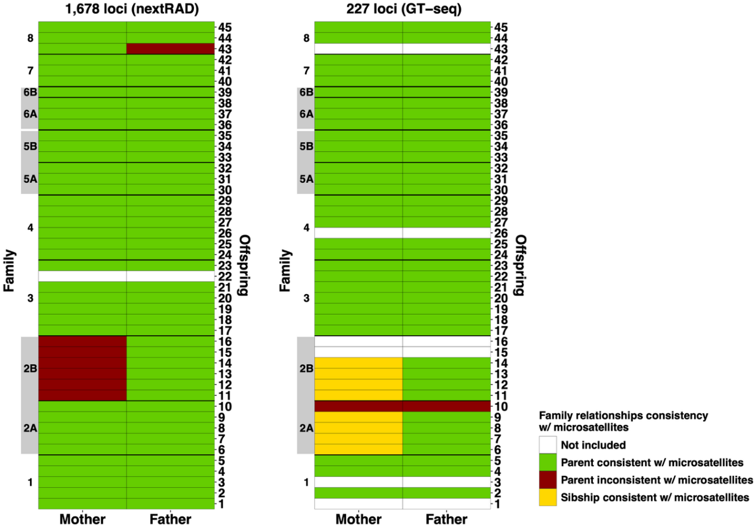
Figure 2.—Schematic representation of parentage analysis results using the original nextRAD data and the optimized GT-seq panel compared to microsatellites.
(Each line represents an offspring (numbered from 1 to 45 on the right) and each column the assigned mother and father. Families are identified on the left and gray boxes denote the half-sibling families. Green cells mean that the corresponding parent identification was consistent with results from microsatellites, yellow means that sibship was recovered and was consistent with microsatellites, red means that neither parent assignment nor sibship were consistent with microsatellites.)

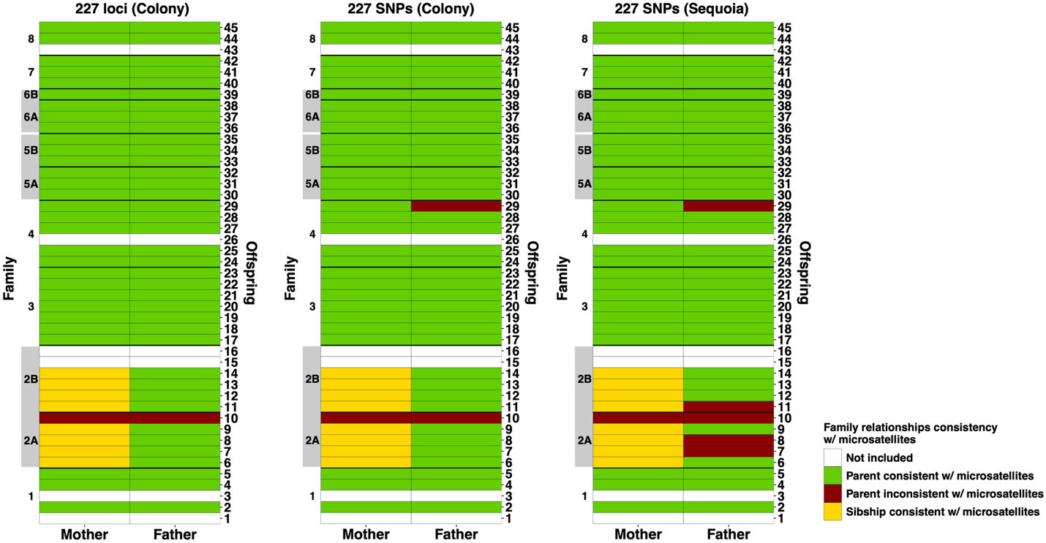
Figure 3.—Schematic representation of parentage analysis results using COLONY and Sequoia compared to microsatellites.
(COLONY was used to estimate parentage with the optimized GT-seq panel containing microhaplotypes (227 loci) and with biallelic SNPs only (227 SNPs). Sequoia was used to estimate parentage with biallelic SNPs only. Each line represents an offspring (numbered from 1 to 45 on the right) and each column shows the assigned mother and father. Families are identified on the left and gray boxes denote the half-sibling families. Green cells corresponding parent identifications that were consistent with results from microsatellites, yellow means that sibship was recovered and was consistent with microsatellites, red means that neither parent assignment nor sibship were consistent with microsatellites.)

Panel Development.—Genetic variation in BONY is very limited due to formation of the captive broodstock from a small number of individuals following population collapse. Despite this, we successfully developed a BONY GT-seq panel to replace the existing microsatellite-based genetic monitoring. Using family groups (identified with microsatellites), we were able to verify utility of the 238 loci GT-seq panel for accurate identifications of parent-offspring relationships and for estimating genetic diversity and both N_{e-sib} and N_{e-LD}. These results are consistent with several other studies that show that even in species with extremely limited diversity SNP panels containing relatively few loci can provide sufficient power to determine parentage (e.g., Tokarska et al. 2009). In imperiled species like BONY, massive population declines led to substantial loss of genetic diversity, which limits the number of variable loci discoverable by reduced-representation sequencing methods like nextRAD-seq. Data filtering for quality controls and compatibility of loci with GT-seq library preparation resulted in relatively few loci available (1,678) to develop a GT-seq panel. Using a conspecific reference genome-guided variant calling, as we did, can yield more SNPs (Shafer et al. 2017). We further maximized the number of loci available by filtering SNPs based on the locus position. This strategy enabled us to find flanking regions for primer design and to retain the other candidate SNPs present in that locus. With a few exceptions (e.g., Schmidt et al. 2020) SNP filtering based on locus position is normally not considered when identifying loci for GT-seq panels and loci with insufficient flanking sequence for primer design are typically discarded (Bootsma et al. 2020, Chang et al. 2021). The conspecific reference genome was also useful for mapping designed primers to test if primer pairs were locus-specific. Identification of locus-specific primers before optimization reduces the optimization effort and costs by avoiding ordering primers early in the process that would ultimately be discarded.

Genetic Diversity, Effective Population Size, Relatedness, and Parentage

Historical Material – DNFH F₁s
Genotype data was obtained for 25 archived F₁ DNA samples that represented the original F₁ broodstock. This stock was produced by spawning of adults collected from Lake Mohave at WBNFH in 1981 with subsequent transfer of fry to DNFH (Hamman 1982). Genetic diversity of this sample was greater than in other samples (H_{exp} = 0.284, H_{obs} = 0.369, A_{R} = 1.99, and F_{is} = -0.277) (table 1). N_{e-LD} was 10 (parametric 95% CI from 9 to11). N_{e-sib} was 12 (95% CI from 6 to 30). The majority of the F₁s were unrelated (figure 4) but a few first- and second-degree relationships were detected. For example, individuals with MLE-IBD coefficients similar to expectations to full-siblings (blue triangle in figure 4, top-left panel) and half-siblings, avuncular or grandparent-grandchild (green square in figure 4, top-left panel). A few pairs also show intermediate MLE-IBD coefficients, likely because their parents had variable degrees of relatedness. Parentage analysis for the archived F₁ samples identified 11 fathers and 9 mothers as producing these individuals. Three parent pairs accounted for 68% of the F₁ samples (figure 5). Genetic variation contained in the F₁ fish (N = 30) was previously evaluated using allozymes and mitochondrial DNA (Hedrick et al. 2000) and here we used the newly developed BONY GT-seq panel to reexamine this material. The broodstock was created using paired matings of five wild caught females with five wild caught males (USFWS 2004). The genetic evaluation of the F₁s by Hedrick et al. (2000) suggested that the effective number of founders (N_{ef}) was 3.48 compared to the actual number of founding fish (N = 10). Using SNP data, N_{e} was closer to the original number of founders. GT-seq data showed that one pair of individuals gave rise to a disproportionate number of offspring (N = 8), and two other pairs accounted for four offspring each. This result was consistent with variable proportions of fertilized eggs from each of the original crosses (which varied from 0.049–0.29) and genetic data from allozymes (Hedrick et al. 2000).

SNARRC F₂ & F₃ Broodstocks
Genotype data was obtained from 1,989 BONY broodstock samples held at SNARRC. These represent the F₂ and F₃ generations. H_{exp} was 0.272, H_{obs} was 0.286 and A_{R} was 2.04. There was a slight excess of heterozygotes (F_{is} = -0.050) and N_{e-LD} was 46 (parametric 95% CI from 45 to 47). COLONY identified 20 of the genotyped F₁s as well as many unknowns as parents of the SNARRC broodstocks. N_{e-sib} was 317 (95% CI from 273 to 373).
The F₂ broodstock (N = 13,812) was created from crosses between 120 unrelated pairs representing the five founding families (USFWS 2004; Wilson, W. 2025, USFWS, Dexter, New Mexico, personal communication). This stock and the F₃ broodstocks were created to protect genetic diversity in the face of attrition of the F₁ stock due to aging. Genetic analysis presented here shows that the F₂ and F₃ stocks contain similar levels of allelic richness and heterozygosity to the F₁s and N_{e-sib} was relatively large. The genetics management and captive propagation plan described a suite of different strategies to protect the genetic diversity remaining in the species including (i) only use non-sib matings for production, (ii) use of genetic data to assess relatedness of brood fish, (iii) use a relatedness matrices to categorize relatedness of potential male and female brood fish, and (iv) prohibit spawning of pairs with high relatedness (USFWS 1991b, 2004). The data presented here shows that in general, these strategies have been successful at protecting the remnant diversity in BONY. Individual genetic data of the F₂ and F₃ BONY broodstocks obtained with the new GT-panel could be leveraged by SNARRC in the future to minimize relatedness and maximize diversity when developing future broodstocks.

Cibola High Levee Pond
We conducted the first assessment of genetic diversity, relatedness, and N_{e} for BONY at CHLP.
Genotype data was obtained from 150 samples collected from CHLP in 2023. H_{exp} and H_{obs} were 0.264 and 0.272, respectively, and A_{R} was 2.04. N_{e-LD} was 106 (parametric 95% CI from 100 to 112), and N_{e-sib} was 121 (95% CI from 92 to 1,159). Allelic diversity in the CHLP population slightly exceeded that observed in all others including the stock held at SNARRC. Both H_{exp} and H_{obs} were lower when compared to SNARRC, but these metrics were within the range seen at INWR ponds. For CHLP, the sampled individuals exhibited generally low levels of relatedness, but first-, second-, third-degree relationships, and intermediate states were identified (figure 4). Results from parentage analysis identified 32 sampled/genotyped adults as likely parents of sampled individuals. The mean number of offspring per adult was 1.9 (variance [VAR] = 1.19, range = 1–6) (table 2, figure 6).

Results presented here highlight the importance of CHLP as a site for a semi-sustainable population of BONY. Occasional augmentation of this population likely helped maintain diversity and minimize breeding between close kin. Identifying features of this site that make it conducive to reproduction, recruitment, and persistence of BONY could be instructive as conservation actions for IWNR ponds are developed.

Table 1.—Estimates of population genetic parameters from BONY estimated using the GT-seq panel
(Genetic diversity metrics include: H_{exp,} H_{obs,} F_{is}, % polymorphic loci ( %PL), and A_{R} estimated from F₁ SNARRC broodstock, CHLP, and IP2, IP5, and IP6. The lower (LB) and upper (UB) bound for H_{exp}, H_{obs}, and F_{is} 95% CIs are also provided. Museum of Southwestern Biology (MSB) id, database LOTID, population (Pop), sample date, number of samples genotyped (N_{s}), and number of samples after filtering (N_{f}) are also provided.)
ID | LOTID | Pop | Sample  date | N_{S} | N_{F} | H_{exp} | LB/UB | H_{obs} | LB/UB | F_{is} | LB/UB | A_{R} | % PL
Dexter_F1 | -- | 1981_F1 | -- | 23 | 21 | 0.284 | 0.259/0.309 | 0.369 | 0.333/0.406 | -0.277 | -0.336/-0.219 | 1.99 | 97.07
MSB109811  MSB110782 | 10416  10417 | SNARRC | 2021 | 1965 | 1889 | 0.272 | 0.252/0.292 | 0.286 | 0.264/0.308 | -0.050 | -0.057/-0.044 | 2.04 | 99.85
CHLP23 | 118124 | CHLP | 2/13/23 | 159 | 150 | 0.264 | 0.244/0.284 | 0.272 | 0.25/0.294 | -0.034 | -0.052/-0.018 | 2.06 | 100
INWR
MSB111489 | 10122 | IP2 | 1/6/22 | 110 | 108 | 0.266 | 0.247/0.286 | 0.272 | 0.252/0.292 | -0.026 | -0.043/-0.008 | 2.04 | 99.4
MSB118791 | 10418 | IP2 | 2/22/23 | 300 | 289 | 0.264 | 0.243/0.284 | 0.274 | 0.252/0.297 | -0.042 | -0.054/-0.03 | 2.01 | 97.8
MSB120194 | 10296  10297 | IP2 | 1/26/24 | 380 | 375 | 0.263 | 0.242/0.284 | 0.276 | 0.253/0.299 | -0.051 | -0.066/-0.036 | 2.01 | 98.31
MSB111720 | 10123 | IP5 | 2/22/22 | 300 | 293 | 0.261 | 0.241/0.283 | 0.271 | 0.249/0.293 | -0.037 | -0.05/-0.026 | 1.59 | 100
MSB118137 | 10327 | IP5 | 12/14/22 | 3 | 3 | 0.247 | 0.215/0.279 | 0.226 | 0.192/0.26 | -0.117 | -0.774/0.109 | 1.45 | 78.19
MSB120192 | 10294 | IP5 | 1/26/24 | 8 | 4 | 0.25 | 0.225/0.274 | 0.245 | 0.219/0.271 | -0.048 | -0.148/0.012 | 1.53 | 89.65
INWR_6_AD | -- | IP6 | 2017 | 300 | 271 | 0.269 | 0.25/0.288 | 0.275 | 0.255/0.296 | -0.0254 | -0.04/-0.01 | 1.93 | 99.89
MSB109845 | 10427 | IP6 | 2/4/21 | 23 | 22 | 0.269 | 0.248/0.291 | 0.268 | 0.245/0.291 | -0.017 | -0.06/0.025 | 1.88 | 96.37
IP6_2021 | -- | IP6 | 4/1/21 | 51 | 45 | 0.274 | 0.254/0.294 | 0.281 | 0.259/0.302 | -0.0352 | -0.06/-0.011 | 1.91 | 97.94
MSB111488 | 10121 | IP6 | 12/14/21 | 50 | 44 | 0.267 | 0.247/0.287 | 0.27 | 0.249/0.291 | -0.0223 | -0.047/0.001 | 1.91 | 98.9
MSB114541 | 10124 | IP6 | 3/10/22 | 46 | 46 | 0.273 | 0.252/0.293 | 0.273 | 0.251/0.295 | -0.0124 | -0.039/0.011 | 1.91 | 98.61
MSB118136 | 10331 | IP6 | 12/15/22 | 93 | 93 | 0.273 | 0.253/0.292 | 0.277 | 0.256/0.298 | -0.0204 | -0.045/0.002 | 1.92 | 99.12
MSB120198 | 10299 | IP6 | 12/20/23 | 47 | 47 | 0.272 | 0.252/0.291 | 0.270 | 0.249/0.291 | -0.0041 | -0.03/0.02 | 1.92 | 98.24
MSB122759 | 10343 | IP6 | 1/30/24 | 13 | 13 | 0.277 | 0.256/0.299 | 0.287 | 0.262/0.313 | -0.0757 | -0.168/-0.01 | 1.89 | 96.48

Table 2. — LD N_{e} and sibship N_{e} for archived (Dexter F₁) and contemporary hatchery stocks (MSB109811), Cibola High Levee Pond (CHLP) and ponds at INWR
(95% confidence intervals are provided (LB/UB).)

Collection |  | LD N_{e} | LB/UB | N_{e-sib} | LB/UB
Dexter_F1 | 1981_F1 | 10 | 9, 11 | 12 | 6, 30
MSB109811 | SNARRC | 46 | 45, 47 | 317 | 273, 373
CHLP23 | CHLP | 106 | 100, 112 | 121 | 92, 1159
INWR
Pond 2 | Adults-2023 | 20 | 19, 20 | 337 | 286, 397
 | Recruits-2024 | 82 | 77, 87
Pond 5 | -- | -- |  | -- | --
Pond 6 | Adults-2017 | 52 | 50, 53 | 147 | 116, 191
Pond 6 | Recruits-2021 | 79 | 73, 87
Pond 6 | Recruits-2022 | 78 | 65, 98
Pond 6 | Recruits-2023 | 73 | 69, 78
Pond 6 | Recruits-2024 | 99 | 89, 111

Table 3.—Summary statistics for reproductive success measured by the number of offspring per male and female for IP2, IP6, and CHLP
 | IP2 Males | IP2 Females | IP6 Males | IP6 Females | CHLP
k _{(Offspring)} | 2.078 | 2.067 | 1.685 | 1.685 | 1.899
SD k | 1.548 | 1.548 | 1.185 | 1.185 | 1.090
VAR of k | 2.396 | 2.398 | 1.403 | 1.403 | 1.187
MIN | 1 | 1 | 1 | 1 | 1
MAX | 11 | 11 | 10 | 10 | 6

Figure 4.—Maximum likelihood estimations of identity-by-descent for each pair of individuals obtained from archived F1 individuals from original broodstock and for the 2023 CHLP sample.
(Each circle represents a pairwise comparison and the red dashed line represents the maximum probability of two individuals sharing zero alleles (k0) or one allele (k1) by descent. On the left panel, theoretical location of different types of family relationships are provided: red circle (k1=1, k0=0) – parent-offspring; blue triangle (k1=0.5, k0=0.25) – full-siblings; green square (k1=0.5, k0=0.5) – half-siblings, avuncular, or grandparent-grandchild; inverted pink triangle (k1=0.25, k0=0.75) – first-cousins; orange diamond (k1=0, k0=0) – monozygotic twins. Individuals close to k1=0, k0 =1 are unrelated.)

Figure 5.—Visualization of F1 pedigree from COLONY analysis.
(The middle row of dots shows the genotyped F1 individuals and the black dots on the left and right of the panel show the inferred parents with grey lines connecting the parents and offspring. The sex was not available for all individuals, so adults are referred to as parent 1 and parent 2.)
Figure 6.—Visualization of pedigree for CHLP from COLONY analysis.
(The middle row of dots shows the genotyped F1 individuals and the black dots on the left and right of the panel show the inferred parents with grey lines connecting the parents and offspring. The sex was not available for all individuals, so adults are referred to as parent 1 and parent 2.)

INWR Ponds
Microsatellites.—Genetic variation was assessed at 18 microsatellites in 36 samples collected from IP2 and 74 individuals collected from IP6 representing year class 2020 recruits. Departures from Hardy-Weinberg equilibrium were detected in IP2 at three loci (G34, Gel225 and G87) and at four loci in IP6 (Gel225, Gel300, Gel257 and G87). Linkage disequilibrium was detected among four pairs of loci including Ca3 and Ca8, Gel226 and Gel287, Gel223 and G13, and Gel225 and Gel300. In all cases, there was a deficiency of heterozygotes. H_{exp} and A_{R} measured in the 2020 recruits in IP2 and IP6 were virtually unchanged from the adults originally stocked (table 3). H_{obs} was less than in the broodstock and F_{is} increased compared to values measured in the stock adults.

Parentage of the 2020 recruits from IP2 were attributed to 12 of the males and 14 of the females stocked in 2017. The remainder of the parents were unsampled adults (N = 27) and a single male individual sampled in 2018. Between one and four recruits were attributed to the adults. In IP6, 29 females and 30 males of 2017 broodstock produced between one and four of the 2020 recruits. Additionally, three recruits sampled in 2018 and 39 unsampled adults were identified as parents of between one and three of the 2020 recruits sampled. N_{e-sib} was 235 for 2020 recruits (95% CI from 184 to 1,299) in IP2 and N_{e-sib} was 174 for 2020 recruits in IP6 (95% CI from 136 to 222).

GT-seq panel.—Genotype data was obtained for 289 adults used to restock IP2 in 2023. The N_{e-LD} estimate for this stock was 20 (95% CI from 19 to 20). H_{exp} and H_{obs} were 0.264 and 0.274, respectively, and A_{R} was 2.01 (see table 1). In recruits sampled prior to the die-off and produced after the die-off (by the restocked adults), all diversity values were virtually identical when compared to the adults and N_{e-LD} was 82 (95% CI from 77 to 87). Based on analysis of parents stocked in 2023 and recruits sampled following restocking, N_{e-sib} for IP2 was 337 (95% CI from 286 to 397).
Relatedness patterns among individuals stocked in IP2 (2023) and IP5 (2022) were similar. Although many pairwise comparisons revealed unrelated individuals, there are many related individuals, including parent-offspring, full-siblings, second and third-degree relationships, and all kinds of intermediate situations. Fewer highly related individuals were identified among recruits produced in IP2 when compared to the stocked adults (figure 7).
Based on results from COLONY (including microhaplotypes) in IP2, 92% of genotyped males and female adults contributed at least one offspring. The AVE, range, and VAR in the number of offspring attributed to adults was very similar between males and females (see table 2). The mean number of offspring per male and female was 1.9.

Figure 7.—Relative number of offspring per adult from CHLP (panel A), IP2 (panel B) and IP6 (panel C).
(Relative number of offspring for males and females are identified by green and purple bars, respectively.) Note that the scales are different in panels A, B and C.

Table 4.—Genetic diversity statistics calculated from microsatellite data prior to development and optimization of the GT-seq panel
(Sample size (N) for adult BONY stocked into IP2, IP5 and IP6 and for progeny produced in these ponds, gene diversity (H_{exp}), heterozygosity (H_{obs}), average inbreeding coefficient (F_{is}), and allelic richness (A_{R}) are provided. Asterisks indicate samples genotyped under this agreement and the other data is provided for reference purposes. YOY is a young of year sample.)
Year | Population | N | Stage | H_{exp} | H_{obs} | F_{is} | A_{R}
2017 | 2 | 300 | Adult | 0.764 | 0.760 | 0.022 | 8.6
2017 | 2 | 105 | Larvae | 0.767 | 0.731 | 0.065 | 8.8
2017 | 2 | 446 | YOY | 0.761 | 0.732 | 0.054 | 8.6
2017 | 2 | 95 | Recruit | 0.759 | 0.761 | 0.015 | 8.7
2018 | 2 | 126 | Recruit | 0.771 | 0.759 | 0.029 | 8.5
2019 | 2 | 96 | Recruit | 0.770 | 0.768 | 0.020 | 8.8
2020* | 2 | 36 | Recruit | 0.760 | 0.740 | 0.036 | 8.5
2017 | 5 | 300 | Adult | 0.773 | 0.755 | 0.040 | 8.7
2017 | 5 | 13 | Recruit | -- | -- | 0.000 | --
2018 | 5 | 25 | Recruit | 0.763 | 0.735 | 0.051 | 8.5
2019 | 5 | 112 | Recruit | 0.763 | 0.742 | 0.046 | 8.7
2017 | 6 | 300 | Adult | 0.774 | 0.77 | 0.023 | 9
2017 | 6 | 8 | Recruit | -- | -- | -0.072 | --
2018 | 6 | 16 | Recruit | -- | -- | 0.009 | --
2019 | 6 | 83 | Recruit | 0.766 | 0.719 | 0.082 | 8.7
2020* | 6 | 74 | Recruit | 0.774 | 0.726 | 0.080 | 8.7

H_{exp} exceeded H_{obs} (0.261 and 0.271 respectively) in the adults used to restock IP5 in 2022. A_{R} was 1.59. The N_{e-LD} estimate for this stock was 22 (95% CI from 22 to 23). Only 11 samples were collected and genotyped from this pond in 2022 and 2023 following the restocking, hence, diversity values were lower for stocked adults (due to small sample size). For all these recruits, both parents were identified with high accuracy (>95%). We did not calculate VRS, N_{e-LD}, or N_{e Sibship} for this pond because of the small number of samples.
IP6 was the only BONY pond at INWR that did not have a fish die-off during the study period. Genotype data was obtained from 271 adults. H_{exp} and H_{obs} were 0.269 and 0.275, respectively, and A_{R} was 1.93 in the originally stocked adults. Genotype data was obtained using the GT-seq panel for recruits sampled in 2021, 2022, 2023/2024 combined. H_{exp} and H_{obs} varied from 0.267 – 0.277 and 0.27 – 0.278, respectively, across collections. IP6 adults (stocked in 2017) exhibited lower levels of relatedness when compared to IP2 and IP5 (figure 8) following their restocking. Although the MLE-IBD coefficients estimated for IP6 revealed a similar range as described for IP2 and IP5, first-, second-, third-degree relationships, and intermediate levels of relatedness, were less frequent. For recruits produced in IP6, results were consistent with patterns seen in IP2, with fewer highly related individuals observed among recruits sampled 2021–2024. Based on results from COLONY, 28–29% of genotyped adults contributed at least one recruit. Adults sampled in 2017 and 2022 accounted for the majority of parents identified, with fewer parents of sample recruits found in the 2021 sample. For both males and females, the average number of offspring was 1.67 (VAR = 1.37, range 1–10) (see table 2). N_{e-sib} was 147 (95% CI from 116 to 191). Estimates of N_{e-LD} were 52 (95% CI from 50 to 53) for adults stocked in 2017, for 2021, 2022 and 2023 recruits N_{e-LD} estimates were 79 (95% CI from 73 to 87), 78 (95% CI from 65 to 98), and 73 (95% CI from 69 to 78) respectively. The most recent estimate (from 2024) was larger at 99 (95% CI from 89 to 111).
Three ponds at INWR were stocked in 2017 with 300 BONY adults each (150 males and 150 females). Genetic diversity, N_{e}, sibship and parentage were initially evaluated in adults and recruits from 2017 to 2020 in IP2, 2017–2019 in IP5 and from 2017–2020 in IP6 using microsatellite loci. Genetic diversity was maintained in each of these ponds between the parents and recruits. Patterns of reproductive success varied across ponds, with higher mean number of offspring per adult and higher variance in number of offspring produced by adults in IP2 compared to IP5 and IP6 (although fewer samples were available for analysis). Here we present genetic monitoring data based on the GT-seq panel for these ponds. Due to die-offs in IP2 in 2022, this pond was restocked in 2023, while IP5 was restocked in 2022 following a die-off in 2020. For this reason, as well as more limited sampling of recruits (especially from IP5), the time-series for these ponds is shorter than what was available for microsatellite data. Major findings include small values of N_{e-LD} for the stocked adults especially for IP2 and IP5, and among stocked adults, there were many individuals with close kin relationships. N_{e-LD} of the adults stocked in 2017 at IP6 was larger and there were fewer individuals with close kin relationships. Encouragingly, in all INWR ponds, the number of individuals that were close kin declined in the recruits in the years following population establishment. This implies that breeding between related individuals is decreasing. Lower values of allelic diversity were recorded in IP5 and IP6 stocked adults, and these values remain similar in the recruits produced in subsequent years. This highlights the importance of using the most genetically diverse fish (i.e., derived from a large number of breeding pairs) to initially stock the ponds. Allelic diversity was higher in the IP2 stocked adults and like results from IP5 and IP6, this diversity was maintained in the recruits (although few years and samples were available for analysis). In all INWR ponds, we found minimal variation in reproductive success among males and females and between ponds which explains the maintenance of diversity between stocked adults and recruits. Genotyping of individuals collected in early 2025 and in future sampling efforts will allow us to continue to track this trend. Results are also consistent with previous microsatellite-based genetic monitoring of INWR ponds and of BONY in the Lake Mohave backwaters (Osborne et al. 2018).

Close-Kin Mark-Recapture.—From the pool of 289 adults and 375 juveniles genotyped from IP2 in 2023, COLONY identified 509 POP. This resulted in N_{CKMR} = 426. For CHLP in 2023, the age of the individuals was determined based on the distribution of size classes reported by USFWS (2023). The group of genotyped individuals included 72 belonging to size classes between 200 and 410 millimeters (mm),] considered as potential adults, and 78 belonging to a size class between 80 and 200 mm, considered as recruits (figure 9). COLONY identified 51 POP, resulting in N_{CKMR} = 220.
We took advantage of a re-stocking event following a fish-kill in IP2 in 2023, as a case-study to evaluate the accuracy of the CKMR method to estimate adult population size. Our preliminary estimates of the number of adults in IP2 in 2023 (parental generation) exceeded the expected number of adults (300 or close to that value). There are two possible reasons for estimation bias from our sampling. A key issue in IP2 was that many stocked individuals were closely related to one another. Relatedness analysis identified not only first-, second- and third-degree relationships, but also a high frequency of pairs with intermediate relatedness, likely resulting from previous matings between individuals with variable levels of relatedness. High degrees of relatedness among parents can be a problem for parentage accuracy as many potential parents can share a large proportion of genotypes. In such situations, false positive assignments can arise from individuals sharing similar genotypes while false negatives can be caused by difficulties distinguishing the correct parents. Since the number of adults estimated was inflated compared to the expected value, it is likely that the number of POP was slightly underestimated, probably due to false negatives (inability to assign correct parents to their offspring). Another explanation to the inflated number of adults estimated can be related to potential fish survival after the die-off event. If so, those fish likely reproduced and contributed offspring. Under this scenario, the number of POP would be smaller than expected compared to the presence of only stocked individuals in IP2.

We used the same CKMR method for CHLP data from 2023 to compare with traditional capture-mark-remark estimates of abundance. In this case, the N_{CMKR} was 220.23 which was considerable smaller than the 537 adults estimate based on the Lincoln-Peterson estimate (Ehlo 2023). In this situation, it is possible that a sampling bias is the source of such discordance. The adult sample was skewed to larger individuals, most of which were females (USFWS 2023). It is known that larger BONY females tend to contribute more to offspring than smaller females (Osborne et al. 2018). However, the CKMR formula employed assumes an equal sex ratio and similar reproductive success between sexes and across ages. As such, incorporating a correction for size- and age-biased sample is needed to employ CKMR to age structure BONY populations.

Preliminary results from CKMR were promising but some additional evaluations and modifications will be necessary. Moving forward with CKMR we will evaluate alternative methods to reliably identify POP in the face of increased parental relatedness to accurately estimate adult population size in closed systems for BONY. Another important consideration in the future is to include corrections for size- and age-structure populations (e.g., Wacker et al. 2021). CKMR models also assume sparse sampling where there should not be a high proportion of full- or half-siblings in the same cohort (Bravington et al. 2016). This is clearly violated in closed backwater populations. We will explore other CKMR approaches such as the simulation-based approach implemented in CKMRsim (Anderson 2024) that includes assessment of false-negative and false positive rates.

Figure 8.—Maximum likelihood estimations of identity-by-descent for each pair of individuals from IP2 (2023–2024), IP5 (2022), and IP6 (2017–2024).
(Each panel represents either the pairwise comparisons among stocked individuals or among individuals sampled after stocking. When available, MSB catalog numbers are provided for each collection. Each circle represents a pairwise comparison and the red dashed line represents the maximum probability of two individuals sharing zero alleles (k0) or one allele (k1) by descent. Individuals close to k1=0, k0 =1 are unrelated and k1=1, k0=0 are parent-offspring pairs.)
Figure 9.—Length-frequency distribution of 159 BONY captured from CHLP in 2023 (adapted from USFWS 2023).

Genetic Monitoring of RASU Populations

Status of Milestones, Activities, and Tasks
- Genotype mainstem samples – All individuals provided from the mainstem have been genotyped.
- Genotype backwater samples – All appropriate individuals provided from backwaters have been genotyped.
- Genotype brood stock – All individuals from the RASU brood stock were genotyped.
- Genotype stocking cohorts (SC) – All individuals provided for the 2020–2024 SC samples.

Methods

Sampling
Specific numbers of individuals were prescribed in the scope of work for completion during this project (table 5). Samples of RASU were provided by the LCR MSCP to fulfill these goals. RASU samples analyzed for this report included historical samples (collected from 1996 through 2019) as well as those specifically sampled for this report. Additional historical samples from lakes Mead and Mohave (individuals collected prior to 2002 and identified as “wild” from Lake Mohave, and individuals collected prior to 1992 from Lake Mead) were included to provide a baseline for comparison.

Targets were achieved for most locations except for Lake Mead and IP (table 5). Failure to achieve sample size targets was mainly due to limited availability of samples; however, in some instances poor quality of DNA resulted in reduced sample size. Specific explanations (table 5) are: 1) fewer broodstock samples were provided from SNARRC than expected (N = 1,314), 2) reduced availability of larvae and recruits from IP as reproduction was not as successful as hoped, 3) augmentation samples for IP were obtained too late (November 2024) for inclusion in this analysis, 4) fewer SC samples were provided than expected, and some samples had poor quality of DNA that prevented analysis, and 5) reduced numbers of adults from mainstem populations reflected lower than expected capture rates from Lake Mead.
Table 5.—Proposed and completed sampling of RASU
(Number of individuals genotyped and proposed and their difference are provided in columns GEN, PROP, and GEN – PROP, respectively.)
Description | GEN | PROP | GEN – PROP
SNARRC Broodstock¹ | 1,313 | 1,500 | -186
YCB adults | 400 | 400 | 0
YCB recruits | 817 | 750 | 67
YCB larvae | 1,289 | 1,250 | 39
YCB historical recruits | 2,706 | 2,296 | 410
Backwater genetic augmentation | 100 | 100 | 0
Total | 5,312 | 4,796 | 516
IP adults | 898 | 900 | -2
IP recruits: juveniles² | 275 | 1,500 | -1,225
IP recruits: larvae² | 403 | 2,500 | -2,097
IP historical recruits | 234 | 212 | 22
Backwater genetic augmentation³ | 0 | 300 | -300
Total | 1810 | 5412 | -3,602
SC⁴ | 2,929 | 6,000 | -3,071
Mainstem adults⁵ | 1,573 | 1,800 | -227
Mainstem larvae | 2,202 | 1,800 | 402
Mainstem historical larvae | 998 | 550 | 448
Mainstem historical adults | 952 | 750 | 202
Total | 8,654 | 10,900 | -2,246
Grand total | 17,090 | 22,608 | -5,518
¹ only 1,314 individuals provided by SNARRC
² reproduction was not as successful as hoped
³ augmentation samples were obtained too late for inclusion in this analysis
⁴ fewer samples provided than expected, poor quality of DNA prevented inclusion of some samples
⁵ lower than expected capture rates from Lake Mead

Extraction and Library Construction
DNA was extracted from samples of RASU larvae and fin clips provided here using magnetic beads. DNA from each individual was released into solution using sodium dodecyl sulfate in sodium chloride – Tris – ethylenediaminetetraacetic acid (STE) buffer, and the protein degraded by addition of proteinase K, yielding a lysate. Historical DNA lysates were cleaned with phenol:chloroform (as described in Tibbets and Dowling 1996). For more recent samples, DNA was removed from the lysate through binding to magnetic beads, while contaminants such as degraded proteins are left in solution. This was done with an Axygen DNA purification kit or Magbio’s HighPrep PCR clean-up kit following the manufacturer’s protocol with the following changes: 25 microliters (µL) of lysate were added to 25 µL of beads. The resulting samples from both above methods were washed twice in 70% ethanol, and DNA was eluted in 40 µL of water. In cases where larval tissue was quite small, the volume of beads was doubled and the volume of elution water halved. The quantity and quality of DNA were assessed using a NanoDrop ND-1000 Spectrophotometer (V3.0.1).

Methods for GT-seq library construction followed Campbell et al. (2015) with slight modifications (Dowling et al. 2020). Amplification included two rounds of PCR, with the first round amplifying sequences for 303 loci for each individual and the second round adding a unique tag for identification of each individual. The product of the second round was then normalized and purified with paramagnetic beads, pooled, and sent to Novogene, Inc (Sacramento, CA) for Illumina sequencing. Upon receipt, Novogene completed a quality control check to quantify the DNA and examine the distribution of fragment sizes. If too many small fragments were found, the library was cleaned with paramagnetic beads to remove fragments <200 bp. Novogene returns demultiplexed reads which were processed with the GTscore pipeline (https://github.com/gjmckinney/GTscore, McKinney et al. 2020).

Statistical Analyses
Genotyped samples were used to estimate and compare population genetic parameters. H_{obs}, H_{exp}, and F_{IS}, along with CIs for these measures, were calculated with dartRverse and associated packages (Mijangos et al. 2022) for each sample. Allelic richness was generated using the R package diveRsity (version 1.9.90, Keenan et al. 2013) function divBasic.

Sample sizes in tables reflect the number of individuals characterized (N_{s}) and those that remained after filtering (N_{f}) to remove poorly performing samples (those missing >25% of loci). N_{e} was calculated for mainstem populations in NeEstimator (Do et al. 2014) using the N_{e-LD} method. For backwater populations, COLONY (Jones and Wang, 2010) was used for parentage assignments and estimates of N_{e-sib} assuming random mating. COLONY was run using the same run parameters as described for BONY, and results were used to calculate metrics to assess reproductive success in backwater populations. Relatedness estimates and comparisons were calculated with COANCESTRY (version 1.0.1.2) using the TrioML estimate of relatedness (Wang 2011). CKMR was used to estimate population size for select YCB populations with known adult population sizes, using the same equation described above for BONY.

Results and Discussion

Broodstock Samples
Broodstock for propagation of RASU is maintained at SNARRC, and they provided fin clip samples from 1,314 individuals. These were characterized using the GT-seq panel, with 1,302 yielding sufficient data to estimate population genetic parameters. Estimates of H_{obs} and H_{exp} were 0.337 and 0.336, respectively, with 95% CIs ranging from 0.336 to 0.339 and from 0.336 to 0.338, respectively (table 6). The estimate of F_{is} was -0.002 and not significantly different from 0 (95% CI from -0.006 to 0.001). A_{R} was 2.000, the maximum possible value. N_{e-LD} was 248 (95% CI ranging from 221 to 278).

Stocking Cohort Samples
Stocking Cohort (SC) samples derived from different sources of individuals (Lake Mohave larvae and SNARRC broodstock) were obtained from individuals stocked into various locations from 2020 through 2024 (table 6). Estimates of H_{obs} averaged 0.343 (range = 0.334–0.386) and 0.338 (range = 0.329–0.355) for Lake Mohave larvae-based and SNARRC-based SCs, respectively, while average H_{exp} was 0.336 (range = 0.327–0.349) and 0.320 (range = 0.306–0.328) for Lake Mohave larvae and SNARRC broodstock, respectively. These estimates exhibit mostly overlapping CIs; therefore, they were not significantly different. This is not a surprise as levels of assayed genetic variation in RASU are high, with this result reflecting choice of SNPs during panel design and the slow response of heterozygosity to population bottlenecks (Allendorf, 1986).

Average measures of F_{is} were -0.012 (range = -0.084–0.007) and -0.043 (range = -0.060–
-0.022) for samples from Lake Mohave and SNARRC SCs, respectively (table 6). There was considerable variation in estimates within and among years, mostly reflecting source of material to be stocked. Eleven of the F_{is} estimates were significantly <0 based on their CIs. Of these eleven, all seven estimates from SCs derived from SNARRC were significant, with the remaining four significant estimates found in the 23 SCs generated with the Lake Mohave-derived source. Two of the four significant Lake Mohave-derived SCs had reduced sample sizes due to filtering (52 and 60 of 100 individuals characterized), indicating a problem with the quality of DNA. DNA quality did not seem to be as important for the SNARRC-derived SCs (average number of samples genotyped and filtered [N_{s} and N_{f}, respectively] were 99.4 and 87.1 individuals, respectively) as filtering did not remove as many individuals as for the four Lake Mohave-derived SCs discussed above. Average A_{R} was higher in Lake Mohave-derived SCs than those from SNARRC (1.998, range = 1.960–2.000; 1.990, range = 1.990–2.000, respectively), consistent with results from F_{is}.

Estimates of N_{e} (table 6) were significantly lower for SNARRC-derived SCs (average N_{e-LD} = 11, average 95% CI from 8 to 14), than those from Lake Mohave-derived SCs (average N_{e-LD} = 393.3, average 95% CI from 229 to 1,568). Average of N_{e-LD} and their CIs from the four Lake Mohave-derived SCs with significant F_{is} values were consistent with other Lake Mohave-derived SCs (average N_{e-LD} = 389, average 95% CI from 221 to 1,336 as compared to average and range in the above sentence). Given this result, the difference in F_{is} between the Mohave-derived samples is consistent with a sampling effect while reduced F_{is} in SNARRC-derived samples reflects reduced numbers of breeders contributing to these SCs.

Table 6.—Estimates of population genetic parameters for RASU broodstock and SCs
(N_{s} and N_{f} are the number of samples that were genotyped and survived filtering, respectively. Estimates of H_{obs}, H_{exp}, and F_{is} are provided with lower and upper confidence limits (95% CI). N_{e-LD} and the upper and lower bounds from bootstrap analysis (LB and UB, respectively) are also provided. A_{R} is the population estimate of allelic richness which has a maximum value of 2 as determined by marker design. * identifies samples with significant F_{is} values that are significantly different from 0. AVE, MAX, and MIN are the average, maximum and minimum values.)
Sample | Brood Source | N_{s} | N_{f} | H_{obs} | 95% CI |  | H_{exp} | 95% CI |  | F_{is} | 95% CI |  | A_{R} | N_{e-LD} | LB/UB
Broodstock | Mohave | 1,314 | 1,302 | 0.337 | 0.336 | 0.339 | 0.336 | 0.336 | 0.338 | -0.002 | -0.006 | 0.001 | 2.000 | 248 | 221 | 278
SC20_10002 | Mohave | 100 | 83 | 0.339 | 0.333 | 0.348 | 0.334 | 0.332 | 0.338 | -0.007 | -0.017 | 0.010 | 2.000 | 434 | 247 | 1,486
SC20_10004 | Mohave | 100 | 29 | 0.342 | 0.333 | 0.352 | 0.335 | 0.334 | 0.341 | -0.008 | -0.012 | 0.007 | 1.990 | 61 | 27 | 1,602
SC20_10005* | Mohave | 100 | 98 | 0.348 | 0.341 | 0.362 | 0.338 | 0.336 | 0.344 | -0.022 | -0.038 | -0.005 | 2.000 | 515 | 343 | 992
SC20_10006 | Mohave | 100 | 98 | 0.338 | 0.332 | 0.343 | 0.336 | 0.335 | 0.339 | -0.003 | -0.010 | 0.009 | 2.000 | 401 | 285 | 657
SC21_10009* | Mohave | 100 | 90 | 0.347 | 0.338 | 0.357 | 0.336 | 0.334 | 0.339 | -0.024 | -0.037 | -0.001 | 2.000 | 443 | 246 | 1,742
SC21_10011* | Mohave | 100 | 60 | 0.386 | 0.367 | 0.414 | 0.349 | 0.344 | 0.359 | -0.084 | -0.118 | -0.047 | 1.990 | 312 | 172 | 1,274
SC21_10014 | Mohave | 100 | 95 | 0.345 | 0.337 | 0.357 | 0.337 | 0.335 | 0.343 | -0.014 | -0.026 | 0.005 | 2.000 | 500 | 308 | 1,228
SC21_10016 | Mohave | 100 | 99 | 0.342 | 0.337 | 0.353 | 0.339 | 0.337 | 0.344 | 0.000 | -0.011 | 0.015 | 2.000 | 93 | 65 | 143
SC21_10018 | Mohave | 100 | 99 | 0.342 | 0.336 | 0.350 | 0.337 | 0.335 | 0.342 | -0.008 | -0.017 | 0.009 | 2.000 | 255 | 166 | 501
SC21_10019* | Mohave | 100 | 52 | 0.360 | 0.350 | 0.372 | 0.335 | 0.335 | 0.339 | -0.051 | -0.062 | -0.027 | 1.990 | 286 | 124 | Infinite
SC21_10020 | Mohave | 100 | 36 | 0.337 | 0.328 | 0.348 | 0.327 | 0.326 | 0.330 | -0.012 | -0.020 | 0.003 | 2.000 | 491 | 191 | Infinite
SC21_10021 | Mohave | 100 | 74 | 0.346 | 0.337 | 0.357 | 0.336 | 0.334 | 0.340 | -0.020 | -0.032 | 0.003 | 1.990 | 538 | 300 | 2,201
SC21_10022 | Mohave | 100 | 90 | 0.334 | 0.328 | 0.341 | 0.335 | 0.333 | 0.338 | 0.007 | -0.003 | 0.022 | 2.000 | 96 | 60 | 189
SC22_10177 | Mohave | 100 | 100 | 0.342 | 0.337 | 0.348 | 0.337 | 0.335 | 0.340 | -0.009 | -0.016 | 0.006 | 2.000 | 594 | 337 | 2,088
SC22_10179 | Mohave | 100 | 99 | 0.338 | 0.331 | 0.344 | 0.336 | 0.333 | 0.339 | 0.000 | -0.008 | 0.018 | 2.000 | 395 | 220 | 1,435
SC22_10180 | Mohave | 100 | 100 | 0.336 | 0.330 | 0.346 | 0.333 | 0.331 | 0.338 | -0.003 | -0.015 | 0.010 | 2.000 | 739 | 448 | 19,686
SC22_10181 | Mohave | 100 | 99 | 0.337 | 0.332 | 0.341 | 0.334 | 0.333 | 0.338 | -0.003 | -0.009 | 0.009 | 2.000 | 448 | 273 | 1,126
SC23_10291 | Mohave | 100 | 93 | 0.335 | 0.329 | 0.340 | 0.334 | 0.333 | 0.337 | 0.004 | -0.003 | 0.018 | 2.000 | 785 | 444 | 2,958
SC23_10298 | Mohave | 33 | 28 | 0.345 | 0.334 | 0.353 | 0.336 | 0.334 | 0.341 | -0.009 | -0.012 | 0.002 | 2.000 | 220 | 108 | 8,085
SC23_10300 | Mohave | 100 | 91 | 0.341 | 0.335 | 0.348 | 0.337 | 0.335 | 0.341 | -0.009 | -0.017 | 0.005 | 2.000 | 119 | 78 | 217.6
SC24_10391 | Mohave | 100 | 96 | 0.336 | 0.331 | 0.342 | 0.334 | 0.332 | 0.337 | -0.003 | -0.009 | 0.010 | 2.000 | 226 | 154 | 395
SC24_10392 | Mohave | 100 | 94 | 0.337 | 0.332 | 0.343 | 0.336 | 0.334 | 0.340 | 0.003 | -0.002 | 0.012 | 2.000 | 324 | 213 | 630
SC24_10393 | Mohave | 100 | 99 | 0.342 | 0.336 | 0.348 | 0.338 | 0.337 | 0.341 | -0.004 | -0.011 | 0.011 | 2.000 | 772 | 471 | 2,008
AVE |  | 97.1 | 82.7 | 0.343 | 0.336 | 0.352 | 0.336 | 0.334 | 0.340 | -0.012 | -0.022 | 0.005 | 1.998 | 393 | 229 | 1,566
MAX |  | 100.0 | 100.0 | 0.386 | 0.367 | 0.414 | 0.349 | 0.344 | 0.359 | 0.007 | -0.002 | 0.022 | 2.000 | 785 | 471 | 8,085
MIN |  | 33.0 | 28.0 | 0.334 | 0.328 | 0.340 | 0.327 | 0.326 | 0.330 | -0.084 | -0.118 | -0.047 | 1.990 | 61 | 27 | 143
SC20_10001* | SNARRC | 96 | 86 | 0.332 | 0.327 | 0.338 | 0.324 | 0.322 | 0.329 | -0.022 | -0.028 | -0.007 | 1.990 | 12 | 10 | 15
SC21_10007* | SNARRC | 100 | 85 | 0.335 | 0.328 | 0.342 | 0.319 | 0.315 | 0.325 | -0.034 | -0.042 | -0.014 | 1.990 | 14 | 11 | 17
SC21_10008* | SNARRC | 100 | 85 | 0.329 | 0.323 | 0.335 | 0.306 | 0.303 | 0.312 | -0.056 | -0.065 | -0.039 | 1.960 | 7 | 5 | 9
SC22_10182* | SNARRC | 100 | 99 | 0.335 | 0.329 | 0.341 | 0.315 | 0.309 | 0.322 | -0.042 | -0.051 | -0.029 | 1.980 | 9 | 6 | 11
SC23_10289* | SNARRC | 100 | 73 | 0.355 | 0.347 | 0.372 | 0.328 | 0.324 | 0.336 | -0.060 | -0.078 | -0.040 | 1.990 | 15 | 11 | 20
SC23_10290* | SNARRC | 100 | 88 | 0.347 | 0.340 | 0.353 | 0.327 | 0.324 | 0.332 | -0.052 | -0.060 | -0.034 | 1.990 | 11 | 8 | 14
SC23_10301* | SNARRC | 100 | 94 | 0.335 | 0.330 | 0.341 | 0.322 | 0.319 | 0.327 | -0.032 | -0.040 | -0.016 | 1.990 | 9 | 7 | 12
AVE |  | 99.4 | 87.1 | 0.338 | 0.332 | 0.346 | 0.320 | 0.316 | 0.326 | -0.043 | -0.052 | -0.026 | 1.984 | 11 | 8 | 14
MAX |  | 100.0 | 99.0 | 0.355 | 0.347 | 0.372 | 0.328 | 0.324 | 0.336 | -0.022 | -0.028 | -0.007 | 1.990 | 15 | 11 | 20
MIN |  | 96.0 | 73.0 | 0.329 | 0.323 | 0.335 | 0.306 | 0.303 | 0.312 | -0.060 | -0.078 | -0.040 | 1.960 | 7 | 5 | 9

Mainstem Samples
Population genetic parameters estimated from samples of adults are reported in table 7. Average estimates of H_{obs} across years for Reach 3, Lake Mohave, and Lake Mead were 0.346 (range = 0.340–0.367), 0.339 (range = 0.333–0.348), and 0.328 (range = 0.315–0.348), respectively, while H_{exp} estimates were 0.339 (range = 0.335–0.347), 0.336 (range = 0.331–0.339), and 0.323 (range = 0.316–0.329), respectively. It is interesting to note that a sample of 120 wild fish from Lake Mohave (e.g., individuals sampled prior to 2002 and identified as wild in the database) and 19 from Lake Mead (individuals sampled prior to 1995) exhibited high H_{obs} and H_{exp}. Estimates of H_{obs} and H_{exp} averaged across samples were highest in Reach 3 and lowest in Lake Mead; however, estimates of heterozygosity are broadly overlapping.

Estimates of F_{is} averaged across years (table 7) for Reach 3, Lake Mohave, and Lake Mead adults were -0.015 (range = -0.049 – 0.000), 0.001 (range = -0.022 – 0.007), and 0.004 (range = -0.029 – 0.023). Only three samples exhibited values significantly < 0, the 2024 sample from Reach 3 (-0.049, CI = -0.063 – -0.047) and wild samples from Lakes Mohave and Mead (-0.022, CI = -0.063 – -0.047 and -0.029, CI = -0.028 – -0.023, respectively). On average, F_{is} was most negative in Reach 3, intermediate in Lake Mohave, and positive in Lake Mead (-0.015, -0.005, and 0.004, respectively).

Average A_{R} was high in Reach 3 and Lake Mohave, yielding maximum values for all samples (average = 2.000, range = 2.000–2.000). A_{R} was lower in Lake Mead with an average of 1.990 (range = 1.980 – 2.000). Like results from the SCs, reduced estimates of F_{is} and A_{R} in Lake Mead reflect a reduced population size.

Effective population size (N_{e-LD}) varied across localities and was highest for samples from Lake Mohave, averaging 639 with a range of 324-1045 across years. The average jacknife interval ranged from a LB of 374; however, UB could not be calculated due to the presence of several infinite values. The lowest estimate was from Lake Mead averaging 62 across years, with a range of 32-925 (average LB/UB interval ranged from 48-241), anwhile estimates for Reach 3 were intermediate with an average of 97, with a range of 49-143 (average LB/UB interval ranged from 66-136) (table 7). Visualization of sample estimates and their bounds (figure 10) illustrates variation in N_{e-LD} over time, with values remaining relatively constant and indicating that N_{e-LD} is significantly lower in adults from Reach 3 and Lake Mead than from Lake Mohave.

Table 7.—Estimates of population genetic parameters for adult mainstem RASU populations
(N_{s} and N_{f} are the number of samples that were genotyped and survived filtering, respectively. Estimates of H_{obs}, H_{exp}, and F_{is} are provided with lower and upper confidence limits (LCI and UCI). N_{e-LD} and the upper and lower bounds from bootstrap analysis (LB and UB, respectively) are also provided. A_{R} is the population estimate of allelic richness which has a maximum value of 2 as determined by marker design. AVE, MAX, and MIN are the average, maximum and minimum values. NA indicates values that could not be calculated due to infinite values.)
Sample | Year(s) | N_{s} | N_{f} | H_{obs} | 95% CI |  | H_{exp} | 95% CI |  | F_{is} | 95% CI |  | A_{R} | N_{e-LD} | LB/UB
Reach 3 | 2009–2019 | 250 | 243 | 0.344 | 0.340 | 0.356 | 0.341 | 0.334 | 0.354 | -0.009 | -0.022 | 0.001 | 2.000 | 121 | 95 | 158
 | 2021 | 120 | 116 | 0.341 | 0.334 | 0.362 | 0.337 | 0.324 | 0.362 | -0.008 | -0.027 | 0.004 | 2.000 | 64 | 51 | 83
 | 2022 | 131 | 130 | 0.340 | 0.329 | 0.366 | 0.339 | 0.330 | 0.362 | 0.000 | -0.013 | 0.023 | 2.000 | 122 | 93 | 171
 | 2023 | 128 | 111 | 0.342 | 0.338 | 0.366 | 0.335 | 0.328 | 0.359 | -0.016 | -0.042 | 0.002 | 2.000 | 49 | 37 | 66
 | 2024 | 107 | 104 | 0.367 | 0.361 | 0.383 | 0.347 | 0.331 | 0.368 | -0.049 | -0.063 | -0.047 | 2.000 | 85 | 62 | 122
 | 2025 | 122 | 119 | 0.341 | 0.330 | 0.364 | 0.337 | 0.327 | 0.358 | -0.009 | -0.028 | 0.022 | 2.000 | 143 | 103 | 216
AVE |  |  |  | 0.346 | 0.339 | 0.366 | 0.339 | 0.329 | 0.360 | -0.015 | -0.033 | 0.001 | 2.000 | 97 | 73 | 136
MAX |  |  |  | 0.367 | 0.361 | 0.383 | 0.347 | 0.334 | 0.368 | 0.000 | -0.013 | 0.023 | 2.000 | 143 | 103 | 216
MIN |  |  |  | 0.340 | 0.329 | 0.356 | 0.335 | 0.324 | 0.354 | -0.049 | -0.063 | -0.047 | 2.000 | 49 | 37 | 66
Lake Mohave | 1988–2001 | 166 | 120 | 0.348 | 0.341 | 0.357 | 0.338 | 0.336 | 0.343 | -0.022 | -0.035 | -0.006 | 2.000 | 674 | 332 | 13,040
 | 1996–2019 | 259 | 231 | 0.341 | 0.335 | 0.357 | 0.339 | 0.333 | 0.351 | -0.003 | -0.013 | 0.009 | 2.000 | 1,045 | 667 | 2,247
 | 2020 | 136 | 127 | 0.336 | 0.322 | 0.360 | 0.336 | 0.325 | 0.358 | 0.007 | -0.010 | 0.026 | 2.000 | 324 | 200 | 740
 | 2021 | 110 | 89 | 0.340 | 0.330 | 0.364 | 0.336 | 0.329 | 0.358 | -0.003 | -0.024 | 0.029 | 2.000 | 625 | 294 | infinite
 | 2022 | 134 | 114 | 0.341 | 0.331 | 0.365 | 0.334 | 0.324 | 0.353 | -0.015 | -0.034 | 0.005 | 2.000 | 358 | 231 | 728.6
 | 2023 | 138 | 135 | 0.342 | 0.329 | 0.366 | 0.335 | 0.328 | 0.351 | -0.012 | -0.016 | 0.009 | 2.000 | 692 | 458 | 1,350
 | 2024 | 166 | 148 | 0.334 | 0.325 | 0.351 | 0.335 | 0.325 | 0.352 | 0.006 | -0.011 | 0.020 | 2.000 | 871 | 583 | 1,661
 | 2025 | 49 | 48 | 0.333 | 0.316 | 0.376 | 0.331 | 0.306 | 0.362 | 0.005 | -0.040 | 0.023 | 2.000 | 522 | 224 | Infinite
AVE |  |  |  | 0.339 | 0.329 | 0.362 | 0.336 | 0.326 | 0.353 | 0.001 | -0.023 | 0.014 | 2.000 | 639 | 374 | NA
MAX |  |  |  | 0.348 | 0.341 | 0.376 | 0.339 | 0.336 | 0.362 | 0.022 | -0.010 | 0.029 | 2.000 | 1045 | 667 | NA
MIN |  |  |  | 0.333 | 0.316 | 0.351 | 0.331 | 0.306 | 0.343 | -0.015 | -0.040 | -0.006 | 2.000 | 324 | 200 | 729
Lake Mead | 1988–1992 | 23 | 19 | 0.348 | 0.339 | 0.358 | 0.328 | 0.327 | 0.332 | -0.029 | -0.028 | -0.023 | 1.980 | 32 | 16 | 179
 | 2010–2019 | 254 | 231 | 0.331 | 0.318 | 0.348 | 0.323 | 0.310 | 0.339 | -0.015 | -0.027 | 0.002 | 2.000 | 41 | 35 | 48
 | 2020 | 35 | 33 | 0.328 | 0.323 | 0.355 | 0.326 | 0.318 | 0.363 | 0.020 | -0.045 | 0.099 | 1.990 | 71 | 41 | 190
 | 2021 | 84 | 83 | 0.327 | 0.319 | 0.355 | 0.329 | 0.317 | 0.365 | 0.013 | -0.016 | 0.023 | 2.000 | 92 | 66 | 140
 | 2022 | 33 | 33 | 0.334 | 0.309 | 0.376 | 0.325 | 0.307 | 0.368 | -0.007 | -0.051 | 0.079 | 1.990 | 67 | 43 | 136
 | 2023 | 40 | 38 | 0.315 | 0.318 | 0.334 | 0.316 | 0.303 | 0.348 | 0.023 | -0.025 | 0.051 | 1.990 | 68 | 36 | 241
 | 2024 | 40 | 39 | 0.316 | 0.307 | 0.368 | 0.318 | 0.295 | 0.359 | 0.021 | -0.045 | 0.069 | 1.980 | 66 | 46 | 109
AVE |  |  |  | 0.328 | 0.319 | 0.356 | 0.323 | 0.311 | 0.353 | 0.004 | -0.034 | 0.043 | 1.990 | 62 | 40 | 149
MAX |  |  |  | 0.348 | 0.339 | 0.376 | 0.329 | 0.327 | 0.368 | 0.023 | -0.016 | 0.099 | 2.000 | 92 | 66 | 241
MIN |  |  |  | 0.315 | 0.307 | 0.334 | 0.316 | 0.295 | 0.332 | -0.029 | -0.051 | -0.023 | 1.980 | 32 | 16 | 48

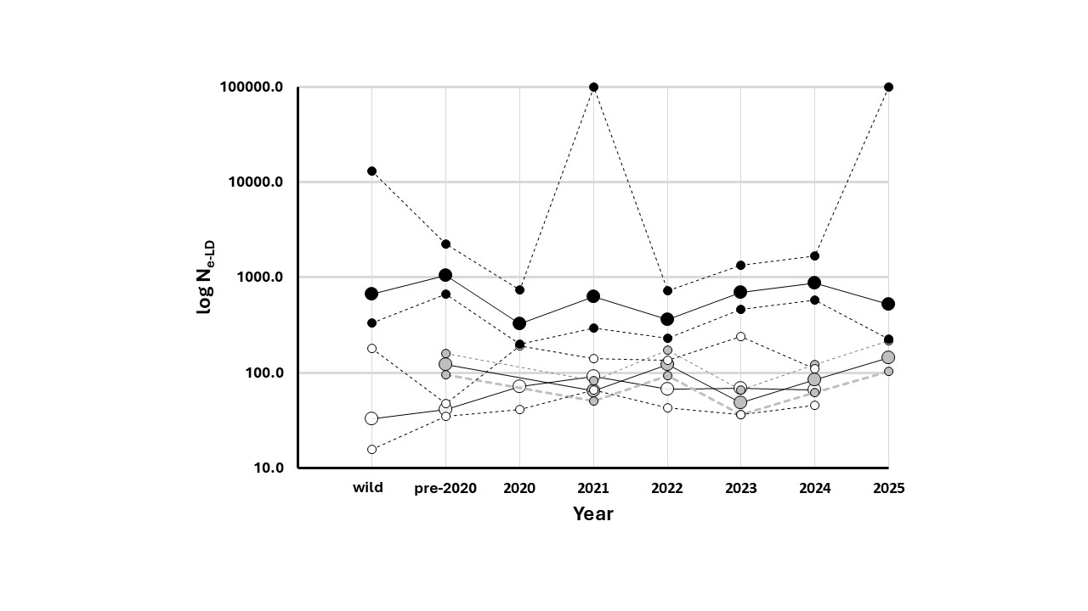
Figure 10.—Change in log N_{e-LD} over time for annual adult mainstem samples
(Annual samples from Lake Mohave, Reach 3, and Lake Mead are represented by black, gray, and white circles, respectively. CIs are identified by dashed lines and smaller symbol size. Infinite estimates are plotted as 100,000.)

Population genetic parameters estimated from mainstem samples of larvae for all years are reported in table 8. Estimates of H_{obs} for Reach 3, Lake Mohave, and Lake Mead averaged 0.337 (range = 0.335–0.340), 0.341 (range = 0.335–0.352), and 0.325 (range = 0.308–0.336), respectively, while H_{exp} estimates averaged 0.336 (range = 0.332–0.338), 0.336 (range = 0.331–0.339), and 0.324 (range = 0.311–0.334), respectively, yielding a pattern similar to that observed in adults.

Estimates of F_{is} averaged across years (table 8) for Reach 3, Lake Mohave, and Lake Mead were 0.003 (range = -0.005–0.014), -0.009 (range = -0.033–0.007), and 0.004 (range = -0.013–0.044). F_{is} values of five samples were significantly different from 0, with two from Lake Mohave (2014, F_{is} = 0.007; 2023, F_{is} = -0.015) and three from Lake Mead (2012, F_{is} = 0.001; 2016, F_{is} = 0.013; 2022, F_{is} = 0.044).

Estimates of A_{R} were highest in Reach 3 (average = 1.989, range = 1.970–2.000), intermediate in Lake Mohave (average = 1.986, range = 1.970–2.000), and lowest in Lake Mead (average = 1.984, range = 1.960–2.000). Like results from the SCs, reduced estimates of F_{is} and A_{R} in Lake Mead likely reflect a smaller population size.

Estimates of N_{e-LD} (table 8) varied across localities with samples from Lake Mohave having the highest estimates averaging 545 with a range of 143-2080 across years. The average jacknife interval ranged from a LB of 241; however, UB could not be calculated due to the presence of several infinite values. Reach 3 exhibited intermediate levels (average = 591, range = 178–2862, average jacknife interval = 229-2923), and Lake Mead the lowest (average = 51, range = 22–104, average jacknife interval = 28-131). Visualization of sample estimates with their confidence intervals (figure 11) illustrates, this point, indicating that N_{e-LD} is significantly lower in larvae from Lake Mead than the other two reaches, consistent with results from analyses of adults.

Table 8.—Estimates of population genetic parameters for larval RASU population samples
(N_{s} and N_{f} are the number of samples genotyped and survived filtering, respectively. Estimates of H_{obs}, H_{exp}, and F_{is} are provided with lower and upper confidence limits (LCI and UCI). N_{e-LD} and the upper and lower bounds from bootstrap analysis (LB and UB, respectively) are also provided. A_{R} is the population estimate of allelic richness which has a maximum value of 2 as determined by marker design. Lake Mohave samples from 2014 and beyond included samples from above Willow Beach. AVE, MAX, and MIN are the average, maximum and minimum values. NA indicates values that could not be calculated due to infinite values.)
Sample | Year(s) | N_{s} | N_{f} | H_{obs} | LCI | UCI | H_{exp} | LCI | HCI | F_{is} | LCI | HCI | A_{R} | N_{e-LD} | LB | UB
Reach 3 | 2016 | 50 | 45 | 0.340 | 0.303 | 0.364 | 0.336 | 0.301 | 0.361 | 0.001 | -0.002 | 0.030 | 1.970 | 300 | 153 | 2,923
 | 2018 | 59 | 41 | 0.336 | 0.290 | 0.361 | 0.335 | 0.301 | 0.352 | 0.014 | -0.030 | 0.063 | 1.970 | 286.3 | 154 | 1,486
 | 2020 | 120 | 116 | 0.335 | 0.320 | 0.353 | 0.332 | 0.316 | 0.350 | -0.001 | -0.013 | 0.024 | 1.970 | 178 | 143 | 229
 | 2021 | 120 | 119 | 0.336 | 0.320 | 0.354 | 0.336 | 0.320 | 0.353 | 0.003 | -0.009 | 0.023 | 2.000 | 234 | 184 | 318
 | 2022 | 131 | 128 | 0.337 | 0.325 | 0.363 | 0.338 | 0.324 | 0.355 | 0.005 | -0.014 | 0.020 | 2.000 | 276 | 209 | 398.0
 | 2023 | 132 | 120 | 0.336 | 0.322 | 0.355 | 0.338 | 0.323 | 0.355 | 0.005 | -0.013 | 0.022 | 2.000 | 284 | 221 | 390
 | 2024 | 132 | 132 | 0.340 | 0.336 | 0.354 | 0.337 | 0.326 | 0.358 | -0.005 | -0.021 | 0.002 | 2.000 | 300 | 221 | 450
 | 2025 | 89 | 87 | 0.338 | 0.330 | 0.360 | 0.335 | 0.320 | 0.359 | 0.001 | -0.027 | 0.015 | 2.000 | 291 | 188 | 595
AVE |  |  |  | 0.337 | 0.318 | 0.358 | 0.336 | 0.316 | 0.355 | 0.003 | -0.016 | 0.025 | 1.989 | 591 | 184 | 849
MAX |  |  |  | 0.340 | 0.336 | 0.364 | 0.338 | 0.326 | 0.361 | 0.014 | -0.002 | 0.063 | 2.000 | 2,862 | 221 | 2,923
MIN |  |  |  | 0.335 | 0.290 | 0.353 | 0.332 | 0.301 | 0.350 | -0.005 | -0.030 | 0.002 | 1.970 | 178 | 143 | 229
Lake Mohave | 1997 | 60 | 48 | 0.349 | 0.295 | 0.375 | 0.338 | 0.308 | 0.370 | -0.019 | -0.018 | 0.005 | 2.000 | 757 | 280 | Infinite
 | 2003 | 50 | 48 | 0.336 | 0.299 | 0.365 | 0.331 | 0.286 | 0.351 | -0.002 | -0.045 | 0.037 | 1.970 | 366 | 191 | 2,676
 | 2008 | 50 | 50 | 0.352 | 0.318 | 0.382 | 0.336 | 0.309 | 0.363 | -0.033 | -0.047 | 0.000 | 1.970 | 242 | 127 | 1,495
 | 2013 | 50 | 50 | 0.346 | 0.319 | 0.374 | 0.339 | 0.306 | 0.359 | -0.014 | -0.057 | 0.023 | 1.970 | 2,080 | 514 | Infinite
 | 2014 | 50 | 47 | 0.337 | 0.302 | 0.355 | 0.335 | 0.303 | 0.360 | 0.007 | 0.006 | 0.040 | 1.970 | 143 | 79.3 | 501
 | 2016 | 68 | 50 | 0.344 | 0.318 | 0.376 | 0.335 | 0.312 | 0.363 | -0.019 | -0.044 | 0.033 | 2.000 | 714 | 274 | Infinite
 | 2018 | 56 | 47 | 0.345 | 0.327 | 0.380 | 0.335 | 0.312 | 0.376 | -0.019 | -0.054 | 0.029 | 1.990 | 832 | 328 | Infinite
 | 2019 | 50 | 50 | 0.340 | 0.311 | 0.370 | 0.334 | 0.307 | 0.359 | -0.009 | -0.038 | 0.029 | 1.970 | 281 | 120 | Infinite
 | 2020 | 120 | 115 | 0.338 | 0.325 | 0.363 | 0.336 | 0.325 | 0.358 | -0.003 | -0.018 | 0.018 | 1.970 | 215 | 151 | 348
 | 2021 | 120 | 112 | 0.336 | 0.329 | 0.357 | 0.336 | 0.325 | 0.356 | 0.005 | -0.015 | 0.020 | 2.000 | 278 | 177 | 572
 | 2022 | 133 | 131 | 0.335 | 0.325 | 0.356 | 0.335 | 0.327 | 0.353 | 0.004 | -0.004 | 0.026 | 2.000 | 564 | 368 | 1,135
 | 2023 | 133 | 131 | 0.343 | 0.337 | 0.356 | 0.337 | 0.328 | 0.353 | -0.015 | -0.036 | -0.007 | 2.000 | 349 | 241 | 595
 | 2024 | 142 | 140 | 0.339 | 0.331 | 0.358 | 0.334 | 0.325 | 0.350 | -0.008 | -0.030 | 0.006 | 2.000 | 476 | 303 | 1,009
 | 2025 | 132 | 128 | 0.339 | 0.326 | 0.361 | 0.337 | 0.324 | 0.356 | -0.004 | -0.017 | 0.016 | 2.000 | 337 | 224 | 626
AVE |  |  |  | 0.341 | 0.319 | 0.366 | 0.336 | 0.314 | 0.359 | -0.009 | -0.030 | 0.020 | 1.986 | 545 | 241 | NA
MAX |  |  |  | 0.352 | 0.337 | 0.382 | 0.339 | 0.328 | 0.376 | 0.007 | 0.006 | 0.040 | 2.000 | 2,080 | 514 | NA
MIN |  |  |  | 0.335 | 0.295 | 0.355 | 0.331 | 0.286 | 0.350 | -0.033 | -0.057 | -0.007 | 1.970 | 143 | 79 | 348
Lake Mead | 2012 | 68 | 50 | 0.327 | 0.263 | 0.355 | 0.324 | 0.286 | 0.363 | 0.001 | 0.021 | 0.021 | 1.990 | 45 | 32 | 65
 | 2014 | 50 | 45 | 0.327 | 0.312 | 0.362 | 0.326 | 0.299 | 0.369 | 0.010 | -0.050 | 0.040 | 1.960 | 50 | 35 | 83
 | 2016 | 50 | 49 | 0.317 | 0.297 | 0.362 | 0.318 | 0.306 | 0.347 | 0.013 | 0.003 | 0.050 | 1.960 | 69 | 51 | 100
 | 2018 | 148 | 126 | 0.336 | 0.314 | 0.356 | 0.334 | 0.307 | 0.345 | -0.005 | -0.024 | 0.004 | 2.000 | 69 | 55 | 91
 | 2019 | 139 | 125 | 0.325 | 0.302 | 0.345 | 0.326 | 0.305 | 0.344 | 0.009 | -0.004 | 0.041 | 1.990 | 53 | 41 | 70
 | 2020 | 163 | 124 | 0.334 | 0.311 | 0.353 | 0.330 | 0.308 | 0.347 | -0.009 | -0.024 | 0.024 | 2.000 | 61 | 50 | 76
 | 2021 | 120 | 116 | 0.333 | 0.317 | 0.358 | 0.330 | 0.313 | 0.351 | -0.004 | -0.026 | 0.013 | 1.970 | 104 | 85 | 131
 | 2022 | 102 | 92 | 0.308 | 0.293 | 0.342 | 0.321 | 0.307 | 0.354 | 0.044 | 0.034 | 0.072 | 1.990 | 25 | 15 | 41
 | 2023 | 132 | 112 | 0.326 | 0.312 | 0.356 | 0.320 | 0.302 | 0.348 | -0.009 | -0.037 | 0.008 | 1.990 | 45 | 35 | 58
 | 2024 | 131 | 130 | 0.327 | 0.309 | 0.360 | 0.319 | 0.303 | 0.350 | -0.013 | -0.039 | 0.009 | 1.990 | 22 | 18 | 28
 | 2025 | 50 | 43 | 0.313 | 0.308 | 0.355 | 0.311 | 0.305 | 0.359 | 0.006 | -0.055 | 0.090 | 1.980 | 23 | 19 | 29
AVE |  |  |  | 0.325 | 0.304 | 0.355 | 0.324 | 0.304 | 0.352 | 0.004 | -0.018 | 0.034 | 1.984 | 51 | 40 | 70
MAX |  |  |  | 0.336 | 0.317 | 0.362 | 0.334 | 0.313 | 0.369 | 0.044 | 0.034 | 0.090 | 2.000 | 104 | 85 | 131
MIN |  |  |  | 0.308 | 0.263 | 0.342 | 0.311 | 0.286 | 0.344 | -0.013 | -0.055 | 0.004 | 1.960 | 22 | 15 | 28

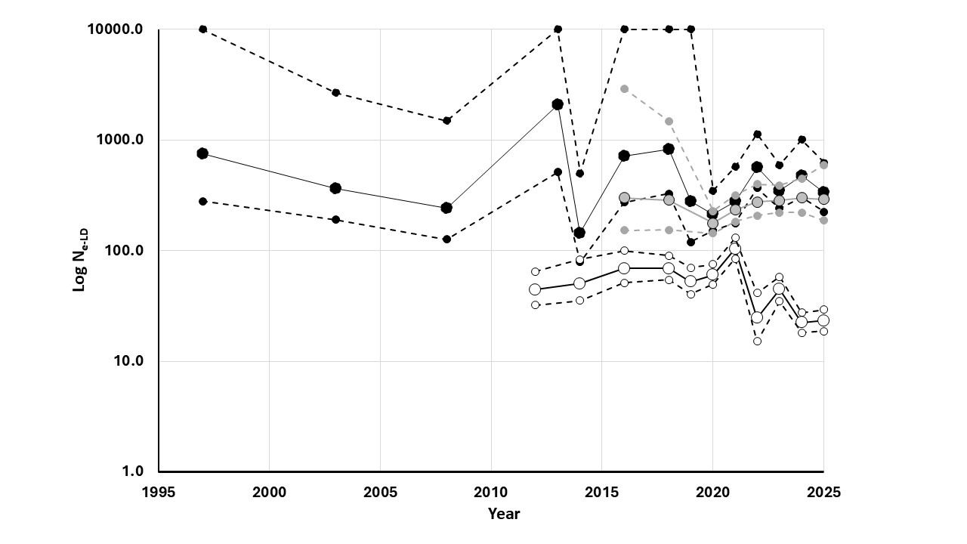
Figure 11.—Change in log N_{e-LD} over time for annual larval mainstem samples.
(Annual samples from Lake Mohave, Reach 3, and Lake Mead are represented by black, gray, and white circles, respectively. CIs are identified by dashed lines and smaller symbol size. Infinite estimates are plotted as 10,000.)

Because of significantly reduced N_{e-LD} values in Lake Mead, average relatedness was estimated (using the TrioML estimator of Wang 2011) for each annual sample of adults (table 9). Analysis of relatedness provided estimates that ranged from 0.041 (Lake Mead 2021) to 0.062 (Lake Mead pre-1992). Estimated relatedness from the sample of wild RASU from Lake Mohave was 0.054. Visualization of change in relatedness over time (figure 12) indicates that relatedness declined from the small group of fish present in the late 1980’s to early 1990’s but has been steadily increasing since 2021.

To further examine relatedness, pairwise estimates between individuals were plotted, with level of relatedness color-coded in a heat map with red being more closely related and white less so (figure 13). The plot is symmetrical, divided into upper and lower halves by the solid line. For the upper half of the matrix, Lake Mead-only and Lake Mohave-only comparisons are divided into two triangles by dashed lines. Examination of these two triangles indicated that Lake Mead-only pairwise comparisons (large triangle) yielded more and redder dots than within Lake Mohave-only pairwise comparisons (small triangle), consistent with higher levels of relatedness among individuals within Lake Mead than Lake Mohave. Another interesting observation is that individuals from Lakes Mead and Mohave do not generally exhibit high levels of relatedness when compared to each other (area bounded by the dashed lines). There are, however, some exceptions, as some individuals from Lake Mead seem to be more closely related to those from Lake Mohave than others from Lake Mead (example indicated by black line to the right of the plot). Explanation of this pattern will require further investigation of the origins of these individuals.

Table 9.—Estimates of within and among sample relatedness from annual samples of Lake Mead
(The relatedness coefficient (TrioML) and its variance (VAR) were calculated as described by Wang (2011) using filtered samples (N_{f}). Lake Mead and Lake Mohave wild samples were collected prior to 1992 and 2002, respectively.)
Sample | N_{f} | Statistic | RBM10-19 | RBM20 | RBM21 | RBM22 | RBM23 | RBM24 | Wild samples
 |  |  |  |  |  |  |  |  | Lake Mead | Lake Mohave
RBM10-19 | 231 | TrioML | 0.054 | ns | ns | ns | ns | ns | ns | ns
 |  | VAR | 0.008
RBM20 | 33 | TrioML | 0.047 | 0.043 | ns | ns | ns | ns | ns | ns
 |  | VAR | 0.006 | 0.005
RBM21 | 83 | TrioML | 0.043 | 0.039 | 0.041 | ns | ns | ns | ns | ns
 |  | VAR | 0.005 | 0.004 | 0.004
RBM22 | 33 | TrioML | 0.051 | 0.049 | 0.041 | 0.045 | ns | ns | ns | ns
 |  | VAR | 0.007 | 0.005 | 0.004 | 0.005
RBM23 | 38 | TrioML | 0.049 | 0.048 | 0.041 | 0.048 | 0.050 | ns | ns | ns
 |  | VAR | 0.005 | 0.006 | 0.004 | 0.005 | 0.005
RBM24 | 39 | TrioML | 0.050 | 0.042 | 0.043 | 0.045 | 0.046 | 0.056 | ns | ns
 |  | VAR | 0.005 | 0.004 | 0.004 | 0.004 | 0.005 | 0.005
Mead wild | 19 | TrioML | 0.032 | 0.034 | 0.037 | 0.034 | 0.034 | 0.035 | 0.062 | ns
 |  | VAR | 0.003 | 0.002 | 0.003 | 0.003 | 0.002 | 0.002 | 0.013
Mohave wild | 120 | TrioML | 0.027 | 0.031 | 0.035 | 0.027 | 0.025 | 0.027 | 0.037 | 0.054
 |  | VAR | 0.001 | 0.001 | 0.002 | 0.001 | 0.001 | 0.001 | 0.002 | 0.003

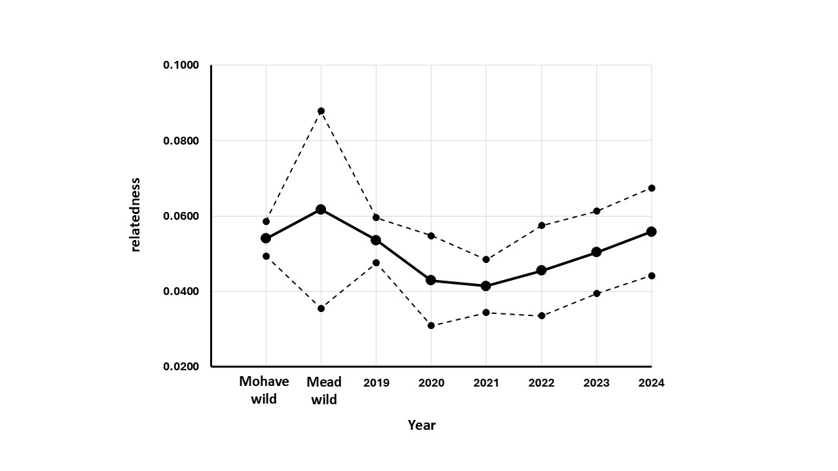
Figure 12.—Relatedness estimates and their standard errors over time for adult Lake Mead RASU samples.
(The solid line with larger symbols represents relatedness estimates while dashed lines with smaller symbols their standard error. Wild samples from Lake Mohave (captured prior to 2002) and Lake Mead (captured prior to 1992) are also plotted to provide perspective.)
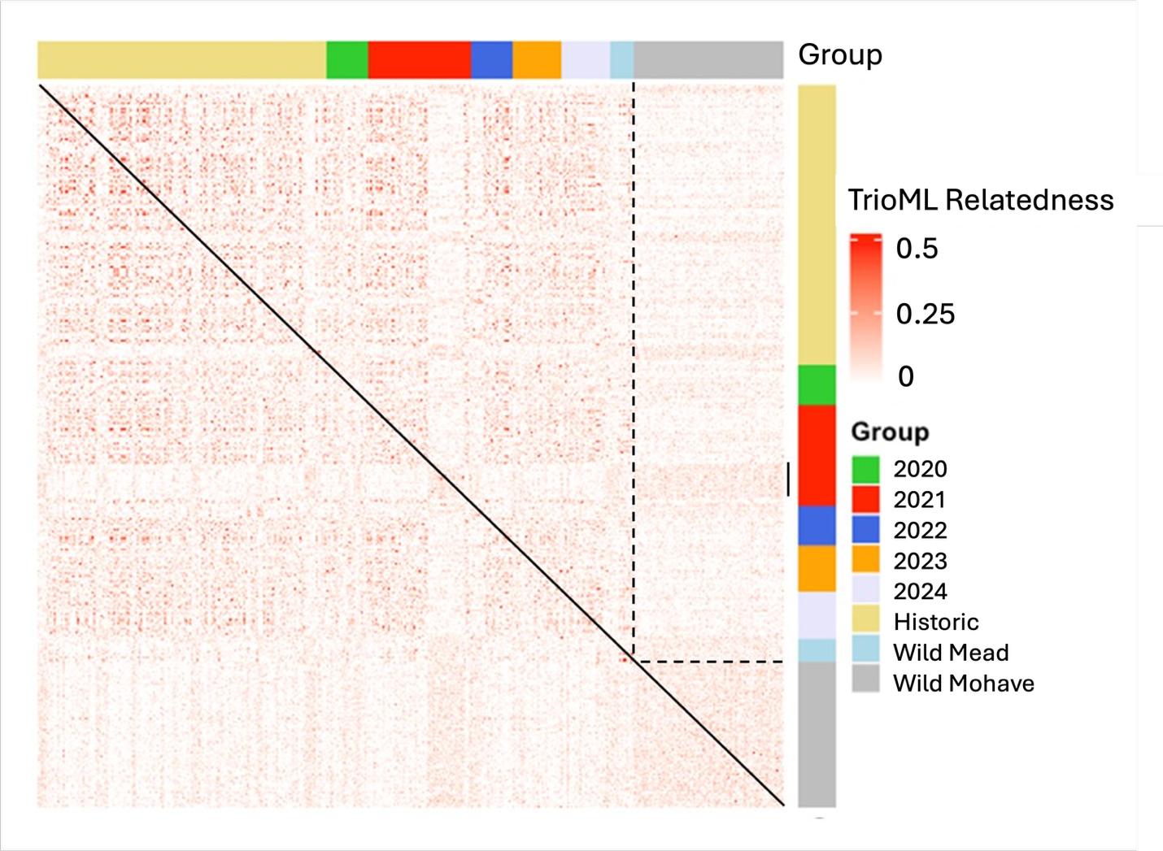
Figure 13.—Heat map showing levels of relatedness among pairs of individuals from Lake Mead.
(Each dot represents the relatedness of a pair of individuals with redder dots meaning a closer relationship. The symmetrical matrix is divided into two identical halves by the solid line. Group membership for pairwise comparisons is provided by colored bars above and to the right of the plot. Dashed lines further divide the matrix into comparisons within lakes Mead and Mohave (larger and smaller triangles, respectively) and between the two lakes (rectangle defined by dashed lines). The small solid black line to the right of the plot shows an example of comparisons involving Mead-Mohave pairs with higher relatedness than most others in that group.)

In summary, genetic monitoring of mainstem RASU populations with the GT-seq panel provided results generally consistent with previous studies using mtDNA and microsatellites. Effective population sizes have been stable in larval samples from Reach 3 and Lake Mohave, but consistently lower and declining in Lake Mead. For adults, N_{e} has been stable in all three reaches but has been higher in Lake Mohave than Reach 3 and Lake Mead. Lower estimates of N_{e} continue to be troubling for Lake Mead. While relatedness of individuals is not currently high, it has been increasing since 2021, consistent with the decline in N_{e} observed in larvae. Consistency of this pattern over time leads to increasing concerns over the status of the Lake Mead population and its ability to persist for the long term.
Off-channel Habitats
RASU have been stocked into several OCHs (YCB and IP1, IP3, and IP4) to establish self-sustaining populations. Samples were obtained from each of these ponds for characterization with the GT-seq panel to provide information on genetic and demographic features of this species.

YCB
After the pond was cleared, YCB was stocked with 200 adults (100 of each sex) in 2013. It was stocked again in 2014 and 2015 with 50 males and 50 females each year, and finally with 100 individuals of unknown sex in 2020. Sampling from YCB was typically successful with large numbers of offspring (larvae and recruits) available most years (table 10).

Estimates of H_{obs} and H_{exp} from stocked adults were consistent with mainstem samples, averaging 0.339 (range = 0.332–0.356) and 0.335 (range = 0.332–0.341), respectively (table 10). Measures of F_{is} averaged -0.008 (range = -0.037–0.006), with only the 2015 adults significantly different from zero (F_{is} = -0.037, CI from -0.056 to -0.015). A_{R} averaged 1.985 (range = 1.970–2.000). Consistent with expectations, estimates of N_{e-LD} from adults reflected their source (Lake Mohave), averaging 597 (range = 282–1,071).

Samples of recruits (fish born in the OCHs) were available for all years, 2013–2024, with the exception of 2014 (table 10). Average estimates of H_{obs} and H_{exp} were 0.337 (range = 0.313–0.352) and 0.324 (range = 0.298–0.334), respectively. Measures of F_{is} averaged -0.030 (range = -0.045 – -0.013), with all but one of 11 estimates significantly different from 0, indicative of an excess of heterozygotes. This is not surprising as small populations with a limited number of breeding individuals are more likely to exhibit significant F_{is} values due to differences in reproductive success and random processes. Average A_{R} estimates across years was 1.992 (range = 1.950–2.000).

Larval samples were available for all years, 2013–2025, except for 2022 (table 10). Estimates of H_{obs} and H_{exp} exhibited an overall average of 0.333 (range = 0.324–0.345) and 0.328 (range = 0.321–0.337), respectively, like values found in YCB adults (table 10). Measures of F_{is} averaged -0.010 (range = -0.023 – 0.002), with 5 of 12 estimates significantly different from 0, all being negative. The average A_{R} estimate across years was 1.988 (range = 1.70–2.000).

For OCHs, N_{e-sib} is more informative than N_{e-LD} as it accounts for potential close relationships expected in these ponds. N_{e-sib} estimates from adults ranged from 194 to 402, with an overall average of 286 (table 10). Estimates of N_{e-sib} ranged from 28 to 135 for larvae, with an overall average of 64. These are lower than adults due to limited contributions of some potential parents. This is not surprising as stocked adults experienced significant mortality soon after stocking events, reducing the number of breeders and skewing their sex ratio (Kesner YEAR, personal communication.). For recruits, estimates of N_{e-sib} ranged from 8 to 72, with an overall average of 45. Estimates of N_{e-sib} are similar for larvae and recruits and are not significantly different (figure 14). There appears to be a trend towards increasing N_{e-sib}; therefore, the number of contributing breeders and genetic variation are being maintained in the standing population at YCB.

To assess change in relatedness over time, COANCESTRY was used to calculate TrioML estimates of relatedness and their variance from 2013 stocked adults and recruits from 2013 through 2025 (except for 2014 when no samples were available). Estimated average relatedness from the sample of adults stocked in 2013 was 0.047. Relatedness estimates from within recruit annual samples ranged from 0.040 (2021) to 0.141 (2013). The 2021 annual sample was small with higher variance (figure 15); however, the next smallest estimate is essentially the same (0.042, 2023 and 2024). Visualization of change in relatedness over time (figure 15) indicates that relatedness spiked in 2013 in the first generation of reproduction and declined to levels similar to the adults by 2016.

Another way to visualize relatedness is provided in figure 16 where pairwise estimates between individuals were plotted, yielding a symmetrical heat map. This plot is divided into upper and lower halves by the solid black line with red dots identifying pairs of individuals that are more closely related and white less so. The number of individuals makes this approach computationally intensive and space required to present the information prohibitive; therefore, example years were selected to illustrate the main point and presented as annual plots. Results are consistent with conclusions drawn from examination of the averages, with 2013 recruits exhibiting high levels of relatedness (Panel 2013 recruits, figure 16). Recruits from 2017 exhibited low levels of relatedness (Panel 2017 recruits, figure 16) that increased in 2019 (Panel 2019 recruits, figure 16) but declined to similar levels as stocked adults in 2023 (Panels 2013 stocked adults and 2023 recruits, figure 16). It is tempting to suggest that the decline in 2020 and beyond reflects the influx of new parents with the 2020 augmentation. Closer examination of the data is required to assess this possibility.
Table 10.—Estimates of population genetic parameters for YCB population samples
(N_{s} and N_{f} are the number of samples that were genotyped and survived filtering, respectively. Estimates of H_{obs}, H_{exp}, and F_{is} are provided with lower and upper confidence limits (LCI and UCI). N_{e-LD} and the upper and lower bounds from bootstrap analysis (LB and UB, respectively) are also provided. A_{R} is the population estimate of allelic richness which has a maximum value of 2 as determined by marker design. AVE, MAX, and MIN are the average, maximum and minimum values.)
Sample | N_{s} | N_{f} | H_{obs} | LCI | HCI | H_{exp} | LCI | HCI | F_{is} | LCI | HCI | A_{R} | N_{e-LD} | LB | UB | N_{e-sib} | LB | UB
Stocked adults
2013 | 200 | 200 | 0.335 | 0.330 | 0.340 | 0.335 | 0.333 | 0.339 | 0.001 | -0.004 | 0.014 | 2.000 | 575 | 416 | 900 | 402 | 329 | 489
2014 | 100 | 100 | 0.334 | 0.329 | 0.339 | 0.332 | 0.330 | 0.336 | -0.001 | -0.007 | 0.008 | 1.970 | 458 | 238 | 2,842 | 271 | 204 | 369
2015 | 100 | 100 | 0.356 | 0.346 | 0.371 | 0.341 | 0.339 | 0.348 | -0.037 | -0.056 | -0.015 | 1.970 | 1,071 | 618 | 3,680 | 194 | 146 | 262
2020 | 100 | 98 | 0.332 | 0.327 | 0.336 | 0.332 | 0.330 | 0.336 | 0.006 | -0.001 | 0.021 | 2.000 | 282 | 161 | 851 | 276 | 208 | 382
AVE |  |  | 0.339 | 0.333 | 0.347 | 0.335 | 0.333 | 0.340 | -0.008 | -0.017 | 0.007 | 1.985 | 597 | 359 | 2,066 | 286 | 222 | 376
MAX |  |  | 0.356 | 0.346 | 0.371 | 0.341 | 0.339 | 0.348 | 0.006 | -0.001 | 0.021 | 2.000 | 1,071 | 618 | 3,680 | 402 | 329 | 489
MIN |  |  | 0.332 | 0.327 | 0.336 | 0.332 | 0.330 | 0.336 | -0.037 | -0.056 | -0.015 | 1.970 | 282 | 161 | 851 | 194 | 146 | 262
Recruits
2013 | 125 | 125 | 0.313 | 0.307 | 0.318 | 0.298 | 0.291 | 0.305 | -0.035 | -0.044 | -0.019 | 1.950 | 18 | 15 | 21 | 8 | 4 | 28
2015 | 125 | 125 | 0.341 | 0.333 | 0.353 | 0.325 | 0.322 | 0.335 | -0.042 | -0.055 | -0.024 | 1.970 | 25 | 21 | 29 | 15 | 8 | 30
2016 | 180 | 164 | 0.352 | 0.345 | 0.360 | 0.334 | 0.332 | 0.338 | -0.045 | -0.056 | -0.030 | 2.000 | 43 | 38 | 49 | 36 | 24 | 57
2017 | 95 | 92 | 0.336 | 0.330 | 0.342 | 0.328 | 0.326 | 0.333 | -0.013 | -0.021 | 0.007 | 2.000 | 63 | 52 | 77 | 72 | 51 | 105
2018 | 156 | 144 | 0.333 | 0.328 | 0.338 | 0.327 | 0.325 | 0.331 | -0.014 | -0.023 | -0.001 | 2.000 | 43 | 38 | 50 | 55 | 39 | 81
2019 | 166 | 153 | 0.345 | 0.339 | 0.351 | 0.327 | 0.325 | 0.330 | -0.044 | -0.053 | -0.028 | 2.000 | 35 | 31 | 40 | 22 | 13 | 39
2020 | 165 | 162 | 0.333 | 0.328 | 0.339 | 0.325 | 0.322 | 0.329 | -0.019 | -0.027 | -0.006 | 2.000 | 56 | 47 | 68 | 63 | 45 | 93
2021 | 9 | 9 | 0.338 | 0.325 | 0.359 | 0.308 | 0.308 | NA | -0.035 | -0.034 | -0.029 | NA | 33 | 17 | 178 | 36 | 16 | 437
2022 | 303 | 291 | 0.345 | 0.339 | 0.352 | 0.329 | 0.327 | 0.333 | -0.040 | -0.050 | -0.027 | 2.000 | 47 | 42 | 52 | 48 | 34 | 73
2023 | 175 | 174 | 0.336 | 0.332 | 0.340 | 0.330 | 0.329 | 0.333 | -0.013 | -0.019 | -0.004 | 2.000 | 68 | 56 | 84 | 71 | 51 | 103
2024 | 165 | 165 | 0.340 | 0.336 | 0.346 | 0.331 | 0.329 | 0.335 | -0.025 | -0.033 | -0.013 | 2.000 | 69 | 59 | 82 | 68 | 49 | 97
AVE |  |  | 0.337 | 0.331 | 0.345 | 0.324 | 0.322 | 0.330 | -0.030 | -0.038 | -0.016 | 1.992 | 45 | 38 | 66 | 45 | 30 | 104
MAX |  |  | 0.352 | 0.345 | 0.360 | 0.334 | 0.332 | 0.338 | -0.013 | -0.019 | 0.007 | 2.000 | 69 | 59 | 178 | 72 | 51 | 437
MIN |  |  | 0.313 | 0.307 | 0.318 | 0.298 | 0.291 | 0.305 | -0.045 | -0.056 | -0.030 | 1.950 | 18 | 15 | 21 | 8 | 4 | 28
Larvae
2013 | 168 | 168 | 0.333 | 0.328 | 0.339 | 0.332 | 0.330 | 0.336 | 0.001 | -0.007 | 0.017 | 1.970 | 85 | 72 | 101 | 64 | 46 | 91
2014 | 301 | 299 | 0.340 | 0.336 | 0.345 | 0.333 | 0.332 | 0.336 | -0.018 | -0.026 | -0.009 | 1.970 | 47 | 42 | 52 | 37 | 25 | 59
2015 | 457 | 364 | 0.345 | 0.341 | 0.349 | 0.337 | 0.335 | 0.340 | -0.021 | -0.027 | -0.010 | 1.970 | 77 | 71 | 84 | 66 | 48 | 94
2016 | 291 | 280 | 0.340 | 0.334 | 0.346 | 0.331 | 0.329 | 0.335 | -0.023 | -0.034 | -0.012 | 1.970 | 68 | 61 | 76 | 91 | 69 | 126
2017 | 269 | 251 | 0.324 | 0.319 | 0.330 | 0.321 | 0.318 | 0.325 | -0.004 | -0.013 | 0.010 | 2.000 | 35 | 31 | 40 | 38 | 26 | 61
2018 | 249 | 240 | 0.326 | 0.322 | 0.330 | 0.323 | 0.322 | 0.326 | -0.007 | -0.014 | 0.005 | 2.000 | 40 | 35 | 45 | 38 | 26 | 62
2019 | 265 | 257 | 0.331 | 0.327 | 0.335 | 0.329 | 0.327 | 0.332 | -0.005 | -0.012 | 0.006 | 2.000 | 92 | 81 | 103 | 135 | 107 | 177
2020 | 265 | 251 | 0.324 | 0.320 | 0.328 | 0.324 | 0.322 | 0.327 | 0.002 | -0.006 | 0.014 | 2.000 | 63 | 57 | 69 | 82 | 61 | 113
2021 | 202 | 188 | 0.330 | 0.325 | 0.336 | 0.325 | 0.323 | 0.329 | -0.011 | -0.021 | 0.002 | 1.950 | 61 | 55 | 68 | 76 | 55 | 107
2023 | 273 | 269 | 0.334 | 0.330 | 0.339 | 0.328 | 0.327 | 0.331 | -0.014 | -0.023 | -0.003 | 2.000 | 43 | 38 | 48 | 32 | 20 | 53
2024 | 274 | 271 | 0.338 | 0.334 | 0.342 | 0.331 | 0.329 | 0.334 | -0.016 | -0.024 | -0.005 | 2.000 | 42 | 36 | 49 | 28 | 18 | 48
2025 | 275 | 240 | 0.326 | 0.322 | 0.330 | 0.325 | 0.323 | 0.328 | 0.000 | -0.007 | 0.012 | 2.000 | 59 | 52 | 67 | 85 | 63 | 115
AVE |  |  | 0.333 | 0.328 | 0.337 | 0.328 | 0.326 | 0.332 | -0.010 | -0.018 | 0.002 | 1.986 | 59 | 53 | 67 | 64 | 47 | 92
MAX |  |  | 0.345 | 0.341 | 0.349 | 0.337 | 0.335 | 0.340 | 0.002 | -0.006 | 0.017 | 2.000 | 92 | 81 | 103 | 135 | 107 | 177
MIN |  |  | 0.324 | 0.319 | 0.328 | 0.321 | 0.318 | 0.325 | -0.023 | -0.034 | -0.012 | 1.950 | 35 | 30.6 | 40 | 28 | 18 | 48

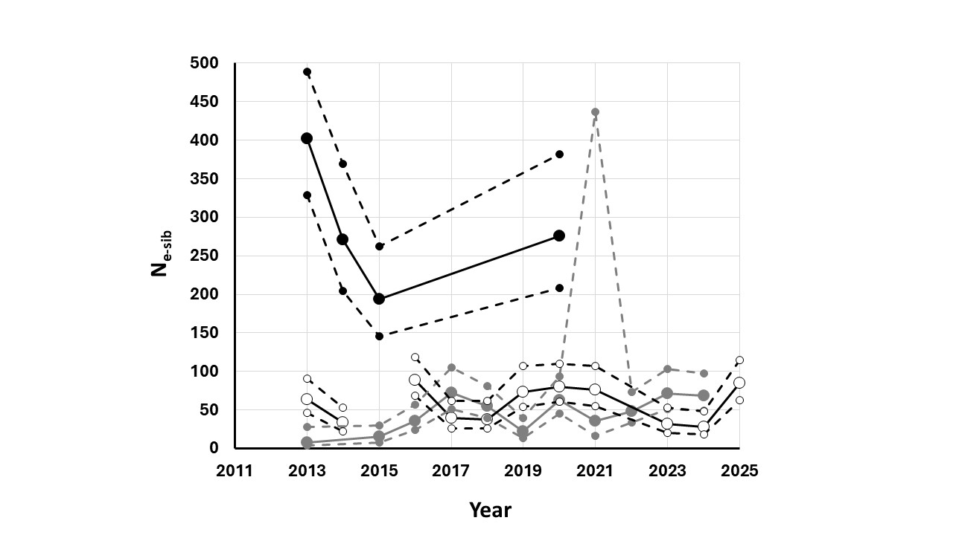
Figure 14.—Change in N_{e-sib} over time for YCB samples.
(Annual samples of adults, recruits, and larvae are represented by black, gray, and white circles, respectively. CIs are identified by dashed lines and smaller symbol size.)
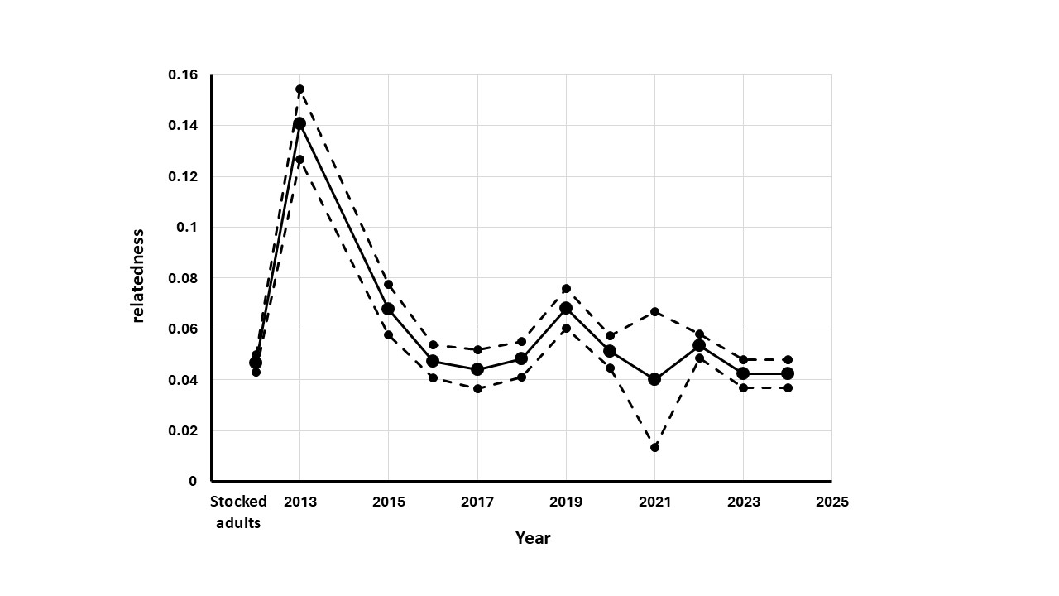
Figure 15.—Relatedness estimates and their standard errors over time for annual YCB recruit samples.
(Solid line and larger symbols represent relatedness estimates while dashed lines and smaller symbols represent their standard errors. Adults stocked in 2013 are also plotted to provide perspective.)

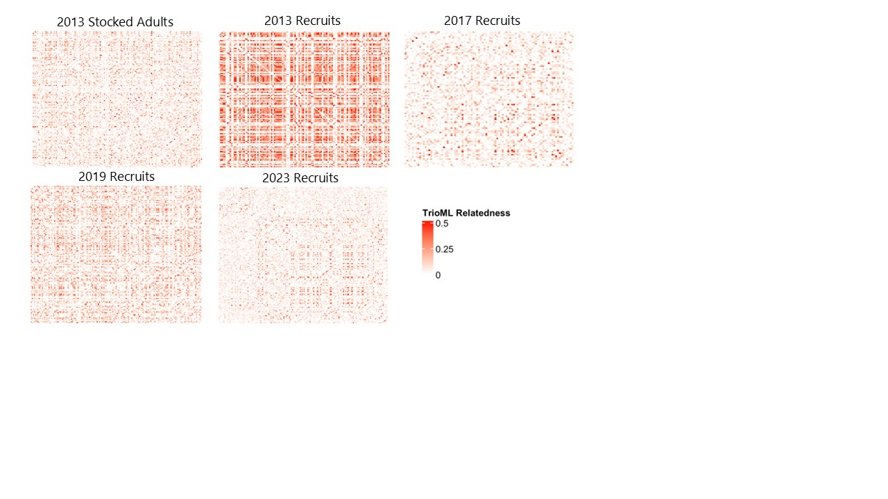
Figure 16.—Heatmaps based on pairwise TrioML relatedness values for YCB populations at timepoints with notable estimates of relatedness.
(Each square is a pairwise comparison between two individuals, with darker red colors indicating higher levels of relatedness while white represents low levels of relatedness. The 2013 stocked adults are included as a baseline for comparison.)

Comparison of GTseq Panel Performance to Microsatellite Panel.—To assess the effectiveness of the GT-seq SNP panel, parentage assignments were completed for a subset of populations genotyped with the microsatellite panel for RASU (Turner et al. 2009). For 2013 larvae and recruits, assignment proportions were nearly 100% for both microsatellites and SNPs (figure 17), with a slight improvement observed for SNPs. Where parents were identified, parentage assignments were concordant for both SNPs and microsatellites. In subsequent years, assignment percentage dropped for both microsatellites and SNPS, likely due to unsampled individuals reproducing in the pond; however, for these populations (2014 larvae and 2015 recruits), SNPs provided a notable increase in assignment percentage. Therefore, the SNP panel appears to provide an accurate means of parentage assignment with improved performance over the microsatellite panel.

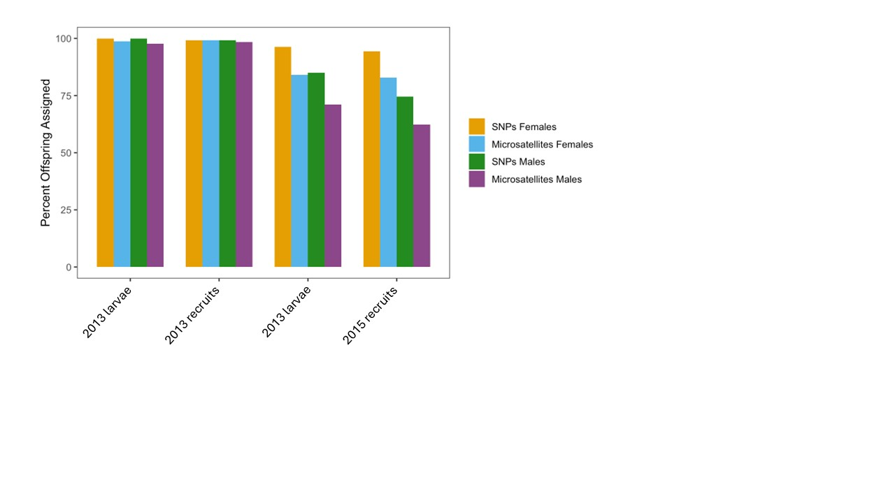
Figure 17.—Comparison of parentage assignment of the RASU GT-seq SNP panel to parentage assignment with microsatellite markers.
(Colored bars [legend to the right] identify different marker types [SNPs and microsatellites] and sex of the parent.)

Parentage Assignment and Reproductive Success.—Parentage assignments were completed in COLONY for YCB recruits, and metrics for VRS were calculated from the parentage assignments (table 11). Percentage of offspring that were assigned a known female as a parent was near 100% in 2013 and 2014 but continually decreased in subsequent years (figure 18). Assignment percentage was lower for males than females and dropped notably in 2014. Given that males mature sooner than females, it is possible that unsampled males began reproducing in the pond in 2014, resulting in lower assignment percentage. For both sexes, assignment percentage continued to decrease in later years as more unsampled individuals reproduced and relatedness increased complexity of the computations, leading to difficulty in parentage assignments.

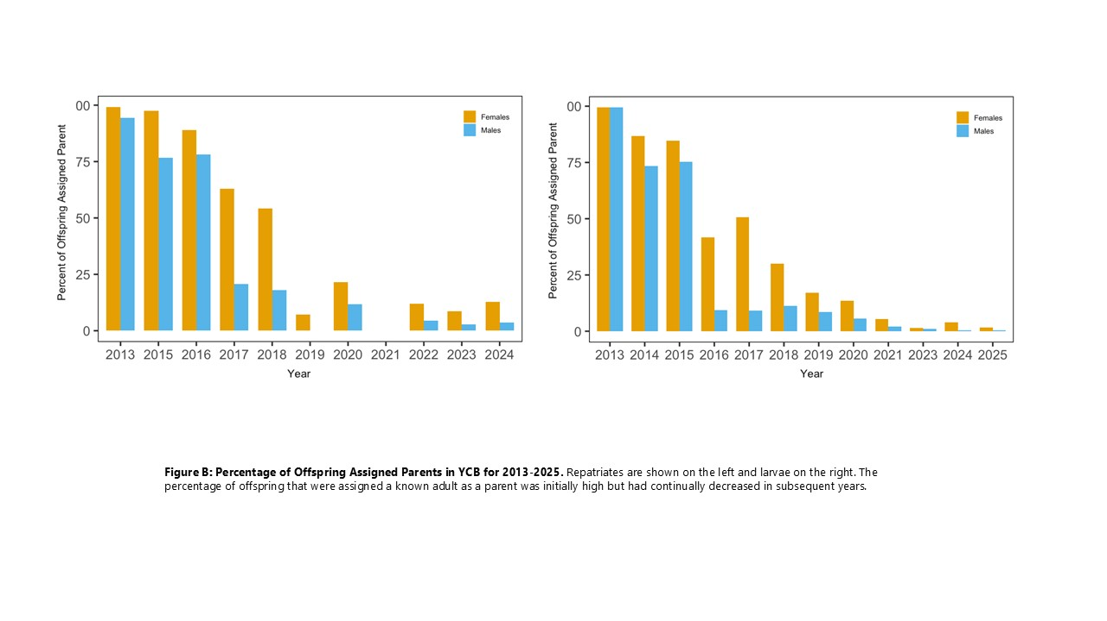
Figure 18.—Percentage of offspring assigned parents in YCB, 2013–2025.
(Recruits are shown on the left and larvae on the right. Color of bars identified larvae and recruits assigned female (orange) and male (blue) parents, respectively.)

Table 11.—Summary of parental contributions to recruits and larvae from YCB
(N is the number of recruits or larvae sampled, variance (VAR), and standard deviation (SD). MIN and MAX are the minimum and maximum number of offspring from reproducing individuals.)
Sample | Year | N | Males |  |  |  |  |  | Females
 |  |  | # reproducing | AVE # progeny | VAR | SD | MIN | MAX | # reproducing | AVE # progeny | VAR | SD | MIN | MAX
Recruits | 2013 | 125 | 24 | 5.2 | 41.3 | 6 | 1 | 25 | 15 | 8.3 | 356.8 | 6.4 | 1 | 75
 | 2015 | 125 | 17 | 7.3 | 121.1 | 11 | 1 | 46 | 24 | 5.2 | 33.6 | 11.0 | 1 | 25
 | 2016 | 164 | 28 | 5.9 | 34.0 | 6 | 1 | 20 | 39 | 4.2 | 31.1 | 5.8 | 1 | 30
 | 2017 | 92 | 40 | 2.3 | 3.7 | 2 | 1 | 11 | 47 | 2.0 | 2.6 | 1.9 | 1 | 9
 | 2018 | 144 | 46 | 3.1 | 7.6 | 3 | 1 | 12 | 36 | 4.0 | 11.8 | 2.8 | 1 | 14
 | 2019 | 153 | 43 | 3.6 | 8.7 | 3 | 1 | 14 | 19 | 8.1 | 135.1 | 2.9 | 1 | 40
 | 2020 | 162 | 63 | 2.6 | 7.1 | 3 | 1 | 17 | 66 | 2.5 | 11.1 | 2.7 | 1 | 20
 | 2021 | 9 | 6 | 1.5 | 0.7 | 1 | 1 | 3 | 5 | 1.8 | 0.7 | 0.8 | 1 | 3
 | 2022 | 291 | 66 | 4.4 | 23.1 | 5 | 1 | 25 | 54 | 5.4 | 62.2 | 4.8 | 1 | 39
 | 2023 | 174 | 58 | 3.0 | 7.7 | 3 | 1 | 16 | 64 | 2.7 | 9.9 | 2.8 | 1 | 24
 | 2024 | 165 | 46 | 3.6 | 8.7 | 3 | 1 | 15 | 61 | 2.7 | 8.2 | 3.0 | 1 | 15
Larvae | 2013 | 168 | 48 | 3.5 | 5.7 | 2.4 | 1 | 9 | 51 | 3.3 | 13.7 | 2.4 | 1 | 25
 | 2014 | 299 | 27 | 10.9 | 137.5 | 11.7 | 1 | 46 | 64 | 4.6 | 27.7 | 11.7 | 1 | 25
 | 2015 | 364 | 60 | 6.1 | 62.9 | 7.9 | 1 | 32 | 85 | 4.3 | 15.1 | 7.9 | 1 | 20
 | 2016 | 280 | 79 | 3.5 | 8.6 | 2.9 | 1 | 12 | 77 | 3.6 | 17.4 | 2.9 | 1 | 24
 | 2017 | 251 | 62 | 4.0 | 16.7 | 4.1 | 1 | 21 | 50 | 5.0 | 78.6 | 4.1 | 1 | 55
 | 2018 | 240 | 51 | 4.7 | 19.1 | 4.4 | 1 | 21 | 40 | 6.0 | 75.6 | 4.4 | 1 | 42
 | 2019 | 257 | 87 | 3.0 | 5.1 | 2.3 | 1 | 12 | 89 | 2.9 | 5.9 | 2.3 | 1 | 12
 | 2020 | 251 | 64 | 3.9 | 11 | 3.3 | 1 | 15 | 61 | 4.1 | 14.4 | 3.3 | 1 | 17
 | 2021 | 188 | 57 | 3.3 | 5.5 | 2.3 | 1 | 9 | 53 | 3.5 | 12.0 | 2.3 | 1 | 18
 | 2023 | 269 | 56 | 4.8 | 28.1 | 5.3 | 1 | 22 | 64 | 4.2 | 86.5 | 5.3 | 1 | 71
 | 2024 | 271 | 69 | 3.9 | 32.2 | 5.7 | 1 | 28 | 75 | 3.6 | 93.6 | 5.7 | 1 | 83
 | 2025 | 240 | 168 | 1.4 | 0.8 | 0.9 | 1 | 7 | 43 | 5.6 | 32.2 | 0.9 | 1 | 24

YCB Recruits.—Metrics to assess VRS for stocked adults and unknown parents were calculated for YCB recruits from 2013 to 2024 (table 11). The number of males that produced at least one offspring in each year ranged from 6 in 2021 to 66 individuals in 2022 with an average of 40 male parents per year. Across all years, the number of offspring per male ranged from 1 to 46.

The number of females contributing offspring ranged from 5 in 2021 to 66 in 2020 with an average of 39 females reproducing per year. The number of offspring per reproducing individual ranged from 1 to 75.

For both males and females, the variance in offspring per individual was often high with small numbers of individuals accounting for many offspring each year (figure 19).

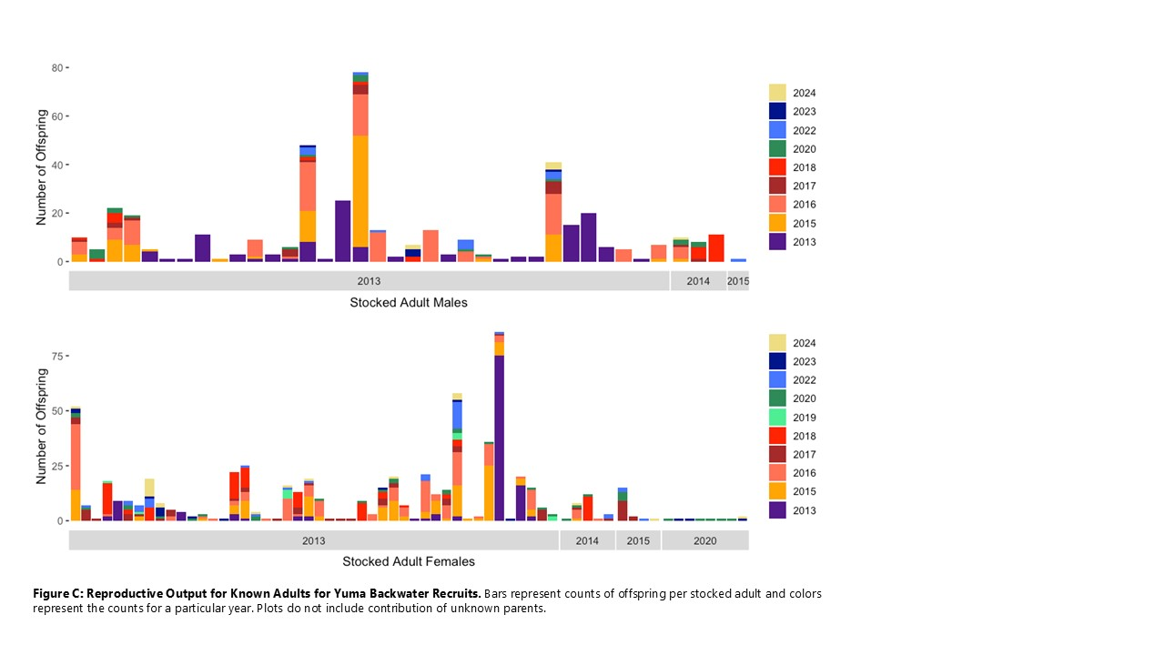
Figure 19.—Reproductive output of known adults for YCB recruits.
(Bars represent counts of offspring per stocked adult and colors represent the counts for a particular year. Plots do not include contributions of unknown parents. The low number of parents in 2021 is a result of the small number of progeny genotyped in that year.)

YCB Larvae.—Metrics to assess VRS of stocked adults and unknown parents were calculated for YCB larvae from 2013 to 2025 (see table 11). The number of males that produced at least one offspring in each year ranged from 27 in 2014 to 168 individuals in 2025, averaging 69 male parents per year. The number of offspring per male ranged from 1 to 46.

The number of females contributing offspring ranged from 40 in 2018 to 89 in 2019 with an average of 62.7 females reproducing per year. The number of offspring per individual ranged from 1 to 83.

As with recruits, the variance in offspring per individual was often high with small numbers of individuals accounting for large numbers of offspring each year (figure 20).

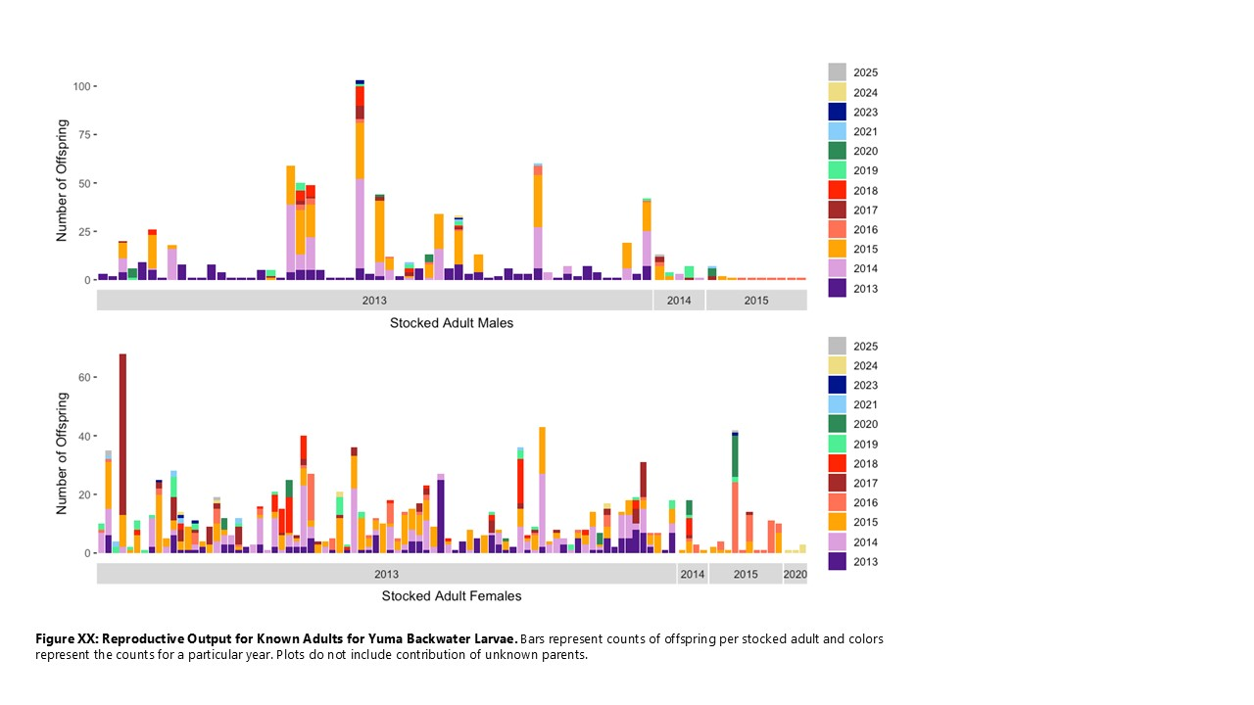
Figure 20.—Reproductive output of known adults for YCB larvae.
(Bars represent counts of offspring per stocked adult and colors represent the counts for a particular year. Plots do not include contribution of unknown parents.)

YCB parentage summary.—The results of parentage analysis in YCB for both recruits and larvae demonstrate variability in reproductive success, with some individuals producing many offspring in a given year while those same individuals contribute few or no offspring in other years. Lack of offspring from an individual in a year could mean no progeny were produced, or it could also be the result of sampling error. Declining levels of relatedness in YCB (figure 15) likely indicate that individuals stocked in later years and their unsampled progeny remain active in the pond and continue to contribute offspring, adding genetic variability to this population.

Population Monitoring.— Detection probability for RASU stocked in 2013 and 2014 in YCB was significantly dependent on TL, sex, and release year, although the TLs released in 2014 had minimal range and likely had little influence on model results (figure 21). Females were also released at a larger size (TL) on average than males, increasing the probability of post-stocking detection of female RASU. This difference in apparent survival between males and females resulted in a skewed sex ratio in YCB that was apparent from known survivor analysis (figure 22). YCB was stocked with 100 males and 100 females in 2013, but fewer than 50 males were detected beyond the initial post-stocking period (90 days), whereas a majority of the 100 females were detected (survived) the post-stocking period.

Few RASU stocked into YCB in 2014 survived the initial post-stocking period based on detection probability and known survivor analysis. This was likely in part due to the lack of large fish stocked (mean release size of 371 mm TL compared to 404 in 2013). However, even at smaller TL, the detection probability for RASU stocked in 2014 was lower than RASU stocked in 2013. The 2015 stocking was not assessed for post-stocking detection probability, but their fate was likely similar to the 2014 stocking based on known survivor counts

The sudden increases in total known population (figure 23) correspond to netting and trapping efforts in YCB that were used to assess the RASU population in YCB, harvest surplus RASU, and PIT tag newly recruited fish. These recruit “cohorts” experienced significant post-release mortality which was not illustrated in the known survival plots as they did not survive the initial 90 days post-release. The recruits that survived the initial 90 days had similar survival patterns to stocked fish except for the recruit cohort in 2018. Approximately 100 RASU recruits survived the initial 90 days post-stocking but went undetected sometime in early 2019. This loss of a recruitment cohort even after initially surviving may be an indication that YCB was becoming overcrowded. Management of YCB shifted after this loss with an emphasis on transferring (harvesting) RASU to reduce overall biomass while still stocking to maintain genetic diversity.

The PIT tagged RASU population in YCB after the initial stocking in 2013 was estimated at approximately100 fish, which is similar to the population size from known survivor analysis (figure 23). The PIT tagging of recruited RASU led to the PIT tagged population exceeding 200 individuals for four estimates from 2016 through 2019. The population of PIT tagged RASU was below 200 in all subsequent years for which estimates could be made. Mark recapture estimates closely aligned with the known survivor numbers indicating that the known survivor count is an accurate accounting of PIT tagged RASU in YCB. Recruitment to the PIT tagged population in YCB requires both adequate natural recruitment in the backwater, and adequate sampling effort to PIT tag a proportion of those recruits. To date, natural recruitment and sampling effort has been sufficient for the population size from both analyses (known survivors and mark-recapture) to exceed the initial estimate. Although there have been supplemental stockings after 2013, the majority of the population of PIT tagged RASU in YCB today is made of naturally recruited fish.

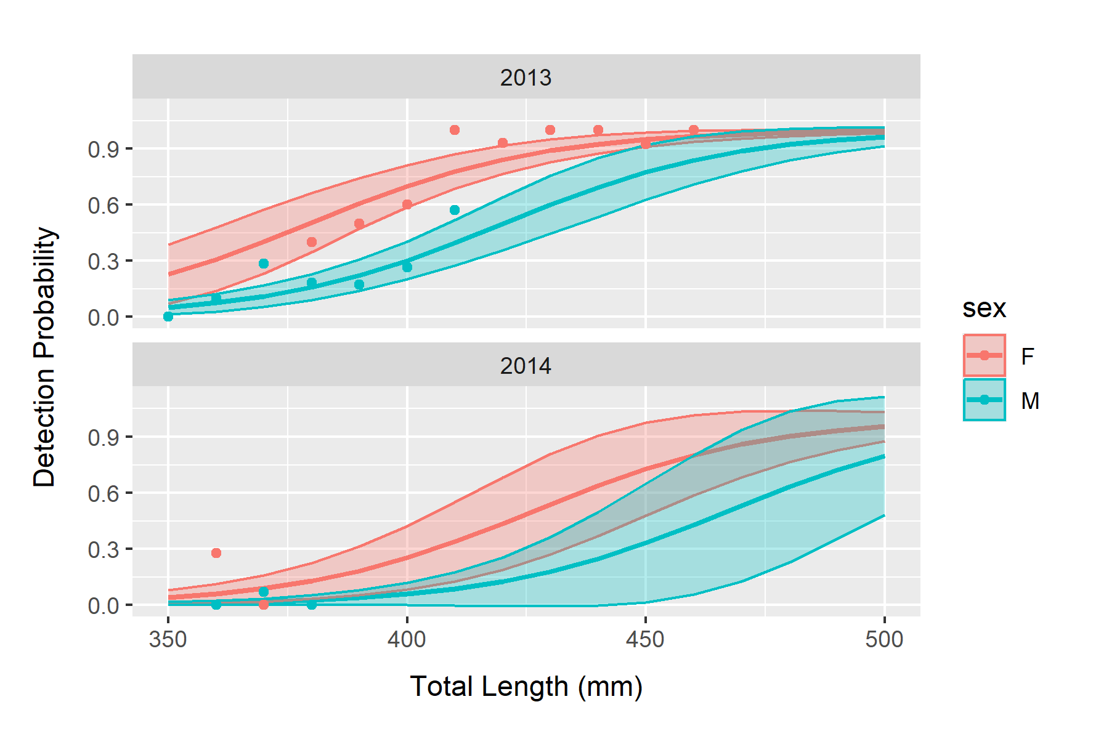
Figure 21.—Detection probability of RASU stocked in 2013 (top) and 2014 (bottom) in YCB based on PIT scanning from 2013 through 2025.
Lines represent best-fit results from the GLM, shaded area 95% confidence intervals, and points represent actual detection proportion for released fish grouped by TL in 10 mm increments.

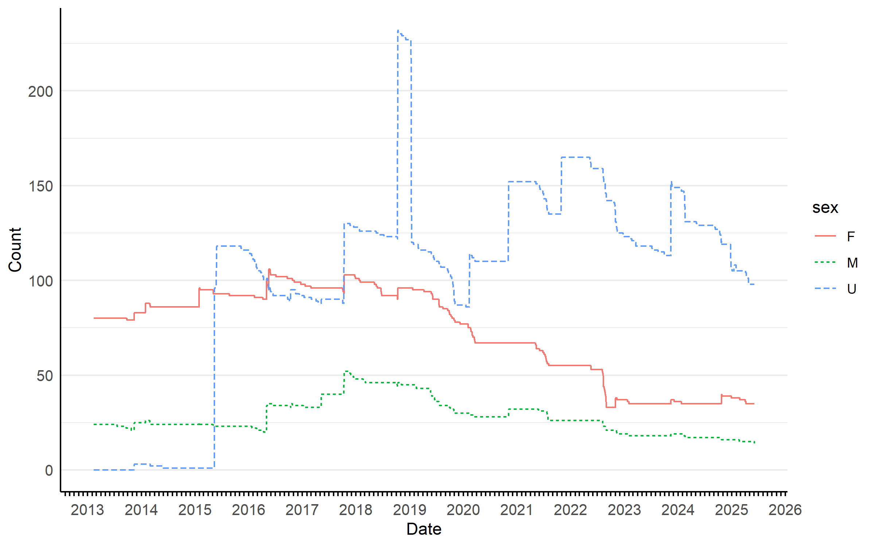
Figure 22.—The total number of known RASU survivors by sex in YCB based on PIT scanning from 2013 through 2025.
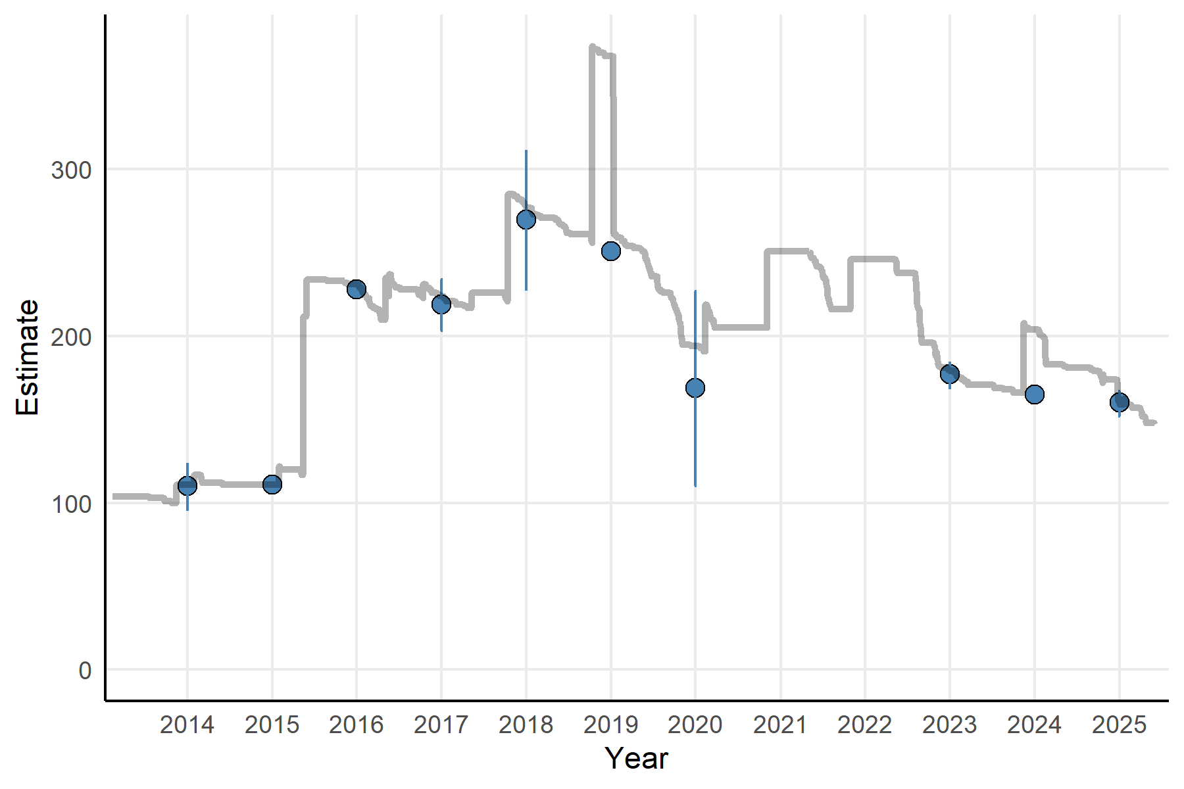
Figure 23.—Population estimates (blue points) of PIT tagged RASU in YCB and their 95% Confidence Interval (vertical lines) based on PIT scanning data from 2013 through 2025.
Grey line depicts total known RASU survivors (all sexes combined) .

A majority of male and female RASU stocked in 2013 contributed to offspring for the first five years post-stocking. This is especially significant for 2013, where only about ¼ of the males stocked survived 90 days post-stocking, and yet many contributed to offspring before perishing. The proportion of females from the initial stocking dropped below 50% in 2018 and in males in 2021. This general trend is likely due to the increasing number of naturally recruited untagged RASU contributing to offspring, and the resulting difficulties with assigning parentage. In contrast, the proportion of male and female RASU stocked in 2014 and 2015 that contributed to offspring in their stocking year was near zero. This lack of contribution could be due to a lack of sexual maturity in stocked fish, RASU TL was smaller in 2014 and 2015 compared to 2013. In subsequent years the proportion of male and female survivors of these stockings was variable due to their low overall numbers. One male from each stocking in 2014 and 2015 survived beyond the first year, both contributed to offspring at least once.

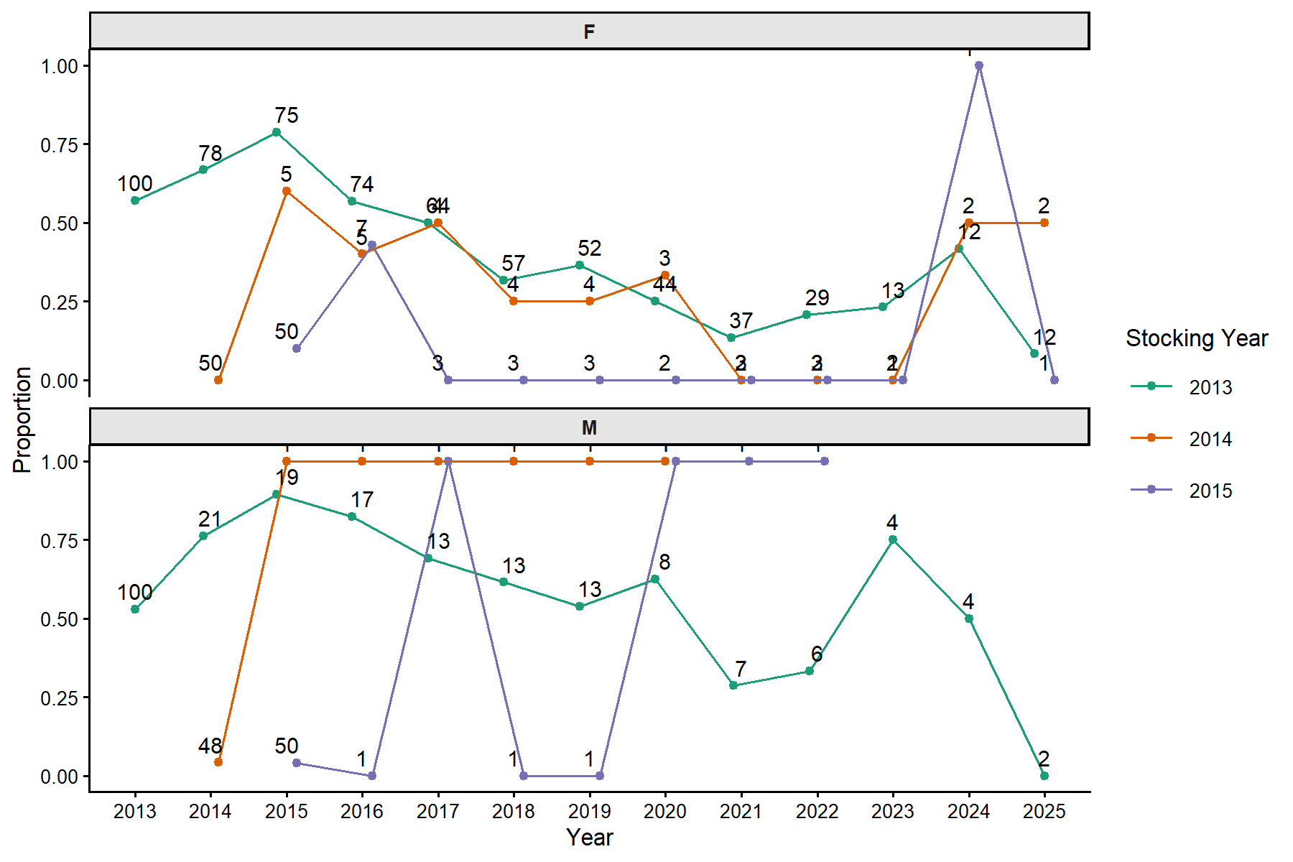
Figure 24.—Proportion of female (F - top) and male (M - bottom) PIT tagged RASU stocked into YCB that contributed to offspring based on parentage assignment data and known survivor analysis.
Counts represent total number of known survivors that contribute to proportion calculation .

Close-Kin Mark-Recapture.—Population sizes were estimated using CKMR from 2013 recruits and larvae, and 2014 larvae and 2015 recruits. These were chosen as a demonstration of CKMR as the number of stocked adults is a close approximation of actual adult population size. For 2013, there was a pool of samples including 200 adults, 125 recruits, and 168 larvae. COLONY identified 564 POP for recruits and larvae, yielding N_{CKMR} of 207.8. For 2014, including 2014 larvae and recruits sampled in May 2015, there were 300 adults genotyped, 125 recruits, and 299 larvae. COLONY identified 535 POP, resulting in N_{CKMR} = 279.4. Therefore, N_{CKMR} provided a close estimate of the known adult population at these times and shows promise as a tool for monitoring population size in RASU using the GTseq panel of SNPs.

Status of YCB.—Results from genetic monitoring of YCB provide excellent information on the genetics and demography of RASU. The population in YCB is stable and self-sustaining, with consistent levels of genetic variation and N_{e} over time. This population provides an excellent opportunity to further examine a closed, stable population of RASU and what actions are necessary to maintain such populations as described originally by Minckley et al. (2003).

INWR Ponds
IP1, IP3, and IP4 were stocked with 300 adult RASU (150 of each sex) in 2016 following renovation of these ponds. Additional individuals were stocked again late in 2024 and are not included herein. Sampling from the three ponds at INWR was less successful than YCB, with 912, 9, and 26 progeny sampled from IP1, IP3, and IP4, respectively, over the 6-year sampling period. Small sample sizes precluded meaningful analysis of samples from IP3 and IP4; therefore, only analyses of larvae and recruits from IP1 are provided (table 12).

Estimates of H_{obs} and H_{exp} from stocked adults were consistent with mainstem samples (average = 0.339, range = 0.333–0.345; average = 0.337, range = 0.335–0.338, respectively). Measures of F_{is} averaged -0.005 (range = -0.018–0.006), with adults stocked in IP3 significantly different from zero (F_{is} = -0.018, 95% CI from -0.029 to 0.007). The estimate of A_{R} was 1.990 for adults stocked in each pond. Consistent with expectations, estimates of N_{e-LD} from stocked adults were like their source (Lake Mohave) (average 418.2, range = 373.5–440.7) while N_{e-sib} estimates from adults ranged from 346–370 (average of 353.

Samples of recruits were available from 6 of the 7 years sampled, with no samples available for 2023 (table 12). Average estimates of H_{obs} and H_{exp} were 0.337 (range = 0.331–0.344) and 0.324 (range = 0.313–0.332), respectively. Average of F_{is} was -0.029 (range = -0.046 – -0.014), with four of six estimates significantly different from 0, all being negative. The average A_{R} estimate across years was 1.985 (range = 1.970–2.000). The average estimate of N_{e-sib} was 29, ranging from 20 to 46. This decrease in estimates of N_{e-sib} relative to the stocked adults is also not surprising as the population of recruits is further reduced due to high mortality at the larval/early juvenile stage (Kesner YEAR, personal communication). As with YCB, N_{e-sib} for stocked adults was significantly higher than those measured from larvae and recruits (figure 21). Unlike YCB, N_{e-sib} was lower in larvae than recruits. This pattern suggests that larval samples are not reflective of reproduction in the pond, consistent with the difficulty in sampling larvae at IP (Lantow YEAR, personal communication).

Larval samples were available from IP1 from 5 of the 7 years sampled (exceptions were 2023 and 2024; table 12). Estimates of H_{obs} and H_{exp} averaged 0.333 (range = 0.328–0.337) and 0.307 (range = 0.295–0.318), respectively, like values found in IP1 adults (0.333, 95% CI from 0.331 to 0.336, and 0.335, 95% CI from 0.334 to 0.337, respectively). Measures of F_{is} averaged -0.049 (range = -0.076 – -0.029), with all estimates significantly different from 0, all being negative. The average A_{R} estimate across years was 1.970 (range = 1.950–1.990). Estimates of N_{e-sib} ranged from 5 to 14, with an overall average of 10. These estimates are lower than parents due to limited contributions of parents as described above for YCB, possibly further exacerbated in INWR due to limited reproduction relative to YCB.

COANCESTRY was used to calculate mean Trio ML estimates of relatedness and their variances for adults, larvae, and recruits from INWR Pond 1. Estimated mean relatedness for 2016 stocked adults was 0.041. For recruits, estimates of mean relatedness ranged from 0.057 in 2022 to 0.099 in 2019. Relatedness estimates for larvae were higher on average, ranging from 0.093 in 2021 to 0.230 in 2022. Figure XX demonstrates the higher and more variable relatedness in larval populations compared to adults and recruits. Relatedness among recruits is trending toward similar levels to 2016 adults. The disparity in relatedness levels among larvae compared to recruits suggests that larval samples are not a random or representative sample of progeny in Pond 1.

Table 12.—Estimates of population genetic parameters for IP1 population samples
(N_{s} and N_{f} are the number of samples genotyped and survived filtering, respectively. Estimates of H_{obs}, H_{exp}, F_{is}, and A_{R} are provided with lower and upper confidence limits (LCI and UCI) as are the upper and lower bounds from bootstrap analysis (LB and UB) of N_{e-LD} and N_{e-sib}.)
Sample | N_{s} | N_{f} | H_{obs} | LCI | HCI | H_{exp} | LCI | HCI | F_{is} | LCI | HCI | A_{R} | N_{e-LD} | LB | UB | N_{e-sib} | LB | UB
2016 stocked adults
IP1 | 300 | 299 | 0.333 | 0.331 | 0.336 | 0.335 | 0.334 | 0.337 | 0.006 | 0.000 | 0.015 | 1.990 | 440 | 358 | 563 | 370 | 309 | 439
IP3 | 299 | 281 | 0.345 | 0.341 | 0.352 | 0.338 | 0.337 | 0.343 | -0.018 | -0.029 | -0.007 | 1.990 | 374 | 299 | 487 | 344 | 287 | 406
IP4 | 299 | 278 | 0.339 | 0.335 | 0.343 | 0.337 | 0.336 | 0.340 | -0.003 | -0.008 | 0.006 | 1.990 | 441 | 350 | 582 | 346 | 292 | 416
AVE |  |  | 0.339 | 0.336 | 0.344 | 0.337 | 0.335 | 0.340 | -0.005 | -0.012 | 0.005 | 1.990 | 418 | 336 | 544 | 353 | 296 | 420
MAX |  |  | 0.345 | 0.341 | 0.352 | 0.338 | 0.337 | 0.343 | 0.006 | 0.000 | 0.015 | 1.990 | 441 | 358 | 582 | 370 | 309 | 439
MIN |  |  | 0.333 | 0.331 | 0.336 | 0.335 | 0.334 | 0.337 | -0.018 | -0.029 | -0.007 | 1.990 | 374 | 299 | 487 | 344 | 287 | 406
Recruits
2018 | 152 | 146 | 0.337 | 0.332 | 0.343 | 0.330 | 0.328 | 0.337 | -0.014 | -0.022 | 0.003 | 1.980 | 17 | 14 | 21 | 22 | 13 | 42
2019 | 38 | 35 | 0.331 | 0.321 | 0.346 | 0.313 | 0.310 | 0.321 | -0.038 | -0.053 | -0.017 | 1.970 | 27 | 21 | 43 | 30 | 18 | 51
2020 | 69 | 68 | 0.332 | 0.327 | 0.338 | 0.321 | 0.317 | 0.325 | -0.025 | -0.031 | -0.009 | 1.980 | 31 | 23 | 43 | 26 | 16 | 47
2021 | 87 | 81 | 0.341 | 0.335 | 0.351 | 0.321 | 0.317 | 0.329 | -0.046 | -0.060 | -0.028 | 1.980 | 23 | 16 | 32 | 20 | 12 | 38
2022 | 68 | 62 | 0.344 | 0.335 | 0.353 | 0.332 | 0.329 | 0.339 | -0.026 | -0.039 | -0.006 | 2.000 | 40 | 29 | 58 | 46 | 31 | 72
2024 | 51 | 51 | 0.337 | 0.327 | 0.351 | 0.324 | 0.322 | 0.329 | -0.023 | -0.038 | 0.007 | 2.000 | 25 | 20 | 33 | 32 | 20 | 54
AVE |  |  | 0.337 | 0.330 | 0.347 | 0.324 | 0.321 | 0.330 | -0.029 | -0.041 | -0.009 | 1.985 | 27 | 21 | 38 | 29 | 18 | 51
MAX |  |  | 0.344 | 0.335 | 0.353 | 0.332 | 0.329 | 0.339 | -0.014 | -0.022 | 0.007 | 2.000 | 40 | 29 | 58 | 46 | 31 | 72
MIN |  |  | 0.331 | 0.321 | 0.338 | 0.313 | 0.310 | 0.321 | -0.046 | -0.060 | -0.028 | 1.970 | 17 | 14 | 21 | 20 | 12 | 38
Larvae
2019 | 44 | 44 | 0.337 | 0.328 | 0.346 | 0.318 | 0.313 | 0.326 | -0.039 | -0.050 | -0.015 | 1.970 | 20 | 15 | 26 | 13 | 6 | 26
2020 | 175 | 172 | 0.337 | 0.334 | 0.341 | 0.314 | 0.310 | 0.319 | -0.057 | -0.068 | -0.040 | 1.950 | 13 | 12 | 15 | 9 | 4 | 24
2021 | 15 | 15 | 0.330 | 0.317 | 0.346 | 0.307 | 0.302 | 0.315 | -0.029 | -0.039 | -0.006 | 1.950 | 14 | 6 | 56 | 14 | 7 | 31
2022 | 161 | 161 | 0.334 | 0.330 | 0.339 | 0.295 | 0.290 | 0.303 | -0.076 | -0.090 | -0.058 | 1.990 | 10 | 9 | 7 | 5 | 2 | 20
2025 | 52 | 52 | 0.328 | 0.320 | 0.337 | 0.301 | 0.295 | 0.315 | -0.046 | -0.061 | -0.021 | 1.990 | 14 | 11 | 17 | 8 | 4 | 21
AVE |  |  | 0.333 | 0.326 | 0.342 | 0.307 | 0.302 | 0.316 | -0.049 | -0.062 | -0.028 | 1.970 | 14 | 10 | 24 | 10 | 5 | 24
MAX |  |  | 0.337 | 0.334 | 0.346 | 0.318 | 0.313 | 0.326 | -0.029 | -0.039 | -0.006 | 1.990 | 20 | 15 | 56 | 14 | 7 | 31
MIN |  |  | 0.328 | 0.317 | 0.337 | 0.295 | 0.290 | 0.303 | -0.076 | -0.090 | -0.058 | 1.950 | 10 | 6 | 7 | 5 | 2 | 20

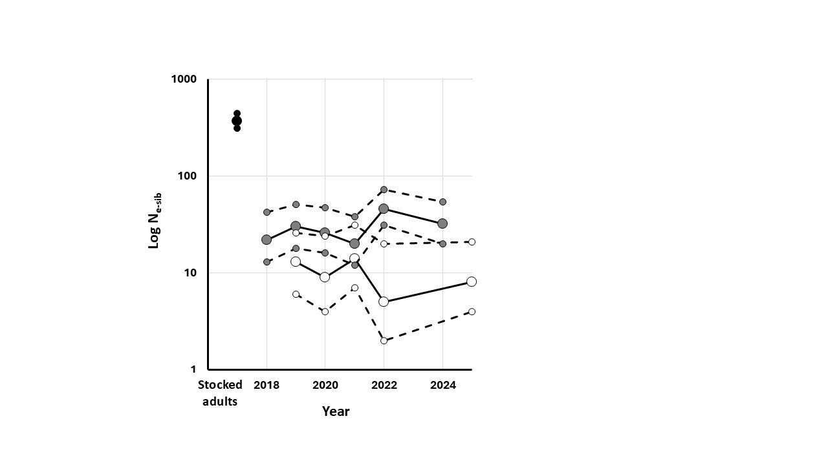
Figure 25.—Change in log N_{e-sib} over time for IP1 samples.
(Annual samples of adults (stocked in 2016), recruits, and larvae are represented by black, gray, and white circles, respectively. CIs are identified by dashed lines and smaller symbol size.)

Parentage Assignment and Reproductive Success.—Parentage assignments for IP1 were completed in COLONY and metrics of reproductive success were calculated based on parentage assignments (table 13), with percentage of offspring assigned to parents provided in figure 22. For recruits, male assignment percentage was generally stable for 2018–2022, ranging from 64 to 97% but was substantially lower in 2024 at 9.8% (no recruits were available for 2023). Assignment percentage of female parents for recruits was generally higherfor this period, ranging from 53 to 88% assignment for 2018-2022 and 7.8% in 2025. Patterns were similar for larvae. For 2019–2022, assignment percentage ranged from 53 to 96% for males and 72 to 100% for females. No larvae were available for 2023 and 2024. As with recruits, parentage assignments were low in 2025 at 0% for females and 2% males.

Initial assignment percentages were lower in IP1 as compared to YCB. Several individuals may have remained in the pond after it was cleared for stocking. These unsampled individuals have likely reproduced, resulting in lower assignment percentage. The decrease in assignment percentage in 2024 for recruits and in 2025 for larvae (no larvae were sampled in 2024) may be explained by reproduction by individuals born in the pond which have not been genotyped or reproduction by fish stocked in 2024 that have not yet been genotyped. Pairwise relatedness was plotted for select groups from IP to further explore these patterns considering parentage results (Figure XX). Recruits from 2024 have similar levels of relatedness to other groups of recruits. It may be this sample was largely produced by ungenotyped individuals in the parent pool, resulting in similar levels of relatedness to other groups but undetectable paternity. Larvae from 2025 have higher intragroup relatedness compared to other progeny and lower levels of relatedness compared to outside groups, which supports the hypothesis that 2024 stocked fish parented these individuals.

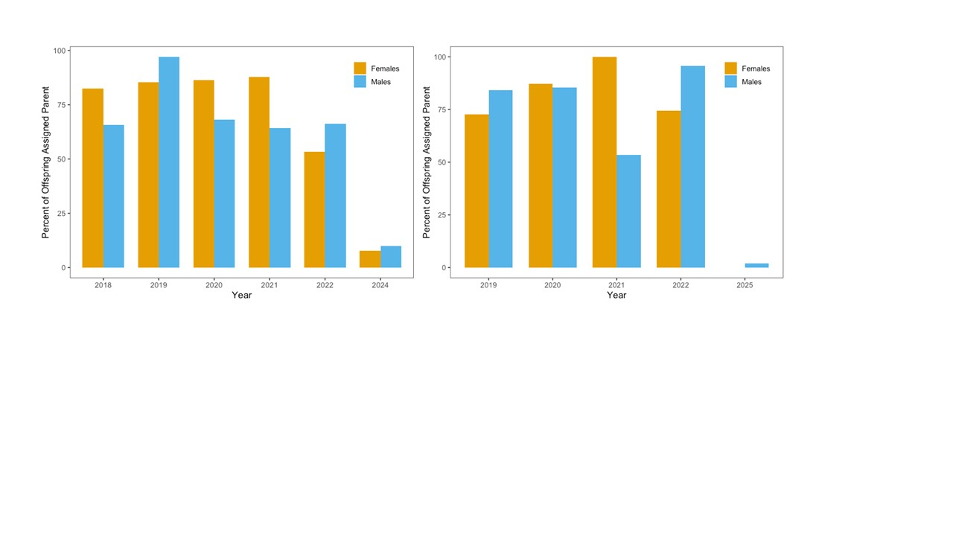
Figure 26.—Percentage of offspring assigned parents in IP1 for 2018–2025.
(Recruits are shown in the left panel and larvae are shown in the right panel.)

Table 13.—Summary of parental contributions to recruits and larvae from IP1
(N is the number of recruits or larvae sampled, variance (VAR), and standard deviation (SD). MIN and MAX are the minimum and maximum number of offspring from reproducing individuals.)
Sample | Year | N | Males |  |  |  |  |  | Females
 |  |  | # reproducing | AVE # progeny | VAR | SD | MIN | MAX | # reproducing | AVE# progeny | VAR | SD | MIN | MAX
Recruits | 2018 | 146 | 26 | 5.3 | 47.6 | 6.9 | 1 | 24 | 32 | 4.3 | 33.3 | 5.8 | 1 | 20
 | 2019 | 35 | 15 | 2.3 | 9.2 | 3.0 | 1 | 13 | 18 | 1.9 | 4.0 | 2.0 | 1 | 9
 | 2020 | 68 | 27 | 2.4 | 5.8 | 2.4 | 1 | 11 | 27 | 2.4 | 13.1 | 3.6 | 1 | 17
 | 2021 | 81 | 25 | 3.2 | 12.1 | 3.5 | 1 | 17 | 29 | 2.8 | 24.7 | 5.0 | 1 | 22
 | 2022 | 62 | 26 | 2.4 | 3.9 | 2.0 | 1 | 9 | 30 | 2.1 | 2.7 | 1.6 | 1 | 7
 | 2024 | 51 | 17 | 3.0 | 5.6 | 2.4 | 1 | 8 | 21 | 2.4 | 2.9 | 1.7 | 1 | 7
Larvae | 2019 | 44 | 17 | 2.6 | 8.1 | 2.9 | 1 | 12 | 11 | 4.0 | 23.2 | 4.8 | 1 | 17
 | 2020 | 172 | 23 | 7.5 | 114.5 | 10.7 | 1 | 44 | 17 | 10.1 | 523.1 | 22.9 | 1 | 97
 | 2021 | 15 | 9 | 1.7 | 1.0 | 1.0 | 1 | 4 | 7 | 2.1 | 4.1 | 2.0 | 1 | 6
 | 2022 | 161 | 15 | 10.7 | 557.6 | 23.6 | 1 | 94 | 12 | 13.4 | 768.4 | 23.6 | 1 | 94
 | 2025 | 52 | 8 | 6.5 | 98.9 | 9.9 | 1 | 29 | 14 | 3.7 | 21.1 | 9.9 | 1 | 18

IP1 Recruits.—COLONY results were used to calculate metrics to assess variance in reproductive success for reproductive adults from IP1 recruits from 2018–2024 (table 13).
The number of males that produced at least one offspring in each year ranged from 15 in 2019 to 27 individuals in 2020, averaging 22.7 per year. The number of progeny per male ranged from 1–24 with an average of 3.1. The number of females contributing offspring ranged from 18 in 2019 to 30 in 2022, with an average of 26 per year. The number of offspring per female ranged from 1 to 22 with an average of 2.7 per individual.

The variance was higher in females than in males and highest in 2018 for both sexes, which results from a small number of individuals producing large numbers of offspring in that year (figure 23); however, overall, a large number of individuals contributed offspring in 2018 (26 males and 32 females).

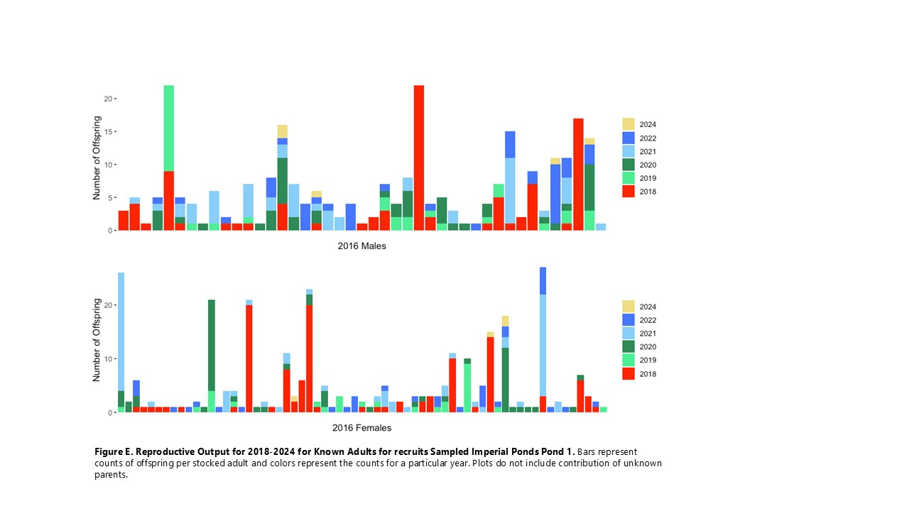
Figure 27.—Reproductive output of known adults for recruits sampled in IP1, 2018–2024.
(Bars represent counts of offspring per stocked adult, and colors represent the counts for a particular year. Plots do not include contributions of unknown parents.)

IP1 Larvae.—Reproductive success of stocked adults and unknown parents was assessed for larvae sampled in IP1 from 2019 to 2025 (table 13). The number of males that produced at least one offspring ranged from 8 in 2025 to 23 in 2020, averaging 14.4 males reproducing per year. The number of offspring per male ranged from 1 to 94 with an average of 6 offspring per male per year. The number of females that produced at least one offspring ranged from 7 in 2021 to 17 in 2020, with an average of 12.2 females reproducing per year. The number of offspring per female ranged from 1 to 97 with an average of 6.7 offspring per female. For both sexes, reproduction was dominated by single individuals in 2020 and 2022 (figure 24) resulting in high variances and standard deviations for those years.

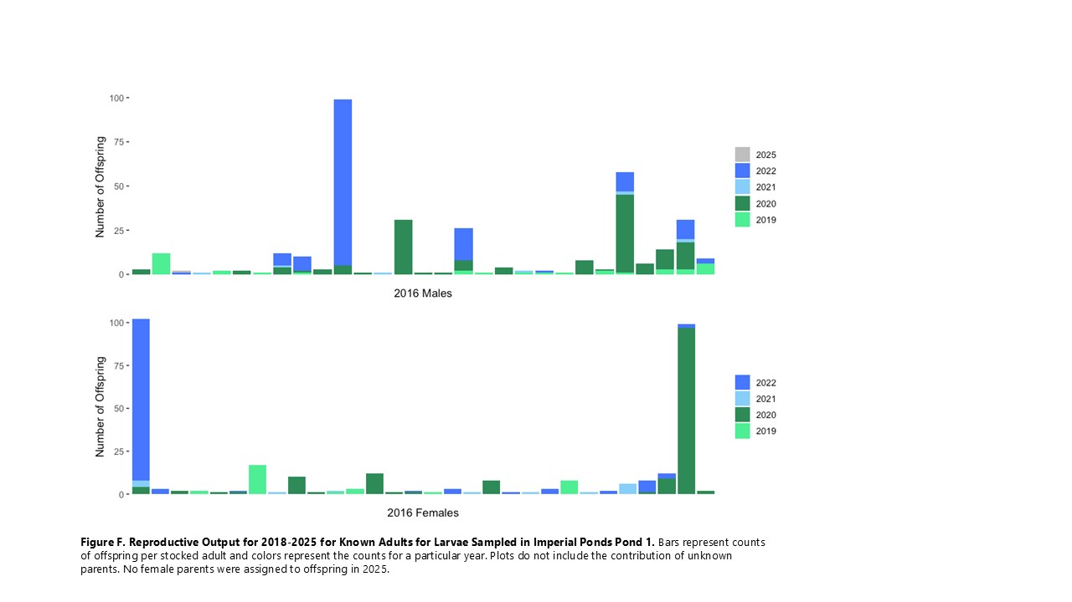
Figure 28.—Reproductive output of known adults for larvae sampled in IP1, 2018–2025.
(Bars represent counts of offspring per stocked adult and colors represent the counts for a particular year. Plots do not include the contribution of unknown parents. No female parents were assigned to offspring in 2025.)

IP1 Summary.—Like YCB, parentage assessment and VRS metrics for IP1 recruits indicate variability in individual contributions from year to year. Additionally, 2016 stocked adults continue to produce offspring into 2025. The distinct decline in assignment percentages in 2024 and 2025 indicated that ungenotyped individuals are active and reproducing in the pond. Larval reproduction is more sporadic than recruits despite similar numbers of sampled offspring. The VRS metrics for larvae are inconsistent with concurrent recruit populations and do not appear to be a good representation of reproduction in IP1. Given the inconsistent nature of larval production in the pond, the low contribution of 2016 stocked adults to 2025 larvae may not be representative. Although only one 2016 male and no females were assigned as parents to 2025 larvae, it is possible that 2016 adults are still reproducing and may be identified in parentage assessment of future recruit populations.

Male marker development
Application of male specific genetic markers.—During the development of the GT-seq panel three male-specific genetic markers (MMs) were identified (Dowling et al. 2020). Each marker identifies a specific fragment of DNA found in males but not females. To assess the accuracy of these markers, DNA from individuals of known sex from two sources were used: 1) parents of progeny from Arizona Juvenile backwater (AJ; N = 64 of each sex), and 2) individuals captured and sexed from Lake Mohave multiple times (N = 135) (Dowling et al. 2020). DNA was amplified for all three MMs and electrophoresis of dye-stained fragments was used to detect the presence or absence of fragments. Genetic sex obtained from the combination of these three markers was consistent with sex determined by reproduction in AJ (90.6% concordant) and sexed individuals captured from Lake Mohave (91.8% concordant). Most conflicting individuals were males without MM fragments, a result also found in other related taxa (Goto-Kazeto et al. 2006). These markers were also successfully used to assess sex of larvae, indicating that these markers have broad applications for questions of interest for RASU populations.

Methods.—Given successful application of these MMs, these loci were added to the GT-seq panel such that genetic sex will be available for every genotyped fish. This requires development of an algorithm that allows for identification of genotypic sex from the number of sequences produced from each of the three MMs. Assignment of sex from GT-seq data for the MMs used binary logistic regression methods, requiring a reference (training) set of samples that could be used to identify the sex of unknown individuals. A set of RASU for which both gel-assigned sex (as described in Dowling et al. 2020) and GT-seq MMs were available was compiled and filtered to develop the sex assignment algorithm for GT-seq markers. Sex identification of individuals from the GT-seq panel was completed using the open-source statistical platform R (v4.5.1, R Core Team, 2025) and Rstudio (v2025.05.0, Posit Software, PBC, 2025). To be considered for the reference sample set, an individual had to have the same gel-assigned sex for all three MMs (male or female) and more than 75% of the 303 GT-seq panel loci scored. Raw SNP reads for all 303 loci and 3 male markers were combined for all individuals that met this criteria, and normalized relative to one another across libraries using the R package DESeq2 (v.1.48.1, Love et al. 2014), The data set was partitioned into a 75% training set and 25% testing set, using R package caret (v.7.0-1, Kuhn 2008). The training set informed the generalized linear model (GLM) using R package stats (v.4.5.1, R Core Team 2025) and the following equation: model <- glm (gel_sex_M ~ MM1 + MM2 + MM3, data=train, family=binomial), where ‘gel_sex_m’ equals 1 for male or 0 for female, and ‘MM1’, ‘MM2’, and ‘MM3’ are the normalized number of SNP reads for the three male markers, respectively. Model assumptions such as linearity, no multicollinearity, and no outliers were tested using the R package car (v.3.1-3, Fox and Weisberg 2019). McFadden’s Pseudo R² was calculated as a goodness-of-fit measure using the package DescTools (v.1.48.1, Signorell 2025).

Using the model and the ‘predict’ function, probabilities of individuals being assigned male were predicted back on the training set, with individuals with probabilities > 90% then classified as male and probabilities <10% classified as female. Individuals with probabilities between 10 and 90% were not assigned to either sex and were removed from the training set. Additionally, any training individuals with mismatches between gel-assigned and model-assigned sex were removed before re-training the model to create an optimized training set of samples. Predicted probabilities of an individual being male were then calculated with the above thresholds for the testing set of samples.

The model developed on the optimized training set was then applied to a larger testing set of 2022 and 2023 stocking cohort samples for which gel-identified sex was known. This larger testing set was filtered with the same criteria as discussed above, and raw SNP reads were combined with and normalized relative to raw SNP reads of the optimized training set. Predicted probabilities of being male were generated, and using the 90/10% threshold, model-assigned sex was called and compared to gel-assigned sex.

Results.—The original gel and SNP data set includes adults and recruits from stocking cohorts, mainstem Colorado River, backwaters, and the SNARRC broodstock, spanning multiple collection years and nine GT-seq libraries generated during this agreement. The initial model was trained with 935 individuals, yielding the demographics provided in tables 14 and 15. From the initial training set, 98 individuals were predicted to have probabilities of being male that were intermediate between the 90/10% thresholds used to assign sex, and 27 individuals were assigned a sex based on this threshold that disagreed with the gel-assigned sex. Removing these 125 unknown and mismatched individuals yielded an optimized training set of 810 individuals that was used to re-train the model (tables 14 and 15).

Table 14.—Breakdown of the gel and GT-seq data set by sample category
(The three scenarios include 1) the full data set before partitioning into training and testing sets, 2) the original partitioned training set, and 3) the optimized training set)
Category | N before partitioning |  | N original training set | N optimized training set
Broodstock 2021 | 105 |  | 77 | 73
IP1 adults 2016 | 86 |  | 62 | 54
Lake Mohave adults 2022–2024 | 8 |  | 6 | 6
SC 2020 | 388 |  | 297 | 239
SC 2021 | 422 |  | 314 | 278
SC 2022 | 48 |  | 40 | 34
YCB recruits 2018-2023 | 189 |  | 139 | 126
Total | 1,246 | 935 |  |  | 810

Table 15.—Proportions of gel-assigned sexes
(The three scenarios include 1) the full data set before partitioning into training and testing sets, 2) the original partitioned training set, and 3) the optimized training set)
Gel-assigned sex | N before partitioning | N original training set | N optimized training set
Male | 553 | 425 | 342
Female | 693 | 510 | 468
Total | 1,246 | 935 | 810

The model developed using the initial training set had highly significant coefficients for the intercept, MM1 and MM3 (table 16), indicating that an increase in log odds of being male for MM1 and MM3 reads are significantly better than what would be expected by the null model; the McFadden’s Pseudo R² suggests 71.8% of variation in the data is explained by the model. Following optimization, estimates for all three male markers and the y-intercept were insignificant, and McFadden’s Pseudo R² was 1 (table 17). The differences between models likely reflect incorrect predictions in the original data set and removal of unidentified individuals from the original training data set. The optimized model had lower null and residual deviances and lower AIC (Akaike information criterion), indicating a better model fit and high predictive power given the high R² and significant y-intercept.

Table 16.—Logistic regression model parameters using the glm function in R package stats
(The model used optimized training set as input. *** identifies significant factors. The standard error (SE) and statistical probability (PR) are also provided)
Coefficients | Estimate | SE | z value | PR (>|z|)
Intercept*** | -2.68053 | 0.171827 | -15.6 | < 2e-16
MM1*** | 0.30291 | 0.035851 | 8.449 | < 2e-16
MM3*** | 0.13232 | 0.024023 | 5.508 | 3.63e-08
MM2 | -0.00115 | 0.000691 | -1.669 | 0.0951
Null deviance | 1288.45, 934 degrees of freedom
Residual deviance | 362.97, 931 degrees of freedom
AIC | 370.97
Number of Fisher Scoring Iterations | 10
McFadden's Pseudo R² | 0.718286

Table 17.—Logistic regression model parameters produced by glm function in R package stats
(The model used optimized training set as input. The standard error (SE) and statistical probability (PR) are also provided.)
Coefficients | Estimate | SE |  | z value |  | PR (>|z|)
Intercept | -24.99383 |  | 4590.4347 |  | -0.005 |  | 0.996
MM1 | 2.88277 |  | 1045.3817 |  | 0.003 |  | 0.998
MM3 | 1.09429 |  | 345.84613 |  | 0.003 |  | 0.997
MM2 | -0.01196 |  | 8.94179 |  | -0.001 |  | 0.999
Null deviance | 1.1032e+03, 809 degrees of freedom
Residual deviance | 9.1003e-08, 806 degrees of freedom
AIC | 8
Number of Fisher Scoring Iterations | 25
McFadden's Pseudo R² | 1
The regular and optimized training sets were both used to identify GT-seq-based sex on a testing set of 311 individuals. The optimized training set produced more accurate model-based sex predictions for the testing set, when compared to those made with the original training set (92.6% correct overall vs. 88.1% correct overall, table 18). Using the optimized training set, the model-assigned GT-seq sex matched gel-assigned sex for 112 of the 128 gel-identified males (87.5% accuracy) and 176 of the 183 gel-identified females (96.2% accuracy) in the testing set. There were fewer testing individuals that had intermediate probabilities and were not assigned a sex by the 90/10% threshold for the optimized set (N = 8) than the initial set (N = 27); most of these were gel-identified males (table 19).

Table 18.—Percentage of testing individuals where model-assigned sex agreed with gel-assigned sex using the original and the optimized training sets
(The 90/10% threshold was applied. The standard error (SE) and statistical probability (PR) are also provided. Information for individuals not assigned a sex is found in column NS)
Gel-assigned sex | Original training set predictions |  |  | Optimized training set predictions
 | % Correct | % Incorrect | % NS | % Correct | % Incorrect | % NS
Female | 93.4 | 2.2 | 4.4 | 96.2 | 2.7 | 1.1
Male | 80.5 | 4.7 | 14.8 | 87.5 | 7.8 | 4.7
Total | 88.1 | 3.2 | 8.7 | 92.6 | 4.8 | 2.6

Table 19.—Comparison of gel-assigned sex and model-assigned sex for the testing set, using the original and optimized training sets (N = 935 and 810, respectively)
(Individuals not assigned a sex (NS).)
Gel-assigned sex | Original training set |  |  |  | Optimized training set
 | Female | Male | NS | Total | Female | Male | NS | Total
Female | 171 | 4 | 8 | 183 | 176 | 5 | 2 | 183
Male | 6 | 103 | 19 | 128 | 10 | 112 | 6 | 128
Total | 177 | 107 | 27 | 311 | 186 | 117 | 8 | 311

When the optimized training set of 810 individuals was normalized along with the testing set of 686 SC individuals from 2022 and 2023, the model parameters for the logistic regression model changed only slightly, with a notable difference being lower coefficient estimates and standard deviations for the three male marker predictor variables, and a highly significant intercept, consistent with high predictive power of the model (table 20). The model correctly predicted 80.1% of the gel-males, with 6.0% incorrectly predicted as females and 13.9% not classified due to a predicted probability between the 10/90% thresholds (table 21). For gel-identified females, 98.3%were predicted correctly, with only 1.2% incorrectly predicted as males, and 0.5% not classified due to intermediate probability. Overall, the model correctly predicted the gel-assigned sex of 90.8% of the individuals.

Table 20.—Logistic regression model parameters produced by glm function in R package stats, when model used optimized training set (normalized with the larger SC testing set) as input
(The standard error (SE) and statistical probability (PR) are also provided.)
Coefficients | Estimate | SE | z value | PR (>|z|)
Intercept*** | -6.26 | 1.01 | -6.18 | 6.32e-10
MM1 | 0.73 | 0.999368 | 0.727 | 0.467
MM3 | 0.33 | 0.671721 | 0.497 | 0.619
MM2 | -0.003 | 0.005 | -0.65 | 0.513
Null deviance | 1103.2 on 809 degrees of freedom
Residual deviance | 14.6 on 806 degrees of freedom
AIC | 22.564
Number of Fisher Scoring Iterations | 16
McFadden's Pseudo R² | 0.99

Table 21.—Percentage of testing individuals from larger testing set (SC 2022 and SC 2023 individuals), where model-assigned sex agreed with gel-assigned sex using the optimized training set
(Individuals not assigned a sex (NS))
Gel-assigned sex | Correct predictions |  | Incorrect predictions |  | NS
 | N | % | N | % | N | %
Female | 398 | 98.3 | 5 | 1.2 | 2 | 0.5
Male | 225 | 80.1 | 17 | 6.0 | 39 | 13.9
Total | 623 | 90.8 | 22 | 3.2 | 41 | 6.0

Conclusions.—The classification results from our optimized model show that RASU sex can be predicted with high accuracy (90.8–92.6%, tables 21 and 18, respectively) using the male markers in the GT-seq panel relative to gel-scored sex identifications. Because gels match field-identified sex at a similar rate (90.6–91.8%) as reported in Dowling et al. (2020), our results (gels vs. GT-seq data) represent a reduction in predictive efficiency relative to phenotype. Most of the individuals misidentified by our model were males (6.0–7.8%, tables 21 and 18, respectively, with very few gel-identified females misidentified as males by our model (1.2–2.7%, tables 21 and 18, respectively).

With continued optimization, we hope to achieve greater accuracy as demonstrated in other studies. McKinney et al. (2020) discovered three SNP markers for Chinook salmon (Oncorhynchus tshawytscha) that varied between 78 and 91% accuracy. Trenkel et al. (2020) correctly assigned sex to 96% of the 1,680 thornback rays (Raja clavata) tested, using 19 sex-linked SNP loci and calculation of heterozygote excess. Blåhed et al. (2018) tested four SNP markers to identify the sex of moose (Alces alces), with all 28 males and 29 out of the 31 females correctly determined. It should be noted that in the RAD library used to generate SNPs for monitoring of RASU, sex-specific SNP markers were not found, with only the three MM loci allowing for differentiation of the sexes – present in most adult male RASU, absent in adult female RASU (Dowling et al. 2020). Stovall et al. (2018) used presence/absence markers like those in RASU, and their use GT-seq data for calling sex of New Zealand fur seals (Arctocephalus forsteri) yielded 98% accuracy for the 94 females and 95.9% accuracy for the 72 males studied.

There are several factors that could be complicating sex assignment of RASU – amplification failure (Blåhed et al. 2018), low association between sex markers and sex determining genes (McKinney et al. 2020), and environmental sex determination (e.g., water temperature, Goto-Kazeto et al. 2006; exposure to wastewater treatment effluent, Vadja et al. 2011). While geographic differences in marker utility have been noted in some studies (Von Bargen et al. 2015), our model proved useful for individuals from various backwater and riverine populations of the lower Colorado River. We will continue to explore ways to improve the training set relative to sample quality, which may include examining the effect of individual libraries, enhancing the number of MM reads, and developing better data filters. The refined algorithm can then be applied to every RASU genotyped with the SNP panel that includes MM reads – probability of being male can be predicted, and sex confidently assigned, even if male marker PCR and gels have not been run.

Database Development

Status of Milestones, Activities, and Tasks
The following are from page 12 of the Agreement and include activities of both Reclamation and Marsh & Associates (M&A):

- Remote passive integrated transponder (PIT) scanning Yuma Cove Backwater – Completed by Reclamation as proposed
- Remote PIT scanning Imperial Ponds – Completed by Reclamation as proposed
- Remote PIT scanning Reach 2 (Lake Mohave) – Completed by M&A and Reclamation as proposed
- Remote PIT scanning data uploads – Completed by M&A and Reclamation as proposed
- Database table structure development – Completed as proposed

Online Interface and Database Structure
Development of the database and online interface for genetic specimens (i.e., larvae and fin clips) has been completed. The database schema was finalized, and all documentation including collection protocols, a descriptive dictionary of the database, and data entry manuals have been completed and are available through the database’s online interface (https://www.lcrgenetics.net/). The completed online interface includes forms and processes for specimen and genetic data entry and download as well as summary reports for fin clip specimens including the availability of genetic data (SNP) and can be filtered by individual collection events (EventID) (figure 25). All Lots associated with a selected event are summarized with the following fields – LotID, LotDate, SampleType, EventID, CollectionAgency, Species. Calculated fields displayed in the reports include – Specimens count, NFWG count (specimen records that can be cross-referenced with the NFWG database), SNPs count, and SexMarker count (see below for explanation of SNPS and SexMarker). Larval/Juvenile summary reports also have an event filter. All Lots associated with the selected event are summarized with the following fields – LotID, LotDate, SampleType, EventID, CollectionAgency, Species. The remaining fields displayed are the counts including – SNPs count, and SexMarker count.

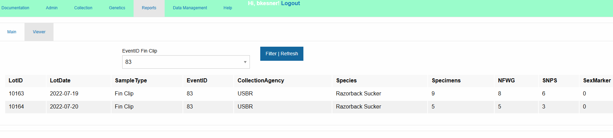
Figure 29.—An example summary report of fin clip samples from the LCR genetics database online interface.

The process for uploading specimen SNP data was finalized for RASU in fiscal year (FY) 2024 and for BONY in FY2025. SNP data for RASU and BONY specimens collected under this agreement have been coded with the current LotID-SpecimenID format, and data uploads can be conducted by individual lot files or multi-lot files (figure 26). Programmed quality checks of uploaded SNP data are conducted before writing to any database tables, and all upload attempts are logged into a separate table. The user will be notified of any errors to correct before attempting to upload again. A step-by-step instruction manual is available as a pdf on the documentation page of the online interface (https://www.lcrgenetics.net/ ).

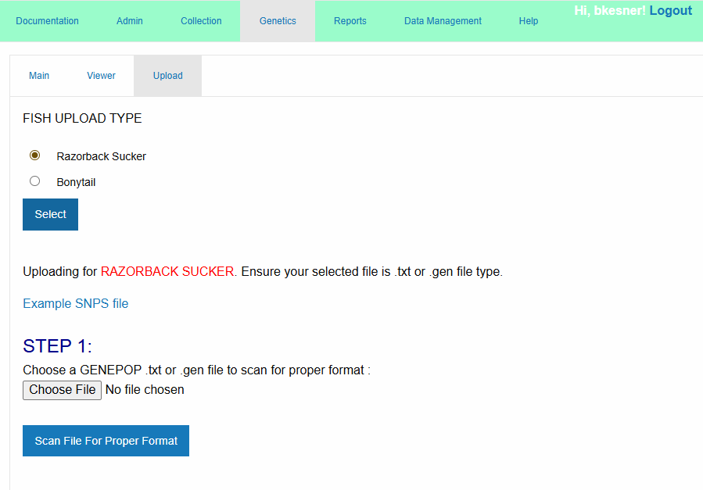
Figure 30.—Upload form for SNP data from the LCR genetics database online interface.
A data upload process for RASU male-specific sex markers (see section above) was developed and tested in FY2024 (figure 27). This process uploads .csv records of RASU sex markers, three in total, and a genetic sex determination which summarizes the sex marker data for each RASU. Each sex marker was coded in the database as “M” when present and “F” when absent. For the summary field, the presence of all three sex markers was indicative of a male, and the absence of all three sex markers was indicative of a female. Any other combination of sex markers was considered unknown, coded as a “U.” As of July 31, 2025, a total of 165 genetic sex records for RASU have been uploaded.

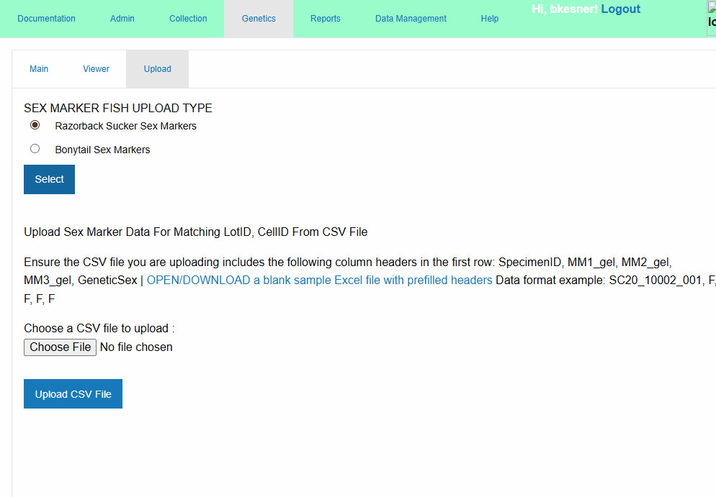
Figure 31.—Upload form for sex marker data from the LCR genetics database online interface.

RStudio projects have been developed for data management and reporting and are maintained as private repositories on GitHub. Access is available upon request. Currently, the data management project is used to investigate specimen records without linked collection records in the database. The reporting project provides summary statistics, and an export script to produce “Genepop” files for statistical analysis. As of August 10, 2025, the database contains a total of 13,251 fin clip sample records: 9,127 RASU (table 22) and 4,120 BONY (table 23). A total of 5,282 SNP genetic records has been uploaded and matched to fin clip samples and their associated PIT tag (4,200 RASU and 1,082 BONY). In addition to adult fin clip samples, 1,538 SNP genetic records for larval RASU have been uploaded (table 24). Weekly MySQL database and application backups were completed on schedule.

Table 22.—RASU fin clip records in the LCR genetics database with specimen records (Samples) and genetic data (SNPs)
Year | Location | Project | Samples | SNPs
2020 | Lake Mohave (Reach 2) | Mainstem Population Monitoring | 180 | 0
2021 | Achii Hanyo | Mainstem Stocking Cohorts | 200 | 181
2021 | Bubbling Ponds | Mainstem Stocking Cohorts | 196 | 171
2021 | Lake Mead Hatchery | Mainstem Stocking Cohorts | 400 | 267
2021 | Lake Mohave (Reach 2) | Mainstem Population Monitoring | 90 | 46
2021 | SNARRC | Broodstock Monitoring | 689 | 677
2021 | Willow Beach NFH | Mainstem Stocking Cohorts | 100 | 90
2022 | Achii Hanyo | Mainstem Stocking Cohorts | 100 | 97
2022 | Imperial Ponds | Backwater Population Monitoring | 90 | 0
2022 | Lake Havasu (Reach 3) | Mainstem Population Monitoring | 299 | 130
2022 | Lake Mead (Reach 1) | Mainstem Population Monitoring | 33 | 33
2022 | Lake Mead Hatchery | Mainstem Stocking Cohorts | 400 | 283
2022 | Lake Mohave (Reach 2) | Mainstem Population Monitoring | 194 | 95
2022 | SNARRC | Broodstock Monitoring | 624 | 596
2022 | Willow Beach NFH | Mainstem Stocking Cohorts | 200 | 164
2022 | Yuma Cove Backwater | Backwater Population Monitoring | 270 | 0
2023 | Achii Hanyo | Mainstem Stocking Cohorts | 400 | 379
2023 | Imperial Ponds | Backwater Population Monitoring | 68 | 68
2023 | Lake Havasu (Reach 3) | Mainstem Population Monitoring | 115 | 110
2023 | Lake Mead (Reach 1) | Mainstem Population Monitoring | 40 | 36
2023 | Lake Mohave (Reach 2) | Mainstem Population Monitoring | 282 | 98
2023 | Lake Mohave Backwaters | Mainstem Stocking Cohorts | 16 | 5
2023 | Willow Beach NFH | Mainstem Stocking Cohorts | 100 | 94
2023 | Yuma Cove Backwater | Backwater Population Monitoring | 304 | 291
2024 | Achii Hanyo | Mainstem Stocking Cohorts | 300 | 0
2024 | Imperial Ponds | Backwater Population Monitoring | 55 | 0
2024 | Lake Havasu (Reach 3) | Mainstem Population Monitoring | 212 | 42
2024 | Lake Mead (Reach 1) | Mainstem Population Monitoring | 53 | 38
2024 | Lake Mohave (Reach 2) | Mainstem Population Monitoring | 260 | 53
2024 | Lake Mohave Backwaters | Mainstem Stocking Cohorts | 99 | 0
2024 | Willow Beach NFH | Mainstem Stocking Cohorts | 233 | 0
2024 | Yuma Cove Backwater | Backwater Population Monitoring | 273 | 156
2025 | Achii Hanyo | Backwater Stocking Cohorts | 1,100 | 0
2025 | Achii Hanyo | Mainstem Stocking Cohorts | 300 | 0
2025 | Imperial Ponds | Backwater Population Monitoring | 52 | 0
2025 | Lake Havasu (Reach 3) | Mainstem Population Monitoring | 157 | 0
2025 | Lake Mead (Reach 1) | Mainstem Population Monitoring | 53 | 0
2025 | Lake Mohave (Reach 2) | Mainstem Population Monitoring | 144 | 0
2025 | Lake Mohave Backwaters | ? | 9 | 0
2025 | Willow Beach NFH | Mainstem Stocking Cohorts | 100 | 0
2025 | Yuma Cove Backwater | Backwater Population Monitoring | 337 | 0
Totals |  |  | 9,127 | 4,200

Table 23.—BONY fin clip records in the LCR genetics database with specimen records (Samples) and genetic data (SNPs)
Year | Location | Project | Samples | SNPs
2021 | Imperial Ponds | Backwater Population Monitoring | 74 | 23
2021 | SNARRC | Broodstock Monitoring | 1,504 | 0
2022 | Imperial Ponds | Backwater Population Monitoring | 212 | 206
2022 | SNARRC | Backwater Stocking Cohorts | 300 | 300
2022 | SNARRC | Broodstock Monitoring | 566 | 0
2023 | Achii Hanyo | Mainstem Stocking Cohorts | 100 | 0
2023 | Imperial Ponds | Backwater Population Monitoring | 94 | 96
2023 | Lake Havasu (Reach 3) | Mainstem Population Monitoring | 3 | 0
2023 | Reach 4 (Parker to Cibola) | Mainstem Population Monitoring | 159 | 157
2023 | SNARRC | Backwater Stocking Cohorts | 300 | 300
2024 | Imperial Ponds | Backwater Population Monitoring | 368 | 0
2025 | Imperial Ponds | Backwater Population Monitoring | 440 | 0
Totals |  |  | 4,120 | 1,082

Table 24.—RASU larval genetic records with genetic data (SNPS) in the LCR genetics database
Year | Location | Project | SNPs
2022 | Imperial Ponds | Backwater Population Monitoring | 161
2022 | Lake Havasu (Reach 3) | Mainstem Population Monitoring | 128
2022 | Lake Mead (Reach 1) | Mainstem Population Monitoring | 92
2022 | Lake Mohave (Reach 2) | Mainstem Population Monitoring | 138
2023 | Lake Havasu (Reach 3) | Mainstem Population Monitoring | 120
2023 | Lake Mead (Reach 1) | Mainstem Population Monitoring | 112
2023 | Lake Mohave (Reach 2) | Mainstem Population Monitoring | 123
2023 | Yuma Cove Backwater | Backwater Population Monitoring | 269
2024 | Lake Havasu (Reach 3) | Mainstem Population Monitoring | 125
2024 | Lake Mead (Reach 1) | Mainstem Population Monitoring | 125
2024 | Lake Mohave (Reach 2) | Mainstem Population Monitoring | 98
2024 | Lake Mohave Backwaters | ? | 47
Totals |  |  | 1,538

RASU and BONY Tissue Archive

Status of Project Milestones, Activities and Tasks
- Archival system development – completed as proposed.
- Database table structure integrated with M&A and LCR MSCP – Completed as proposed.
- Fin clip samples affixed to gridded Whatman filter paper – Completed as proposed. Details of material received for the project are in table 24. Tissues distributed for analysis are in tables 26 and 27.
- Tissue samples cataloged and barcoded – Cataloging and barcoding procedures are finalized, fully implemented, and completed as proposed.
- Data back-up – Tissue archive data are entered into the database and backed up as proposed. Sample collection information is available online at https://arctosdb.org.

Tissue Archive and Museum of Southwestern Biology (MSB) Database Integration
The tissue archive for this project is based on a Whatman filter paper system designed to preserve and store fin clip tissues obtained from adult RASU and BONY. Affixing fin clip tissues to pre-printed Whatman sheets was a recurring task during project performance and grew the tissue archive by more than 20,000 samples. Tissues collected at hatcheries or grow-out facilities were adhered to the Whatman sheets using the fish’s natural mucus as an adhesive and air-dried on site. Tissues collected in the field by project partners were preserved as fin clips or whole larvae in 95% ethanol, or as fin clips affixed to pre-printed Whatman sheets as described above. When tissues were received at the MSB in ethanol, they were removed from the fixative, air-dried, and affixed to Whatman sheets with a non-reactive adhesive and cover slip. MSB personnel used a similar procedure on ethanol-preserved fin clip tissues that were formerly held in freezers or on shelves in the Dowling and Turner laboratories. That system now is implemented fully as a standard protocol for archiving historical tissues. The result is an economical, retrievable, and storage-efficient system for accurately archiving many thousands of samples.

To facilitate sample collection by partners, MSB created a pre-printed Whatman sheet template in collaboration with Reclamation and other project partners, including M&A and the LCR MSCP. Custom templates also were created for SNARRC to curate samples from BONY and RASU broodstocks. Whatman sheets were printed and shipped to agencies, filled, and returned to the MSB for tissue archiving. Over the performance period, the MSB tested and refined the archival processes to achieve maximal utility to the project and future applications.

Completed Whatman sheets, fin clips, and larval samples were accessioned into the MSB after receipt from the lead agency (e.g., figure 28). Completed Whatman sheets and associated information were entered in the MSB database and assigned an MSB catalog number. When all Whatman sheets were verified and given MSB identification, each sheet was vacuum sealed and stored in a temperature-controlled collections room. Samples preserved in 95% ethanol were dried and adhered to corresponding Whatman sheets with MSB identification, a glass cover slip was affixed with Scotch tape (figure 29), and then the entire sheet was vacuum sealed for long-term storage. All associated information with samples received was entered into the MSB database. Table 25 shows samples received from cooperators (e.g., Reclamation, USFWS) during the project performance period from FY2021 to FY2025.

A vial-jar system was used to archive fish larvae not used for genotyping (figure 30). Hundreds to a thousand fish larvae that range in size between 8 and 15 mm in total length can be maintained in individual borosilicate (nonreactive) glass vials (8 dram ≈ 1 fluid ounce ≈ 30 milliliters). Vials are closed with a tight-fitting cotton ball and stored in 3-liter Le Parfait jars filled with 95% ethanol, in a vial-jar curation system. Data from vial jars with larvae are curated similarly to fin clips preserved on Whatman sheets. To date, there are more than 3,600 larval fish specimens that were not used for genotyping in this project but are stored in the collection for future scientific use.

MSB Curation, Archive, and Sample Distribution Activities for FY2025
For the last year of this project (FY2025), the MSB focused on curating and archiving materials received from partner agencies, entering associated data into the MSB Catalog and Arctos Collaborative Collections database (https://arctosdb.org), and transferring data to the LCR MSCP Genetics Database currently maintained by M&A.

Over the course of the project, samples were distributed for genotyping. Tables 26 and 27 show samples sent from the MSB to the Dowling and Turner laboratories, respectively, from FY2021 to FY2025. Procedures and protocols developed in this project will continue for the foreseeable future, including the barcoding system implemented for rapid and accurate sample location.

Table 25.—Summary of tissues (fin clips) received and incorporated into MSB collections during FY2021 to FY2025
(Accession number (ACC) refers to the project and source of fin and larvae samples. Lots refer to collections of fin clips from the same sampling event or group. The term ‘individuals’ refers to the number of distinct fin clips and larvae received. FMS = Flannelmouth Sucker.)
Accessioned Materials | Lots FY2021 |  |  |  | Individuals FY2021
 | FMS | RASU | BONY | Total | FMS | RASU | BONY | Total
ACC2021-VIII:4 SNARRC RASU/BONY Broodstock Genetic Samples | 0 | 9 | 0 | 9 | 0 | 896 | 0 | 896
ACC2021-VIII:5 Dowling Lab Legacy Genetic Samples | 0 | 15 | 1 | 16 | 0 | 126 | 23 | 149
ACC2021-VIII:19 RASU/BONY Genetic Monitoring | 0 | 1 | 1 | 2 | 0 | 689 | 1,504 | 2,193
Accessioned Materials | Lots FY2022 |  |  |  | Individuals FY2022
 | FMS | RASU | BONY | Total | FMS | RASU | BONY | Total
ACC2021-VIII:4 SNARRC RASU/BONY Broodstock Genetic Samples | 0 | 1 | 2 | 3 | 0 | 624 | 866 | 1,490
ACC2021-VIII:5 Dowling Lab Legacy Genetic Samples | 0 | 0 | 0 | 0 | 0 | 0 | 0 | 0
ACC2021-VIII:19 RASU/BONY Genetic Monitoring | 0 | 130 | 3 | 133 | 0 | 3,141 | 212 | 3,353
Accessioned Materials | Lots FY2023 |  |  |  | Individuals FY2023
 | FMS | RASU | BONY | Total | FMS | RASU | BONY | Total
ACC2021-VIII:4 SNARRC RASU/BONY Broodstock Genetic Samples | 0 | 0 | 1 | 1 | 0 | 0 | 300 | 300
ACC2021-VIII:5 Dowling Lab Legacy Genetic Samples | 0 | 0 | 0 | 0 | 0 | 0 | 0 | 0
ACC2021-VIII:19 RASU/BONY Genetic Monitoring | 0 | 119 | 5 | 124 | 0 | 2,907 | 358 | 3,265
Accessioned Materials | Lots FY2024 |  |  |  | Individuals FY2024
 | FMS | RASU | BONY | Total | FMS | RASU | BONY | Total
ACC2021-VIII:4 SNARRC RASU/BONY Broodstock Genetic Samples | 0 | 0 | 0 | 0 | 0 | 0 | 0 | 0
ACC2021-VIII:5 Dowling Lab Legacy Genetic Samples | 0 | 0 | 0 | 0 | 0 | 0 | 0 | 0
ACC2021-VIII:19 RASU/BONY Genetic Monitoring | 2 | 91 | 6 | 99 | 4 | 3,274 | 773 | 4,051
Accessioned Materials | Lots FY2025 |  |  |  | Individuals FY2025
 | FMS | RASU | BONY | Total | FMS | RASU | BONY | Total
ACC2021-VIII:4 SNARRC RASU/BONY Broodstock Genetic Samples | 0 | 0 | 0 | 0 | 0 | 0 | 0 | 0
ACC2021-VIII:5 Dowling Lab Legacy Genetic Samples | 0 | 1 | 0 | 1 | 0 | 180 | 0 | 180
ACC2021-VIII:19 RASU/BONY Genetic Monitoring | 0 | 86 | 7 | 93 | 0 | 4,035 | 2,025 | 6,060
Grand total |  |  |  | 481 |  |  |  | 21,937

Table 26.—Number of RASU tissues (fin clips and larvae) sent from MSB to the Dowling laboratory during FY2022 to FY2025
Source | FY2022 | FY2023 | FY2024 | FY2025 | Total
Reach 1/Lake Mead
larvae | 103 | 132 | 132 | 50 | 417
adults | 33 | 40 | 41 |  | 114
Reach 2/Lake Mohave
larvae | 132 | 132 | 142 | 132 | 538
adults | 132 | 132 | 124 | 72 | 460
Reach 3/Lake Havasu
larvae | 132 | 132 | 132 | 89 | 485
adults | 132 | 115 | 120 |  | 367
Reach 5/Imperial Pond
larvae | 163 | 18 | 156 | 52 | 389
adults | 90 | 68 |  | 51 | 209
YCB
larvae | 0 | 275 | 275 | 275 | 825
adults | 165 | 165 | 304 | 165 | 799
SCs
adults | 1,596 | 500 | 555 | 1,320 | 3,971
SNARRC Broodstock
adults | 1,314 |  |  |  | 1,314
Grand total |  |  |  |  |  | 9,888

Table 27.—Number of BONY tissues (fin clips) sent from MSB to the Turner laboratory during FY2021 to FY2025
Source | FY2021 | FY2022 | FY2023 | FY2024 | FY2025 | Total
Reach 3 |  |  |  | 107 |  | 107
Reach 4 |  |  | 354 |  |  | 354
Reach 5 | 79 | 142 |  | 995 | 51 | 1,267
SC |  |  |  | 100 |  | 100
SNARRC Broodstock |  |  | 600 | 2,070 |  | 2,670
Grand total |  |  |  |  |  | 4,498

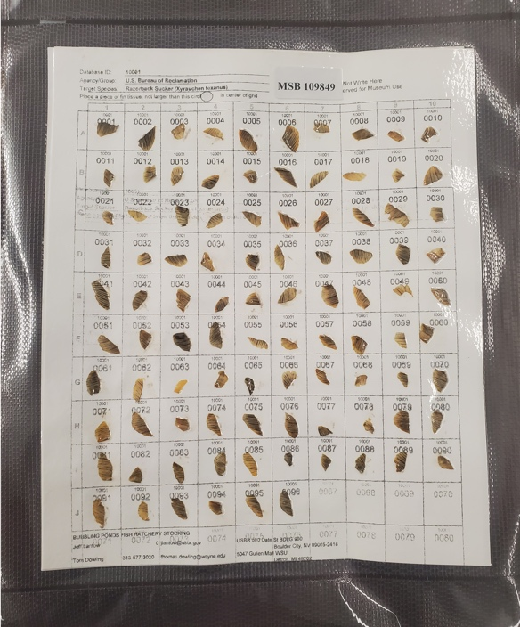
Figure 32.—Whatman filter paper with fin clips from Reclamation.
(Fin clips were adhered using the fishes’ mucus and dried. Each sheet received by the MSB is cataloged, processed, and stored in vacuum sealed bags.)

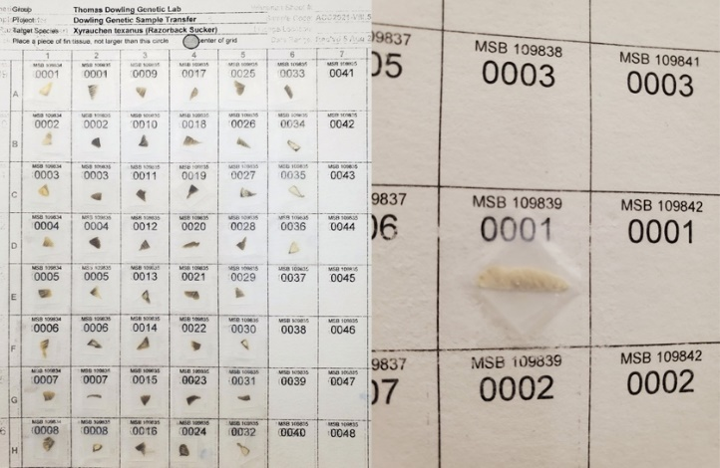
Figure 33.—Whatman filter paper with legacy fin clips from the Dowling laboratory.
(Fin clips preserved in 95% ethanol were dried and adhered to Whatman sheets with non-reactive adhesive. A glass cover slip was affixed with Scotch tape to ensure sample placement. Each sheet with legacy samples was cataloged, processed, and stored in vacuum sealed bags as above.)

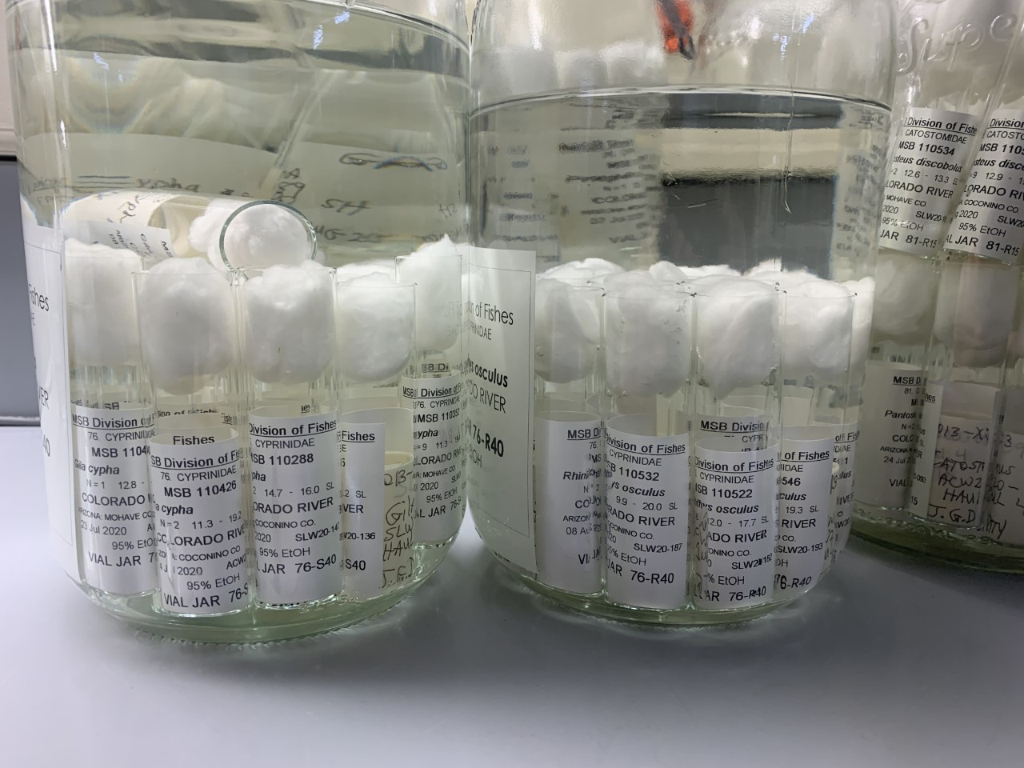
Figure 34.—Vial-jar system for storing larval fishes associated with the project.
(Each borosilicate glass vial is 8 dram (≈1 fluid ounce, ≈30 milliliter), and these are nested within 3-Liter Le Parfait bailtop jars. Vials and jars are filled with 95% ethanol to preserve DNA. Le Parfait jars are stored in the general collections area for MSB Fishes.)

Literature Cited
Allendorf, F. W. 1986. Genetic drift and the loss of alleles versus heterozygosity. Zoobiology 5:181-190.
Anderson, E. C. 2024. CKMRsim. https://github.com/eriqande/CKMRsim/
Belmar-Lucero, S., J. L. A. Wood, S. Scott, A. B. Harbicht, J.A. Hutchings, D. J. Fraser. 2012. Concurrent habitat and life history influences on effective/census population ratios in stream-dwelling trout. Ecology and Evolution 2: 562-573.
Bernos, T. A. and D. J. Fraser. 2016. Spatiotemporal relationship between adult census size and genetic population size across a wide population size gradient. Molecular Ecology 25: 4472-4487.
Bestgen, K.R., T.E. Dowling, B. Albrecht, and K.A. Zelasko. 2021. Large-river fish conservation in the Colorado River basin: progress and challenges with endangered razorback sucker. In: Standing between life and extinction: Ethics and ecology of conserving aquatic species in the American Southwest. Editors, D. Propst, J. Williams, K. Bestgen, and C. Hoagstrom. University of Chicago Press.
Blåhed, I.-M., H. Königsson, G. Ericsson, and G Spong. 2018. Discovery of SNPs for individual identification by reduced representation sequencing of moose (Alces alces). PLoS ONE 13: e0197364.
Bolger, A.M., M. Lohse, and B. Usadel. 2014. Trimmomatic: A flexible trimmer for Illumina Sequence Data. Bioinformatics btu170.
Bootsma, M. L., K. M. Gruenthal, G. J McKinney, L. Simmons, L. Miller, G. Sass, and W. A. Larson. 2020. A GT‐seq panel for walleye (Sander vitreus) provides important insights for efficient development and implementation of amplicon panels in non‐model organisms. Molecular Ecology Resources 20:1706-1722.
Bullard, M., E. L. Best, and J. Hammen. 2022. Native Fish Monitoring in Reach 3 of the Lower Colorado River, 2020 Annual Report. Submitted to the Lower Colorado River Multi-Species Conservation Program, Bureau of Reclamation, Boulder City, Nevada, by the Bureau of Reclamation, Technical Service Center, Fisheries and Wildlife Group, Denver, Colorado.
Bravington, M. V., P. M. Grewe, and C. R. Davies. 2016. Absolute abundance of southern bluefin tuna estimated by close-kin mark-recapture. Nature Communications 7:13162.
Camacho, C., G. Coulouris, V. Avagyan, N. Ma, J. Papadopoulos, and K. Bealer. 2009. BLAST plus: architecture and applications. BMC Bioinformatics BioMed. Cent. 10:1.
Campbell, N.R., S.A. Harmon, and S.R. Narum. 2015. Genotyping-in-Thousands by sequencing (GT-seq): A cost effective SNP genotyping method based on custom amplicon sequencing. Molecular Ecology Resources 15:855-867.
Carson, E. W., T. F. Turner, M. J. Saltzgiver, D. Adams, B. R. Kesner, P. C. Marsh, T. J. Pilger, and T. E. Dowling. 2016. Retention of ancestral genetic variation across life-stages of an endangered, long-lived iteroparous fish. Journal of Heredity 107:567-572.
Chang, S.L., Ward, H.G. and Russello, M.A., 2021. Genotyping-in-Thousands by sequencing panel development and application to inform kokanee salmon (Oncorhynchus nerka) fisheries management at multiple scales. PLoS One, 16(12):p.e0261966.
Coulon A. 2010. Genhet: an easy‐to‐use R function to estimate individual heterozygosity. Molecular Ecology Resources, 10(1), 167-169.
Danecek, P.,A. Auton, G. Abecasis, C.A. Albers, E. Banks, M.A. DePristo, R.E. Handsaker, G. Lunter, G.T. Marth, S.T. Sherry, G. McVean, and R. Durbin. 2011. The variant call format and VCFtools. Bioinformatics 27:2156–2158.
Denney, N.H., Jennings, S. and J. D. Reynolds. 2002. Life–history correlates of maximum population growth rates in marine fishes. Proceedings of the Royal Society of London. Series B: Biological Sciences 269:2229-2237.
Do, C., R.S. Waples, D. Peel, G.M. Macbeth, B.J. Tillett, and J.R. Ovenden. 2014. NEESTIMATOR v2: re-implementation of software for the estimation of contemporary effective population size (N_{e}) from genetic data. Molecular Ecology Resources 14:209–214.
Dowling, T.E., B.R. Kesner, P.C. Marsh, K.R. Shollenberger, and T.F. Turner. 2019. Genetic and Demographic Studies to Guide Conservation Management of Razorback Suckers in Off-Channel Habitats, Final Report. Submitted to the Lower Colorado River Multi-Species Conservation Program, Bureau of Reclamation, Boulder City, Nevada, by Wayne State University, Detroit, Michigan; Marsh & Associates, LLC, Tempe, Arizona; and University of New Mexico, Albuquerque, New Mexico, under Agreement No. R13AC300016.
Dowling, T.E., P.C. Marsh, A. T. Kelsen, and C.A. Tibbets. 2005. Genetic monitoring of wild and repatriated populations of endangered razorback sucker (Xyrauchen texanus, Catostomidae, Teleostei) in Lake Mohave, Arizona–Nevada. Molecular Ecology 14: 123–135.
Dowling, T.E., W.L. Minckley, and P.C. Marsh. 1996a. Mitochondrial DNA diversity within and among populations of razorback sucker (Xyrauchen texanus) as determined by restriction endonuclease analysis. Copeia 1996: 542–550.
Dowling, T. E., W. L. Minckley, P. C. Marsh, and E. Goldstein. 1996b. Mitochondrial DNA diversity in the endangered razorback sucker (Xyrauchen texanus): analysis of hatchery stocks and implications for captive propagation. Conservation Biology 10:120-127.
Dowling, T. E., M. J. Saltzgiver, D. Adams, and P. C. Marsh. 2012a. Assessment of genetic variability in a recruiting population of endangered fish, the razorback sucker (Xyrauchen texanus, Family Catostomidae), from Lake Mead, AZ-NV. Transactions of the American Fisheries Society 141:990-999.
Dowling, T. E., M. J. Saltzgiver, and P. C. Marsh. 2012b. Genetic structure within and among populations of the endangered razorback sucker (Xyrauchen texanus) as determined by analysis of microsatellites. Conservation Genetics 13:1073-1083.
Dowling, T.E., T.F. Turner, E.W. Carson, M.J. Saltzgiver, D. Adams, B. Kesner, and P.C. Marsh. 2014. Genetic and demographic responses to intensive management of razorback sucker in Lake Mohave, Arizona-Nevada. Evolutionary Applications 7: 339–54.
Dowling, T.E., A. J. Wicks, J. B. Corush, and T. J. Krabbenhoft. 2020. Development of SNP markers for sex determination, parentage assessment, and population genetics of razorback sucker, 2020 Final Report. Submitted to the Lower Colorado River Multi-Species Conservation Program, Bureau of Reclamation, Boulder City, Nevada, by Wayne State University, Detroit, Michigan, under Agreement No. R16AP00174.
Ehlo, C. 2023. Cibola high levee pond monitoring trip report. Arizona Fish and Wildlife Conservation Office. 5 pp.
Fox, J., and S. Weisberg. 2019. An R companion to applied regression. Sage, Thousand Oaks.
Gaggiotti, O.E. and R. D. Vetter. 1999. Effect of life history strategy, environmental variability, and overexploitation on the genetic diversity of pelagic fish populations. Canadian Journal of Fisheries and Aquatic Sciences 56:1376-1388.
Galván‐Femenía, I., J. Graffelman, and C. Barceló‐i‐Vidal. 2017. Graphics for relatedness research. Molecular Ecology Resources 17:1271-1282.
Garrant, D., J. J. Dodson, and L. Bernatchez. 2001. A genetic evaluation of mating system and determinants of individual reproductive success in Atlantic salmon (Salmo salar L.). Journal of Heredity 92:137-145.
Garrison, E., Z. N. Kronenberg, E. T. Dawson, B. S. Pedersen, and P. Prins. 2022. PLoS Computational Biology 8:1009123. https://doi.org/10.1371/journal.pcbi.1009123
Garrison, E., and G. Marth. 2012. Haplotype-based variant detection from short-read sequencing. arXiv Prepr. arXiv1207.3907. https://github.com/freebayes/freebayes.
Goto-Kazetzo, R., Y. Abe, K. Masai, E. Yamaha, S. Adachi, and K. Yamauchi. 2006. Temperature-dependent sex differentiation in goldfish: establishing the temperature-sensitive period and effect of constant and fluctuating water temperatures. Aquaculture 254:617-624.
Haas, T. F, B. R. Kesner, and P. C. Marsh. 2019. Population Status and Distribution of Razorback Sucker and Bonytail Downstream of Palo Verde Dam, 2019 Interim report. Submitted to the Lower Colorado River Multi-Species Conservation Program, Bureau of Reclamation, Boulder City, Nevada, by Marsh & Associates, Tempe, Arizona, under Reclamation agreement no. R16PD00904.
Hamman, R. L. 1982. Induced spawning and culture of bonytail chub. Progressive Fish Culturalist 44:201-203.
Hedrick, P. W., and P. S. Miller. 1992. Conservation genetics: techniques and fundamentals. Ecological Applications 2:30-46.
Hedrick, P.W., T.E. Dowling, W.L. Minckley, B.D. DeMarais, and P.C. Marsh. 2000. Establishing a captive broodstock for an endangered species: Bonytail chub (Gila elegans) as a case study. Journal of Heredity 91:3539.
Hill, W. G. 1981. Estimation of effective population size from data on linkage disequilibrium. Genetics Research, 38(3), 209-216.
Huisman, J. 2017. Pedigree reconstruction from SNP data: parentage assignment, sibship clustering and beyond. Molecular Ecology Resources 17(5):1009-1024.
Humphrey, K. G., B. R. Kesner, and P. C. Marsh. 2016. Distribution and Post-Stocking Survival of Bonytail in Lake Havasu, 2013 – 2016. Report submitted to the Bureau of Reclamation, Boulder City, Nevada, by Marsh & Associates, LLC, Tempe, Arizona.
Jolly, G. M. 1965. Explicit estimates from capture-recapture data with both death and immigration-stochastic model. Biometrika 52:225–247. https:// doi. org/ 10. 1093/ biomet/ 52.1-2.225
Jones, O. R., and J. Wang. 2010. COLONY: a program for parentage and sibship inference from multilocus genotype data. Molecular Ecology Resources 10:551-555.
Karam, A.P. and P.C. Marsh. 2010. Predation of adult razorback sucker and bonytail by striped bass in Lake Mohave, Arizona-Nevada. Western North American Naturalist 70:117-120.
Keenan, K., P. McGinnity, T.F. Cross, W.W. Crozier, and P.A. Prodöhl. 2013. diveRsity: An R package for the estimation and exploration of population genetics parameters and their associated errors. Methods in Ecology and Evolution 4:782-788.
Kesner, B. R., A. P. Karam, C. A. Pacey, and P. C. Marsh. 2010. Demographics and post-stocking survival of repatriated razorback sucker in Lake Mohave. Annual Report. Bureau of Reclamation Agreement No. 09-FG-30-0002, Boulder City, Nevada. Marsh & Associates, Tempe, Arizona.
Kesner, B.R., J.B. Wisenall, and P.C. Marsh. 2016. Adaptive management of an imperiled catostomid in Lake Mohave, lower Colorado River, USA. In M. Nageeb Rashed, ed., Lake Sciences and Climate Change, 119–133. InTech, DOI: 10.5772/63808.
Kuhn, M. 2008. Building predictive models in R using the caret package. Journal of Statistical Software 28:1-26.
Lande, R. 1988. Genetics and demography in biological conservation. Science 241:1455-1460.
Lande, R. 1995. Mutation and conservation. Conservation Biology 9:782-791.
Langmead, B. and S.L. Salzberg. 2012. Fast gapped-read alignment with Bowtie 2. Nature Methods 9:357.
Laurie-Ahlberg, C. C., and B. S. Weir. 1979. Allozymic variation and linkage disequilibrium in some laboratory populations of Drosophila melanogaster. Genetics 92:1295–1314.
Li, H., B. Handsaker, A. Wysoker, T. Fennell, J. Ruan, N. Homer, G. Marth, G. Abecasis, and R. Durbin. 2009. The sequence alignment/map format and SAMtools. Bioinformatics 25:2078–2079.
Love, M. I., W. Huber, and S. Anders. 2014. Moderated estimation of fold change and dispersion for RNA-seq data with DESeq2. Genome Biology 15:550. doi: 10.1186/s13059-014-0550-8.
Lower Colorado River Multi-Species Conservation Program (LCR MSCP). 2004. Lower Colorado River Multi-Species Conservation Program, Volume II: Habitat Conservation Plan. Final. December 17. (J&S 00450.00.) Sacramento, CA.
_____. 2021. Native Fish Augmentation Plan, 2021–2025. Bureau of Reclamation, Boulder City, Nevada.
Lynch, M. 1996. A quantitative-genetic perspective on conservation issues. Pp. 471-501 in J. C. Avise and J. L. Hamrick, eds. Conservation Genetics: Case Histories from Nature. Chapman & Hall, NY.
Marsh, P.C. 2004. Threatened fishes of the world: Gila elegans Baird and Girard 1953 (Cyprinidae). Environmental Biology of Fishes 70:144.
Marsh, P. C., G. A. Mueller, and M. R. Schwemm. 2013. Diel cover use and local site fidelity of a large southwestern cyprinid, bonytail Gila elegans, in a lower Colorado River backwater. Western North American Naturalist 73:211-218.
Marsh, P. C., T. E. Dowling, B. R. Kesner, T. F. Turner, and W. L. Minckley. 2015. Conservation to stem imminent extinction: the fight to save razorback sucker Xyrauchen texanus in Lake Mohave and its implications for species recovery. Copeia 103:141-156.
Marsh, P. C., T. E. Dowling, T. F. Turner, M. J. Osborne, and B. R. Kesner. 2024. Maturation of an off-channel habitat concept to conserve native fishes in the Lower Colorado River. Monographs of the Western North American Naturalist 15:1–38.
McKinney, G. J., R. K. Waples, C. E. Pascal, L.W. Seeb, and J.E. Seeb. 2018. Resolving allele dosage in duplicated loci using genotyping‐by‐sequencing data: A path forward for population genetic analysis. Molecular Ecology Resources 18: 570–579.
McKinney, G. J., C. E. Pascal, W. D. Templin, S. E. Gilk-Baumer, T. H. Dann, L. W. Seeb, and J. E. Seeb. 2020. Dense SNP panels resolve closely related Chinook salmon populations. Canadian Journal of Fisheries and Aquatic Sciences 77:451–461. doi:10.1139/cjfas-2019-0067
Meirmans, P.G. 2020. GENODIVE version 3.0: Easy-to-use software for the analysis of genetic data of diploids and polyploids. Molecular Ecology Resources DOI: 10.1111/1755-0998.13145.
Mijangos, J. L., B. Gruber, O. Berry, C. Pacioni, and A. Georges. 2022. dartR v2: An accessible genetic analysis platform for conservation, ecology and agriculture. Methods in Ecology and Evolution 13:2150–2158.
Minckley, W.L., D.G. Buth, and R.L. Mayden. 1989. Origin of brood stock and allozyme variation in hatchery-reared bonytail, an endangered North American cyprinid fish. Transactions of the American Fisheries Society 118:131–137.
Minckley, W.L., D.G. Buth, and R.L. Mayden. 1989. Origin of brood stock and allozyme variation in hatchery-reared bonytail, an endangered North American cyprinid fish. Transactions of the American Fisheries Society 118:131–137.
Minckley, W.L. and J.E. Deacon. 1991. Battle against extinction: Native fish management in the American West. University of Arizona Press, Tucson. pp. 303-357.
Minckley, W.L., P.C. Marsh, J.E. Deacon, T.E. Dowling, P.W. Hedrick, W.J. Matthews, and G. Mueller. 2003. A conservation plan for native fishes of the lower Colorado River. Bioscience 53: 219–34.
Minckley, W.L., and P.C. Marsh. 2009. Inland fishes of the greater Southwest: chronicle of a vanishing biota. Tucson: University of Arizona Press.
MSCP (Multispecies Conservation Program). 2005. Final Habitat Conservation Plan. Lower Colorado River Multi-Species Conservation Program, Sacramento, California.
MSCP (Multispecies Conservation Program). 2006. Final Fish Augmentation Plan. Lower Colorado River Multi-Species Conservation Program, Boulder City, Nevada.
Mueller, G. 2006. Ecology of bonytail and razorback sucker and the role of off-channel habitats in their recovery. US Geological Survey.
Mueller, G.A. 1995. A program for maintaining the razorback sucker in Lake Mohave. Pages 127-138 in H.L. Schramm, Jr., and R.G. Piper, editors. Uses and Effects of Cultured Fishes in Aquatic Ecosystems. American Fisheries Society Symposium 15, American Fisheries Society, Bethesda, Maryland.
Mueller, G.A., and P.C. Marsh. 2002. Lost: a desert river and its native fishes—a historical perspective of the Lower Colorado River. U.S. Geological Survey, Information and Technology Report USGS/BRD/ITR-2002–001. Denver, Colorado: U.S. Government Printing Office.
Osborne, M.J., A.V. Sanchez, T.E. Dowling, and T.F. Turner. 2018. Variance in reproductive success is driven by environmental factors, not mating system, in Bonytails. Transactions of the American Fisheries Society 147:1100-1114.
Osborne, M.J., D. MacGuigan, T. Krabbenhoft, G. Caeiro Dias, T. F. Turner. In prep. A chromosome-level genome assembly for the critically endangered Bonytail (Gila elegans).
Pacey, C.A., P.C. Marsh, and B.R. Kesner. 2023. Lower Colorado River Native Fishes Database 2023 Draft Annual Report. Submitted to the Lower Colorado River Multi-Species Conservation Program, Bureau of Reclamation, Boulder City, Nevada, by Marsh & Associates, LLC, Tempe, Arizona, under Agreement No. R17AP00016.
Persson, L., 1988. Asymmetries in competitive and predatory interactions in fish populations. In Size-structured populations (pp. 203-218). Springer, Berlin, Heidelberg.
Posit team (2026). RStudio: Integrated Development Environment for R. Posit Software, PBC, Boston, MA. Puritz, J.B., C.M. Hollenbeck, and J.R. Gold. 2014. dDocent: a RADseq, variant-calling pipeline designed for population genomics of non-model organisms. PeerJ 2:e431.
Quinlan, A.R., and I.M. Hall. 2010. BEDTools: a flexible suite of utilities for comparing genomic features. Bioinformatics 26:841-842.
R Core Team (2026). _R: A Language and Environment for Statistical Computing_. R Foundation for Statistical Computing, Vienna, Austria. Russello, M. A., M. D Waterhouse, P. D. Etter, and E. A. Johnson. 2015. From promise to practice: pairing non-invasive sampling with genomics in conservation. PeerJ 3:e1106.
Ruzzante D.E., G. McCracken, S. Parmelee, K. Hill, A. Corrigan, J. MacMillan, and S.J. Walde. 2016. Effective number of breeders, effective population size and their relationship with census size in an iteroparous species, Salvelinus fontinalis. Proceedings of the Royal Society of London, B 283. DOI: 10.1098/rspb.2015.2601.
Ryman, N., and L. Laikre. 1991. Effects of supportive breeding on the genetically effective population size. Conservation Biology 5:325-329.
Schooley, J. D., B. R. Kesner, J. R. Campbell, J. M. Barkstedt, and P. C. Marsh. 2008. Survival of razorback sucker in the lower Colorado River. Final Project Report, U.S. Bureau of Reclamation Agreement No. 06-FC-30-002, Arizona State University, Tempe.
Schmidt, D.A., P. Govindarajulu, K. W. Larsen, M. A. and Russello. 2020. Genotyping‐in‐thousands by sequencing reveals marked population structure in Western Rattlesnakes to inform conservation status. Ecology and Evolution 10:7157-7172.
Shafer, A. B., C. R. Peart, S. Tusso, I. Maayan, A. Brelsford, C. W. Wheat, and J. B. Wolf. 2017. Bioinformatic processing of RAD‐seq data dramatically impacts downstream population genetic inference. Methods in Ecology and Evolution 8:907-917.
Signorell, A. 2025. DescTools: tools for descriptive statistics. https://CRAN.R-project.org/package=DescTools
Soulé, M. E., and B. A. Wilcox (eds.). 1980. Conservation biology: an evolutionary-ecological approach. Sinauer Associates, Sunderland, MA.
Steffensmeier, Z. D., K. B. Mayes, and J. S. Perkin. 2024. Linking short-term movement rate of pelagic-broadcast spawning fishes to river fragment length and conservation status. Biological Conservation 293:110585.
Stovall, W.R., S. Grosser, K. Rutherford, and N.J. Gemmell. 2018. Genetic sex assignment in wild populations using genotyping-by-sequencing data: a statistical threshold approach. Molecular Ecology Resources 18:179-190.
Tibbets, C. A., and T. E. Dowling. 1996. Effects of intrinsic and extrinsic factors on population fragmentation in three North American minnows (Teleostei: Cyprinidae). Evolution 50:1280-1292.
Tokarska, M., T. Marshall, R. Kowalczyk, J. M. Wójcik, C. Pertoldi, T. N. Kristensen, V. Loeschcke, V. R. Gregersen, C. Bendixen. 2009. Effectiveness of microsatellite and SNP markers for parentage and identity analysis in species with low genetic diversity: the case of European bison. Heredity 103:326-332.
Trenkel, V. M., P. Boudry, V. Verrez‐Bagnis, and P. Lorance. 2020. Methods for identifying and interpreting sex‐linked SNP markers and carrying out sex assignment: Application to thornback ray (Raja clavata). Molecular Ecology Resources 20:1610-1619.
Turner, T.F., Dowling, T.E., Marsh, P.C., Kesner, B.R. and Kelsen, A.T., 2007. Effective size, census size, and genetic monitoring of the endangered razorback sucker, Xyrauchen texanus. Conservation Genetics 8:417-425.
Turner, T.F., T.E. Dowling, M.J. Osborne, M.V. McPhee, R.E., Broughton, and J. R. Gold. 2009. Microsatellite markers for the endangered razorback sucker, Xyrauchen texanus, are widely applicable to genetic studies of other catostomine fishes. Conservation Genetics 10:551-553.
Untergasser, A., I. Cutcutache, T. Koressaar, J. Ye, B.C. Faircloth, M. Remm, and S.G. Rozen. 2012. Primer3—new capabilities and interfaces. Nucleic Acids Research 40:e115-e115.
U.S. Fish and Wildlife Service (USFWS). 1980. Bonytail chub; determination as an endangered species. Federal Register 45:27710-27713.
_____. 1991a. Endangered and threatened wildlife and plants; the razorback sucker (Xyrauchen teanus) determined to be an endangered species; final rule. Federal Register 56:54957-54967.
_____. 1991b. Bonytail (Gila elegans) genetics management and captive propagation plan. Dexter National Fish Hatchery and Technology Center, Dexter, New Mexico, pp 73.
_____. 2004. Bonytail (Gila elegans) Genetics Management and Captive Propagation Plan- Draft. Dexter National Fish Hatchery and Technology Center, 73 pp.
_____. 2023. Cibola High Levee Pond monitoring: trip report submitted to the Lower Colorado Species Conservation Program. Boulder City, Nevada, 5 pp.
Vajda, A. M., L. B. Barber, J. L. Gray, E. M. Lopez, A. M. Bolden, H. L. Schoenfuss, and D. O. Norris. 2008. Demasculinization of male fish by wastewater treatment plant effluent. Aquatic Toxicology 103:213-221.
Von Bargen, J., C.T. Smith, and J. Rueth. 2015. Development of a Chinook salmon sex identification SNP assay based on the growth hormone pseudogene. Journal of Fish and Wildlife Management 6:213–219.

Wacker, S., H. J. Skaug, T. Forseth, Ø. Solem, E. M. Ulvan, P. Fiske, and S. Karlsson. 2021. Considering sampling bias in close‐kin mark–recapture abundance estimates of Atlantic salmon. Ecology and Evolution 11:3917-3932.
Wang, J. 2011. COANCESTRY: a program for simulating, estimating and analysing relatedness and inbreeding coefficients. Molecular Ecology Resources 11:141-145.
_____. 2013. A simulation module in the computer program COLONY for sibship and parentage analysis. Molecular Ecology Resources 13:734-739.
Waples, R.S. 2005. Genetic estimates of contemporary effective population size: to what time periods do the estimates apply? Molecular Ecology 14:3335–3352.
Waples, R.S. and Yokota, M., 2007. Temporal estimates of effective population size in species with overlapping generations. Genetics 175:219-233.
Whitlock, M.C., 1992. Temporal fluctuations in demographic parameters and the genetic variance among populations. Evolution 46:608-615.
Willis, S.C., C.M. Hollenbeck, J.B. Puritz, J.R. Gold, and D.S. Portnoy. 2017. Haplotyping RAD loci: an efficient method to filter paralogs and account for physical linkage. Molecular Ecology Resources 17:955–965.
Zheng, X, D. Levine, J. Shen, S. M. Gogarten, C. Laurie, and B. S. Weir. 2012. A high-performance computing toolset for relatedness and principal component analysis of SNP data. Bioinformatics 28:3326-3328.

Fin clips of four flannelmouth suckers (Catostomus latipinnis) captured in Lake Havasu (Reach 3) were collected and recorded, but there currently is no protocol for processing or analyzing genetic data for this species.

