Population Monitoring.— Detection probability for RASU stocked in 2013 and 2014 in YCB was significantly dependent on TL, sex, and release year. The range of TLs released in 2014 (345 mm to 410 mm TL) was narrowed markedly compared to 2013 (328 mm to 525 mm), and so TL likely had little influence on model results (figure 21) for 2014. Females were also released at a larger size (TL) on average than males, increasing the probability of post-stocking detection of female RASU. This difference in apparent survival between males and females resulted in a skewed sex ratio of the stocked survivors in YCB for all stocking years (table 12). YCB was stocked with 100 males and 100 females in 2013, but only 24 males were detected beyond the initial post-stocking period (90 days), compared to 80 females. All stockings after 2013 had lower post-stocking detection rates, but male survivorship was notably lower. Two out of a total of 119 males stocked between 2014 and 2020 were detected after the post-stocking period. The 2020 stocking of 100 razorback sucker included 21 males and 79 of unknown sex. None of the males and 28 razorback suckers of unknown sex survived the post-stocking period (90 days). The apparent survival of the 2020 stocking was therefore higher overall (combined sexes) than similar stockings in 2014 and 2015, but lower than the initial stocking in 2013.

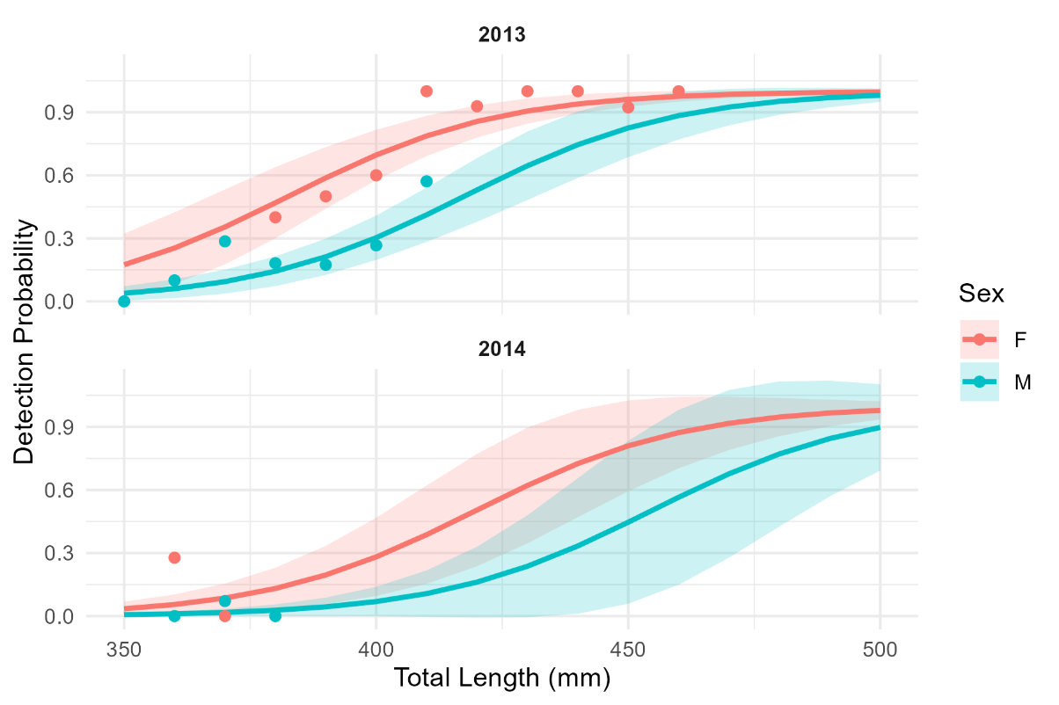
Figure 21.—Detection probability of RASU stocked in 2013 (top) and 2014 (bottom) in YCB based on PIT scanning from 2013 through 2025.
Lines represent best-fit results from the GLM, shaded area 95% confidence intervals, and points represent actual detection proportion for released fish grouped by TL in 10 mm increments.

Table 12. —RASU stocked and survived (≥90 DAL) at Yuma Cove Backwater by stocking year and sex.
Survival columns show count followed by percent survival in parentheses. U = unknown sex.
 | Stocked |  |  |  | Survived (≥90 DAL)
Year | F | M | U | Total | F | M | U | Total
2013 | 100 | 100 | 0 | 200 | 80 (80%) | 24 (24%) | — | 104 (52%)
2014 | 50 | 48 | 0 | 98 | 5 (10%) | 1 (2%) | — | 6 (6%)
2015 | 50 | 50 | 0 | 100 | 10 (20%) | 1 (2%) | — | 11 (11%)
2020 | 0 | 21 | 79 | 100 | — | 0 (0%) | 28 (35%) | 28 (28%)

The sudden increases in total known population (figure 23) correspond to netting and trapping efforts in YCB that were used to assess the RASU population in YCB, harvest surplus RASU, and PIT tag newly recruited fish. These recruit “cohorts” experienced significant post-release mortality which was not illustrated in the known survival plots as they did not survive the initial 90 days post-release. The recruits that survived the initial 90 days had similar survival patterns to stocked fish except for the recruit cohort in 2018. Approximately 100 RASU recruits survived the initial 90 days post-stocking but went undetected sometime in early 2019. This loss of a recruitment cohort even after surviving the 90 day post-release period may be an indication that YCB was becoming overcrowded. Management of YCB shifted after this loss with an emphasis on transferring (harvesting) RASU to reduce overall biomass while still stocking to maintain genetic diversity.

The PIT tagged RASU population in YCB after the initial stocking in 2013 was estimated at approximately100 fish, which is similar to the population size from known survivor analysis (figure 23). The PIT tagging of recruited RASU led to the PIT tagged population exceeding 200 individuals for four estimates from 2016 through 2019. The population of PIT tagged RASU was below 200 in all subsequent years for which estimates could be made. Mark recapture estimates closely aligned with the known survivor numbers indicating that the known survivor count is an accurate accounting of individual PIT tagged RASU survivors in YCB. Recruitment to the PIT tagged population in YCB requires both adequate natural recruitment in the backwater, and adequate sampling effort to PIT tag a proportion of those recruits. To date, natural recruitment and sampling effort has been sufficient for the population size from both analyses (known survivors and mark-recapture) to exceed the initial estimate. Although there have been supplemental stockings after 2013, the majority of the population of PIT tagged RASU in YCB today is made of naturally recruited fish.

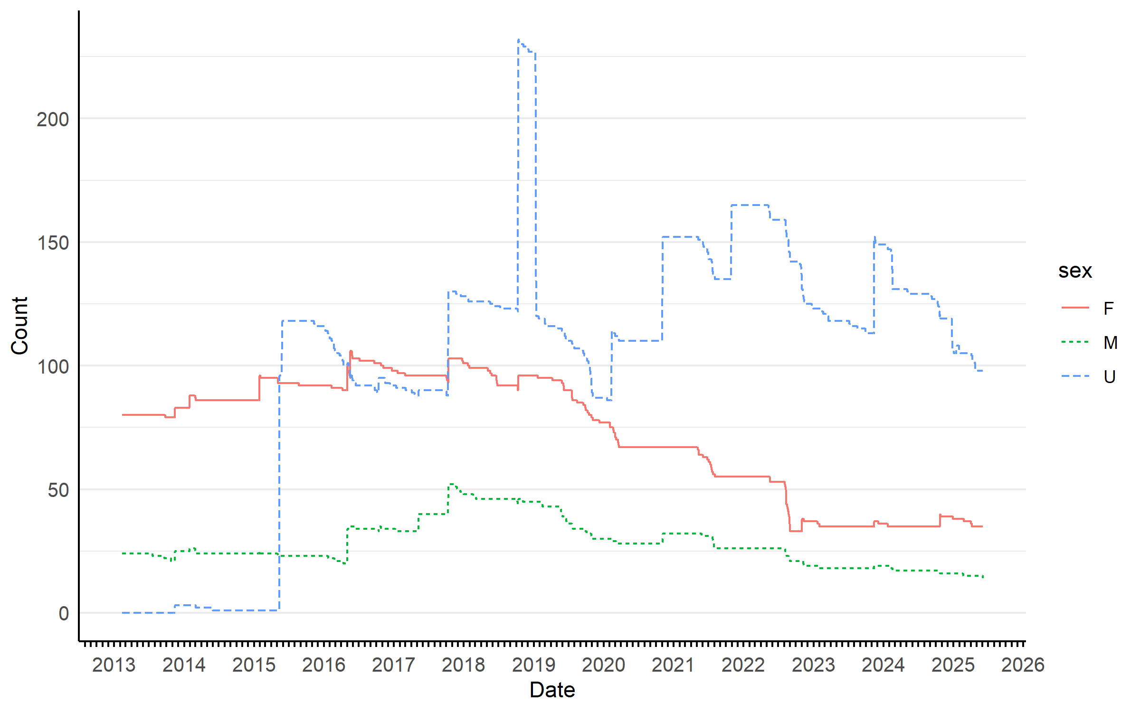
Figure 22.—The total number of known RASU survivors by sex in YCB based on PIT scanning from 2013 through 2025.
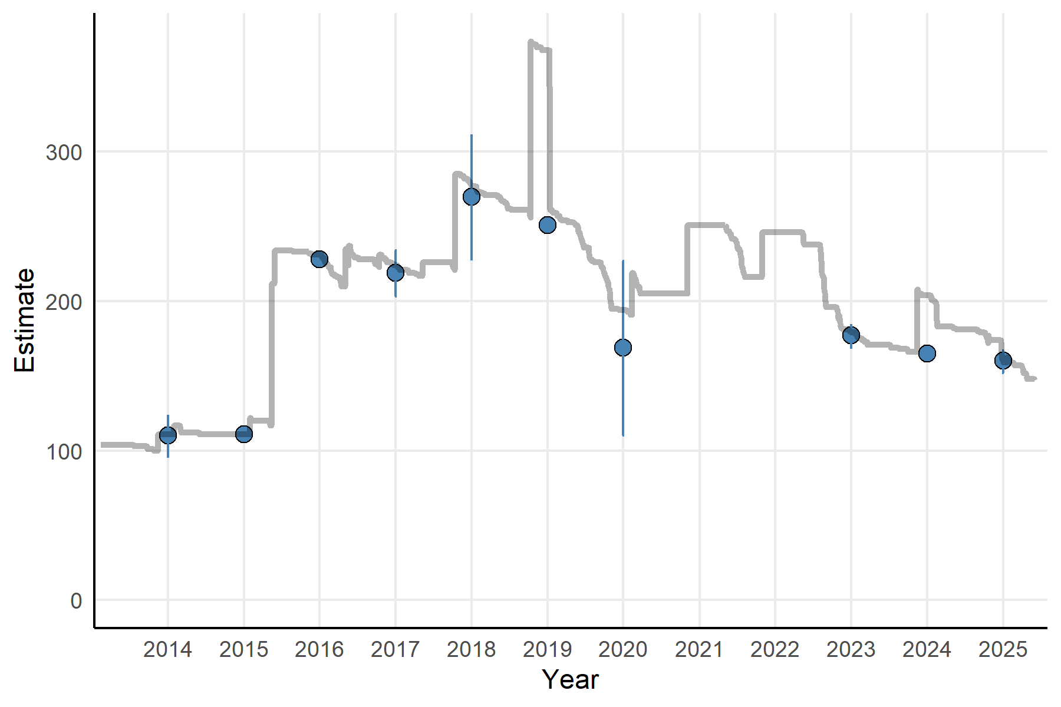
Figure 23.—Population estimates (blue points) of PIT tagged RASU in YCB and their 95% Confidence Interval (vertical lines) based on PIT scanning data from 2013 through 2025.
Grey line depicts total known RASU survivors (all sexes combined) .

A majority of surviving male and female RASU stocked in 2013 contributed to offspring for the first five years post-stocking. This is especially significant for 2013, where only about ¼ of the males stocked survived 90 days post-stocking, and yet many contributed to offspring before likely perishing. The proportion of females from the initial stocking dropped below 50% in 2018 and in males in 2021. This general trend is likely due to the increasing number of naturally recruited untagged RASU contributing to offspring, and the resulting difficulties with assigning parentage. In contrast, the proportion of male and female RASU stocked in 2014 and 2015 that contributed to offspring in their stocking year was near zero. This lack of contribution could be due to a lack of sexual maturity in stocked fish, RASU TL was smaller in 2014 and 2015 compared to 2013. In subsequent years the proportion of male and female survivors of these stockings was variable due to their low overall numbers. One male from each stocking in 2014 and 2015 survived beyond the first year, both contributed to offspring at least once.

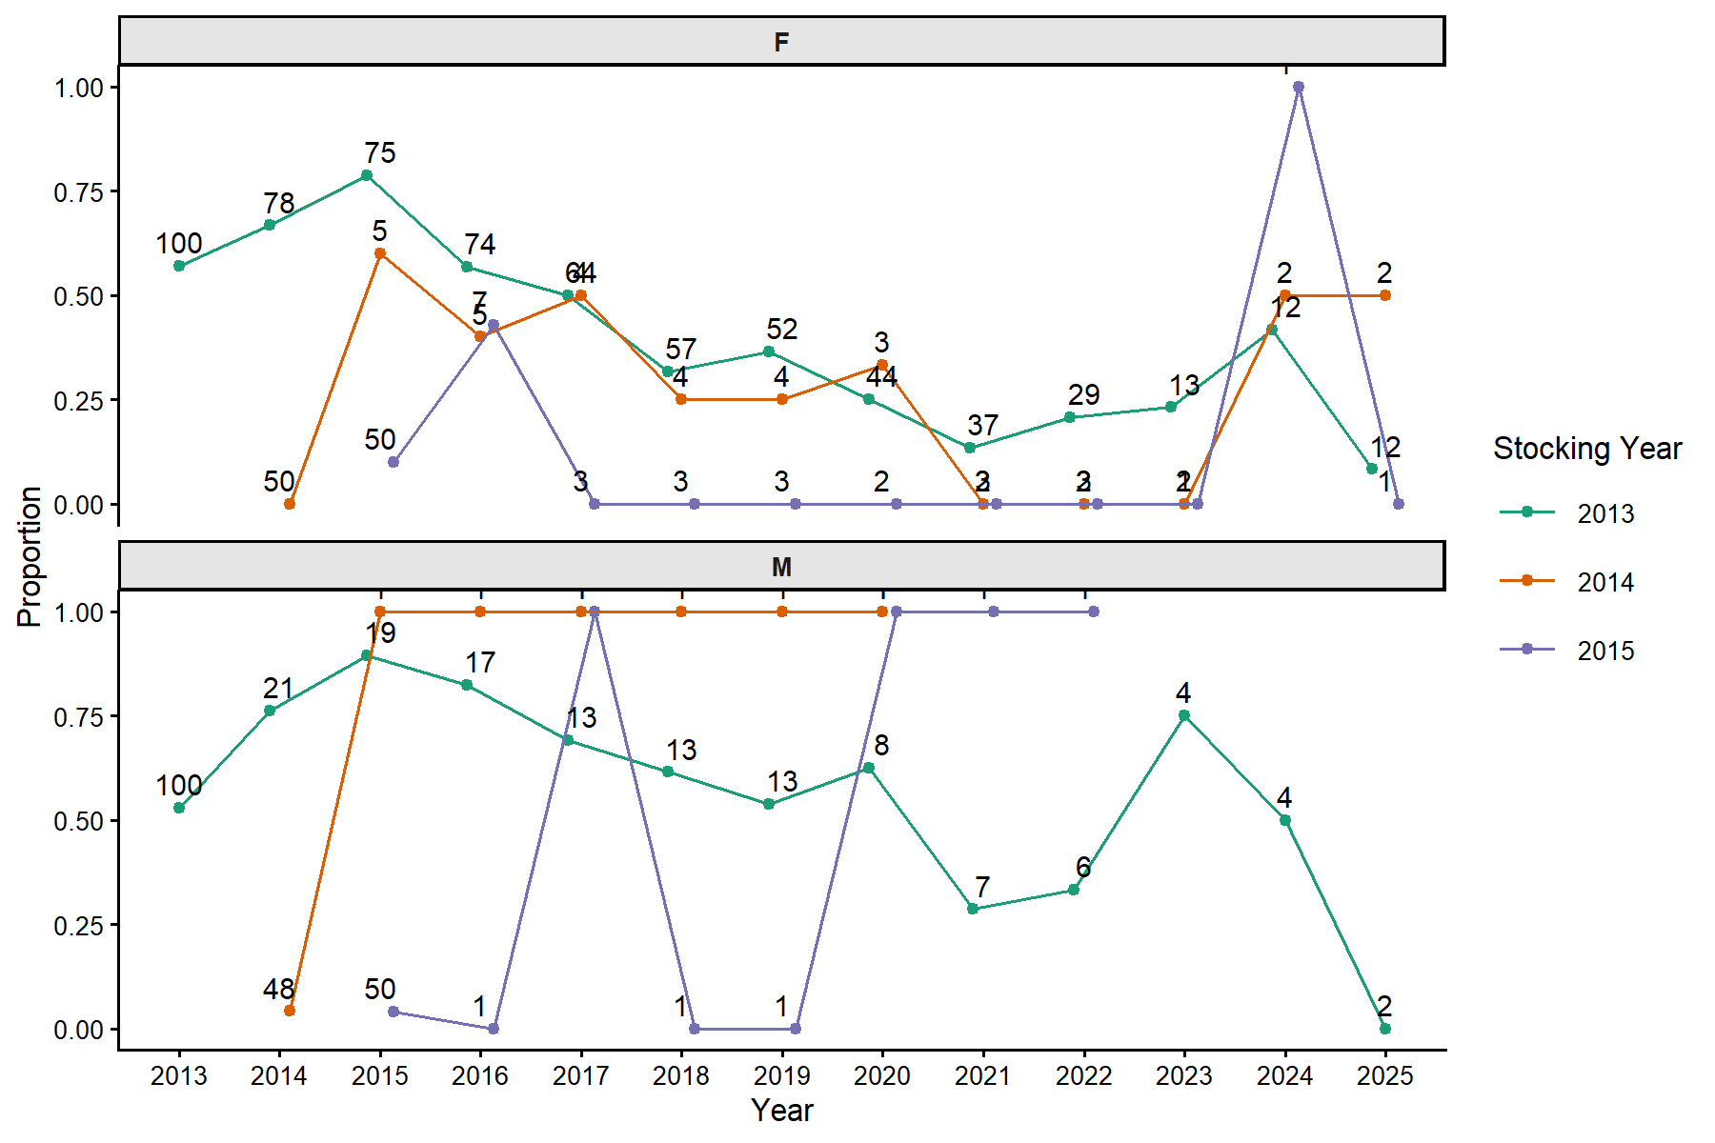
Figure 24.—Proportion of female (F - top) and male (M - bottom) PIT tagged RASU stocked into YCB that contributed to offspring based on parentage assignment data and known survivor analysis.
Counts represent total number of known survivors that contribute to proportion calculation .

