Bonytail (GIEL) Off-Channel Model: Data Support for the Proposed IPM Critique
Figures illustrating data limitations referenced in the critique of the proposed Bonytail integrated population model
Purpose
This report uses figures built from data and model results already on hand — the completed GIEL-only fit (data/BWRobustDesign_MCMC_giel.RData), the underlying PIT-scan and netting records (data/ReportingData.RData), the recorded die-off windows (data/BWDieOffEvents.csv), and a scratch recruit-density build (data/GIEL_scratch_data.RData) from the 2026-09-10 GIEL structure assessment — to illustrate, rather than just assert, where the current data support a simpler model than the one proposed.
No new model fitting was performed for this report; every figure below is derived from existing fits or directly from the raw monitoring data.
1. Where the proposed IPM aligns with the data: ponds sustain fish, open water does not
The proposed IPM’s split between an off-channel (OCH) state-space model and an open-water CJS survival model reflects a real contrast in this system: bonytail persist for years in the IPCA ponds, subject to occasional catastrophic but discrete losses, whereas Lake Havasu open-water releases showed rapid, near-total mortality regardless of predator assemblage or fish size. The known-alive trajectories below show the pond-side half of that contrast directly: Pond 6 (IP6) tracks a fairly stable seasonal pattern with no catastrophic event, while Ponds 2 and 5 (IP2, IP5) each show a single sharp, well-defined collapse matching the pump-failure die-offs documented in Marsh et al. (2024) and pinned to specific months here.
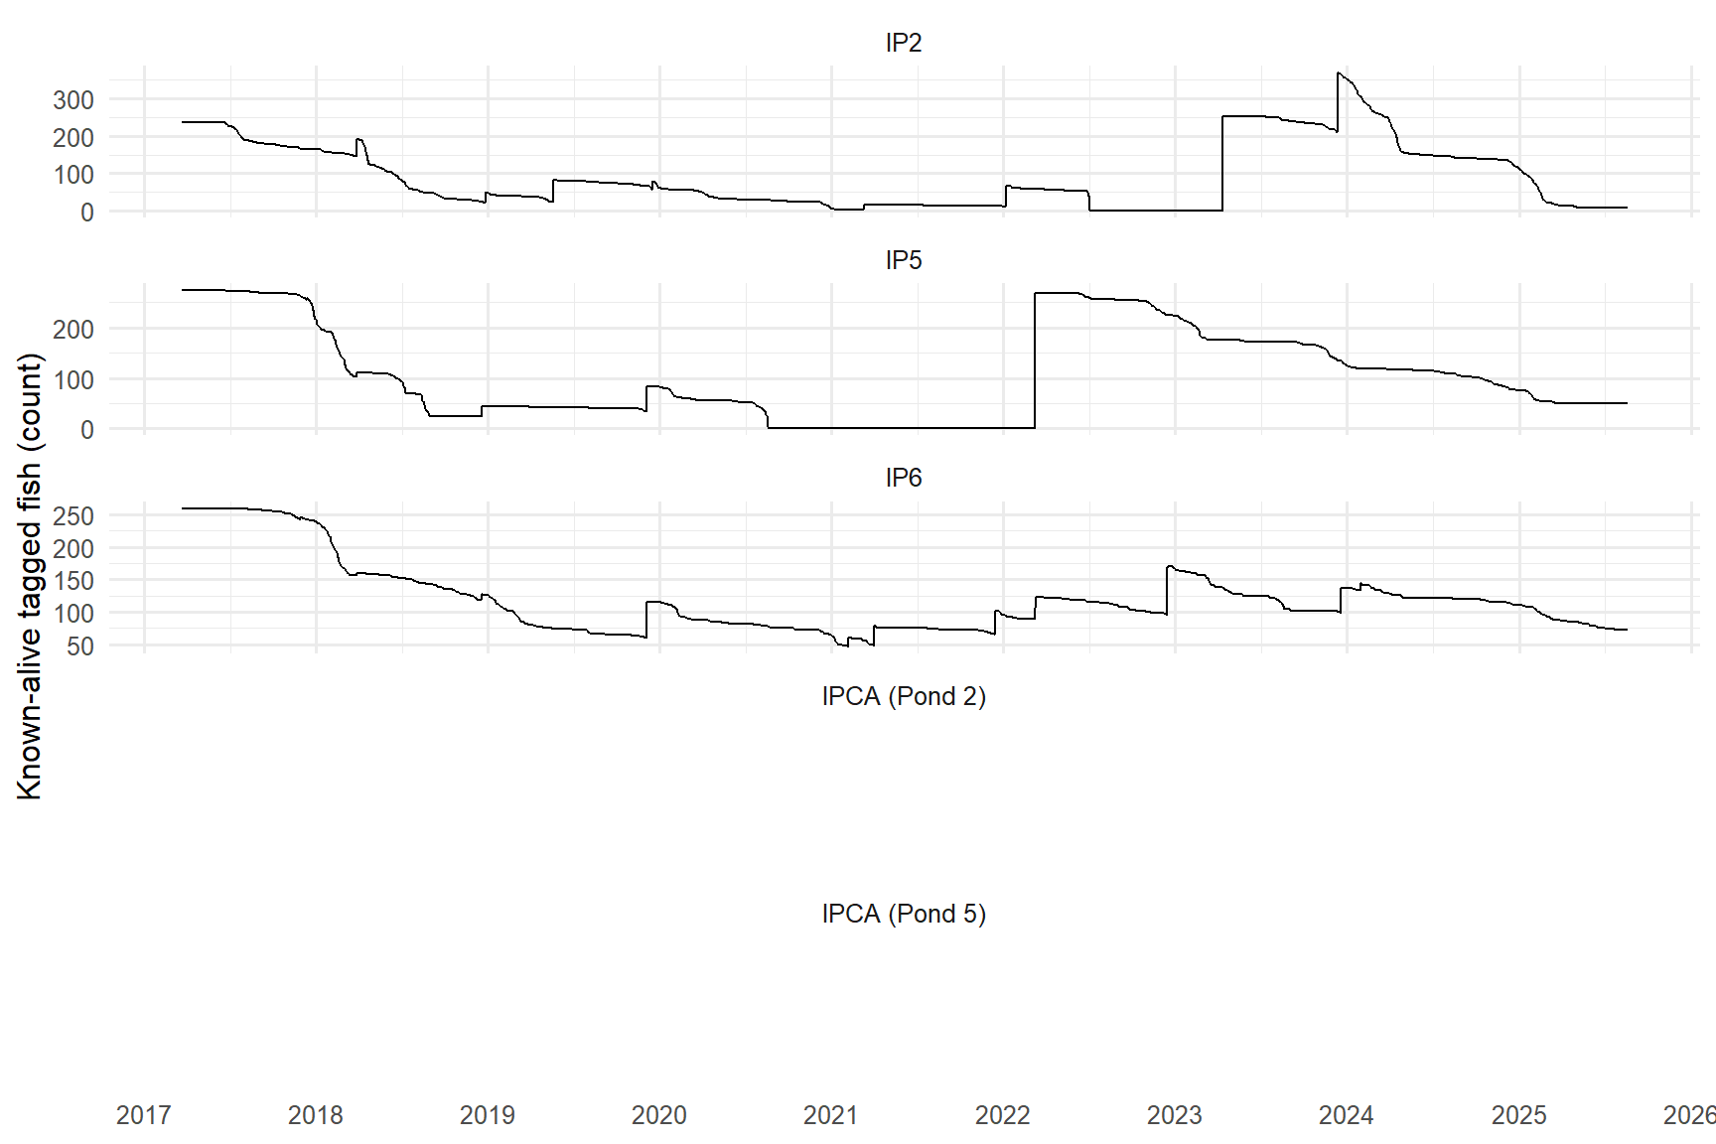
Figure 1: Daily known-alive bonytail count by pond, 2017-2025. Shaded bands mark the confirmed die-off windows (IP5 Jan-Sep 2020, IP2 Jan-Jul 2022) pinned from this same known-alive series. IP6 has no recorded die-off.
The proposed IPM’s own text attributes both events to well-pump failure (“operational, not environmental”), and our dE/Evt mechanism (a dated, per-pond survival offset) is a direct, explicit implementation of that same idea, in place of a diffuse year random effect. Sections 2c and the model-vs-floor comparison below examine how well that explicit mechanism actually recovers the true magnitude of these crashes.
2. Where the proposed IPM’s complexity outruns the data
2a. Stage structure: the data support one size break, not three or four
The proposed IPM carries multiple early wild sub-stages (S1-2, S2-4, S3-4, S4-4), an architecture that mirrors the three-stage density-dependent model built for razorback sucker at Yuma Cove. For bonytail, re-sighting of netting-tagged juveniles (n = 1,438, IP2/IP5/IP6, 2017-2024) shows a single break, at the pond model’s existing 250 mm stage threshold — not a second break near 350 mm as in the razorback sucker model.
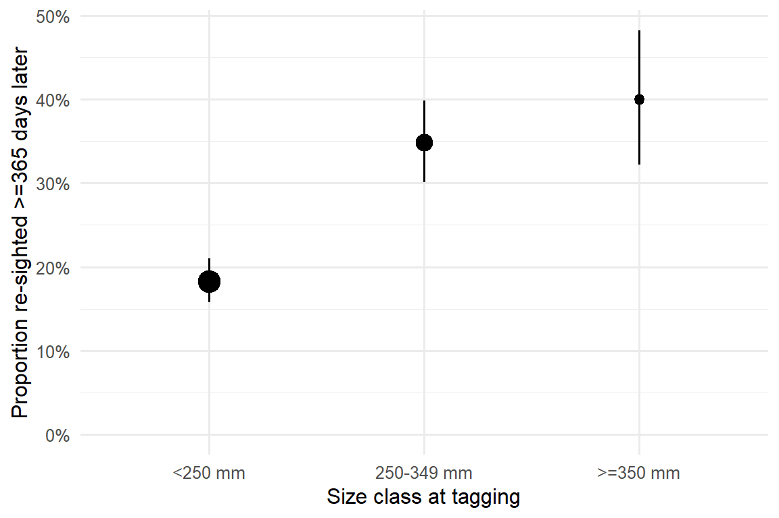
Figure 2: Proportion of netting-tagged bonytail juveniles re-sighted >=365 days later, by size class at tagging (n = 1,438). Error bars are 95% Wilson confidence intervals; point size scales with sample size.
Both the 250-349 mm and >=350 mm classes clearly out-survive the <250 mm class, but a logistic model controlling for stocking/tagging-cohort year (FY) finds no difference between them (log-odds difference = 0.13 +/- 0.21, z = 0.64, p = 0.52). A three- or four-stage architecture built around finer size distinctions above 250 mm is not identifiable from this re-sighting pattern.
2b. Covariate complexity vs. data sufficiency
Two separate lines of evidence argue against adding covariate slopes (environmental, density, or otherwise) to bonytail survival right now: recruitment is too sparse and skewed to fit a density-dependent term, and even the pond-seasons without any density signal show wide, unpatterned swings in survival that a shared covariate slope would need to explain.
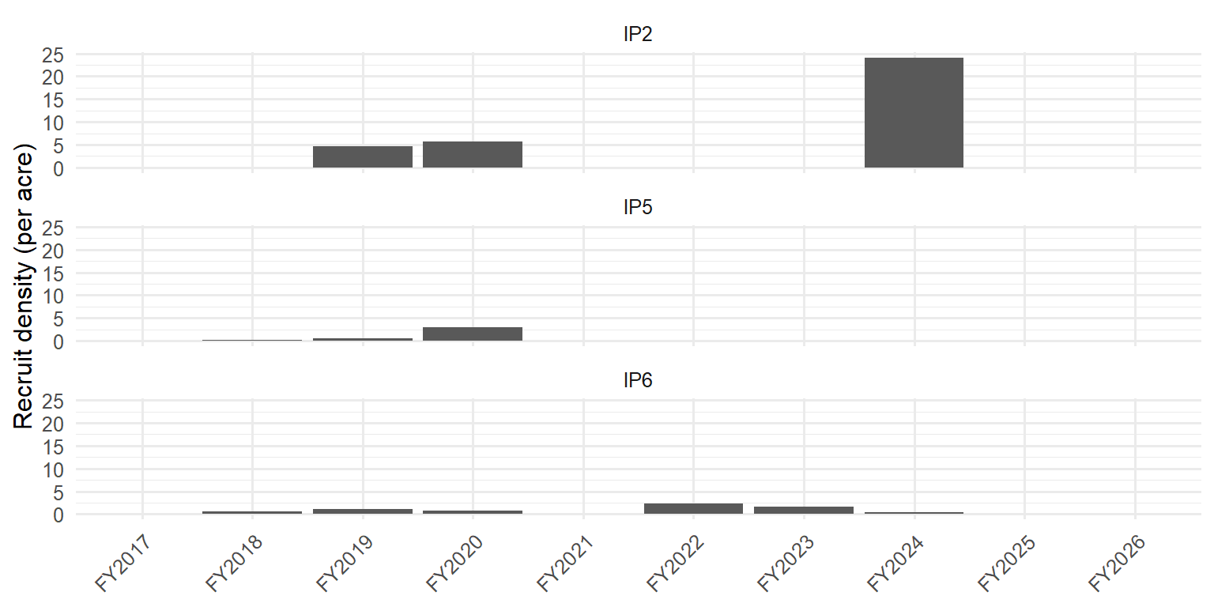
Figure 3: Recruit density (untagged juveniles handled at fall netting, per acre) by pond and season. Most pond-seasons show zero or near-zero recruit density; IP2’s FY2024 value (24.1/acre) is an order of magnitude above every other observation.
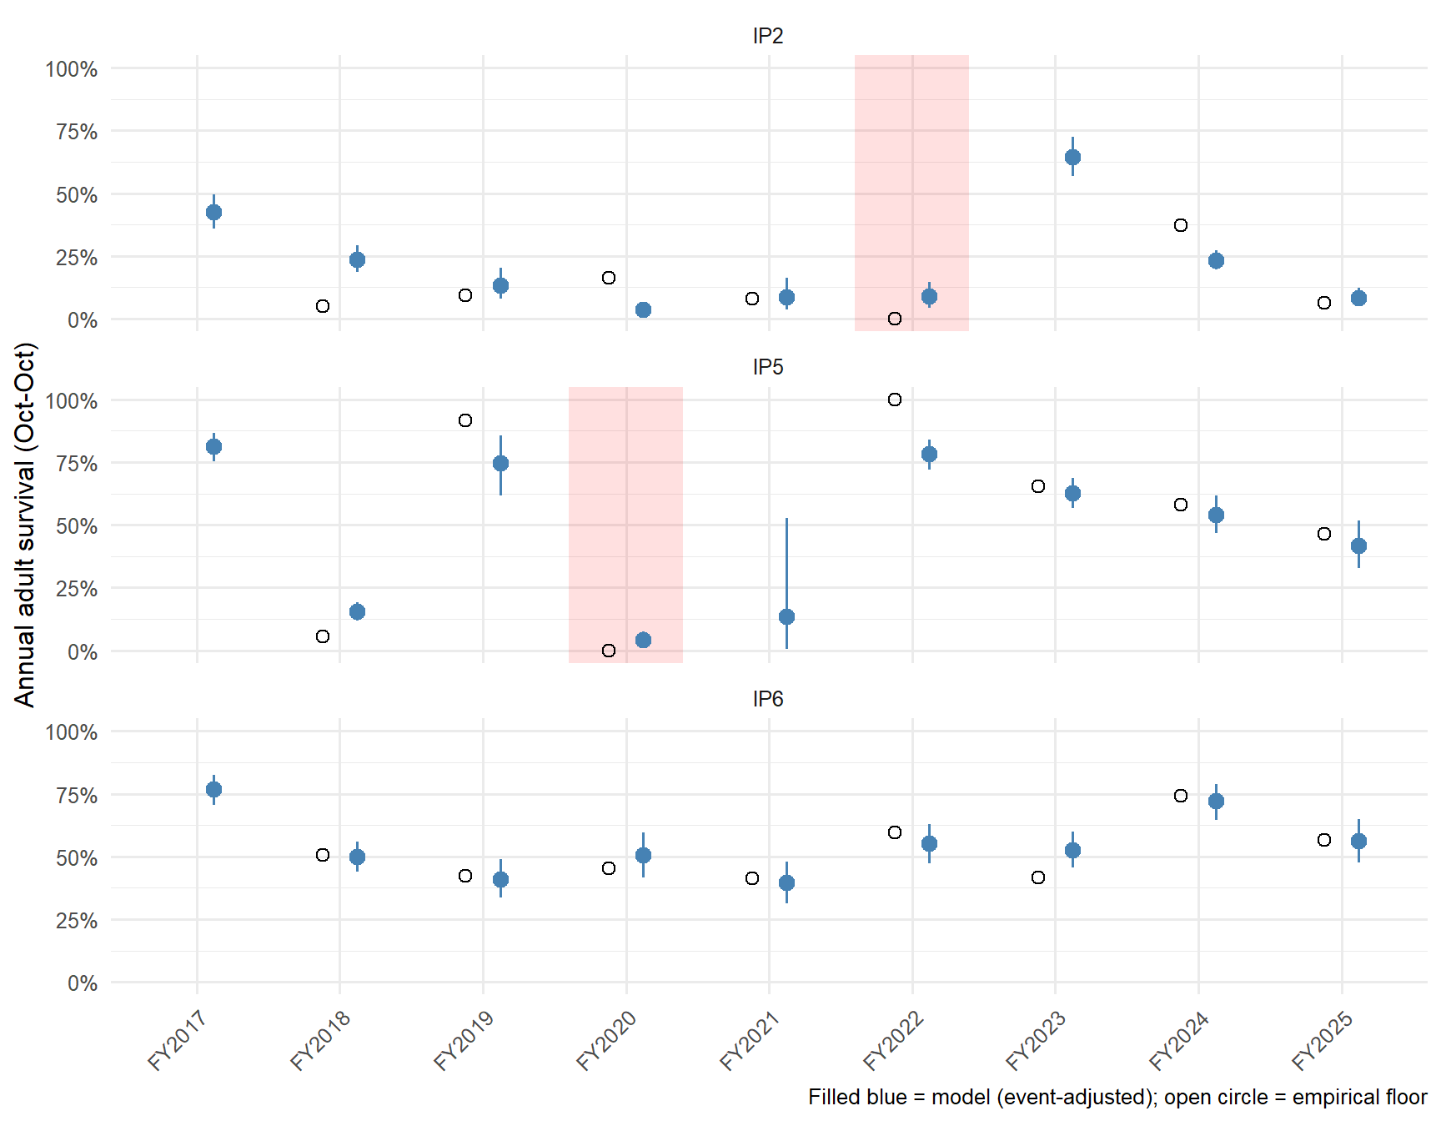
Figure 4: Empirical annual adult survival floor (fraction of adults known alive at one October census re-sighted after the next; open circles) vs. the fitted joint robust-design model’s event-adjusted realized annual survival (filled points with 95% credible interval). Red shading marks the two confirmed die-off pond-seasons (IP5 FY2020, IP2 FY2022).
Two patterns stand out. First, restricted to the 19 non-event pond-seasons with at least 15 known-alive fish, empirical survival floors range from about 0.05 to 0.92 with no visible trend by year or pond — the kind of unpatterned variation a single shared covariate slope is unlikely to resolve, consistent with the recruit-density figure showing almost no continuous gradient to regress against in the first place. Second, the model-vs-floor comparison shows the die-off mechanism working well when the event window spans most of a season (IP5 FY2020: model 4.1% vs. floor 0.0%) but under-correcting when the window covers only part of a season (IP2 FY2022: model 8.9% vs. floor 0.0%) — the same partial-season under-correction documented for razorback sucker’s analogous IP1 FY2022 crash. A year-level random effect, as the proposed IPM uses, would face the same partial-season smoothing problem and arguably has less structure than our explicit dE term to resist it.
2c. Origin-based survival: architecture, not sample size, is the current limit
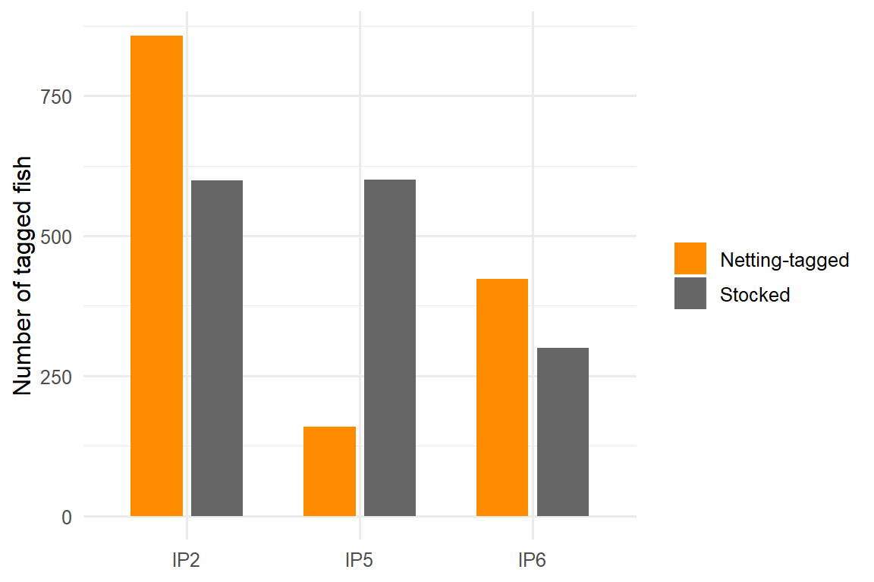
Figure 5: Sample size of tagged bonytail by origin and pond. ‘Netting-tagged’ fish (origin = tagged at a subsequent netting event, the closest available proxy for recruited/wild-hatched fish) are common at all three ponds.
Sample sizes for a stocked-vs-wild survival contrast are not the limiting factor (IP2: 857 netting-tagged vs. 599 stocked; IP5: 159 vs. 600; IP6: 423 vs. 300). What is missing is the model term itself: the fitted joint robust-design model only lets origin affect a temporary post-release survival offset (b_post, active for a few months after tagging); established adult survival (lphiA) has no origin split at all. The proposed IPM’s stocked-vs-wild split on established survival is conceptually reasonable and the raw sample sizes could support a first attempt, but it requires a model extension we have not yet built, and — given how thin and event-dominated the non-crash seasons already are (§2b) — any such split should be checked for robustness rather than assumed informative.

3. Summary comparison
Aspect | Your GIEL OCH model | Proposed BONY IPM (OCH component) | What Havasu shows
Stage structure | 2 stages (<=250 mm, >250 mm); single size break, confirmed by re-sighting (Fig. 2) | 4 stages with early wild sub-stages (S1-2, S2-4, S3-4, S4-4) | Telemetry + PIT could not identify a bare survival curve
Density effects | No density-dependent survival/growth; recruit density near-zero in most pond-seasons (Fig. 3) | Environmental covariates on phi^4 and F; implicitly assumes smooth gradients | Survival near-zero in open water; mortality is a ceiling, not a gradient
Die-offs | Explicit dE event terms with dated windows; partial-season windows under-correct (Fig. 4) | 2020/2022 IPCA die-offs treated as year random-effect shocks, operational not environmental | Catastrophic, rapid losses; no environmental covariate successfully modeled
Covariates (general) | None yet on survival; empirical floors swing widely with no smooth pattern (Fig. 4) | Environmental (DO, temp, water level) on phi^4/F; release/habitat on phi^3; shared slopes across ponds | Attempted CJS/Barker with time-varying survival/detection failed - parameters nearly 0 to 1
Origin split (stocked vs. wild) | Not implemented on established survival; sample sizes sufficient but architecture missing (Fig. 5) | Explicit origin-based survival split by pond for phi^4 | Open water: almost no long-term survivors; origin contrasts likely swamped by predation

4. Bottom line
The figures above show, rather than assert, why the proposed IPM’s stage structure, covariate stack, and origin split are ahead of what current GIEL data can identify: a single, well-supported size break; recruit density that is zero in most pond-seasons with one extreme outlier; empirical survival that swings widely between “clean” pond-seasons with no discernible pattern; a die-off mechanism that works well only when its window spans most of a season; and an origin split that is conceptually sound but not yet built into the fitted model. None of this required a new model run — all of it comes from the completed GIEL-only fit and the underlying monitoring records. The existing 2-stage joint robust-design model, with explicit dated die-off terms, remains the better match to what the data currently support; the highest-value next steps are pond-specific (e.g., checking IP2 for additional unflagged mortality) rather than adding covariate layers.

