MULTI MIRROR | 2016-2017

CHAPTER-1

INTRODUCTION

1.1 About Computer Graphics:

Computer graphics refers to the transfer of pictorial data into and out of a computer. Using analog-to-digital conversion techniques, a variety of devices such as curve tracers, digitizers, and light pens connected to graphic computer terminals, computer-aided design programs, or optical scanners can be used to store pictorial data in a digital computer. By reversing the process through digital-to-analog conversion techniques, the stored data can be displayed in graphical form on a mechanical plotting board, or plotter, or on a television like graphic display terminal. Raster graphics stores and displays images as a bit map, a series of closely spaced dots (or pixels) arranged in rows and columns. Vector, or object-oriented, graphics stores the images as mathematical formulas; images are displayed by calculating the coordinates of the end points and then drawing lines. Computer Graphics become a powerful tool for the rapid and economical production of pictures. There is virtually no area in which Graphical displays cannot be used to some advantage so it is not surprising to find the use of CG so widespread.

Although early application in engineering & science had to relay on expensive &cumbersome equipment’s, advances in computer technology have made interactive computer graphics a practical tool.

Today we find Computer Graphics in a diverse area such as science, engineering, medicine, business, industry, government, art, entertainment, education and training. Now you are able to answer about computer graphics as generalized tool for drawing and creating pictures and simulate the real world situations within a small computer window. Early Graphics System used for general purpose computers were based on standard Von Neumann architecture. Such computers were characterized by a single processing unit that processes a single instruction at a time.

There are different types of Graphics architectures which are:

Display processors: The earliest attempts to build special purpose graphics system were concerned primarily with relieving the general purpose computer from the task

Dept. of CSE, EWIT. Page 1
MULTI MIRROR | 2016-2017

of refreshing the display continuously. These display processors had conventional architecture but included instructions to display primitives on the CRT.

Pipeline Architectures: The availability of inexpensive solid state memory led to the universality of raster display. For computer graphics application, the most important use of custom VLSI circuits has been in creating pipeline Architectures.

The graphics Pipeline: Each object comprises a set of graphical primitives. Each primitive comprises set of vertices.

Vertex processing: The assignment of vertex colors can as simple as program specifying a color or as complex as computation of a color from a physically realistic lightning model that incorporates the surface properties of the object and the characteristic light sources in the scene.

Clipping and primitive assembly: We must do clipping because of the limitations of that no imaging system can see the whole world at once. The human retina has a limited size corresponding to an approximately 90-degree field of view.

1.2 History

William fetter was credited with coning the term Computer Graphics in 1960, to describe his work at Boeng. One of the first displays of computer animation was future world (1976), which included an animation of a human face and hand-produced by Carmull and Fred Parkle at the University of Utah.

There are several international conferences and journals where the most significant results in computer-graphics are published. Among them are the SIGGRAPH and Euro graphics conferences and the association for computing machinery (ACM) transaction on Graphics journals.

1.3 Applications of Computer Graphics

Nowadays Computer Graphics used in almost all the areas ranges from science, engineering, medicine, business, industry, government, art, entertainment, education and training.

Dept. of CSE, EWIT. Page 2
MULTI MIRROR | 2016-2017

1.3.1 CG in the field of CAD

Computer Aided Design methods are routinely used in the design of buildings, automobiles, aircraft, watercraft, spacecraft computers, textiles and many other applications.

1.3.2 CG in presentation Graphics

Another major application area presentation graphics used to produce illustrations for reports or generate slides. Presentation graphics is commonly used to summarize financial, statistical, mathematical, scientific data for research reports and other types of reports. 2D and 3D bar chart to illustrate some mathematical or statistical report.

1.3.3 CG in computer Art

CG methods are widely used in both fine art and commercial art applications. Artists use a variety of computer methods including special purpose hardware, artist’s paintbrush program (lumena), other pain packages, desktop packages, math’s packages, animation packages that provide facility for designing object motion. Ex: cartoons design is an example of computer art which uses CG.

1.3.4 Entertainment

Computer graphics methods are now commonly used in making motion pictures, music, videos, games and sounds. Sometimes graphics objects are combined with the actors and live scenes.

1.3.5 Education and Training

Computer generated models of physical financial, economic system is often as education aids. For some training application special systems are designed. Ex: specialized system is simulator for practice sessions or training of ship captain, aircraft pilots and traffic control.

1.3.6 Image Processing

Although the methods used in CG image processing overlap, the 2 areas are concerned with fundamentally different operations. In CG a computer is used to create picture. Image processing on the other hand applies techniques to modify existing pictures such as photo scans, TV scans.

Dept. of CSE, EWIT. Page 3
MULTI MIRROR | 2016-2017

1.3.7 User Interface

It is common for software packages to provide a graphical interface. A major component of a graphical interface is a window manager that allows a user to display multiple window area. Interface also displays menus, icons for fast selection and processing.

1.4 Overview of OpenGL

OpenGL (Open Graphics Library) is a standard specification defining a cross-language, cross-platform API for writing applications that produce 2D and 3D computer graphics. The interface consists of over 250 different function calls which can be used to draw complex three-dimensional scenes from simple primitives. OpenGL was developed by Silicon Graphics Inc. (SGI) in 1992 and is widely used in CAD, virtual reality, scientific visualization, information visualization, and flight simulation. It is also used in video games, where it competes with Direct3D on Microsoft Windows platforms (see OpenGL vs. Direct3D). OpenGL is managed by a non-profit technology consortium, the Khronos Group.

OpenGL serves two main purposes:

To hide the complexities of interfacing with different 3D accelerators, by presenting the programmer with a single, uniform interface.

To hide the differing capabilities of hardware platforms, by requiring that all implementations support the full OpenGL feature set (using software emulation if necessary).

Most of our application will be designed to access OpenGL directly through functions in three libraries. Functions in the main GL (or OpenGL in windows) library have names that begin with the letters gl and are stored in a library usually referred to as GL (or OpenGL in windows). The second is the OpenGL Utility Library (GLU). This library uses only GL functions but contains code for creating common objects and simplifying viewing. All functions in GLU can be created from the core GL library but application programmers prefer not to write the code repeatedly. The GLU library is available in all OpenGL implementations; functions in the GLU library begin with letters glu.

To interface with the window system and to get input from external devices into our programs, we need at least one more system-specific library that provides the “glut”

Dept. of CSE, EWIT. Page 4
MULTI MIRROR | 2016-2017

between the window system and OpenGL. For the X window system, this library is functionality that should be expected in any modern windowing system.

Fig 1.1 shows the organization of the libraries for an X Window System environment. For this window system, GLUT will use GLX and the X libraries. The application program, however, can use only GLUT functions and thus can be recompiled with the GLUT library for other window systems.
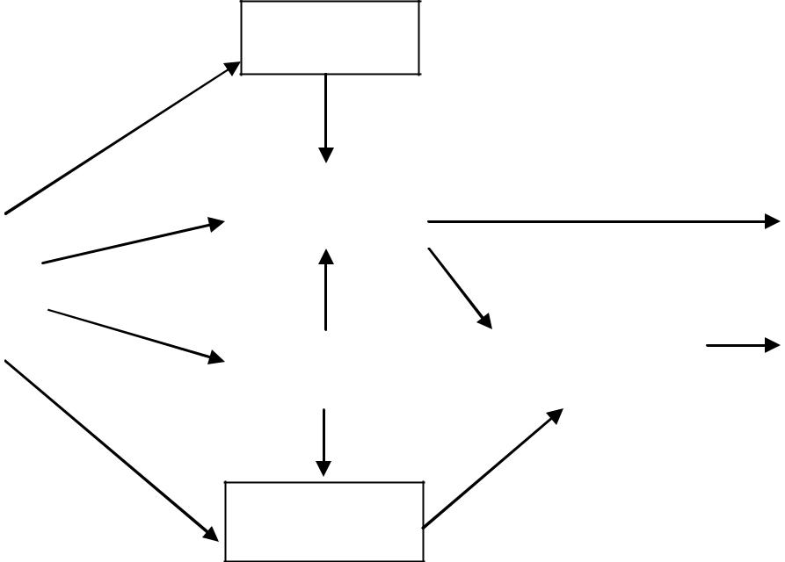

GLU

 |  | GL
OpenGL |  |  |  |  |  |  | Frame
Application |  |  |  |  |  |  | Frame
Application |  |  |  |  |  |  | Buffer
Program |  |  |  |  |  |  | Buffer
 |  | GLUT |  |  | Xlib, Xtk

GL

Fig 1.1 Library organizations

OpenGL's basic operation is to accept primitives such as points, lines and polygons, and convert them into pixels. This is done by a graphics pipeline known as the OpenGL state machine. Most OpenGL commands either issue primitives to the graphics pipeline, or configure how the pipeline processes these primitives. Prior to the introduction of OpenGL 2.0, each stage of the pipeline performed a fixed function and was configurable only within tight limits. OpenGL 2.0 offers several stages that are fully programmable using GLSL.

OpenGL is a low-level, procedural API, requiring the programmer to dictate the exact steps required to render a scene. These contrasts with descriptive APIs, where a programmer only needs to describe a scene and can let the library manage the details of rendering it. OpenGL's low-level design requires programmers to have a good knowledge of the graphics pipeline, but also gives a certain amount of freedom to implement novel rendering algorithms.

Dept. of CSE, EWIT. Page 5
MULTI MIRROR | 2016-2017

OpenGL has historically been influential on the development of 3D accelerators, promoting a base level of functionality that is now common in consumer-level hardware:

Rasterized points, lines and polygons as basic primitives. Simplified version of the Graphics Pipeline Process; excludes a number of features like blending, VBOs and logic operations

A transform and lighting pipeline

Z-buffering

Texture mapping

Alpha blending

A brief description of the process in the graphics pipeline could be:

Evaluation, if necessary, of the polynomial functions which define certain inputs, like NURBS surfaces, approximating curves and the surface geometry.

Vertex operations, transforming and lighting them depending on their material. Also clipping non visible parts of the scene in order to produce the viewing volume.

Rasterization or conversion of the previous information into pixels. The polygons are represented by the appropriate colour by means of interpolation algorithms.

Per-fragment operations, like updating values depending on incoming and previously stored depth values, or colour combinations, among others.

Lastly, fragments are inserted into the Frame buffer.

Many modern 3D accelerators provide functionality far above this baseline, but these new features are generally enhancements of this basic pipeline rather than radical revisions of it.

Uses:

3D modelers are used in a wide variety of industries. The medical industry uses them to create detailed models of organs. The movie industry uses them to create and manipulate characters and objects for animated and real-life motion pictures. The video game industry uses them to create assets for video games. The science sector uses them to create highly detailed models of chemical compounds. The architecture industry uses them to create models of proposed buildings and landscapes. The engineering community uses them to design new devices, vehicles and structures as well as a host of other uses.

Dept. of CSE, EWIT. Page 6
MULTI MIRROR | 2016-2017

CHAPTER-2

OpenGL FUNCTIONS

2.1 Keyboard functions:
V/v: To view ortho/perspective

L/l: Lighting on/of

2.2 Mouse functions:

Press right key to get menu consisting of options start ortho/perspective view help and quit

2.3 High level designs:

init(): This function initializes light source for ambient, diffuse and specular types.

display(): This function creates and translates all the objects in a specified location in a particular order and also rotates the objects in different axes. glClear(GL_COLOR_BUFFER_BIT); glFlush();

timerfunc(): This function starts a timer in the event loop that delays the event

loop for delay milliseconds.

MainLoop(): This function whose execution will cause the program to begin an event processing loop.

PushMatrix(): Save the present values of attributes and matrices placing ,or pushing on the top of the stack.

PopMatrix(): We can recover them by removing them from stack

Translated(): In translate function the variables are components of the displacement vector.

main(): The execution of the program starts from this function. It initializes the graphics system and includes many callback functions.

PostRedisplay(): It ensures that the display will be drawn only once each time the program goes through the event loop.

glLightfv(): The glLightfv function returns light source parameter values.

Return Value

This function does not return a value

Dept. of CSE, EWIT. Page 7
MULTI MIRROR | 2016-2017

glMaterialfv(): The glMaterialfv function specifies material parameters for the lighting model.

Syntax:

void WINAPI glMaterialfv(GLenum face, GLenum pname, constGLfloat *params);

Parameters: face

The face or faces that are being updated. Must be one of the following: GL_FRONT, GL_BACK, or GL_FRONT and GL_BACK.

pname

The material parameter of the face or faces being updated. The parameters that can be specified using glMaterialfv are as follows:

GL_AMBIENT,GL_DIFFUSE,GL_SPECULAR,GL_EMISSION,GL_SHINI NESS,GL_AMBIENT_AND_DIFFUSE,GL_COLOR_INDEXES params The value to which parameter GL_SHININESS will be set.

2.4 Built in functions:

glClearColor:

This function call sets the present RGBA clear color used when clearing the color buffer.

General syntax:

void glClearColor(Glclampf r,Glclampf g,Glclampf b,GLclampf a); Variables of type GLclampf are floating type number between 0.0 and 1.0. Eg: glClearColor(1.0,0.0,0.0,1.0);

glFlush:

This function call forces any buffered OpenGL command to execute. General Syntax: void glFlush();

glutInit:

This function call initializes glut library.

General Syntax: void glutInit(int *argc,char **argv); The arguments from main are passed in and can be used by an application.

Dept. of CSE, EWIT. Page 8
MULTI MIRROR | 2016-2017

Eg: glutInit(&argc,argv);

glutCreateWindow:

This function call creates a window on the display, the string title can be used to label the window.

General Syntax: void glutCreateWindow(char *title);

Eg: glutCreateWindow(“CLIPING PLANE”);

glutInitDisplayMode:

This function call request a display with the properties that are specified in m mode. The value of mode is determined by the logical OR operation of options including the color model.

General syntax: void glutInitDisplayMode(unsigned int mode);

Eg: glutInitDisplayMode(GLUT_DOUBLE | GLUT_RGB | GLUT_DEPTH);

glutInitWindowSize:

This function call specifies the initial height and width of window in pixels. General syntax: void glutInitWindowSize(int width,int height);

glutInitWindowPosition:

This function call specifies the initial position of top left corner of the window in pixels.

General syntax: void glutInitWindowPosition(int x,int y);

Eg: glutInitWindowPosition(100,100);

glutDisplayFunc:

This function call registers the display function *func is executed when the window needs to be redrawn.

General syntax: void glutDisplayFunc(void (*func) (void))

Eg: glutDisplayFunc(display);

glutPostRedisplay:

This function call request the display call back be executed after the current call back returns.

General Syntax: void glutPostReDisplay();

Dept. of CSE, EWIT. Page 9
MULTI MIRROR | 2016-2017

Eg: glutPostRedisplay();

glutMainLoop:

This function call causes the program to enter an event processing loop. It should be the last statement in main.

General Syntax: void glutMainLoop();

Eg: glutMainLoop();

glViewPort:

This specifies a width*height view port in pixels whose lower left corner is at (x,y) measure from the origin of the window.

General syntax: void glViewPort(int x,int y,GLSizei width,GLSizei height);

Eg: glViewPort(0,0,w,h);

glMatrixMode:

This function call specifies which matrix will be effected by subsequent transformation.

General syntax: void glMatrixMode(Glenum mode);

Mode values can be GL_MODELVIEW,GL_PROJECTION,GL_TEXTURE. Eg: glMatrixMode(GL_PROJECTION);

glLoadIdentity:

This function call sets current transformation matrix to an identity matrix. General syntax: void glLoadIdentity();

Eg: glLoadIdentity().

glPushMatrix and glPopMatrix:

These function call pushes to and pop from the matrix stack corresponding to the current matrix mode.

General syntax: void glPushMatrix(); void glPopMatrix();

Eg: glPushMatrix();glPopMatrix();

gluLookAt:

This function call post multiplies the current matrix by a matrix determined by a viewer at the eye point looking at that with the specified up direction.

Dept. of CSE, EWIT. Page 10
MULTI MIRROR | 2016-2017

General syntax: void gluLookAt(GLdouble eyex, GLdouble eyey, GLdouble eyez, GLdouble atx, Gldouble aty, GLdouble atz, GLdouble upx, GLdouble upy, GLdouble upz);
Eg: gluLookAt( 0.0,0.0,5.0,0.0,0.0,0.0,0.0,1.0,0.0);

gluPerspective:

This function call defines a perspective viewing volume using the y direction field of view for measured in degrees, the aspect ratio of the front clipping plane and the near and far distances.

Syntax: void gluPerspective(GLdouble fov, GLdouble aspect, GLdouble near, GLdouble far);

Eg: gluPespective(45.0,(GLfloat) w/(GLfloat) h,1.0,300.0);

glutMouseFunc:

The function call registers the mouse call back function *f. The call back returns

(GL_LEFT_BUTTON,GLUT_MIDDLE_BUTTON,GLUT_RIGHT_BUTTO N), the state of the button after the event will be either up or down (GLUT_UP,GLUT_DOWN) and position of the mouse relative to top left corner of the window.

General syntax: void glutMouseFunc(void *f(int button,int state,int x,int y);

Eg: glutMouseFunc(mousefunc);

glutReshapeFunc:

This function call registers the reshape call back function f. The call back function returns the height and width of the new window. The Reshape call back invokes a display call back.

General syntax: void glutReshapeFunc(void *f(int width,int height));

Eg: glutReshapeFunc(myreshape);

glutSwapBuffers:

This function call swaps the front and back buffers. General syntax: void glutSwapBuffers();

Eg: glutSwapBuffers();

Dept. of CSE, EWIT. Page 11
MULTI MIRROR | 2016-2017

glRotate:

This function call alter the current matrix by a rotation of angle degrees about the axis (dx,dy,dz).

General syntax:void glRotate[fd](TYPE angle,TYPE dx,TYPE dy,TYPE dz); Type can be either GLfloat and GLdouble.

Eg: glRotatef(0.0,1.0,0.0);

glTranslate:

This function call alters the current matrix by a displacement of(x,y,z). General syntax: void glTranslate[fd](TYPE x,TYPE y,TYPE z); Eg: glTranslatef(0.0,1.0,0.0);

glEnable:

This function call enable the z-buffer algorithm either in main or initialization function.

Eg: glEnable(GL_DEPTH_TEST) ;

glClear:

This function is used to clear the window. As the algorithm stores information in the depth buffer, so it necessary to clear the buffer whenever we wish to redraw the display.

Eg: glClear(GL_COLOR_BUFFER_BIT | GL_DEPTH_BUFFER_BIT);

glColor:

This function will set the current drawing color. Eg: glColor3f(1.0,0.0,0.0);

This function will set the current drawing color to red. It conveys that we are using three-color (RGB) model and that the values of the components are given as float.

glShadeModel:

OpenGL primitives can have either flat or smooth shading. Smooth shading, the default, causes the computed colors of vertices to be interpolated as the primitive is rasterized. Flat shading selects the computed color of just one

Dept. of CSE, EWIT. Page 12
MULTI MIRROR | 2016-2017

vertex and assigns it to all the pixel fragments generated by rasterizing a single primitive.

General syntax: void glShadeModel (GLenum mode);

Eg: glShadeModel(GL_SMOOTH);

glutIdleFunc:

This function registers the display callback function f that is executed whenever there are no other events to be handled.

General syntax: void glutIdleFunc(void (*f)(void));

glutCreateMenu:

This function returns an identifier for a top-level menu and registers the callback function f that returns an integer value corresponding to the menu entry selected.

General syntax: void glutCreateMenu(void (*f)(int value));

glutAttachMenu:

This function attaches the current menu to the specified mouse button. General syntax: void glutAttachMenu(int button);

glutAddMenuEntry:

This function adds an entry with the string name displayed to the current menu. Value is returned to the menu callback when the entry is selected.

General syntax: void glutAddMenuEntry(char *name, int value);

glRasterPos:

This function specifies a raster position.

General syntax: void glRasterPos[234]sifd(TYPE xcoord,Type ycoord,…);

glutBitmapCharacter:

This function renders the character with ACII code char at the current raster position using the raster font given by font.

General syntax: voidglutBitmapCharacter(void * font, int char);

Eg: glutBitmapCharacter(GLUT_BITMAP_8_By_13,C);

Dept. of CSE, EWIT. Page 13
MULTI MIRROR | 2016-2017

glBegin:

This function initiates a new primitive of type mode and starts the collection of vertices. Values may include GL_POINTS, GL_LINES and GL_POLYGON. General syntax: void glBegin(glEnum mode);

glEnd:

This function terminates a list of vertices. General syntax: void glEnd();

glVertex:

This function specifies the position of a vertex in 2, 3 or 4 dimensions. The coordinates can be specified as short, int, float or doubles.

General syntax: glVertex[234][sifd](TYPE xcoord, TYPE ycoord,..);

gluQuadricDrawStyle:

This function sets the drawing style(GLU_POINT, GLU_LINE, GLU_FILL) for a quadric object.

General syntax: void gluQuadricDrawStyle(GLUquadricObj *obj, Glenum style);

gluQuadricNormals:

This function sets the automatic normal(GLU_NORMAL, GLU_FLAT,

GLU_SMOOTH)

General syntax: voidgluQuadricDrawStyle(GLUquadricObj *obj, Glenum mode);

gluCylinder:

This function draws a hollow cylinder with no ends along the z-axis. If topRadius or bottomRadius is 0, a cone is drawn instead. The cylinder is projected height units along the positive z-axis. The slices argument controls the number of sides along the cylinder. The stacks argument controls the number of segments along the z-axis (across the cylinder) that are generated.

General syntax: void gluCylinder(GLUquadricObj *obj, Gldouble baseRadius, Gldouble topRadius, GLdouble height, GLint slices, GLint stacks);

Dept. of CSE, EWIT. Page 14
MULTI MIRROR | 2016-2017

gluSolidCone:

This function is used to render a solid cone oriented along the Z axis.General syntax: void glutSolidCone(GLdouble base, GLdouble height, GLint slices,

GLint stacks);

glOrtho:

This function defines an othographic viewing volume with all parameters measured from the center of the projection plane.

General syntax: void glOrtho(Gldouble left, Gldouble right, Gldouble bottom, Gldouble top, Gldouble near, Gldouble far);

Dept. of CSE, EWIT. Page 15
MULTI MIRROR | 2016-2017

CHAPTER-3

REQUIREMENT SPECIFICATION

3.1 Hardware Requirements:

• | Processor | : Pentium Pro or higher processor [currently using:
 |  | Intel ® Core TM 2 Duo CPU E4600 @ 2.40GHz X2]
• | Memory | : 128MB RAM or more
• | Hard Disk | : 40 GB

Hard disk speed in RPM : 5400 RPM

• | Keyboard | : QWERTY Keyboard
• | Mouse | : 2 or 3 Button mouse
• | Monitor | : 1024 x 768 display resolution
• | Graphics | : Intel ® 945G X86/MMX/SSE2

3.2 Software Requirements:

• | Operating system | : LINUX(UBUNTU 14.04 LTS)
• | OS type | : 32-bit
• | Graphics Library | : GL/glut.h
• | Development Platform | : OpenGL 2.0/ MS visual studio-Version I5.

Programming language : C/C++ using OpenGL

• Compiler : The GNU Compiler or MS Visual Studio IDE.

Dept. of CSE, EWIT. Page 16
MULTI MIRROR | 2016-2017

CHAPTER-4

SOFTWARE DESIGN

Software design involves problem solving and planning a software solution. This includes both low level component and algorithm design and high level, architecture design.
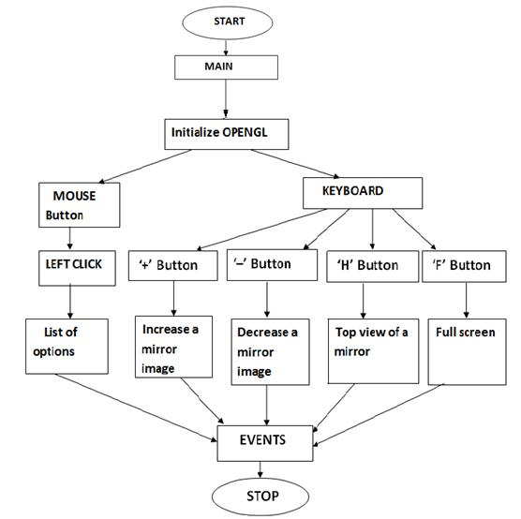

Figure 3.1: Simple flow chart of system

Dept. of CSE, EWIT. Page 17
MULTI MIRROR | 2016-2017

CHAPTER-5

IMPLEMENTATION

#include <math.h>

#include <stdio.h>

#include <stdlib.h>

#include <GL/glut.h>

GLUquadricObj *cone, *base, *qsphere;

/* Some <math.h> files do not define M_PI... */ #define M_PI 3.14159265358979323846 #define trunc(x) ((double)((int)(x))) int draw_passes = 1;

int headsUp = 0;

GLdouble secs;

typedef struct {

GLfloat verts[4][3];

GLfloat scale[3];

GLfloat trans[3];

} Mirror;

Mirror mirrors[] = {

/* mirror on the left wall */

{{{-1., -.75, -.75}, {-1., .75, -.75}, {-1., .75, .75}, {-1,-.75, .75}}, {-1, 1, 1}, {2, 0, 0}},

/* mirror on right wall */

{{{1., -.75, .75}, {1., .75, .75}, {1., .75, -.75}, {1., -.75, -.75}}, {-1, 1, 1}, {-2, 0, 0}},

};

Dept. of CSE, EWIT. Page 18
MULTI MIRROR | 2016-2017

int nMirrors = 2;

void init(void)

{

static GLfloat lightpos[] = {.5, .75, 1.5, 1};

glEnable(GL_DEPTH_TEST);//DIAPLAY object

glEnable(GL_LIGHTING);//display room and object

glEnable(GL_LIGHT0);//providing light to room

glLightfv(GL_LIGHT0, GL_POSITION, lightpos);

glEnable(GL_CULL_FACE);

//glStencilOp(GL_KEEP, GL_KEEP, GL_KEEP);

cone = gluNewQuadric();

qsphere = gluNewQuadric();

}

void make_viewpoint(void)

{

if (headsUp) {

float width = (2 + 2*(draw_passes/nMirrors)) * .75; float height = (width / tan((30/360.) * (2*M_PI))) + 1;

glMatrixMode(GL_PROJECTION);

glLoadIdentity();


gluPerspective(60, 1, height - 3, height + 3);

gluLookAt(0, height, 0,0, 0, 0,0, 0, 1);

} else {

glMatrixMode(GL_PROJECTION);

glLoadIdentity();

gluPerspective(60,1,1, 4+2*(draw_passes / nMirrors)); gluLookAt(-2, 0, .75, 0, 0, 0, 0, 1,0);

}

glMatrixMode(GL_MODELVIEW);

glLoadIdentity();

}

Dept. of CSE, EWIT. Page 19
MULTI MIRROR | 2016-2017

void reshape(GLsizei w, GLsizei h)

{

glViewport(0, 0, w, h);

make_viewpoint();

}

void draw_room(void)

{

/* material for the walls, floor, ceiling */

static GLfloat wall_mat[] = {1.0, 1.0, 1.0, 1.0};

glMaterialfv(GL_BACK, GL_COLOR_INDEXES , wall_mat);//change the room color glBegin(GL_QUADS);

/* floor */

glNormal3f(1, 1, 1);

glVertex3f(-1, -1, 1);

glVertex3f(1, -1, 1);

glVertex3f(1, -1, -1);

glVertex3f(-1, -1, -1);

/* ceiling */

glNormal3f(0, -1, 0);

glVertex3f(-1, 1, -1);

glVertex3f(1, 1, -1);

glVertex3f(1, 1, 1);

glVertex3f(-1, 1, 1);

/* left wall */

glNormal3f(2, 0, 0);

glVertex3f(-1, -1, -1);

glVertex3f(-1, 1, -1);

glVertex3f(-1, 1, 1);

glVertex3f(-1, -1, 1);

Dept. of CSE, EWIT. Page 20
MULTI MIRROR | 2016-2017

/* right wall */

glNormal3f(-1, 0, 0);

glVertex3f(1, -1, 1);

glVertex3f(1, 1, 1);

glVertex3f(1, 1, -1);

glVertex3f(1, -1, -1);

/* far wall */

glNormal3f(0, 0, 1);

glVertex3f(-1, -1, -1);

glVertex3f(1, -1, -1);

glVertex3f(1, 1, -1);

glVertex3f(-1, 1, -1);

/* back wall */

glNormal3f(0, 0, -1);

glVertex3f(-1, 1, 1);

glVertex3f(1, 1, 1);

glVertex3f(1, -1, 1);

glVertex3f(-1, -1, 1);

glEnd();

}

void draw_cone(void)

{

static GLfloat cone_mat[] = {0.f, .5f, 1.f, 1.f};

glPushMatrix();

glTranslatef(0, -1, 0);//PLACING CONE IN ROOM

glRotatef(-90, 1, 0, 0);//CONE ROTATION

glMaterialfv(GL_FRONT,GL_AMBIENT_AND_DIFFUSE , cone_mat);

gluCylinder(cone, .3, 0, 1.25, 30, 20);//HEIGHT AND WIDTH OF THE CONE

glPopMatrix();

}

Dept. of CSE, EWIT. Page 21
MULTI MIRROR | 2016-2017

void draw_sphere(GLdouble secs)

{

static GLfloat sphere_mat[] = {5, .5, 10., 0.};//SET THE COLOR GLfloat angle;

/* one revolution every 10 seconds... */

secs = secs - 10.*trunc(secs / 10.);

angle = (secs/10.) * (360.);//ROTATION OF THE SPHERE

glPushMatrix();

glTranslatef(0, -.5, 0);//HEIGHT

glRotatef(angle, 0, 5, 0);

glTranslatef(.6, 0, 0);//WIDTH

glMaterialfv(GL_FRONT, GL_AMBIENT_AND_DIFFUSE , sphere_mat);//CHANGE THE COLOR OF THE BALL

gluSphere(qsphere, .3, 20, 20);//DRAW THE SPHERE

glPopMatrix();

}

GLdouble get_secs(void)

{

return glutGet(GLUT_ELAPSED_TIME) / 1000.0;// sphere rotation speed

}

void draw_mirror(Mirror *m)

{

glBegin(GL_POLYGON);

glVertex3fv(m->verts[0]);

glVertex3fv(m->verts[1]);

glVertex3fv(m->verts[2]);

glVertex3fv(m->verts[3]);

glEnd();

}

/* A note on matrix management: it would be easier to use push and

Dept. of CSE, EWIT. Page 22
MULTI MIRROR | 2016-2017

pop to save and restore the matrices, but the projection matrix stack

is very shallow, so we just undo what we did. In the extreme this

could lead to mathematic error. */

GLenum reflect_through_mirror(Mirror *m, GLenum cullFace)

{

GLenum newCullFace = ((cullFace == GL_BACK) ? GL_FRONT : GL_BACK); glMatrixMode(GL_PROJECTION);

glScalef(m->scale[0], m->scale[1], m->scale[2]); //MIRROR VERTICES glTranslatef(m->trans[0], m->trans[1], m->trans[2]); glMatrixMode(GL_MODELVIEW);

/* must flip the cull face since reflection reverses the orientation

of the polygons */ glCullFace(newCullFace); return newCullFace;
}

void undo_reflect_through_mirror(Mirror *m, GLenum cullFace)

{

glMatrixMode(GL_PROJECTION); glTranslatef(-m->trans[0], -m->trans[1], -m->trans[2]); glScalef(m->scale[0], m->scale[1],m->scale[2]); glMatrixMode(GL_MODELVIEW); glCullFace(cullFace);
}

void draw_scene(GLdouble secs, int passes, GLenum cullFace,

GLuint stencilVal, GLuint mirror)

{

GLenum newCullFace;

int passesPerMirror, passesPerMirrorRem;

unsigned int curMirror, drawMirrors;

int i;

Dept. of CSE, EWIT. Page 23
MULTI MIRROR | 2016-2017

/* one pass to draw the real scene */

passes--;

/* only draw in my designated locations */ glStencilFunc(GL_EQUAL, stencilVal, 0xffffffff);

/* draw things which may obscure the mirrors first */

draw_sphere(secs);

draw_cone();

/* now draw the appropriate number of mirror reflections. for

best results, we perform a depth-first traversal by allocating

a number of passes for each of the mirrors. */

if (mirror != 0xffffffff)

{

passesPerMirror = passes / (nMirrors - 1); passesPerMirrorRem = passes % (nMirrors - 1);

if (passes > nMirrors - 1) drawMirrors = nMirrors - 1; else drawMirrors = passes;

}

else

{

/* mirror == -1 means that this is the initial scene (there was no * mirror) */

passesPerMirror = passes / nMirrors;

passesPerMirrorRem = passes % nMirrors;

if (passes > nMirrors) drawMirrors = nMirrors;

else drawMirrors = passes;

}

for (i = 0; drawMirrors > 0; i++) {

curMirror = i % nMirrors;

if (curMirror == mirror) continue;

drawMirrors--;

Dept. of CSE, EWIT. Page 24
MULTI MIRROR | 2016-2017

/* draw mirror into stencil buffer but not color or depth buffers */

glColorMask(5, 5, 5, 1);

glDepthMask(0);

glStencilOp(GL_KEEP, GL_KEEP, GL_INCR);

draw_mirror(&mirrors[curMirror]);

glColorMask(1, 1, 1, 1);

glDepthMask(1);

glStencilOp(GL_KEEP, GL_KEEP, GL_KEEP);

/* draw reflected scene */

newCullFace = reflect_through_mirror(&mirrors[curMirror], cullFace); if (passesPerMirrorRem) {

draw_scene(secs, passesPerMirror + 1, newCullFace, stencilVal + 1, curMirror);

passesPerMirrorRem--;

} else {

draw_scene(secs, passesPerMirror, newCullFace, stencilVal + 1, curMirror);

}

undo_reflect_through_mirror(&mirrors[curMirror], cullFace);

/* back to our stencil value */

glStencilFunc(GL_EQUAL, stencilVal, 0xffffffff);

}

draw_room();

}

void draw(void)

{

GLenum err;

GLfloat secs = get_secs();

glDisable(GL_STENCIL_TEST);

Dept. of CSE, EWIT. Page 25
MULTI MIRROR | 2016-2017

glClear(GL_COLOR_BUFFER_BIT | GL_DEPTH_BUFFER_BIT | GL_STENCIL_BUFFER_BIT);

if (!headsUp) glEnable(GL_STENCIL_TEST);

draw_scene(secs, draw_passes, GL_BACK, 0, (unsigned)-1); glDisable(GL_STENCIL_TEST); if (headsUp) {

/* draw a red floor on the original scene */

glDisable(GL_LIGHTING);

glBegin(GL_QUADS);

glColor3f(1, 0, 0);

glVertex3f(-1, -.95, 1);

glVertex3f(1, -.95, 1);

glVertex3f(1, -.95, -1);

glVertex3f(-1, -.95, -1);

glEnd();

glEnable(GL_LIGHTING);

}

err = glGetError();

if (err != GL_NO_ERROR) printf("Error: %s\n", gluErrorString(err)); glutSwapBuffers();

}

/* ARGSUSED1 */

void key(unsigned char key, int x, int y)

{

static int fullscreen = 0;

static int old_x = 50;

static int old_y = 50;

static int old_width = 512;

static int old_height = 512;

switch(key) {

case '+':

draw_passes++;

Dept. of CSE, EWIT. Page 26
MULTI MIRROR | 2016-2017

printf("Passes = %d\n", draw_passes);

make_viewpoint();

break;

case '-':

draw_passes--;

if (draw_passes < 1) draw_passes = 1;

printf("Passes = %d\n", draw_passes);

make_viewpoint();

break;

case 'h': case 'H':

/* heads up mode */

headsUp = (headsUp == 0);

make_viewpoint();

break;

case 'f':

fullscreen = !fullscreen;

if (fullscreen) {

old_x = glutGet(GLUT_WINDOW_X);

old_y = glutGet(GLUT_WINDOW_Y);

old_width = glutGet(GLUT_WINDOW_WIDTH); old_height = glutGet(GLUT_WINDOW_HEIGHT); glutFullScreen();
} else {

glutReshapeWindow(old_width, old_height);

glutPositionWindow(old_x, old_y);

}

break;

case 27:

exit(0);

}

}

void

Dept. of CSE, EWIT. Page 27
MULTI MIRROR | 2016-2017

menu(int item)

{

key((unsigned char)item, 0, 0);

}

int old_x, old_y;

void mouse(int button, int state, int x, int y)

{

old_x = x;

old_y = y;

glutPostRedisplay();

}

main(int argc, char *argv[])

{

glutInit(&argc, argv);

glutInitWindowSize(500, 500);

glutInitWindowPosition(0, 0);

glutInitDisplayString(" stencil>=3 rgb double depth");

glutCreateWindow("multimirror");

glutDisplayFunc(draw);

glutIdleFunc(draw);

glutKeyboardFunc(key);

glutReshapeFunc(reshape);

init();

glutCreateMenu(menu);

glutAddMenuEntry("MultiMirror", 0);

glutAddMenuEntry("", 0);

glutAddMenuEntry("[+] INC IMAGE", '+'); glutAddMenuEntry("[-] DEC IMAGE", '-'); glutAddMenuEntry("[h] TOGLLING HEADS UP", 'h'); glutAddMenuEntry("[f] Toggle fullscreen on/off", 'f');

glutAddMenuEntry("[Esc] Quit", 27);

Dept. of CSE, EWIT. Page 28
MULTI MIRROR | 2016-2017

glutAttachMenu(GLUT_RIGHT_BUTTON);

glutMainLoop();

return 0;

}

Dept. of CSE, EWIT. Page 29
MULTI MIRROR | 2016-2017

CHAPTER-6

SNAPSHOTS
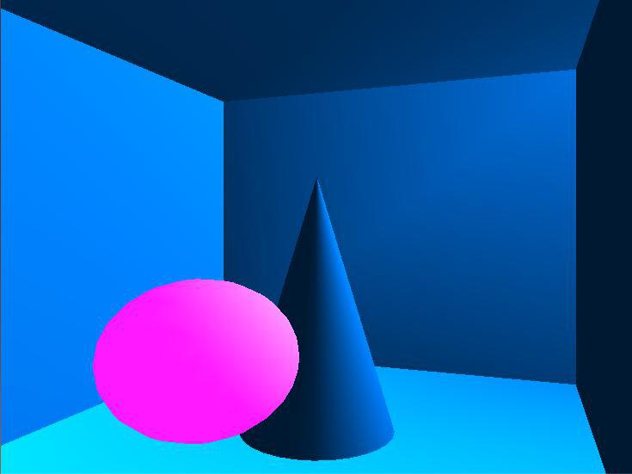

Fig 6.1: A single image of a cone with rotating sphere
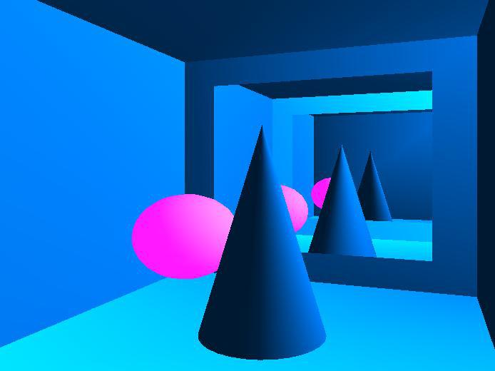

Fig 6.2: Multiple mirror images of a cone

Dept. of CSE, EWIT. Page 30
MULTI MIRROR | 2016-2017
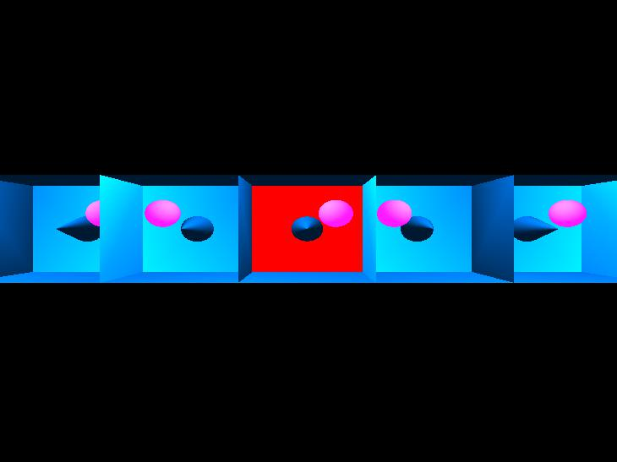

Fig 6.3: Top view of multiple mirror images

Dept. of CSE, EWIT. Page 31
MULTI MIRROR | 2016-2017

CONCLUSION

We had a great experience in the course of designing this package, which made me discover and learn many things as, pertain to the topic of OpenGL programming. I have tried to my best potential to incorporate all the basic level requirements of a normal graphics package for Windows operating system. This is very reliable graphics package supporting various decisions, objects like sphere, cone. Also selection, menu based interface are included. Transformations like translation, rotations are also provided. The project meets the basic requirements of user successfully. It can be implemented to display the multiple mirror images of a cone and to view the image from the top. Since its user friendly it enables the user to interact effectively and easily. The project uses simple translations and rotation that makes it look simple and faster. Special attention has been provided to the interfaces, menus that make it use comfortable.

Dept. of CSE, EWIT. Page 32
MULTI MIRROR | 2016-2017

REFERENCES

Referred Book:

“Interactive Computer Graphics A Top-Down Approach With OpenGL”, By Edward Angel, 5th edition of Pearson Education, 2008.
“Computer Graphics with openGL”, ByDonald D Hearn and M.Pauline Baker,3rd edition

Referred Websites:

http://www.opengl.org

http://www.wikipedia.com

https://www.opengl.org/archives/resources/faq/technical/mirror.c

Dept. of CSE, EWIT. Page 33
MAZE PROBLEM
 | APPENDIX
SL | FUNCTION | DESCRIPTION
NO. | FUNCTION | DESCRIPTION
1 | void glutSetWindow(int id) | sets the current window to the
1 | void glutSetWindow(int id) | window with identifier id.
2 | void glutContextVersion(int major_version, int | sets the desired context.
2 | minor_version) | sets the desired context.
 |  | sets the desired context to
3 | void glutContextProfile(init profile) | either GLUT_CORE_PROFILE
3 | void glutContextProfile(init profile) | or GLUT_COMPATIBILITY_
 |  | PROFILE.
4 | void glGenVertexArrays(GLsizei n, GLuint | Generates an unused identifiers
4 | *array) | for vertex array objects in array.
5 | void glGenBuffers(GLsizei n, GLuint *buffer) | Generates an unused identifiers
5 | void glGenBuffers(GLsizei n, GLuint *buffer) | for buffer objects in buffer.
 |  | updates size bytes starting at
6 | void glBufferSubData(GLenum target, Glint iptr | offset in the current buffer
6 | offset, GLsizeiptrsize,constGLvoid *data) | object with data of type target
 |  | starting at data.
7 | void glEnableVertexAttribArray(GLuint index) | enables the vertex array with
7 | void glEnableVertexAttribArray(GLuint index) | identifier index.
 |  | registers the display callback
8 | void glutIdleFunc(void (*f)(void)) | function f that is executed
8 | void glutIdleFunc(void (*f)(void)) | whenever there are no
 |  | otherevents to be handled.
 |  | registers the motion callback
 |  | function f. The position of
9 | void glutMotionFunc(void (*f)(int x, int y)) | mouse is returned by the
9 | void glutMotionFunc(void (*f)(int x, int y)) | callback when the mouse is
 |  | moved at with least one of the
 |  | mouse buttons pressed.
Dept. of CSE, EWIT. Page 51 |  | 2017-18

MAZE PROBLEM
 |  | registers the motion callback
 | void glutPassiveMotionFunc(void (*f)(int x, int | function f. The position of the
10 | void glutPassiveMotionFunc(void (*f)(int x, int | mouse is returned by the
10 | y)) | mouse is returned by the
 | y)) | callback when the mouse is
 |  | moved.
 |  | sets the desired mode for
 |  | polygon rendering the faces
11 | void glPolygonMode(glEnum faces, glEnum | (GL_FRONT_AND_BACK).
11 | mode) | Mode can be
 |  | GL_POINTS,GL_LINES, or
 |  | GL_FILL.
12 | void glPointSize(GLfloat size) | sets the point size attribute in
12 | void glPointSize(GLfloat size) | pixels.
 |  | sets flag to make the depth
13 | glDepthMask(GLboolean flag) | buffer read-only (GL_FALSE)
 |  | or writable (GL_TRUE).
 | glTexParameter[if](GLenum target, | sets the texture parameter param
14 | glTexParameter[if](GLenum target, | to value for texture of type
14 | GLenumparam, TYPE value) | to value for texture of type
 | GLenumparam, TYPE value) | target.
 |  | returns in name the first
15 | glGenTextures(GLsizei n, GLuint name) | integer of n unused integer for
 |  | texture-object identifiers.
 | glDeleteTextures(GLsizei n, GLuint | deletes n texture objects from
16 | glDeleteTextures(GLsizei n, GLuint | the array name array that holds
16 | *namearray) | the array name array that holds
 | *namearray) | texture-object names.
17 | void glDrawBuffer(GLenum buffer) | selects the color-buffer buffer
17 | void glDrawBuffer(GLenum buffer) | for rendering.
 |  | selects one of the 16 logical
 |  | writing modes if the feature
18 | void glLogicOp(GLenum op) | GL_COLOR_LOGIC_OP is
18 | void glLogicOp(GLenum op) | enabled. Modes include
 |  | replacement (GL_COPY), the
 |  | default, and exclusive or
Dept. of CSE, EWIT. Page 52 |  | 2017-18

MAZE PROBLEM
 |  | (GL_XOR).
19 | void glGetBooleanv(GLenum name, GLboolean | writes the present value of the
19 | *param) | parameter name into param.
 |  | creates an empty program
20 | GLuintglCreateProgram() | object and returns an identifier
 |  | for it.
 |  | returns the current value of a
21 | intglutGet(GLenum state) | GLUT state variable such as
21 | intglutGet(GLenum state) | GLUT_WINDOW_WIDTH,
 |  | GLUT_WINDOW_HEIGHT.
 |  | creates an empty shader object
 |  | of type
22 | GLuint glCreateShader(GLenum type) | GL_VERTEX_SHADER or
 |  | GL_FRAGMENT_SHADER
 |  | and returns an identifier for it.
23 | void glCompileShader(GLuint shader) | Compiles shader object shader.
 |  | identifies the source code for
 |  | shader as coming from an
 | void glShaderSource(GLuint shader, GLsizei | array of n strings strings of
24 | nstrings, const GLchar**strings, const | lengths characters. If the shader
 | Glint*lengths) | is a single null-terminated string,
 |  | then nstrings is 1 and lengths is
 |  | NULL.
25 | void glAttachShader(GLunit program, GLuint | Attaches shader object shader
25 | shader) | to program object program.
 |  | links together the application
26 | void glLinkProgram(GLuint program) | and shaders in program object
 |  | program.
27 | void glUseProgram(GLuint program) | makes program the active
27 | void glUseProgram(GLuint program) | program object.
 | void glGetProgram(GLuint program, GLenum | returns in param the value of
28 | void glGetProgram(GLuint program, GLenum | parameter pname for program
28 | pname, GLinit *param) | parameter pname for program
 | pname, GLinit *param) | object program.
Dept. of CSE, EWIT. Page 53 |  | 2017-18

MAZE PROBLEM
 | void glGetShaderiv(GLuint shader, GLenum | returns in param the value of
29 | void glGetShaderiv(GLuint shader, GLenum | parameter pname for shader
29 | pname, GLint *param) | parameter pname for shader
 | pname, GLint *param) | object shader.
 |  | returns the info log string for
30 | void getProgramInfoLog(GLuint program, | program object program into the
30 | GLsizei maxL, GLsizei *len, GLchar *infoLog) | array info of lenthmaxL and the
 |  | length of the string in len.
 | void getShaderInfoLog(GLuint program, | returns the info log string for
31 | void getShaderInfoLog(GLuint program, | shader object program into the
31 | GLsizei maxL, GLsizei *len,GLchar *infoLog) | shader object program into the
 | GLsizei maxL, GLsizei *len,GLchar *infoLog) | array info of lenthmaxL.
 |  | renders the character with ASCII
 |  | code char at the current
 |  | raster position using the stroke
32 | void glutStrokeCharacter(void* font, int char) | font given by
32 |  | fontGLUT_STROKE_MONO
 |  | and
 |  | GLUT_STROKE_ROMAN.
 | void glutWireTeapot(GLdouble size) | generates a Utah teaport
 | void glutWireTeapot(GLdouble size) | including normals and texture
33 | void glutSolidTeapot(GLdouble | including normals and texture
33 | void glutSolidTeapot(GLdouble | coordinates of size.
 |  | starts a new display list with
 |  | identifier name. The value of
 | void glNewList(GLuint name, Glenum mode) | mode determines if the list is
34 | void glNewList(GLuint name, Glenum mode) | placed on the server with or
 |  | without executing the list.
 |  | GL_COMPILE_AND_EXEUTE.
 | void glEndList() | ends the specification of a
35 | void glEndList() | display list.
 |  | sets the render mode to mode
36 | void glRenderMode(Glenum mode) | (GL_RENDER,GL_SELECTION
 |  | GL_FEEDBACK).
37 | void glSelectBuffer(Glsizei n, Gluint *buff) | specifies the array buff of n
37 | void glSelectBuffer(Glsizei n, Gluint *buff) | integers to place selection data.
Dept. of CSE, EWIT.

MULTI MIRROR |  | 2016-2017
 |  | creates a projection matrix for
 | void gluPickMatrix(GLdouble x, GLdouble y, | picking that restricts rendering
38 | void gluPickMatrix(GLdouble x, GLdouble y, | to a w X h area centered at (x,y)
38 | GLdouble w, GLdouble h, GLint *vp) | to a w X h area centered at (x,y)
 | GLdouble w, GLdouble h, GLint *vp) | in window coordinates within
 |  | the viewport vp.
39 | void glGenVertexArrays(GLsizei n, GLuint | Generates an unused identifiers
39 | *array) | for vertex array objects in array.
 | void glMapGrid1fd(Glint n, TYPE u0, TYPE | sets up an equally space grid of
40 | u1) | n partitions between u0 and u1
40 | void glMapGrid2fd(Glint n, TYPE u0, TYPE u1, | (and of m partitions between v0
 | Glint m, TYPE v0, TYPE v1) | & v1).
 |  | defines quadric object obj as a
41 | void gluSphere(GLUquadricObj *obj, GLdouble | sphere of radius using slices
41 | radius, GLint slices, GLint stacks) | lines of longitude and stacks
 |  | lines of lattitude.
 | gluBuild2Dmipmaps(GLenum target, GLinti | builds and loads a set of
 | format, GLint width, GLint height, GLenum | builds and loads a set of
42 | format, GLint width, GLint height, GLenum | mipmaps.
42 | format, GLenum type, void *texels) | mipmaps.
 |  | binds name to texture of type
43 | glBindTextures(Glenum target, Gluint name) | target (GL_TEXTURE_1D,
43 | glBindTextures(Glenum target, Gluint name) | GL_TEXTURE_2D,
 |  | GL_TEXTURE_3D).
44 | glHint(Glenum option, Glenum hint) | requests that hint to be applied
44 | glHint(Glenum option, Glenum hint) | to option.
45 | void glDisableClientState(Glenum array) | disables one of the array.
 |  | defines the operation
 |  | (GL_ACCUM, GL_LOAD,
46 | glAccum(Glenum operation, Glfloat value) | GL_RETURN, GL_ADD)
 |  | performed by the accumulation
 |  | buffer using the constant value.

Dept. of CSE, EWIT. Page 38
MULTI MIRROR |  |  | 2016-2017
 |  |  | sets fog parameter param to
47 |  |  | value. Parameters include
47 | void glFog[if](Glenum param, TYPE value) |  | GL_FOG_MODE,
 |  |  | GL_FOG_COLOR,GL_FOG_
 |  |  | DENSITY.
 |  |  | draws elements of the standard
 |  |  | OpenGL types mode, such as
 | void glDrawElements(Glenum mode, Glsizei n, |  | GL_POLYGON or
 |  |  | GL_LINES, using n indecies
 | Glenum type, void *indices) |  | GL_LINES, using n indecies
48 |  |  | from the array indices of type
 |  |  | GL_UNSIGNED_BYTE,
 |  |  | GL_UNSIGNED_SHORT, or
 |  |  | GL_UNSIGNED_INT.
 | void | glVertexPointer(Glint dim, Glenum type, | specifies data for arrays. The
 | Glsizei stride, Glvoid *array) |  | specifies data for arrays. The
 |  |  | data are in array of type with
 | void | glColorPointer(Glint dim, Glenum type, | data are in array of type with
 | void | glColorPointer(Glint dim, Glenum type, | dimension dim, stride is the
 | Glsizei stride, Glvoid *array) |  | dimension dim, stride is the
 |  |  | number of bytes between
 | void | glNormalPointer(Glint dim, Glenum type, | number of bytes between
 | void | glNormalPointer(Glint dim, Glenum type, | consecutive data values (0
 | Glsizei stride, Glvoid *array) |  | consecutive data values (0
 |  |  | indicates the data are packed in
49 | void | glTextCoordPointer(Glint dim, Glenum type, | indicates the data are packed in
49 | void | glTextCoordPointer(Glint dim, Glenum type, | array).
 | Glsizei stride, Glvoid *array) |  | array).
 | Glint glGetUniformLocation(GLuint program, |  | returns the index of uniform
 |  |  | variable name from the linked
 | constGlchar *name) |  | variable name from the linked
50 |  |  | program object program.

Dept. of CSE, EWIT. Page 39

