**Data**

At this section, we will take a look to the data which we are going to use to solve the problem. First I have used the location data of the boroughs of Bursa. Bursa has 17 boroughs. Before we find the venues we need to find the coordinates of the boroughs. I have used the geolocator library to find the latitude and longitude values for each borough. You can find the values below.

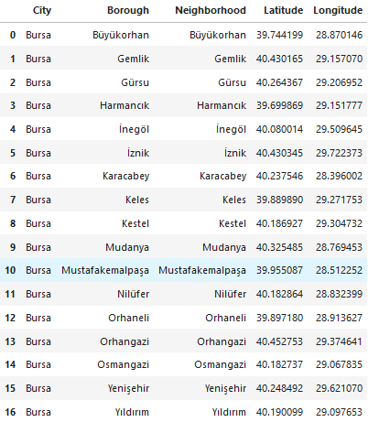

Table 1 Latitude and Longitude values of boroughs

The neighborhood values was empty for the each borough. So I used borough values for the neighborhood values too. Now we can create the map of Bursa. We need the latitude and longitude values of the Bursa. Latitude value is equal to 40.182737 and longitude value is the 29.0678352. Now we can draw a map to see the distrubition of the Bursa’s boroughs.

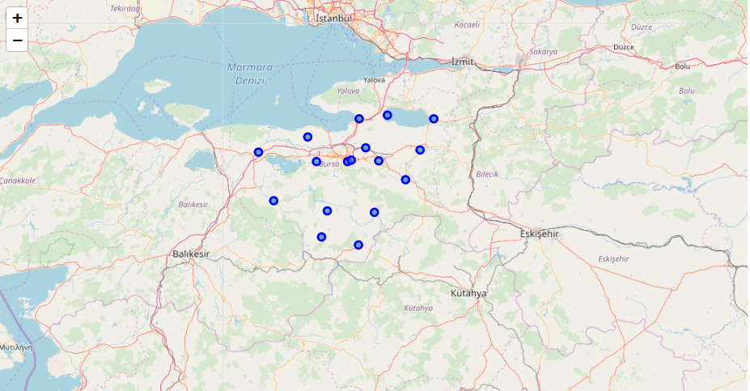

Map 1 Distrubition of the Boroughs

After we draw the map we will use Foursquare API to find the venues for each boroughs. I have used a function to find the venues at 4.1 kilometers radius. Bursa’s littlest borough is ‘Yıldırım’ which is 110 kilometers square. If we want to draw a circle from the coordinate base of the Yıldırım radius of this circle will be 4180 meters. So I used this distance for all boroughs. I have found 904 venues for 17 boroughs. You can see the first and last five rows of the data frame.

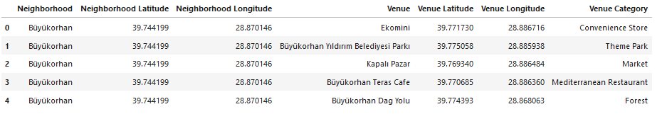

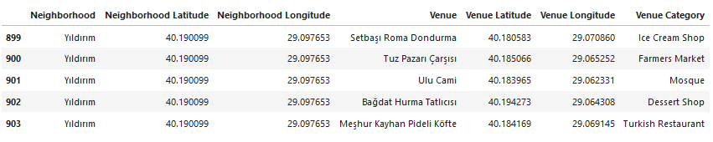

Table 2 First and Last Five Rows of the Data Frame

Now, I will group the venues according to counts for all boroughs to see the number of the venues in each borough.

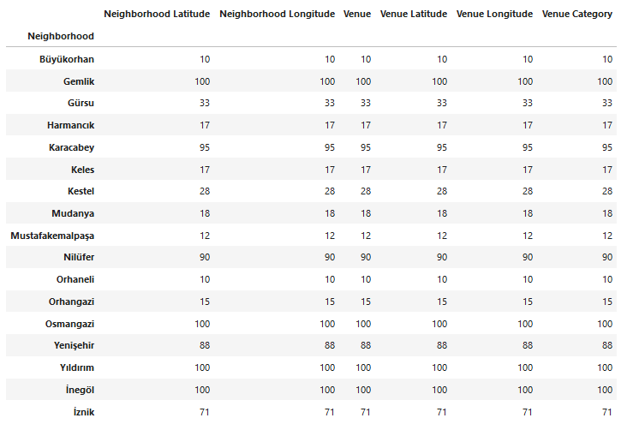

Table 3 Number of Venues at Boroughs

We need the categories of the venues to find most common venues. I will use the *unique* method of the dataframe. There are 180 unique categories in our data frame. In the next section, we will use this data to create a new data frame to use in clustering algorithm.