

**İhsan Doğramacı Bilkent University**

**Fall 2017**

**CS353 – Database Systems**

**Term Project Proposal Report**

**Group 33:**

Osman Sefa İbiş - 21301693

Mustafa Mert Aşkaroğlu - 21400195

Gökalp Köksal - 21400549

İbrahim Berker Kırdök - 21502870

**Table of Contents**

[**Table of Contents 2**](https://docs.google.com/document/d/1Ci_wSMNkocZNEZqhr-HI7xGHOPcVK7oH-h317LmVf-A/edit#heading=h.gjdgxs)

[**Description of the Project 3**](https://docs.google.com/document/d/1Ci_wSMNkocZNEZqhr-HI7xGHOPcVK7oH-h317LmVf-A/edit#heading=h.17dp8vu)

[Requiring a Database System 3](https://docs.google.com/document/d/1Ci_wSMNkocZNEZqhr-HI7xGHOPcVK7oH-h317LmVf-A/edit#heading=h.26in1rg)

[**E/R Diagram of the Conceptual Design 4**](https://docs.google.com/document/d/1Ci_wSMNkocZNEZqhr-HI7xGHOPcVK7oH-h317LmVf-A/edit#heading=h.lnxbz9)

[**Requirements**](https://docs.google.com/document/d/1Ci_wSMNkocZNEZqhr-HI7xGHOPcVK7oH-h317LmVf-A/edit#heading=h.4i7ojhp) **5**

[Functional Requirements](https://docs.google.com/document/d/1Ci_wSMNkocZNEZqhr-HI7xGHOPcVK7oH-h317LmVf-A/edit#heading=h.1ci93xb) 5

[Non- Functional Requirements](https://docs.google.com/document/d/1Ci_wSMNkocZNEZqhr-HI7xGHOPcVK7oH-h317LmVf-A/edit#heading=h.sqyw64) 5

[**Limitations**](https://docs.google.com/document/d/1Ci_wSMNkocZNEZqhr-HI7xGHOPcVK7oH-h317LmVf-A/edit#heading=h.2u6wntf) **6**

[**Website**](https://docs.google.com/document/d/1Ci_wSMNkocZNEZqhr-HI7xGHOPcVK7oH-h317LmVf-A/edit#heading=h.2dlolyb) **7**

**Description of the Project**

In this project a web application which is similar to the “Yemek Sepeti” will be implemented. This application will mostly aim to the restaurants which have no delivery staff. Restaurants and customers who will order their food via this application are will be the users of the system. System will arrange the delivery route and the employees who will be delivering the orders to the customers. In other words, customers will order their food and the system will assign a courier for the delivery not the restaurant.

Users of the system will be restaurants and the customers. Therefore, there will be different types of registering to the application. Restaurants and customers will sign up as “Restaurant” and “Customer” respectively. Users with “Restaurant” tag will have to provide their valid company information and password to sign up. However, users with “Customer” tag will sign up with a valid e-mail address and a password. Restaurants will provide their information about their company and their products onto their webpage. For example, they will have to provide serving region information to be shown to the customers whose are in the same region. Similarly, customers will have to provide region information to see restaurants which can serve to them.

**Requiring a Database System**

The main motivation of our web application is being a connection between restaurants and customers. This goal requires keeping lots of information as a data. Therefore, implementing an efficient database system plays an integral role to keep, update and manage our data systematically. In addition to that, database systems are most commonly preferred by designers who are implementing huge systems to keep their data safe. Moreover, a database system will be beneficial way to analyze data and use it for a purpose. For instance, an analyzer who want to categorize customer portfolio in terms of age would need a well implemented database system to reach information systematically and quickly.

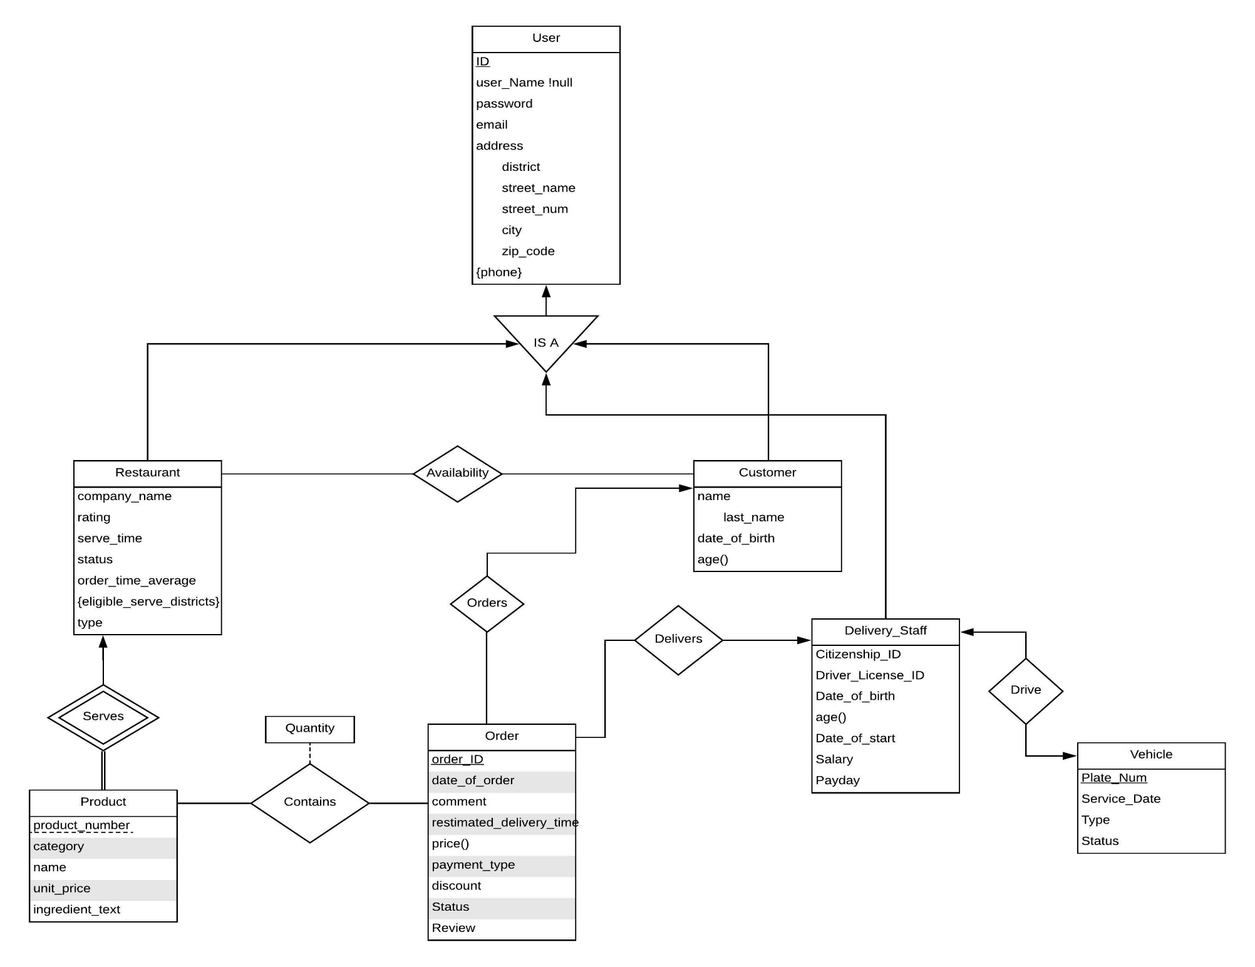**E/R Diagram of the Conceptual Design**

**Requirements**

**Functional Requirements**

* System has sign-in and sign up feature.
  + A user could be a restaurant, a customer or a delivery staff
* Restaurants can add/change their products and information to their own page.
* Users can see all restaurants that serves to their districts and products are served by them.
* Customers can order products from restaurants that serve to their districts.
* Customers can display their previous orders.
* Customers can rate and add review about their orders.
* System could control if a vehicle is under repair or not.
* A restaurant can select one or more districts to serve.
* Customer can order products for future date or time.
* Customer can search restaurants.
* Customer can filter restaurants by their types.
* Users can change/update their personal information
* Delivery staffs can display their previous delivered orders.

**Non- Functional Requirements**

* There shall be password requirements for security like length, special characters, etc.
* For access security the passwords shall never be viewable after the point of sign-in.
* The interface of the application shall be user friendly and the system will be easy to learn, operate, etc.
* Access permissions for system data shall only be modified by the system’s data administrator.
* The system shall be able to perform its required functions for a specific time period.
* Data storage for the database system should meet the storage space necessity for the application.
* The application shall perform the specified functions without failure. (ex: order, availability, etc.)

**Limitations**

* Company name cannot be larger than 30 characters
* User name cannot be larger than 30 characters
* User name cannot start with number
* Username cannot be left null
* User password cannot be left null
* Restaurant name cannot start with number
* Customer name cannot start with number
* Delivery Staff salary attributes cannot be lower than 1.603 TL
* Restaurant name cannot be left null
* Quantity attribute in “Contains” relation cannot be 0
* A product cannot be created without a restaurant
* Serve time cannot be larger than 90 minutes.
* Delivery Staff’s age attribute cannot be less than 18.
* Product price cannot be negative number.
* Order’s discount attribute cannot be negative number.
* Vehicle cannot be used if it is under repair.
* Restaurant rating cannot be negative

**Website**

Our webpage is:

https://brker.github.io/hungerbox/