Chat Server Documentation

What chat server does?
Chat server is implemented for room based messaging among the clients. The server is listening different ports for each room, so client should join to a port for communicating with others. Each room can have maximum 32 clients (this may increase) and server can open 9 rooms (this may increase too). The server is listening the port 8080 initially. If 10 rooms are open, the server will listen the ports between 8081-8089 as the rooms (that makes 9 rooms). The port 8080 just says to the client that there are some rooms where client can join.

The example below shows the chat server has opened with 3 childs and each have 3 threads. The server uses preforking and prethreading at the same time. Each child (fork) has three threads that clients can join. 8080 is the main port, others are the room ports.
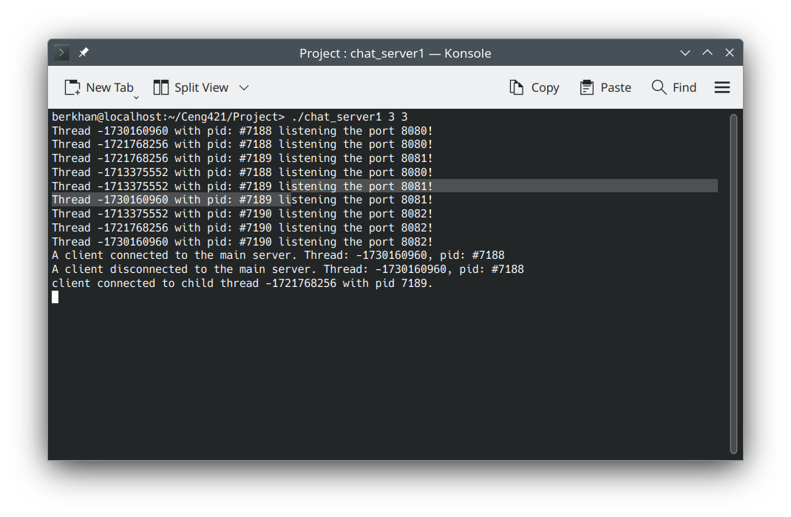
Main port sent the open room list and the client joined the room 1 (port 8081). When a client entered the room, if the room is not full, it will connect in and can message with clients in that room.
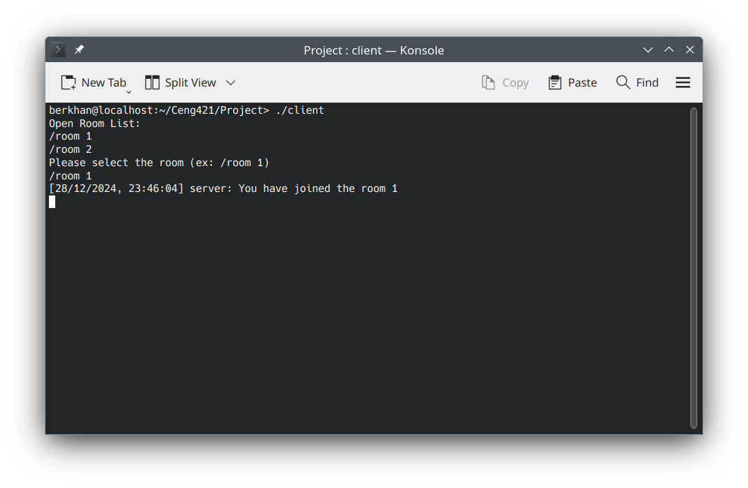
There is a room example below. There are two rooms that clients can join. Two clients are joining the room 1, but one client is joining to the room 2. While two clients can communicate with each other, the other client cannot receive the messages since it is in the different room.
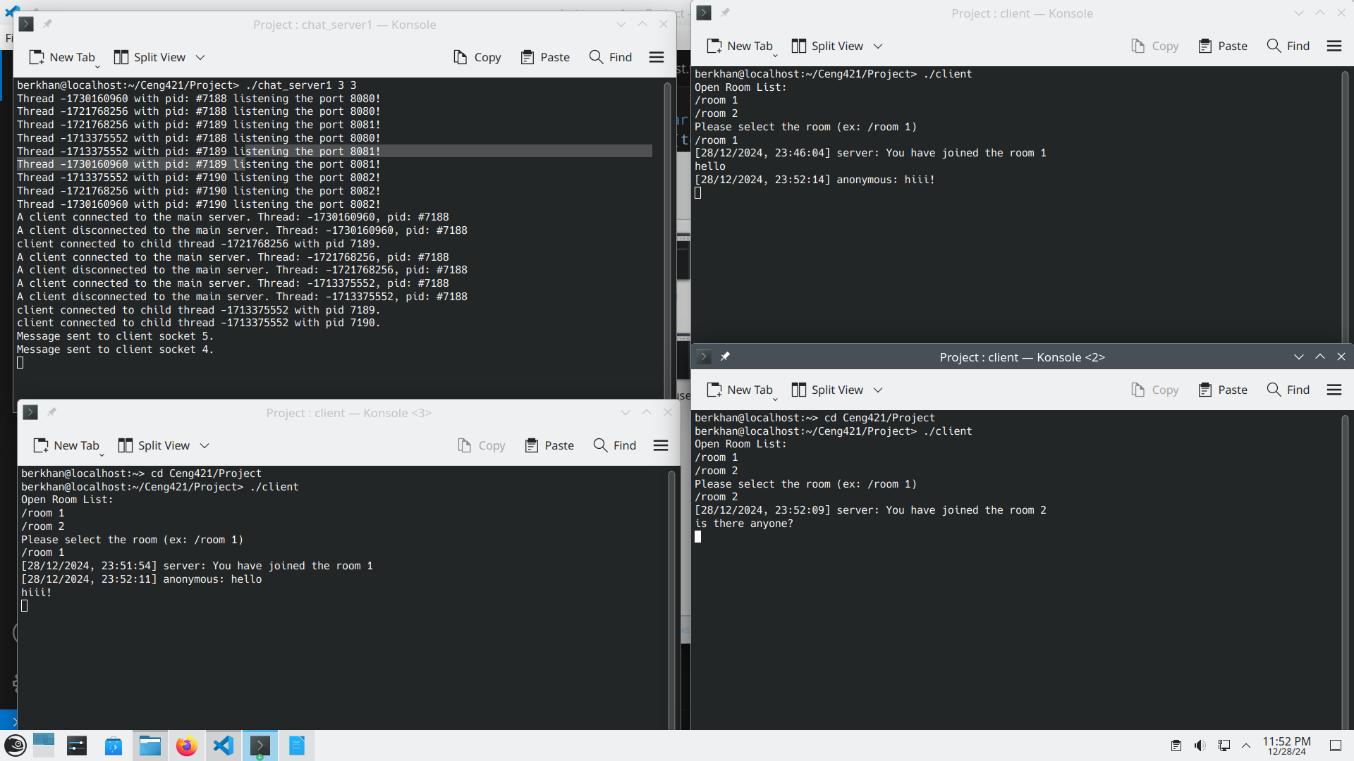
When clients join to the room, they will be messaging as anonymous until they authenticated their name (username) with a password. For authentication, they need to register.

How rooms work?
Each room has been identified as different ports, so they have their own capacity and user list. To identify different rooms, chat server uses preforking. Since they are in different port, there will be no communication between rooms. Each preforking has maximum 32 prethreads. These threads are where users connect and communicate. Each room has its own users dictionary and client sockets array. Client sockets array where anonymous and authenticated users’ sockets are stored. When user join to the room, its socket will be entered to the sockets array. When there is a broadcasting, the server simply loops that array. Users dictionary is the dictionary where authenticated users are stored. When a user authenticated, its name (username) and socket number would be stored in there.

How client communicates with the chat server?
If client sent sequence has ‘/’ as the first latter, they will be communicating with the server. There are some features that the server provides:
- /register <name> <password>
- /authenticate <name> <password>
- /exit
- /online
- /private <name> <message>
- /request <name>
- /requests
- /accept <name>
- /decline <name>
- /accepts
- /remove <name>
- /online_accepts

/register → does registration for the clients. Their names have to be unique and between 3-50 characters. Passwords have to be between 3-50 characters too. Supported characters: a-z and A-Z and 0-9 and ‘_’ and ‘.’ and ‘#’.
/authenticate → does authentication in the server. Before authentication, the client have to be registered.
/exit → removes the authentication to do messaging as anonymous. That does not mean registration is removed.
/online → receives online list in that room. Only authenticated users can be seen in the list.
/private → only authenticated users can do private messaging. Private messaging can be done with the clients in the same room.
/request → sending request to the target name. If the name is not exists, or the sender is not authenticated the requesting will fail. There are 64 requests limit to have.
/requests → seeing the list of the requests that have sent to the client. Only authenticated users can do that.
/accept → accepting the requests of the senders. Only authenticated users can do that. There are 64 accepts limit to have.
/decline → declining the requests of the senders. Only authenticated users can do that.
/accepts → seeing the list of the accepts that have been accepted by the client. Only authenticated users can do that.
/remove → removing the user from the accepted list. Only authenticated users can do that.
/online_accepts → seeing the online accepts of this client with their room information. (ex: ali /room 1, sena /room 2)

Example of authentication
The example below shows using of register, authenticate, online, exit, and private. Private messages are sent to the server, server finds the user who will get it and sends to that user. To send private messages the server just searches for online users. When the user is not found, the message would not be sent.

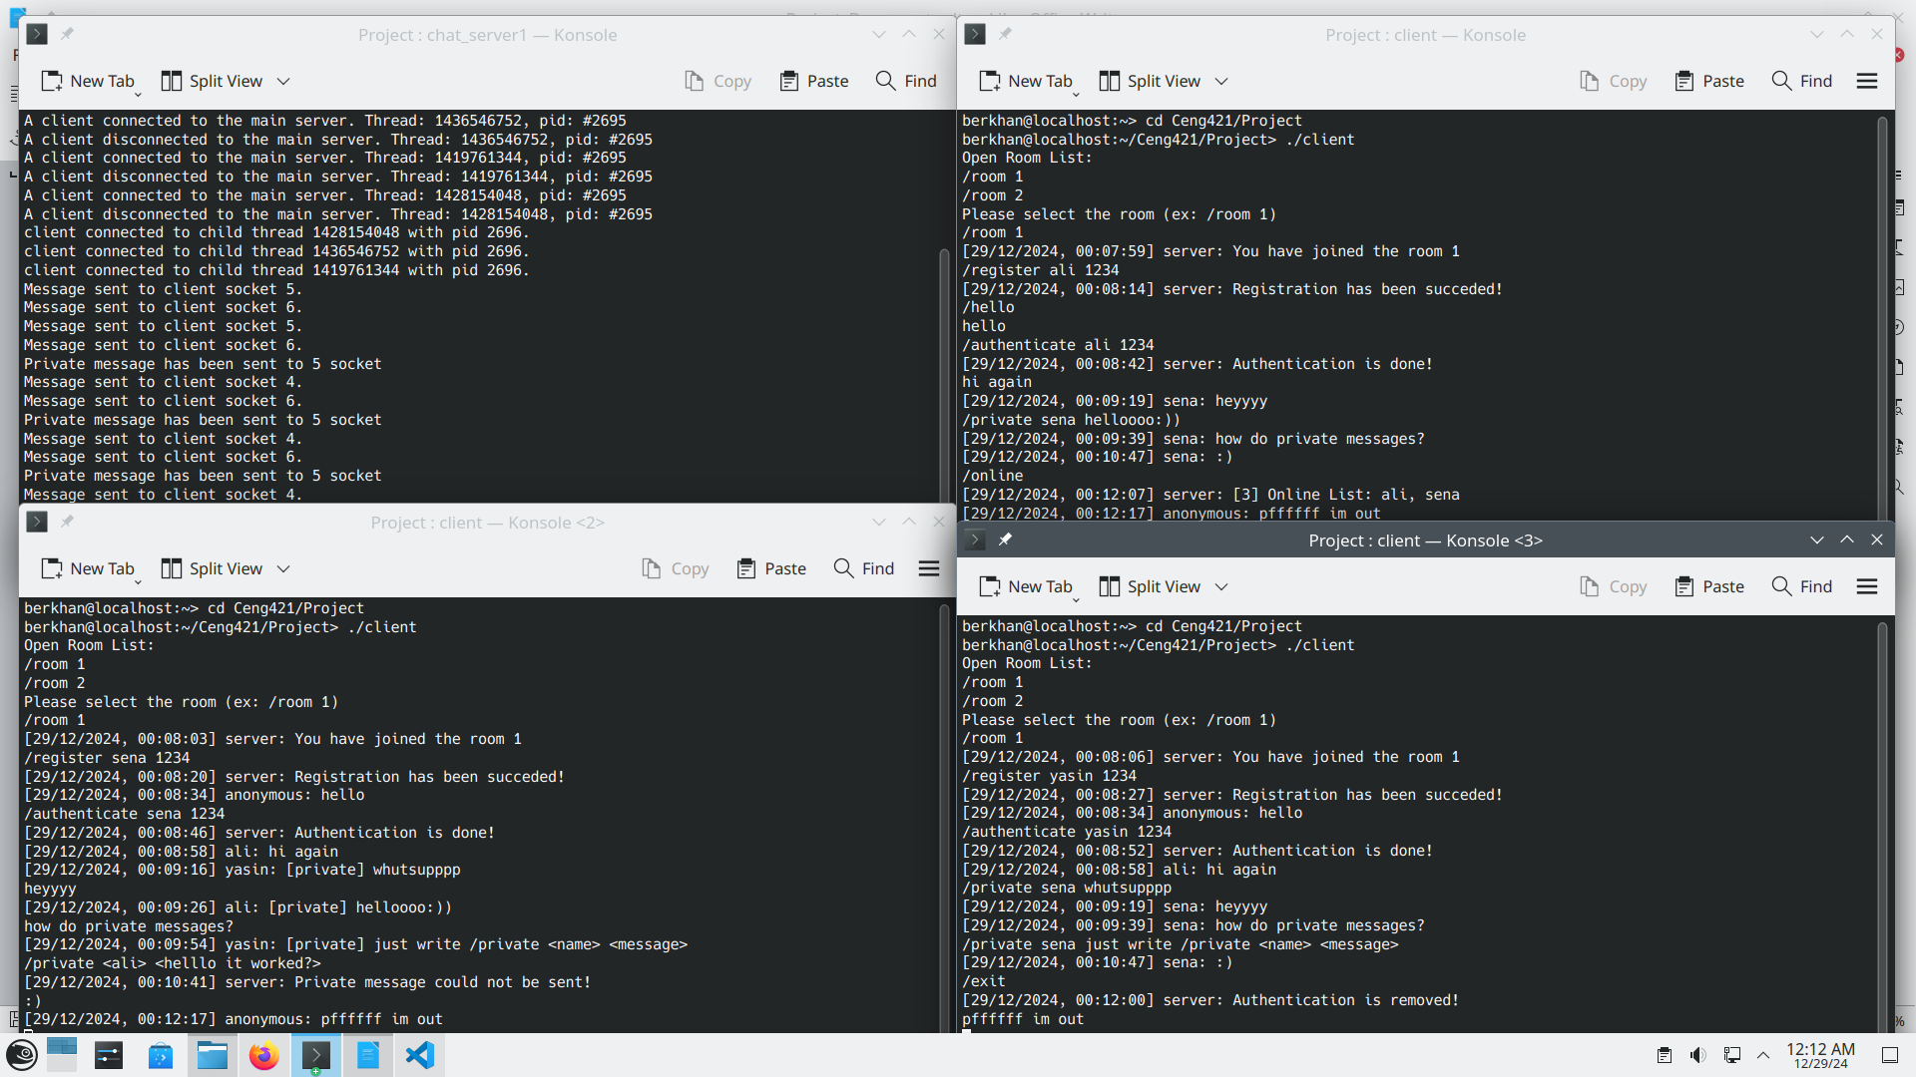
The registration is not based on the rooms. When a client registered successfully, the server saves it into a file named “registered_users.txt”. Therefore, when a client registered in a room, it can authenticate in all rooms that are open. An example of registered users file is shown below.

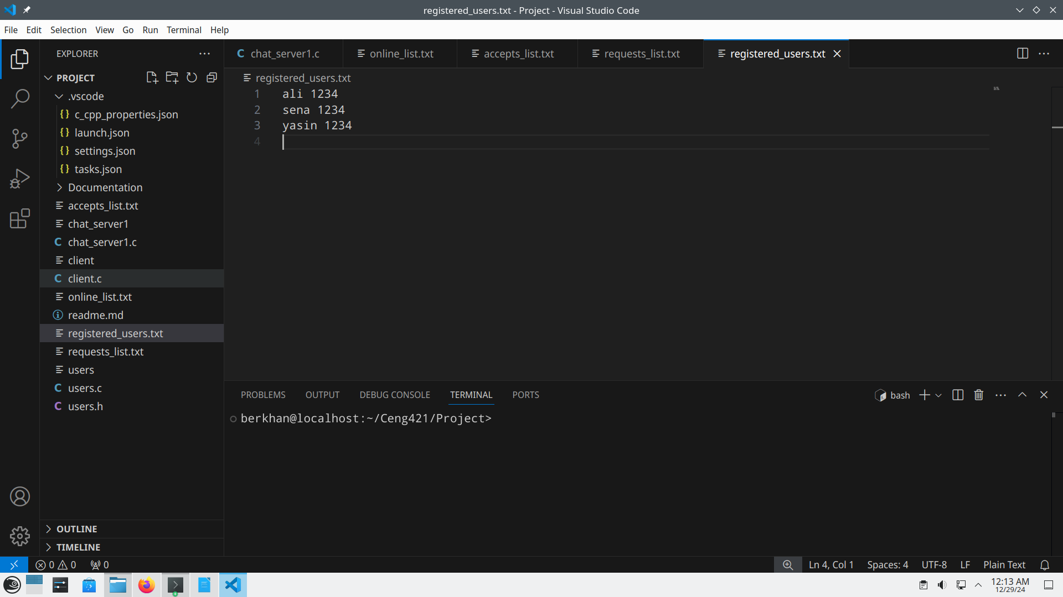
Why anonymous users cannot send private messages?
An anonymous user can only be identified as sockets. The client cannot know other clients sockets, so they need a unique attribute such as name (username). Also, a private message from anonymous, or to anonymous cannot be understood by the server and the receiver. Who sent it, where to sent it?

How chat server handles the broadcasting?
Broadcasting is when a client does not use the server communication (“/”) messages. Every clients can send broadcasting messages. The user simply writes the message without beginning with “/”. When server receives it, the message would be sent to all sockets in client sockets array. This is called broadcasting.

How chat server handles the registration?
A client has to be unauthenticated for the registration. The client has to be in a room to register. When it sends proper “/register <name> <password>” the server will append it into the file. When registration is done successfully, server will send “Registration has been succeded!”. When registration is failed, it might be about uniqueness of the name, length of name, length of password, and unavailable characters. Then server sends “Registration has been failed!”.

How chat server handles the authentication?
A client has to be unauthenticated for the authentication. The client has to be in a room to authenticate. When it sends proper “/authenticate <name> <password>” the server will check the registered the user is exists and password is right. Also, the server will check users dictionary if it is already exists in there. If it is not exists, the server adds the name with client’s socket. Then authentication would be done successfully. Users dictionary is where authenticated users are stored with their socket values. Each room has its own users dictionary. Since each thread knows its own client’s socket, threads can receive the name by their socket, or others socket by other’s name. Thus, private messaging would be available.

How chat server handles the private messaging?
A client has to be authenticated for the private messaging. The client has to know the name of the user to send the message. The client can search for it as sending “/online”. When the client sends proper “/private <name> <message>” the server will check the users dictionary for if the name is exists in there. If it is exists, the server would get the receiver’s socket from the dictionary. Then the server sends the message to the socket. Since users dictionary belongs to the room, users can only send the private messages to members of the same room.

What if two threads manipulate the registered file (or arrays, dictionaries) at the same time?
Threading might be dangerous when manipulating the same structures-variables in the server. It can crush the server when there is a conflict. The server uses mutual exclusion feature in “pthread.h” library to handle it. This feature handles the manipulating when two threads try to reach to the same resources. The second manipulator would wait until the first manipulator will finish. Therefore, there will not be conflicts when registered file, dictionaries, or arrays being manipulated.

Example of requests
The example below shows using of request, accept, requests, accepts, decline, remove, and online_accepts. Requests are sent to the server, if server finds the target user, it will be stored in the file named “requests_list”. To accept requests the requests list must be checked. If it exists, accepting will happen, if not it gives error.
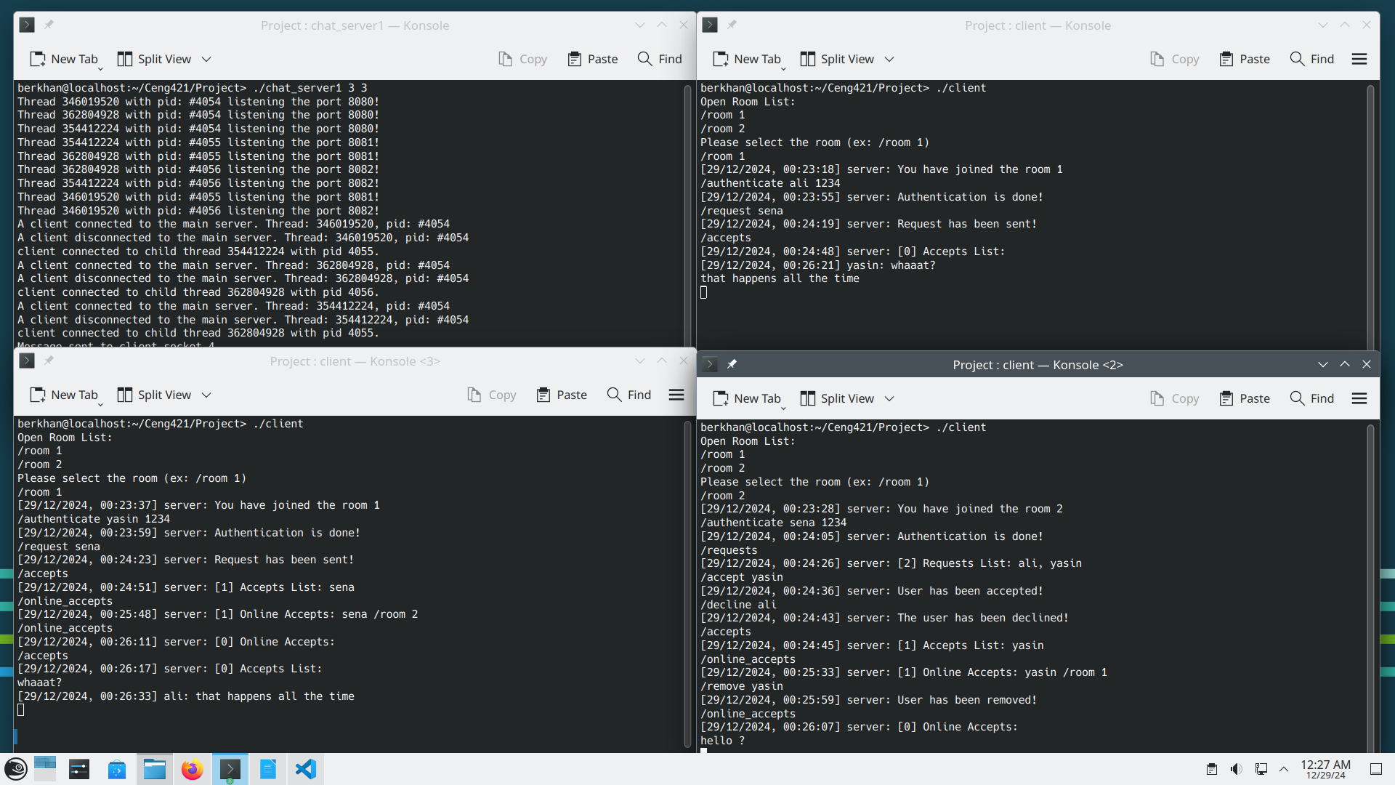
Requests, accepts, and online_list are stored in the files. There are examples of requests_list, accepts_list, and online_list files below.
Requests:
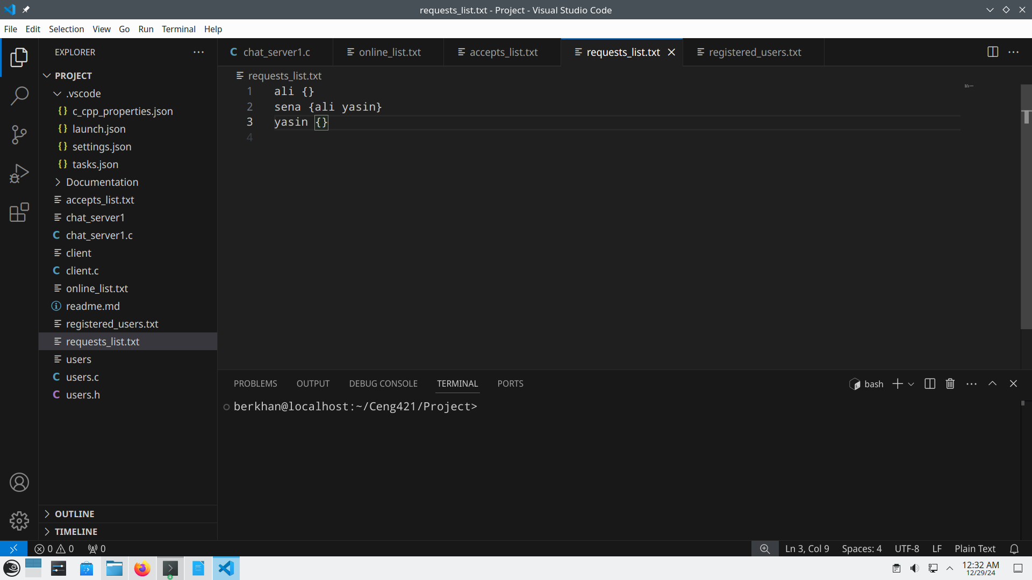

Accepts:
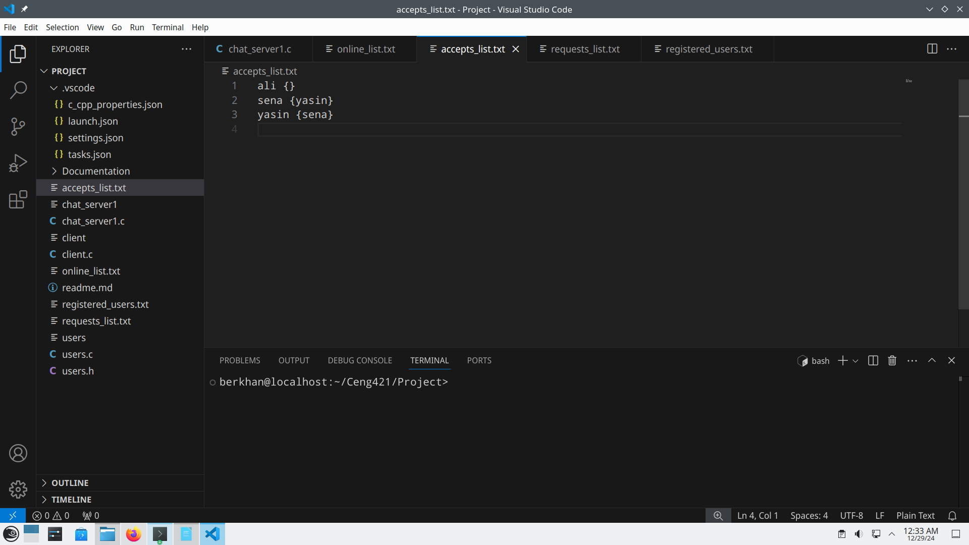
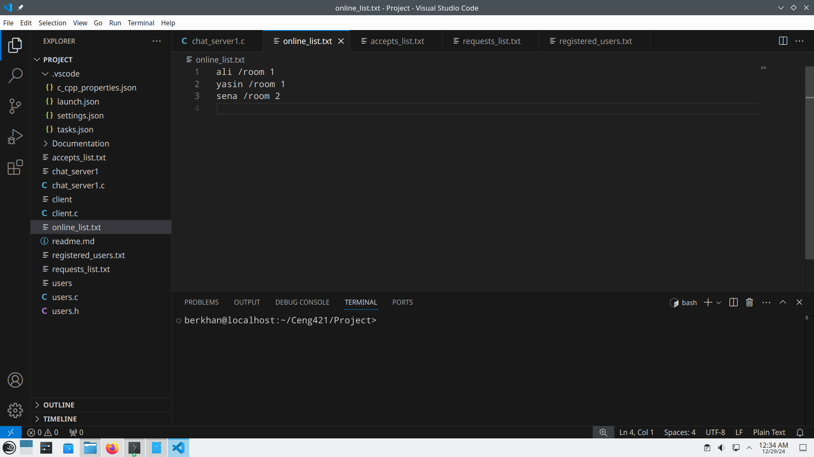
Online list:

How chat server handles the requests?
A client has to be authenticated for the requesting. The client has to know the name of the user to send the request. The client can search for it as sending “/online”. When the client sends proper “/request <name>” the server will check the registered users for if the name is exists. If it is exists, the server will move on to check if request is sent before. To do that, it checks the “requests_list” file if target name already has the sender name. If it hasn’t, then server adds the sender’s name to the target’s requests list.

How chat server handles the accepts?
A client has to be authenticated for the accepting. The client has to know the name of the user to accept the request. The client can search for it as sending “/requests”. When the client sends proper “/accept <name>” the server will check if request is actually sent. To do that, it checks the “requests_list” file if target name already has the sender name. If it has, then server adds the sender name to the target’s accepts list. Also, the target’s name will be added to the sender’s accepts list. Because, accepting means both sides are being connected somehow.

How chat server handles the online list and online accepts?
A client has to be authenticated for the online list. When the client is authenticated, its name and room information will be added to the “online_list” file. If an authenticated user send “/online_accepts”, the server will get this user’s accepts list and search if any accepted friend is in the “online_lists” file. If any one exists, it will be send to the user with their accepted users’ name and room information. If users “/exit”, they will be removed from the online list, so anonymous users would not be listed in there.
Why the server have request, accept and online accepts features?
Since this server is room based communication program, we need to store users information for their interactions. Users might need to communicate with their friends, or do not want to lost each other in those rooms. Online accepts provides that users accepted friends’ name and room information. We cannot give each users name and room information for every user. That depends on the users, so we have requesting and accepting features.

Why the server does not have saved messages feature?
We do not want the server have the permanent messages since people could be afraid of their talking in these days. We believe, when messages are volatile, people will use that kind of platforms even more. Ethernet is meant to have sharing and solidarity, but being identified make everything to be personal. Do not having permanent messages is a way to escape from it.

Included libraries in the Server:
#include <stdio.h>
#include <string.h>
#include <stdlib.h>
#include <ctype.h>
#include <sys/types.h>
#include <sys/socket.h>
#include <sys/ioctl.h>
#include <sys/wait.h>
#include <netinet/in.h>
#include <arpa/inet.h>
#include <unistd.h>
#include <pthread.h>

chat_server1.c have “users.h” as included library. “users.h” made to implement users dictionary. It has some methods to add into the dictionary, to remove the user from the dictionary etc.
To run server we have this “gcc (SUSE Linux) 7.5.0”. I used Linux Opensuse KDE Leap 15.6 version. To compile the server we need to write “gcc -o chat_server1 chat_server1.c users.c -pthread” onto the terminal. To compile the client we just need to write “gcc -o client client.c” onto the terminal. To run the server we need to write “./chat_server1 <Fork Number> <Thread Number>” like “./chat_server1 3 3” onto the terminal. To test the server with other computers our the client has been modified to connect the IP address “192.168.207.152”. If one need to connect to the local host, he/she need to change the IP addresses in the client before compiling it.

