1. **PROBLEM DEFINITION**

In this exercise, we have used continuous Hopfield model over 2 neurons. The differential equations that describes neurons are given as follows:

where g function is the continuous activation function at the output of each neuron given as

We know that equilibrium points for this 2 neuron system can be found via making left hand sides of the describing equations above equal to 0. Then, by writing one variable in terms of the other one, one can solve (using MATLAB’s *fsolve* function as shown in the code) equilibrium points.

We are interested in the energy of the overall system (in this case, total energy of 2 neurons). Energy equation is given as

* and we assumed that .

In order to evaluate energy term, we need to inverse g function and take the definite integral over given points.

* )

Now that we have derived all the necessary terms and functions, all we have to do is run our simulation for different values of and plot corresponding contour maps of energy levels and equilibrium points.

1. **VISUALISATION**

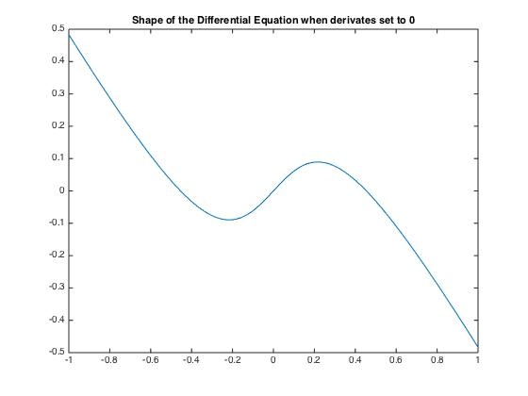

There are 3 equilibrium points as expected. Non-zero ones are located symmetric to y-axis and around -1 and 1.

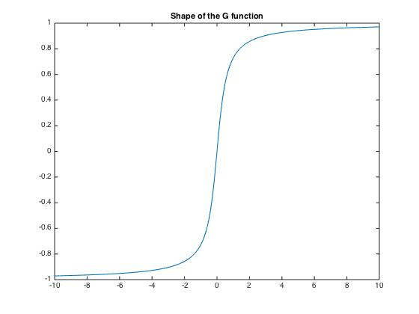

Shape of the g function is almost like a hard-type nonlinear function.

Following is an illustration of movement of equilibrium points with respect to varying lambda values. They move towards the corner of the contour map figure as expected.

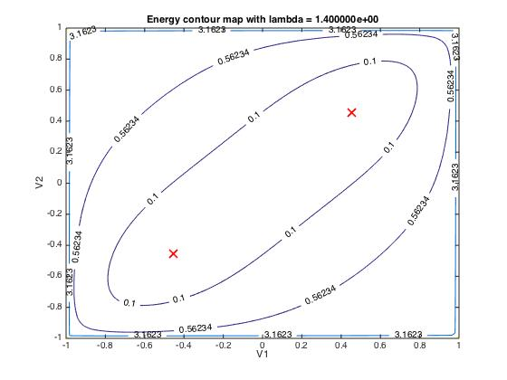

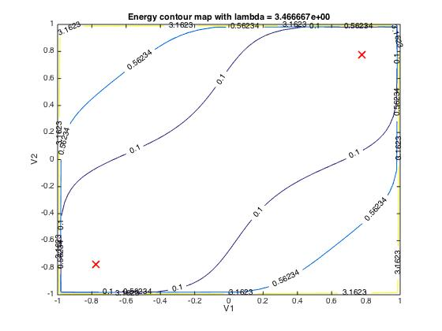

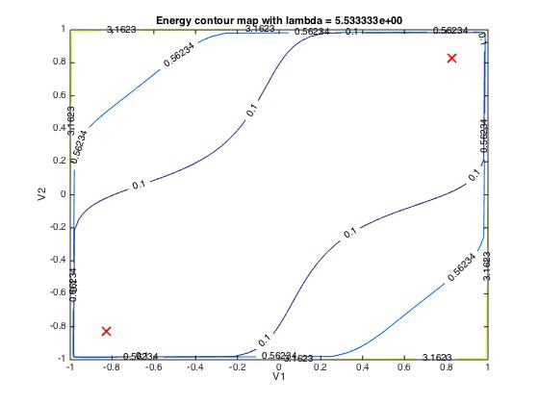

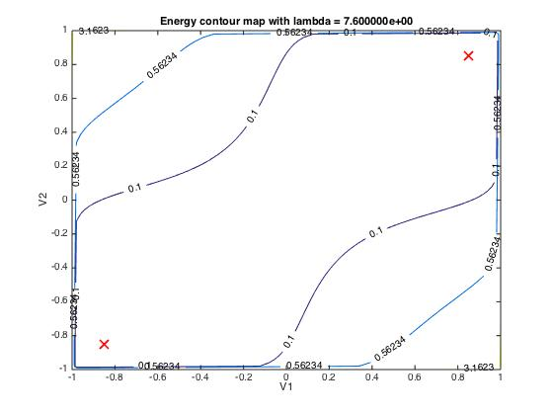

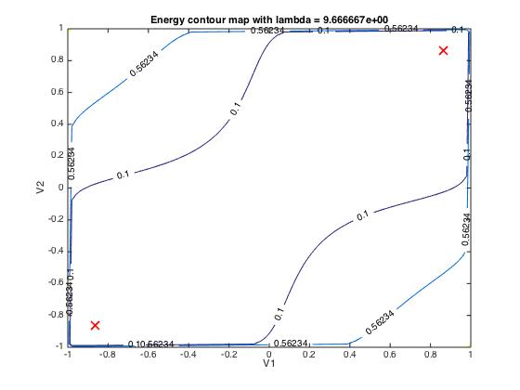

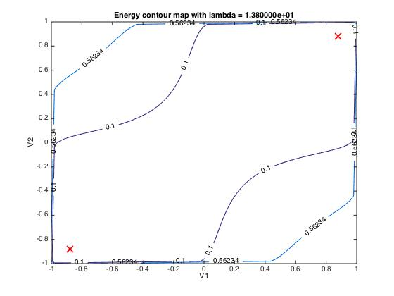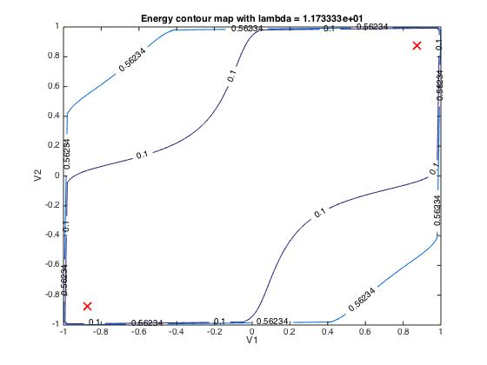

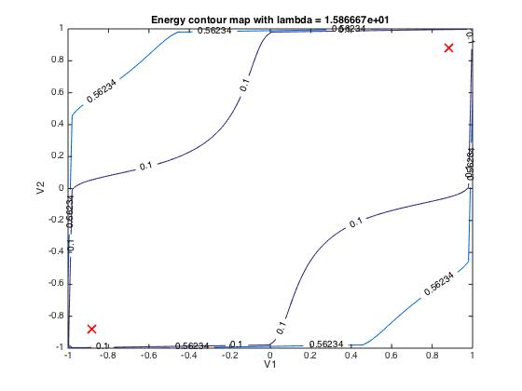

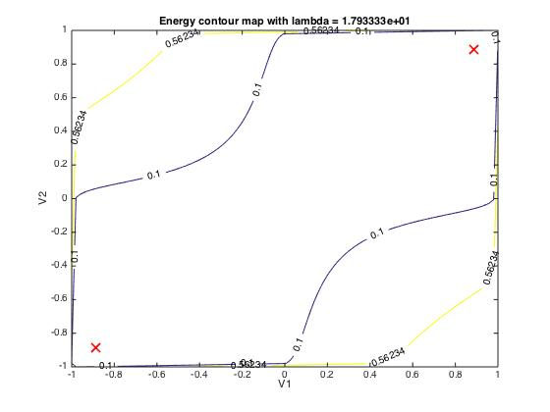

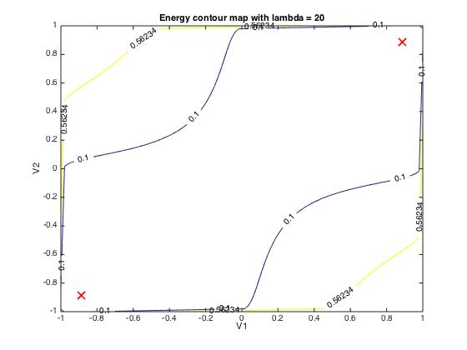

1. **CONCLUSION**

As is increased, energy term is determined by the first term (the term involving T matrix and potentials coming to the neuron + neuron’s potential) and the equilibrium points are moving towards the edges of the contour map (or the hypercube as the terminology in the lecture). This is in agreement such that as increased, g function becomes steeper (as goes to g function becomes a step function) and the continuous model converges to discrete model.