1. **Problem Definition**

Hopfield Model, as discussed in lectures can be used in learning applications, such that a neural network can retrieve data under noise. As an example in the following task; we are given 5 arbitrary (ideally patterns that are not close to each other) input patterns and distort them with different level of noise (variance is changing between 1 to 3). The task is, using Hopfield network, recover the distorted patterns to their initial values. Following is example of this process for the input patterns [1,2,4,7,8].

Each figure consists of 7 sub-figures; 1st one is the original pattern and the next 3 of them are distorted versions of the input pattern with increasing variance levels. The last 3 of them are the recovered version of the distorted versions, each tagged with associated variance level in the title.

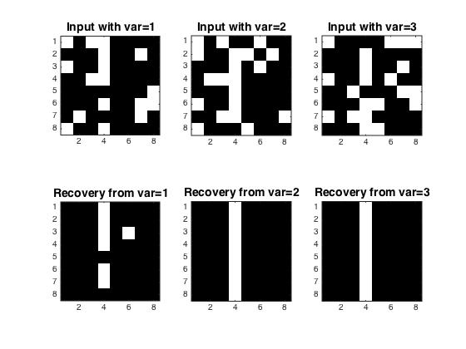

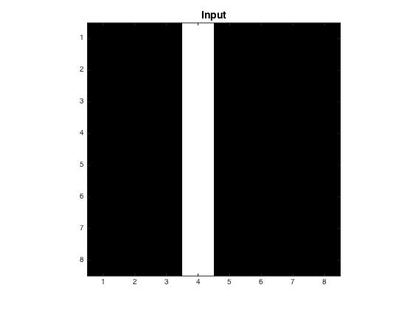

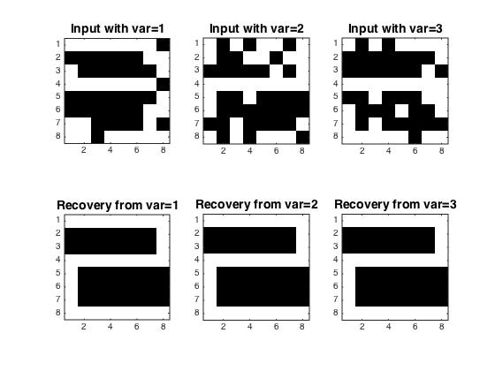

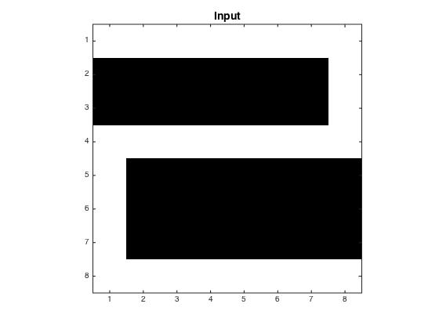

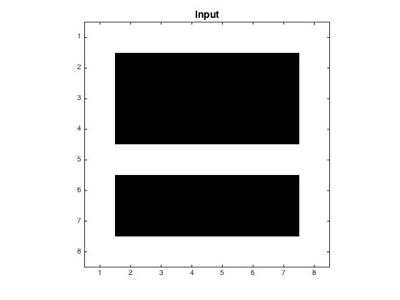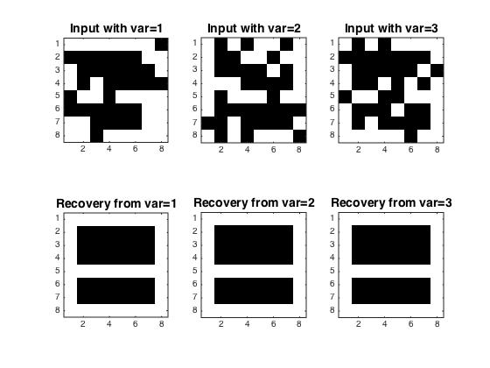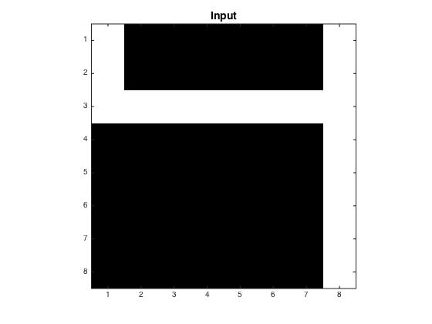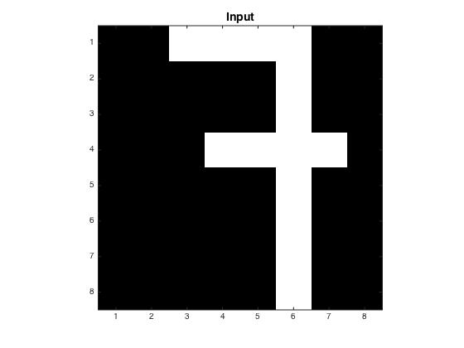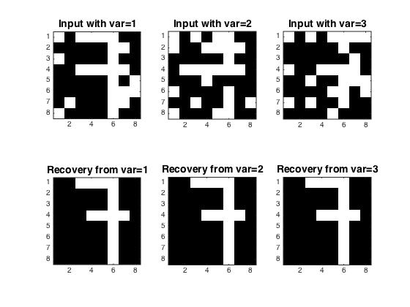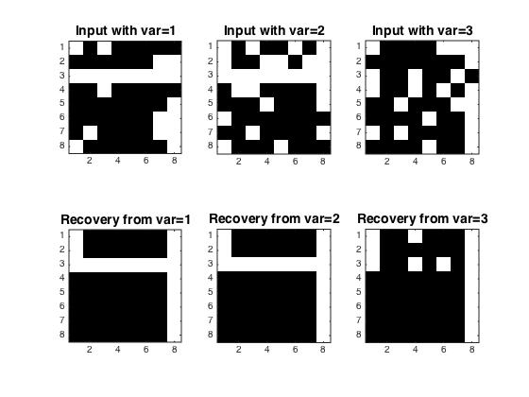

1. **Conclusion**

One might see that as the variance increases, the recovery task gets harder as expected. Moreover, as discussed within the lecture, the network might converge to a different equilibrium point than the desired the one if the input patterns are chose “close” to each other. While this phenomenon has not taken place in screen shots; one can achieve this wrong conclusion of the network simply iterating with the algorithm with random inputs.