1. **PROBLEM DEFINITION**

In this exercise, we have used competitive learning model in unsupervised learning. To simulate this algorithm, 450 input points generated on spherical coordinate system for 3 clusters. The task is to find the mean values for these clusters.

1. **VISUALISATION**

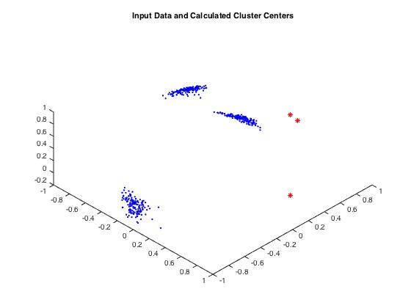

Figure : Initial Weights

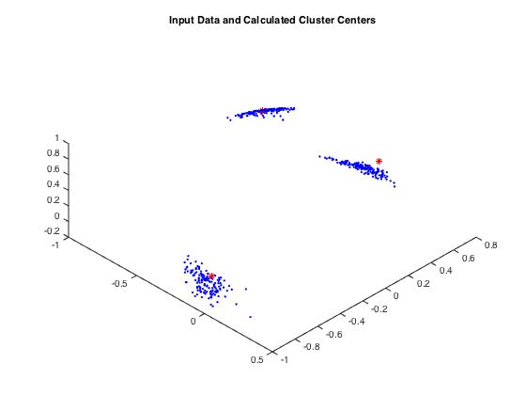

Figure 2: Weights after seeing 33% of patterns

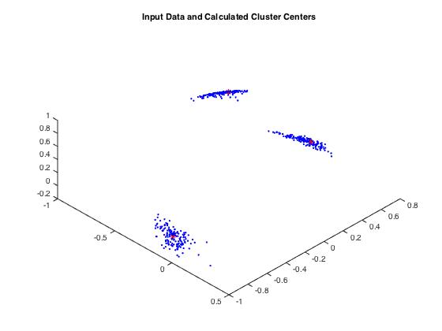

Figure 3: Weights after seeing 67% of patterns

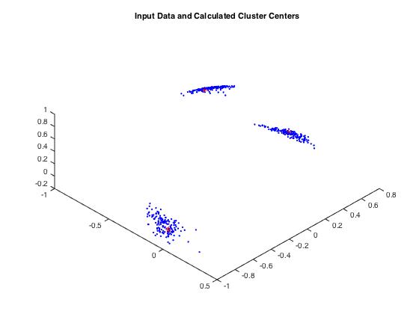

Figure 4: Weights after seeing 100% of patterns

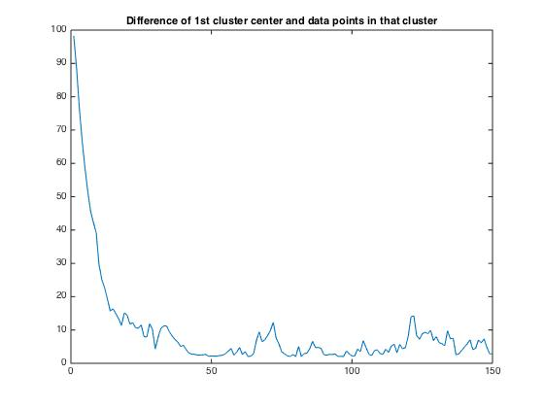

Figure 5: Difference of 1st cluster center and pattern wrt patterns in that cluster

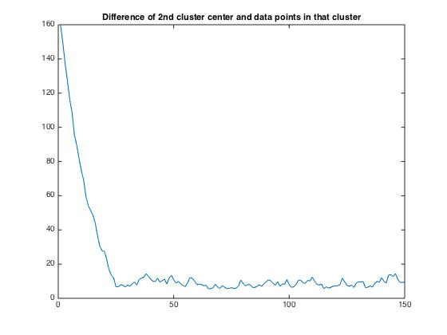

Figure : Difference of 2nd cluster center and pattern wrt patterns in that cluster

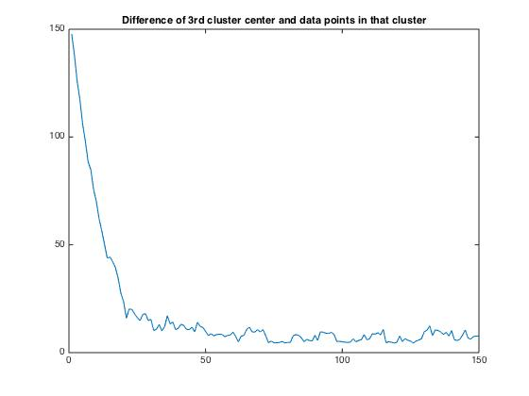

Figure : Difference of 3rd cluster center and pattern wrt patterns in that cluster

1. **CONCLUSION**

Weight update rule promotes winning cluster center for each input pattern and thus seeing more and more input pattern moves initial guess of cluster centers to correct positions. This can be seen as both on the movement of initial guess of clusters as well as on the error graph above.