1. **PROBLEM DEFINITON**

In this exercise, we have demonstrated a single perceptron model usage for clustering a random data. The data set consist of 50 points each having 3 features (one can think about them as x, y, and z on 3D graph) and labeled as 1 if all the 3 features are greater than 0 and labeled as 0 if all the 3 features are less than 0. The perceptron model is used to find correct weight parameters, which separate these two clusters from each other. The weights will define a plane on a 3D space.

1. **VISUALISATION**

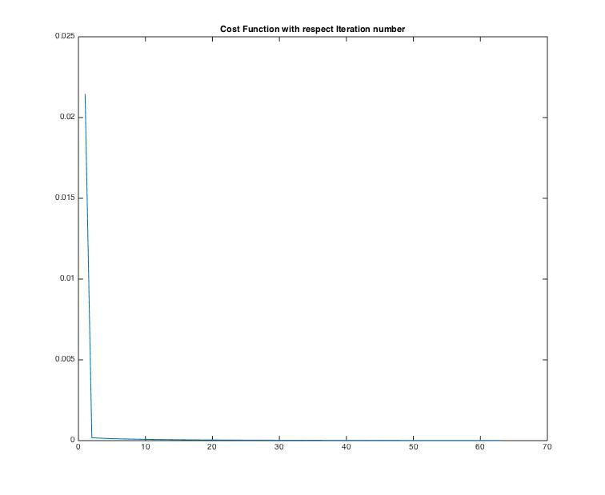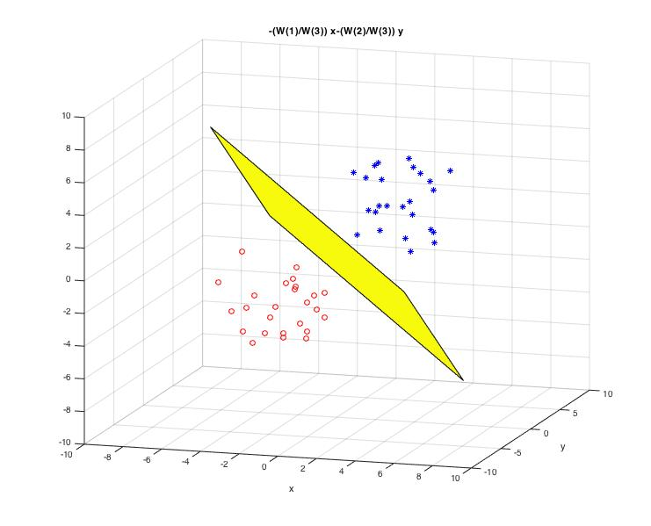

1. **CONCLUSION**

As it can be seen from Figure-1, single perceptron model can separate data set properly. Figure-2 shows cost function J after each iteration. As long J is greater than threshold (it is selected as 1e-5 for in this case) cost function keeps decreasing as expected.