1. **PROBLEM DEFINITION**

In this exercise, we have used multi layer perceptron model (MLP) to make non linear separations. There are 3 different tasks within the exercise:

* 1. **Separation of XOR data**

Input data is truth table for XOR:

|  |  |  |
| --- | --- | --- |
| 0 | 0 | 0 |
| 0 | 1 | 1 |
| 1 | 0 | 0 |
| 1 | 1 | 1 |

The sigmoid function is selected as:

For this task, 1 hidden layer with 3 neurons is used. Notice that a bias term is added to the output except for output layer (we have discussed the help of bias term in the lecture).

To test the success of the trained network, input data is fed forward through the network and the output is plotted with labels of the data. It’s needless to mentioned that cost function vs number of iterations are also plotted (this is true for the rest of the exercises too.)

* 1. **Separation of Sinus data**

100 data points are generated randomly. Data is fed through a 4 layers of ANN, which has 2 hidden layers having 15 neurons each. The sigmoid function is selected as:

This will capture all the values of sinus between -1 and 1. Again, bias terms are added at the output of each layer except for the output layer.

To test the success of the trained network, 50 more random sinus data points is generated, fed through the network and the output of the network along with generated data labels are plotted.

* 1. **Separation of IRIS data**

Input data is given having 4 features and 3 possible classes. Total number of the sample is 150 and 100 of it is used for training the data. The mappings for the 3 different types is given as:

* Iris-setosa = 0
* Iris-versicolor = 1
* Iris-virginica = 2

The sigmoid function chosen for this exercise is:

However, as the labels of the data is discrete, the output of last layer is fed through a floor function; thus assigning the outcome to one of the classes.

1. **VISUALISATION**
   1. **XOR**

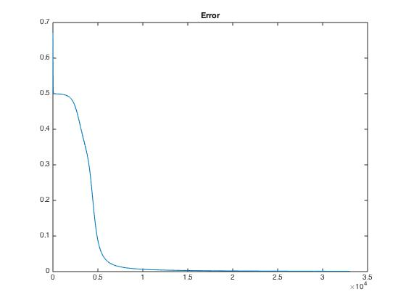

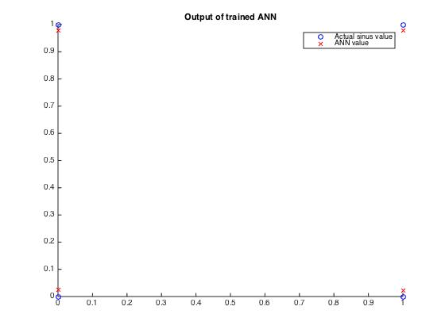

* 1. **Sinus**

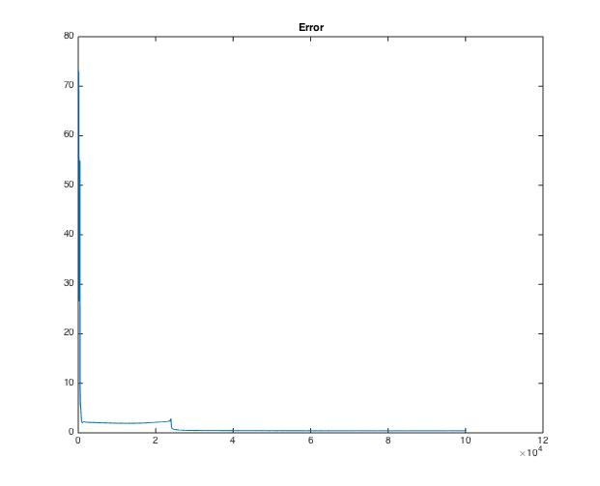

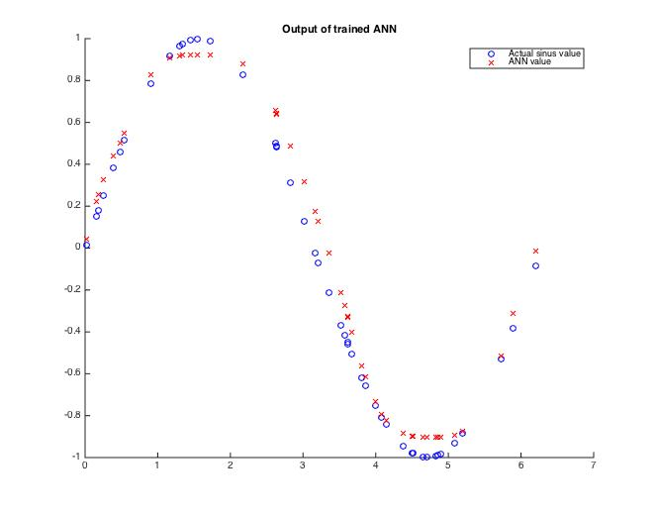

* 1. **IRIS Data**

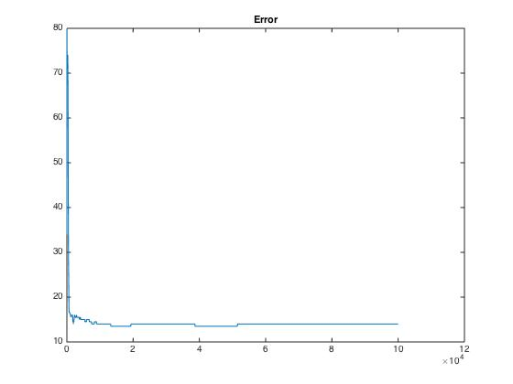

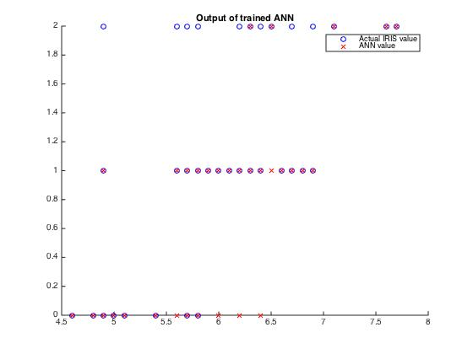

1. **CONCLUSION**

As can be observed from the charts, XOR and Sinus data are successfully separated using a ANN network. IRIS data performance is not good as XOR and Sinus. One possible reason for that is that there might be out-layers in IRIS data set. Another reason could be the weights of the features; feature scaling might help to increase performance. Nevertheless, the performance is ok to some extend.