Clay Brooks
4/24/2014
2612-9495

FINAL PROJECT

Introduction
For the final project, I chose to design and build a guitar tuner. The goal of this device is to automatically match the frequency of the note being played and display how close the note is to the desired frequency. The tuner has two functions; tuning by guitar input and tuning by ear. Each function can be selected using a switch and relevant information will be displayed to the LCD screen.
The device has multiple stages used to capture the frequency of the input signal. First, the signal is fed into a low-pass amplifier that amplifies the signal by approximately 20 V/V. This amplified signal is then fed into a comparator that will toggle when the voltage passes a certain threshold. A micro-controller was used to count the threshold crossings. The controller was also used to control the LCD screen as well as a DAC and audio amplifier.
Design
A switch input was used to choose between the two tuning modes. The first tuning mode would be active if the switch value was high. The second tuning method would activate if the switch was low.
The first tuning method was tuning the guitar using the actual signal from the guitar. The signal was first fed into an operational amplifier stage. As mentioned earlier, the amplification was about 20 V/V, a DC offset of 2.5 V and a cut off frequency of 500 Hz. This was critical in removing high frequency harmonics from the input signal. Doing so allowed for the comparator to accurately toggle on threshold crossings of the input signal. To count these crossing, the amplified signal was fed back into the op-amp with the positive terminal tied to 2.5 V. Once the AC signal rose above or fell below 2.5V, the comparator output would toggle high to low or low to high. This signal was then fed into the micro-controller and served as an interrupt for the system. Every time the comparator output toggled low to high, the interrupt was triggered and a counter was incremented. A second timer interrupt would occur every second and the number of high to low transitions would be counted. This number would serve as the frequency of the wave. While the micro-controller was waiting for the toggle interrupt or the timer interrupt, it would calculate the frequency, output the closest frequency to an LCD and display LED's showing how far off you were from perfect. If the input signal was slightly sharp, two LED's to the right of the center LED would light up. If you extremely sharp, only the far right LED would light up. The same was done for signals that were flat compared to the desired frequency.
The second mode for tuning was tuning by ear. The user would choose which the desired frequency by turning a knob of a potentiometer. The selected note was displayed onto the LCD screen. Once the note was selected, a timer interrupt would occur at the corresponding frequency. Once inside this timers ISR, sine wave data would be sent out to the DAC to play a sine wave of the desired frequency.

Hardware Layout Diagrams
LTC1632: Op-amp and Comparator
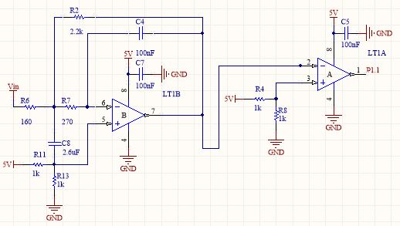

Voltage Regulator
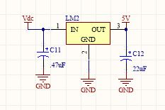

LM386: Audio Amplification
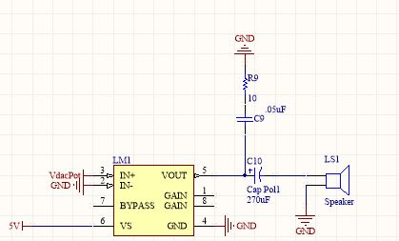

LED Array
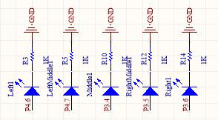

Programmer
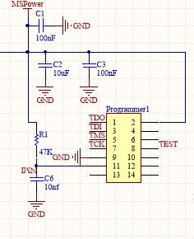

LT1661: DAC
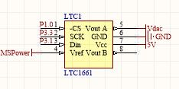

Input Switch
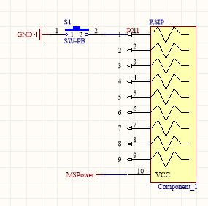

MSP430
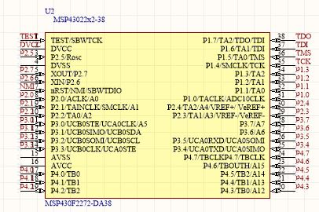

LCD
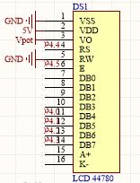

Software Flow

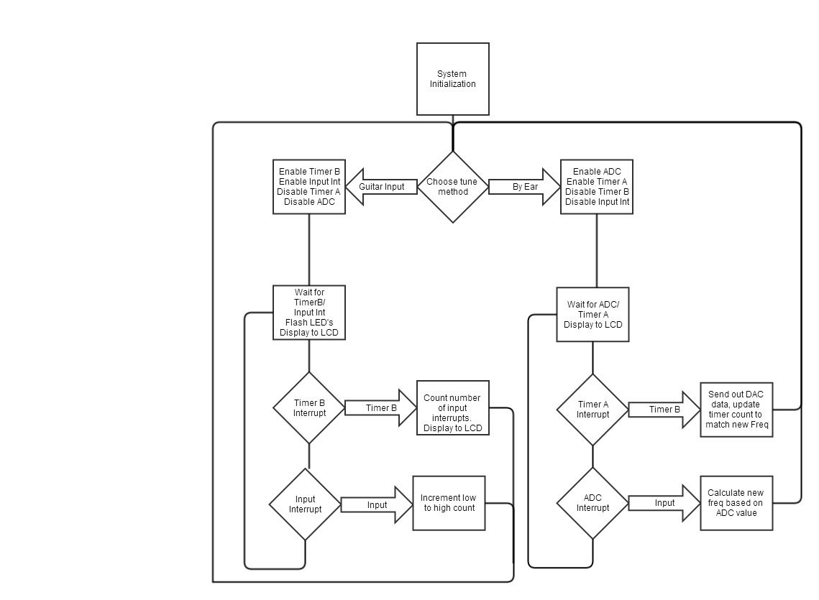

Bill of Materials
LM386 - $0.42
LT1632 - $3.70
LT1661 -$1.90
MSP430 - $0.00
LCD - $25.88
Speaker - $4.00
1/4” female connector -$1.00
LM2940 - $10.00
6 LED's - $0.50
3 Potentiometers - $5.00
1 Switch Bank - $0.30
1 sip resistor - $0.40
18 resistors - $6.30
18 capacitors - $8.42

Overall Price – $67.82

Experimental Results
The operational amplifier was design to have about a 25 V/V gain with a cutoff frequency of approximately 600 Hz. It was recorded to have about a 20 V/V gain with the cut off frequency just above 500 Hz. This deviation from what it was designed for was acceptable, a lower cutoff frequency works better for the system and 20 V/V was sufficient enough for the comparator. The calculated delay values for the DAC weren't exact. This is due to the overhead in function calls and calculations. The actual delay values were slightly larger to achieve the correct output frequencies. The measured frequencies of the input signal were very accurate. The largest difference between theoretical and actual was 2 Hz at higher frequencies.

Conclusion
One difficulty I encountered was with the comparator. Initially, an LM741 was used as a comparator. After testing the system, it was realized the 741 doesn't have rail to rail voltage swings. The “low” voltage on the output of the 741 was 1.7 V. This was still considered a high voltage for the micro-controller. The 741 was removed and the second op amp terminal of the LT1632 was used instead. Overall, the system worked extremely well. The experimental results were very close to the expected values. The frequency measurements were very accurate and the frequency of the notes being played out through the speaker were within 1% of the expected value. The main design limitation was the MSP430. A better micro-controller/micro-processor would have made the frequency calculations more accurate and much faster. An entire second had to elapse to calculate the input signal frequency. A device with hardware multipliers and a faster clock frequency could calculate the frequencies more accurately and much faster than the MSP430. An FFT could have been implemented and the results would have been near perfect.

