**PD2 LAB QUESTIONS**

1. Predict the output of following C programs.

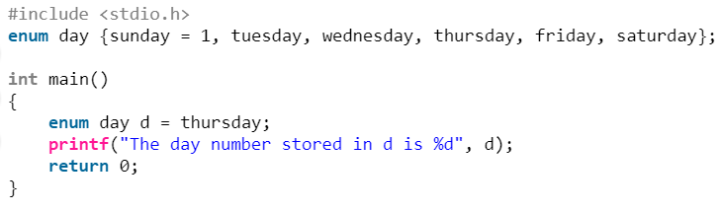

2. Predict the output of following C programs.

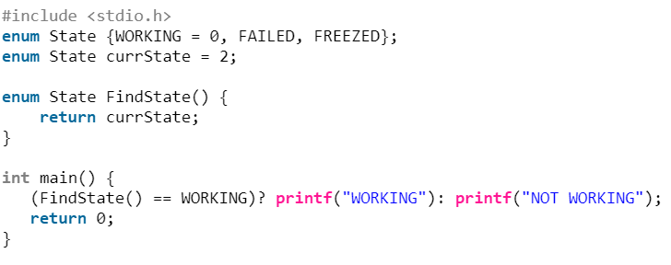

3. Predict the output of following C programs.

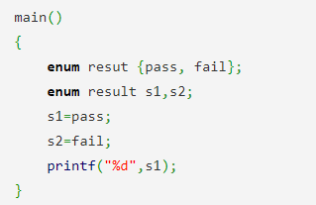

4. Predict the output of following C programs.

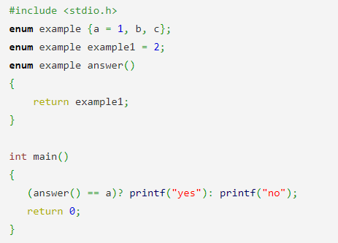

5. Predict the output of following C programs.

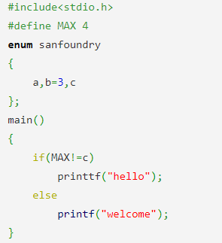

6. Point out the error( if any) in the following code.

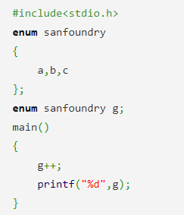

7. What will be the output of the following C code if input given is 2?

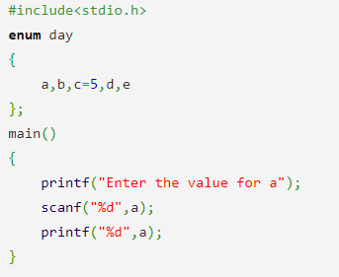

8. What will be the output of the following C code if the code is executed on a 32 bit platform?

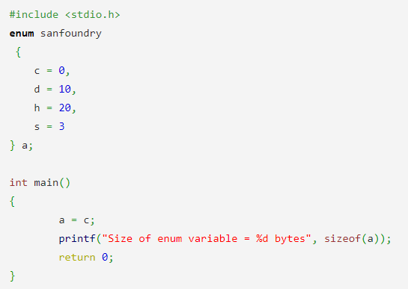

9. Predict the output of following C programs.

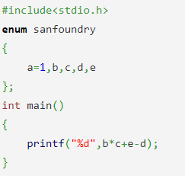

10. Predict the output of following C programs.

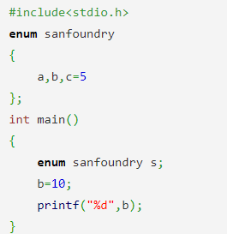

11. Predict the output of following C programs.

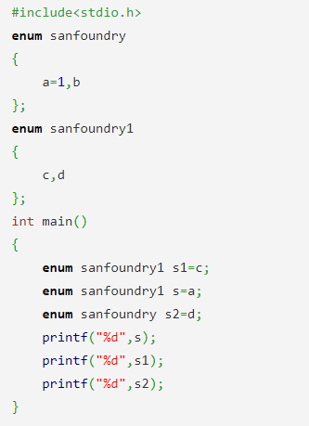

**Soru Ders:**

Ders devam listesinde bulunan öğrenciler için kullanılacak ‘student’ isimli struct yapısını, ‘number’, ‘name’, ‘surname’, ve ‘midtermGrade’ alanlarından oluşacak şekilde tanımlayınız. Tanımladığınız bu yapıyı kullanarak 10 öğrenci için bir struct dizisi oluşturunuz ve klavyeden 3 öğrencinin bilgilerini alınız. Daha sonra bilgileri alınan öğrencilerin bilgilerini ekrana yazdırınız.

Define a struct named ‘student’ for course attendance list of students. This struct consists of ‘number’, ‘name’, ‘surname’, and ‘midtermGrade’ fields. Using this struct you defined, create a struct array for 10 students and get the information of 3 students from the keyboard. Then, print the information of the students whose information was entered.

11. Predict the output of following C programs.

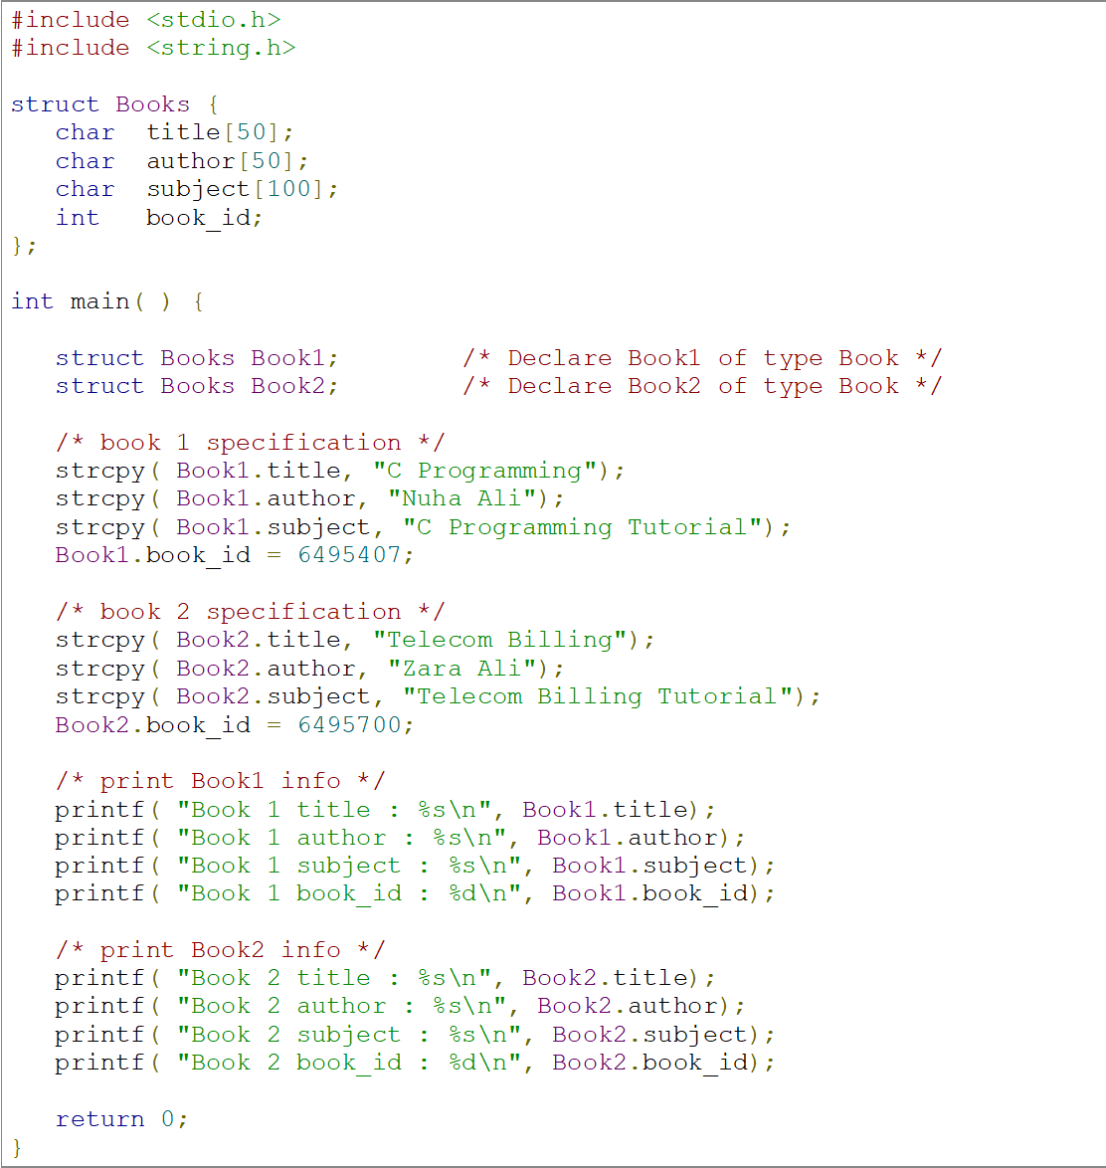

12. Predict the output of following C programs.

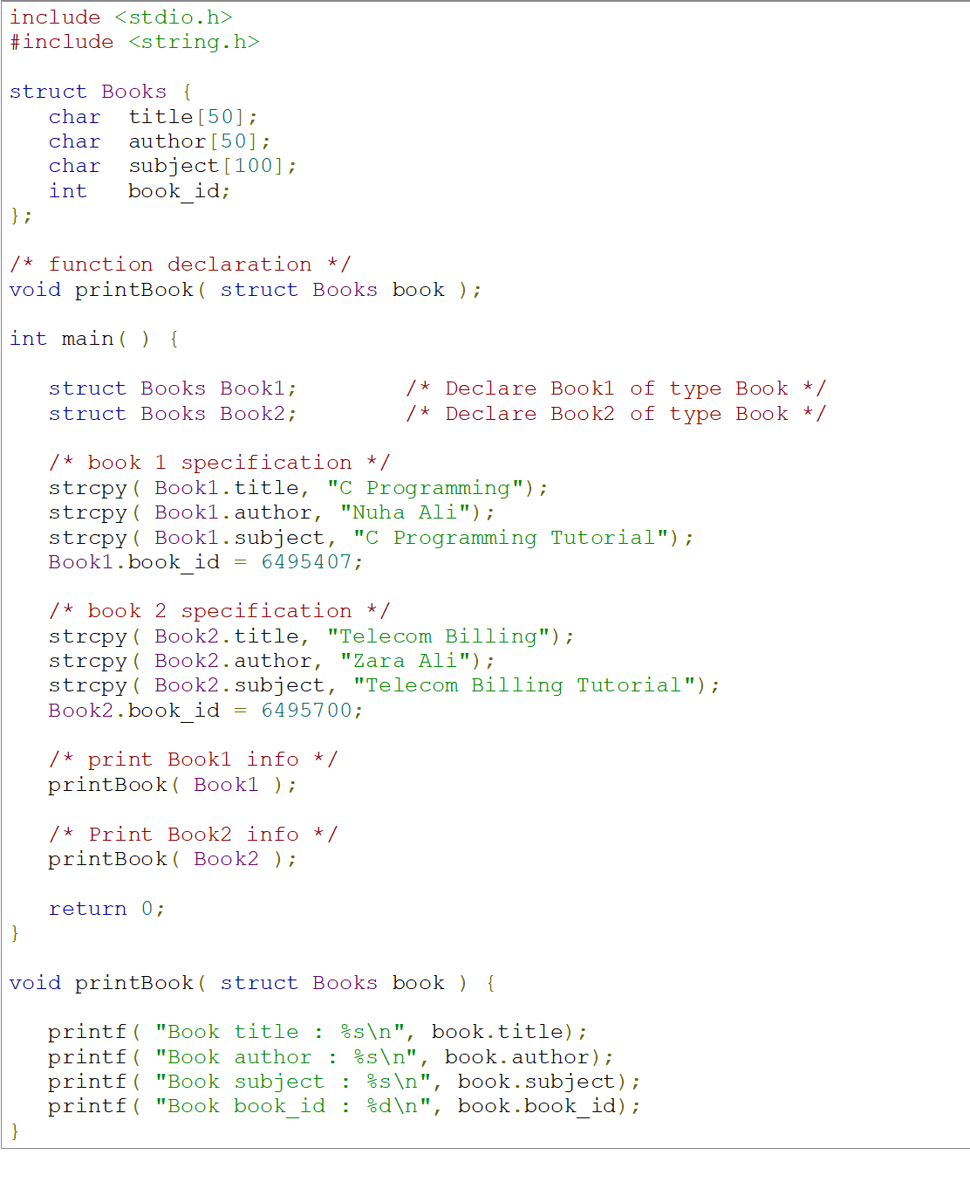

13. Predict the output of following C programs.

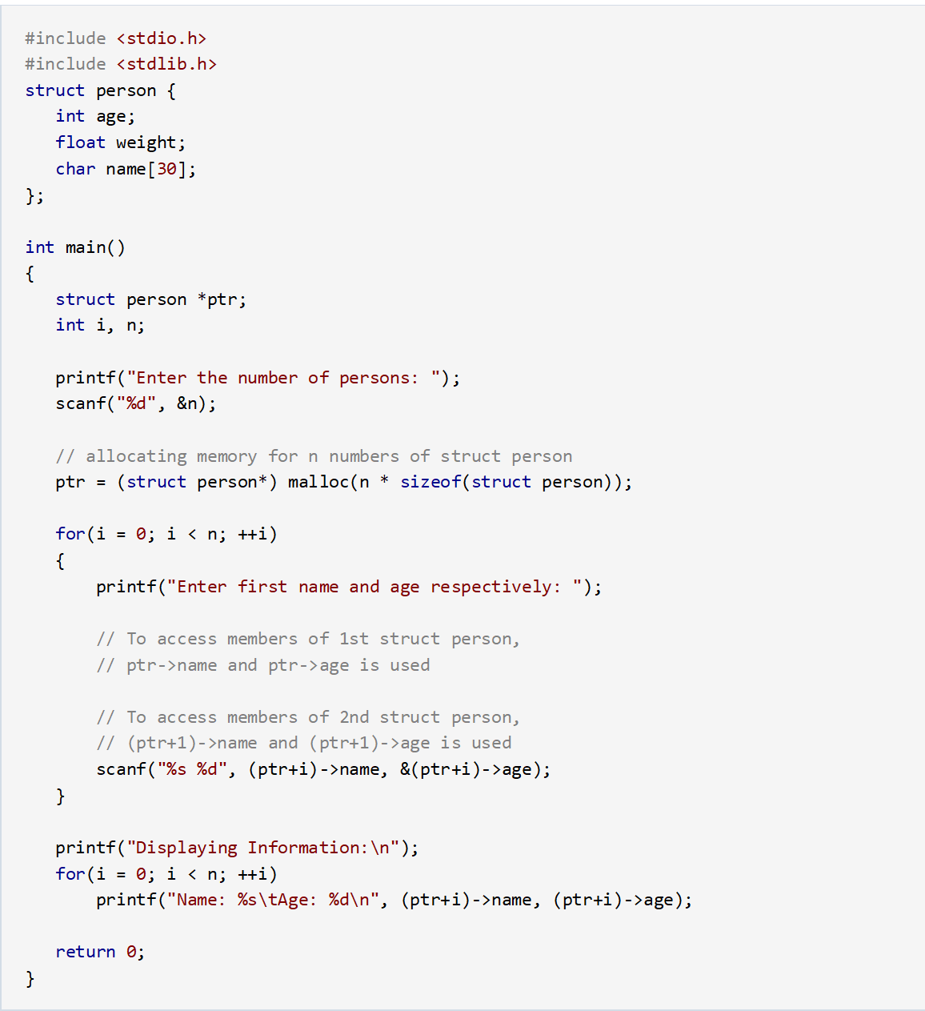

**Additional Questions:**

14. Write C program to add two Complex Numbers by passing structure to a function. (In this example, you should take two complex numbers as structures and add them by creating a user-defined function.)

15. Write C program to store information of students using structure. (In this example, you should store the information of 5 students by using an array of structures.)

16. Write C program to store data in structures dynamically. (In this example, you should to store the information entered by the user using dynamic memory allocation.)

17. What will be the output of the C program?

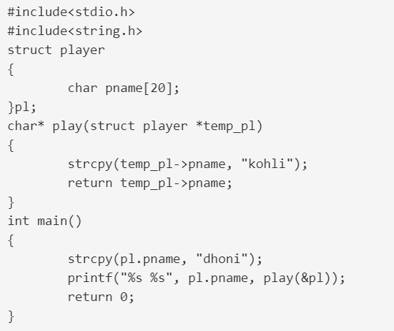

18. What will be the output of the C program?

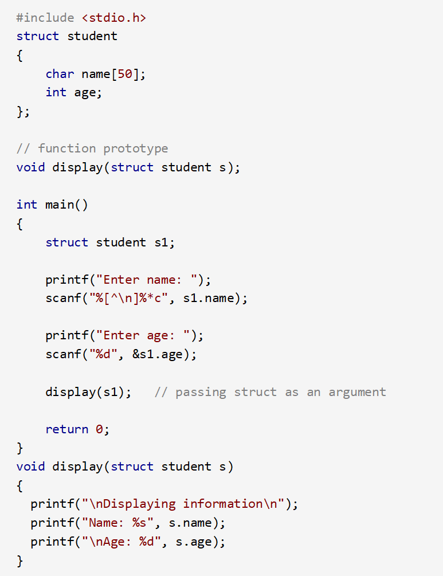

19. What will be the output of the C program?

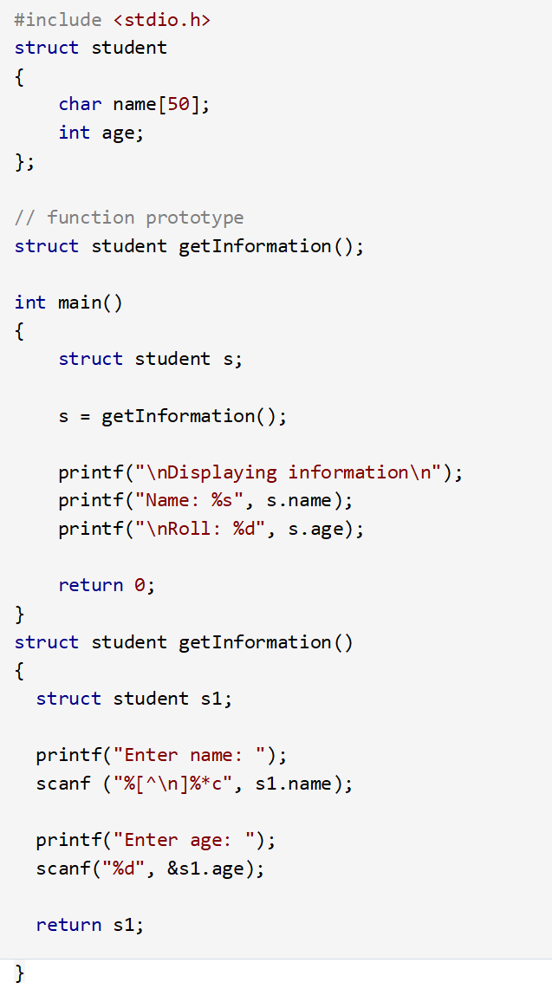

20. What will be the output of the C program?

