Brian Lambert

STA 404

Module 1: Perceptual Distortion Graphic

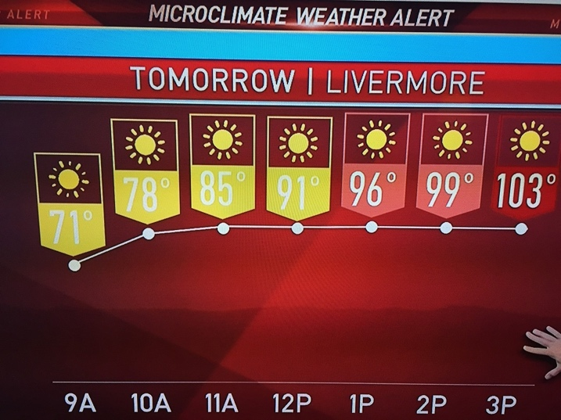

<http://viz.wtf/post/162441839861/weather-line-chart-from-local-news-station>

The image above clearly shows a local weather channel from Livermore displaying their temperature forecast for the day. This graphic begins fine while the temperature increases from 71 to 85 by showing an increasing line between points. However, the graphic goes awry when the line connecting 85 to 91 degrees is horizontal. This gives the illusion to viewers that the temperature is not increasing as much as it actually is.

To fix this visualization, simply continue the upward trend of the line as the temperature continues to rise which would easily show the user that the temperature is still rising. While it’s not a distortion, I would also choose a different color scale for the temperatures because there is hardly a difference in color for the temperatures 71 to 91, a 20 degree jump.