

**LA GRANDEE INTERNATIONAL COLLEGE**

**Simalchaur, Pokhara, Nepal**

A Project Mid-Term Report

On

**D-Academe**

**Submitted to:**

LA GRANDEE International College

Bachelor of Computer Application (BCA) Program

In partial fulfillment of the requirements for the degree of Program Name under

Pokhara University

**Submitted by:**

|  |  |  |  |
| --- | --- | --- | --- |
| **Name:** | **Program** | **Semester** | **P.U. Registration Number** |
| Sangam Subedi | BCA | 6th | 2021-1-53-0366 |
| Prabin Shrestha | BCA | 6th | 2021-1-53-0358 |
| Amit Baral | BCA | 6th | 2021-1-53-0346 |

**Date: 16/12/2024**

**Declaration for**

**“D-Academe”**

**Student’s Declaration**

We hereby declare that we are the only authors of this work and that no sources other than the listed here have been used in this work.

Name: Sangam Subedi Name: Amit Baral

Class Roll No.: 22 Class Roll No.: 2

PU-Registration No.: 2021-1-53-0366 PU-Registration No.: 2021-1-53-0346

Semester: 6th Semester Semester: 6th Semester

**Date: 16/12/2024 Date: 16/12/2024**

Signature: ............... Signature: ...............

Name: Prabin Shrestha

Class Roll No.: 14

PU-Registration No.: 2021-1-53-0358

Semester: 6th Semester

**Date: 16/12/2024**

Signature: ...............

**Supervisor’s Declaration**

I hereby recommend that this project entitled **D-Academe** is done under my supervision by **Sangam Subedi, Amit Baral and Prabin Shrestha** during their SixthSemester in partial fulfillment of the requirements for the degree of **BCA** under **Pokhara University** is completed to my satisfaction and be processed for final evaluation.

____________________________

**Sunil Sapkota**

**Date: 16/12/2024**

# **Table of Content**

**Table of Content** iii

**1.** **Introduction** 1

**2.** **Project Overview** 2

**3.** **Progress and State** 3

**4.** **Issues** 4

**5.** **System Design** 5

**5.1 DFD** 5

**5.2 ER-Diagram** 7

**6.** **Methodology** 8

**6.1** **Planning Phase** 8

**6.2** **Risk Analysis** 9

**6.3** **Engineering** 9

**6.4** **Evaluation** 9

**7.** **Project Gantt Chart** 10

**8.** **Need to Be Done** 11

# **Introduction**

In today’s fast-changing world, the need for better and more accessible education is greater than ever. To meet this demand, our decentralized online learning platform has made great progress, with 80% of the project now complete. This is an important step as we work toward creating a platform that makes education more inclusive, engaging, and flexible for everyone.

Our platform is built to remove common barriers to learning, like limited access to quality education, location issues, and rigid course schedules. By using decentralized technology, we are creating a system where students and teachers can work together to improve the learning process. This builds trust, accountability, and gives everyone more control.

So far, we have added features like discussion forums and mentorship opportunities to encourage collaborative learning. However, two key features—live learning and buy course—are still being developed.

The live learning feature will allow students and teachers to interact in real time. It is almost finished and will make learning more dynamic and engaging by letting students ask questions, join discussions, and work with their peers.

The buy course feature will let users easily purchase and join courses. We are designing it to be simple, secure, and user-friendly, so learners can explore a wide range of educational opportunities.

With most of the core features already done, we are now focused on completing these two important components. We are also preparing for the platform’s launch by testing it thoroughly and collecting feedback from users.

This progress report highlights how far we’ve come and the work we’re doing to finish the live learning and buy course features. Together, we are building a platform that will make education more accessible, interactive, and empowering for everyone.

# **Project Overview**

Our decentralized online learning platform is nearly complete, with 80% of the work already finished. The remaining key features, including live learning and course purchasing, are under development and will be completed on time. We are on track to deliver an accessible, engaging, and flexible solution that transforms the learning experience for everyone.

# **Progress and State**

* **Completed Features**

**Dashboard:** A fully functional dashboard that allows users to access key features.

**Course Contents:** Structured display of course materials for learners.

**Login with MetaMask:** Integration of MetaMask wallet for secure user authentication.

**Token Purchase:** Implementation of a token-based system for purchasing courses.

**Front-End Design:** UI/UX developed with smooth navigation and responsiveness.

* **Yet to be:**

**Enrolled Course**: To display the list of courses a user has enrolled in.

**Database Update:** Backend optimization for updating and managing course data.

**Live Class Feature:** Integration of a real-time live learning feature for students and instructors.

**Buy Course Functionality:** Development of the "buy course" feature for seamless transactions.

**CSS Styling:** Final touch-ups on design aesthetics for better user experience.

# **Issues**

While developing the project, we have face the numerous challenges and some of the major ones are as follows.

* **Technical Challenges**: Difficulty in implementing advanced features like live learning and secure payment systems.
* **Time Management**: Balancing project work with other studies or responsibilities.

# **System Design**

Dataflow, Entity-relationship diagram are used for understanding the system's design and its functionalities, and both are important for creating proper documentation.

## **5.1 DFD**

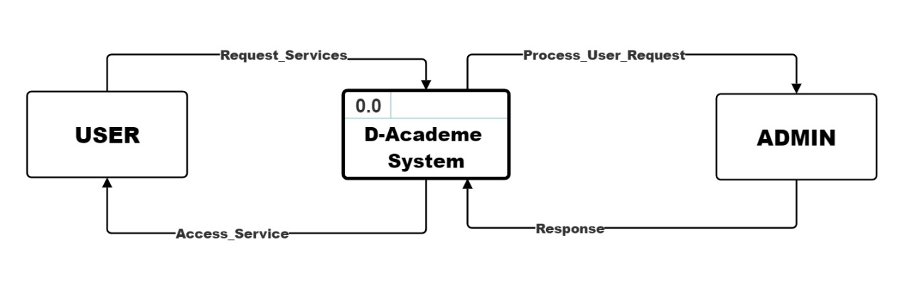

**5‑1 Level 0, DFD**

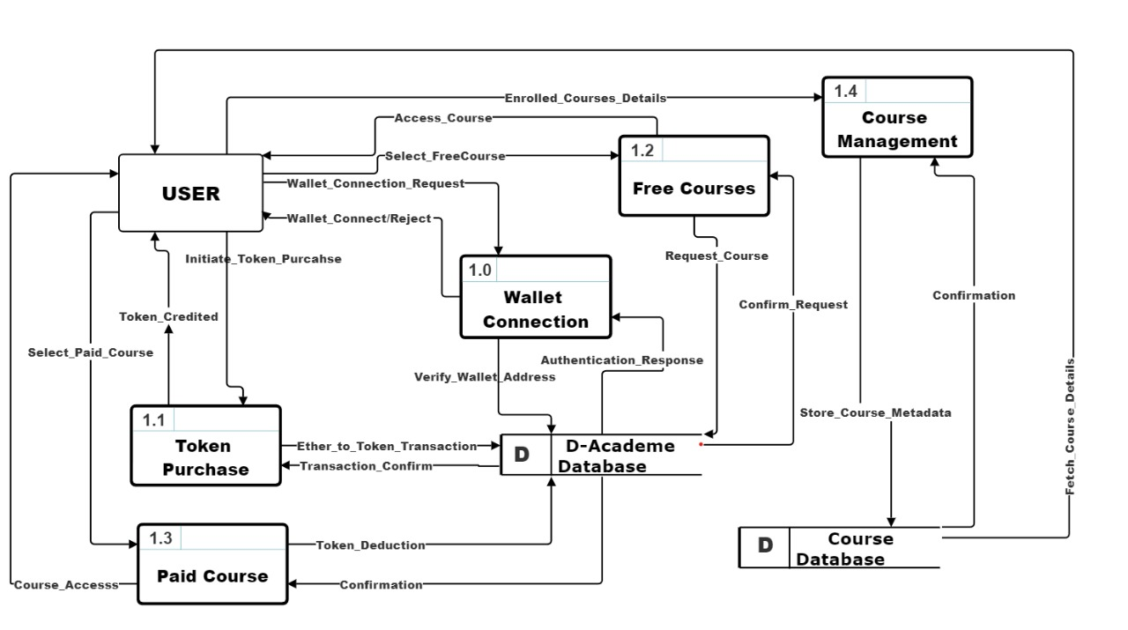

**5‑2 Level 1, DFD**

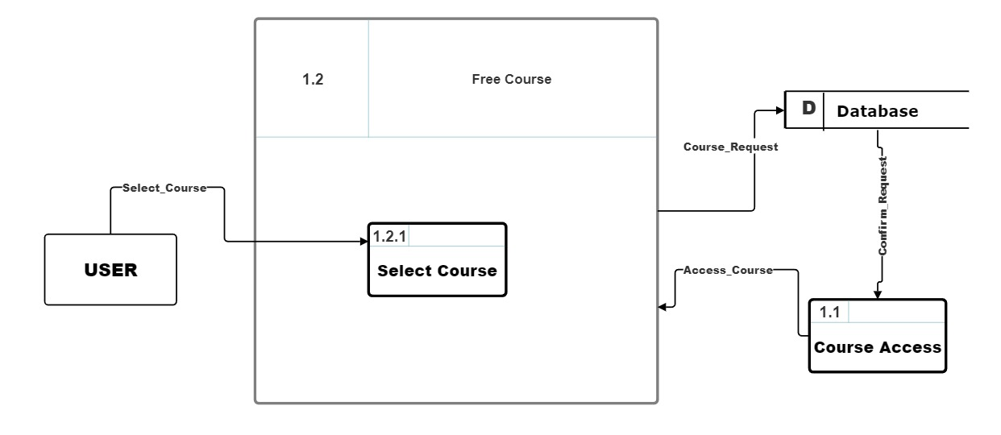

**5‑3 Level 2, DFD for free course**

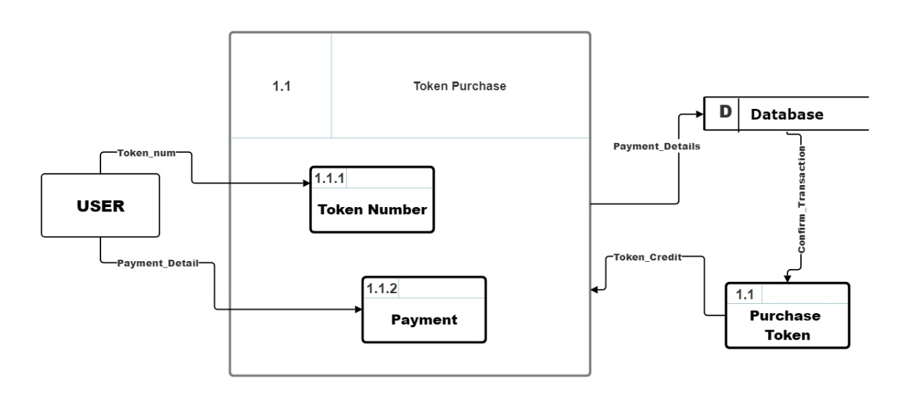

**5‑4 Level 2, DFD for token purchase**

## **5.2 ER-Diagram**

An Entity Relationship Diagram is a diagram that represents relationships among entities in a database. It is commonly known as an ER Diagram.

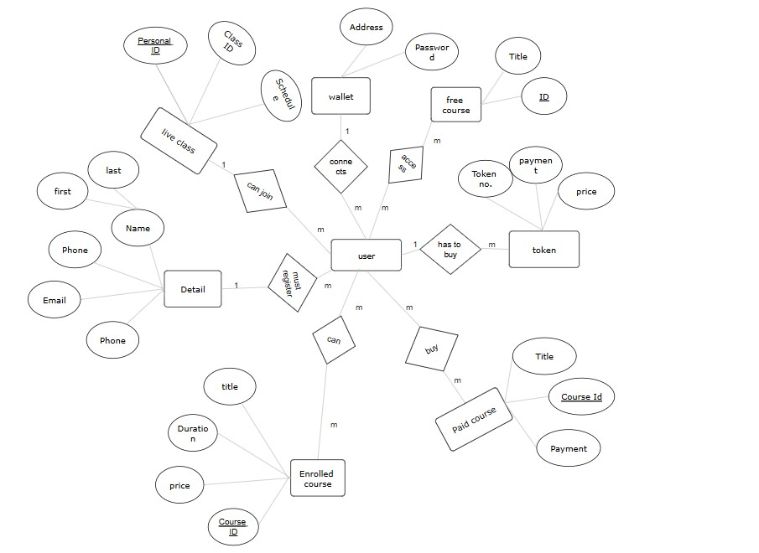

**5‑5 ER-Diagram for Dacademe**

# **Methodology**

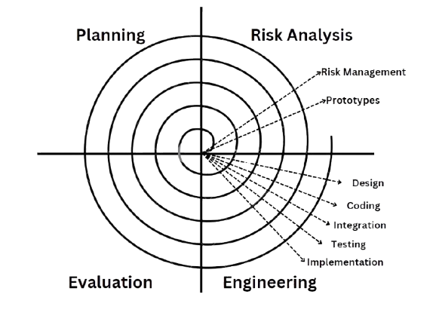

Figure 6‑1:Spiral Model

The Spiral Model is used in this project. A sophisticated method for developing software, the spiral model offers a framework for taking on challenging tasks and refining and assessing risks iteratively. The model is shown as a spiral, where each loop or phase denotes a different step in the process of evolution. It serves as the foundation for the majority of software development processes, which include planning, risk analysis, engineering, and evaluation.

The phases in Spiral model are: -

## **Planning Phase**

The project's goals, parameters, and extent are specified at the planning phase. In order to determine the resources, deadlines, and deliverables, stakeholders collaborate. In order to create a strong basis for the project, requirements collecting and preliminary feasibility study are also completed during this phase.

## **Risk Analysis**

The spiral model's most unique characteristic is its risk analysis. Prototypes and models are used in this phase to identify, assess, and mitigate potential risks. To lower the chance of failure, the development team evaluates operational, financial, schedule-related, and technological risks.

## **Engineering**

This is the real development phase, during which system design, testing, and coding are done. The product is built incrementally, with every cycle resulting in a deliverable or prototype that changes with each iteration.

## **Evaluation**

Stakeholders assess the current build or prototype at the end of each cycle. Testers, clients, and end users all provide feedback. In the following iteration, the product might see improvements or adjustments in response to this input. This stage assists in guaranteeing that the product meets the expectations of the user.

# **Project Gantt Chart**

* 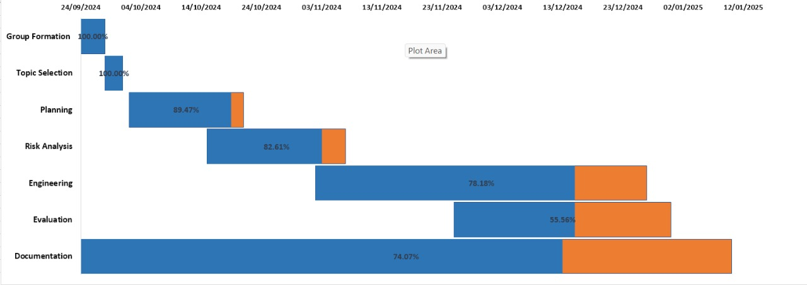

# **Yet to be Done**

* Buy course function
* Live class integration
* Fully functional CRUD operation