

**LA GRANDEE INTERNATIONAL COLLEGE**

**Simalchaur, Pokhara, Nepal**

A Project Proposal/Report

On

**D-Academe**

**Submitted to:**

LA GRANDEE International College

Bachelor of Computer Application (BCA) Program

In partial fulfillment of the requirements for the degree of Program Name under

Pokhara University

**Submitted by:**

|  |  |  |  |
| --- | --- | --- | --- |
| **Name:** | **Program** | **Semester** | **P.U. Registration Number** |
| Sangam Subedi | BCA | 6th | 2021-1-53-0366 |
| Prabin Shrestha | BCA | 6th | 2021-1-53-0358 |
| Amit Baral | BCA | 6th | 2021-1-53-0346 |

**Date: 02/10/2024**

**Declaration for**

**“D-Academe”**

**Student’s Declaration**

We hereby declare that we are the only authors of this work and that no sources other than the listed here have been used in this work.

Name: Sangam Subedi Name: Amit Baral

Class Roll No.: 22 Class Roll No.: 2

PU-Registration No.: 2021-1-53-0366 PU-Registration No.: 2021-1-53-0346

Semester: 6th Semester Semester: 6th Semester

**Date: 02/10/2024 Date: 02/10/2024**

Signature: ............... Signature: ...............

Name: Prabin Shrestha

Class Roll No.: 14

PU-Registration No.: 2021-1-53-0358

Semester: 6th Semester

**Date: 02/10/2024**

Signature: ...............

**Supervisor’s Declaration**

I hereby recommend that this project entitled **D-Academe** is done under my supervision by **Sangam Subedi, Amit Baral and Prabin Shrestha** during their SixthSemester in partial fulfillment of the requirements for the degree of **BCA** under **Pokhara University** is completed to my satisfaction and be processed for final evaluation.

____________________________

**Sunil Sapkota**

**Date: 02/10/2024**

# **Table of Content**

**Table of Content** iii

**1.** **Introduction** 1

**2.** **Problem statement** 2

**3.** **Objectives** 3

**4.** **Background Study** 4

**5.** **System Design** 5

**6.** **Methodology** 6

**7.** **Project Gantt Chart** 7

**8.** **Deliverables** 8

**References** 9

# 

# **Introduction**

In today’s fast-changing world, the need for innovative education solutions has never been greater. We’re excited to introduce our new decentralized online learning platform project, aimed at making education more accessible, engaging, and effective for everyone.

Our project is designed to break down traditional barriers to learning. With the rise of technology, many students face challenges such as limited access to quality education, geographical constraints, and rigid course structures. We believe that learning should be flexible and inclusive, allowing individuals from diverse backgrounds to thrive.

One of the foremost features of our platform is live learning. This feature enables real-time interaction between students and teachers, fostering a dynamic learning environment. Instead of simply watching pre-recorded lectures, students can engage in discussions, ask questions, and collaborate with peers. This interactive approach not only enhances understanding but also builds a sense of community among learners.

Moreover, our decentralized model control are shared among users. This means that students and educators have a greater say in the learning process, from course creation to content delivery. By leveraging decentralized technology, we can provide a transparent and secure platform that promotes trust and accountability.

We are committed to creating a space where education is not just a one-way street but a collaborative journey. Our platform will include various resources such as discussion forums, peer reviews, and mentorship opportunities, allowing learners to support each other and share knowledge.

# **Problem statement**

* Centralized Control: Traditional online learning platforms often face challenges related to centralized control. This can lead to issues with data ownership, censorship, and limited transparency.
* Limited Accessibility: Access to quality education can be restricted by geographical location, financial resources, or language barriers. Traditional platforms may not effectively address these limitations.
* Lack of trust and security: Concerns regarding data privacy, security breaches, and the potential for fraud can deter individuals from fully engaging in traditional online learning platforms.
* Interoperability Challenges: The lack of interoperability between different learning platforms hinders the seamless transfer of credits, credentials, and other learning materials.
* Live interaction: There is no live interaction approaches in existing online platform so we cannot determine whether the courses provided by different online platform is effectively working or not.

# **Objectives**

1. Create a real-time learning environment for active participation, discussions, and collaboration with educators.
2. Offer flexible, self-paced learning that fits diverse schedules and personal commitments.

# **Background Study**

The rise of decentralized technologies, combined with the growing demand for accessible and flexible online education, presents new opportunities for enhancing e-learning platforms. Traditional e-learning systems face several persistent challenges, including content ownership, engagement, personalized learning, and the legitimacy of credentials. Leveraging blockchain technology, specifically NFTs (Non-Fungible Tokens) and tokens, offers innovative solutions to these problems, while also addressing the need for scalability and fairness in a decentralized environment.

# **Methodology**

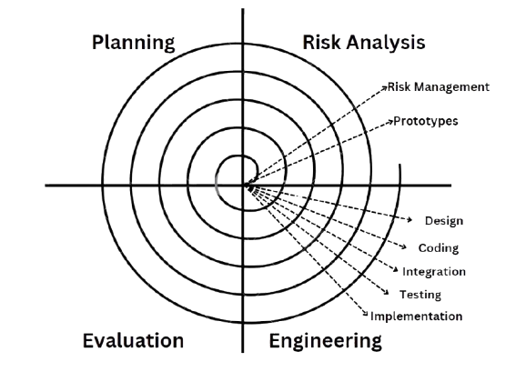

Figure 6‑1:Spiral Model

The Spiral Model is used in this project. A sophisticated method for developing software, the spiral model offers a framework for taking on challenging tasks and refining and assessing risks iteratively. The model is shown as a spiral, where each loop or phase denotes a different step in the process of evolution. It serves as the foundation for the majority of software development processes, which include planning, risk analysis, engineering, and evaluation.

The phases in Spiral model are: -

## Planning Phase

The project's goals, parameters, and extent are specified at the planning phase. In order to determine the resources, deadlines, and deliverables, stakeholders collaborate. In order to create a strong basis for the project, requirements collecting and preliminary feasibility study are also completed during this phase.

## Risk Analysis

The spiral model's most unique characteristic is its risk analysis. Prototypes and models are used in this phase to identify, assess, and mitigate potential risks. To lower the chance of failure, the development team evaluates operational, financial, schedule-related, and technological risks.

## Engineering

This is the real development phase, during which system design, testing, and coding are done. The product is built incrementally, with every cycle resulting in a deliverable or prototype that changes with each iteration.

## Evaluation

Stakeholders assess the current build or prototype at the end of each cycle. Testers, clients, and end users all provide feedback. In the following iteration, the product might see improvements or adjustments in response to this input. This stage assists in guaranteeing that the product meets the expectations of the user.

# **Project Gantt Chart**

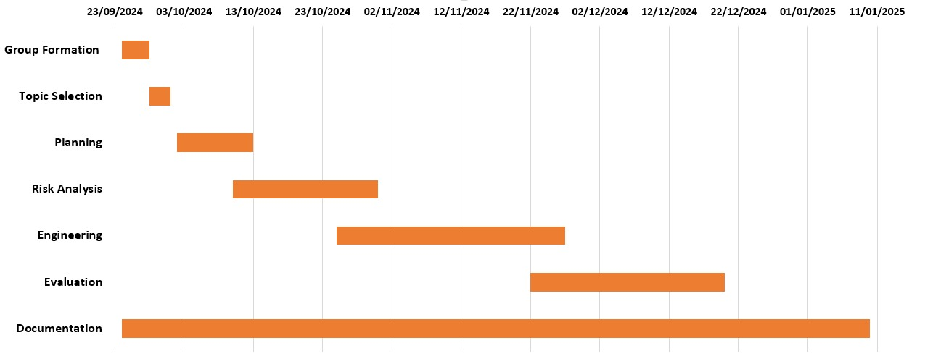

# **Deliverables**

* System Design: Detailed design specifications for the decentralized learning platform
* Functional Prototype: A working prototype showcasing the key features and functionalities.
* Comprehensive Testing: Thorough testing and evaluation of the platform's performance and user experience.
* Deployment Plan: A detailed plan for the platform's deployment and ongoing maintenance.

# 