
Pokhara University Affiliate

LA GRANDEE INTERNATIONAL COLLEGE
Simalchaur, Pokhara, Nepal

A Project Proposal/Report
on
“FinTrack”

Submitted to
Bachelor of Computer Application (BCA) Department
LA GRANDEE International College

In partial fulfillment of the requirements for the degree of Bachelor of Computer Application under Pokhara University

Submitted by
Amit Baral :2021-1-51-0366
Prabin Shrestha :2021-1-51-0358
Sangam Subedi :2021-1-51-0346
Bachelor of Computer Application, 8th Semester
Date: September 24, 2025
Table of Contents
1. Introduction 1
2. Background Study 2
3. Problem Statement 4
4. Objectives 5
5. Methodology 6
6. Project Gantt Chart 8
7. Project deliverables 9
8. References 10

List of Figure

Figure 5.1 Agile Methodology 8
Figure 6.1 Project Gantt Chart 9

Introduction
The project "FinTrack – Smart Income and Expense Management System" is a comprehensive financial management solution that combines the convenience of a mobile application with the powerful oversight of a web-based admin panel. This system is designed to help individuals and family efficiently track, analyze, and manage their income and expenses, ultimately fostering better financial decision-making and control.
The primary aim of this project is to create a user-friendly, secure, and scalable platform where users can log their daily financial transactions, categorize spending, set budgets, and review reports to monitor their financial health. The web-based admin panel provides administrators with advanced tools to manage users, monitor system performance, and ensure data integrity, making it suitable for both personal and small business use cases.
In today’s fast-paced digital world, financial management has become increasingly complex. Many individuals and businesses struggle with poor budgeting practices and lack of financial visibility. By leveraging mobile-first technology, cloud-based storage, and responsive design, FinTrack provides real-time access to financial data anytime, anywhere.
The significance of this project lies in its ability to promote financial literacy, improve savings habits, and enhance transparency in money management. It is aligned with current industry trends where digital transformation and automation are key drivers of efficiency. The system not only simplifies daily expense tracking but also generates detailed analytical reports, empowering users to make data-driven financial decisions.
In essence, FinTrack bridges the gap between personal finance management and modern digital technology, offering a smart, accessible, and efficient solution for today’s financial challenges.

Background Study
In the present era of rapid technological advancement, effective financial management has become a crucial part of both personal and professional life. Individuals and families often face challenges in maintaining accurate records of income and expenses, leading to poor budgeting, overspending, and limited financial visibility. Similarly, small businesses encounter difficulties in monitoring cash flow and generating reliable financial reports, which are essential for informed decision-making. Traditional methods, such as manual bookkeeping or basic spreadsheets, are often time-consuming, error-prone, and lack the advanced features required to meet modern financial needs.
The emergence of digital financial management tools has addressed some of these issues, yet many existing solutions remain limited (karobarapp.com, 2025). Common gaps include:
- Lack of detailed financial reports: Many applications provide only basic summaries without offering in-depth analytical insights into spending patterns and income distribution.
- Absence of receipt management features: Users often struggle to store and validate expenses as most platforms do not allow photo uploads of receipts or proof of transactions.
- Limited guidance on expense optimization: Few systems provide personalized suggestions or recommendations that help users manage their expenses more efficiently.
To bridge these gaps, FinTrack – Smart Income and Expense Management System has been conceptualized as a comprehensive and user-centric platform. The system leverages mobile-first technology for user convenience, cloud-based storage for data security, and a responsive web-based admin panel for oversight and management. Users can log daily transactions, categorize their spending, set budgets, upload receipts for verification, and review detailed reports to monitor their financial health. Meanwhile, administrators gain advanced tools to manage user accounts, track system performance, and ensure data integrity.
The significance of FinTrack lies in its alignment with current industry trends of digital transformation and automation. By providing real-time access to financial data anytime and anywhere, the platform not only enhances transparency but also promotes financial literacy and better savings habits. Its ability to generate detailed analytical reports empowers users to make informed, data-driven financial decisions. Additionally, the inclusion of features like receipt uploads and intelligent suggestions for expense management distinguishes FinTrack from many conventional financial applications.
In summary, FinTrack addresses the shortcomings of existing financial management tools by offering a secure, scalable, and intelligent solution that integrates advanced reporting, receipt management, and smart recommendations. It serves as a bridge between modern digital technology and personal finance management, thereby enabling individuals, families, and small businesses to take control of their financial journey with greater ease and confidence.

Problem Statement
- Individuals and families struggle to maintain proper records of income and expenses, leading to poor budgeting and overspending.
- Current solutions are often complex, expensive, or lack features like family expense sharing and centralized tracking.
- Manual tracking through notebooks or spreadsheets is time-consuming, error-prone, and lacks real-time updates.

Objectives
- Provide a simple mobile app for individuals and families to record and monitor income and expenses in real time
- Allow families to share and track household expenses collectively for better budgeting and transparency.
- Use AI to analyze spending patterns and give personalized financial advice, tips, and alerts to improve money management.
- Build a secure web-based admin panel to manage users, ensure data security, and monitor overall system performance

Methodology
The development of FinTrack – Smart Income and Expense Management System will follow the Agile methodology (agilealliance.org, 2025), which emphasizes flexibility, collaboration, and iterative progress. Agile is ideal for this project as it allows continuous improvement based on user feedback and changing requirements.
The methodology will be carried out through the following key phases:
- Planning and Requirement Gathering:
  - Identify core features such as personal and family tracking, AI feedback, and admin control.
  - Define user roles: Individual User, Family Group, and Admin.
  - Create a product backlog with prioritized tasks and features.
- Design and Prototyping:
  - Develop wireframes and UI/UX designs for the mobile app and web panel.
  - Plan database structure and cloud integration for secure data storage.
- Iterative Development (Sprints):
  - Divide the project into short sprints (2–3 weeks).
  - Develop features in small, manageable increments, such as:
    - Sprint 1: Basic income and expense tracking.
    - Sprint 2: Family expense sharing and group management.
    - Sprint 3: AI-powered feedback system.
    - Sprint 4: Web-based admin panel and reporting tools.
- Testing and Quality Assurance:
  - Perform continuous testing after each sprint to identify and fix bugs early.
  - Ensure the system meets security, performance, and usability standards.
- Deployment and User Feedback:
  - Deploy the mobile app and web panel for initial use.
  - Collect real-time feedback from users and admins to improve features.
- Maintenance and Continuous Improvement:
  - Regularly update the system with new features and security patches.
  - Enhance the AI system to provide smarter insights over time.
  - 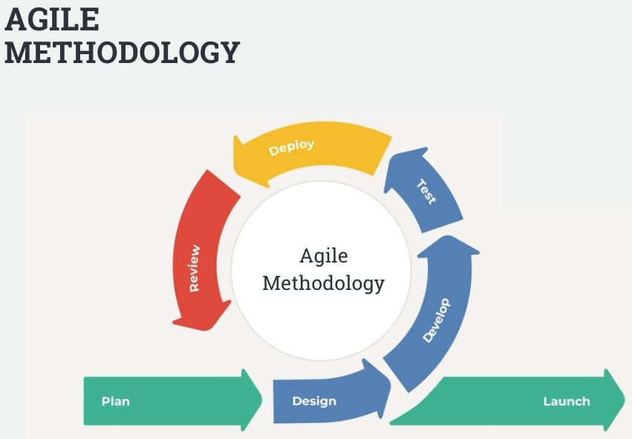
Figure 5.1 Agile Methodology (InterQuality, 2025)

Project Gantt Chart
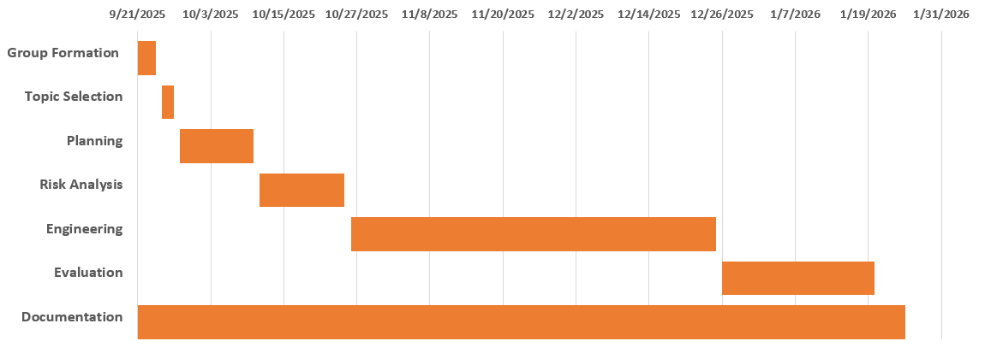
Figure 6.1 Project Gantt Chart

Project deliverables
- Simple Mobile Application for logging income and expenses.
- User Manual to guide end-users in operating the mobile app.
- Documentation Report covering project design, implementation, and testing.

References
- Agile Alliance. (n.d.). What is Agile? | Agile 101. https://agilealliance.org/agile101/
- Karobar. (n.d.). Features [Web page]. https://www.karobarapp.com/en-us#features
- InterQuality. (2025). Agile methodology. Retrieved September 25, 2025, from https://interqualitybg.com/en/resources/scrum-and-agile-resources/agile-methodology

