# Lab 4

## Arrays and Vectors

Skills Required

* Create Arrays, and Vectors, iterate over them.
* Create Functions, Include Headers and other files, Loops (while, for), Conditional (if, switch), Datatypes, assignment, etc.

This assignment will have you use a 2-dimensional array or a 2-dimensional vector of integers to create a matrix and do matrix addition and matrix multiplication. Since you can’t resize a 2-dimensional array you can create a 20x20 integer array, only using the columns and rows for the sizes the user creates. The program will ask the user for the size of the first matrix; rows and columns, and then the values for the cells in the matrix. It will then do the same for the second matrix, then if possible, add the matrices together. (The # of rows and columns have to be equal) Then do matrix multiplication on the matrices if they can be multiplied together. Rules for that are given below.

The choice of 2-dimensional array or vector is up to you, they both have advantages and drawbacks. I suggest you choose one make sure you can populate it with data and output before getting into the details of the project. Below are 2 examples of creating a matrix.

// Creating a matrix with 2-dimensional array. and set row 0 column 2 to 5

int matrix1[20][20];

matrix1[0][2] = 5;

vector<vector<int>> matrix1;

matrix1.resize(7); // Set the number of rows to 7

matrix1.at(0).resize(6); // Set the number of columns in row 0 to be 6

matrix1.at(0).at(2) = 5;

1. Assignment
   1. Ask the user for the number of rows in the 1st matrix, and then the number of columns for it. Let them enter all the values for the matrix, then display it back to them.
   2. Do the same for matrix 2.
   3. If the matrices (rows and columns are the same for both) can be added, then add the 2 matrices together and output the results.
      1. To be able to add 2 matrices they must be the same size. Matrices are added by adding corresponding elements:
 $$a=\left[\begin{matrix}a_{0,0} & a_{0,1} & a_{0,2} \\ a_{1,0} & a_{1,1} & a_{1,2}\end{matrix}\right] b=\left[\begin{matrix}b_{0,0} & b_{0,1} & b_{0,2} \\ b_{1,0} & b_{1,1} & b_{1,2}\end{matrix}\right]$$

 $$a+b=\left[\begin{matrix}a_{0,0}+b_{0,0} & a_{0,1}+b_{0,1} & a_{0,2}+b_{0,2} \\ a_{1,0}+b_{1,0} & a_{1,1}+b_{1,1} & a_{1,2}+b_{1,2}\end{matrix}\right] \\ \left[\begin{matrix}1 & 2 & 3 \\ 4 & 5 & 6\end{matrix}\right]+\left[\begin{matrix}7 & 8 & 9 \\ 10 & 11 & 12\end{matrix}\right]=\left[\begin{matrix}8 & 10 & 12 \\ 14 & 16 & 18\end{matrix}\right]$$

 4. If the matrix can be multiplied then multiply them together and output the results. 2 matrices, a and b, can be multiplied together if the number of columns in matrix a is equal to the number of rows in b. The resulting matrix size will be the number of rows in matrix a, and the number of columns of matrix b. Note that because matrix multiplication is ‘left to right,’ it is not commutative; a*b ≠ b*a. (Indeed, b*a may not even be defined.)
      1. A value at a particular row column $\sum_{i=0}^{n}{a_{row, i}*b_{i, col}}$. n is the number of columns in matrix a (which is also the number of rows in matrix b).

$\left[\begin{matrix}1 & 2 & 3 \\ 4 & 5 & 6\end{matrix}\right]*\left[\begin{matrix}1 & 2 \\ 3 & 4 \\ 5 & 6\end{matrix}\right]=\left[\begin{matrix}22 & 28 \\ 49 & 64\end{matrix}\right]$

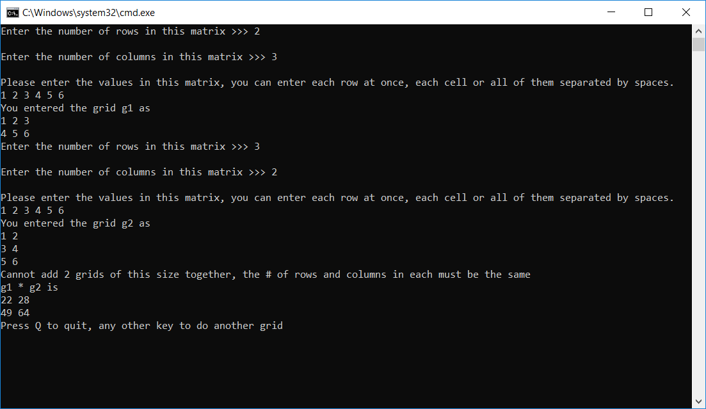

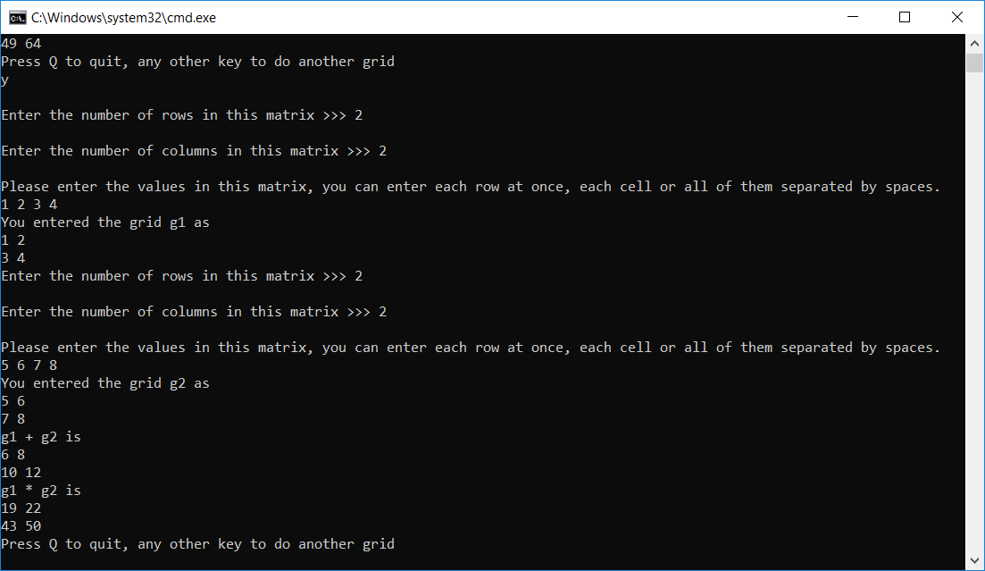

1. Save all files and either upload to GitHub or zip up the project folder and upload it by the deadline.