數位邏輯實驗 — 作業二
系級：資工2A 姓名：林博仁 學號：09957010
➢ 實驗名稱：2 to 4 Decoder和3 to 8 Decoder
➢ 實驗目的：
- 學習Decoder解碼電路的概念
- 學習Gate Level的使用
- 熟悉Xilinx ISE 軟體操作
➢ 電路圖：
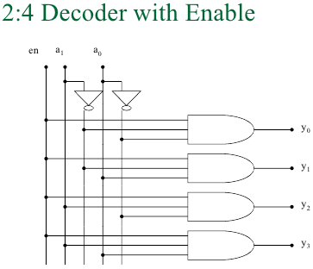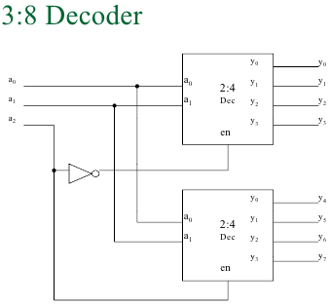
➢ Verilog HDL code：
/* 模組名稱：1對2解碼器(decoder)*/
`ifndef DECODER1TO2_V_INCLUDED
`define DECODER1TO2_V_INCLUDED
`timescale 1ns / 100ps

module decoder1to2(o1, o0, i);
output o1, o0;
input i;
wire ibar;

not
inv(ibar, i);
assign o1 = i;
assign o0 = ibar;
endmodule
`endif

/* 模組名稱： 2 to 4 line decoder with enable
*/
`ifndef DECODER2TO4WITHENABLE_V_INCLUDED
`define DECODER2TO4WITHENABLE_V_INCLUDED
`timescale 1ns / 100ps
`include "Source_code/decoder1to2/decoder1to2.v"

module decoder2to4withEnable(o, i, En);
output [3:0]o;
input [1:0]i;
input En;
wire o3a, o2a, o1a, o0a, raw1, raw1bar, raw0, raw0bar;

//
decoder1to2
dec0(raw0, raw0bar, i[0]),
dec1(raw1, raw1bar, i[1]);

//
and
a3(o3a, raw1, raw0),
a2(o2a, raw1, raw0bar),
a1(o1a, raw1bar, raw0),
a0(o0a, raw1bar, raw0bar),

e3(o[3], o3a, En),
e2(o[2], o2a, En),
e1(o[1], o1a, En),
e0(o[0], o0a, En);

endmodule
`endif

/* 模組名稱：decoder3to8
*/
`ifndef DECODER3TO8_V_INCLUDED
`define DECODER3TO8_V_INCLUDED
`include "Source_code/decoder2to4withEnable/decoder2to4withEnable.v"
`include "Source_code/decoder1to2/decoder1to2.v"
`timescale 1ns / 100ps

module decoder3to8(out, in);
input [2:0]in;
output [7:0]out;
wire i2, i2bar;

decoder1to2 dec12_2(i2, i2bar, in[2]);
decoder2to4withEnable
dec24_0(out[3:0], in[1:0], i2bar),
dec24_1(out[7:4], in[1:0], i2);
endmodule
`endif

➢ 模擬結果：
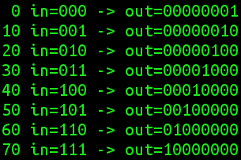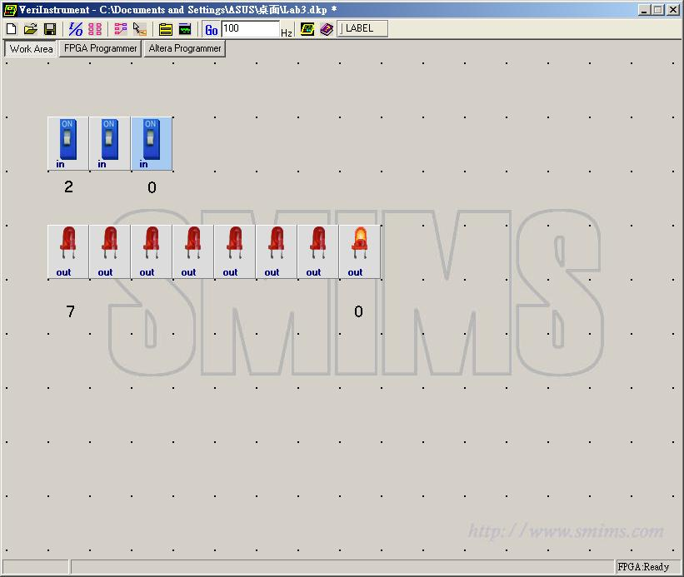
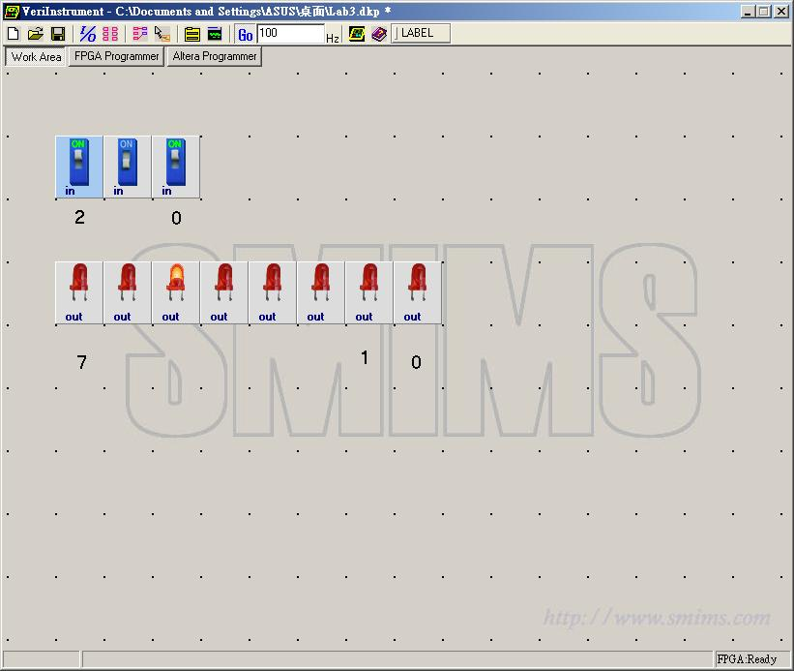➢ 心得討論：

