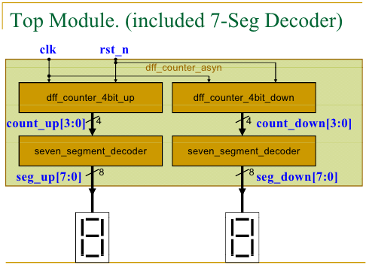
數位邏輯實驗 — 作業五
系級：資工2A 姓名：林博仁 學號：09957010

➢ 實驗名稱： 非同步D Flip Flop 計數器(4bits)
➢ 實驗目的：
- 瞭解D Flip Flop的概念
- 學習使用D Flip Flop 完成計數器
- 了解何謂正緣觸發以及負緣觸發的差異性
- 熟悉Xilinx ISE 軟體操作
➢電路圖：

➢ Verilog HDL code：
/* 模組名稱： D型正反器（負緣觸發）*/
`ifndef DFLIPFLOPNEGCLKRST_V
`define DFLIPFLOPNEGCLKRST_V
`timescale 1ns / 100ps
module dFlipFlopNegClkNegRst(Q, Qbar, D, Clk, ClrN);
input D, Clk, ClrN;
output reg Q, Qbar;

always @(negedge Clk or negedge ClrN)
begin
if(~ClrN) begin
Q <= 0;
Qbar <= 1;
end else begin
Q <= D;
Qbar <= ~D;
end
end
endmodule
`endif

/* 模組名稱： D型正反器（負緣觸發）*/
`ifndef DFLIPFLOPPOSCLKNEGRST_V
`define DFLIPFLOPPOSCLKNEGRST_V
`timescale 1ns / 100ps
module dFlipFlopPosClkNegRst(Q, Qbar, D, Clk, ClrN);
input D, Clk, ClrN;
output reg Q, Qbar;

always @(posedge Clk or negedge ClrN)
begin
if(~ClrN) begin
Q <= 0;
Qbar <= 1;
end else begin
Q <= D;
Qbar <= ~D;
end
end
endmodule
`endif

//非同步clock之四位元D型正反器（下數）
`ifndef FOURBITDFFDOWNCOUNTWASYNCLK_V
`timescale 1ns / 100ps
`include "Source_code/dFlipFlopPosClkNegRst/dFlipFlopPosClkNegRst.v"
module fourBitDFFdownCounterWasynClock(count, Clk, ClrN);
output [3:0]count;
input Clk, ClrN;
wire w3, w2, w1, w0;
wire [3:0]dummy;

dFlipFlopPosClkNegRst c0(w0, dummy[0], ~w0, Clk, ClrN),
c1(w1, dummy[1], ~w1, w0, ClrN),
c2(w2, dummy[2], ~w2, w1, ClrN),
c3(w3, dummy[3], ~w3, w2, ClrN);

assign count[0] = w0,
count[1] = w1,
count[2] = w2,
count[3] = w3;

endmodule
`endif

//非同步clock之四位元D型正反器（上數）
`ifndef FOURBITDFFUPCOUNTWASYNCLK_V
`timescale 1ns / 100ps
`include "Source_code/dFlipFlopNegClkNegRst/dFlipFlopNegClkNegRst.v"
module fourBitDFFupCounterWasynClock(count, Clk, ClrN);
output [3:0]count;
input Clk, ClrN;
wire w3, w2, w1, w0;
wire [3:0]dummy;

dFlipFlopNegClkNegRst c0(w0, dummy[0], ~w0, Clk, ClrN),
c1(w1, dummy[1], ~w1, w0, ClrN),
c2(w2, dummy[2], ~w2, w1, ClrN),
c3(w3, dummy[3], ~w3, w2, ClrN);

assign count[0] = w0,
count[1] = w1,
count[2] = w2,
count[3] = w3;

endmodule
`endif

//七段顯示器解碼器
//輸入port
// binary coded decimal 0~15
//輸出port
// 七段顯示器a~h顯示訊號
`ifndef SEVENSEGMENTDISPLAYDECODER_V
`define SEVENSEGMENTDISPLAYDECODER_V
`timescale 1ns / 100ps

module sevenSegmentDisplayDecoder(out, in);
output [7:0]out;
input [3:0] in;

//h(currently not used)
assign out[7] = 0;

//g
assign out[6] = ~in[3] & ~in[2] & in[1] |
~in[3] & in[2] & ~in[1] |
in[3] & in[2] & in[0] |
in[1] & ~in[0] |
in[3] & ~in[2];
//f
assign out[5] = ~in[1] & ~in[0] |
~in[3] & in[2] & ~in[1] |
in[3] & ~in[2] & ~in[1] |
in[1] & in[3] |
in[2] & in[1] & ~in[0];

//e
assign out[4] = in[1] & ~in[0] |
in[3] & ~in[1] & ~in[0] |
~in[2] & ~in[1] & ~in[0] |
in[2] & in[3] |
in[3] & in[1] & in[0];
//d
assign out[3] = in[3] & ~in[1] |
~in[2] & ~in[1] & ~in[0] |
in[2] & ~in[1] & in[0] |
in[0] & in[3] & ~in[2] |
~in[3] & ~in[2] & in[1] |
in[2] & in[1] & ~in[0];

//c
assign out[2] = ~in[1] & ~in[3] |
in[0] & ~in[3] |
~in[3] & in[2] & in[1] |
in[3] & ~in[1] & in[0] |
in[3] & ~in[2];

//b
assign out[1] = ~in[3] & ~in[2] |
~in[3] & ~in[1] & ~in[0] |
~in[3] & in[1] & in[0] |
in[3] & ~in[1] & in[0] |
in[3] & ~in[2] & ~in[0];

//a
assign out[0] = ~in[2] & ~in[1] & ~in[0] |
in[3] & ~in[1] & ~in[0] |
~in[3] & in[1] & in[0] |
~in[1] & in[3] & ~in[2] |
~in[3] & in[2] & in[0] |
in[2] & in[1] & in[0] |
in[1] & ~in[0];
endmodule
`endif

/* 模組名稱：dff_counter_asyn*/
`timescale 1ns / 100ps
`include "Source_code/fourBitDFFdownCounterWasynClock/fourBitDFFdownCounterWasynClock.v"
`include "Source_code/fourBitDFFupCounterWasynClock/fourBitDFFupCounterWasynClock.v"
`include "Source_code/sevenSegmentDisplayDecoder/sevenSegmentDisplayDecoder.v"
module dff_counter_asyn(seg_up, seg_down, Clk, resetN);
input Clk, resetN;
output [7:0] seg_up, seg_down;
wire [3:0] count_up, count_down;

fourBitDFFupCounterWasynClock dff_counter_4bit_up(count_up, Clk, resetN);
fourBitDFFdownCounterWasynClock dff_counter_4bit_down(count_down, Clk, resetN);
sevenSegmentDisplayDecoder up_display(seg_up, count_up),
down_display(seg_down, count_down);

endmodule
➢ 模擬結果：
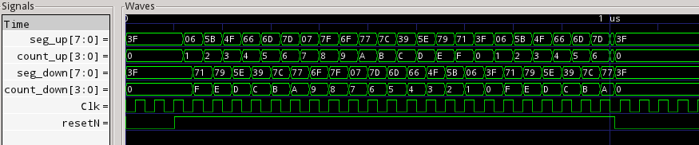
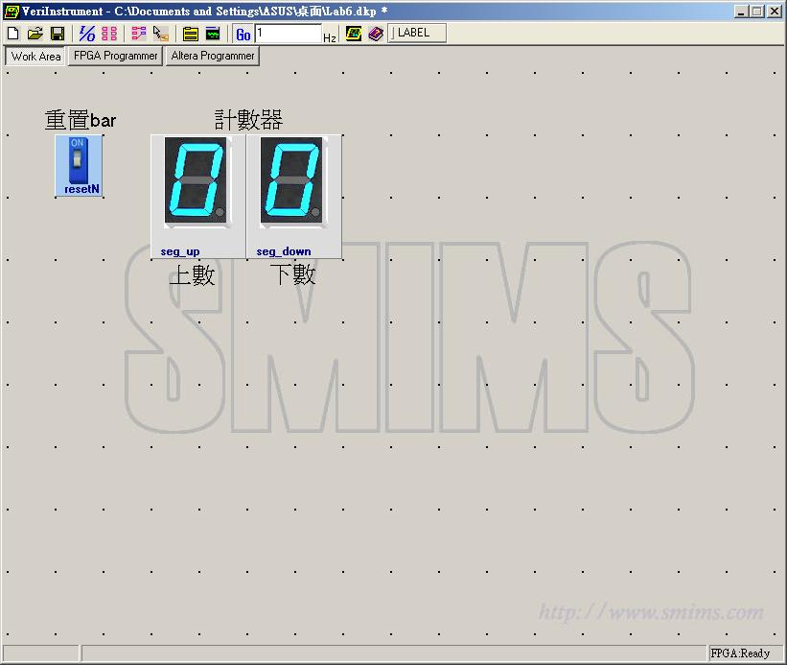
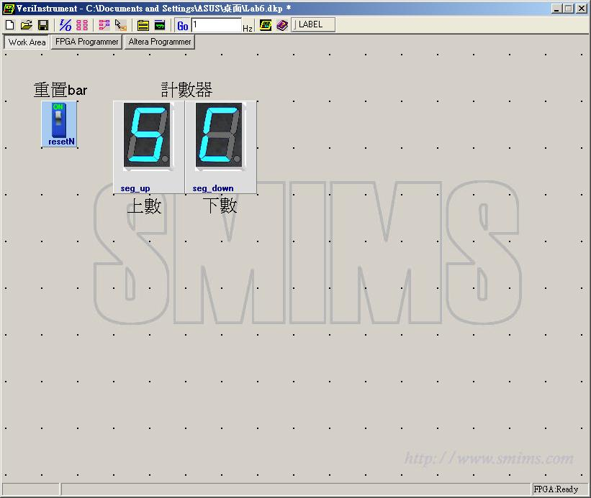
➢ 心得討論：

