數位邏輯實驗 — 作業六
系級：資工2A 姓名：林博仁 學號：09957010

➢ 實驗名稱：使用同步 D Flip Flop 計數器以及七段顯示器跳學號
➢ 實驗目的：
- DFF的應用
- 學習使用D Flip Flop 完成計數器
- 使用卡諾圖化簡布林函數
➢ 電路方塊圖：

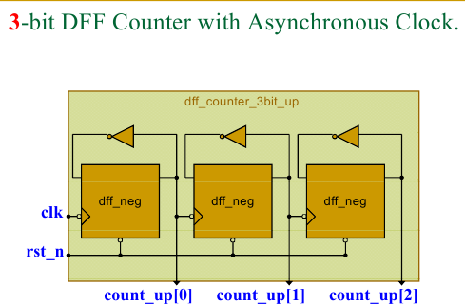

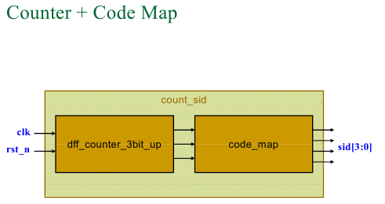
➢學號真值表：

➢ Verilog HDL code：
//非同步clock之三位元D型正反器上數計數器
`ifndef THREEBITDFFUPCOUNTWASYNCLK_V
`timescale 1ns / 100ps
`include "Source_code/dFlipFlopNegClkNegRst/dFlipFlopNegClkNegRst.v"
module threeBitDFFupCounterWasynClock(count, Clk, ClrN);
output [2:0]count;
input Clk, ClrN;
wire w2, w1, w0;
wire [2:0]dummy;

dFlipFlopNegClkNegRst c0(w0, dummy[0], ~w0, Clk, ClrN),
c1(w1, dummy[1], ~w1, w0, ClrN),
c2(w2, dummy[2], ~w2, w1, ClrN);

assign count[0] = w0,
count[1] = w1,
count[2] = w2;

endmodule
`endif
/* 模組名稱：SID counter*/
`timescale 1ns / 100ps
`include "Source_code/threeBitDFFupCounterWasynClock/threeBitDFFupCounterWasynClock.v"
module count_sid(sid, clk, rstN);
input clk, rstN;
output [3:0]sid;
wire [2:0]num;

threeBitDFFupCounterWasynClock count(num, clk, rstN);
assign sid[3] = ~num[2] & ~num[1] & num[0] |
~num[2] & num[1] & ~num[0],
sid[2] = ~num[2] & num[1] & num[0] |
num[2] & ~num[1] & ~num[0],
sid[1] = num[2] & ~num[1] & ~num[0],
sid[0] = ~num[2] & num[0] |
num[1] & ~num[2] |
num[2] & ~num[0];

endmodule
/* 模組名稱：Lab7 top module */
`timescale 1ns / 100ps
`include "Source_code/count_sid.v"
`include "Source_code/sevenSegmentDisplayDecoder/sevenSegmentDisplayDecoder.v"

module dff_counter_sid_top(seg, clk, rst_n);
input clk, rst_n;
output [7:0]seg;
wire [3:0]sid;

count_sid countSid(sid, clk, rst_n);
sevenSegmentDisplayDecoder display(seg,sid);
endmodule
➢ 模擬結果：
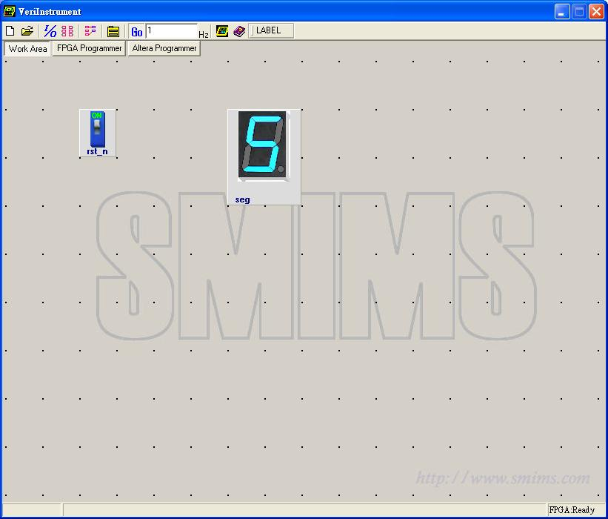
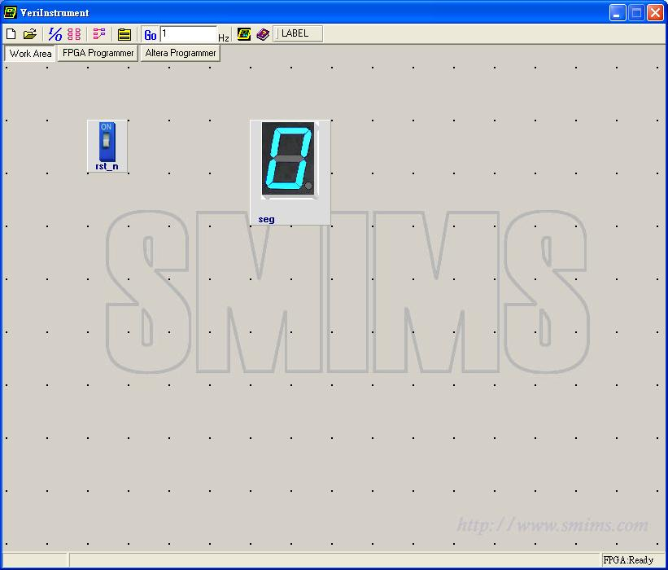
➢ 心得討論：

