horizontal line

Software Requirements Specification

**19th April 2021**

**Terre Haute Card Shop**

Zachary Dewitt

Patience Hore

Tessa Carpenter

Rodney McGarrah

Ben Tidd

**Green Team**

**Ivy Tech Community College**

**Instructor Sullens**

# REQUIREMENTS DEFINITION

# PURPOSE AND SCOPE

The purpose of the project is to create a shopping system. This system will allow users to browse an inventory from which they can purchase products through a secure payment portal. The proposed system will have a secure payment portal, an option for the customer to select delivery, and shipping options of their preference. The proposed system will also keep track of his inventory and should also include a shipping calculator.

# RATIONALE

The owner currently sells trading cards on eBay but has mentioned their customers are having issues with the website. The client has also mentioned that his customers have been experiencing issues with the current payment method, which is PayPal; therefore we will be looking towards other payment method options. So, our goal is to streamline a new website that will provide a seamless transaction for the user and help the owner keep track of their inventory.

# ESSENTIAL CHARACTERISTICS

**Essential Requirements**

|  |  |
| --- | --- |
| **ID** | **Description** |
| **E01** | **To keep track of inventory.** |
| **E02** | **The website should be user friendly.** |
| **E03** | **Keep track of previous purchases.** |
| **E04** | **User login for returning customers** |
| **E05** | **Register button for new customers** |
| **E06** | **Sales total calculator.** |
| **E07** | **Make it mobile-friendly, so that it can be viewed on a cellphone/tablet.** |
| **E08** | **Alternative payment options.** |
| **E09** | **Sponsor maintainable.** |
| **E10** | **Shopping cart interface.** |
| **E11** | **Contact page.** |
| **E12** | **User interface.** |
| **E13** | **Secure purchasing.** |

**Desirable Requirements**

|  |  |
| --- | --- |
| **ID** | **Description** |
| **D01** | **A way for the customer to calculate the cost of shipping before purchasing an item.** |
| **D02** | **A shipping station.** |
| **D03** | **Completion date.** |

**Optional Requirements:**

|  |  |
| --- | --- |
| **ID** | **Description** |
| **O01** | **Link to Facebook page.** |

# ENVIRONMENT

The website will be hosted via third party. The owner of the website, David, will have full control over the website, along with the ability to add or update listings to his website. The users will be able to access the website through a web browser. Users will have the ability to add items to their shopping cart, calculate shipping costs, sign up for updates, and be able to ask questions about an item.

# PROPOSAL FOR THE SOLUTION

The client provided requirements and proposed a website for the solution.

# ASSUMPTIONS ABOUT HOW THE ENVIRONMENT BEHAVES

Having a third party host the website will mean that David will not have to worry about maintaining his own server equipment and that he will only have to worry about paying for website features and the amount of traffic his website brings in. The way the users will be able to interact with the website should prevent them from being able to perform the same actions that David will be able to, preventing the users from causing any errors from improper usage. Changing requirements could be a possibility if David looks to add or remove any features to his website or upgrade any existing features, the requirements could also be a factor if the website traffic becomes large and David wants to make sure that any information on the website is secure and that the users will not have any issues with accessing the website.

# 

# REQUIREMENTS SPECIFICATION

# INTRODUCTION

1. **Purpose**

The purpose of the project is to provide David the ability to be able to sell his cards online without having to use eBay or any other vendor.

1. **Scope**

The new proposed system should have a secure payment, an option for the customer to select delivery, and shipping options of their preference. The new proposed system would keep track of his inventory and should also include a shipping calculator.

# DESCRIPTION

1. **Current System**

Our client currently uses the third-party shopping site eBay. David has made it clear to us that he wants to move away from using the third-party shopping site eBay. His reasoning is that he would like to earn all his commission, make it more user-friendly for his customers, and get away from using PayPal.

1. **Users**

The users of this upcoming shopping website that we plan to design and develop will be our client’s customers and most importantly our client, so that he can maintain the website and update at his own leisure.

1. **Features**

This shopping website will be sponsor maintainable by allowing David to have access to his card inventory, previous sales, but also be able to post updates on the websites of current sales etc. On the user side, we plan to make this website user / mobile-friendly, that way it is accessible on a cell phone or tablet; but also easy to use. Sometimes, customers may need to contact our client to see if there is a certain card or if the price of the card is firm, for that we will have a contact page for them to reach out to David. With it being user friendly, we want to take the guesswork out of the user interface, this website will have a simpler shopping cart interface. Within the shopping cart interface, our system will display the sales total, have a better alternative payment method known as Stripe, and all the while keeping everything tight and secure.

1. **Environment**

This website will be hosted from a third-party host. We want to allow David to have full access to the website, so that if he needs to add any listings or sales, he is able to do so. The website will need to be accessible 24/7 365 days a year. We will be using the HTML environment to design and develop this website.

1. **Constraints**

The fact that we want to give David full access to adding listings and sales, we need to implement a way for him to be able to do so on the website itself; which may act as a design constraint for us.

1. **Assumptions & Dependencies**

The transactions will go through securely via the alternative payment method Stripe. This should allow the customers to be able to feel safe whenever they are purchasing from an online shopping website as The Terre Haute Card Shop, itself.

# INTERFACES

1. **User Interface**
   1. **General Users** will be able to browse an inventory of trading cards. Users will also be able to purchase the trading cards through a secure payment portal. They will have the ability to login/create an account to view their previous purchases. There will be a Contact Us link to allow the user to contact the owner with questions.
   2. **Owner** - They will have full control over the website. They have the ability to add or update listings to the website.
2. **Software Interface:** The website will be built using HTML and on the Windows Operating System. It will be compatible with all browsers as well as on a cell phone or tablet.

# 

# NON-FUNCTIONAL REQUIREMENTS

|  |  |
| --- | --- |
| **ID** | **Description** |
| **NF01** | **Performance**- the proposed system is expected to have a fast response time and run without any interruptions. |
| **NF02** | **Security-** encryption is required to make payments and to keep personal information safe and secure. |
| **NF03** | **Privacy-**how personal information is stored. |
| **NF04** | **Scalability-** should be scalable to meet normal traffic and increased traffic. |
| **NF05** | **Compatibility-** the proposed system should be compatible with all browsers as well on a cell phone or a tablet. |
| **NF06** | **Availability-** the proposed system should run 24/7 365 days a year since it’s an online store. |

# DATA FLOW DIAGRAM

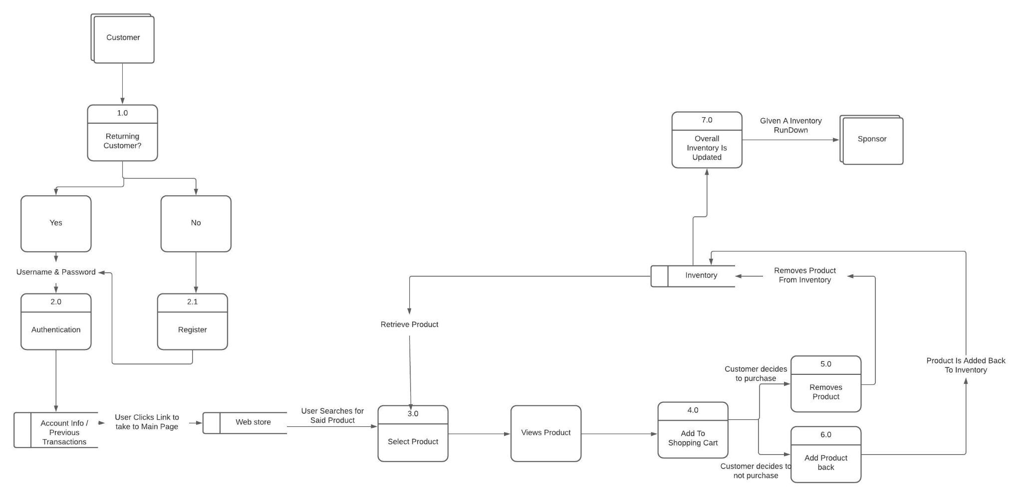

# USE CASE DIAGRAM

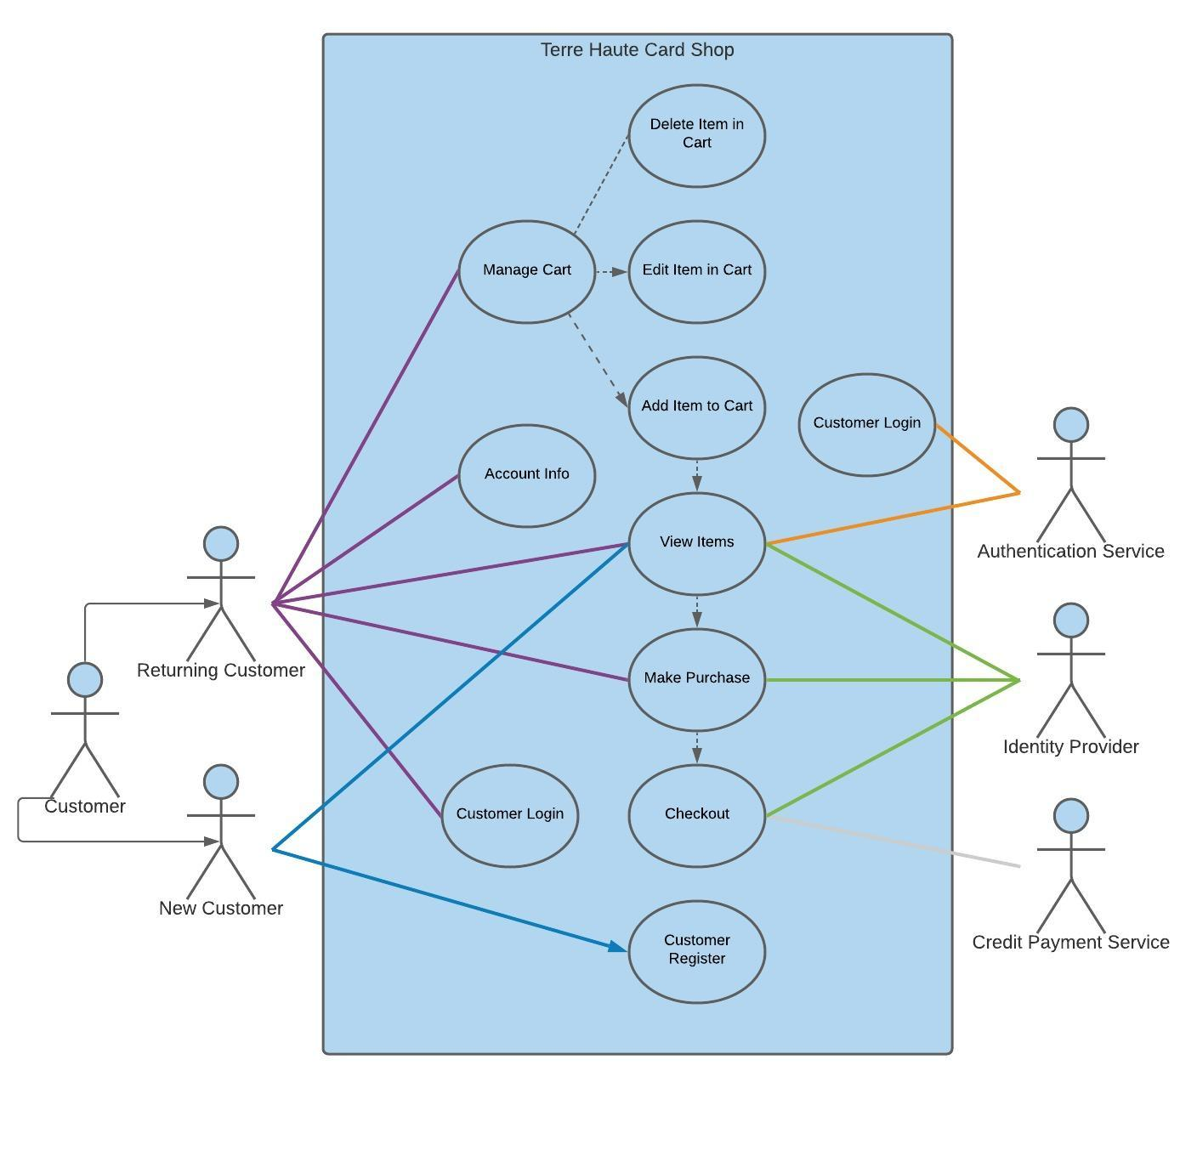

# VALIDATION

1. **Review**The team met with the owner to discuss the SRS and any concerns they may have. All requirements have been checked and confirmed to ensure they are actual needs for the client. Requirements were also checked for consistency, completeness, validity, and feasibility.
2. **Validity Check**Making sure that everything flows good before we send it off to David for him to use for his business. We need to test everything from the user interface to the shopping interface. Make sure that there are no broken links between pages, the total cost calculator computes correctly, and that it can be maintainable by David himself.
3. **Feasibility Check**The only requirements that question feasibility are the desirable requirements: using a shipping station and a way for the customer to calculate the cost of shipping before purchasing an item. At this time, it is unknown if we will be able to implement this on our website. We have confirmed that it will be feasible to implement all of the essential requirements.
4. **Consistency**

All the requirements are clear and no requirements conflict with each other.

1. **Completeness**

The requirements listed are relevant to the website and do not have any ambiguity.

1. **Validity**

Under the optional requirements, a link to Facebook, is not entirely relevant to the website. While it is a good idea to be able to advertise the website across platforms, it might lead to people buying and selling any product listed on Facebook compared to using the website.

1. **Realism**Of this project for our client David, the only requirement that may be somewhat of a question is the use of Stripe. Getting the actual permission to add that to the website might be a bit troublesome.