Emergent Properties

Simple building blocks operating within an architectural framework can lead to incredible growth and innovation, for example:

DNA Earth and its various climate zones Vast diversity of life on our planet
Containers Kubernetes Vast diversity of cloud-native applications

Toward a Unified Forwarding Paradigm

Over the past couple decades, the networking industry has evolved a complex alphabet soup of encapsulation types to perform different forwarding and policy functions. Technologies such as VXLAN for overlays, NSH for service chaining, and MPLS for traffic engineering are just a few examples. This technology fragmentation has led to siloed operational environments and the need to invest in costly gateways to stitch traffic across domains. Unlike the simple building blocks examples above, the complexity of networks and stitching various domains together has been a direct barrier to agility and innovation.

Segment Routing in general, and SRv6 uSID in particular represent a simple set of building blocks with emergent properties that can change the entire networking paradigm. With SRv6 uSID we can unify all encapsulation services (Segmentation, Steering, Service Chain, etc.) under a single forwarding technology which operates natively over IP. In fact, SRv6 allows us to create a Unified Forwarding Architecture operating End-to-End while providing massive scale, operational simplicity, and delivering as a platform for network agility and innovation.


I mean it when I say End-to-End: the Unified Forwarding Architecture means SRv6/IPv6 from access to core, thru the data center and across the cloud, and into the host or endpoint where our applications and workloads live.

And because SRv6 is fundamentally IPv6 technology, End-to-End also means interop with brownfield IPv6 networks.

Ok, but this is an Isovalent blog…

Yes, it is, and truth be told, I’ve been dreaming of extending SRv6 to the host and giving application and infrastructure owners direct access to this powerful set of tools for years. The way I see it, the combination of Kubernetes/cloud-native and SRv6 will lead to an explosion of network innovation.

Which is why my colleague Arkadiusz Kaliwoda and I were so excited to try out Isovalent’s Cilium Enterprise with support for SRv6 L3VPN in our labs!

Isovalent has been working closely with Bell Canada the last couple years on their SRv6 implementation, which came out in beta in the 1.13 release. Kali and I got access a few months later and have been collaborating and comparing notes while working with 1.15 and 1.16. This blog walks through my lab setup with K8s with Cilium SRv6 connected to a network of Cisco IOS-XR routers also running SRv6. In parallel Kali’s Cilium SRv6 exploration has led to him publishing a series of demos on youtube.

A very brief network engineer’s guide to installing Kubernetes

You’ll need:

- One or more servers or VMs to host your K8s cluster

- To decide which K8s distribution to deploy
There are a lot of options for K8s deployments, some examples: Microk8s, Redhat Openshift, or in my case I just run straight Kubeadm…see also these instructions

- Install your CNI (Container Network Interface)
To get access to the SRv6 features we ask that you engage your Cisco/Isovalent account team for licensing or to engage in “Proof of Value” testing of Isovalent Enterprise Cilium

In my case I launched a medium/large Ubuntu 22.04 VM (16 vCPU, 32GB of memory), then used Containerlab to define and launch a small topology of Cisco XRd routers. The routers were configured to run SRv6 for both ISIS and BGP; lots of configuration examples can be found here: SRv6-Labs on Github

Once my virtual XR network was in place I attached a pair small Ubuntu VMs to my XRd leaf nodes and installed Kubernetes using the instructions above.

I then installed Isovalent Enterprise Cilium with SRv6 enabled on the K8s VMs. At a high level my lab looked like this:
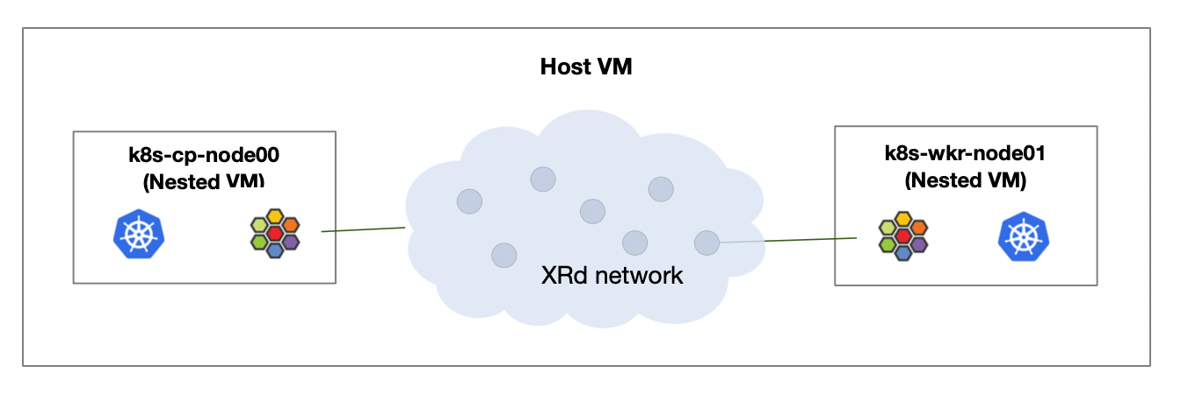
With my Kubernetes cluster ready and my routers configured it was time to configure Cilium SRv6 L3VPN, and then deploy some pods in different VRFs.

A quick summary of the steps involved:

- Establish BGP peering between Cilium and the upstream routers
- Define an SRv6 Locator pool for the K8s cluster
- Configure VRF(s) on the K8s cluster
- Configure Cilium SRv6 Responder
- Define and launch a couple simple pods/containers attached to specific VRFs
- Run some pings, verify connectivity and that Cilium is performing SRv6 encapsulation/decapsulation as expected
- Celebrate!

Establish BGP peering between Cilium and the upstream routers


First we create a Cilium BGP CRD yaml file. In my case I established both IPv4 and IPv6 eBGP sessions between Cilium and the upstream XR routers and configured the IPv6 sessions to exchange “mpls_vpn” address-family information. Here is my BGP yaml with comments added in red:

apiVersion: "cilium.io/v2alpha1"
kind: CiliumBGPPeeringPolicy
metadata:
name: k8s-wkr-node01
spec:
nodeSelector:
matchLabels:
kubernetes.io/hostname: k8s-wkr-node01 <-- node this portion of the config belongs to
virtualRouters:
- localASN: 65015 <----- worker node's BGP ASN
exportPodCIDR: true <----- advertise local PodCIDR prefix
mapSRv6VRFs: true <----- SRv6 L3VPN
srv6LocatorPoolSelector:
matchLabels:
export: "true" <--- advertise Locator prefix into BGP IPv6 underlay
neighbors:
- peerAddress: "10.15.1.1/32" <----- ipv4 peer address for xrd15
peerASN: 65010
families: <----- address families for this BGP session
- afi: ipv4
safi: unicast
- peerAddress: "2001:db8:18:15::1/128" <--- ipv6 peer address for xrd15
peerASN: 65010
families:
- afi: ipv6 <--- address families for this BGP session
safi: unicast
- afi: ipv4
safi: mpls_vpn <----- L3VPN AFI/SAFI

Once BGP was configured I used Cilium’s BGP CLI to verify sessions were established:

cilium bgp peers

In the output I expect to see both IPv4 and IPv6 sessions active and the advertisement and receipt of several BGP NLRIs for ipv4, ipv6, and ipv4/mpls_vpn (aka, SRv6 L3VPN). For example:

cisco@k8s-cp-node00:~/cilium-srv6/cilium$ cilium bgp peers

Node Local AS Peer AS Peer Address Session State Uptime Family Received Advertised
k8s-cp-node00 65014 65010 10.14.1.1 established 2m36s ipv4/unicast 20 1
65014 65010 2001:db8:18:14::1 established 2m36s ipv6/unicast 32 1
ipv4/mpls_vpn 6 0
k8s-wkr-node01 65015 65010 10.15.1.1 established 2m35s ipv4/unicast 20 1
65015 65010 2001:db8:18:15::1 established 2m35s ipv6/unicast 32 1
ipv4/mpls_vpn 6 0

From a routing protocols perspective (BGP and ISIS) the topology now looks like this:

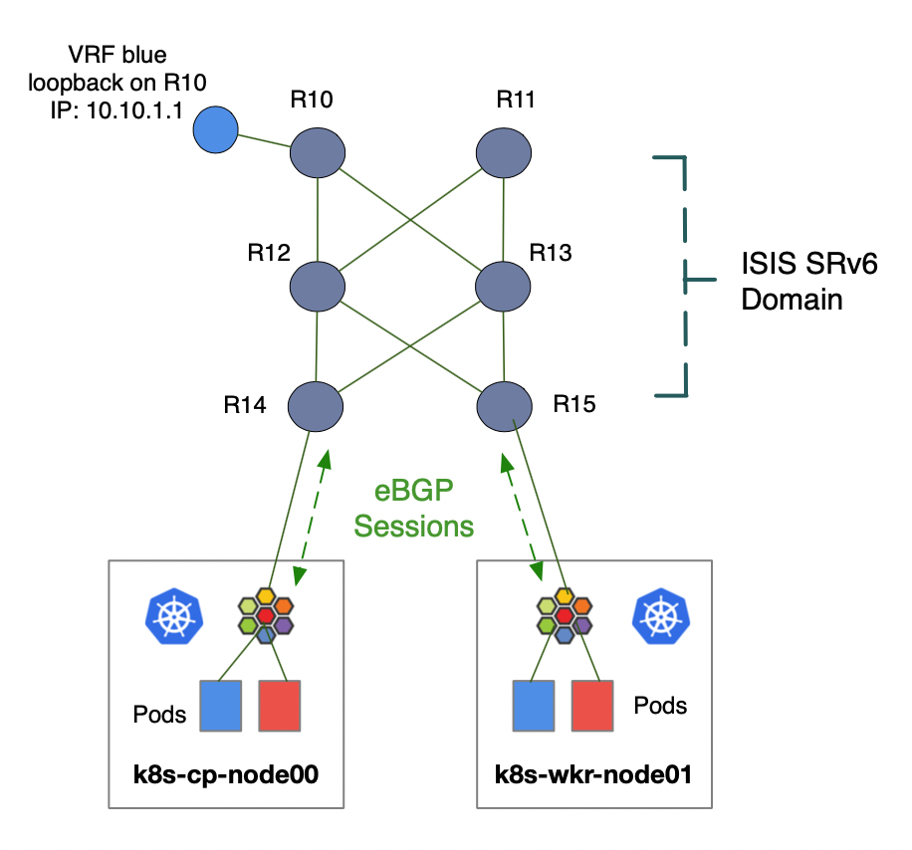
Next, I created an SRv6 Locator Pool CRD which will trigger Cilium’s SID Manager to dynamically allocate SRv6 Locators to each node in the cluster. In this case I’ve specified the use of uSID, a locator range prefix fc00:0:100::/40, locator block length of 32 bits and locator node length of 16 bits. SID Manager sees this configuration as meaning a range of 256 locators each with a /48 bit mask. Cilium SID Manager also supports /64 length locators, which I’ll explore in part 2 of this blog.

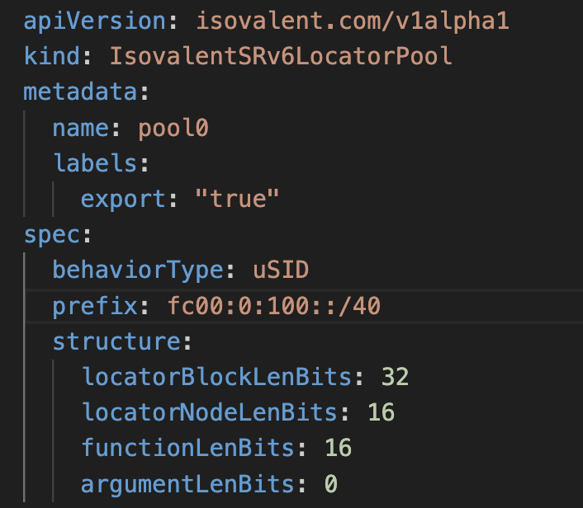

After applying the locator-pool.yaml we can use the ‘kubectl get sidmanager’ command to list the cluster’s SRv6 Locators and their meta data. Example output, again with my comments in red:

kubectl get sidmanager -o yaml

cisco@k8s-cp-node00:~$ kubectl get sidmanager -o yaml
apiVersion: v1
items:
- apiVersion: isovalent.com/v1alpha1
kind: IsovalentSRv6SIDManager
metadata:
creationTimestamp: "2024-08-18T19:12:50Z"
generation: 1
name: k8s-cp-node00
resourceVersion: "2593"
uid: 4220c57d-478d-4764-92c9-d050e4a53a9a
spec:
locatorAllocations:
- locators:
- behaviorType: uSID
prefix: fc00:0:15b::/48 <--- Locator for the control plane node
structure:
argumentLenBits: 0
functionLenBits: 16
locatorBlockLenBits: 32
locatorNodeLenBits: 16
poolRef: pool0 <---- locator pool name/id
status:
sidAllocations: [] <---- no SIDs yet, we'll see SIDs allocated when we create VRFs in the next step
- apiVersion: isovalent.com/v1alpha1
kind: IsovalentSRv6SIDManager
metadata:
creationTimestamp: "2024-08-18T19:12:50Z"
generation: 1
name: k8s-wkr-node01
resourceVersion: "2594"
uid: bb01d730-2e9a-44e7-9b17-90f2df7ae553
spec:
locatorAllocations:
- locators:
- behaviorType: uSID
prefix: fc00:0:134::/48 <------ Locator for the worker node
structure:
argumentLenBits: 0
functionLenBits: 16
locatorBlockLenBits: 32
locatorNodeLenBits: 16
poolRef: pool0
status:
sidAllocations: []
kind: List
metadata:
resourceVersion: ""

Next, I created a Kubernetes namespace and VRF into which future pods/containers can be deployed. For the sake of simplicity, the namespace and VRF are both named “blue”, but in reality there is no requirement that they match. In the ‘further reading’ section of this blog I included a link to a Layer-3 VPN tutorial that walks through things like RouteTargets seen in the VRF yaml:
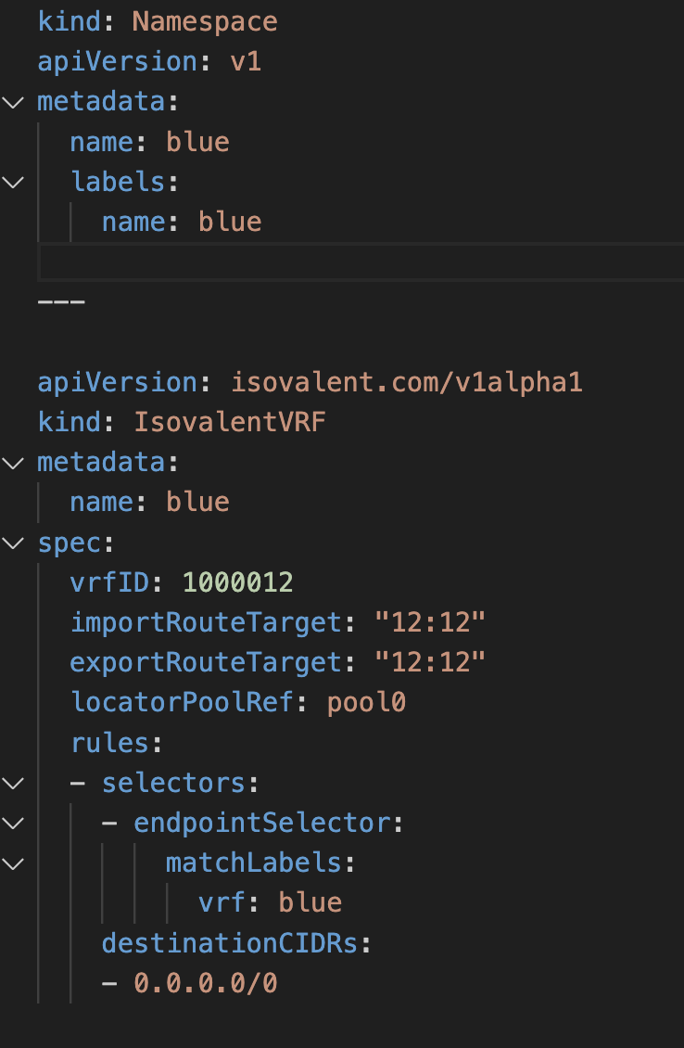

And then I spun up a simple Alpine pod/container into my blue namespace/VRF:
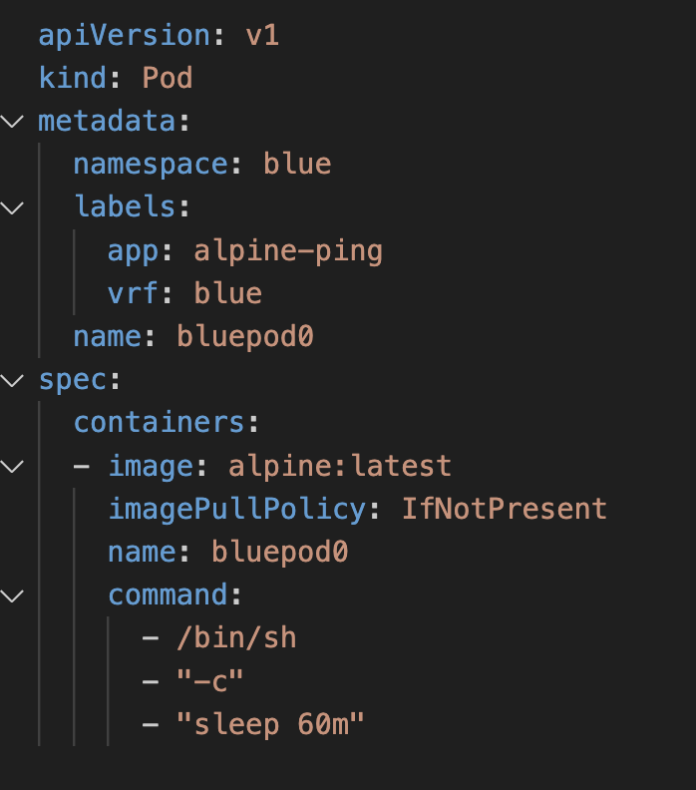

A quick check of my new pod’s status:

cisco@k8s-cp-node00:~/cilium-srv6/cilium$ kubectl get pods -n blue
NAME READY STATUS RESTARTS AGE
bluepod0 1/1 Running 1 (26m ago) 86m

With my container “bluepod0” up and running I check the SRv6 SID Manager again and see Cilium has allocated an SRv6 L3VPN SID for the pod:

kubectl get sidmanager k8s-cp-node00 -o yaml

Example output from sidmanager; blue VRF’s SID in bold:

cisco@k8s-cp-node00:~/cilium-srv6/cilium/cilium$ kubectl get sidmanager k8s-cp-node00 -o yaml
apiVersion: isovalent.com/v1alpha1
kind: IsovalentSRv6SIDManager
metadata:
creationTimestamp: "2024-08-18T19:12:50Z"
generation: 1
name: k8s-cp-node00
resourceVersion: "27756"
uid: 4220c57d-478d-4764-92c9-d050e4a53a9a
spec:
locatorAllocations:
- locators:
- behaviorType: uSID
prefix: fc00:0:15b::/48 <------- control plane node locator
structure:
argumentLenBits: 0
functionLenBits: 16
locatorBlockLenBits: 32
locatorNodeLenBits: 16
poolRef: pool0
status:
sidAllocations:
- poolRef: pool0
sids:
- behavior: uDT4 <---- uSID L3VPN IPv4 table lookup for inbound traffic
behaviorType: uSID
metadata: blue
owner: srv6-manager
sid:
addr: 'fc00:0:15b:e46b::' <--- uSID locator+function entry for control plane node VRF blue
structure:
argumentLenBits: 0
functionLenBits: 16
locatorBlockLenBits: 32
locatorNodeLenBits: 16

Per the previous set of steps, once the allocated SIDs appear in the sidmanager output, we need to apply the ‘srv6-responder’ annotation the node. This will tell Cilium to program eBPF egress policies which will apply SRv6 encapsulations to outbound traffic (analogous to FIB entries):

kubectl annotate --overwrite nodes k8s-cp-node00 cilium.io/bgp-virtual-router.65014="router-id=10.14.1.2,srv6-responder=true"

kubectl annotate --overwrite nodes k8s-wkr-node01 cilium.io/bgp-virtual-router.65015="router-id=10.15.1.2,srv6-responder=true"

Finally, I verified the egress policy was established with the “kubectl get IsovalentSRv6EgressPolicy” command:

kubectl get IsovalentSRv6EgressPolicy -o yaml

Example of partial output:

cisco@k8s-cp-node00:~/cilium-srv6/cilium$ kubectl get IsovalentSRv6EgressPolicy -o yaml
apiVersion: v1
items:
- apiVersion: isovalent.com/v1alpha1
kind: IsovalentSRv6EgressPolicy
metadata:
creationTimestamp: "2024-08-30T21:53:54Z"
generation: 1
name: bgp-control-plane-c0dde75d6edfc035dee7ce80bc27628c89435459e6d8681d3ebfbd5366a736f2
resourceVersion: "3277"
uid: badc91bf-7624-42cb-bcc1-99fa1ec187cb
spec:
destinationCIDRs:
- 10.10.1.0/24 <---- destination prefix in VRF blue (vrfID 1000012)
destinationSID: 'fc00:0:10:e004::' <---- prefix is reachable via xrd10.
Cilium/eBPF will encapsulate using this SID
vrfID: 1000012
kind: List
metadata:
resourceVersion: ""

At this point all the SRv6-L3VPN elements are in place. My blue VRF essentially looks like this:
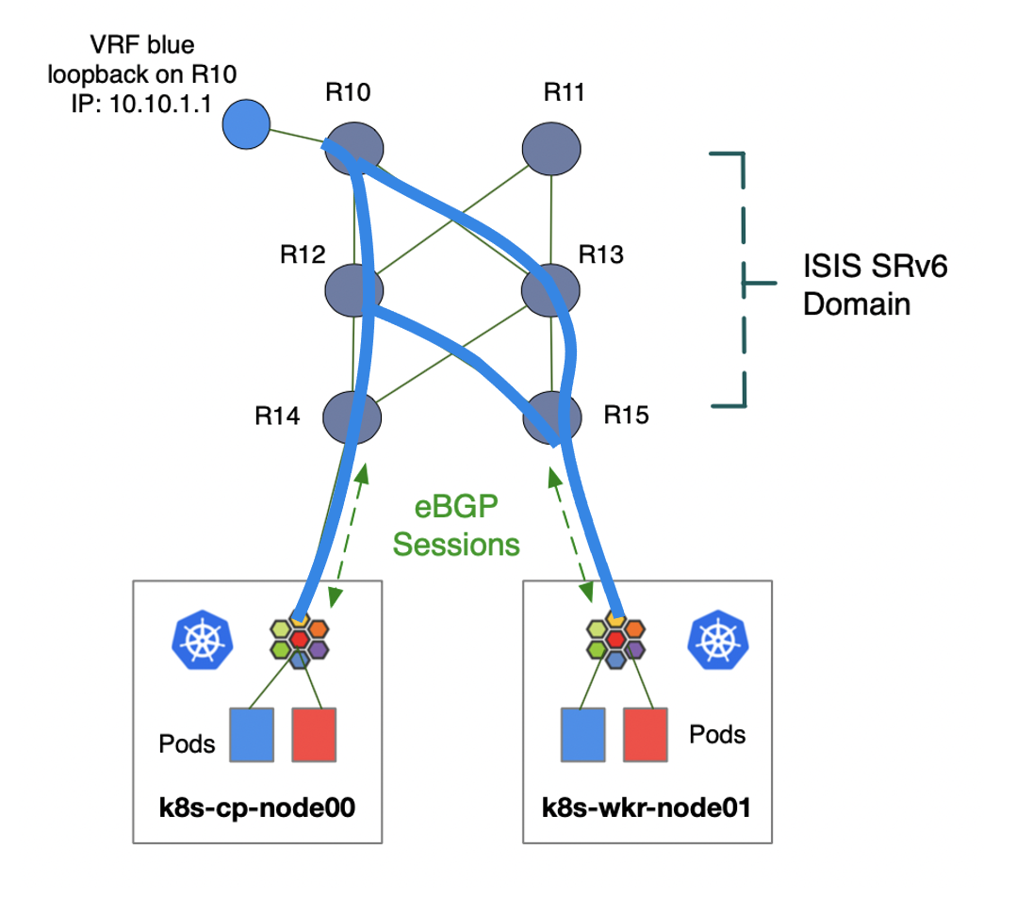
Next it was time to test, so I exec’d into my bludpod and ran some pings:

kubectl exec -it bluepod0 -n blue -- sh

/ # ping 10.10.1.1 -i .3 -c 2
PING 10.10.1.1 (10.10.1.1): 56 data bytes
64 bytes from 10.10.1.1: seq=0 ttl=253 time=3.889 ms
64 bytes from 10.10.1.1: seq=1 ttl=253 time=3.989 ms

--- 10.10.1.1 ping statistics ---
2 packets transmitted, 2 packets received, 0% packet loss
round-trip min/avg/max = 3.767/3.859/3.989 ms

Replies to ping are always a good thing. As a final confirmation step, I ran a little tcpdump on the host VM and re-ran the ping just to see the SRv6 dataplane in action. I’ve highlighted the outer SRv6 / IPv6 destination addresses in red:

cisco@topology-host:~$ sudo tcpdump -ni xrd15-host | grep ICMP
tcpdump: verbose output suppressed, use -v[v]... for full protocol decode
listening on xrd15-host, link-type EN10MB (Ethernet), snapshot length 262144 bytes

02:48:17.139602 IP6 2001:db8:18:15:5054:61ff:fe01:a008 > fc00:0:10:e004::: IP 10.200.1.47 > 10.10.1.1: ICMP echo request, id 24, seq 0, length 64
02:48:17.146192 IP6 fc00:0:10::1 > fc00:0:192:b6fb::: IP 10.10.1.1 > 10.200.1.47: ICMP echo reply, id 24, seq 0, length 64
02:48:17.446667 IP6 2001:db8:18:15:5054:61ff:fe01:a008 > fc00:0:10:e004::: IP 10.200.1.47 > 10.10.1.1: ICMP echo request, id 24, seq 1, length 64
02:48:17.450682 IP6 fc00:0:10::1 > fc00:0:192:b6fb::: IP 10.10.1.1 > 10.200.1.47: ICMP echo reply, id 24, seq 1, length 64

Conclusion and next steps

In the end I have a Kubernetes cluster that can directly participate in my SRv6 L3VPN environment, giving me the ability to extend my network segmentation technology truly end-to-end, to the application/workload itself. I should also note that Cilium’s VRF implementation is decoupled from K8s namespaces, so I could have deployed my test pod in namespace blue, but on the network side it could have been assigned to VRF red. Or I could have a cluster-wide application spanning multiple K8s namespaces, but all attached to VRF blue, which is quite powerful in and of itself.

That said, Isovalent has developed a nice foundational set of SRv6 features, but the future potential is vast as I can envision a rich suite of SRv6 capabilities such as traffic steering, service chaining, and SRv6-proxy capabilities on the long-term roadmap.



Up next I plan to publish a version of this lab to Cisco’s dCloud catalog and make it available to all users with CCO access. Once published I’ll write up part 2 of this blog and cover Cilium eBPF debug commands and explore different network and routing protocol design choices and their implications for host-based, cloud-native SRv6 with Cilium!

Further reading:

Segment-routing resources
https://www.segment-routing.net/

Isovalent learning tracks
https://isovalent.com/learning-tracks/

Cilium labs:
https://cilium.io/labs/

A nice quick Layer-3 VPN Tutorial:
https://networklessons.com/mpls/mpls-layer-3-vpn-explained

BGP Overlay Service Based on Segment Routing over IPv6 (SRv6)
https://datatracker.ietf.org/doc/rfc9252/

T-Shirts and swag!
https://cilium.myspreadshop.com/all

