***Website Brief Overview***

Vicious Cycles is a state-owned bike store that is located halfway between Fayetteville and Raleigh in North Carolina. We sell a wide variety of manual and automatic bicycles, including mopeds, bicycles, tricycles, electronic bikes, hoverboards and much more. We also sell motorcycles from the top names of the business including Harley Davidsons, Hondas, Suzukis, and Kawasakis, to name a few. For manual bicycles we carry such lines as Schwinn, Huffy, and so much more. In addition, we even have accessories, and purchase your old bicycle.

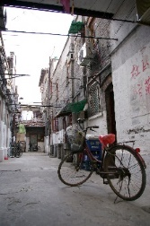***Target Audience***

Our primary audience is a multi-diverse range of customers that would enjoy affordable and quality modes of transportation.

If a customer has a particular type of bike in mind, we will custom build it for them. We are also available to make suggestions regarding size, color, etc.

Prices, images, and more are available on the mobile app and on our website.

We are a business-to-customer organization (B2C), which focuses on meeting the needs for our customers given these unpredictable times we are facing regarding COVID.

***Challenges***

There are several challenges that may impact our vision for the company. One primary challenge that would impact our vision for the company would be the COVID-19 pandemic. There may be difficulties getting parts for example, due to transportation setbacks and lack of workforce. Another challenge that remains is the competition of other businesses that specialize in custom building bicycles and motorcycles. This could cause us to need to develop new strategies to maximize the sales of our products.

***Increasing the Need***

Due to the demographics and their appeal for an alternative mode of transportation, there seems to be a growing need for bicycles and motorcycles.

This may be due to the demographics and their appeal for alternate mode of transportation.

The demand is increasing it appears to purchase bicycles and motorcycles.

It also appears that the level of enjoyment and the sense of adventure for those who can afford quality modes of transportation is intriguing.

***Objectives***

Our objective in order to have 100% customer satisfaction is to provide 24/7 support for all customers.

Additionally, we will provide high quality materials to construct our products.

Our workmanship is 100% guarantee. If you are not satisfied with the quality of your product within six months, we will refund your item 100%.

***Schedule***

Due to the COVID pandemic, our production cycle is lasting approximately two-four weeks depending on the style, make and model.

All materials are ordered by an affiliated company. The materials are then shipped directly to our store to begin the production process.

We will notify a customer immediately if there is a delay in production.

Our hours of operation are from 8-5 Monday through Friday, pickups and deliveries are typically scheduled on Saturday mornings. We are closed on Sundays.

***Uniqueness***

We think what makes us unique is to provide a wide variety of sizes, bike frames, colors and styles to choose from based on your personal preferences.

Also, given the circumstances of the COVID pandemic, our products will be thoroughly cleaned using our safety sanitizing protocols.

We will gladly deliver your bike to your home if you prefer, providing contactless delivery for your convenience.

***Requirements***

We feel our website will inspire people to purchase our products. Vicious Cycles is a state-owned business. Our products are the main attraction of this website.

The website conveys style, quality, power and speed, and freedom.

***Technical Requirements***

The technical requirements include how the bicycles or bikes are going to be built. Secondly, the project for each type of bicycle will be designed and monitored for delays in production. Next, Quality assurance checks will be needed to monitor the integrity and safety protocols of the development. Finally, specific documentation will be used as a reference or resource to the design team, including timelines, and statistics.

***Our Products***

Not only do we customize bikes, we also have available products to assist monitoring and operate your vehicles which includes motor oil, filters, tires, and engine parts. We also provide a six-month warranty on our products in which you can return your item for a full refund with a receipt.

***Deliverables***

Vicious Cycles will post our sales and profits quarterly on our website.

Through market research, we can somewhat predict the materials, colors and styles that may be popular in the Spring and Summers.

Specific prototypes of a variety of bike designs will be developed by our production team to analyze and package for future distribution.

***Product Design and Quality***

Vicious Cycles is committed to high quality products at unbeatable prices. We additionally sell private-label tire brands like Douglas that has been established since 1998.

Our products have become very popular among our buyers.

Vicious Cycles is a name you can trust, with a price you can afford.

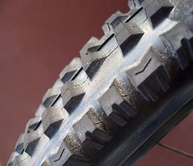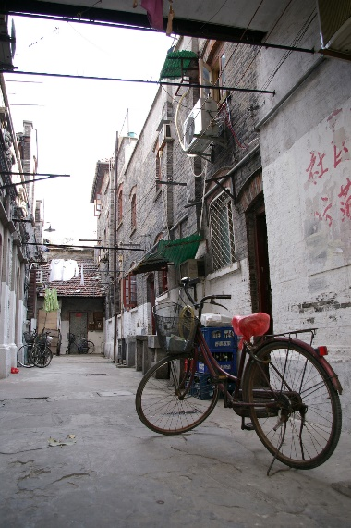***About Us***

Vicious Cycles, Inc. is an Erwin, North Carolina-based cycle workshop founded by John Doe in late 1998.

Our customer service staff attends to the day-to-day operations, even with the ongoing pandemic! We believe that each bike should represent the personality, and lifestyle of its owner.

We believe in the significance of individualism.

We believe in having fun, but safely.

We believe Vicious Cycles, Inc. will help make your dreams come true.

***Customer Service and Satisfaction***

At Vicious Cycles, we are committed to providing superior customer service and satisfaction. Whether it is a simple design or a custom design, we have been in production since 1998.

Regarding COVID-19, we work closely with the state and local officials to stay up to date on the stringent guidelines.

Whether you wish to have curbside pickup or contactless delivery, get in style with a new bike today! Talk to our representatives and you will be out there in no time!

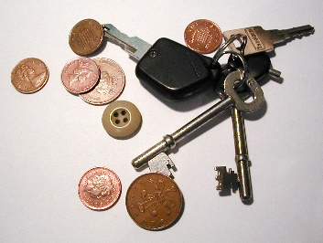***How Can I Buy from Vicious Cycles?***

Vicious Cycles products can be purchased/ordered at our store, located on 143 Main Street in Erwin NC.

Due to the pandemic, store hours have been adjusted because of cleaning efforts.

You can also make an appointment on our website to speak to one of our representatives in person.

Masks are required to be worn if coming into our store.

All custom builds will need a 25% down payment before projects will begin and must be paid in full, when completed. Custom bikes can be returned within six months of purchase with a receipt.

***Trade Shows***

Due to the pandemic, all trade shows will be held virtually.

See our website for full details.

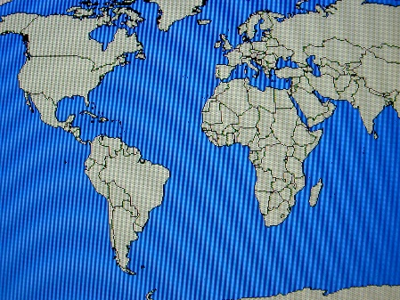***Contact Us***

**Vicious Cycles, Inc.** 143 Main Street

Erwin, NC 28339

Phone: (910) 897-5555 Fax: (910) 892-8901

We are also on: Twitter and Facebook

Website: www.viciouscycles.net