***Website Brief Overview***

Vicious Cycles is a state-owned bike store that is located halfway between Fayetteville and Raleigh. We sell a wide variety of bikes, including Harley Davidsons, mopeds, bicycles, tricycles, and much more. We can also buy your old bicycle. In addition, we even have accessories.

***Target Audience***

Our target audience is mainly bikers who love to ride bikes on a sunny or snowy day. They already know which bike they want, so we will not place helpful hints about size, colors, etc. Prices, images, and more are available on the mobile app. We are a business-to-customer organization (B2C).

***Requirements***

We want a site where buyers will want the item that inspires them. We want the Internet to know we are a state-owned business. The bicycles are the main attraction of this website and everything should be designed around that. The website should convey style, quality, power/speed, and freedom. Also, the website should contain options for curbside pickup and/or provide contactless delivery options due to the ongoing pandemic.

***Our Products***

Not only do we customize bikes, we also have other products like motor oil for vehicles, low priced gasoline that outsmarts other gas stations, and even your favorite type of soda.

***Product Design and Quality***

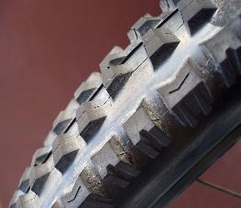Vicious Cycle is committed to high quality products at unbeatable prices. We sell private-label brands like Douglas and has been keeping that promise since 1998. Our products have become a top choice for buyers, making other companies go out of business. We make excellent deals that outbid other competitors, including Walmart, Firestone, and Pep Boys. Vicious Cycle Products is a name you can put your trust into, at a price you can afford. Of course, custom work is another thing entirely. You can have trust in any of our products, and if you have any questions about our products or you are not satisfied, stop by our office and we will take care of it.

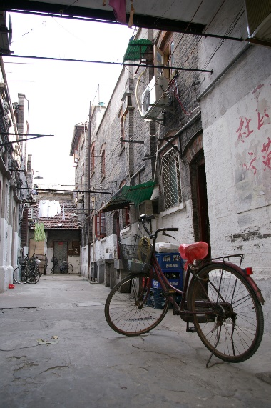***About Us***

Vicious Cycles Inc is an Erwin-based cycle workshop founded by John Doe in late 1998. John builds the bikes, but the state owns the entire workforce, including handling, shipping, and support. Our customer service staff attends to the day to day operations, even during the ongoing pandemic, and even attain to biking standards too!

We believe that every machine should be an extension of its owner. We believe in the significance of individualism. We believe in the stories between your cycle and you. We believe in having fun. No matter the circumstances, we bike hard and we bike often.

Things happen all the time (you get into accidents). You will ride again and again, and that is a Vicious Cycle! Make your best dreams come true, with the Vicious Cycle!

***Customer Service and Satisfaction***

At Vicious Cycles, we are committed to providing superior customer service and satisfaction. Our customer support team will help you buy that cool bicycle whether it is a simple work bike to custom bicycles, in which we have been doing since 1998. Even during these challenging times, we are satisfied with the results. These custom builds take a long time (some even longer due to shortage of parts due to the ongoing pandemic) to make. We work closely with state and local officials to get the item you want, either curbside pickup or contactless delivery. Get in style with a new bike today! Talk to our representatives and you will be out there in no time!

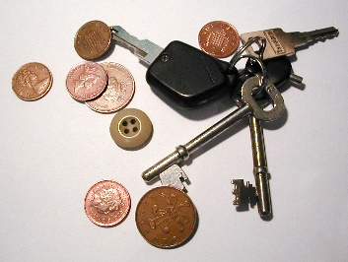***How Can I Buy from Vicious Cycles?***

Vicious Cycle products can be purchased/ordered at our store, located on 143 Main Street in Erwin NC. Due to the pandemic, store hours have been adjusted because of cleaning efforts. Get to our store today and get started with a purchase of a bike with your credit card.

All custom builds will need a 25% down payment before projects will begin and must be paid in full. All custom bikes cannot be returned.

You can also get your product by curbside pickup, or by contactless delivery.

***Trade Shows***

We hold numerous trade shows annually but due to everyone staying home, we believe the real showroom can be found on and off the road, even in your room!

***Contact Us***

**Vicious Cycles**

143 Main Street

Erwin, NC 28339

Phone: (910) 897-5555 Fax: (910) 892-8901

We are also on Twitter and Facebook.