1. INTRODUCTION

The equipment covered by this specification is a data acquisition and display equipment for providing the control room operator, the process alarm, messages the status display for the groups of process variables, the trend curve display etc., on the Video Display Units (VDU’S) and event printouts, logs and plots on printer. As it shall be a computer-based system and shall be used as aid to control room operator, it s known as the “COMPUTERIZED OPERATOR INFORMATION SYSTEM” (COIS) and shall be referred to as such subsequently. The system shall be based on standard hardware such as Pentium III or IV and standard software such as Windows NT/UNIX/LINUX Operating system. These servers are connected to clients and broadcast data available to them to all clients. Using this system an end user (Operator) can view plant data in different displays available for current data and generated history files and can take decision accordingly.
COIS also provides facility for storage of data up to 30 days@1 sec on hard disk and storage of data on CD/DVD for beyond 30days.
Data storage and offline analysis module is for storing the data files generated in the server offline on to a CD/DVD beyond 30 days. Each file consists of 8 hours data @ 1 sec (i.e.: a shift file) .These files are zipped and stored onto a CD/DVD .For offline analysis these files are unzipped and are placed on the hard disk .The data can be viewed in different display formats.

The plant inputs to the COIS shall be analog voltage or current inputs representing process variables i.e. temperature, pressure, flow etc., and contact inputs representing normal/alarm states etc. details of input/output, scanning rates, processing displays, hard copy and response time requirements.

The main functions of COIS are:

- Acquire various types of plant signals, process them according to the specified predefined algorithms and generate outputs to control the same process.
- Receive/send signals from/to other computer systems for information.
- Present the plant data (acquired and processed) in various formats on Video Display
- Units (VDU’S) and printers (display or printouts on demand automatic context driven alarm driven and alarm archiving).
- Provide facility to operators in configuring the operating parameters and design parameter to control overall plant in a safe and efficient manner

The MMI (Man Machine Interface) shall be General Display Nodes(GND’s) and Alarm Display Nodes (AND’s). each Display Nodes shall consist of Video Display Units(VDU’) a keyboard having touch pad and a CPU .GND’s and AND’s are mounted on the operator console for the operator seated in front of the control and on Control room panels.

1.1 Motivation
The proposed system will aim to automate all the activities and eliminate all the drawbacks that the existing system. The proposed system will aim at the efficient method of zipping back up in CD/DVD as well as retrieval. The important functionalities of the proposed system are listed as:

- The proposed system will save significant amount of time and effort invested in zipping and restoring (unzipping).
- It provides a mechanism through which the operator can select the shift files which are needed for backup.
- The zipped files are immediately burned to CD/DVD..
- The system also provides appropriates help documents and manuals to help all kinds of users.
- The retrieved files are directly stored onto the hard disk.
- The files are zipped before backup which saves space .The compression ratio is very high, the original shift file of around 700mb is compressed to less than 10 mb.
- With each shift file of size 700mb not too many history files can stay on hard disk for long backup saves hard disk space.

The software of this module is installed in the servers making easy for the backup .The backup process automatically starts the zipping process. The system will be developed in a modular fashion and will be well documented. This facilitates new modules and functionality to be added without much unwarranted effort and troubles.

1.2 Problem Definition:

There are 1000’s of parameters at different parts of a nuclear reactor which have to be monitored. The parameters include inputs , outputs , and various process parameters. It is literally impossible to manually monitor all the process parameters of a nuclear reactor.

All these parameters @ 1sec will make the size of each shift file 700mb .We have three shifts per day and 30 days per month makes it a minimum of 90 shift files .These large history files have to be backed up. Before backing up the file size of 700mb makes it 1 CD per shift file or 3 to 4 shift file per DVD so these files have to be compressed. The compressed files should then be written to CD/DVD. These history files are important and are need to be monitored then the files from the CD/DVD should be restored this process includes unzipping the files and storing the unzipped files on to the hard disk. Also the operator must be able to choose the shift files which he wants to backup. A software/hardware fault in the system should not cause loss of data or information. Large amount of space is required to store the data in hard drive. Zipping software is needed. Software for burning CD/DVD is required. The communication between the subsystems must be over a deterministic, real time network.

1.3 Objective of the Project:
Data storage and offline analysis module is for storing the data files generated in the server offline on to a CD/DVD beyond 30 days. Each file consists of 8 hours data @ 1 sec (i.e.: a shift file) .These files are zipped and stored onto a CD/DVD .For offline analysis these files are unzipped and are placed on the hard disk .The data can be viewed in different display formats.

The project has to design and implement a system to:

- Store data in the CD/DVD from the hard drive at the rate of 1 sec for every month.
- To restore back to hard drive from CD/DVD when required.
- A software/hardware fault in the system should not cause loss of data or information.
- Plant view works in two modes
- Current mode- current data +30 days data in hard disk (Backup).
- History mode (offline)-restore.
- Information must be stored in Data Collector file @ 1 sec.
- 24 hours information in 3 shifts of 8 hours each.
- 3 data col files per day.
- Each day is divided into three shifts of 8 hours each.
- When the required CD/DVD is placed in the drive the required files are placed in the hard drive.
- Unzipping the files – we need to select a day a proper day for which the data collector files exists and the shift number (i.e . between 1,2 and 3).
- The requested file from the CD/DVD gets unzipped and copied into a folder in the hard drive.
- A datacoll file consists of 650mb of data. To reduce memory occupied by the data. Zippping is done.
- By the end of the day all three datacoll files are zipped and stored in a folder named Zip files.
- Beyond one month all the 93 files are stored in to CD/DVD.

1.4 Limitations of the Project:
The proposed system is limited by compulsions that are focused below:

- As this is the main data acquisition and information system of the power plant. It is very sensitive and should be highly reliable, fault tolerant. High MTBF (Mean Time between Failure).
- The communication between subsystems is to over a deterministic, real time network.
- Data shall be transferable from optical disk to off-line PC.

1.5 Organization of Documentation:
This project mainly deals with the DVD/CD backup and restore. The first chapter gives us a clear view of the proposed system, the problem that has been faced by the existing system, limitations of the proposed system and objective of the existing system. The second chapter deals with introduction of the existing system, Constraints and limitations of the existing system and analysis of information that has been gathered.
The third chapter deals with the analysis phase. In analysis phase, we give the clear view of the requirements of the project such as user requirements, software requirements and hardware requirements. It also consists if the system architecture that is the content diagram of the project along with a flow chart. The fourth chapter deals with the design phase which includes DFD diagrams and UML diagrams. It also consists of the module design and organization of it.
The fifth chapter deals with implementations and results which further consist of the key functions of the project such as data base design, description of jsp and oracle. I further consists o login forms, output screens and result that has been analyzed. Finally, the last chapter consists of the test cases and validation phase. It gives the clear view of how the tests have been applied for the project.

- LITERATURE SURVEY
2.1 Introduction:
The analysis of our project is done With respect to the other modules of the COIS system mainly to understand the data flow and also the format of data in the data coll file. There are different zipping algorithms; a lot survey has been done the most appropriate zipping algorithm to get the reliable as well as good compression ratio.
The formats of the datacoll files are also surveyed the format needs to be known thoroughly to be able to create zip files, we also need to know the how to build simple interactive applications in VC++.The following functions is to be performed under Current Mode:
- Information store in DataCollector file @1sec.
- 24 hours info in 3 shifts of 8 hours each.
- 3 Datacol files per day.
- File Zipping.
- Writing in to CD/DVDs.
Information stored in Datacollector file @1sec .A datacollector file is a temporary circular file. A datacollector collects information from common segment @ 1 second up to eight hours continuously. A datacollector file stores up to 700 MB information. A datacollector file is divided into segments. Each segment consists of 1 sec information.
1 hour = 3600 secs.
8 hours = 28800 secs.
Also different DVD burning software is considered.

2.2 Existing System:

The existing system is out dated which become very inconvenient for maintenance. The existing system has the following flaws or drawbacks which are rectified by the proposed system.
- The backup done on tape drive which is outdated storage device and cumbersome to handle.
- The operator cannot select the shift files but only dates; the shift files are automatically selected.
- The datacol files are not zipped before being backed up.
- The process of burning the zipped files to CD/DVD is not automated .The operator has to manually start the burning process.
In the existing system many of the flaws can be overcome with the installation of the proposed software into the systems.

2.4 Analysis Of The Information Gathered:

24 hours information is in 3 shift files of 8 hours each. Each day is divided into three shifts of 8 hours. Each shift will have a respective datacol file.
23:00:01 to 07:00:00 --→First shift.
07:00:01 to 15:00:00 -→Second shift.
15:00:01 to 23:00:00 →Third shift
Before the shift starts all the valid bits of previous shifts are made bad(0).As the shift starts each second’s data is stored and the valid bit is made good(1).After end of each shift a replicate of datacol file is stored in a backup drive by the copy thread.
A datacol file consists of 650 MB of data .To reduce memory occupied by the data, zipping is done. By end of the day all three datacol files are zipped and stored in a folder named ZIPFILES.

2.5 Conclusion:

Thus, based on the survey done, the system was partitioned into various functional modules to bring down the complexity of the system. These modules help in identifying specific functions and also create an easy to understand and develop approach during system development.

Once the modules have been identified, the next task is to identify the inter relationship among these modules. These modules must work together to achieve the overall goal of training function automation. Figure recruiter login will depict the overall system with its various modules. The process of identifying each module’s tasks, the inputs to this module and the outputs expected from them have been identified and represented in the next few sub sections. A table will be used to illustrate all these details in a concise manner.

3. ANALYSIS

3.1 Introduction:

Analysis is the process of breaking a complex topic or substance into smaller parts to gain a better understanding of it. This chapter deals with the system requirements of the application. This phase gives the detailed description of the analysis that has been performed for the Computer Operator Information System- Data Storage And Offline Analysis. In this phase, we give the detailed analysis of the user requirements that is nothing but the detailed description of the requirements of how the files should be zipped and burned to CD/DVD and then again restored to the hard disk. Not only this but also, it gives the clear cut view of how effective this zipping and backup and restore is.
The analysis phase also deals with the software requirements that are essential for developing the software. The other component with which the analysis phase deals with is the hardware requirements. These are also the most important and essential components in building this backup module. These are helpful for the further processes involved like design, coding and testing.

3.2 Software Requirement Specification:

3.2.1 User Requirements:

The following details give us a clear cut view of the requirements required by the user. They is as follows:
- All the datacoll files must be zipped.
- The user must be able to select the shift files which are to be backed up.
- The selected shift files must be written to CD/DVD.
- The selected files must be retrieved and stored on to the hard drive back from CD/DVD.

3.2.2. Software Requirements:

The software selection was done after considering a few alternatives and constraints imposed by the company. The following table outlines the software used for designing and implementing the system. It also provides a brief explanation for the purpose of the software or software technology being used and why it was selected.
Software Selection

Visual C++ 6.0
Microsoft SQL Server 7.0 or above
Windows 2003 server + 18 clients

Visual C++ DOT NET was chosen because of its abiliy make simple interactive applications . Also Windows server 2003 is selected as the OS for the Server because its functionality and ease with which a LAN can be connected and maintained.As well as for the better communication between the servers and the clients.

3.2.3 Hardware Requirements:
The following table summarizes the environment in which the system was developed.
The System’s Development Environment
SERVER CONFIGURATION:

Processor | PENTIUM IV
Clock speed | 2.5 GHz
Memory  RAM | 1GB
Secondary storage device  Hard disk | 60GB
Input device  Keyboard | 121 KEYMOUSE
Output deices  Visual display unit | 17” COLOR MONITOR

Others
1.44MB floppy disk drive
48x24x48x CD-ROM Drive
10/100MBPS Ethernet card - 2 nos.
AGP card with 4MB video memory
2 serial/1 parallel port and 2 USB

CLIENT CONFIGURATION
Processor | PENTIUM IV
Clock speed | 2.5 GHz
Memory:  RAM | 512MB
Secondary Storage Devices:  Hard disk | 40GB
Input device:  Keyboard | 121 KEYS
output device  visual display unit : | 15” COLOR MONITOR

3.3 Content Diagram of Project:

System architecture

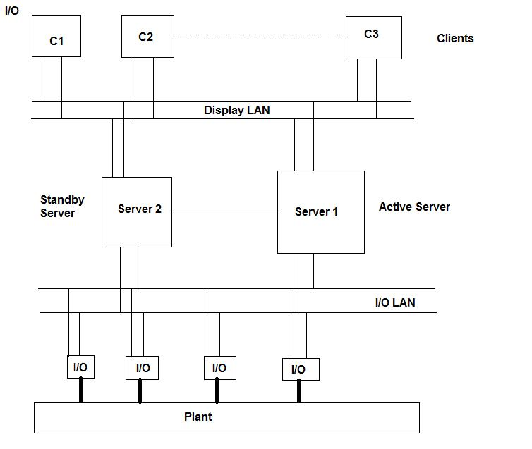

3.4 Algorithm and Flowcharts:
Flowchart is a diagrammatic representation that illustrates the sequence of operations to be performed to get the solution of a problem. Flowcharts are generally drawn in the early stages of formulating computer solutions. Flowcharts facilitate communication between programmers and business people. Often we see how flowcharts are helpful in explaining the program to others .Hence, it is correct to say that a flowchart is a must for the better documentation of a complex program.

Processing Steps are placed in this shape

Decision box.

Alternate process.

Data

The following flow chart depicts the main procedure of the proposed system:

Backup:
START

GLOBAL
APPLICATION OBJECT IS CREATED

ONINIT
DIALOG()

GETDATA()

ONSTART BACKUP()

CHECK DATE DETAILS()
YES NO

ADDACTION FOLDER()
TERMINATE THE APPLICATION

STOP

3.5 Conclusion:

Thus on conclusion, this analysis phase has dealt with all the software, hardware and user requirements that were essential for the development of this project Computer Operator Information System –Data Storage And Offline Analysis Module. It deals with basically of two modules that is current mode-backup, history mode-restore. These modules help in identifying specific functions and also create an easy to understand and develop approach during system development.
Once the modules have been identified, the next task is to identify the inter relationship among these modules. These modules must work together to achieve the overall goal of training function automation. The current mode will take the information stored in datacol file @1 sec and zip these files and will write the zipped files to CD/DVD. The history mode will take the shift files which are zipped and stored on to CD/DVD and unzip them the store them on to the hard disk.

4. DESIGN
4.1 INTRODUCTION:
The working software model has to be analyzed and designed before the coding starts. The main objects that is important in the design of the system serves as the important attributes of the project development. The class’s attributes methods and associations identified during analysis must be designed for implementation as a data type expressed in the implementation language. New classes must be introduced to store intermediate results during program execution.
Emphasis shifts from the application domain to implementation and computer concepts such as user interfaces or view layer and access layer. During the analysis, we look at the physical entities or business objects in the system; that is, who the players are and how they cooperate to do the work of the application.
During the design phase, we elevate the model into logical entities, some of which might relate more to the computer domain than the real- world or the physical domain as people or employees. The goal here is to design the classes that we need to implement the system. The difference is that, at this level, we focus on the view and access classes, such as how to maintain information or the vest way to interact with user or present information.

Dataflow diagrams:
The system will be depicted using various Data Flow Diagrams (DFD), which helps in understanding the inputs and outputs expected from the system.

The DFDs that are used to depict the system are as listed below

- The level 0 DFD .
- The level 1 DFD .
- The level 2 DFD .
- The level 3 DFD.

Level 0 DFD
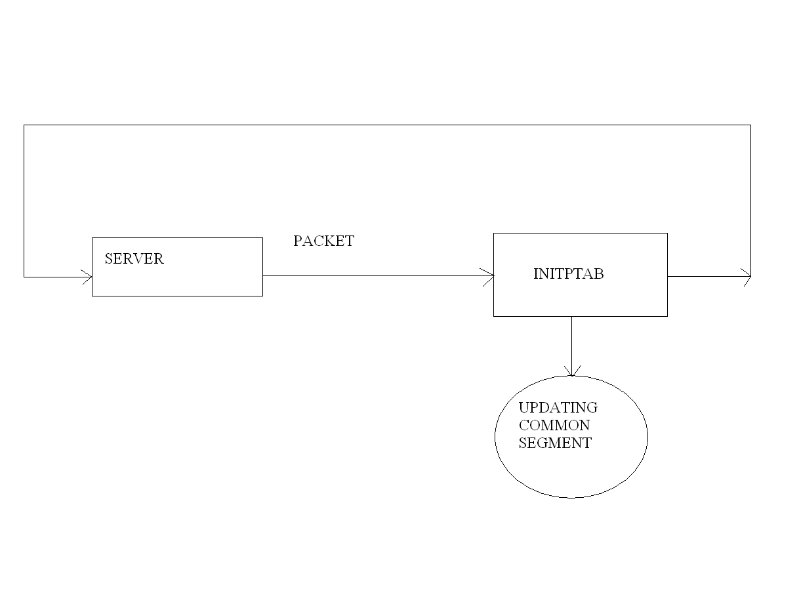
Level 1 DFD :

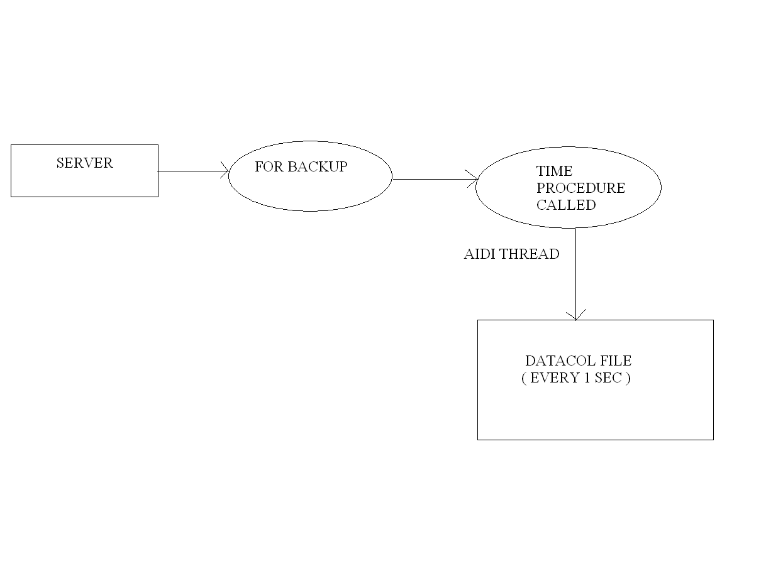

Level 2 DFD:

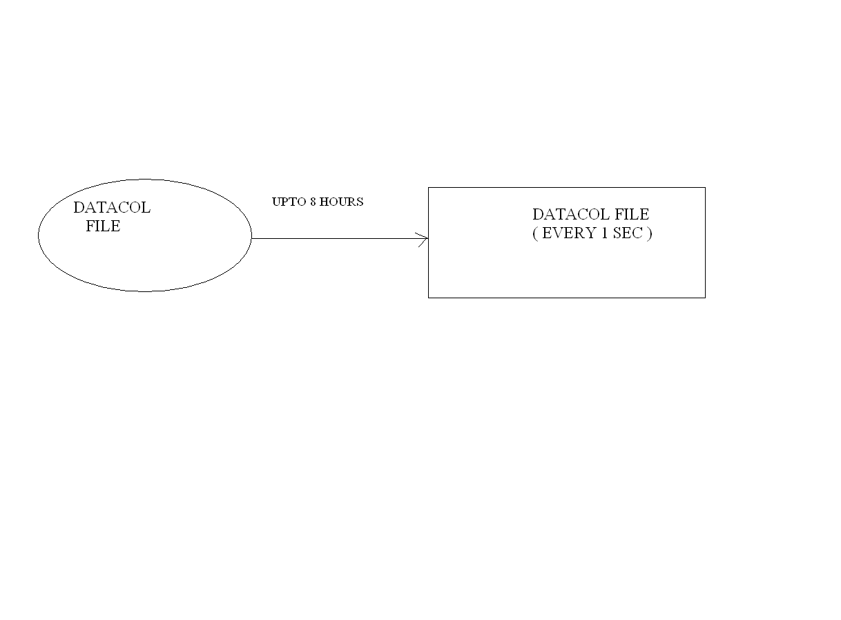

Level 3 DFD:

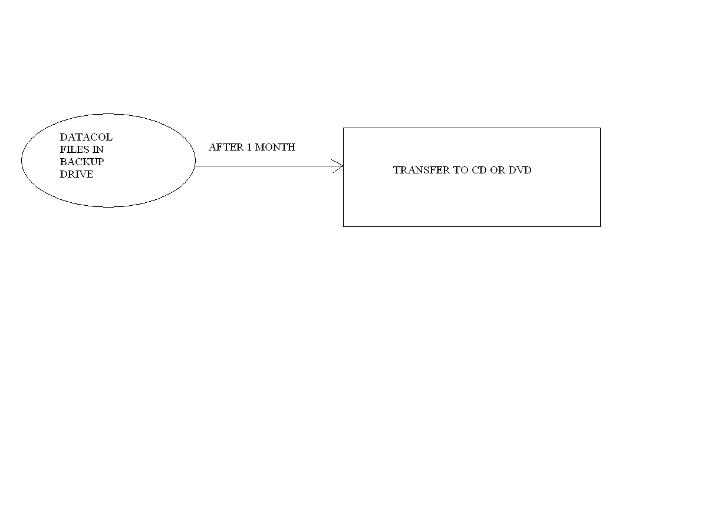

4.2 UML DIAGRAMS:
The unified modeling language allows the software engineer to express an analysis model using the modeling notation that is governed by a set of syntactic semantic and pragmatic rules.
UML is a standard notation for the modeling of real-world objects as a first step in developing an object-oriented design methodology. It can also be called as the language to generate software blueprints. UML is used to visualize, specify, construct and document the artifacts of the software-intensive systems.
To represent the project in UML, we have certain principles designed in it. Those are called the building blocks of UML. They are:
- Things
- Relationships
- Diagrams
The Things describe the static, dynamic, organizational and explanatory parts of UML.
The relationships are the basic relational building blocks of UML and we use them to write web-form models. They are:
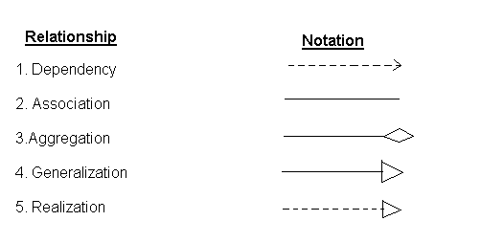
The diagrams in the UML show the representation of the any project or software to the user. The project can be mainly represented in 9 diagrams:
- Class Diagram
- Object Diagram
- Use case Diagram
- Sequence Diagram
- Collaboration Diagram
- State chart Diagram
- Activity Diagram
- Component Diagram
- Deployment diagram
The UML diagrams representing our project are as follows:
USE CASE DIAGRAM:
Use case diagrams are used to build the dynamic aspects of UML. They are the central to modeling the behavior of a system, a subsystem, or a class. Use case is a description of a set of sequences of actions, including variants that the system performs to yield an observable result of value to an actor. Graphically, a use case is rendered as an ellipse.
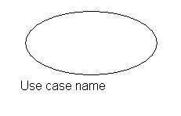
A use case diagram is a diagram that shows a set of use cases and actors and their relationships. An actor represents a coherent set of roles that users of use cases play when interacting with these use cases.

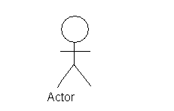

Use case diagram :
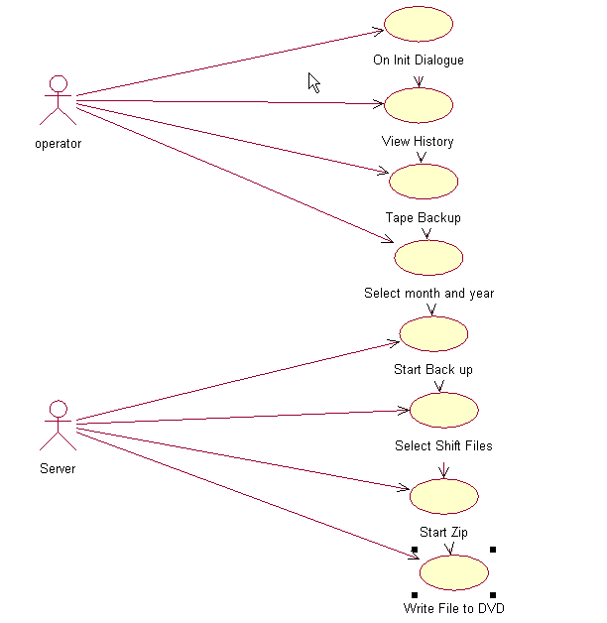

Class Diagram:
We use class diagram to model the static view of a system. Class diagrams give the foundation for other related diagrams i.e., component diagram and deployment diagram. Class diagrams are the most common diagrams found in modeling object-oriented systems. Class diagrams are important not only for visualizing, specifying and documenting structural models, but also for constructing executable systems through forward and reverse engineering.
A class diagram shows a set of classes, interfaces and collaborations and their relationships. Graphically, a class diagram is collection of arcs and vertices and is rendered as a rectangular box with 3 partitions as shown in figure below:

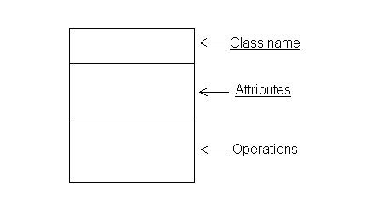

Class diagram:
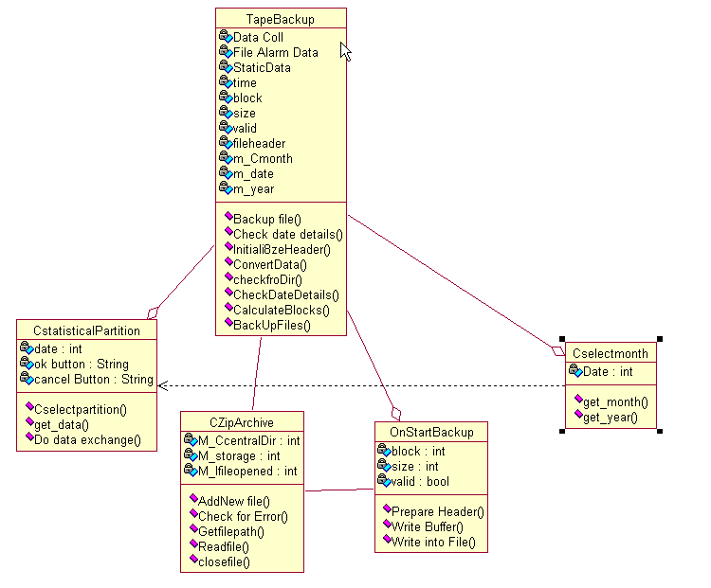

SEQUENCE DIAGRAM:
A sequence diagram emphasizes the time ordering of messages. It is formed by placing the objects that participate in the interaction at the top of your diagram, across the X axis .Typically, the object that initiates the interaction at the left, and increasingly more subordinate objects to the right. The messages that these objects send and receive are placed along the Y axis, in order of increasing time from top bottom. This gives the reader a clear visual cue to the flow of control over time.

An object is a concrete manifestation of an abstraction to which a set of operations can be applied and which has a state that stores the effects of the operations. Object is rendered as a rectangular box with its name underlined in it

A link is a semantic connection among objects. In general, a link is an instance of an association. A link specifies a path along which one object can dispatch a message to another (or the same) object.A message is the specification of a communication among objects that conveys information with the expectation that activity will ensue.

Sequence diagram
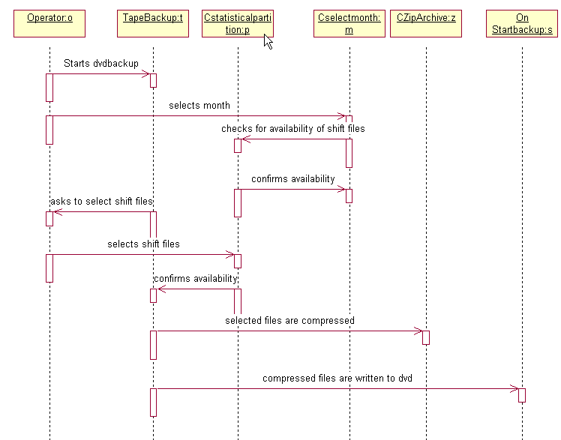

COLLABORATION DIAGRAM:
A collaboration diagram emphasizes the organization of the objects that participate in an interaction .It is formed by first placing the objects that participate in the interaction as the vertices in a graph. Then the links are rendered that connect these objects as the arcs of this graph. Finally, adorn these links are adorned with the messages that objects send and receive. This gives the reader a clear visual cue to the flow of control in the context of the structural organization of objects that collaborate.

Collaboration diagram:
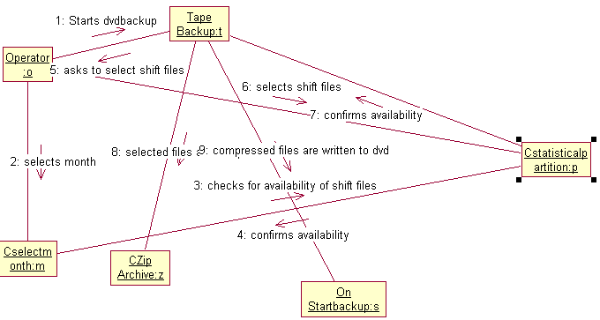

STATE CHART DIAGRAM:
State chart diagram: A state chart diagram shows a state machine, emphasizing the flow of control from state to state. State machine: A state machine is a behavior that sequences of states an object goes through during its lifetime in response to events, together with its responses to those events. State: A state is a condition or situation in the life of an object during which it satisfies some condition, performs some activity, or waits for some event. Event: An event is the specification of a significant occurrence that has a location in time and space.

State chart diagram:
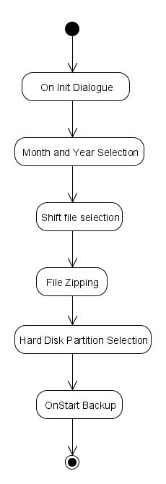

ACTIVITY DIAGRAM:
An activity diagram shows the flow from activity to activity. An activity is an ongoing non-atomic execution within a state machine. Activities ultimately result in some action, which is made up of executable atomic computations that result in a change in state of the system or the return of a value.
Activity diagram:
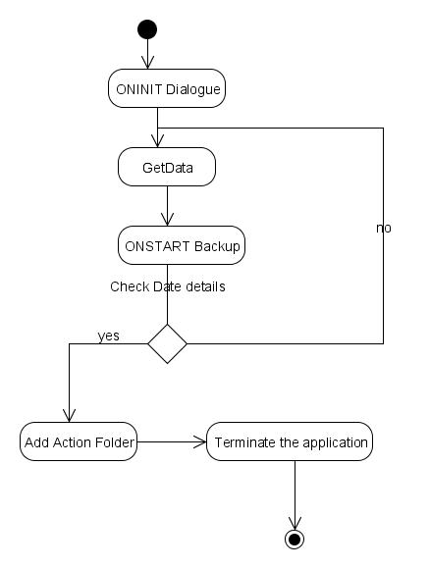

Component Diagram:

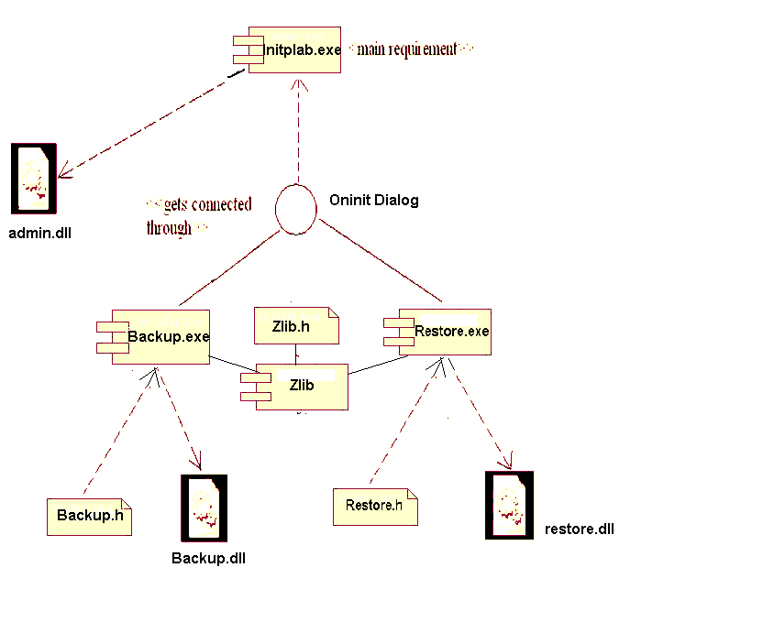

Deployment Diagram:

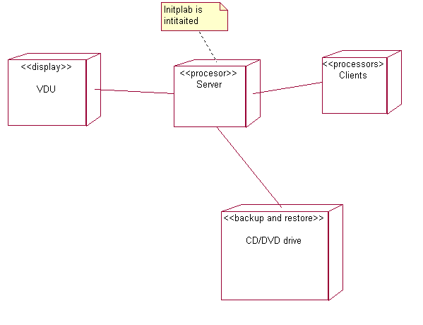

:

Module Architecture Design
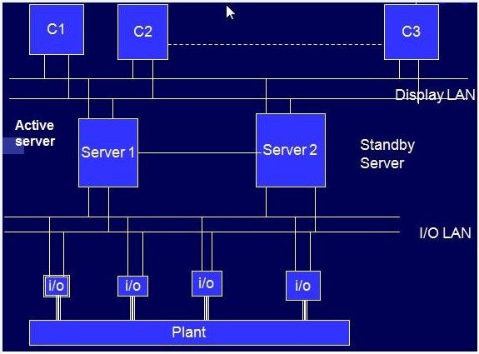

4.4 Conclusion:
This project has been designed and implemented a system in order to automate the functions of the computer operator, of Nuclear Power plant. The system has been designed to zip the shift files and then to be backed up on to CD/DVD. As well these shift files which are backed up on to the CD/DVD can be retrieved back and can be unzipped and copied back onto the hard disk.
UML DAIGRAMS:
In this design phase we also used UML diagrams. UML is a graphical language for documenting, visualizing, specifying and constructing the artifacts of the software intensive system.

CHAPTER 5

IMPLEMENTATION &RESULTS

5.1 INTRODUCTION:
Implementation is the process of having systems personnel checkout and put new equipment into use. In this stage only the efficiency and performance of the software are appraised.
The system implementation will include the following activities:
1). Testing the data with model data.
2). Ensuring the user acceptance.
3). Monitoring the feed back from the system.
4). Ensuring the efficiency and accuracy of the system.
5). Installing the system.

5.2 EXPLANATION OF KEY FUNCTIONS:
VISUAL BASIC 6.0 DEVELOPMENT ENVIRONMENT
A Visual Basic 6.0 application works in three modes—design mode, run mode, and break mode. Most of the work of creating an application is done in the design mode. An application that is in a state of execution is said to be in the run mode, while an application that is in the state of suspension is said to be in the break mode.
The Visual Basic 6.0 interface contains the standard interface elements found in the windows environment, like support for long filenames in the File Open dialog box, and control buttons. It consists of the following items:
- Menu Bar
- Form
- Project Window
- Toolbox
- Properties Window
- Code Editor Window
- Object Browser
- Form Layout Window
- Context Menu
- Standard Toolbar

5.3 METHOD OF IMPLEMENTATION:

5.3.1 Month And Year Selection

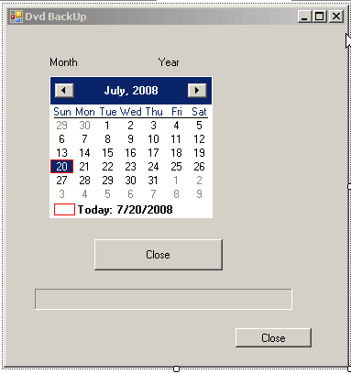

5.3.2 SHIFT FILES SELECTION
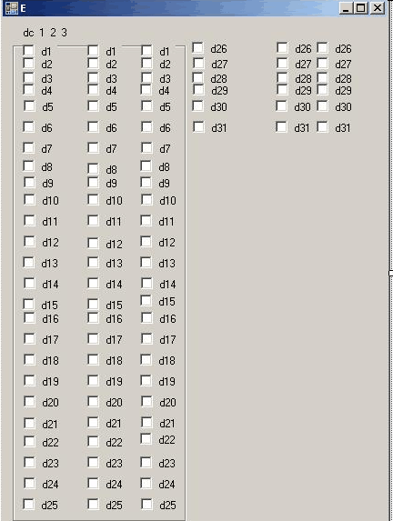

5.3.3 SUSESSFULLY ADDED

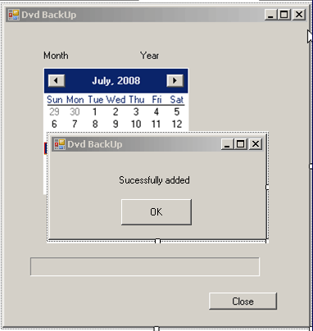

5.3.4 BACKUP COMPLETE

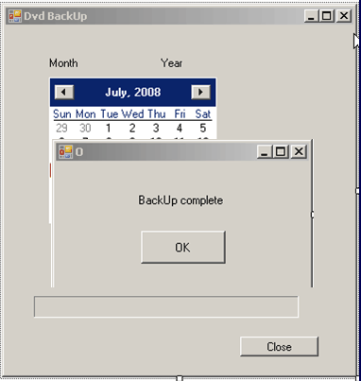

5.3.5 WRITING TO DVD

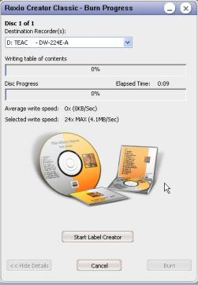

5.3.6 FOLDER WITH ZIPPED FILES

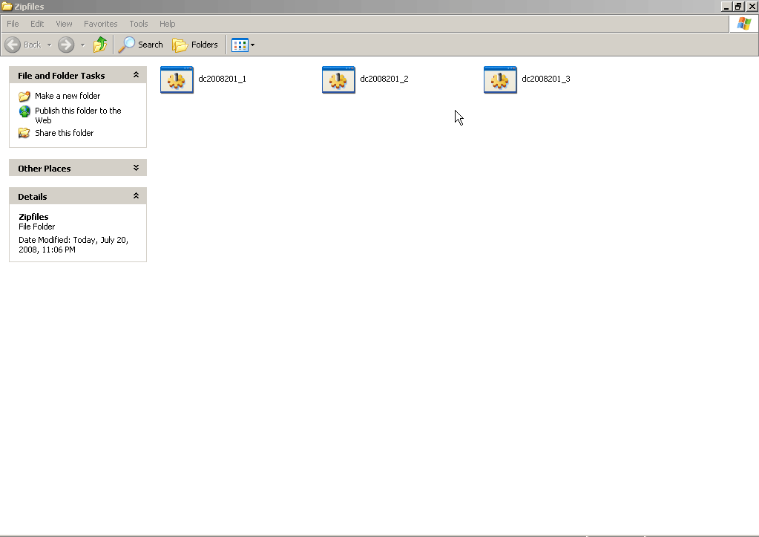

5.3.7 DVD RESTORE

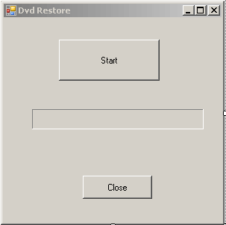

5.3.8 DATE YEAR AND SHIFT FILE SELECTION

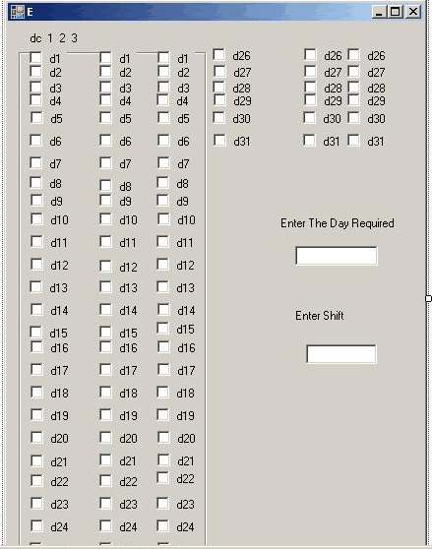

5.3.9 EXTRACTION SUCESSFUL

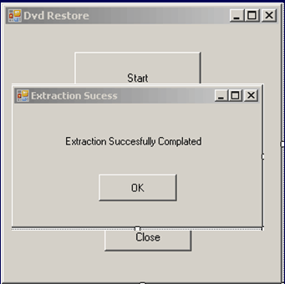

5.3.10 RESTORED HISTORY FILES

5.4 CONCLUSION:
According to the above said implementation consideration the model test data required for the system are collected, with the help of the data the performance of the system was appraised, feed back of the system. As well as the user was observed and the required modifications are carried out and the new system was implemented successfully.

6. TESTING AND VALIDATION

6.1 Introduction:

Testing is the criteria of software quality assurance and represents the ultimate review of specification design and coding. Testing is destructive step, demolished the software. It cannot show the absence of error it only shows presence of errors.
Testing is a process of executing a program with the intent of finding an error. A successful test is one that uncovers a yet undiscovered error test cases were developed with this purpose in mind.
Prior to the actual implementation of the system it had to be tested comprehensively and every possible error uncovered. Since it is not possible to test the system exhaustively, the black box testing method was used for system testing. The black box testing usually demonstrates that software functions are operational; that the input is properly accepted and the output is correctly produced; and that integrity of external information (databases) is maintained.
The following table outlines the tests that were performed on the system to ensure correctness and unearth errors which were subsequently debugged.

6.2 Design of Test Cases and Scenarios:

UNIT TESTING:

Unit Testing will be done to test field validations, navigation, functionality of the programs and its blocks. These tests are applied on various functions within each program and other critical program blocks. The following tables outline two sample test cases for Unit Testing performed on the system

Unit Testing – Test Case 1

Test Case Description
This test case deals with the selection of month and year. The creation program takes many inputs. The test should check for proper inputs and verify whether the shift files are available for the given date or not.

Expected Inputs
- Selection of month and year.
Expected Outputs
- Alert window for erroneous inputs.
- Confirmation of selection.
Actual Test Results
- An alert window was shown whenever the user gave some date for which the shift files are not available.
- Confirmation of availability of shift files for the selected dates..

Unit Testing – Test Case 2
Test Case Description
This test case deals with the selection of shift files for the already selected date we have to choose by selecting one of the check boxes.
Expected Inputs
- The operator selects the shift files by selcting the check boxes.
Expected Outputs
- Checks for the availability of the selected shift on the selected date.
Actual Test Results
- Sucessfuly added message
- Error if the shift files are not available.
MODULE TESTING:

Module testing will be done to test the interaction between the various programs within one module. It checks the functionality of each program with relation to other programs within the same module. It then tests the overall functionality of each module. The following tables outline two sample test case for Module Testing performed on the system.
Module Testing – Test Case 1

Test Case Description
This test case deals with the module creation in the Recruiters module.
Expected Inputs
- A date is selcted and also the shift files are selected for backup.
Expected Outputs
- This should zip the selected shift files and burn them on to CD/DVD
Actual Test Results

- The burning process started and the files are successfully burned to the CD/DVD.

Module Testing – Test Case 2

Test Case Description
This test case deals with the Restoration of the files from CD/DVD to the hard disk.
Expected Inputs
- Selection of the date and shift files
Expected Outputs
- The selected shift files must be stored on to the hard disk and must be unzipped.
Actual Test Results
- The selected files are stored on to the hard disk and unzipped.

INTEGRATION TESTING:

Integration testing is done to test the functionality and interfacing between the modules. The system is built up of various modules which work together to automate the activities of the HR department. These modules should work together in a seamless way to achieve the desired results. Integration testing will test for this property of the modules. The modules display a cause and effect relationship, if data in one module is changed, then it affects the data to change in some other module also. Integration testing needs to check if the modifications do not adversely affect some other modules.

Integration Testing – Test Case 1

Test Case Description
This test case deals with the both backup and restore. Both the modules are performed on the same files.
Expected Inputs
- Selection of month and year as well as the shift files for the both the modules.
Expected Outputs
- The files which are zipped and burned on to the CD/DVD and the files which are restored onto the hard disk must be same.
Actual Test Results
- Both the files are same.

ACCEPTANCE TESTING:

Acceptance testing was done after the implementation of the system. The acceptance testing will check if the system works correctly in the user environment and if all the user specified functionalities are present. It also tests if the system adheres to the company policies and quality standard. The Computer operator information system- data storage and restore was tested and accepted after the acceptance testing.

6.3 Validation:

In software project management, software testing, and software engineering, Verification and Validation (V&V) is the process of checking that a software system meets specifications and that it fulfils its intended purpose. It is normally part of the software testing process of a project. In pharmaceutical industry, verification involves testing the suitability of well established procedures or (compendia) methods, whereas validation varies from Cross validation, Empirical validation, periodic partial validation, internal/external validation, competence validation by nature, and Cleaning validation, Process validation, Equipment validation, or Documentation validation by tasks.
Validation checks that the product design satisfies or fits the intended usage (high-level checking) — i.e., you built the right product. This is done through dynamic testing and other forms of review.
According to the Capability Maturity Model (CMMI-SW v1.1), “Validation - The process of evaluating software during or at the end of the development process to determine whether it satisfies specified requirements. [IEEE-STD-610] Verification- The process of evaluating software to determine whether the products of a given development phase satisfy the conditions imposed at the start of that phase. [IEEE-STD-610]."
In other words, validation ensures that the product actually meets the user's needs, and that the specifications were correct in the first place, while verification is ensuring that the product has been built according to the requirements and design specifications. Validation ensures that ‘you built the right thing’. Verification ensures that ‘you built it right’. Validation confirms that the product, as provided, will fulfill its intended use.
Within the modeling and simulation community, the definitions of validation, verification and accreditation are similar:
- Validation The process of determining the degree to which a model, simulation, or federation of models and simulations, and their associated data are accurate representations of the real world from the perspective of the intended use(s).^{[1]}
- Accreditation is the formal certification that a model or simulation is acceptable to be used for a specific purpose.^{[2]}
- Verification: The process of determining that a computer model, simulation, or federation of models and simulations implementations and their associated data accurately represents the developer's conceptual description and specifications.^{[3]}

The system was validated after the testing phase. The system needed to zip the shift files and then they need to be burned onto CD/DVD. In the restoration mode the files which are zipped and stored onto the CD/DVD should be stored back onto the hard disk and unzipped.
The next phase in the validation was to educate the users of the system. A demonstration of all the functions that can be carried out by the system was given to all the training department personnel, who will make extensive use of the system. An user manual which will help the user in using the system is also provided. Employees who are not part of the training department have been sent instructions on how to utilize the modules that they are allowed to.
The maintenance aspect of the system will be another important phase of the project. The module should first identify all the data processing tasks that should be done.
In the event where the existing modules need to be modified and changed, the system is coded with extensive documentation for easy modification to be effected. The programmer should initially try to understand the logic behind the module that is going to be altered and only then change the module. Some of the programs within a module have got a substantial degree of cohesion and should be handled with some care. Efforts have been put in to make the programs independent, but the flow of the project required some amount of interdependence. Care should be exercised when making changes to such programs. The system should be thoroughly tested, post-modification to ensure correctness and proper running.

6.4 Conclusion:

Thus the testing has been performed using unit testing, Module testing, Integration testing and Acceptance testing. These test cases give us the clear cut view of whether the project has come out with the results expected. They are used to test the module in each and every possible way and it is done to check out whether the result obtained is valid. Though while developing the training function automation system, all efforts were made to encompass all the required tasks into the system, there could be new requirements that arise at any stage of time. This means that new modules need to be added to the system. Following the same process and techniques used in the development of this system will ensure seamless compatibility of the new module.

7. CONCLUSION
Thus, the proposed project turns out to be the user friendly and economically friendly to the company. The complexities of the existing system are mostly overcome by this proposed system. This system can also reduce the wastage of the hard disk space, and the zipping also makes this a economical solution because we can have more history files stored in CD/DVD. In this proposed system, it has advanced featured compared to the existing system, like storing the history files in CD/DVD. This kind of system saves a lot of time and energy and money.

The future enhancements could be referred to as that which can overcome the limitations, which may include automation of whole process of backup after 30 days without the involvement of operator as the present system requires the operator to initiate the process manually.

8. REFERENCES

The following books were used extensively for the project development and implementation

- Sommerville “Software Engineering” Tata Mc McGraw-Hill Publishing Company Limited.
- "Programming windows with MFC " by Jeff Prosise
- "Programming VC++" by Kruglinski
- A First Book of Visual C++ (West Computer Science) by Gary J. Bronson .

WEBSITES:
MFC Professional's Site
Visual C++ 5.0 Standard C++ Library
Sam's Visual C++ Programmer Stuff
Codeguru: the best site for Visual C++
Visual Studio / Visual C++ FAQ
Visual C++ Tips (Must Visit)
Visual C++ Barcode FAQ & Tutorial
Visual C++ FAQ

69. ANNEXTURE

The project mainly deals with the computer operator information – data storage and offline analysis. The Operator first of all opens the Initplab, in the history tab we have we have the backup and restore options.
First in the backup mode we first need to select the date by selecting the month and year .After the month and year are selected the corresponding shift files have to be selected .The shift files will be accepted only if the selected shift files are available in the local hard drive .Then the it proceeds by zipping the selected files and these files are written to the CD/DVD the operator has to insert a blank CD/DVD and start the burning process by clicking on the burn button on the Roxio CD/DVD burner which is automatically initiated by the program and also the shift files already zipped are added to it. This completes the backup procedure.

A datacol file consists of 650MB of data. To reduce memory occupied by the data, zipping is done. By end of the day all three datacol files are stored on the local hard disk. Beyond one month all the 93 files are zipped and stored in a folder and then are written to CD/DVD.
In history mode –restore mode the restore option has to be initiated in the history tab and the CD/DVD with the required shift files must be inserted into the drive then the shift file number has to be entered i.e 1,2 or 3 the selected shift files will be unzipped and stored onto the local hard drive. The required month’s CD/DVD is placed in the hard drive for the verification of the data. We need to select a day – a proper day for which the data collector files exists and proper shift number must be entered . The requested file from thr CD/DVD gets unzipped and copied into a folder in the hard disk.

Finally I conclude that this project plays an important role in allowing the operator to easily access the site for acquiring jobs history files and also makes the backup and restore. The project that has now been developed is successful in automating all the functions of operator.

