COMP9331 Assignment CDHT Report

Name: Ran Bai

Student ID: z5187292

1. Environment

Development environment: Python 3.7 on windows

Test environment: Python 3.7.2 on CSE VLab

1. How to run code

Put command script below into test.sh, then run **chmod u+x script_for_python.sh** in the xterm, finally, run this .sh file with command **./script_for_python.sh**:

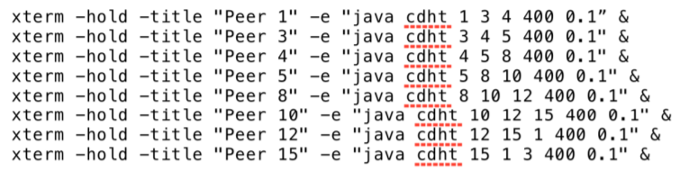

Input a command:

Command 1: request X. (X is a integer from 0000 to 9999).This command is using to request a file in built p2p network.

Command 2: quit. This command is to let the current peer exit the p2p network.

Kill a peer:

pressing Ctrl + C in the xterm which means that the peer has already crashed.

1. Message format

|  |  |  |
| --- | --- | --- |
| Num | Function | Format |
| 0 | Ping request | “ping request” + “\r\n” + own peer id |
| 1 | Ping response | “ping response” + “\r\n” + own peer id |
| 2 | Request next successor | “Request NextSucc” + “\r\n” + “successor number(1 or 2)” + “\r\n” + crash successor id |
| 3 | Response next successor | “Response NextSucc” + “\r\n” + first successor id |
| 4 | Departure request | “Departure request” +”\r\n” + own peer id |
| 5 | File location request | “file location request” + “\r\n” + request peer id + “\r\n” + filename + “\r\n” + TTL(time to live) |
| 6 | File location response | “file location response” + “\r\n” + own peer id + “\r\n” + filename |
| 7 | Data packet transfer | “file packet send” + “\r\n” + seq number + ”\r\n” + data |
| 8 | Data packet ACK | “file packet ACK” + “\r\n” + ACK number |
| 9 | All packets sent, Push to file | “file FIN/PSH” |
| 10 | Packets Push msg ACK | “file FIN/PSH ACK” |
| 11 | Departure response | “Departure response” |

1. Design

The whole program has a total of five threads, which are ping first successor, ping second successor, TCP message server, UDP message server, screen input listener.

1. Two ping thread will keep sending ping request by UDP, but rest 6s in 2 consecutive requests. If a peer does not respond to 4 consecutive ping requests, then his predecessors will think that it has crashed. Every ping request timeout is 5s.
2. When a new TCP/UDP request message arrived, TCP/UDP message server will open a new thread that confirm the type of information requested, and perform the corresponding action and respond according to the message format.
3. Screen input listener will wait to accept screen input (request X and quit). Other orders will prompt unresponsive command.
4. During the file transfer, I adopt stop-and-wait protocol, And after all the data packets have been sent, a packet with a FIN flag indicating that all data has been transmitted will be sent to end the file transfer.
5. Demo address

<https://www.youtube.com/watch?v=4ZPHGYY97Cc>