Time Series Project Proposal  
Brendan Graham  
February 24, 2016

A current project at my job consists of reviewing the use of socioeconomic data in airport forecasting practices, so I thought it would be interesting to develop an airport passenger forecast of my own for Philadelphia international Airport (PHL) using historical enplanements at the airport as well as income and employment data for the Philadelphia area ("Enplanement" is an industry term for boarding an aircraft).

The data set I put together consists of 104 observations from January 2007 to August 2015 of 1) monthly enplanements at PHL, 2) monthly employment and 3) average monthly income. The enplanement data is T-100 domestic market data from the Bureau of Transportation Statistics which consists of monthly enplanements by originating airport.[1] The employment data is from the Current Employment Statistics (CES) program run by the Bureau of Labor Statistics and consists of monthly, not-seasonally adjusted, non-farm employees for the Philadelphia Metropolitan Division.[2] The earnings data also comes from the CES and consists of average weekly earnings for private (non-governmental) employees for the Philadelphia Metropolitan Division, which I multiplied by 4 to estimate average monthly earnings.[3]

The time series plot of historical monthly enplanements has a cyclical pattern evident of seasonality. It also shows a slight downward trend and heterogeneous variance across time. The employment time series also shows seasonality, and downward trend followed by an upward trend in recent years. The earnings data shows a positive trend and heterogeneous variance.

Another issue I may have to address is the differerence in scales among the three time series. Monthly enplanements range between 791,104 to 1,322,734 while monthly employment and earnings range from 854,000 to 924,400 and 3,205.52 to 3,859.32, respectively.

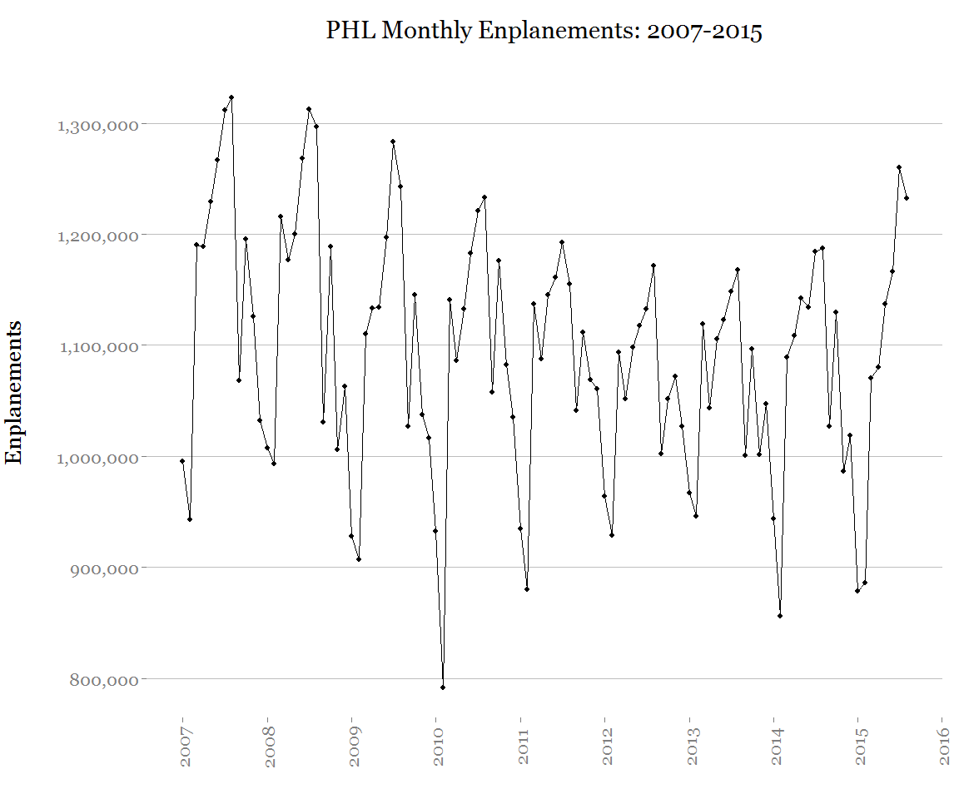

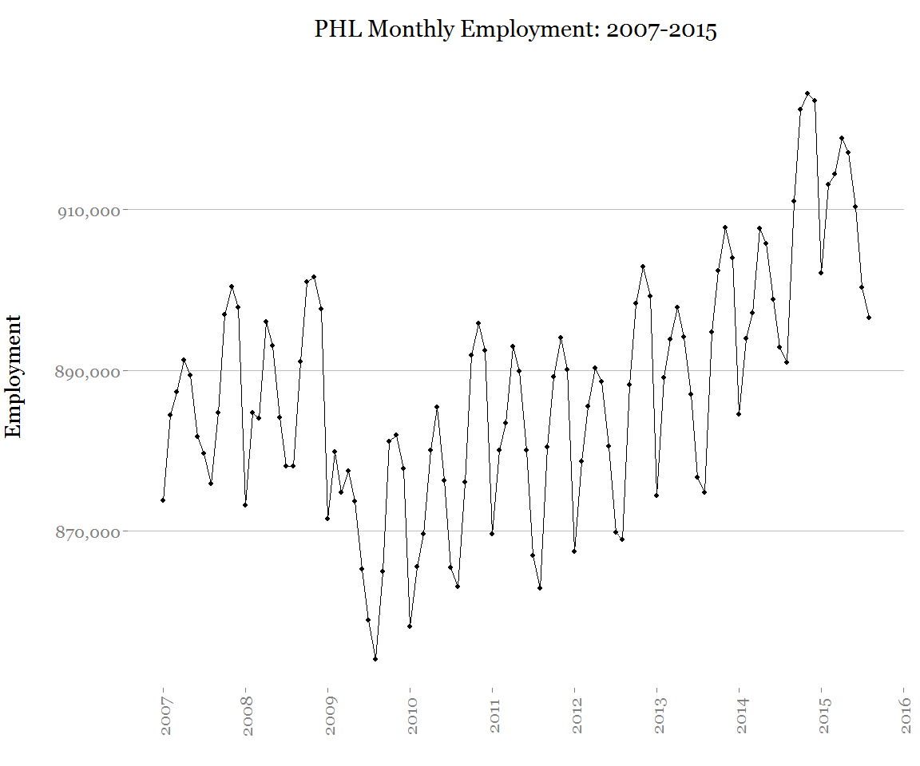

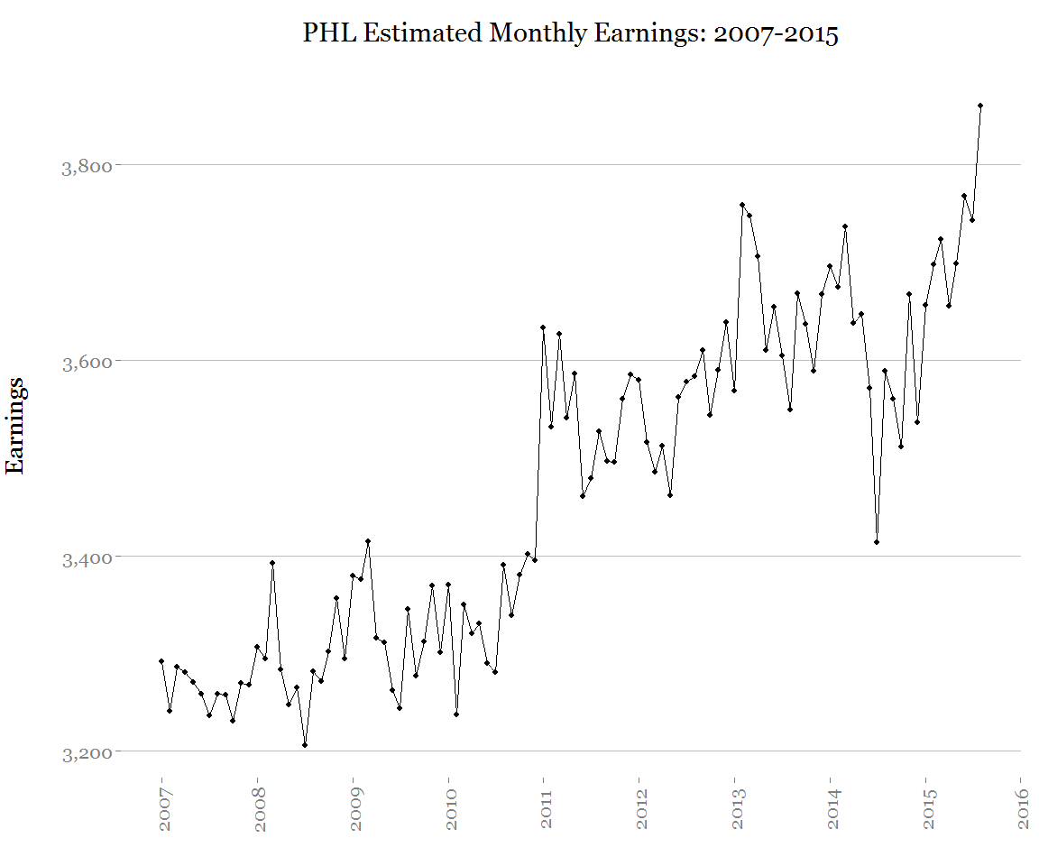

One of the aims of the project at my work is to explore if the use of socioeconomic data improves passenger forecasts, so I think it would be interesting to develop a forecast using only the historical enplanement data, and then a second forecast using the historical enplanement data combined with the employment and earnings data and see if the model improves. Additionally, the FAA produces passenger forecasts for each airport[4], so it would be interesting to see how my forecast compares.

1. <http://www.transtats.bts.gov/DL_SelectFields.asp?Table_ID=310&DB_Short_Name=Air%20Carriers>
2. <http://www.bls.gov/sae/>
3. The Philadelphia Metropolitan Division is a sub-division of the Philadelphia-Camden-Wilmington Metropolitan Statistical Area
4. FAA Terminal Area Forecasts (TAF), <http://tafpub.itworks-software.com/taf2014/TAF_AIRPORTSVIEW.asp>