Brendan Graham  
MAT 8444  
3/23/16

Using the classical decomposition technique from class, I fit an ARMA(3,2) model to the residuals of my regression which results in the following forecast:

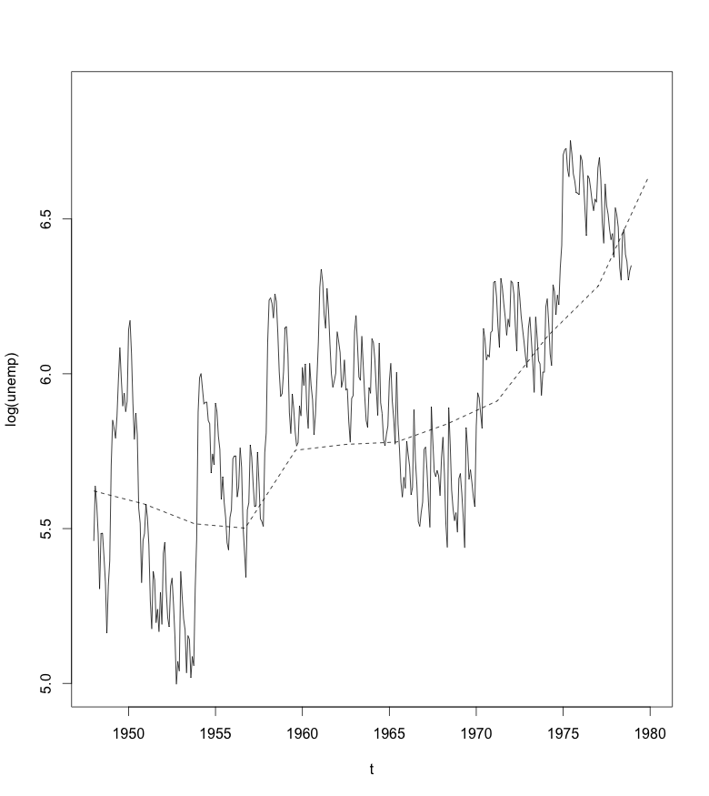

Using an ARMA(3,2) model with seasonal differencing results in the following forecast for the next year:

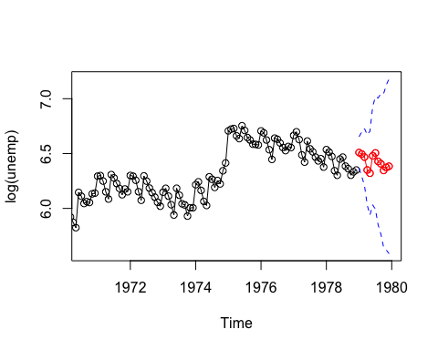

If I were interested in the overall trend I would prefer the regression/classical decomposition model, but if I were interested in knowing the monthly fluctuations I would prefer to use the ARMA model.

4.1)

1. Changing n from 100 to 128 changes the fundamental frequencies of x1, x2 and x3 from 0.06, 0.10, 0.40 to 0.046875, 0.078125 and 0.3125, respectively. This change is apparent in the original and new plots of the sums of x1, x2 and x3.

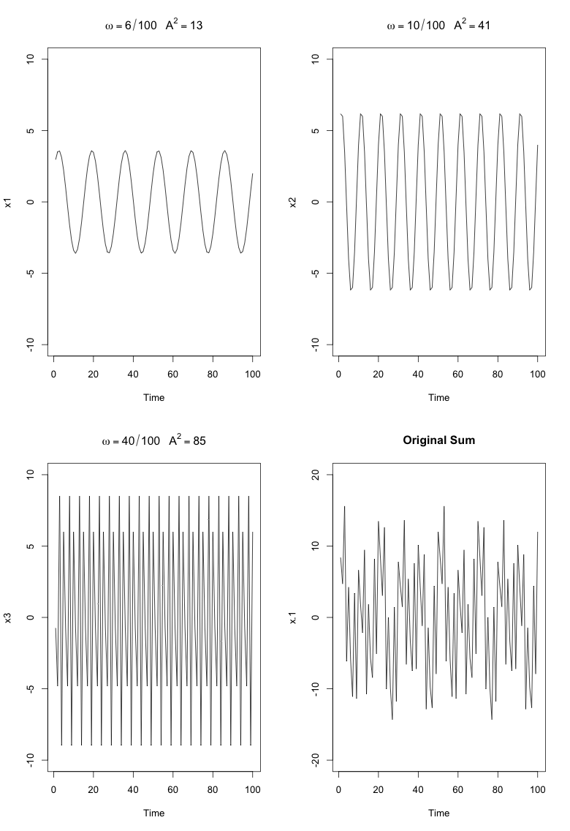

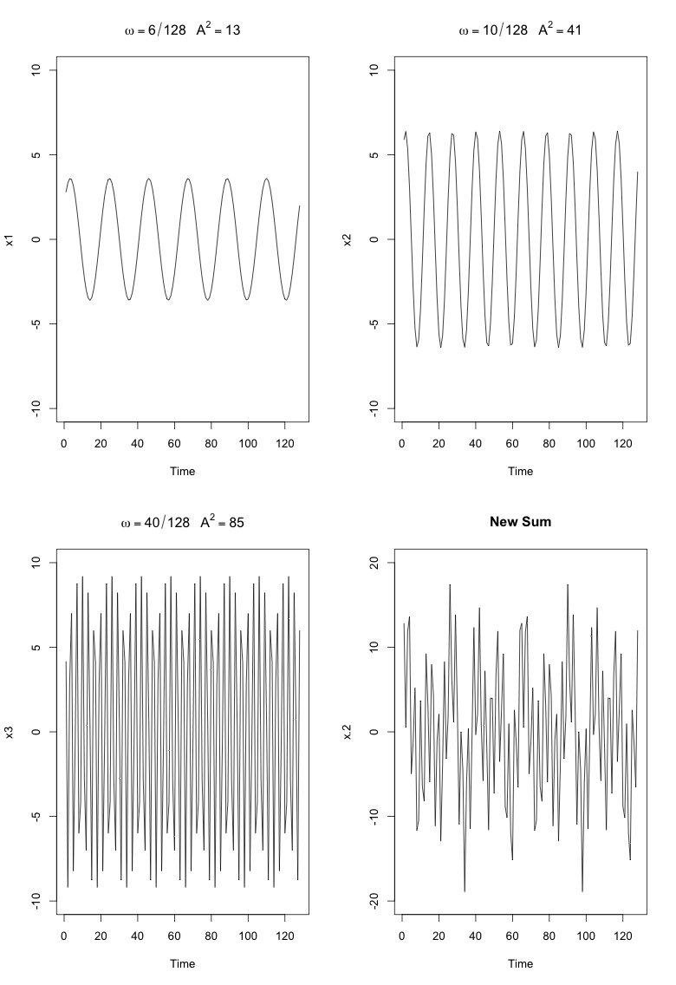

1. The change in fundamental frequencies is also apparent in the scaled periodograms. The old periodogram on top shows spikes corresponding to the original frequencies, 0.06, 0.10 and 0.40, while the new periodogram shows spikes at the new frequencies, 0.046875, 0.078125 and 0.3125.

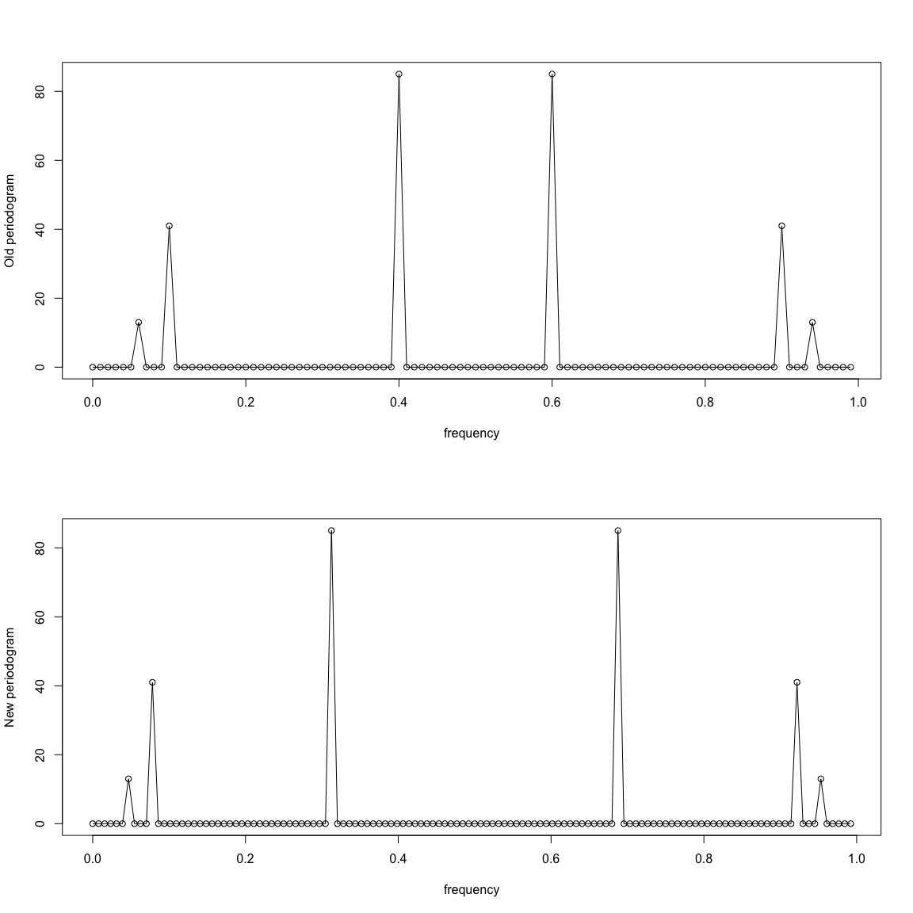

1. The addition of the white noise term disrupts the regularly repeating cycle of the original plot. The addition of the white noise term also introduces some minor fluctuations across the periodogram at every frequency, but the 3 spikes at the specificed freqiencies are still present. The previous periodogram has no fluctuations ther than the spikes at the 3 specified frequencies.

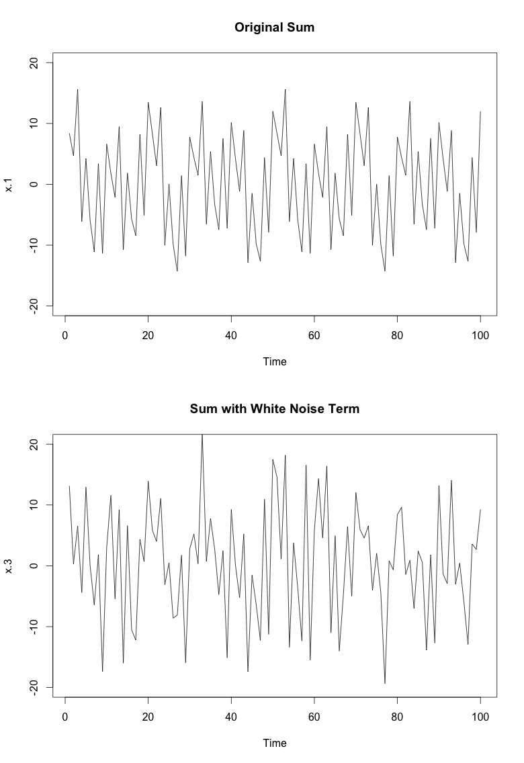 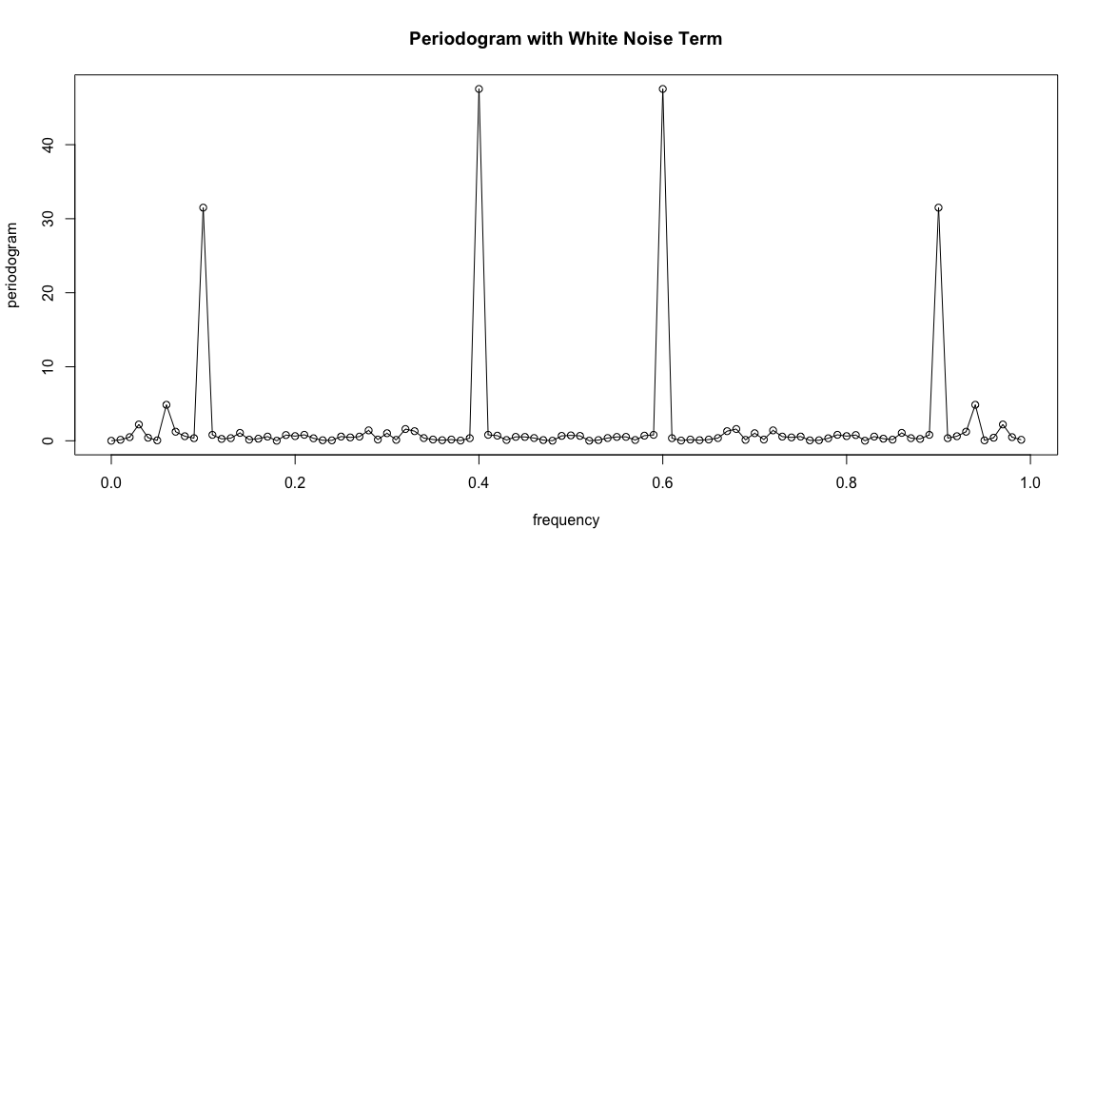

1. The scaled periodogram below is based on re-centered (mean = 0) monthly passengers from Philadelphia International Airport. The most important frequency seems to be around .08, with other spikes occuring around 0.02, 0.25, and 0.41. The large spike at a frequency of about .08 suggests a regularly occuring pattern of about 1/12 = .08333, which makes sense since the plot is based on monthly data.

