Brendan Graham  
MAT 8444 HW8  
March 23, 2016

1) Using the classical decomposition technique from class, I fit an ARMA(3,2) model to the residuals of my regression. This results in the following forecast

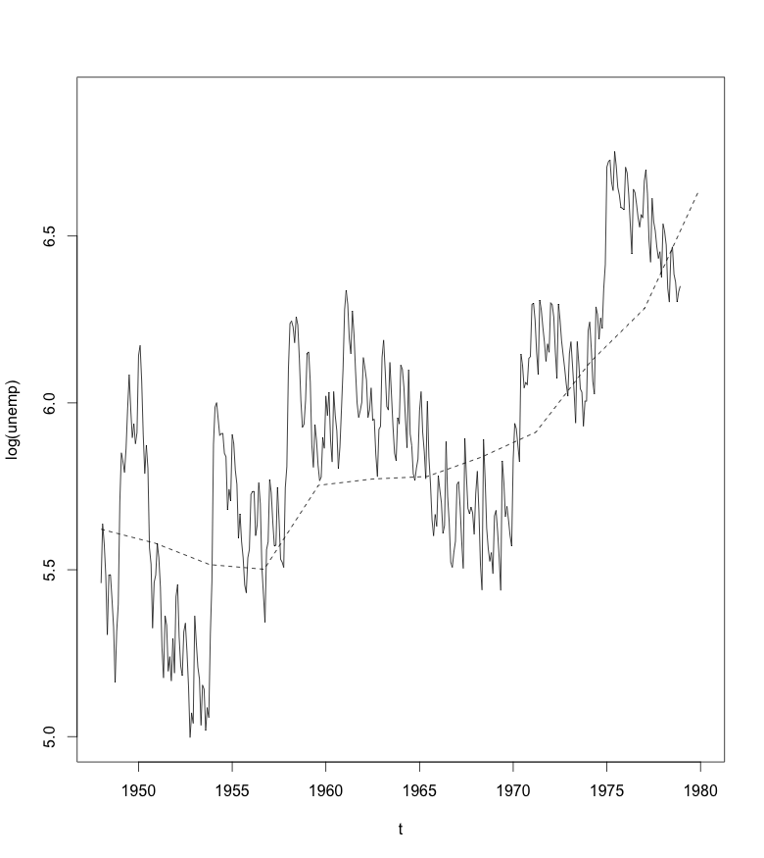

Using an ARMA(3,2) model with seasonal differencing results in the following forecast for the next 4 quarters, which seems more reasonable than the previous forecast since it accounts for monthly fluctuations.

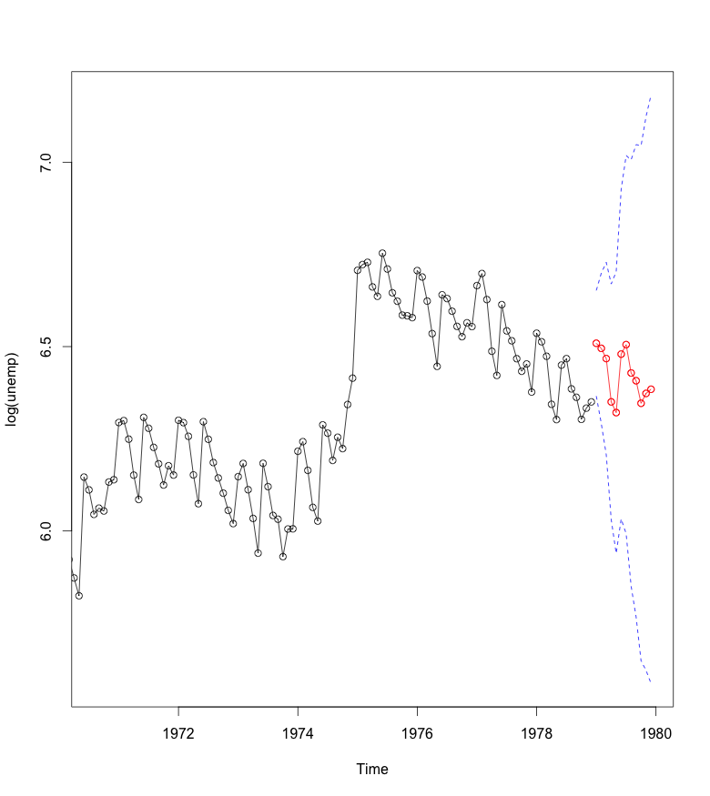

4.1)

1. Changing n from 100 to 128 reduces the frequencies in x1, x2 and x3 from 0.06, 0.10, 0.40 to 0.046875, 0.078125 and 0.3125, respectively. The increase in n doesn't affect how the plots of x1, x2, and x3 look, but it does change the plot of their sum.

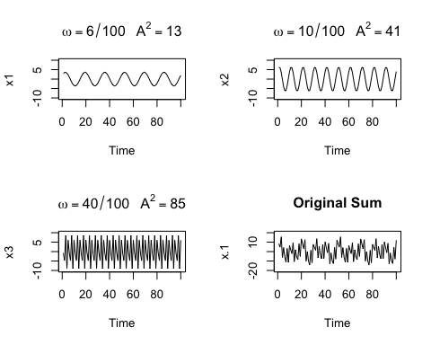 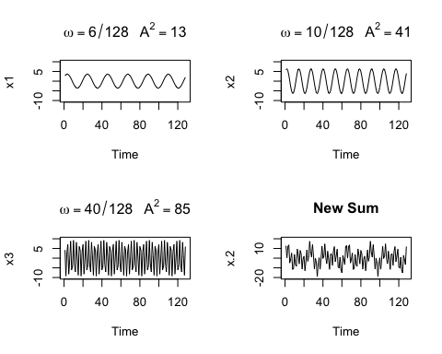

1. The change in frequency is present in the scaled periodograms. The old periodogram on top shows spikes corresponding to the original frequencies, 0.06, 0.10 and 0.40, while the new periodogram shows spikes at the new frequencies, 0.046875, 0.078125 and 0.3125. Overall, increasing N reduced the frequencies which is reflected in the 3 spikes shifted to lower frequencies in the new periodogam relative to the old periodogram.

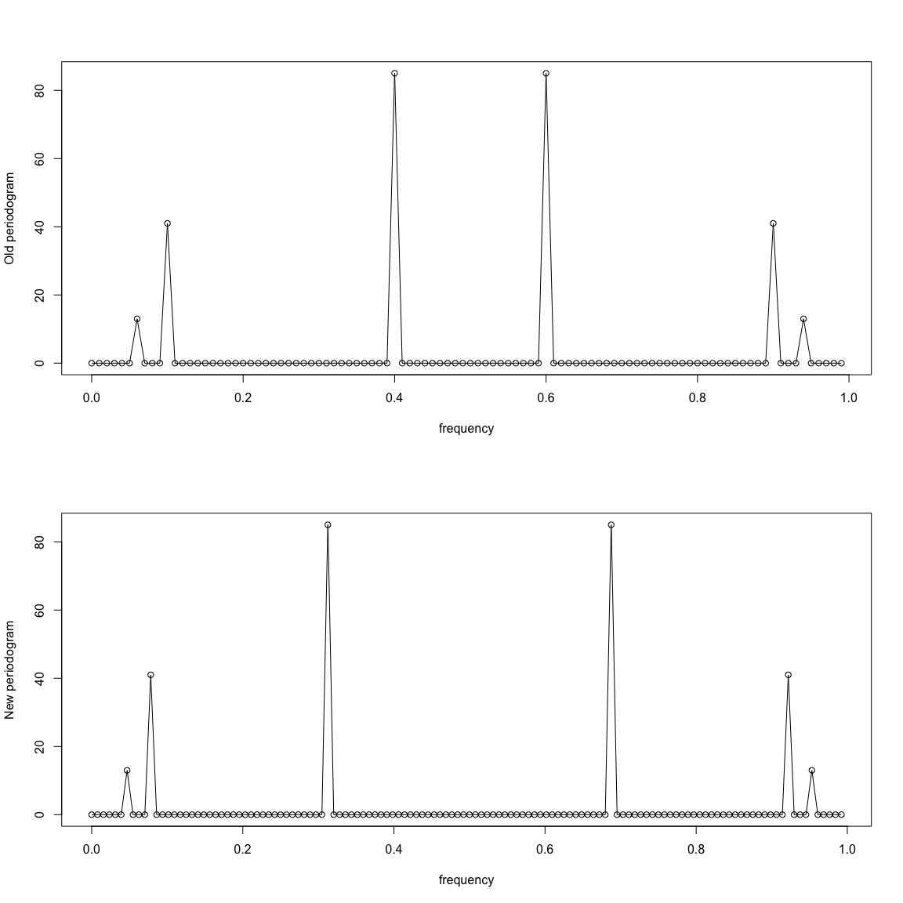

1. The addition of the white noise terms to the sums of the three series For the periodogram, the addition of the white noise term also introduces some minor fluctuations at every frequency, but the 3 spikes at the specificed freqiencies are still present. The previous periodogram has none of these fluctuations other than the spikes at the 3 specified frequencies.

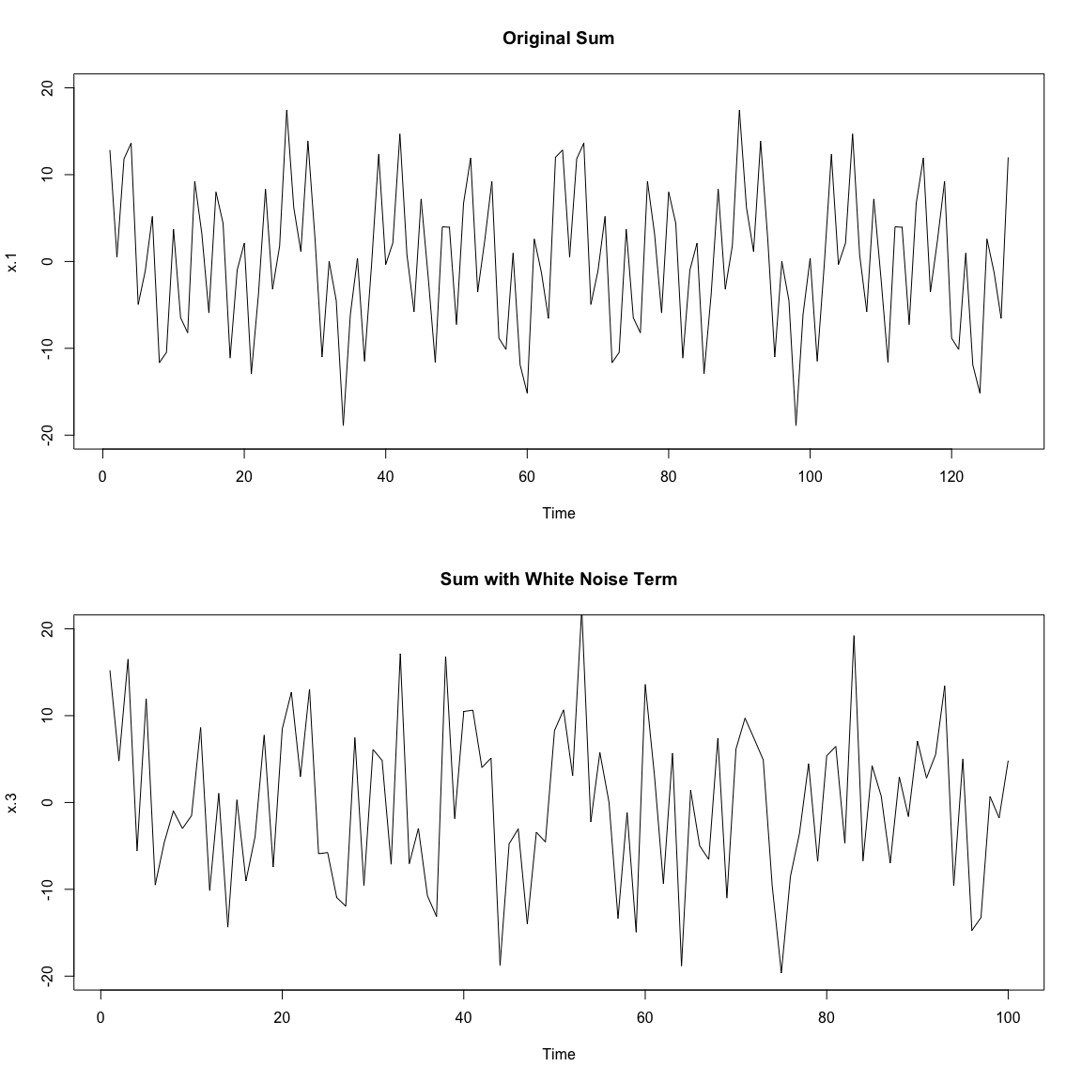 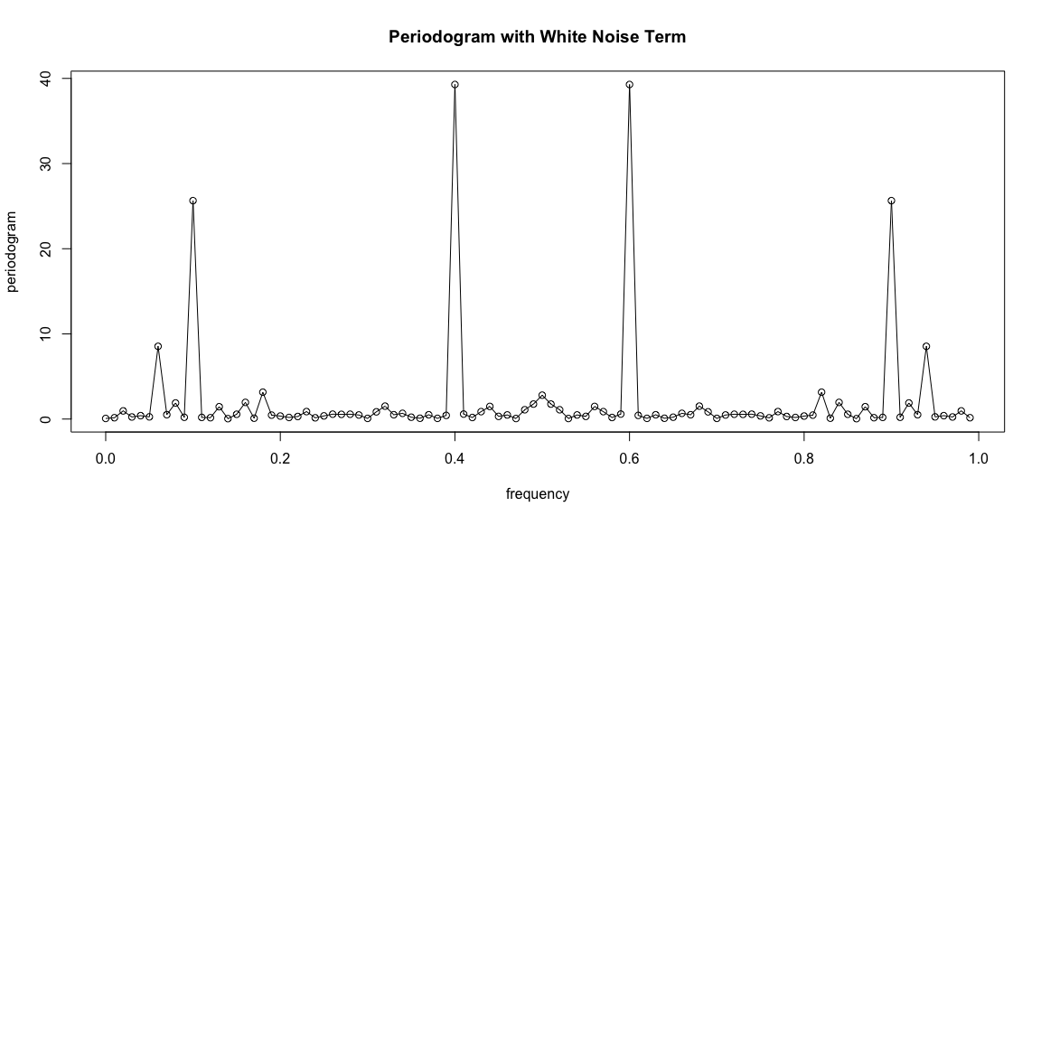

1. The scaled periodogram below is based on re-centered (mean = 0) monthly passengers from Philadelphia International Airport. The most important frequency seems to be around .08, with other spikes occuring around 0.02, 0.25, and 0.41. The large spike at a frequency of about .08 suggests a regularly occuring pattern of about 1/12 = .08333, which makes sense since the plot is based on monthly data.

