**Lighting & Shading: Organization with Structures**

Brendan Ward | btw4293

**User Guide**

The scene consists of a lineup of 4 objects designed to show off the goals of the project all placed above a simple ground grid which provides context and scale. Each object is shaded according to the parameters of a different material. From the left, the first object is a large, slowly spinning sphere designed to make easy assessment of the Gouraud and Phong shaders. The next three objects move and flex in various ways to show off more dynamic range of the shaders. Two lights are active in the scene; the first is a simple set light that always shares a position with the camera while the second is set to a fixed point in space and can be reconfigured with user input. The reference sphere is set to a ‘red plastic’ material that shows a good balance of ambient, diffuse, and specular light. From the left, the next object is a stack of 3 spheres which bends back and forth. They are shaded with a ‘pearl’ material that is slightly pink but also reflective. The next object is a set of 3 balls, 2 of which curl around the center one in opposite directions before retreating and starting the pattern over again. This object is shaded with a ‘blue plastic’ material similar to the first. The final object is two joined spheres, the smaller of which migrates across the surface of the stationary larger sphere. In all objects, the movements are most easily viewed with the Gouraud shader, which more easily exposes the geometry.

The canvas will resize with the page, taking up the entire window except for a small portion at the bottom which shows the controls. Foremost, a button allows the user to switch between Gouraud and Phong shading types. Next to this are instructions detailing the camera navigation. WASD allows the user to reposition the camera (strafing, towards/away from view) and IJKL controls the orientation of the camera (tilt up/down, rotate left/right). Below the instructions, a table of input boxes allows the user to access the properties of the stationary point light. The first row modifies x/y/z position in world coordinates. The remaining rows are rgb values of ambient, diffuse, and specular lights respectively. The values automatically update based on the current contents of the box.

**Results**

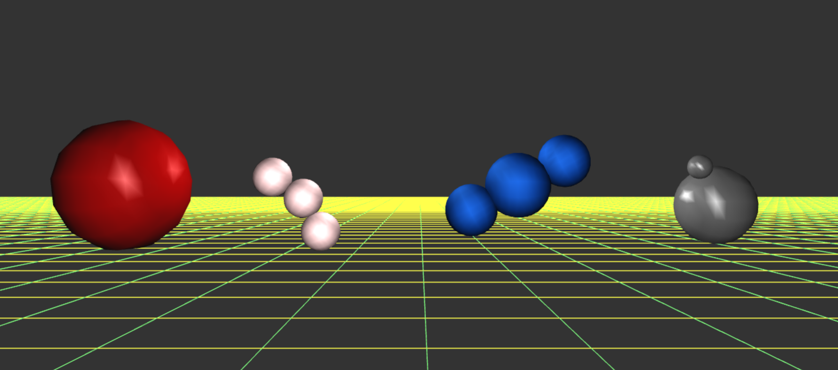

Figure : An overview of the entire scene in Gouraud shading.

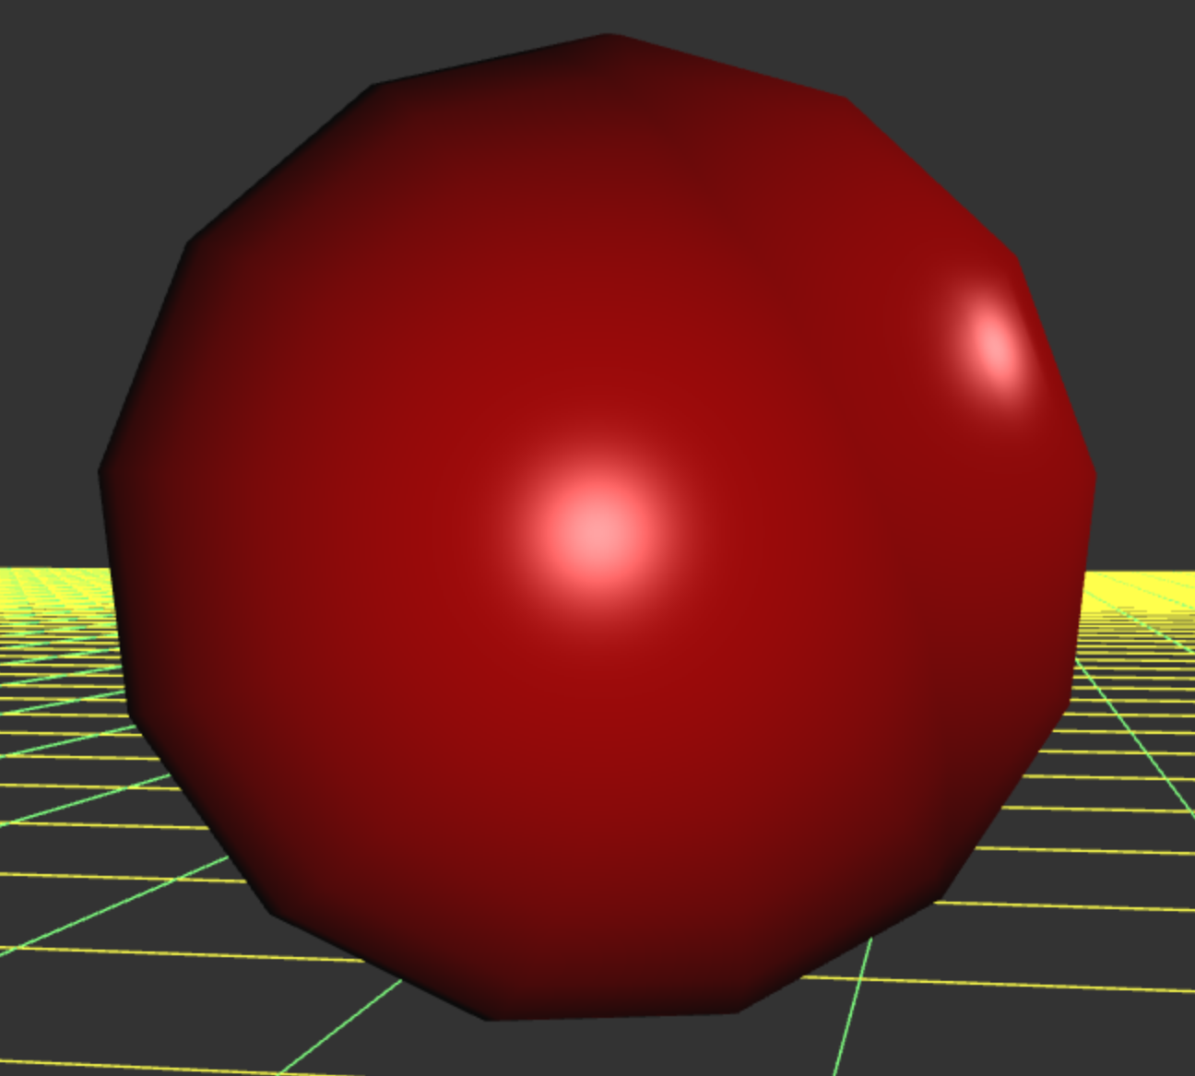

Figure : Closeup of the sphere in Phong shading. Note the separate specular highlights of the headlight and point light.

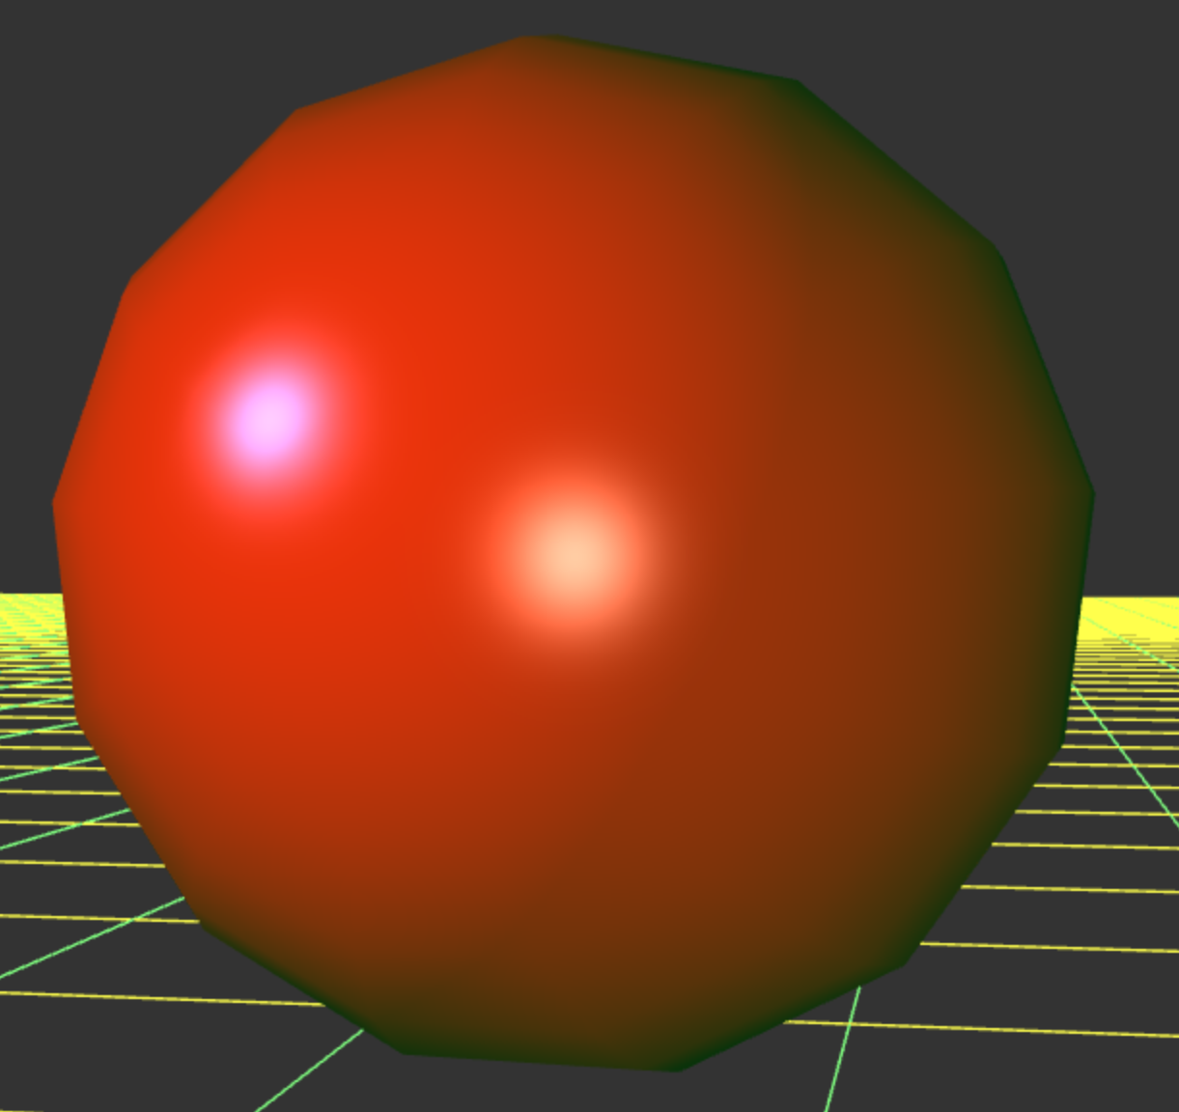

Figure : The same closeup but with the point light parameters adjusted. The note the changes in ambient and specular color, as well as position.

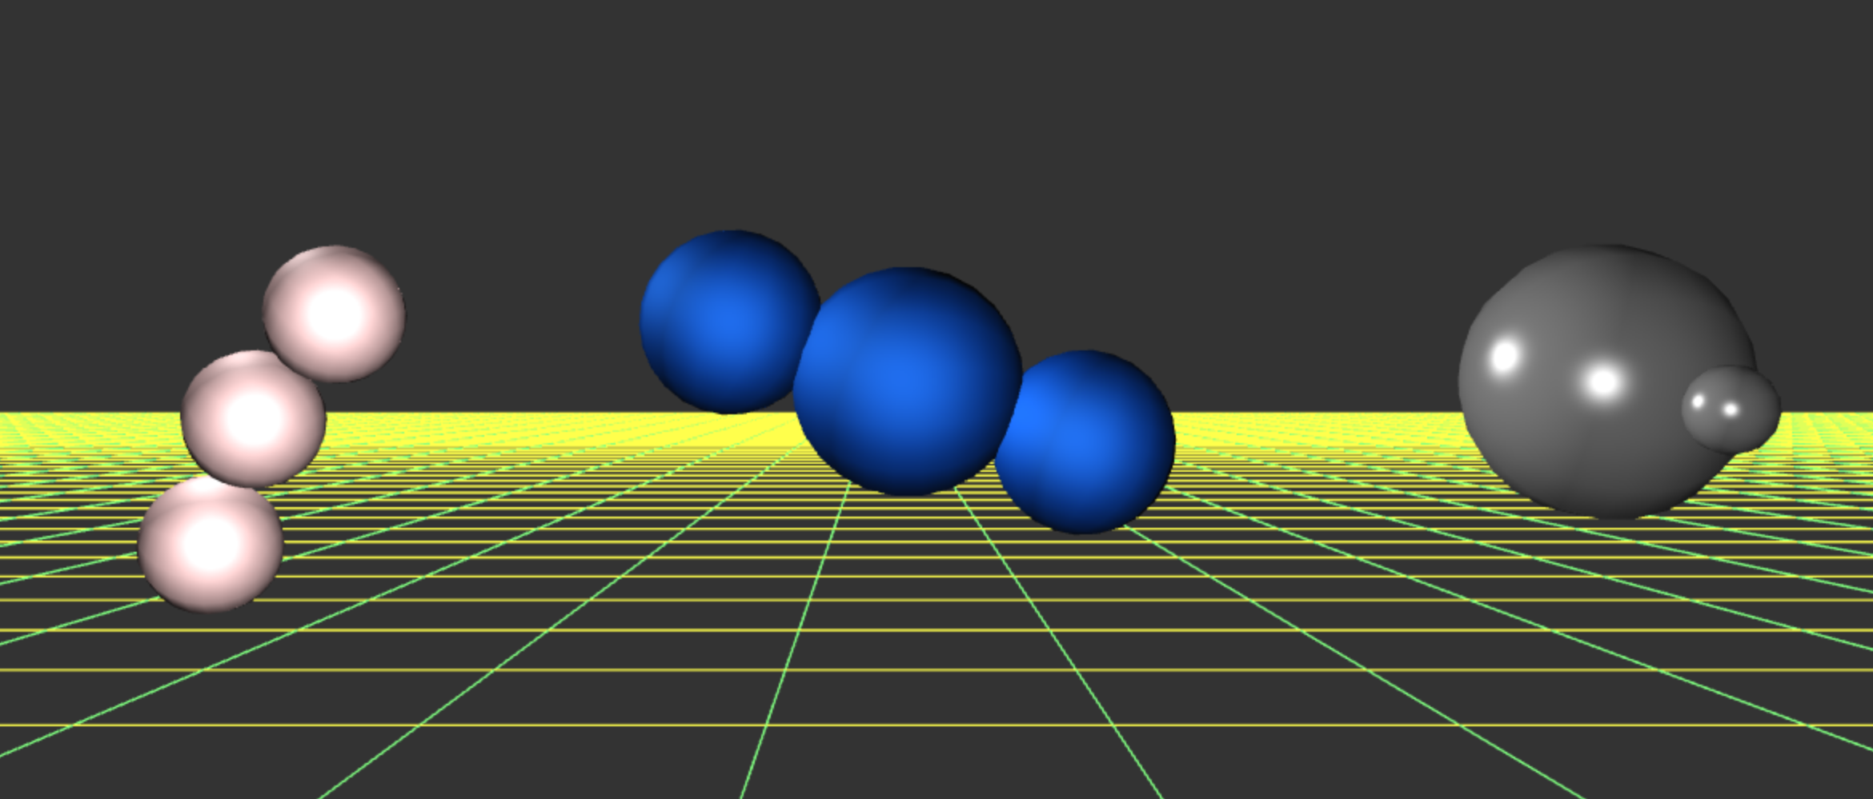

Figure : An example showing another state of movement of the extra objects.

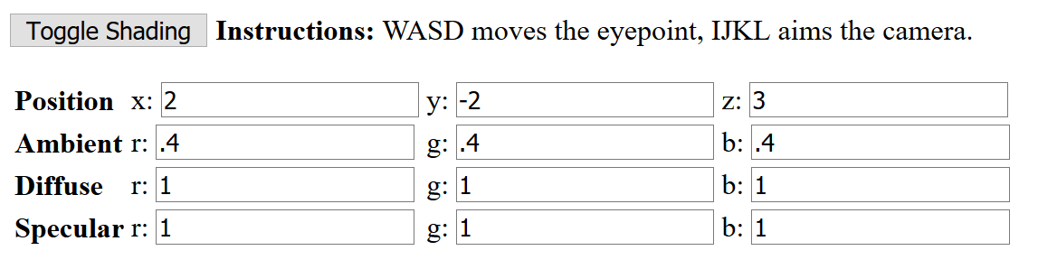

Figure : The on-screen instructions, showing the default state of the input boxes.

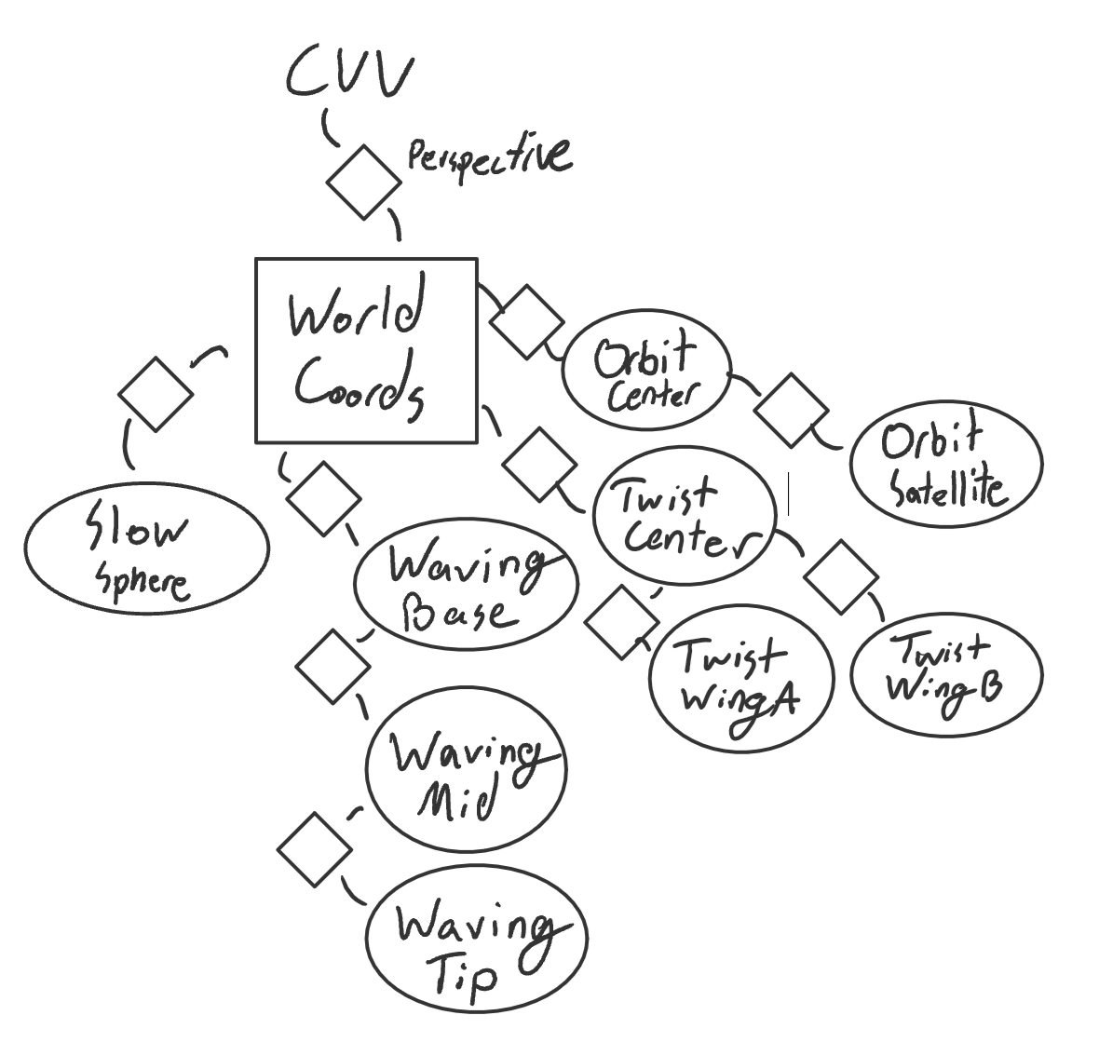

Figure : Scene graph, including viewport camera transformation.