NEXTJS NEXTAUTH+MONGODB

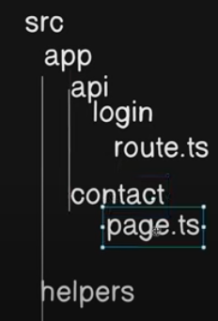

* helpers file or database connections are made outside of the app directory.
* Api is name of special routes in which we define our API for Backend Interaction
* For DataModeling we install mongoose “npm install mongoose” (it usually helps us to communicate with MongoDB)

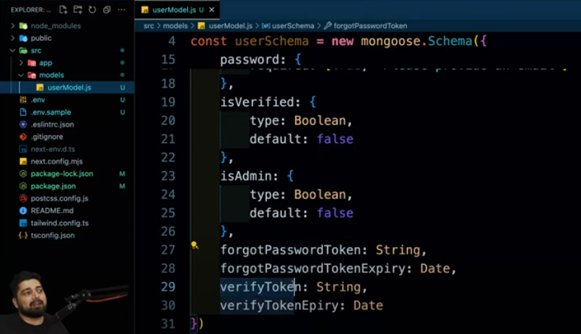

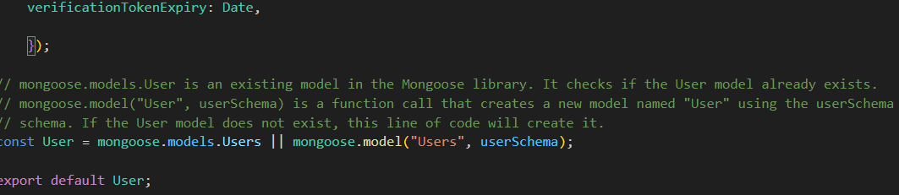

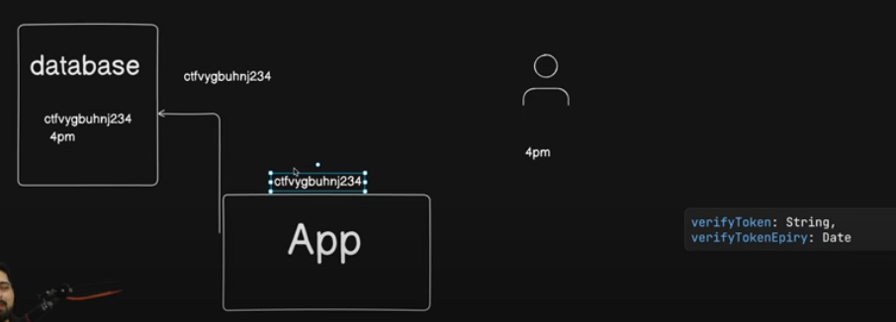

APP ka kaam hai woe token generate kary phir woe token user or DB me save karta hai or phir compare karta hai

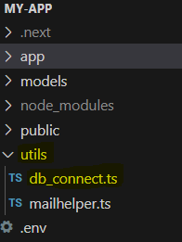

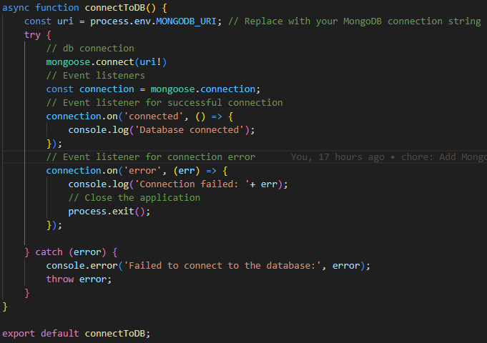

*npm i nodemailer*

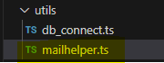



This library is use to encrypt the password

* Uuvid and hash me ye difference hai k hash jo hai woe Special character use karta hai jab k Uuvid use nhi karta . Uuvid is same as a bcryptjs module

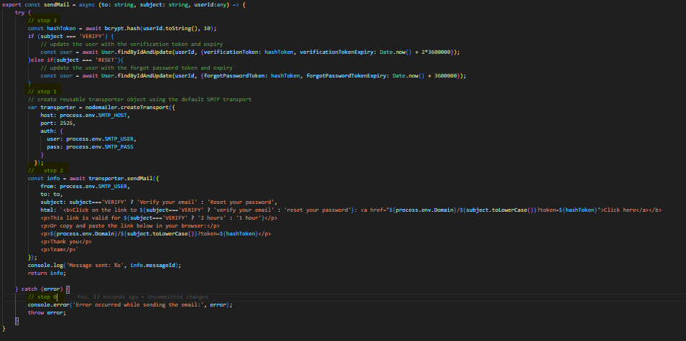

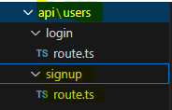

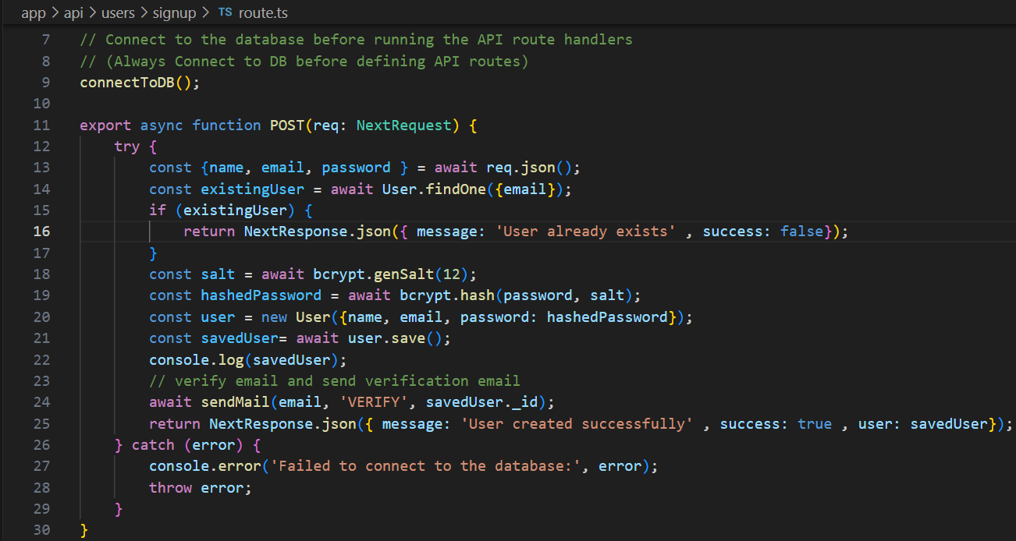

Check on postmen this is working find or not ……………… Jab be data base ko access karen gy yap phir asay continent ko access jo app say bhr hai tw hum usk lye hum await use kartay hai

