A Project Report on
CUSTOMER CHURN PREDICTION USING MACHINE LEARNING AND POWER BI
Submitted in partial fulfillment of the requirements for
Bachelor of Computer Applications (Data Analytics)
MACHINE LEARNING LAB
Paper Code: BCADA 5P 126
Submitted by
Student 1: Sam Joshuva Register No.: 241BCADA19
Student 2: Muhammed Sinan Register No.: 241BCADA70
Student 3: Jonathan Jijoy Register No.: 241BCADA26
Student 4: Muhammed Adir Register No.: 241BCADA13
Student 5: Siddharth S Register No.: 241BCADA44

ST. JOSEPH'S UNIVERSITY, BENGALURU - 27
DEPARTMENT OF ADVANCED COMPUTING
ACADEMIC YEAR: 2026-2027

CERTIFICATE
This is to certify that the project titled
“Customer Churn Prediction Using Machine Learning and Power BI”
has been successfully completed as part of the Machine Learning Lab (Paper Code: BCADA 5P 126) prescribed by ST. JOSEPH'S UNIVERSITY, under the Department of Advanced Computing, Bachelor of Computer Applications (Data Analytics) programme during the academic year 2026-2027.

Signature of the Teacher in-charge | Head of the Department
____________________________ | ____________________________

DECLARATION
We hereby declare that the project report titled “Customer Churn Prediction Using Machine Learning and Power BI” submitted for the Machine Learning Lab (BCADA 5P 126), Bachelor of Computer Applications (Data Analytics), is a record of the work carried out by our group. The work presented in this report has not been submitted elsewhere for any other academic award.
We further declare that all datasets, libraries, external references, code resources and AI-assisted tools used during the project have been appropriately acknowledged wherever applicable.

Place: Bengaluru
Date: __________________
Signatures of Students:
1. Sam Joshuva (241BCADA19)
2. Muhammed Sinan (241BCADA70)
3. Jonathan Jijoy (241BCADA26)
4. Muhammed Adir (241BCADA13)
5. Siddharth S (241BCADA44)

ACKNOWLEDGEMENT
We express our sincere gratitude to St. Joseph's University, Bengaluru, the Department of Advanced Computing, and the faculty members of the Machine Learning Lab for providing the academic guidance and resources required to complete this project. We thank our teacher in-charge and project guide for their feedback throughout the stages of data preparation, model development, evaluation, and dashboard implementation. We also acknowledge the support of our team members, whose contributions across data engineering, data analysis, data science, machine learning, analytical engineering, and Power BI development helped us complete the work collaboratively. Finally, we acknowledge the project datasets, Python libraries, machine-learning tools, and Power BI resources used during the project.

ABSTRACT
Customer churn is a classification problem in which customer information is used to estimate whether a customer is likely to leave a service. This project develops a customer churn prediction workflow using a combined telecom customer dataset and presents the results through a Power BI dashboard. Five source tables covering demographics, services, customer status, location, and population were integrated using Customer ID and, for population information, Zip Code. The final dataset contains 7,043 customer records and 61 columns. The data preparation process included duplicate checks, missing-value inspection, removal of identifier and target-derived fields from the modelling inputs, categorical encoding, and missing-value handling. Exploratory analysis examined churn distribution, contract type, satisfaction, internet service, customer tenure, and customer-value measures. Logistic Regression was implemented as a baseline model, while an XGBoost classifier was developed using a preprocessing pipeline with one-hot encoding for categorical variables. The data was split into 80% training and 20% testing sets using stratification and random state 42. Logistic Regression achieved about 91.2% accuracy, while XGBoost achieved about 96% accuracy and a ROC-AUC of 0.9924. The XGBoost confusion matrix contained 1,021 true negatives, 14 false positives, 38 false negatives, and 336 true positives. Additional analysis produced a top-decile lift of 3.77 and identified 350 predicted churners in the test set, representing approximately $1.46 million in CLTV at risk. The Power BI dashboard communicates churn rate, customer counts, CLTV at risk, contract and internet-type patterns, customer-level risk, churn probability, and other model outputs. Overall, the project demonstrates an end-to-end workflow from data integration and modelling to decision-oriented visualisation.
Keywords: Customer Churn, XGBoost, Classification, CLTV at Risk, Power BI

CONTENTS
1. INTRODUCTION
1.1 Overview of the Project
1.2 Problem Statement
1.3 Objectives of the Project
1.4 Scope of the Project
1.5 End User / Stakeholder and Project Value
2. DATASET AND DATA UNDERSTANDING
2.1 Dataset Description
2.2 Dataset Source
2.3 Features / Variables and Target
2.4 Class Distribution / Data Distribution
2.5 Dataset Limitations
3. DATA PREPARATION AND EXPLORATORY DATA ANALYSIS
3.1 Data Cleaning
3.2 Preprocessing
3.3 Feature Extraction / Feature Engineering
3.4 Exploratory Data Analysis
3.5 Key Insights from EDA
4. MACHINE LEARNING METHODOLOGY
4.1 ML Problem Type
4.2 Train-Test / Validation Strategy
4.3 Algorithms / Models Used
4.4 Model Training
4.5 Hyperparameter Tuning
4.6 Mathematical / Statistical Concepts Used
5. MODEL EVALUATION AND RESULTS
5.1 Evaluation Metrics
5.2 Model Comparison
5.3 Final Model Selection
5.4 Error Analysis / Confusion Matrix / Residual Analysis
5.5 Interpretation of Results
6. DASHBOARD / VISUALISATION AND IMPLEMENTATION
6.1 Dashboard / Visualisation
6.2 Important KPIs / Insights
6.3 Prediction / Application Workflow
6.4 Sample Input and Output
7. CHALLENGES, LIMITATIONS AND IMPROVEMENTS
7.1 Challenges Faced
7.2 Approaches That Did Not Work
7.3 Current Limitations
7.4 Future Improvements
8. TEAM CONTRIBUTION AND LEARNING
8.1 Team Roles and Contributions
8.2 Skills / Learning Outcomes
9. CONCLUSION
10. REFERENCES / BIBLIOGRAPHY
11. APPENDICES

1. INTRODUCTION

1.1 Overview of the Project
Customer churn prediction uses customer, service, billing, satisfaction, and related information to identify customers who may leave a service. This project focuses on a telecom customer dataset and builds an end-to-end workflow that combines data engineering, exploratory analysis, machine learning, customer-risk analysis, and Power BI visualisation. The solution estimates churn probability, compares predictive models, identifies important predictive features, quantifies customer lifetime value (CLTV) associated with predicted churners, and presents the results in a decision-oriented dashboard.

1.2 Problem Statement
The problem is to classify each customer as likely to churn or not churn using available customer-level information. Inputs include demographic attributes, service usage and subscription information, contract and payment details, satisfaction measures, financial measures, and location/population information. The expected output is a binary churn prediction together with a churn probability/risk view. The problem is relevant because identifying higher-risk customers supports focused retention analysis rather than treating all customers equally.

1.3 Objectives of the Project
- Integrate the available telecom customer source tables into a single analysis-ready dataset.
- Perform data cleaning, preprocessing, exploratory analysis, and identify meaningful churn patterns.
- Train and evaluate Logistic Regression and XGBoost classification models for customer churn prediction.
- Build a Power BI dashboard that communicates churn risk, model outputs, customer value, and analytical insights.

1.4 Scope of the Project
The project includes source-table integration, data quality checks, exploratory analysis, categorical encoding, model training and evaluation, feature-importance analysis, lift analysis, CLTV-at-risk analysis, model export, and Power BI dashboard development. It does not include a production deployment, live streaming customer data, automated retention actions, or a demonstrated causal analysis of why customers churn.

1.5 End User / Stakeholder and Project Value
The primary end users are analysts, data-science teams, customer-retention teams, and decision makers who need a structured view of churn risk. The solution supports prioritisation of customers for further retention analysis, examination of churn patterns across contracts and services, and assessment of customer value associated with predicted churn. Academically, it demonstrates an end-to-end application of data analytics, machine learning, and business intelligence tools.

2. DATASET AND DATA UNDERSTANDING

2.1 Dataset Description
The project uses the combined telecom customer churn dataset supplied with the project. It contains 7,043 customer records and 61 columns in Excel format. The data covers demographics, services, customer status/churn, location, and population information. The target variable is Churn Value, a binary variable where 0 represents no churn and 1 represents churn. There are 5,174 non-churn records and 1,869 churn records.

2.2 Dataset Source
Dataset Name: customer_churn_combined.xlsx
Source / URL: https://www.ibm.com/docs/en/cognos-analytics/12.0.x?topic=samples-telco-customer-churn
Access Date: September 2026

2.3 Features / Variables and Target
Important inputs include Age, Senior Citizen, Dependents, Number of Dependents, Number of Referrals, Tenure in Months, Internet Service, Internet Type, Online Security, Contract, Paperless Billing, Payment Method, Monthly Charge, Total Charges, Satisfaction Score, CLTV, and location/population variables. The target is Churn Value. Identifier fields and target-derived churn fields were excluded from the final modelling inputs.
Variable Group | Examples | Role
Demographics | Gender, Age, Senior Citizen, Dependents | Predictor
Services | Internet Service, Internet Type, Online Security, Streaming | Predictor
Account / Contract | Tenure, Contract, Payment Method, Paperless Billing | Predictor
Financial | Monthly Charge, Total Charges, CLTV | Predictor
Satisfaction | Satisfaction Score | Predictor
Target | Churn Value / Churn Label | Target

2.4 Class Distribution / Data Distribution
The target is moderately imbalanced: 1,869 of 7,043 customers (26.5%) are churners, while 5,174 (73.5%) are non-churners. The notebook therefore used stratified sampling during train-test splitting. Contract type also shows a strong difference in observed churn rates in the supplied data: Month-to-Month 45.8%, One Year 10.7%, and Two Year 2.5%.
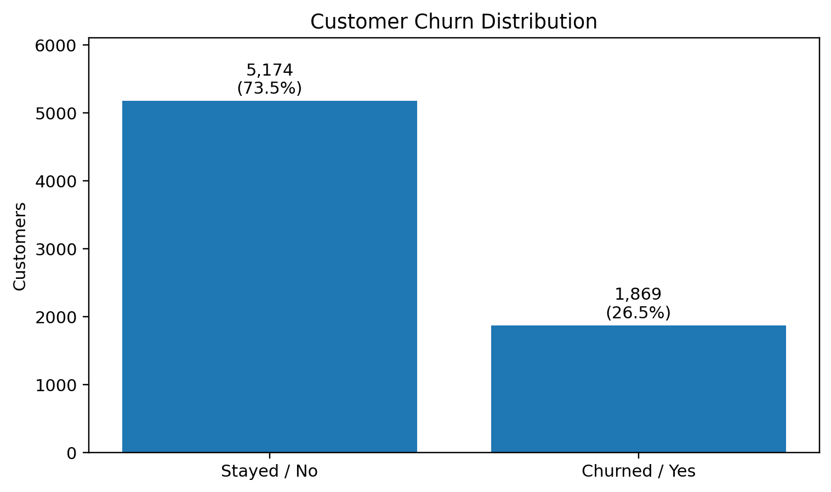
Figure 2.1. Distribution of the binary churn target.

2.5 Dataset Limitations
The dataset contains 7,043 records, which is adequate for a lab-scale classification experiment but limited compared with a production telecom population. Several fields contain missing values in the supplied data, including Offer, Internet Type, Churn Category, and Churn Reason. The modelling workflow handled missing predictor values after encoding. The target is imbalanced toward non-churn, so accuracy alone is not sufficient for evaluating the minority class. The dataset is also a static project dataset, so model performance may not represent future or unseen customer populations.

3. DATA PREPARATION AND EXPLORATORY DATA ANALYSIS

3.1 Data Cleaning
The five source tables were checked for common keys and duplicate records before merging. Demographics, services, status, and location each contained 7,043 rows, while the population table contained 1,671 ZIP-code records. Duplicate Customer IDs were zero in the customer-level tables, and duplicate ZIP Codes were zero in the population table. The merged dataset contained 7,043 rows and 61 columns, with zero complete-row duplicates. Missing values were inspected; Offer, Internet Type, Churn Category, and Churn Reason contained missing entries. Numerical outlier checks were performed using boxplots and IQR calculations for selected variables. The notebook found 676 observations outside the IQR bounds for Number of Referrals; these observations were inspected rather than automatically removed.

3.2 Preprocessing
For the final XGBoost workflow, predictors were separated into categorical and numerical columns. Categorical variables were transformed using OneHotEncoder with handle_unknown='ignore', while numerical variables were passed through without scaling. Missing values in the earlier baseline workflow were filled with zero after dummy encoding. The final model used a ColumnTransformer inside a scikit-learn Pipeline so preprocessing and model training were applied consistently.

3.3 Feature Extraction / Feature Engineering
No complex domain-specific feature extraction was performed. The main feature-engineering steps were relational integration of the five source tables, selection/removal of modelling columns, categorical one-hot encoding, and creation of model-derived analytical outputs such as churn probability, risk deciles, lift, predicted churn, and CLTV at risk. The Power BI report also uses dashboard-level measures and cleaned display fields for interactive analysis.

3.4 Exploratory Data Analysis
Month-to-Month customers show a substantially higher observed churn rate (45.8%) than One Year (10.7%) and Two Year (2.6%) customers.
Overall churn is 26.5%, so the test split was stratified to preserve the target-class proportions.
The XGBoost feature-importance analysis identifies Satisfaction Score as the largest model feature importance, followed by contract and internet-service related variables.

3.5 Key Insights from EDA
- Month-to-Month customers show a substantially higher observed churn rate (45.8%) than One Year (10.7%) and Two Year (2.6%) customers.
- Overall churn is 26.5%, so the test split was stratified to preserve the target-class proportions.
- The XGBoost feature-importance analysis identifies Satisfaction Score as the largest model feature importance, followed by contract and internet-service related variables.

4. MACHINE LEARNING METHODOLOGY

4.1 ML Problem Type
Binary classification. The model predicts Churn Value as 0 (not churned) or 1 (churned).

4.2 Train-Test / Validation Strategy
The supplied notebook used an 80:20 train-test split with random_state=42 and stratify=y. This produced 5,634 training observations and 1,409 testing observations. The final XGBoost workflow removed identifier columns and known target/leakage fields such as Churn Label, Churn Value, Churn Score, Churn Category, Churn Reason, and Customer Status before training. A separate validation set or cross-validation procedure was not used in the supplied notebook.

4.3 Algorithms / Models Used
Two classification approaches were tested. Logistic Regression was used as a baseline because it provides a simple and interpretable linear classification benchmark. XGBoost was then used as the final tree-based boosting model because it can model nonlinear relationships and interactions among mixed customer attributes. The XGBoost configuration used 300 estimators, maximum depth 5, learning rate 0.05, subsample 0.8, colsample_bytree 0.8, random state 42, and logloss as the evaluation metric.

4.4 Model Training
The workflow was implemented in Python using pandas for data handling, scikit-learn for splitting, preprocessing, pipelines and evaluation, and XGBoost for the final classifier. The process was: load source files, inspect and merge tables, check data quality, select target and predictors, remove identifiers and target-derived fields, split the data, fit preprocessing and XGBoost on the training set, generate predictions and probabilities on the test set, evaluate performance, perform lift and feature-importance analysis, and save the trained pipeline as telco_churn_xgboost.pkl.

4.5 Hyperparameter Tuning
No GridSearchCV or RandomizedSearchCV was performed in the supplied notebook. The XGBoost hyperparameters were specified directly in the model definition and represent a manually configured experiment. For a lab project, this kept the workflow focused on the complete modelling-to-dashboard pipeline; systematic tuning remains a possible future improvement.

4.6 Mathematical / Statistical Concepts Used
Accuracy is the proportion of all test observations classified correctly. Precision for the churn class is TP/(TP+FP), indicating how many customers predicted as churners were actually churners. Recall is TP/(TP+FN), indicating how many actual churners were detected. F1-score is the harmonic mean of precision and recall: 2(Precision×Recall)/(Precision+Recall). ROC-AUC measures the model's ability to rank positive and negative cases across classification thresholds. Lift compares the churn rate in a selected high-risk group with the overall churn rate; a lift of 3.77 means the top risk decile had about 3.77 times the overall churn rate in the test analysis.

5. MODEL EVALUATION AND RESULTS

5.1 Evaluation Metrics
The project used accuracy, precision, recall, F1-score, confusion matrix, and ROC-AUC. Because churn is the minority class, precision, recall, F1-score and ROC-AUC provide more information than accuracy alone. The confusion matrix further shows the numbers of correctly and incorrectly classified churners and non-churners.

5.2 Model Comparison
The following comparison uses the evaluation results recorded in the supplied notebook.
Model | Key settings / workflow | Accuracy | Churn Precision | Churn Recall | Churn F1 | ROC-AUC
Logistic Regression | max_iter=1000; one-hot encoded predictors | 91.2% | 0.85 | 0.82 | 0.83 | Not recorded
XGBoost | 300 trees; depth 5; lr 0.05; subsample 0.8; colsample 0.8 | 96.0% | 0.96 | 0.90 | 0.93 | 0.9924

5.3 Final Model Selection
XGBoost was selected as the final model. In the supplied test results it achieved 96.0% accuracy, 0.96 precision, 0.90 recall, 0.93 F1-score for the churn class, and ROC-AUC of 0.9924. Compared with the Logistic Regression baseline, it produced stronger minority-class performance and a stronger overall test result. The selection is supported by the recorded evaluation metrics and the model's additional probability-based outputs used for lift and customer-risk analysis.

5.4 Error Analysis / Confusion Matrix / Residual Analysis
The XGBoost confusion matrix contains 1,021 true negatives, 14 false positives, 38 false negatives, and 336 true positives. Thus, the model correctly identified most non-churners and churners in the test set. The main error relevant to retention analysis is the 38 false negatives: customers who actually churned but were predicted as non-churners. There were 14 false positives, representing customers predicted to churn who did not churn in the test labels.
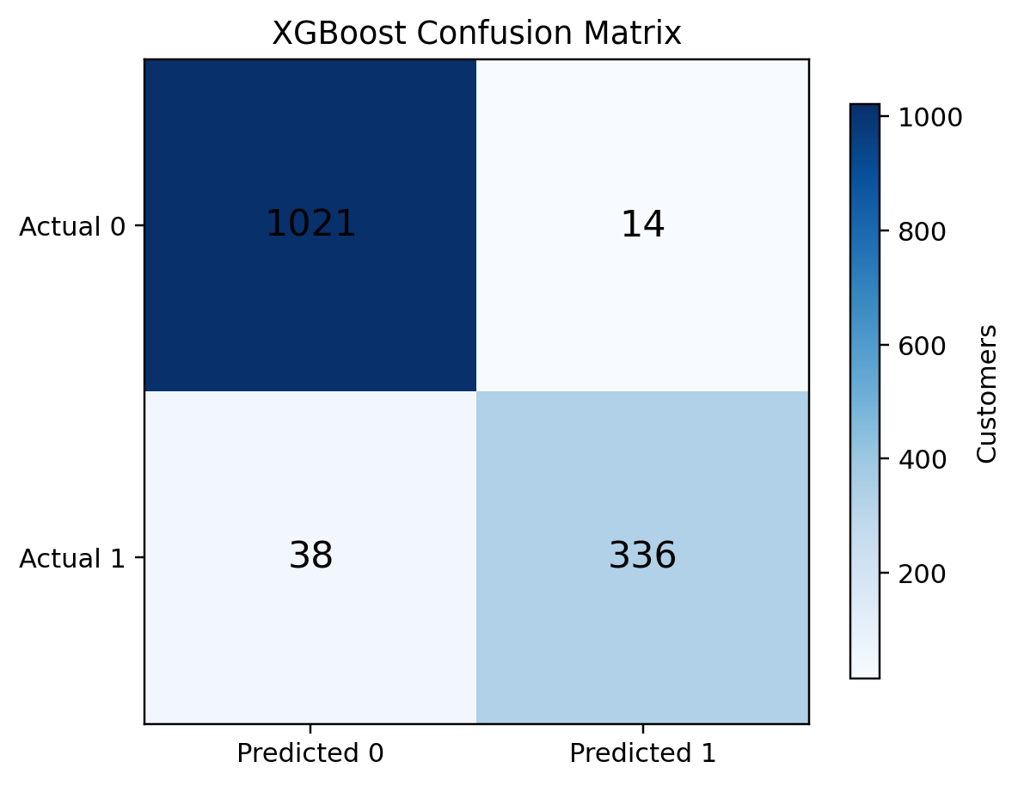
Figure 5.1. XGBoost confusion matrix on the 1,409-customer test set.

Total customers in the modelling dataset: 7,043.
Observed churn rate: 26.5% (1,869 churners out of 7,043 customers).

Predicted churners in the recorded XGBoost test analysis: 350.

CLTV represented by predicted churners in the test analysis: $1,460,111; top-10% lift: 3.77.
The supplied Power BI file contains two report pages. The main dashboard page includes KPI cards for total customers, churned customers, churn rate, average CLTV, and CLTV at risk; slicers for contract, senior-citizen status, internet type, and tenure; and charts for churn rate by contract and internet type and actual churn rate by risk decile. The second page provides customer-level risk information including selected customer ID, predicted outcome, risk level, churn probability, CLTV, contract, and tenure. This design connects portfolio-level churn analysis with individual-customer risk inspection.
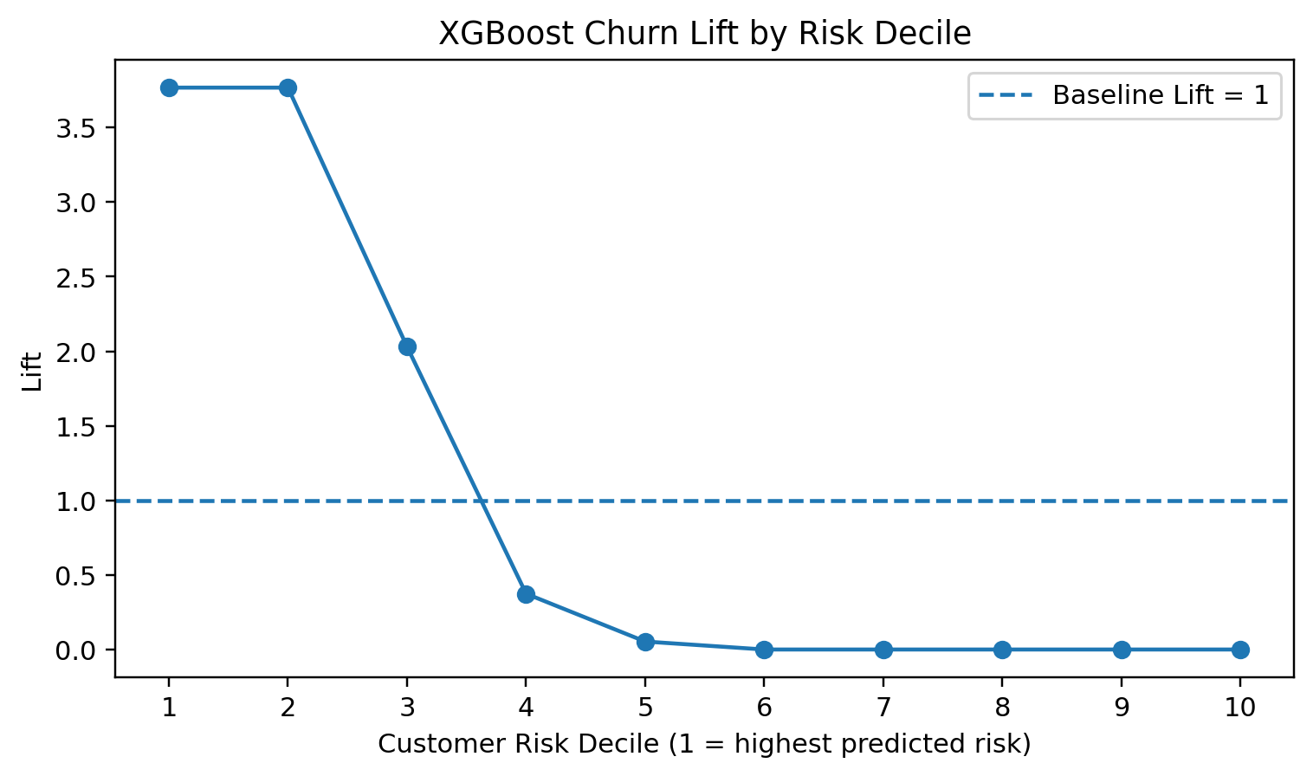
Figure 6.1. Lift analysis used as a dashboard-ready model-performance visual.

6.2 Important KPIs / Insights
- Total customers in the modelling dataset: 7,043.
- Observed churn rate: 26.5% (1,869 churners out of 7,043 customers).
- Predicted churners in the recorded XGBoost test analysis: 350.
- CLTV represented by predicted churners in the test analysis: $1,460,111; top-10% lift: 3.77.

6.3 Prediction / Application Workflow
For a new customer record, the input follows the same feature structure used during model development. Categorical fields are transformed using the fitted OneHotEncoder, numerical fields pass through the preprocessing stage, and the resulting feature vector is supplied to the trained XGBoost classifier. The model produces a binary predicted churn label and a churn probability. These outputs can then be used to assign a risk view, analyse customer value, calculate lift by risk group, and present the results in Power BI.

6.4 Sample Input and Output
One recorded test-set example had Age 80, Senior Citizen = Yes, Dependents = No, Tenure = 1 month, Internet Service = Yes, Internet Type = Fiber Optic, Contract = Month-to-Month, Monthly Charge = $70.30, Satisfaction Score = 1, and CLTV = $4,962. In the notebook's test analysis, this customer received a churn probability of approximately 99.986%, was predicted as a churner, and the actual test label was churn.
Sample field | Value | Model output
Tenure | 1 month | Churn probability ≈ 99.986%
Contract | Month-to-Month | Predicted churn = 1
Monthly Charge | $70.30 | Actual churn = 1
Satisfaction Score | 1 | CLTV = $4,962

7. CHALLENGES, LIMITATIONS AND IMPROVEMENTS

7.1 Challenges Faced
The main challenges were integrating multiple source tables with different schemas, checking key consistency, handling missing categorical values, controlling target-derived fields during modelling, and presenting a high-dimensional encoded feature set. The project also had to account for target imbalance and interpret probability-based outputs such as lift and CLTV at risk. Moving the model outputs into an interactive Power BI report required additional transformation and dashboard-level measures.

7.2 Approaches That Did Not Work
No experiment in the supplied notebook is documented as completely non-functional. Logistic Regression was successfully trained and provided a useful baseline, but its recorded minority-class performance was lower than the later XGBoost results. The project therefore used the baseline as a comparison point rather than treating it as the final solution. The notebook also performed outlier inspection without automatically deleting the identified observations, reinforcing that an outlier should not be removed solely because it falls outside an IQR rule.

7.3 Current Limitations
The current solution does not establish causal reasons for churn, does not automatically contact or retain customers, and is not demonstrated as a live production service. Its evaluation is based on the supplied static dataset and a single stratified 80:20 split. The recorded feature importance values should be interpreted as model behaviour rather than proof that a feature causes churn. The project also does not include systematic hyperparameter search or time-based validation.

[1] Project-provided telecom customer churn dataset: customer_churn_combined.xlsx and the source tables used in the supplied notebook.
[2] pandas documentation — Python data analysis and DataFrame operations: https://pandas.pydata.org/docs/

[3] scikit-learn documentation — preprocessing, model selection, pipelines and evaluation metrics: https://scikit-learn.org/stable/

[4] XGBoost documentation — XGBClassifier and gradient boosting: https://xgboost.readthedocs.io/
Student Name / Register No. | Assigned Role | Major Contribution | Tools / Skills Used
Sam Joshuva  241BCADA19 | Data Engineer | Integrated demographics, services, status, location and population tables; performed key/duplicate checks and built the analysis-ready dataset. | Python, pandas, Excel, data integration
Muhammed Sinan  241BCADA70 | Data Analyst | Performed EDA, distributions, data-quality checks and interpretation of churn patterns and analytical insights. | Python, pandas, EDA, statistics, visualisation
Sam Joshuva  241BCADA19 | Data Scientist | Developed the modelling approach, baseline Logistic Regression and final XGBoost workflow; evaluated model performance. | scikit-learn, XGBoost, classification, evaluation
Jonathan Jijoy  241BCADA26 | ML Engineer | Implemented model training pipeline, prediction workflow, probability scoring, lift analysis and model export. | Python, XGBoost, Pipeline, joblib
Muhammed Adir  241BCADA13 | Analytical Engineer | Performed customer-risk and CLTV-at-risk analysis and retention-scenario calculations; supported analytical interpretation. | Python, pandas, analytical modelling, CLTV analysis
Siddharth S  241BCADA44 | Power BI Developer | Developed the Power BI dashboard, KPI cards, slicers, customer-risk page and interactive churn visualisations. | Power BI, report measures, dashboard design, data visualisation

[5] Microsoft Power BI documentation — dashboard and report development: https://learn.microsoft.com/power-bi/
The project developed practical skills in multi-table data integration, data-quality checking, exploratory data analysis, categorical preprocessing, binary classification, model evaluation, feature-importance analysis, lift analysis, and customer-value analytics. The team also gained experience with scikit-learn pipelines, XGBoost, model persistence using joblib, Excel-based datasets, and Power BI dashboard design. Working across defined roles strengthened collaboration, documentation, interpretation of analytical results, and communication of technical findings to end users.

9. CONCLUSION
This project developed an end-to-end customer churn prediction solution using a combined telecom dataset of 7,043 customers. The team integrated five source tables, performed data-quality and exploratory analysis, prepared categorical and numerical predictors, and compared Logistic Regression with XGBoost. Logistic Regression achieved 91.2% accuracy, while the final XGBoost model achieved about 96.0% accuracy, 0.90 churn recall, 0.93 churn F1-score, and ROC-AUC of 0.9924 on the recorded test set. The model also supported probability-based lift analysis, with a top-decile lift of 3.77, and CLTV-risk analysis identifying 350 predicted churners representing approximately $1,460,111 in CLTV in the recorded test analysis. The Power BI dashboard translates these outputs into interactive KPIs, filters, customer-risk views, and churn-pattern visualisations. The main learning outcome was the integration of data engineering, analytics, machine learning, and business intelligence into one reproducible project workflow.

10. REFERENCES / BIBLIOGRAPHY
References used for the project workflow are listed below. The original URL of the supplied dataset was not recorded in the notebook, so it is identified as a project-provided source rather than assigning an unverified external URL.
[1] Dataset source - https://www.ibm.com/docs/en/cognos-analytics/12.0.x?topic=samples-telco-customer-churn
[2] Library / official documentation
[3] Chatgpt - https://chatgpt.com/
[4] Claude – https://claude.ai/

11. APPENDICES

Appendix A - GitHub Repository
Repository Link: https://github.com/broCode9686/ml_project.git.

Appendix B - Additional Screenshots / Outputs
