**TEST 1 -** Cropped background, all clearly positive bands

1. Original image and detected strips

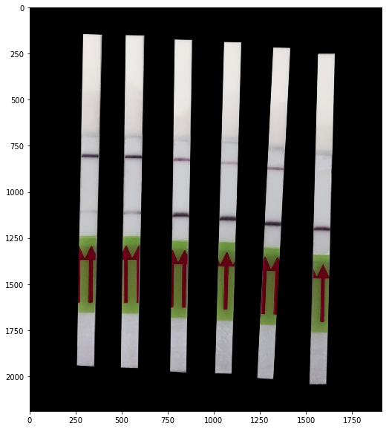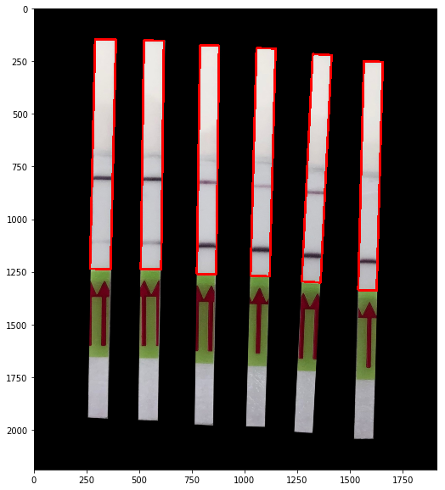

1. Cropped strips

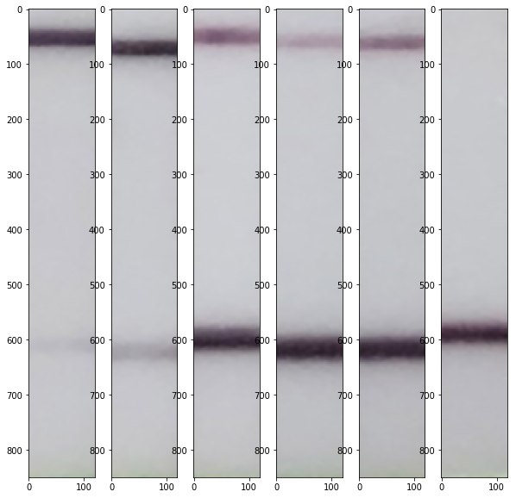

1. Raw intensity data

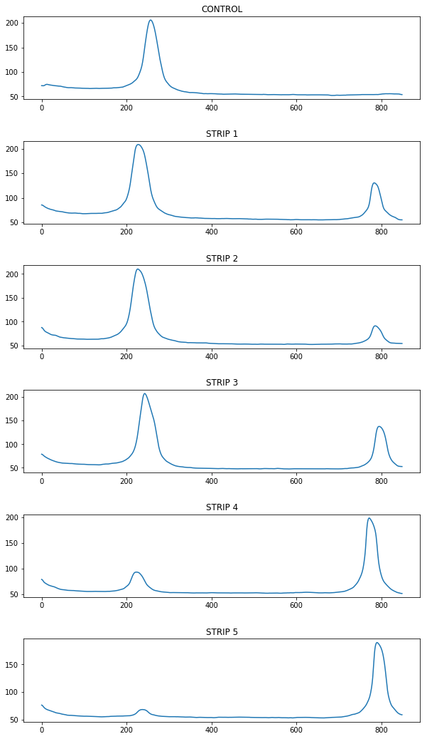

1. Control-normalized positive signal

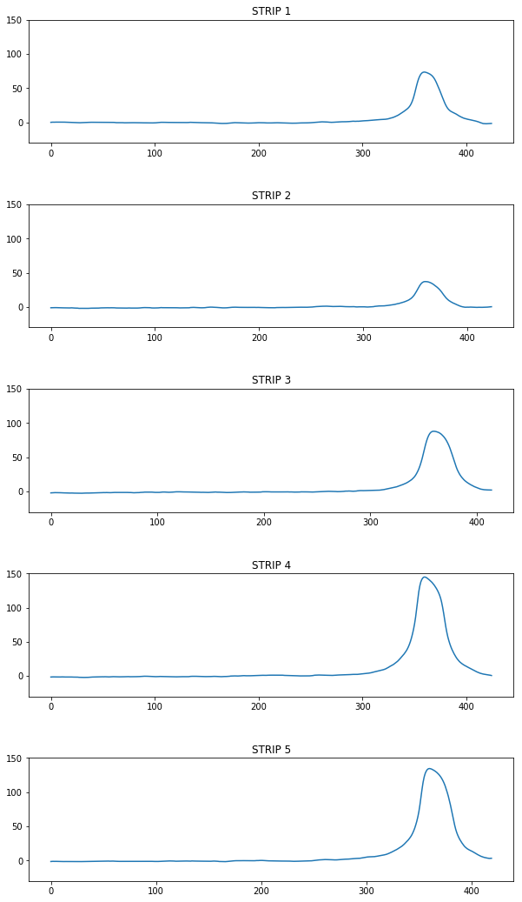

Using 10 x sdev of the normalized signal as threshold for classification, all are positive.

**TEST 2 –** Original dark background, all clearly positive but one

1. Original image and detected strips

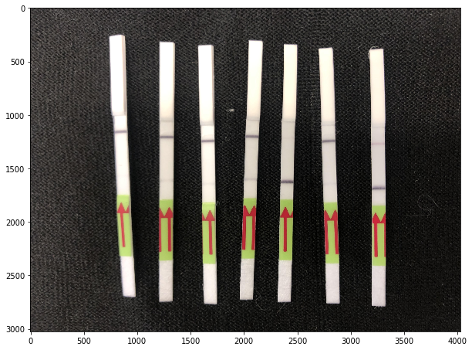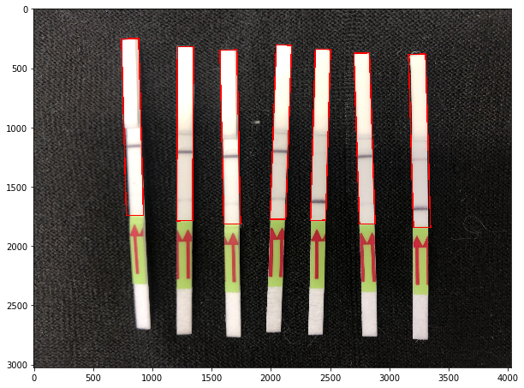

1. Cropped strips

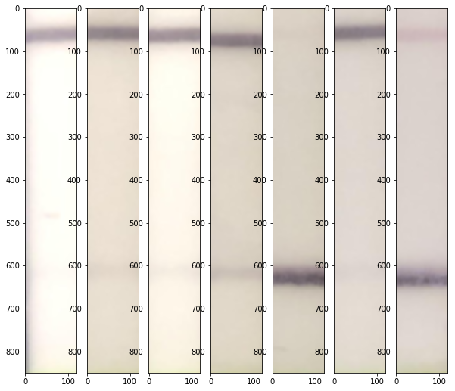

1. Raw intensity data

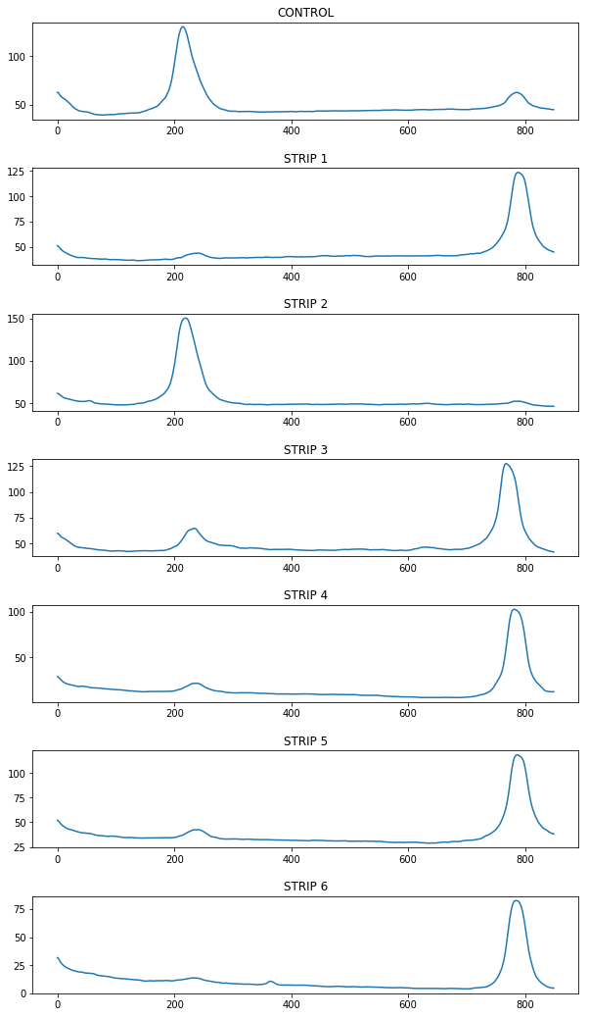

1. Control-normalized positive signal

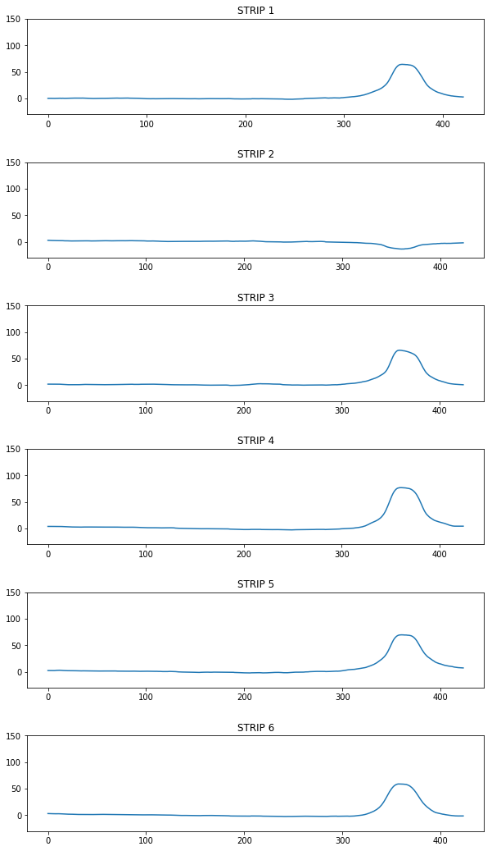

Using 10 x sdev of the normalized signal as threshold for classification, all but strip 2 are positive.

**TEST 3 –** Cropped background, limit of detection

1. Original image and detected strips

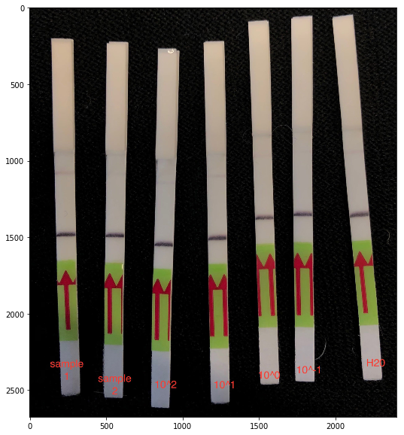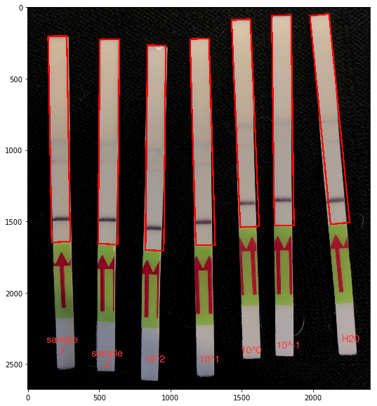

1. Cropped Strips

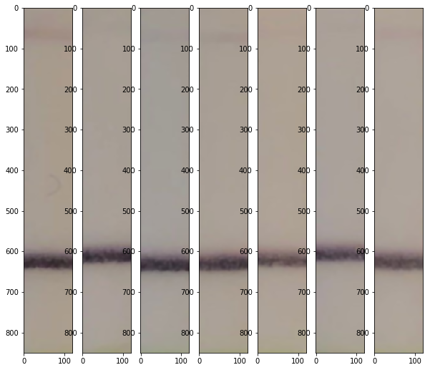

1. Raw intensity data

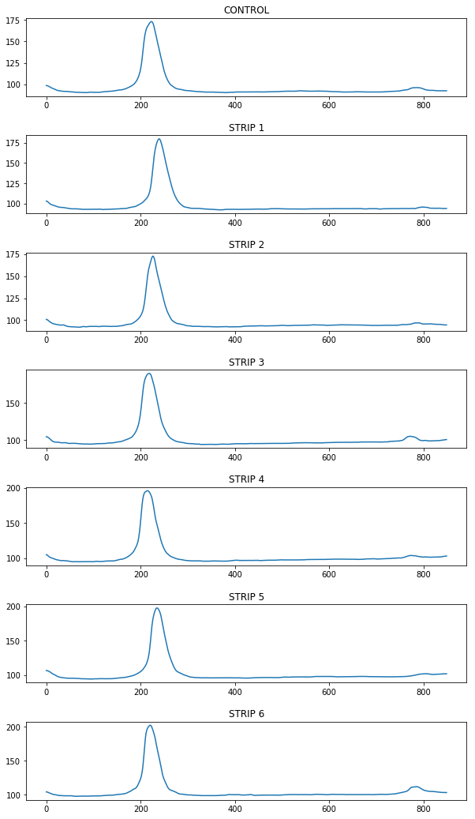

1. Control-normalized positive signal

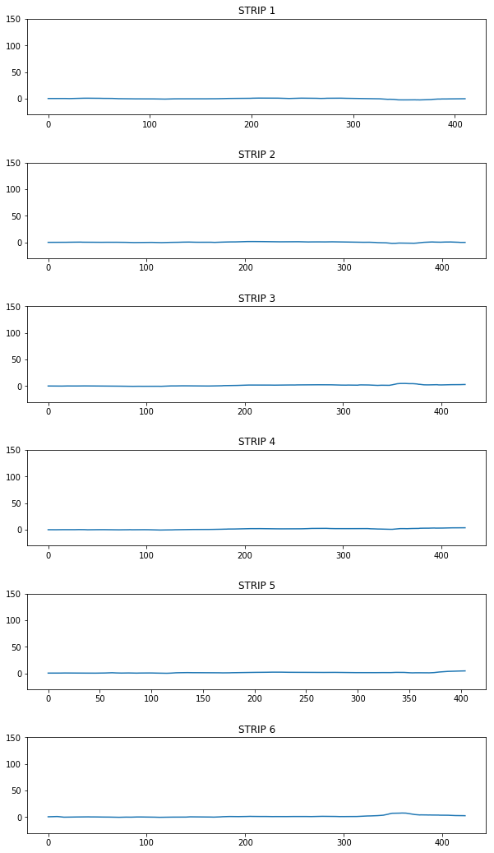

Using 10 x sdev of the normalized signal as threshold for classification, only strip 6 is considered (marginally) positive.

**TEST 4 –** Cropped background, clearly positive tests and one limit of detection

1. Original image and detected strips

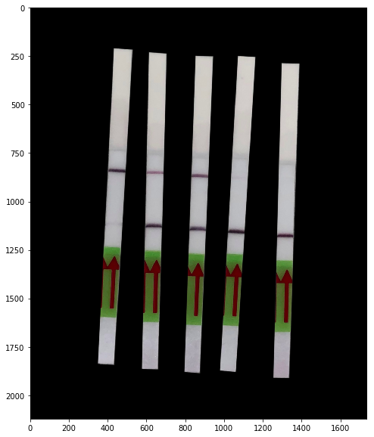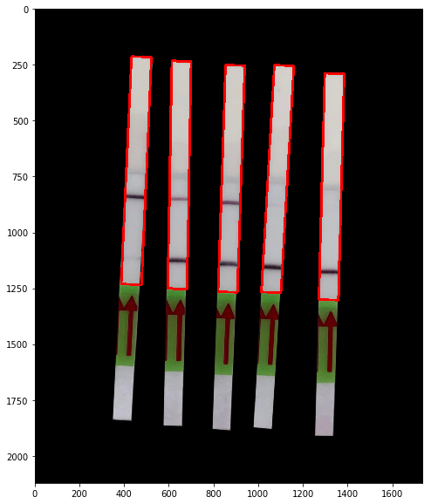

1. Cropped Strips

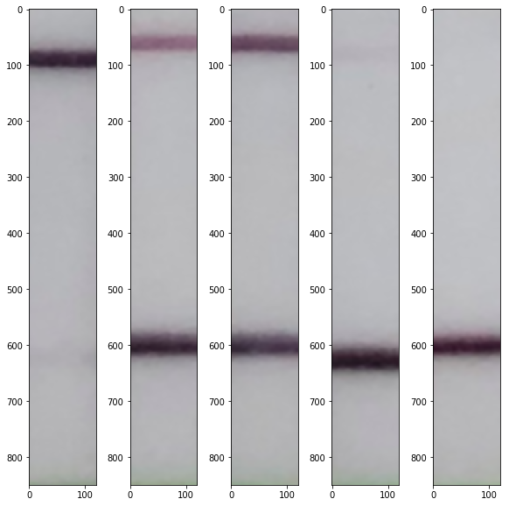

1. Raw intensity data

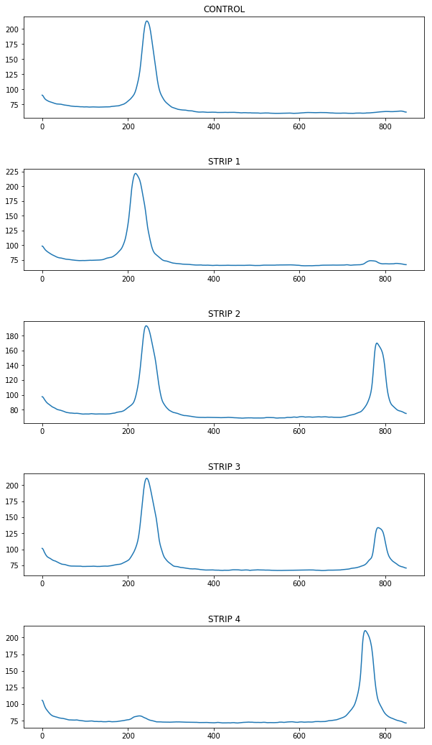

1. Control-normalized positive signal

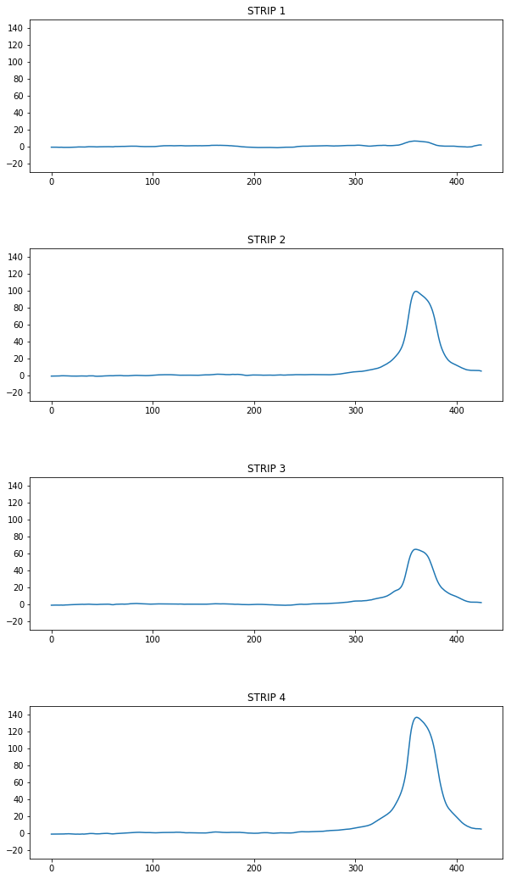

Using 10 x sdev of the normalized signal as threshold for classification, all but strip 1 are considered positive.

**TEST 5 –** Original light background, only positive and limit of detection

1. Original image and detected strips

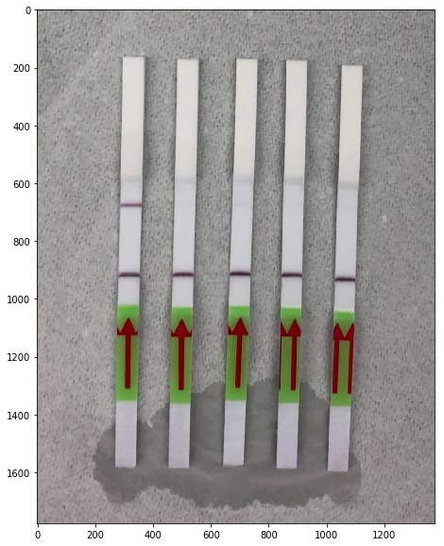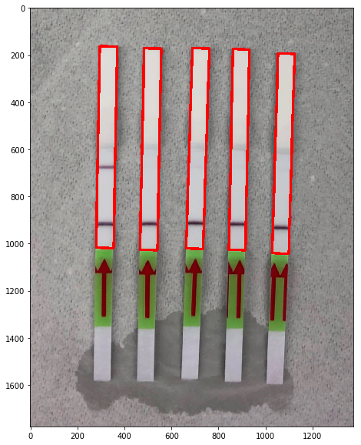

1. Cropped Strips

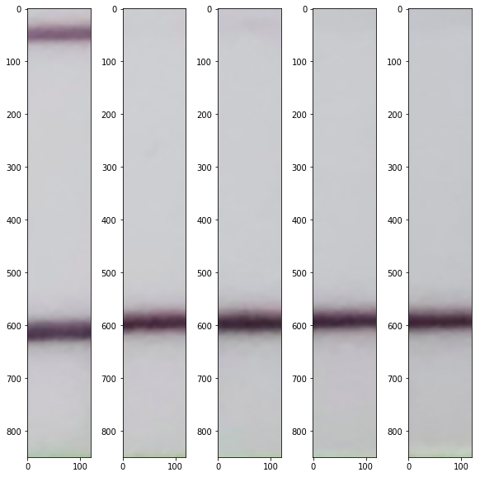

1. Raw intensity data

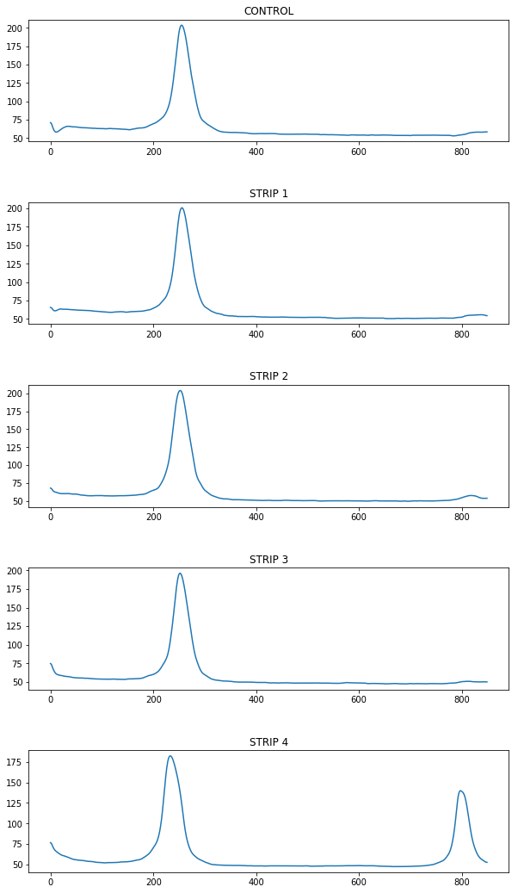

1. Control-normalized positive signal

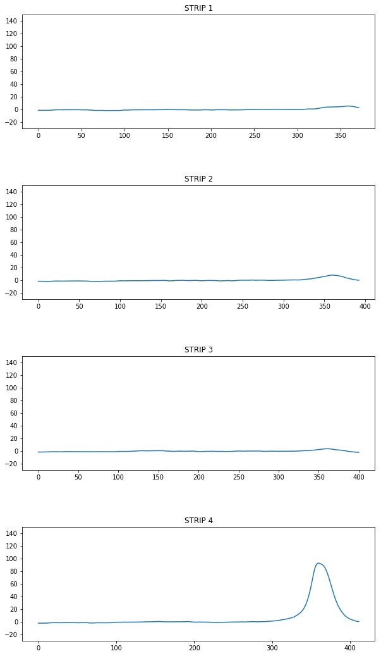

Using 15 x sdev of the normalized signal as threshold for classification, strips 2 and 4 are considered positive. With 10 x sdev, strip 1 is considered positive as well (although very marginally).