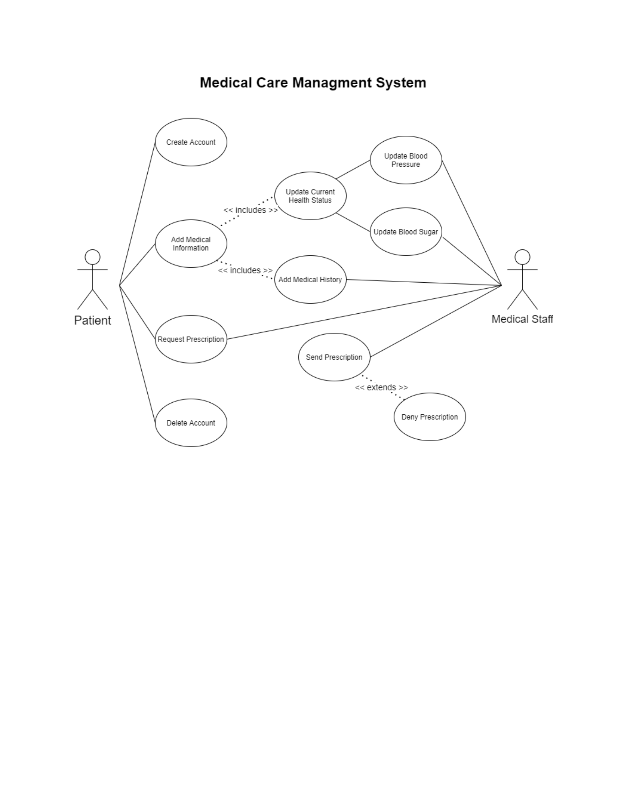

Use Case: Send a prescription

Primary Actors: Doctor or Nurse, Patient

Precondtions: Nurses only have access to sending prescriptions that are not controlled.

Main Scenerio:

1. A patient request a refill on a prescription

2. Prescription gets sent to the nurse.

3. Doctor or Nurse selects a drug and dose.

4. Doctor or Nurse verifies drug and dose.

5. Doctor or Nurse sends prescription electronically.

6. Patient gets notification a prescription has been sent.

Alternative Scenerios:

1. Patient hasn't been seen in a year

a.) Doctor or Nurse can send notification saying that they need to be seen before they get a refill.

b.) Doctor or Nurse can override the error and send the prescription.

2. Prescription is for a controlled substance

a.) Notification gets sent to the doctor instead

Use Case: Update Current Health Status

Primary Actors: Patient, Doctor

Main Scenerio:

1. Patient feels light headed

2. Patient checks blood pressure and/or blood sugar

3. Patient adds vitals to the medical management system

4. Doctor sees that his blood sugar has been all over the place

5. Sends a prescription for a new dose of insulin

Alternative Scenerios:

1.) Patient is doing a routine check and everything is fine

a.) Everything seems fine to doctor and he leaves everything as is

2.) Doctor enters patient vitals in checkup