Brock Barlow

ID #1113

AIE CIP_CODE_11.0804

4/11/2016 8 Hour Game Assignment

-Name of game: Super Ball 628 (a Super Mario 64 joke)

-a 3d platform game

-will have different levels (max of 3 levels)

-the player can move and jump

-the player will have to collect items, all items must be collected to advance to the next level

--after collecting all the items, a door will appear which will load the next level. If on the last level, a win screen will load.

-will have a title screen that will have three buttons: start, how to play, and exit.

-if the player falls off the platform(s), they will respawn on the last platform they were on.

-some items will be on the ground, some will be in boxes (like in Mario).

-when picking up the items, an explosion sound will play or display an explosion graphic.

-players jump ability will be called “force lift” (the player will be a jedi).

-can pause the game (game freezes and shows controls/buttons.

Design of the objects used in game:

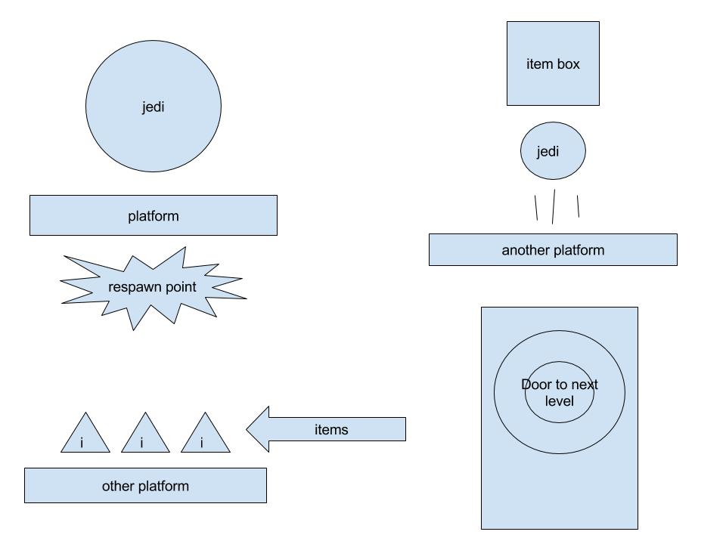

Design of the menus:

