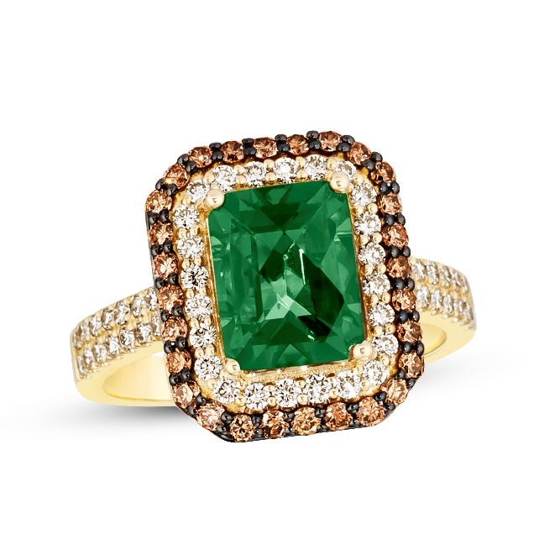upc: 123456789



Blah: 987654

Some other upc: 987654321