# Data Structures and Java (Spring 2015)

## Assignment 0 – Printing

### Assignment objectives:

In this assignment, you may use your knowledge of the following concepts:

1. Use System.out to print out strings

Note that this assignment is not graded.

### Tasks:

#### Task 1

Create a new project in NetBeans with a class called **A0<FirstName><LastName>.java**

#### Task 2

We’re going to print the following concept from: <http://www.nhl.com/gamecenter/en/recap?id=2013020640&navid=sb:recap>

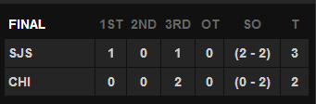

Specifically, print to System.out the following output.

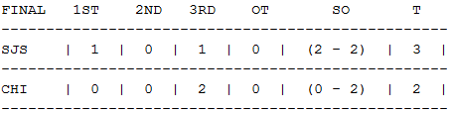

### Deliverables

Please zip your entire project folder containing the **src** sub-folder and the **nbproject** subfolder (the others are not necessary). Name the zip file **A0_firstlastname.zip** and submit to Canvas.