Date: 10/23/2017 | Owner: GROUP G.6
Approval Date: | Manager Approval:

  BACKGROUND :
  Currently, we’ve run into a problem where our car cannot handle the weight of all the components and electronic it needs to support. We need to fix this as soon as possible in order to not damage more of the RC chassis.
  CURRENT CONDITIONS :
  In prototype 1 the group did not anticipate the effect of the additional weight of the batteries on the structural integrity of the vehicle. Due to this oversight, when the batteries and electronics were mounted on the body and the vehicle tested on October 22, 2017, a deformation occurred both between the interface of gears and between the gear mount and the side panels.
  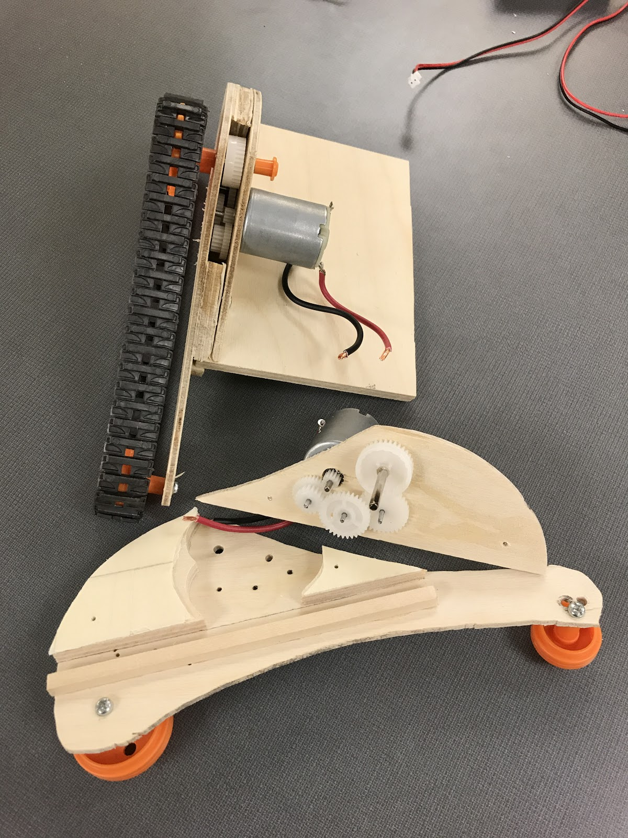
  GOAL:
  Reduce weight as much as possible via smaller and lighter battery packs. Replaced gear chain with a manufactured motor gear housing.
  Strengthen RC chassis by incorporating a stronger material for axes, so that they can support the weight of the RC vehicle and still maintain control and speed.
  ANALYSIS
  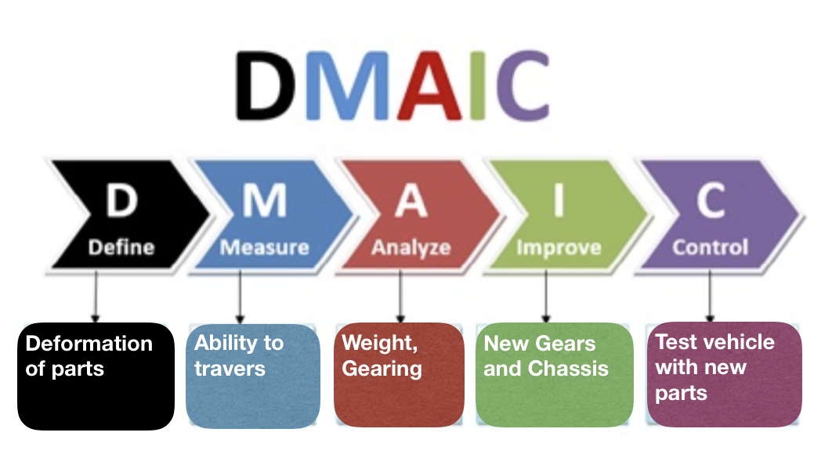
  PROPOSAL
  Replace the battery pack with a lighter Lithium lon Polymer 3.7V battery to power up the feather board for prototype 2
  Replace the cheap axis by 3D printed one
  PLAN
  Brock and YaLan will order a lithium lipo 3.7 volt battery to power the Adafruit Feather circuit board on October 23rd.
  Chris will order 2 motors also on October 23rd that include metal gears, eliminating the need to add external gearing to the vehicle. These motors will replace the motors used in prototype 1.
  Chris will incorporated a stronger axis on October 25th
  FOLLOW UP
  Some sort of failure from ABS axle with new weights being added.
  Track and drive gear

