**Project Proposal**

**Project Purpose**

To create a website for an event planning business in which visitors to the sight have access to resources in planning for weddings, parties and other events. The sight will contain links and helpful ideas for helping people plan their events. Catering and other services will be provided through this sight.

Below are a few key words and why they are relevant to the site:

1. Event (s)- The biggest most important part of this page to be created, it is meant to help others find the resources necessary to have a great time at the activity.

2. Planning- this is an important aspect in preparing a good enjoyable event. This site will give us the items needed to prepare for their important upcoming day.

3. Party- this is an important part at a party some clients will want an event that is more laid back and relaxed, others will want to party. This site will accommodate all users.

4. Entertainment- different types of entertainment will be offered from singers to comedians and actors.

5. Food- a variety of food will be offered. Most will probably be buffet style meals but some events may require a finer dining approach.

6. Venue- different locations will also be offered from farms and ranches to ballrooms and gyms.

7. Idea (s)- The site will be created to inspire others to come up with their own ideas that we can help bring out and make wonderful

8. Create- We will create wonderful decorations and provide an experience that is unforgettable.

9. Wedding- an important event in most people’s lives is their wedding. We help plan and make this process less of a headache.

10. Guide- Always there to guide you in the decision-making process and make sure you have a great experience

**The Target Audience**

The target audience will be broad but focused toward those in southern Idaho and northern Utah. The Visitors to this sight will likely be those interested in planning parties or those with an up combining special occasion in need of help and guidance. The audience will need to have basic computer skills to be able to navigate the page. Visitors will have a great experience in visiting and learning how to piece together the complicated parts of an event.

**Persona**

|  |  |
| --- | --- |
| Picture: | Picture: |
| Name: Jack Damascus | Name: |
| Career: Manager at Adobe | Career: |
| Propose in visiting site: Looking for help planning the company Christmas party. | Propose in visiting site: |
| Hobbies/interests: Skiing, basketball, outdoors, reading | Hobbies/interests: Skiing, basketball, outdoors, reading |
| Personal Bio: Father of 4, married for 13 years, middle aged | Personal Bio: Father of 4, married for 13 years, middle aged |
| Quote: “Plans are nothing Planning is everything.” | Quote: “Plans are nothing Planning is everything.” |

**Web Pages**

Home page- Most items will be accessible from the home screen. It will display information clearly and with proper proximity. A video will be provided that gives input about the business.

Venues- In this page consumers will help clients generate ideas on locations that work best for their specific event. A list will be displayed with various locations around eastern Idaho. It will also have pictures for venues we have done in the past.

Catering-this page will show a few ideas from past events as well as options that we could provide catering services for such as deserts or meals.

Contact Us- This page is right at the heart of the site. Our goal is to have Perspective clients fill out the form on this page. By doing this they provide us with key information on how to help them best.

About Us: This page is incredibly important. It will show the site visitors that we are real people. It is designed with the intent on connecting with those that visit the site. It will help them feel comfortable and know that we provide reliable services.

**Wireframe Sketches**

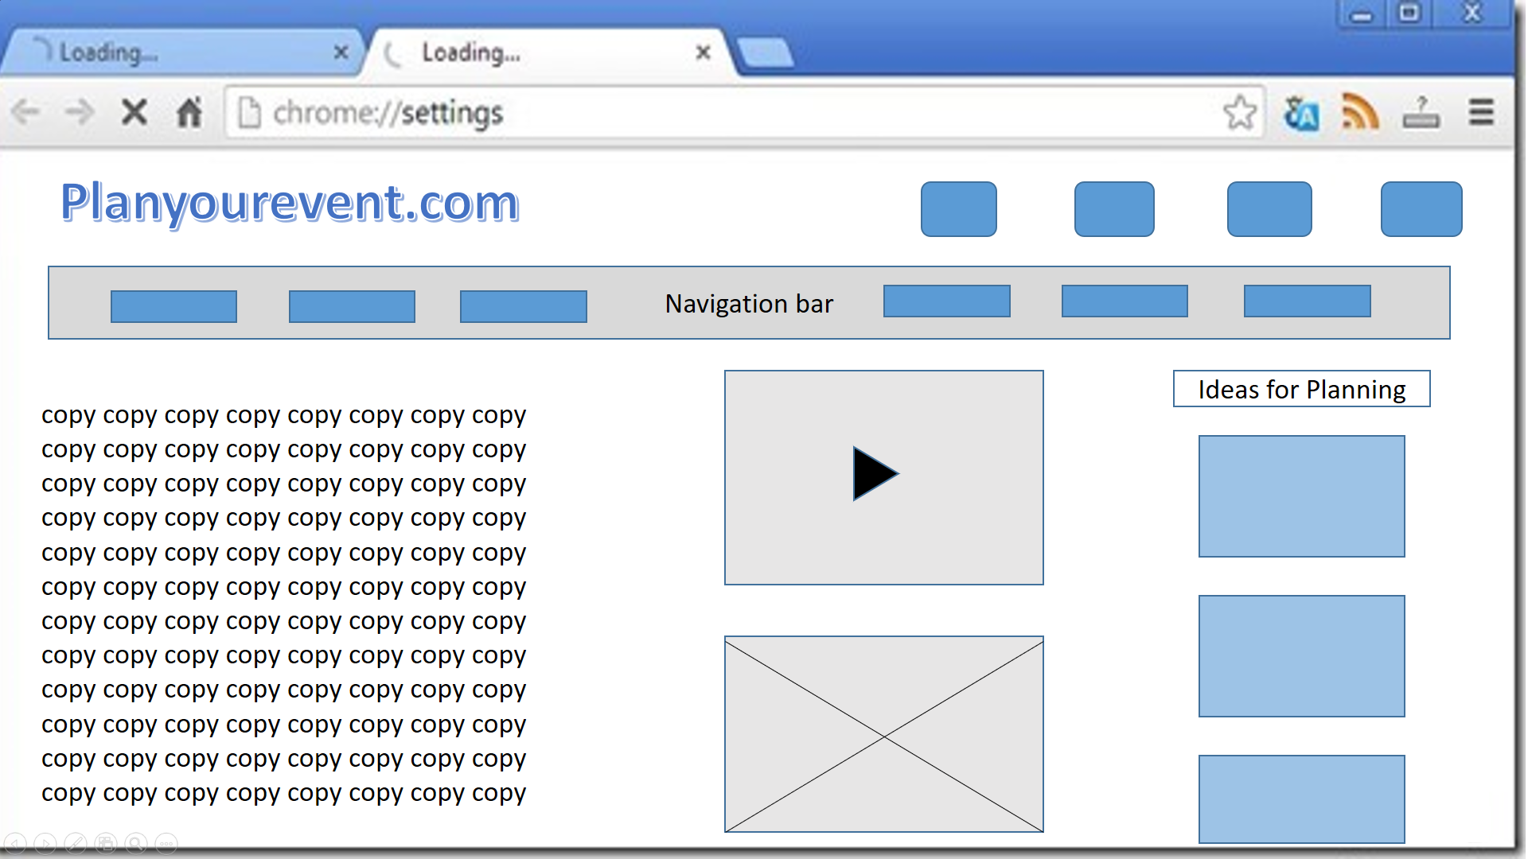

The goal in creating this large wireframe is to create a guide to use while building the site. It will allow users to be in control and access information easily. It was created to be simple and to the point allowing many users to easily understand and navigate the site.

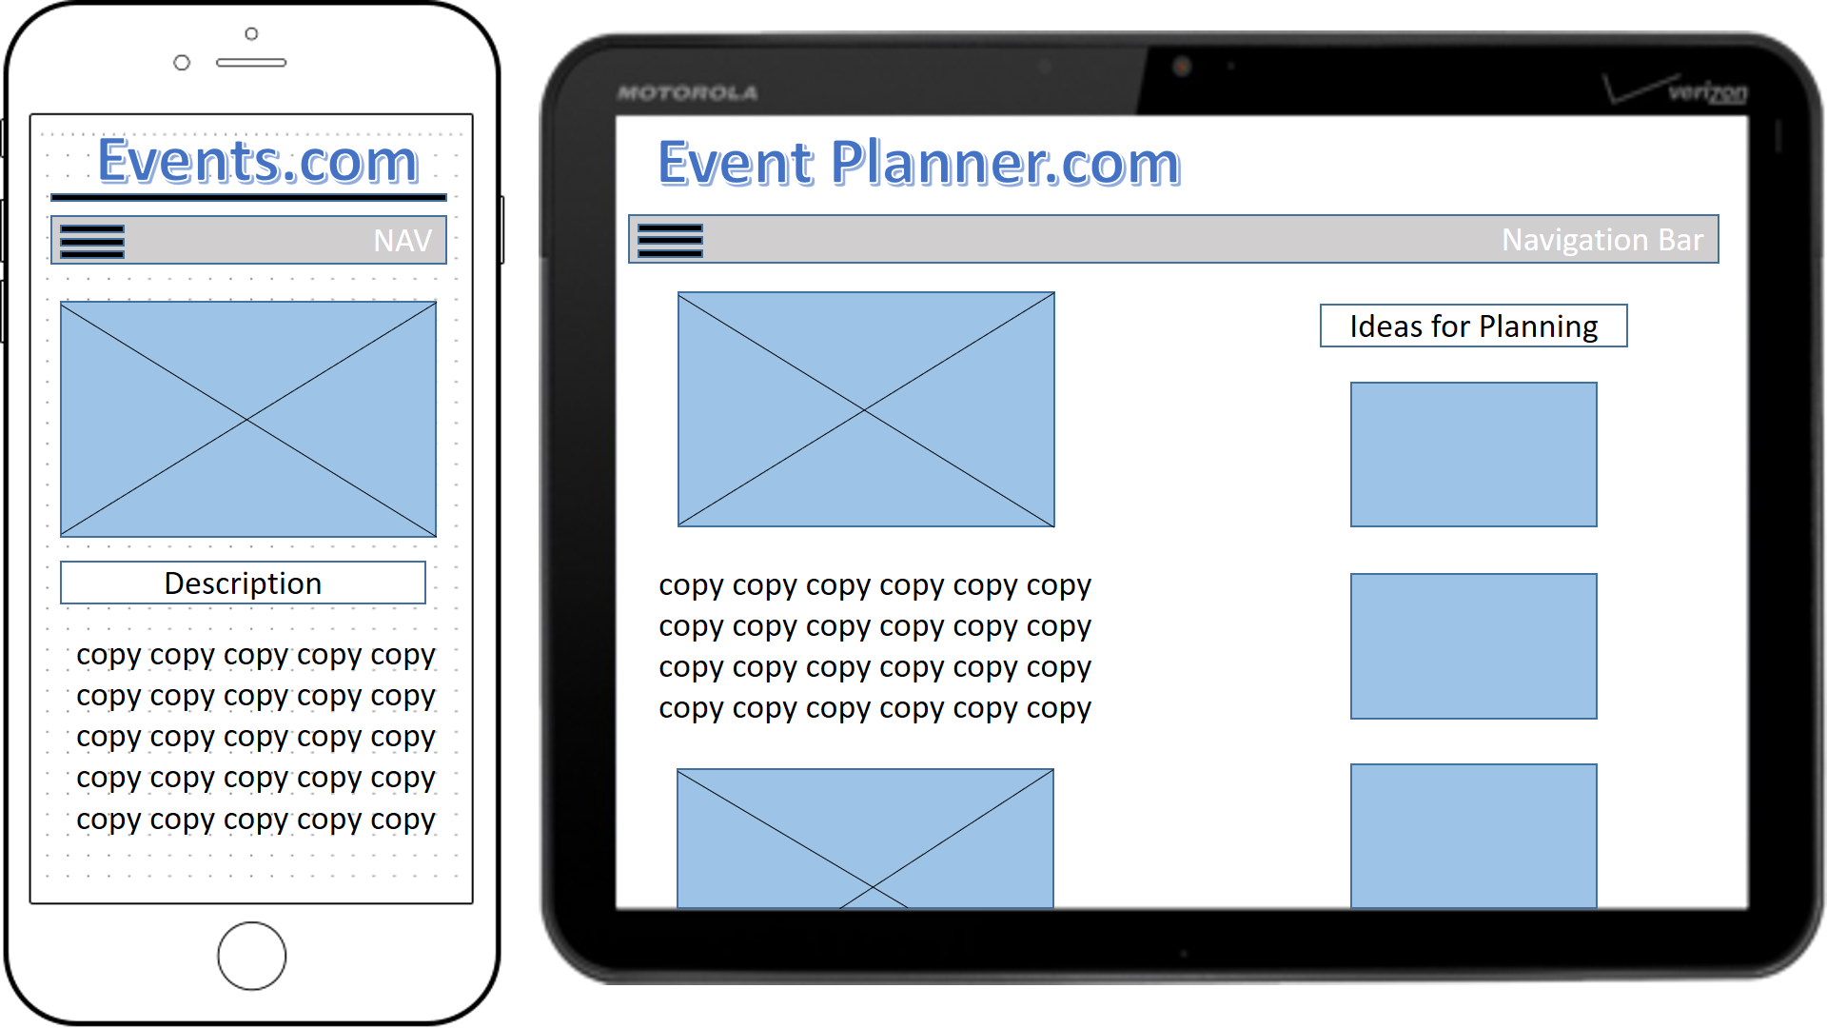

The medium size screen allows basic information to be displayed without lots of clutter and navigation difficulty. It is similar to a large display without unnecessary detail being displayed.

The small screen displays even less information but has effective use of navigation to allow users to access the material needed.

**Usability Concepts**

The font size will be large but easily viewable on a mobile screen. The tags on images and other objects of the page will have multiple defining key words to allow it to be found with ease in search engines. The links will be easily viewable and display well with the background color.