**Final Project: Defense Contract Tracking**

William Brock Rose

109736445

BANA 6800

CU Denver

**Abstract**

This paper is an introduction to the Aerospace and Defense contracting and procurement process. The purpose of data collection, processing and visualization is to provide data driven intelligence to inform decision makers of current market trends. Data visualized in this paper is intended to populate a Customer Relationship Management tool (CRM) used to track customer interactions and engagements.

With the invention of flight on a beach in Kitty Hawk, Wilbur and Orville Wright unknowingly created an entire industry in 1903. The Aerospace and Defense (A&D) industry is fairly nascent when compared with other engineering based industries, dating little over one hundred years since the world’s first successful flight. The result has become an increasingly competitive and highly advanced domain of technological development. With one hundred years, humans have taken basic flight and are now planning interplanetary travel. Since the 1960’s, orbital launches have averaged nearly 100 per year with a recent resurgence in interest in the space domain.

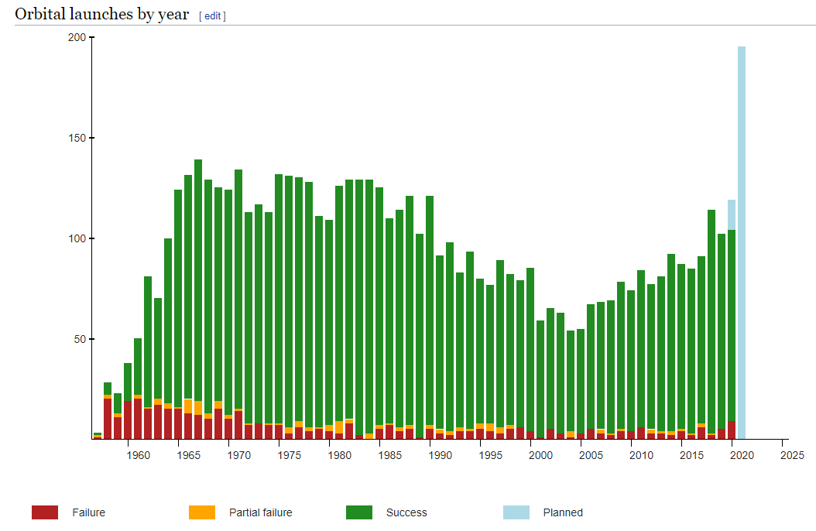

Figure 1: Orbital Space Launches Since 1960’s [1]

New interest in Space has been catalyzed by the United States’ renewed resolve to return to the moon in 2024 and Elon Musk’s mission to Mars. With advancing technologies such as 5G, space is quickly becoming a priority for government and commercial entities alike. New entrants to the Aerospace and Defense market like Space X and Blue Origin have created new industry rivalry in a once monopolized market. The current market landscape within A&D is led by four main defense contractors: Lockheed Martin, Northrop Grumman, Raytheon and Boeing. These four contractors own more than half of the defense budget. Revenue of the top 20 defense contractors is depicted below in Figure 2.

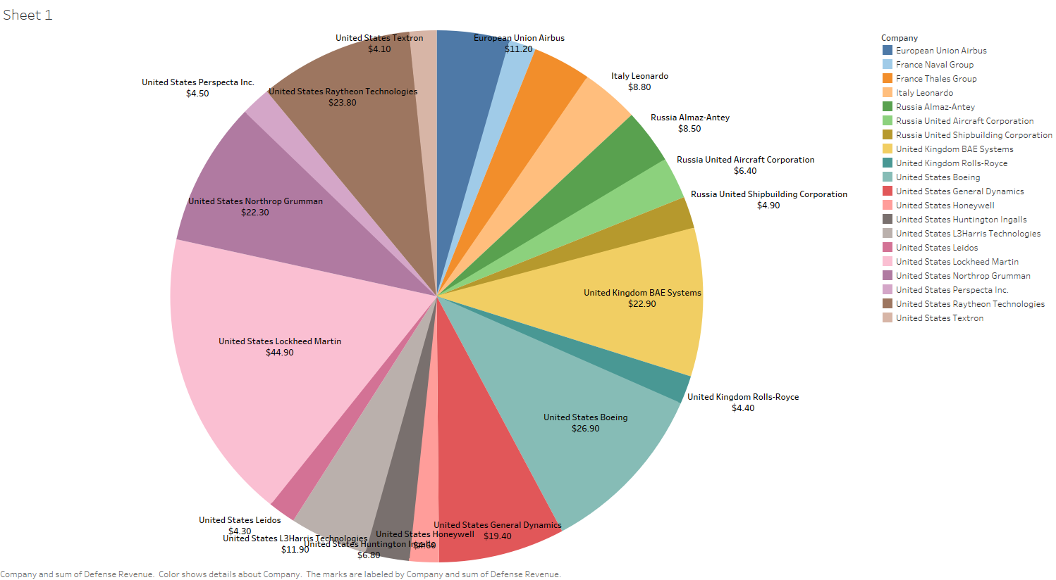

The Aerospace and Defense industry deals almost exclusively with the United States government. The dominant defense contractors have been working with the government acquisition agencies since the mid 1990’s and have helped establish the process for government procurement. When doing business through the government, the process requires specific contracts and approvals before goods and services can be provided. This requires a need for a federal procurement data system (FPDS). The government uses the FPDS to solicit contracts and track federal budget spending with transparency. Websites such as, USASpending.gov and DataLab are used to track the US government’s spending as a result of the Federal Funding Accountability and Transparency Act of 2006. This act required the government to fully disclose all entities of the government receiving federal funds beginning 2007. This act is important to Aerospace and Defense contractors because they are able to understand the customer’s budget and where they are allocating their resources due to the transparency. The budget is then tied to contracts with contractors via the FPDS, allowing contractors to track “who’s winning what” and “what is the customer investing in”. Below is the FY2020 RDT&E Budget released by the government. The government invests in research and development in technology using Activity Codes to denote the technological maturity/technology readiness levels of the technology being invested.

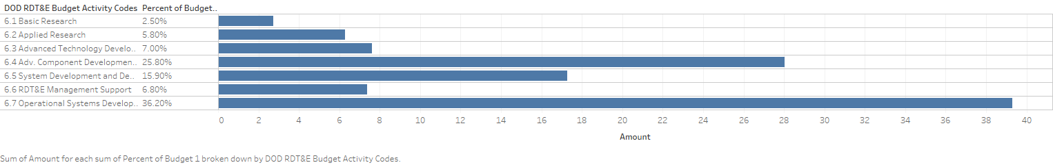

Figure 2: DoD RDT&E Budget Activity Codes

Having access to budget data and where the customer is allocating their resources can guide contractors in decision making. By analyzing Customer Research and Development (CRAD) funds, contractors can make assumptions as to what technology the customer would like to invest in and align their own Internal Research and Development (IRAD) to collaborate and mature the technology jointly. Space acquisition agencies such as Space and Missile Command (SMC) have reorganized their structure to facilitate this new type of acquisition style. Last year, SMC reorganized its directorates from a vertical orientation to a horizontal orientation focused on the development and maturity of technology rather than the specific technology itself. The new acquisition structure is shown below.

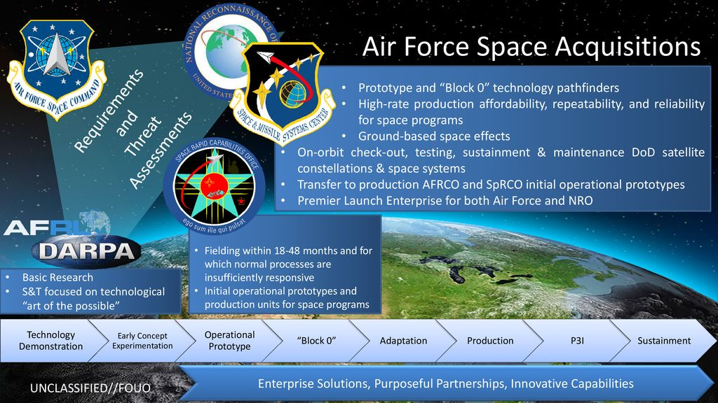

Figure 3: Air Force Space Acquisition [2]

The budget being tracked in RDT&E documents released by the government is being used to fund research labs like AFRL, DARPA and SDA. The funding for these research labs will generally be 6.1 Basic Research and 6.2 Applied Research. As technology matures, the larger amounts of funding will be used to solicit S&T contracts to suppliers and contractors for 6.4 Advanced Component Development. The S&T contracts are the entry point for contractors and suppliers to collaborate with the customer and gain customer intimacy. Shaping the customer and suppliers requirements for advanced system development and operational prototype will disrupt any competitors that are not engaged early in the technology development.

After a technology is approved to the point of operational prototype, the research labs will pass the contracting to acquisition agencies like SMC. SMC will then solicit a request for proposal (RFP) to contractors so that there will be a competitive bid for the contract. Contractors will then undergo a formal business development lifecycle model know as the Shipley model. The Shipley model is track milestones, events and reviews during the lifecycle of a pursuit in the business development pursuit pipeline. The reviews and milestones ensure that proper process and procedures are followed to submit a compliant bid and not be disqualified by the customer.

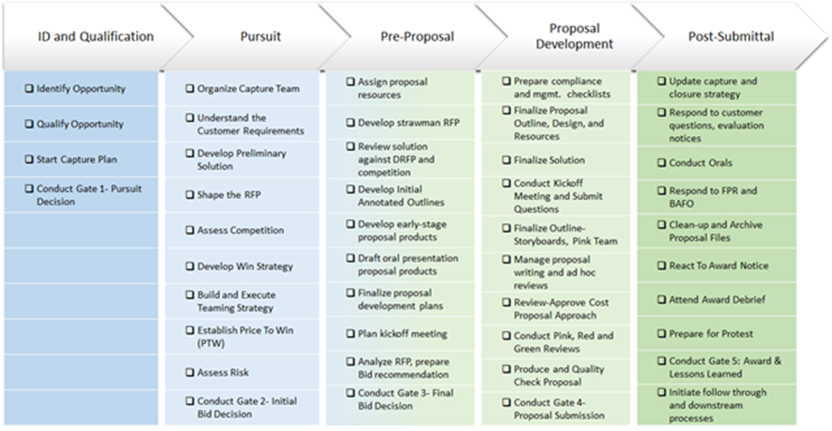

Figure 4: Shipley Business Development Model [3]

At the beginning of the business development process, the primary decision gate is a Pursuit Decision. This is a meeting that decides whether the request for proposal is worth pursuing. In this meeting, the data collected from the contracts, budgets and customer engagements and interactions would provide objective evidence as to whether the pursuit has a high probability of win. When conducting the initial assessment of the competition, decision makers will look at the competitor’s portfolio and track record with the customer. The portfolio may look like a visualization below.

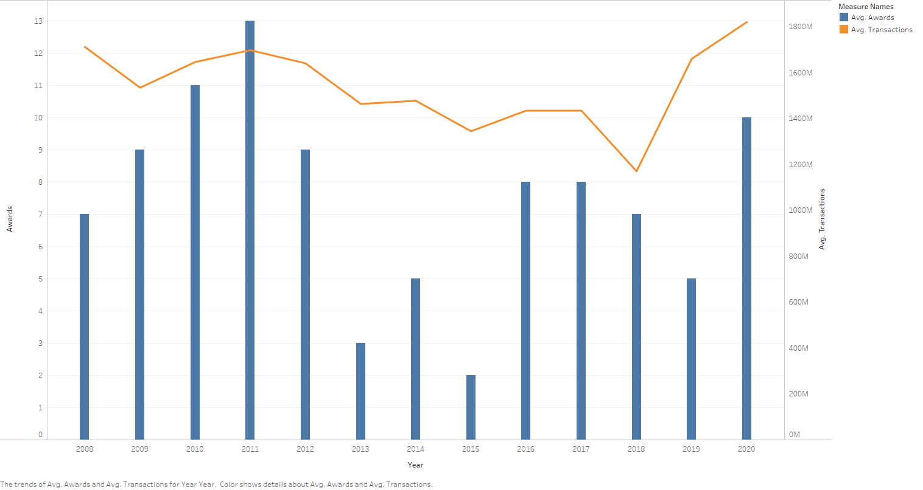

Figure 5: Contractor Award Portfolio

Awards and contract value are tracked with the award data that is provided publicly by the government. The customer’s contract history can be divided into a distribution among the competitors to give an idea of which contractor has the highest amount of customer intimacy or trust. The contract history is also broken into subcontracts, when work from the prime contractor is subcontracted to another contractor. These subcontracts are often given to suppliers that help integrate specific technology into advanced systems. The subcontract data needs to be tracked to give insight to which suppliers have begun developing and maturing the technology needed to produce an operational prototype at the cheapest bid possible. Gathering contract portfolios for contractors and suppliers and relating that back to the customer’s budget will give decision makers the proper intelligence to make a data driven decision.

Once a pursuit reaches the proposal, the proposal is written and submitted for selection for award. The customer will process the proposal and decide which contractor to award the contract. When the government awards a contract, they will disclose the amount of money that the contract is obligated initially and what the total program value will be worth at the end of the period of performance. This contract information is important because it plays into how the customer will either continue to do business with the incumbent or how the competition may try to take away the contract as it nears the end of its period of performance. Below is an interactive dashboard that tracks the award data that is collected from different sources and parsed to associate the contract with the contractor and customer.

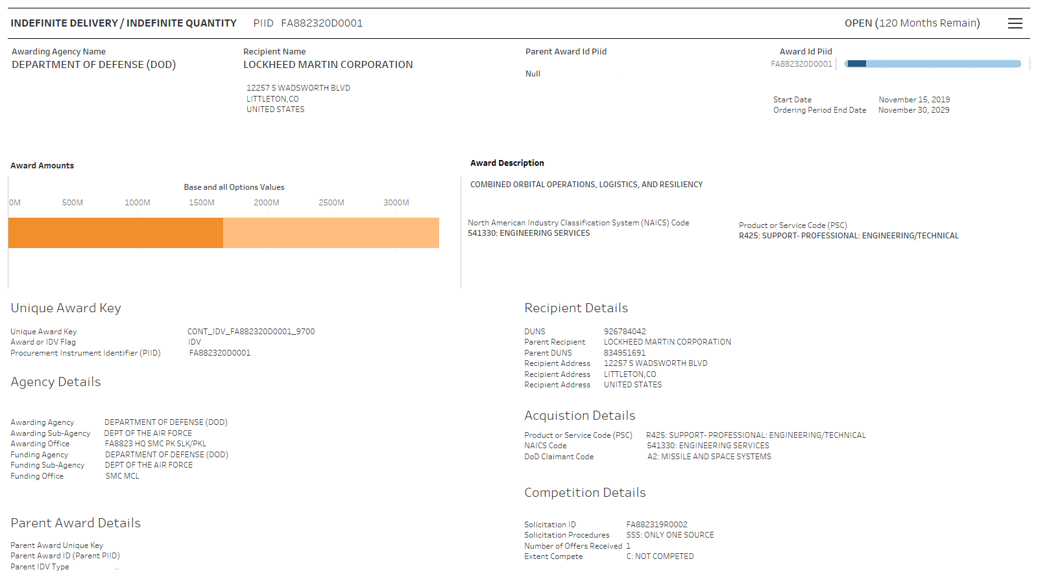

Figure 6: Interactive Contract Dashboard

The dashboard tracks information that is important to creating a digital thread from the earliest engagement with the customer, through the research and development and after the acquisition during the program execution. The contract PIID is the identifier used to associate the contract to the recipient and the customer. The customer is actually broken into two types of agencies, the funding agency and the awarding agency. The funding agency creates the requirements and conducts the gap analysis of current space architecture to ensure that technology addresses any gaps or stays ahead of any developments that could be potential risks. The awarding agencies conduct the acquisition and sustainment of the contract after the award. By having multiple customers associated to budget and award, the government hierarchy is difficult to define. During the last year, the creation of the US Space Force, Space Development Agency and SMC 2.0 created new changes in the hierarchy. Below is an attempt to visualize the government hierarchy in an interactive tree chart using D3.js.

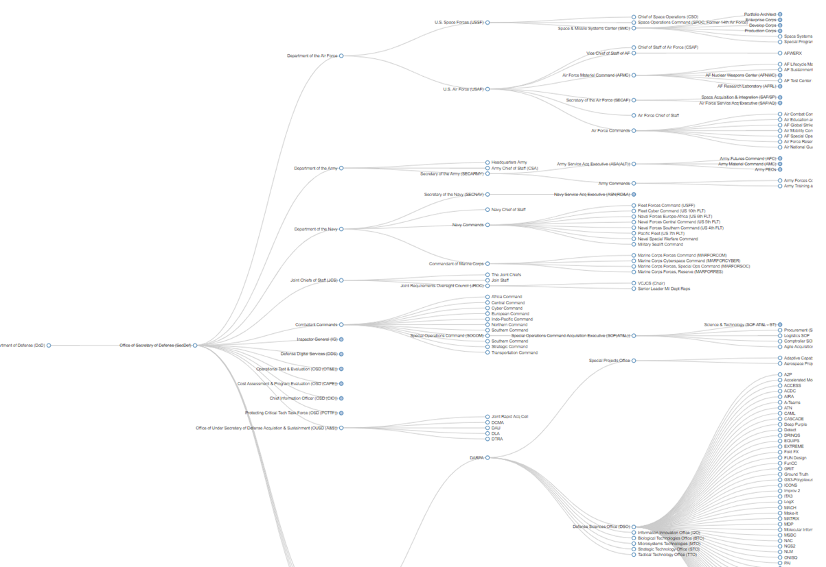

Figure 7: Interactive Collapsible Tree Chart

One of the roadblocks encountered during this definition of contracts and hierarchy was that the government does not use the newly reorganized agencies when soliciting or awarding contracts. The government chooses to use the legacy hierarchy definition with contracts and that data then needs to be mapped to the correct agency in the newly reorganized hierarchy. Having the collapsible hierarchy is useful in conveying these changes to leadership.

The Federal Funding Accountability and Transparency Act of 2006 required the Department of Defense to provide the public transparency concerning funding of government agencies. This act has required the use of a Federal Procurement Data System that tracks the procurements of the government agencies receiving funding. By understanding the government’s new acquisition strategy, funding in research labs and the S&T contracts being solicited by those labs can be early access for contractors to collaborate and invest in next generation technology. If contractors use this data to conduct competitive intelligence reviews of supplier and contractor involvement with the technology being developed by the customer, the data can be leveraged to make strategic partnerships and disruptive initiatives that could increase probability of win of a pursuit.

References

[1] https://en.wikipedia.org/wiki/Timeline_of_spaceflight

[2] https://slideplayer.com/slide/17829207/

[3]

https://www.r3bsolutions.com/breaking-govcon-business-development-lifecycle-make-manageable/