Image Manipulation Presentation

Brock Davis

# Part 1: Colors

pic_1_a.png was produced by switching the red and green channels of image1.png.

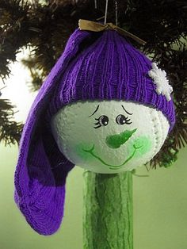

pic_1_a.png

pic_1_b.png was produced by extracting the blue channel of image2.png into a monochromatic image.

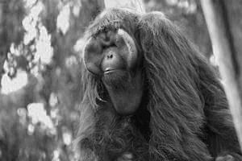

pic_1_b.png

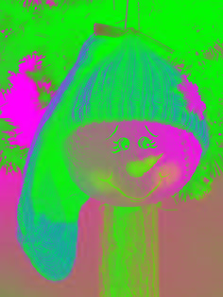

pic_1_c.png was produced by inverting (taking the difference of 255 and the intensity) the green channel of image1.png.

pic_1_c.png

pic_1_d.png was created by increasing the intensity of all channels by 100, capped at 255.

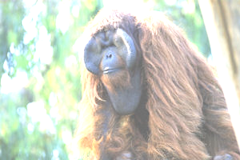

* uint8 does not usually allow this, because after 255, the adding 1 will return the number to 0.

pic_1_d.png

# Part 2: Copy and Paste

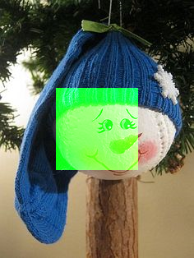

Pic_2_a.png was created by taking the center 100x100 pixels and increasing the green channel to the max(255)

pic_2_a.png

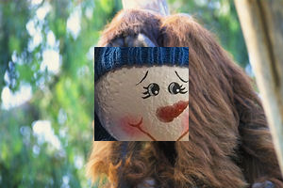

pic_2_b.png was created by inserting the middle 100x100 pixels of image1 to the middle 100x100 pixels of image 2

pic_2_b.png

# Part 3: Stats

* Number of pixels: 74,104
* Min value: 0
* Max value: 255
* Std. Deviation: 67.468
* Mean Intensity: 92.162
* The standard deviation and mean corresponds to most of the intensity of the pixels between in the middle range, instead of at the extremes, which makes sense, because most natural colors don’t have extreme saturation

# Part 04: Flag

pic_4_a.png is made using the specification of the Union Jack to make a picture of it

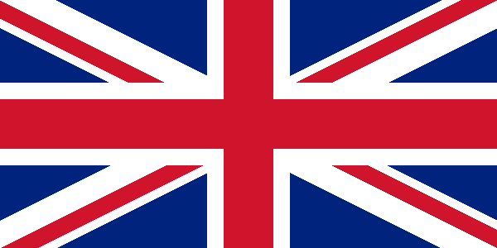

pic_4_a.png

pic_4_a.png was made by subtracting the created flag from the original, downloaded flag.

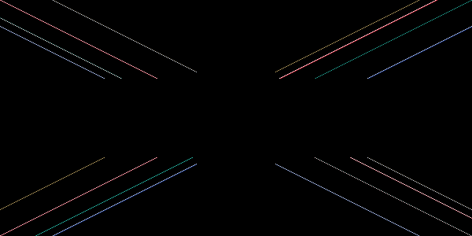

* The discrepancies could be from antialiasing versus no-antialiasing the pictures, or from computer rounding errors used to calculated the intercepts of the diagonals.

pic_4_b.png