**Numbers Pattern 1: using a for loop and range function**

1

2 2

3 3 3

4 4 4 4

5 5 5 5 5

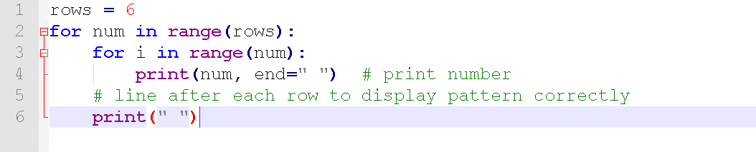

Number Pattern 2: Half pyramid pattern with numbers

1

1 2

1 2 3

1 2 3 4

1 2 3 4 5

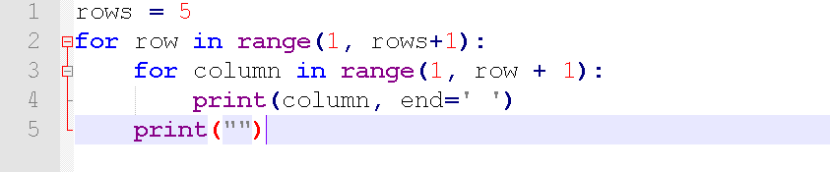

#### Numbers Pattern 3: Inverted Pyramid pattern with numbers

1 1 1 1 1

2 2 2 2

3 3 3

4 4

5

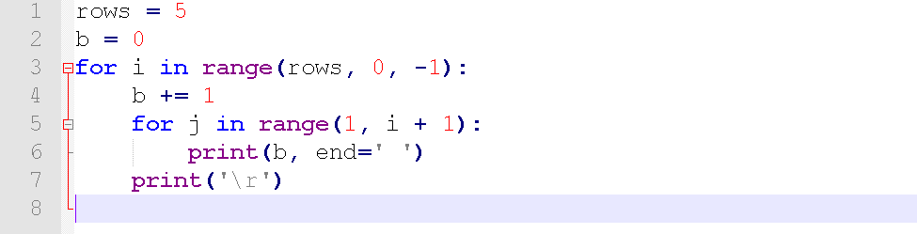

#### Numbers Pattern 4: Inverted Pyramid pattern with same number

5 5 5 5 5

5 5 5 5

5 5 5

5 5

5

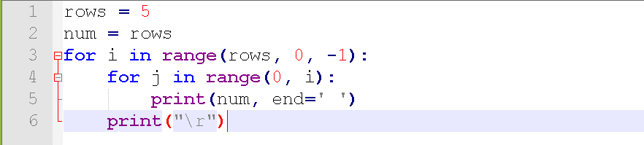

#### Numbers Pattern 5: Display descending order of number

5 5 5 5 5

4 4 4 4

3 3 3

2 2

1

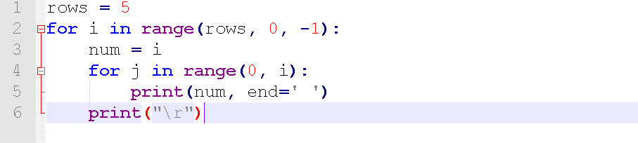

#### Number Pattern 6: Inverted half pyramid pattern with number

0 1 2 3 4 5

0 1 2 3 4

0 1 2 3

0 1 2

0 1

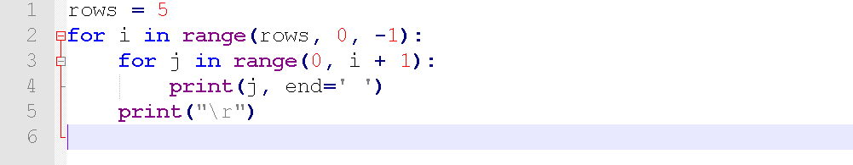

#### Number pattern 7: Square Pattern with numbers

1 2 3 4 5

2 2 3 4 5

3 3 3 4 5

4 4 4 4 5

5 5 5 5 5

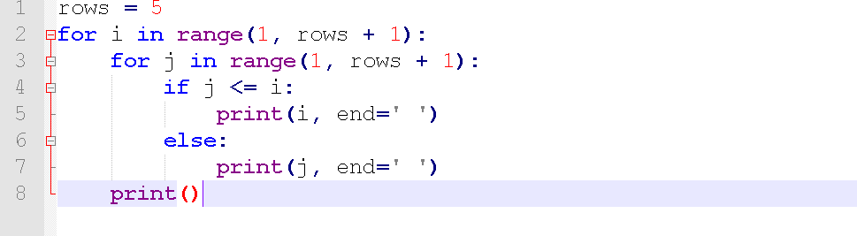

Star Pattern 1: Equilateral triangle pattern with Star (asterisk)

*

* *

* * *

* * * *

* * * * *

* * * * * *

* * * * * * *

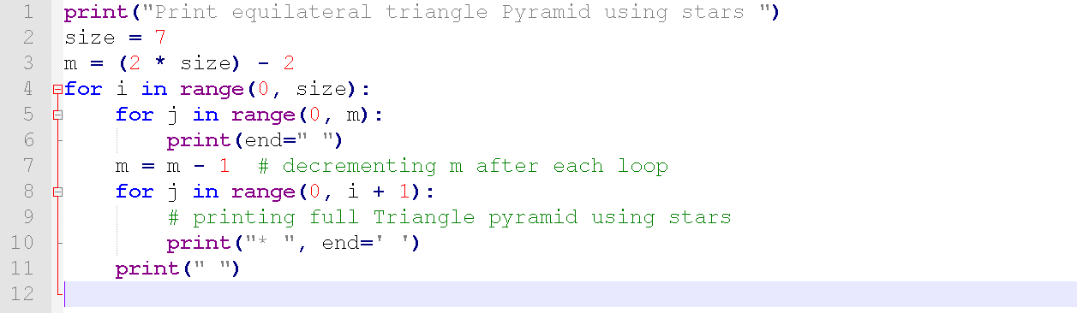Star Pattern 2: Half pyramid pattern with Star (asterisk)

*

* *

* * *

* * * *

* * * * *

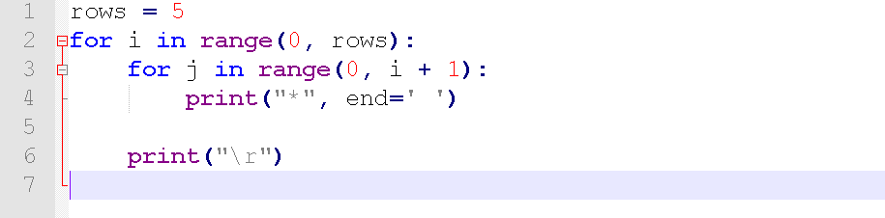

#### Star Pattern 3: Left Half-Pyramid Pattern with Star (asterisk)

*

* *

* * *

* * * *

* * * * *

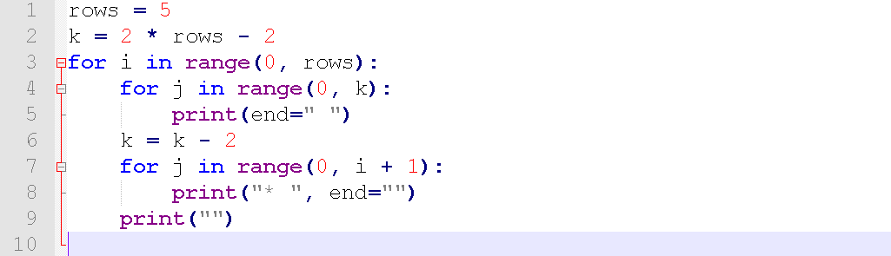

#### Star Pattern 4: Downward Half-Pyramid Pattern with Star (asterisk)

* * * * *

* * * *

* * *

* *

*

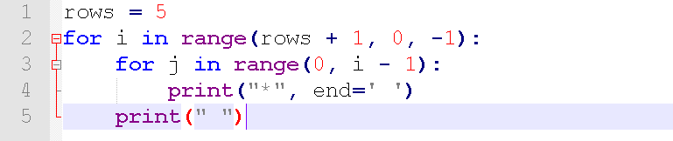

#### Star Pattern 5: Print Right start Pattern with Star (asterisk)

*

* *

* * *

* * * *

* * * * *

* * * *

* * *

* *

*

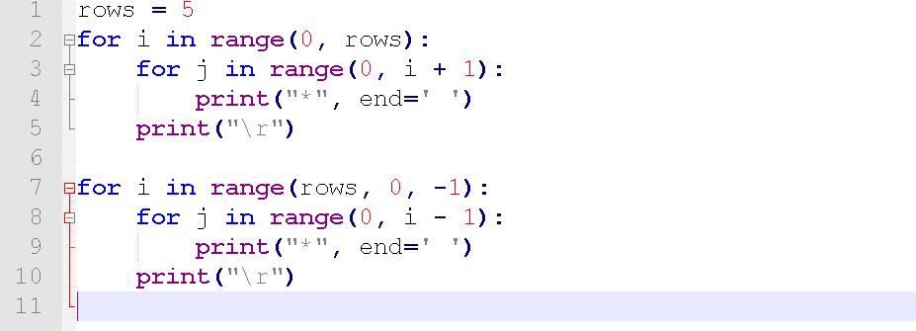

#### Star Pattern 6:  Downward star Pattern

* * * * * *

* * * * *

* * * *

* * *

* *

*

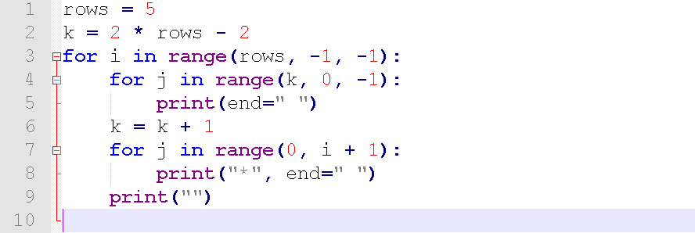

### Diamond Shaped Pattern using stars

*

* *

* * *

* * * *

* * * * *

* * * *

* * *

* *

*

